Supplementary appendix

Methods
A series of FWs was conducted in Ghana in four major cities in 2024: Takoradi (April 23–25), Kumasi (May 22–25), Tamale (May 27–29), and Accra (June 3–5). Each workshop lasted three days, from 9:00 a.m. to 4:00 p.m. daily. Between 20 and 35 stakeholders, representing key organizations, participated in each city’s workshop (see Table 1). The workshops followed five structured phases: preparation, critical analysis, fantasy (visionary), implementation, and action.
The preparation phase focused on the organization, planning, and management of the FW. Through a combination of consultation, observation, and inspection, three to four potential workshop venues were identified in each city. From these options, one venue was carefully selected based on specific criteria to ensure suitability and effectiveness. These criteria included proximity to the city centre for easy access, accessibility by road to facilitate transportation, a relaxed and inspiring atmosphere conducive to creativity, adequate capacity to accommodate all workshop activities comfortably, and a reasonable rental cost to maintain budget efficiency. Following the venue selection, key decisions were made to shape the workshop’s structure and organization. These included identifying the stakeholders to invite, determining the duration of each of the workshop’s five phases to optimize time management, and specifying the necessary resources such as flip charts, markers, pencils, A4 and A3 sheets, crayons, scissors, and glue to support interactive activities. For a comprehensive and inclusive approach to discussions on the implementation and enforcement of air pollution challenges and solutions, a diverse range of stakeholders was deliberately selected. These include individuals and groups directly affected by such policies, as well as those who exert influence over policy decisions; agents responsible for policy implementation and enforcement; specialists possessing technical expertise and practical knowledge of logistical considerations; representatives of marginalized and systematically excluded communities; stakeholders capable of effectively disseminating information and mobilizing broader engagement; and those involved in service provision and support systems pertinent to air pollution mitigation and response. To identify potential stakeholders, a snowball sampling technique was employed, allowing for the systematic and expanding identification of relevant individuals. These stakeholders were then invited to participate in the workshop and contribute actively to the subsequent phases of the FW, ensuring broad and inclusive representation and enhancing the overall effectiveness of the process.
The critical phase focused on developing a critical understanding of the problem: “the obstacles to effective implementation of environmental laws and regulations for managing air pollution in urban Ghana”. The core principles of the FW were emphasized: “everyone is important,” “everything said is important,” “everyone gets the opportunity to speak,” and “everything is written down or visualized” . Each participant received five pieces of paper, along with pencils and pens, and was asked to list the obstacles they believed hindered the enforcement of air pollution laws and regulations in urban Ghana. The resulting barriers were collected, written on flip charts, and displayed on the workshop venue’s walls. Participants reviewed the flip charts to confirm that all identified obstacles had been accurately documented (Figure 1).
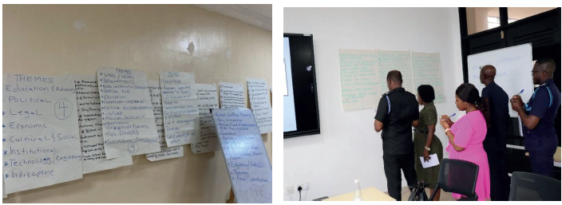
Fig.1: (a) Obstacles affixed to the walls-left (b) participants validating obstacles-right
Next, the barriers were organized into sub-themes. Participants were divided into groups based on the number of sub-themes, with each group assigned a specific sub-theme to discuss. Each group included at least one representative from the relevant stakeholders. The groups then ranked the top five barriers within their assigned sub-theme that they considered most critical. In the following phase, these key barriers became the focus for developing proposed solutions to the identified challenges.
The focus of the Fantasy phase was to develop future-oriented visions and identify the capabilities needed to address each barrier previously identified in the critical phase. Participants were encouraged to think creatively and expansively, guided by questions such as: “What would we do if there were no constraints, unlimited resources, or restrictive laws? What if a fairy could grant all our wishes?” Working within their groups and sub-themes, participants proposed the most effective solutions to the key problems identified in the earlier phase. In line with the principles of FW, everyone was encouraged to suggest solutions freely, without being limited by existing restrictions, traditions, or barriers. The resulting bank of solutions was then carried forward to inform the next phase of the process.
In the implementation phase, all the imaginative solutions generated by participants were further discussed to evaluate their feasibility. Each group then conducted a Strengths, Weaknesses, Opportunities, and Threats (SWOT) analysis on the selected solutions using brainstorming techniques (Helms & Nixon, 2010; Wheelen et al., 2017) 27, 28. The SWOT analysis framework provides a structured approach for evaluating internal strengths and weaknesses alongside external opportunities and threats, making it particularly effective when combined with collaborative brainstorming methods (Gürel & Tat, 2017) 29. Solutions with significant strengths and opportunities were considered most relevant for addressing the identified problems, while those with numerous weaknesses and threats were set aside for the time being.
To refine the selection, participants further applied the Desirability (D) and Possibility (P) criteria, which assess how much the solution meets user needs and how feasible it is to implement within existing constraints. This approach draws from IDEO's design thinking framework, which emphasizes the intersection of desirability (what people desire), feasibility (what is technically possible), and viability (what can be sustainable) as the foundation for innovative solutions (Brown, 2009; IDEO, 2023) 30, 31. The desirability criterion focuses on user-centered design principles, ensuring solutions genuinely resonate with stakeholders' needs and values (Interaction Design Foundation, 2024) 32. The possibility criterion, closely aligned with feasibility assessment, evaluates whether solutions can be realistically implemented given current technical, financial, and organizational constraints (Design Council, 2023) 33.
Solutions scoring at least 60% in both desirability and possibility were deemed practicable and suitable for implementation. This threshold approach ensures that selected solutions maintain a balance between meeting user needs and being realistically achievable, consistent with established innovation frameworks that prioritize both human-centered design and practical implementation considerations (Brown & Wyatt, 2010; Norman & Verganti, 2014) 34, 35.For the most practical solutions identified, a strategic plan was developed outlining who would be responsible for each action, as well as the specific locations, timelines, and methods for implementation. Additionally, a comprehensive report detailing all the critical problems, proposed solutions, and action plans generated during the workshop developed and shared with stakeholders for their comments and feedback.

