Table 1: List of workshop participants
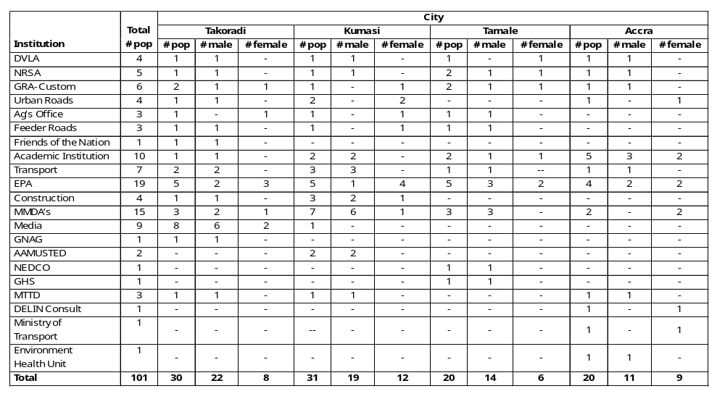
Note: DVLA: Driver and Vehicle Licensing Authority, NRSA: National Road Safety Authority, GRA: Ghana Revenue Authority, Ag: Attorney General, EPA: Environmental Protection Agency, MMDAs: Metropolitan, Municipal, and District Assemblies, GNAG: Ghana National Association of Garages, AAMUSTED: Akenten Appiah-Menka University of Skills Training and Entrepreneurial Development, NEDCO: Northern Electricity Distribution Company, GHS: Ghana Health Services, MTTD: Motor Transport and Traffic Directorate, POP; population

