Supplement Figure 1 Cluster analysis (Bray-Curtis distance) of plant communities. Ⅰ:Cluster 1, Ⅱ: Cluster 2, Ⅲ: Cluster 3, Ⅳ: Cluster 4, Ⅴ: Cluster 5, Ⅵ: Cluster 6
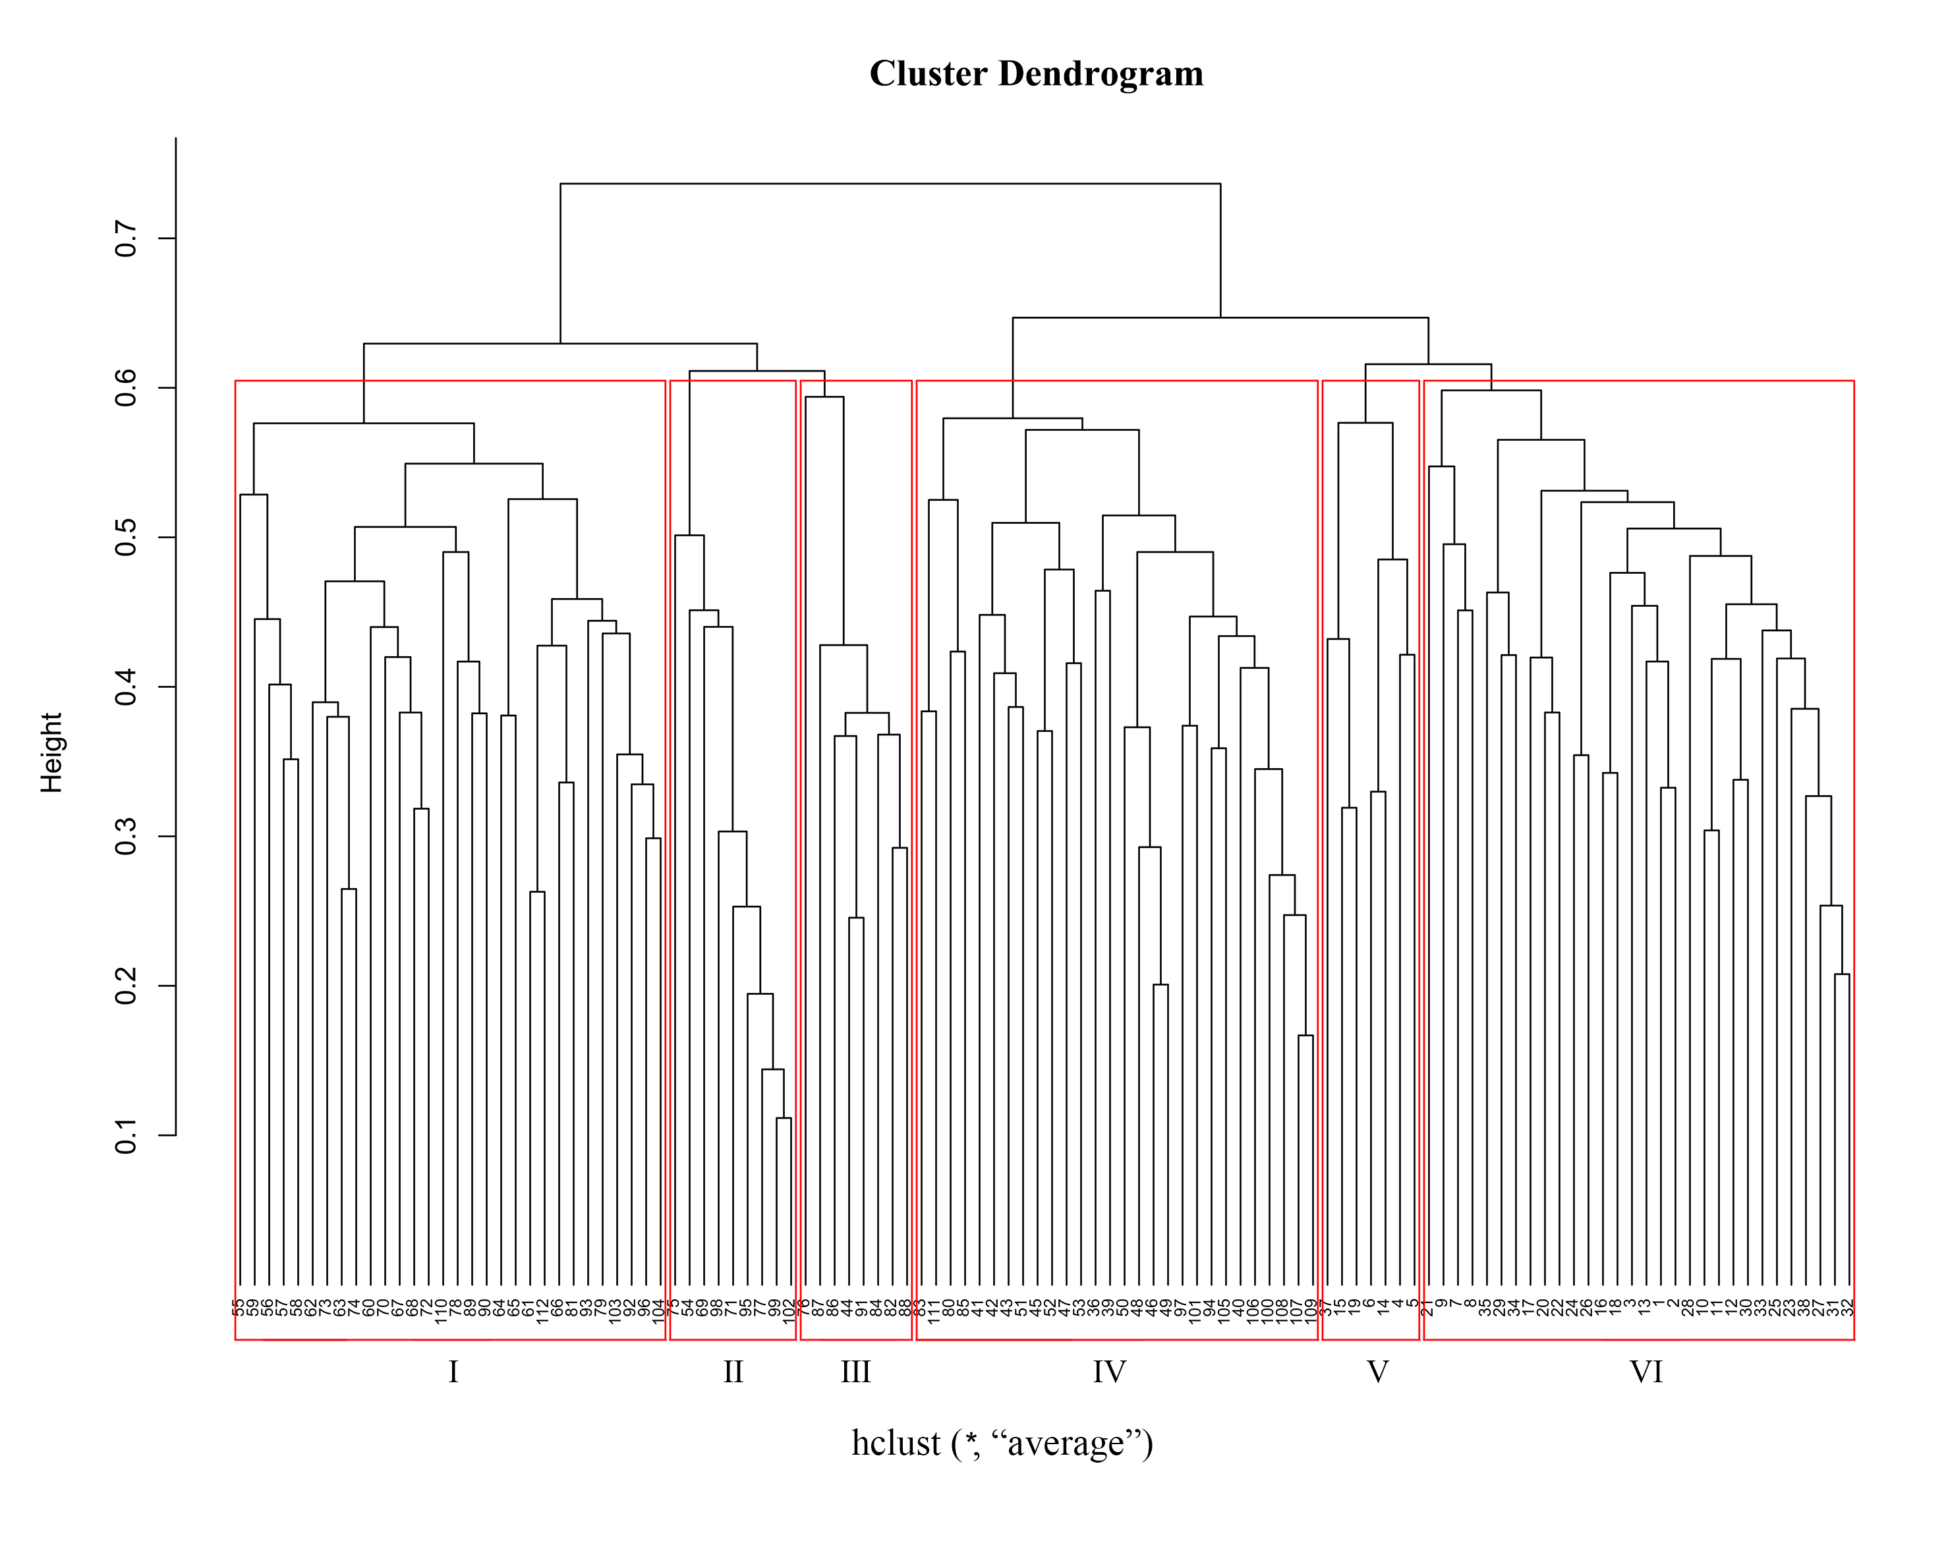

Supplement Figure 2 Relationships between soil nitrogen content and plant species richness in partial correlation regression. (a) overall elevation, (b) low elevation, (c) middle elevation, (d) high elevation
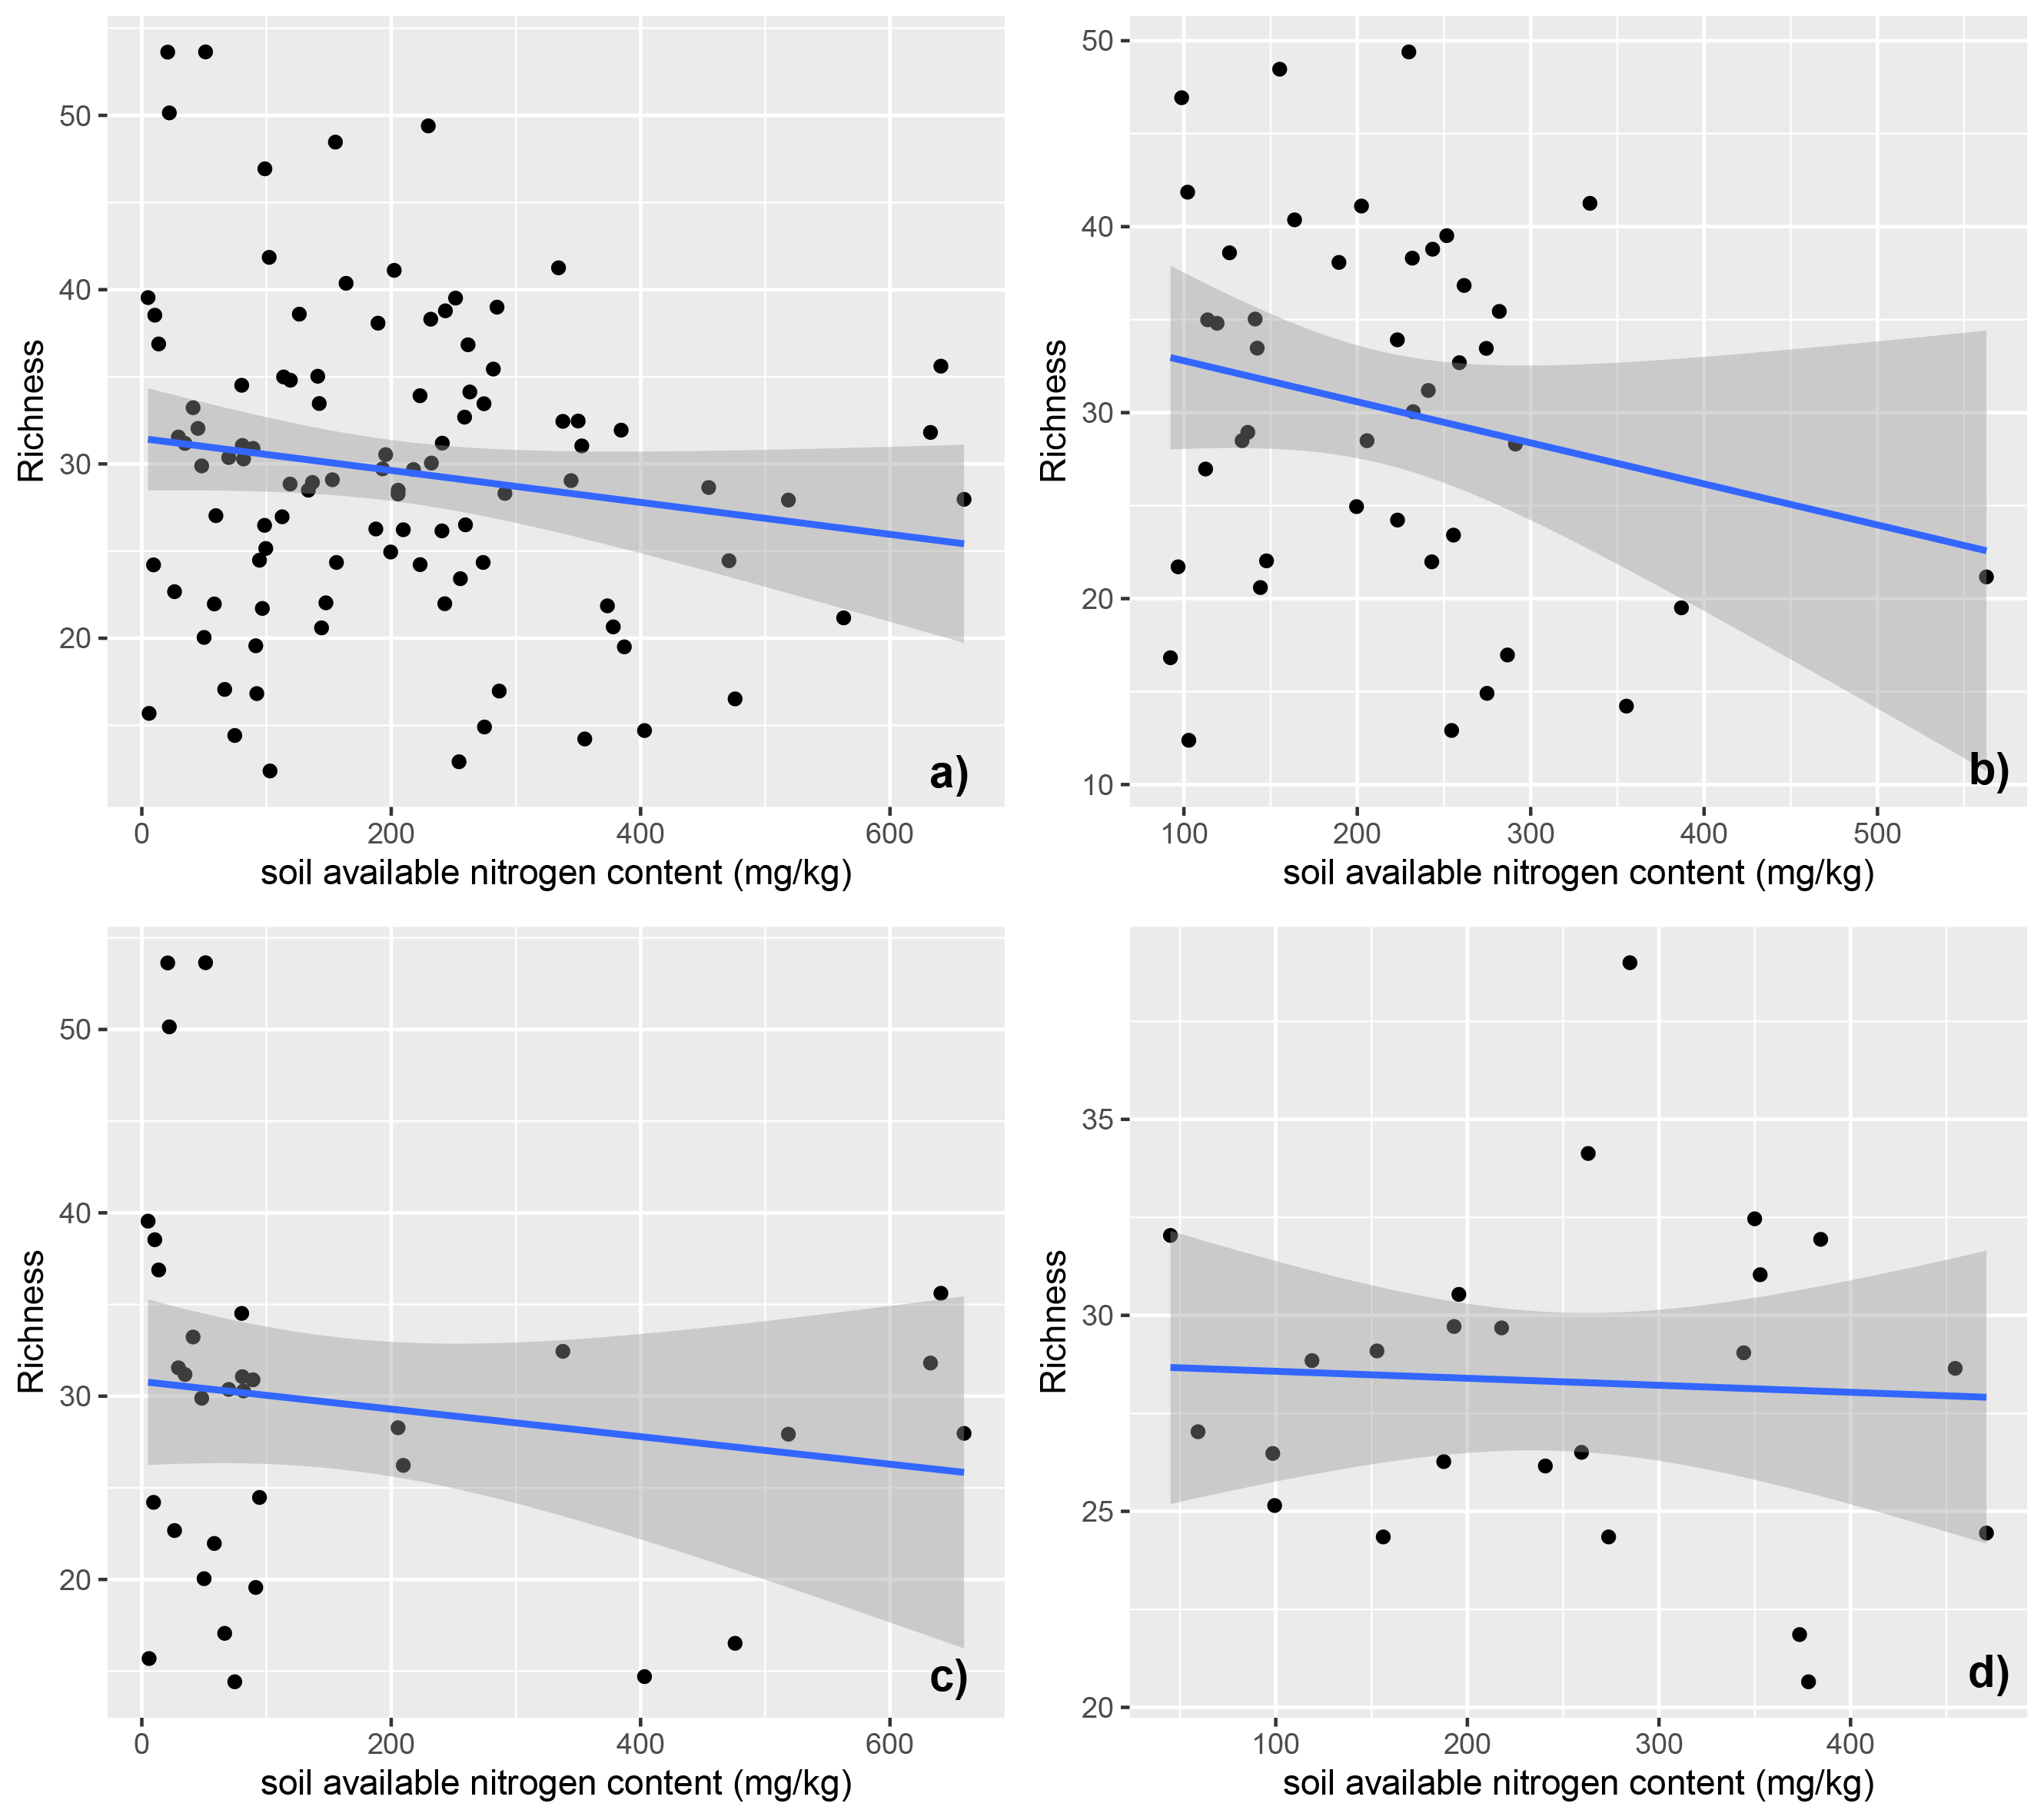
Supplement Table 1 Sørenson’s similarity index among plant community types
Plant community types | Kp | KpM | Ks | Cm | M | G
Kp | 1.00
KpM | 0.61 | 1.00
Ks | 0.68 | 0.75 | 1.00
Cm | 0.57 | 0.61 | 0.62 | 1.00
M | 0.56 | 0.65 | 0.59 | 0.52 | 1.00
G | 0.67 | 0.73 | 0.57 | 0.62 | 0.64 | 1.00
Notes: Kp, Kobresia pygmaea; KpM, Kobresia pygmaea + Miscellaneous plants; Ks, Kobresia setchwanensis; Cm, Carex moorcroftii; M, Miscellaneous plants; G, Gramineae plants.

Supplement Table 2 Results of a stepwise multiple linear regrassion of soil available nitrogen content against explanatory variables
Variable | ANOVA |  | Importance
Variable | F-value | Pr(＞ F) | Importance
SMC | 120.97 | *** | 52.4%
Ele | 35.96 | *** | 11.8%
Tem | 33.13 | *** | 8.4%
SAP | 14.09 | *** | 3.2%
SBD | 4.84 | 0.03 | 1.0%
Notes: SMC, soil moisture content; Ele, elevation; Tem, average annual temperature; SAP, soil available phosphorus content; SBD, soil bulk density.

