Supporting Information
Sources of Environmentally Persistent Free Radicals in PM_{2.5} in Dalian: Important Role of Polycyclic Aromatic Hydrocarbons
Zhansheng Li,¹ Hongxia Zhao*,¹ Xintong Li,¹ Tadiyose Girma Bekele¹

¹ Key Laboratory of Industrial Ecology and Environmental Engineering (Ministry of Education), School of Environmental Science and Technology, Dalian University of Technology, Linggong Road 2, Dalian 116023, China

*Corresponding author phone: +86-411-84707965; Fax: +86-411-84707965; Email: hxzhao@dlut.edu.cn.

Chemicals and regents. Targets standards including 15 PHAs congeners, including Acenaphthylene (ACY, 3-ring), Acenaphthene (ACE, 3-ring), Fluorene (FLU, 3-ring), Phenanthrene (PHE, 3-ring), Anthracene (ANT, 3-ring), Fluoranthene (FLA, 4-ring), Pyrene (PYR, 4-ring), Benzo[a]anthracene (BaA, 4-ring), Chrysene (CHR, 4-ring), Benzo[b]fluoranthene (BbF, 5-ring), Benzo[k]fluoranthene (BkF, 5-ring), Benzo[a]pyrene (BaP, 5-ring), Dibenz[a,h]anthracene (DahA, 5-ring), Indeno[1,2,3-c,d]pyrene (IcdP, 6-ring), Benzo[g,h,i]perlene (BghiP, 6-ring) and 5 surrogate standards NAP-d8, ACE-d10, PHE-d10, CHR-d12, and PYR-d12 were both purchased from Aladdin (Shanghai, China). 2-diphenyl-1-picrylhudrazyl (DPPH) standard was purchased from Aladdin (Shanghai, China). Purities of all the standards were higher than 95%. HPLC grade solvents, including acetone, dichloromethane, ethyl acetate, methanol, and n-hexane were provided by Sigma-Aldrich (St. Louis, MO, USA). Analytical grade chemicals, including anhydrous sodium sulfate, (Na₂SO₄) (60 mesh), were purchased from Sigma-Aldrich (St. Louis, MO, USA). Neutral silica gel (70-230 mesh) was purchased from Thermo Fisher Scientific Co. A Millipore Milli-Q system was used to purify water.

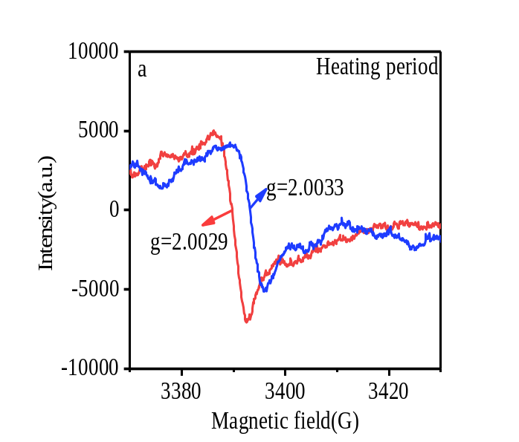
Fig. S1. EPR spectrums of EPFRs bounded to PM2.5 in Dalian

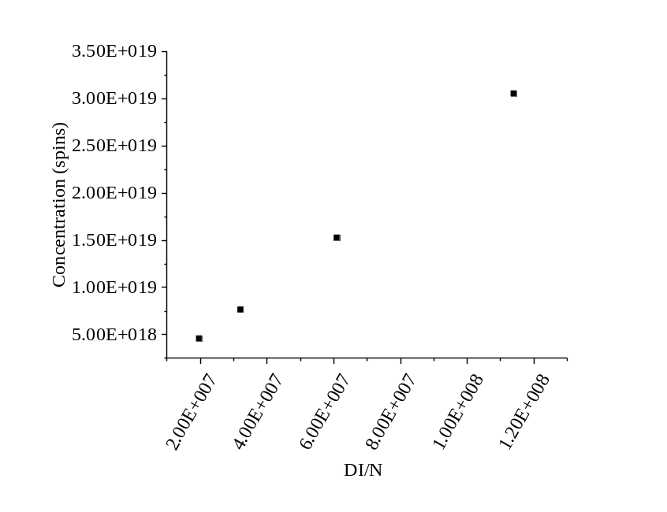
Fig. S2. Liner relationship between DI/N and number of spin for DPPH
EPR spectra of standard substance DPPH: the relationship between doubling integration of fisrt-order derivative and the concentration of spins.
N(spins)=2.33×10¹¹x+1.165×10¹⁵(R²=0.953)
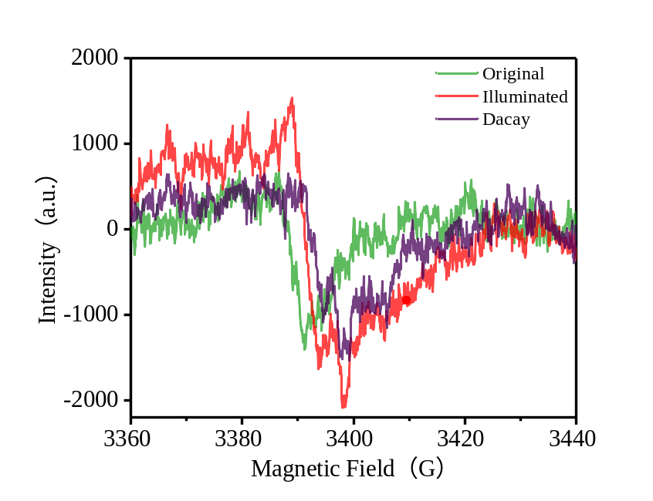
Fig. S3. EPR spectra of the PM2.5 sample before and after visible light
illumination (November 13-15,2018)

Table S1 LOD and LOQ of 15 kinds of PAHs for PM_{2.5} samples
Congener | LOD  (pg/m³) | MDL  (pg/m³)
ACY | 0.670 | 2.21
ACE | 5.09 | 16.8
FLU | 5.30 | 17.5
PHE | 16.2 | 53.5
ANT | 2.01 | 6.61
FLA | 8.46 | 27.9
PYR | 3.69 | 12.2
BaA | 0.681 | 2.25
CHR | 1.15 | 3.80
BbF | 0.593 | 1.96
BkF | 0.612 | 2.02
BaP | 0.842 | 2.78
InD | 0.327 | 1.08
DiB | 0.500 | 1.65
BghiP | 0.506 | 1.67
The limit of detection and the limit of quantification were defined as three and ten times of the ratio of single to noise.

Table S2 PAH concentrations in PM_{2.5} samples in Dalian
Congener | PAHs concentrations in PM2.5 (ng/m³)
 | Range | Mean | Std.
ACY | n.d.-0.16 | 0.04 | 0.06
ACE | n.d.-0.13 | 0.06 | 0.03
FLU | 0.01-0.33 | 0.13 | 0.07
PHE | 0.07-3.65 | 1.34 | 1.36
ANT | n.d.-0.51 | 0.09 | 0.15
FLA | 0.11-13.12 | 2.49 | 3.18
PYR | 0.07-11.9 | 2.13 | 2.74
BaA | 0.02-7.01 | 1.46 | 1.92
CHR | 0.07-9.85 | 2.13 | 2.49
BbF | 0.06-13.0 | 2.86 | 3.2
BkF | n.d,-3.46 | 0.72 | 0.88
BaP | n.d.-5.21 | 1.16 | 1.40
InP | 0.03-4.52 | 1.06 | 1.25
DahA | 0.01-1.95 | 0.25 | 0.36
BghiP | 0.02-3.34 | 0.87 | 0.98
Σ₁₆PAHs | 1.18-72.64 | 16.3 | 19.34
n.d.: not detected

Date | g | ΔHp-p | Concentration | Date | g | ΔHp-p | Concentration
2018.11.15-11.17 | 2.00344 | 8.732 | 1.21×10¹⁵ | 2019.04.03-04.05 | 2.00265 | 6.412 | 3.85×10¹³
2018.11.17-11.19 | 2.00311 | 5.993 | 1.45×10¹⁵ | 2019.04.05-04.07 | 2.00309 | 6.325 | 4.91×10¹³
2018.11.28-11.30 | 2.00325 | 5.962 | 3.56×10¹⁵ | 2019.04.08-04.10 | 2.00295 | 5.865 | 2.829×10¹³
2018.12.03-12.05 | 2.00344 | 5.371 | 2.99×10¹⁴ | 2019.04.10-04.12 | 2.00293 | 5.923 | 2.99×10¹³
2018.12.12-12.14 | 2.00294 | 7.136 | 8.97×10¹⁵ | 2019.04.12-04.14 | 2.00322 | 8.602 | 8.93×10¹³
2018.12.14-12.16 | 2.00333 | 6.549 | 2.54×10¹⁵ | 2019.04.15-04.17 | 2.00293 | 5.372 | 3.85×10¹³
2018.12.17-12.19 | 2.00335 | 5.963 | 1.29×10¹⁵ | 2019.04.17-04.19 | 2.00240 | 5.923 | 3.52×10¹³
2018.12.19-12.21 | 2.00324 | 6.648 | 1.75×10¹⁵ | 2019.04.19-04.21 | 2.00280 | 6.825 | 1.91×10¹³
2018.12.23-12.25 | 2.00335 | 7.527 | 1.60×10¹⁵ | 2019.04.21-04.23 | 2.00263 | 6.159 | 2.68×10¹³
2018.12.28-12.30 | 2.00344 | 6.647 | 1.10×10¹⁵ | 2019.04.25-04.27 | 2.00300 | 6.852 | 2.02×10¹³
2019.01.02-.1.04 | 2.00327 | 6.647 | 5.91×10¹⁴ | 2019.04.28-04.30 | 2.00281 | 6.312 | 7.02×10¹³
2019.01.04-01.06 | 2.00393 | 6.57 | 2.63×10¹⁵ | 2019.04.30-05.02 | 2.00332 | 6.549 | 6.76×10¹³
2019.01.06-01.08 | 2.00290 | 6.158 | 4.71×10¹⁵ | 2019.05.03-05.05 | 2.00275 | 5.963 | 1.60×10¹³
2019.01.08-01.10 | 2.00328 | 7.038 | 2.03×10¹⁵ | 2019.05.05-05.07 | 2.00296 | 6.648 | 3.60×10¹³
2019.01.10-01.12 | 2.00326 | 6.156 | 1.31×10¹⁵ | 2019.05.07-05.09 | 2.00245 | 7.527 | 4.78×10¹³
2019.01.12-01.14 | 2.00344 | 6.863 | 5.91×10¹⁴ | 2019.05.10-05.12 | 2.00303 | 6.647 | 1.13×10¹³
2019.01.14-01.16 | 2.00293 | 6.584 | 2.83×10¹⁵ | 2019.05.13-05.15 | 2.00296 | 5.693 | 4.81×10¹³
2019.01.16-01.18 | 2.00291 | 7.82 | 6.69×10¹⁵ | 2019.05.17-05.19 | 2.00341 | 6.285 | 1.63×10¹³
2019.01.19-01.21 | 2.00325 | 7.038 | 1.12×10¹⁵ | 2019.05.19-05.21 | 2.00326 | 6.648 | 1.86×10¹³
2019.01.21-01.23 | 2.00316 | 7.038 | 4.01×10¹⁵ | 2019.05.22-05.24 | 2.00222 | 6.156 | 3.74×10¹³
2019.01.23-01.25 | 2.00387 | 6.82 | 4.51×10¹⁴ | 2019.05.24-05.26 | 2.00262 | 6.583 | 3.85×10¹³
2019.05.29-05.31 | 2.00302 | 5.868 | 2.13×10¹³ | 2019.05.27-05.29 | 2.00255 | 6.292 | 4.21×10¹³
Table S3 Concentrations(spins/m³), g factor and ΔHp-p(G) of EPFRs in PM₂
Table S4 person correlation coefficients of EPFR with PAH congeners and criteria pollutants.
 | PM_{2.5} | PM₁₀ | SO₂ | NO | O₃ | CO | ACY | ACE | FLU | PHE | ANT | FLA | PYR | BaA | CHR | BbF | BkF | BaP | IND | DiB | BghiP | ∑PAHs
EPFRs | 0.080 | 0.015 | .602** | .453** | -.558** | .405** | .606** | 0.055 | 0.135 | .595** | 0.231 | .552** | .561** | .549** | .545** | .493** | .514** | .560** | .564** | .422** | .564** | .560**
**Statistically significant correlation at p < 0.01 level
*Statistically significant correlation at p< 0.05 level.

