SUPPLEMENTARY TABLES
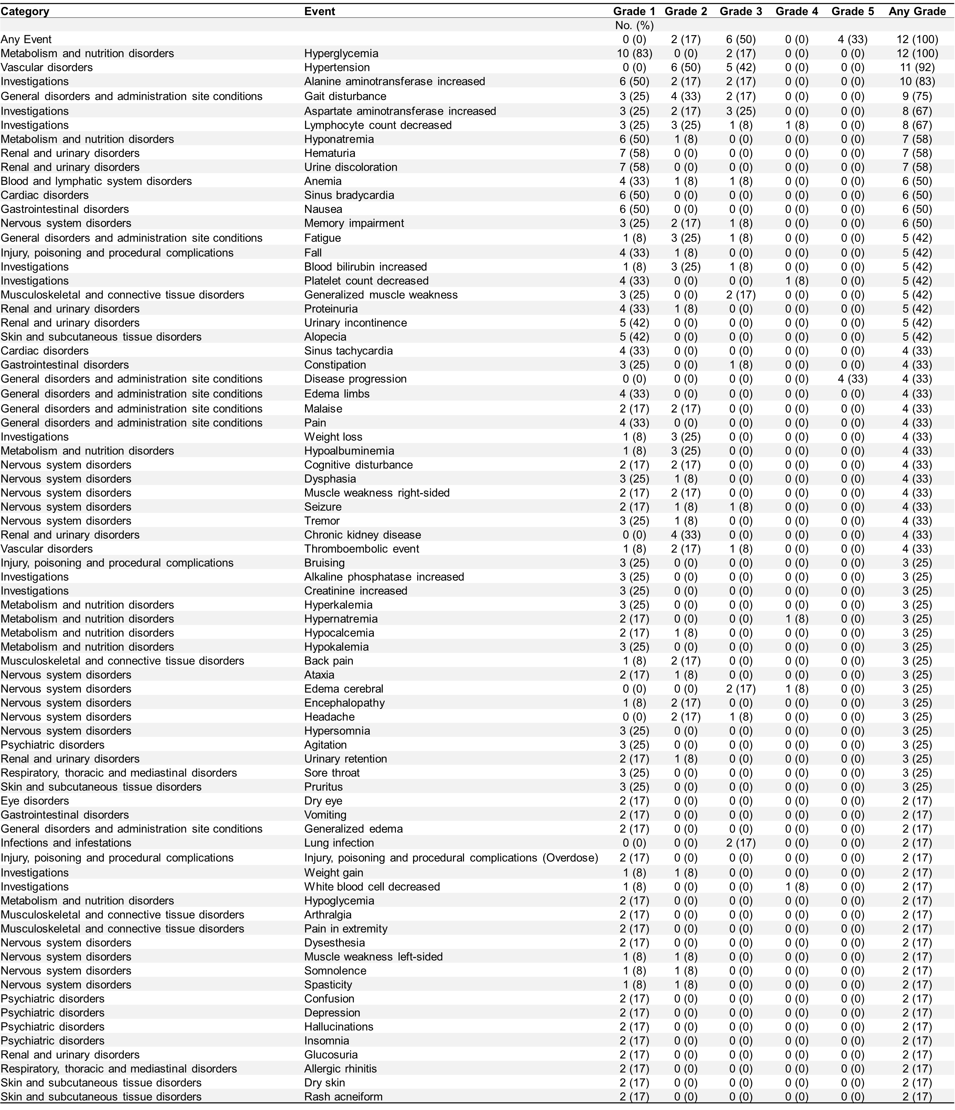
Supplementary Table S1. Overall worst grade toxicity adverse events in cohort A patients.
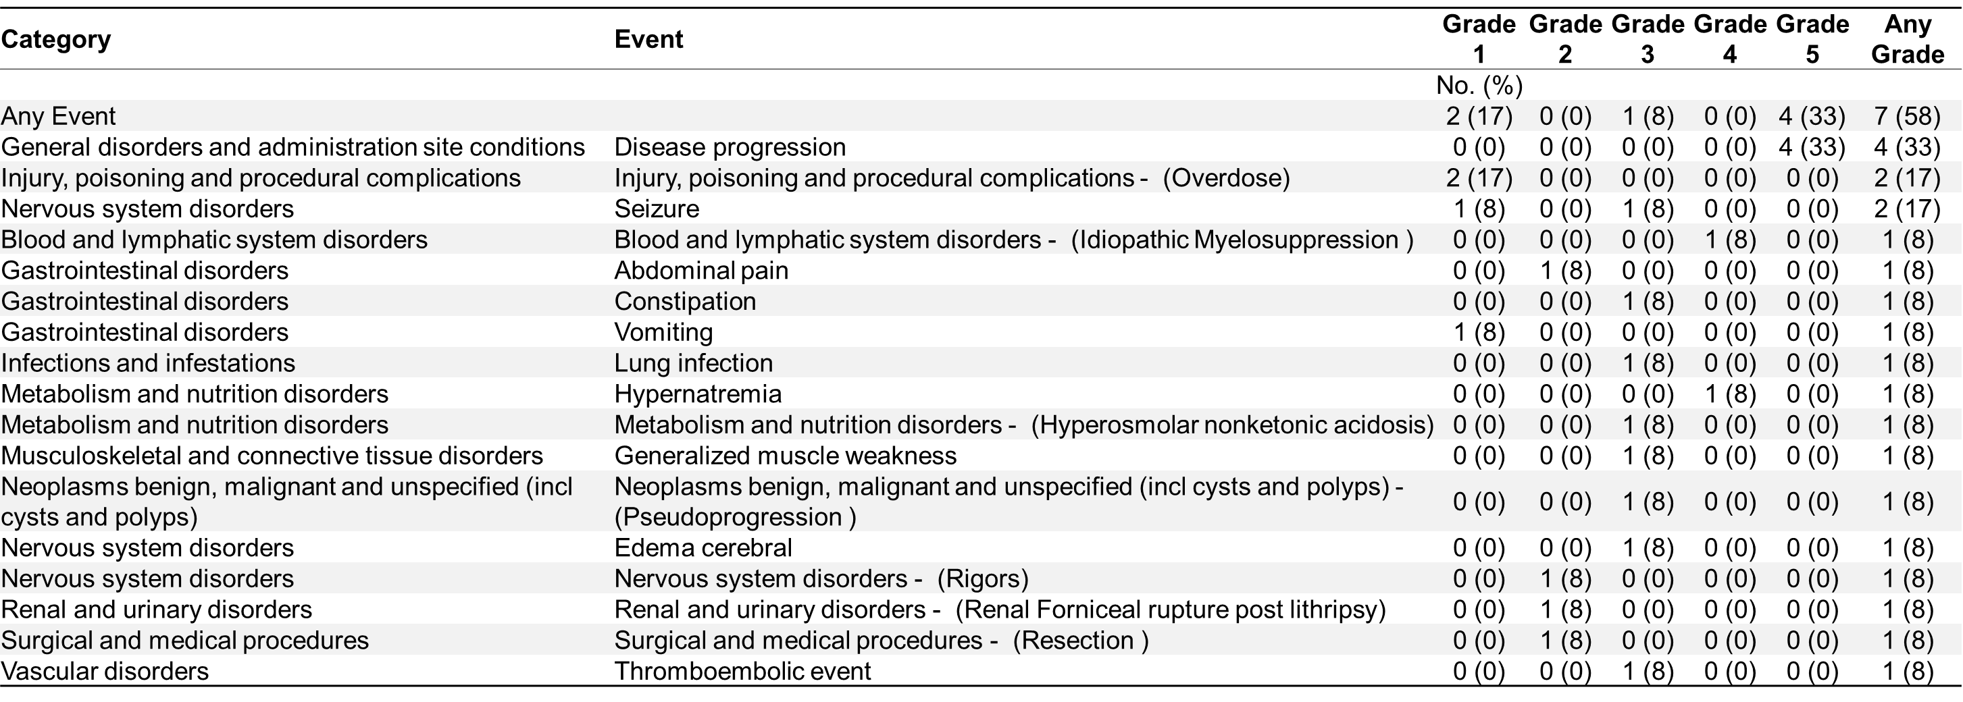
Supplementary Table S2. Summary of serious adverse events in cohort A patients.

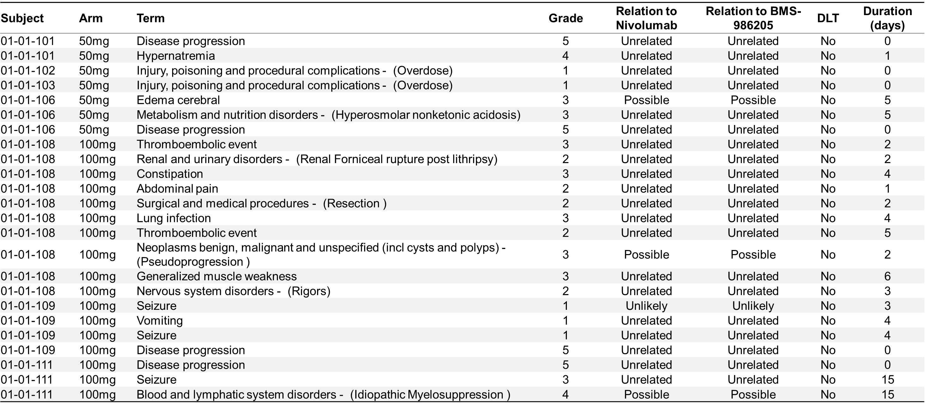
Supplementary Table S3. Listing of serious adverse events in cohort A.

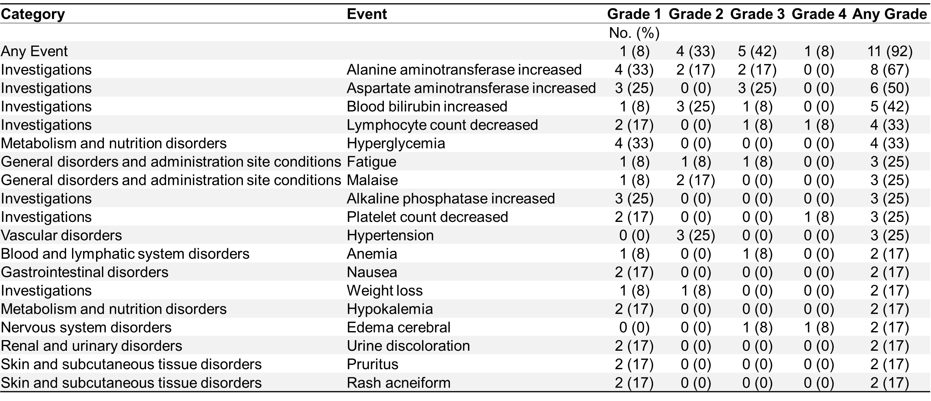
Supplementary Table S4. Overall worst grade toxicity adverse event related to nivolumab in cohort A.

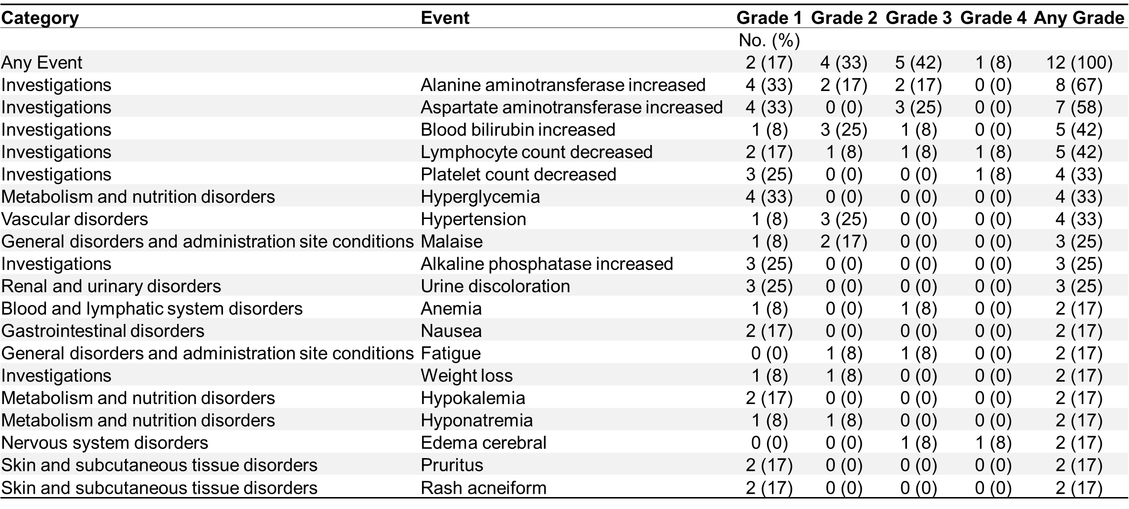
Supplementary Table S5. Overall worst grade toxicity adverse event related to BMS-986205 in cohort A.

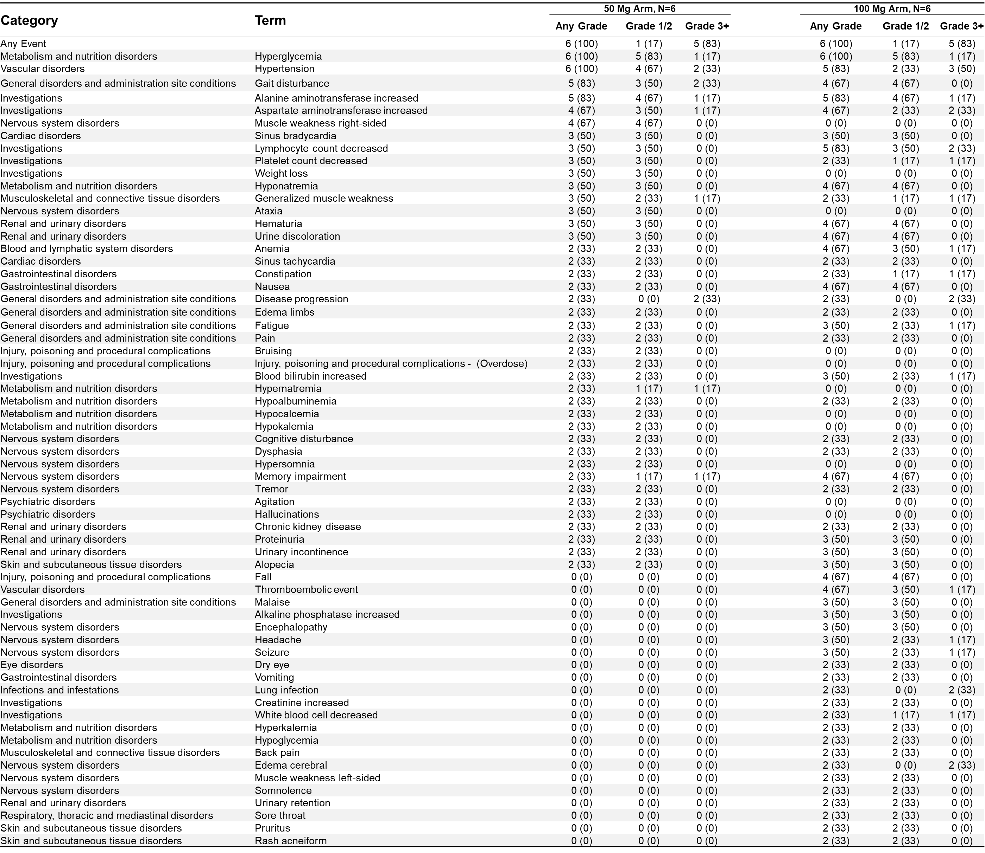
Supplementary Table S6. Worst grade toxicity adverse events in cohort A by arm occurring in >2 patients.

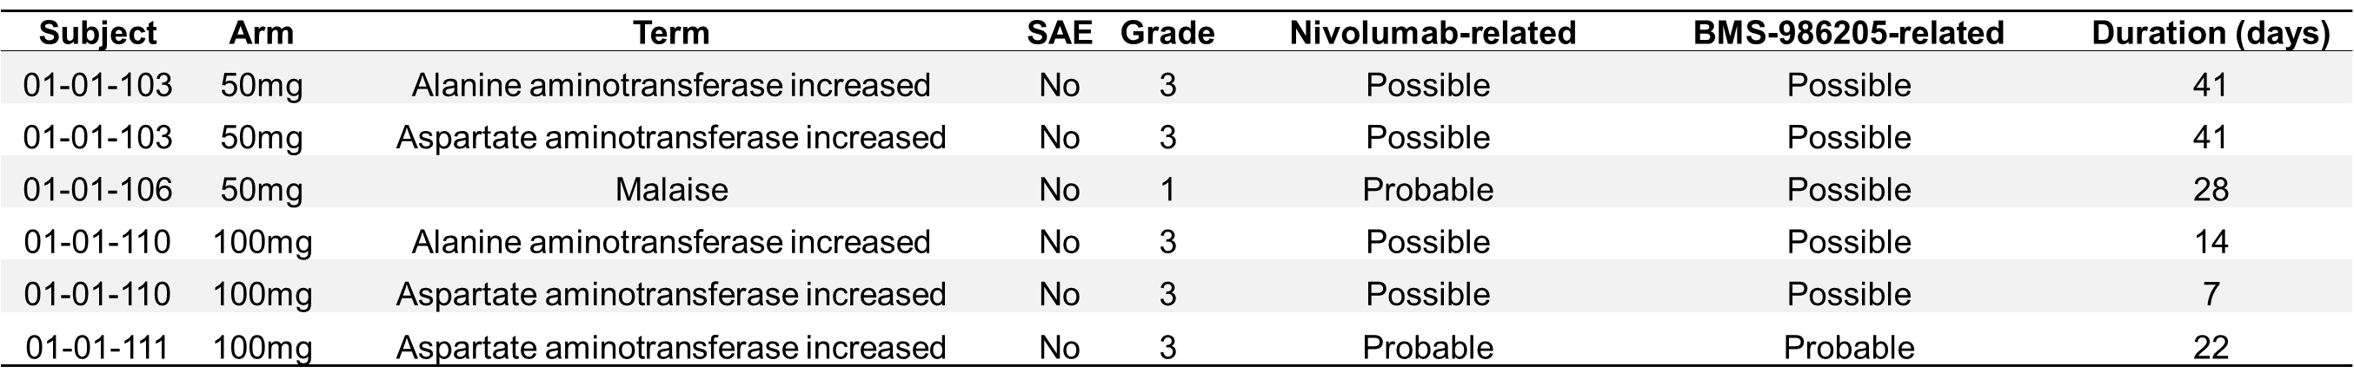
Supplementary Table S7. Dose-limiting toxicities in cohort A.

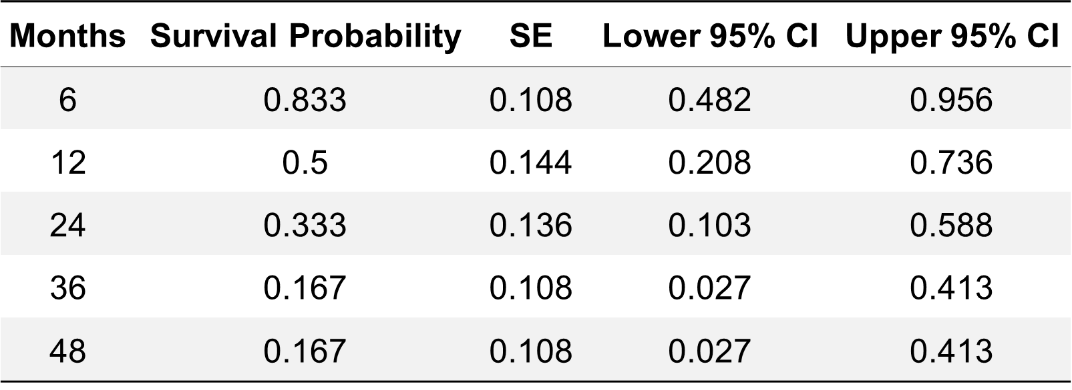
Supplementary Table S8. Overall survival probabilities of cohort A.

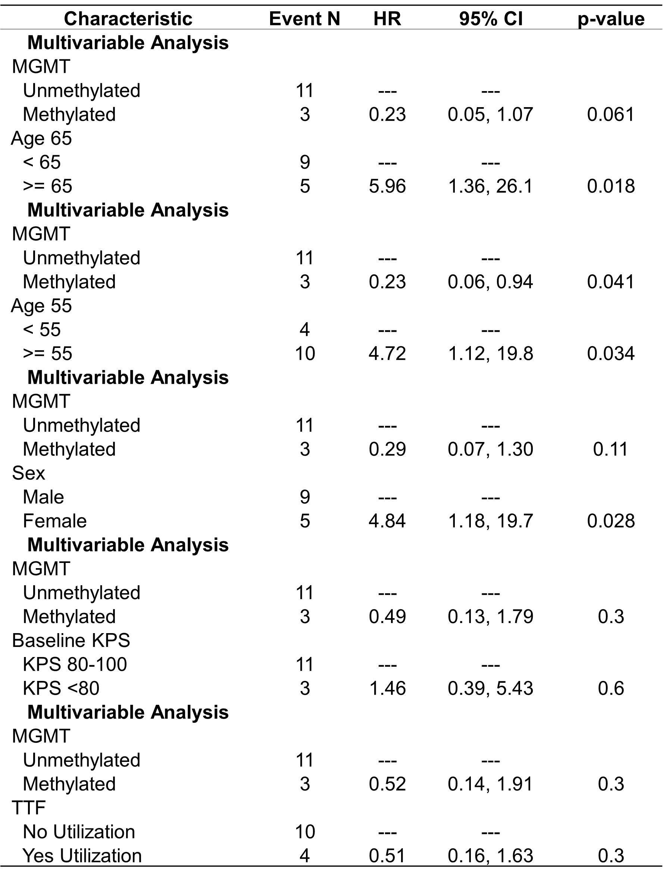
Supplementary Table S9. Multivariable Cox proportional hazard model on overall survival.

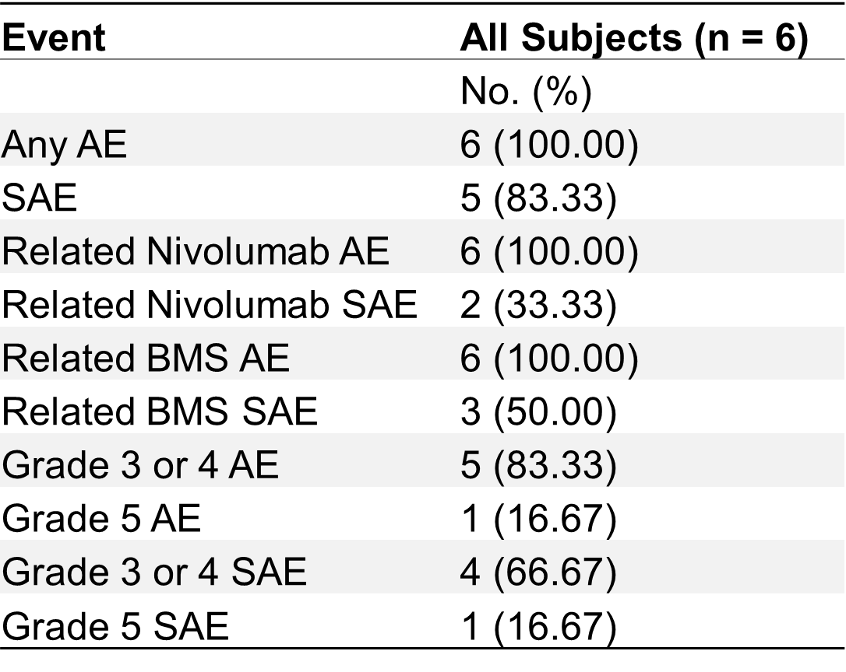
Supplementary Table S10. Summary of cohort B adverse events excluding baseline.

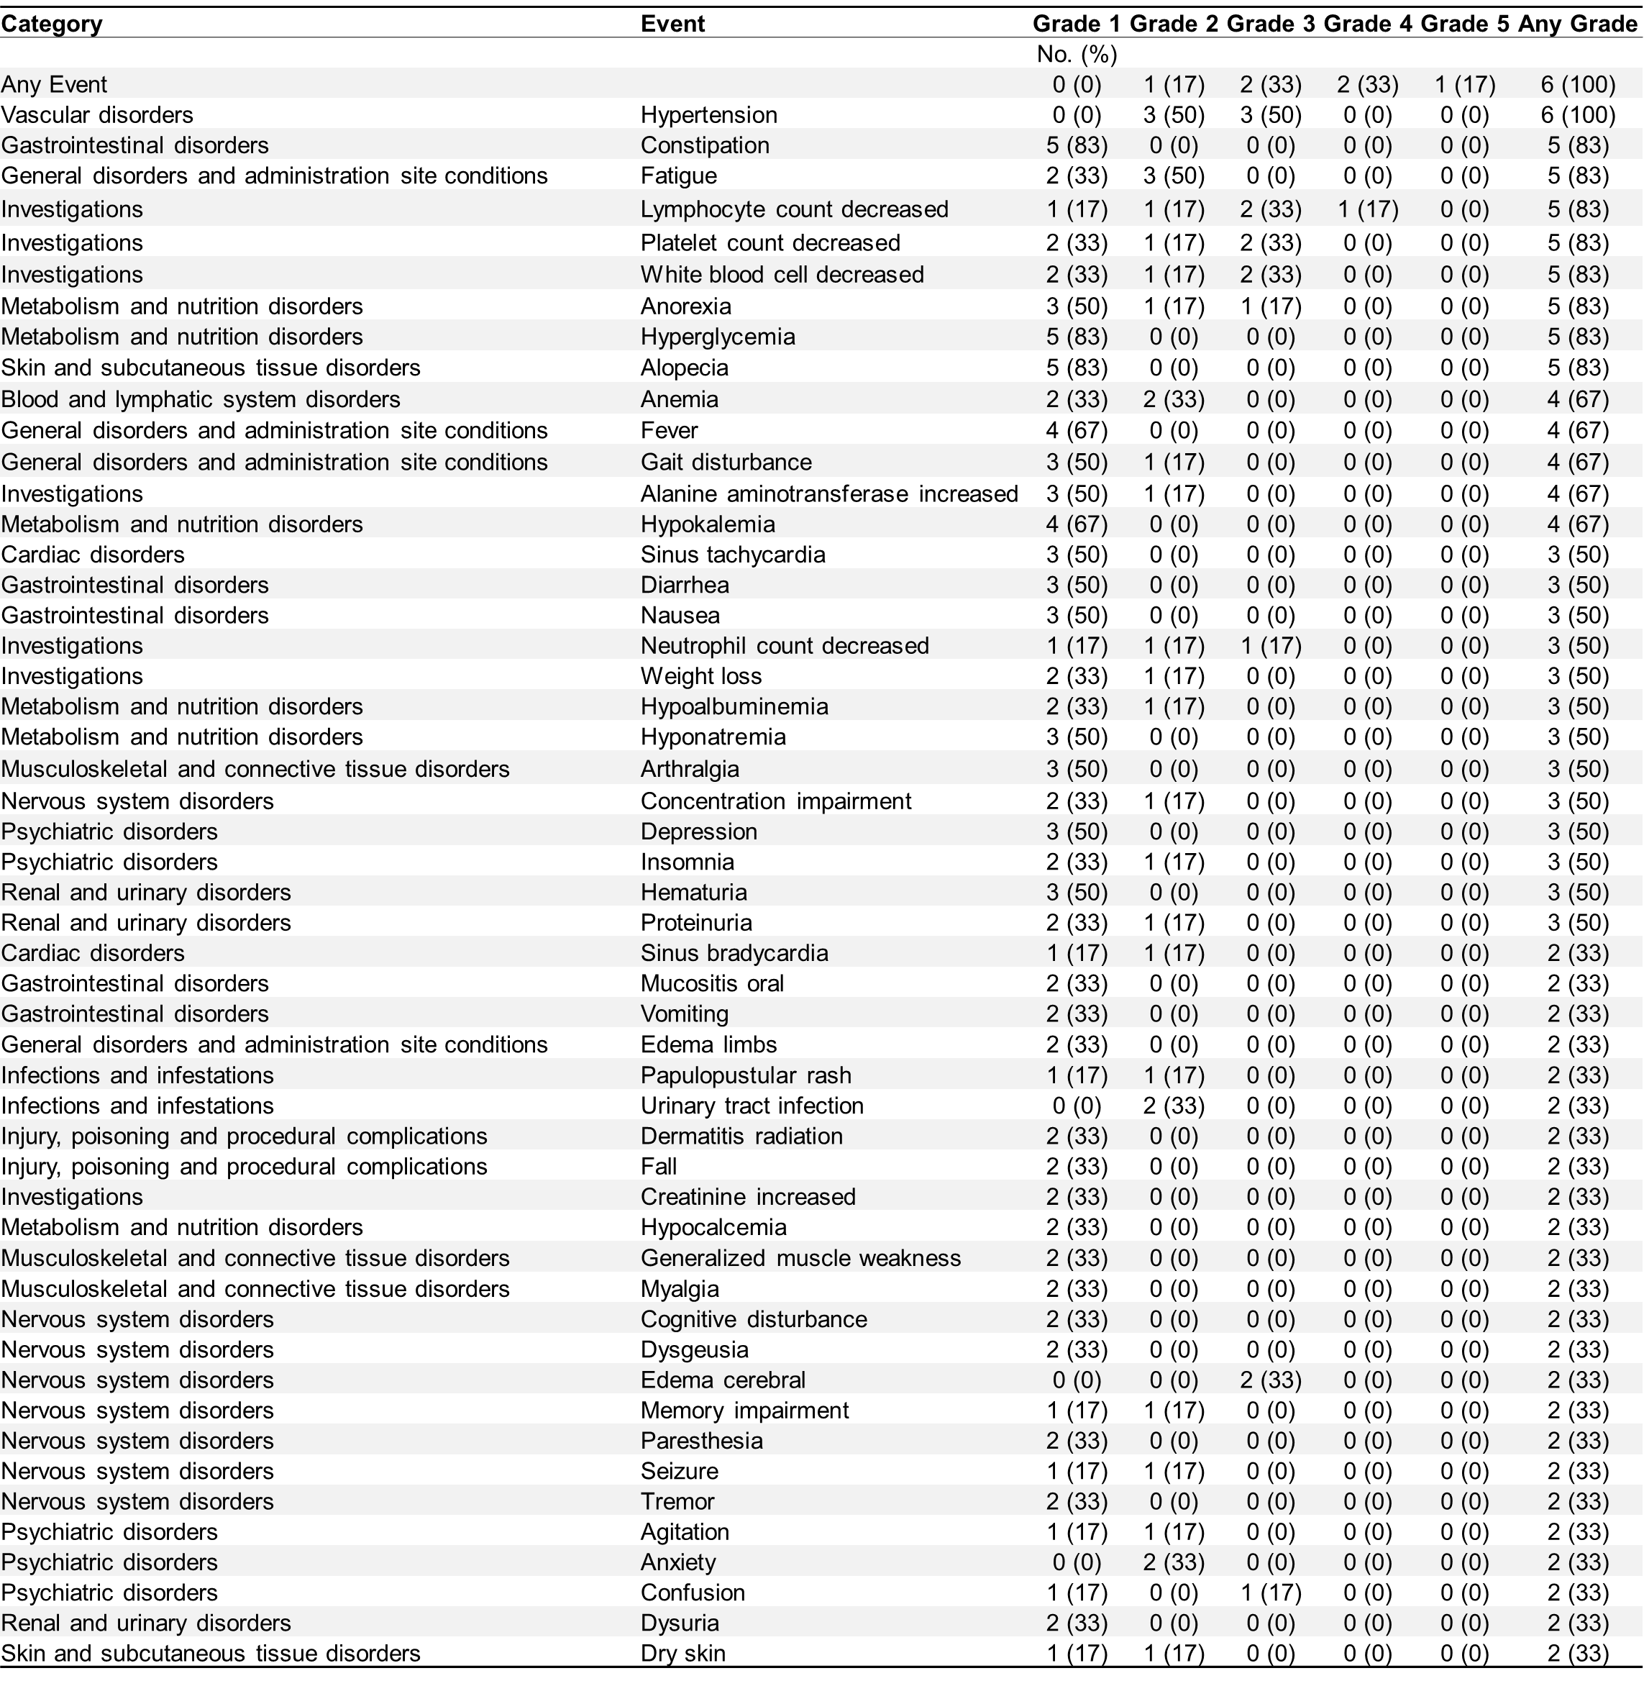
Supplementary Table S11. Overall worst grade toxicity adverse events in patients of cohort B.

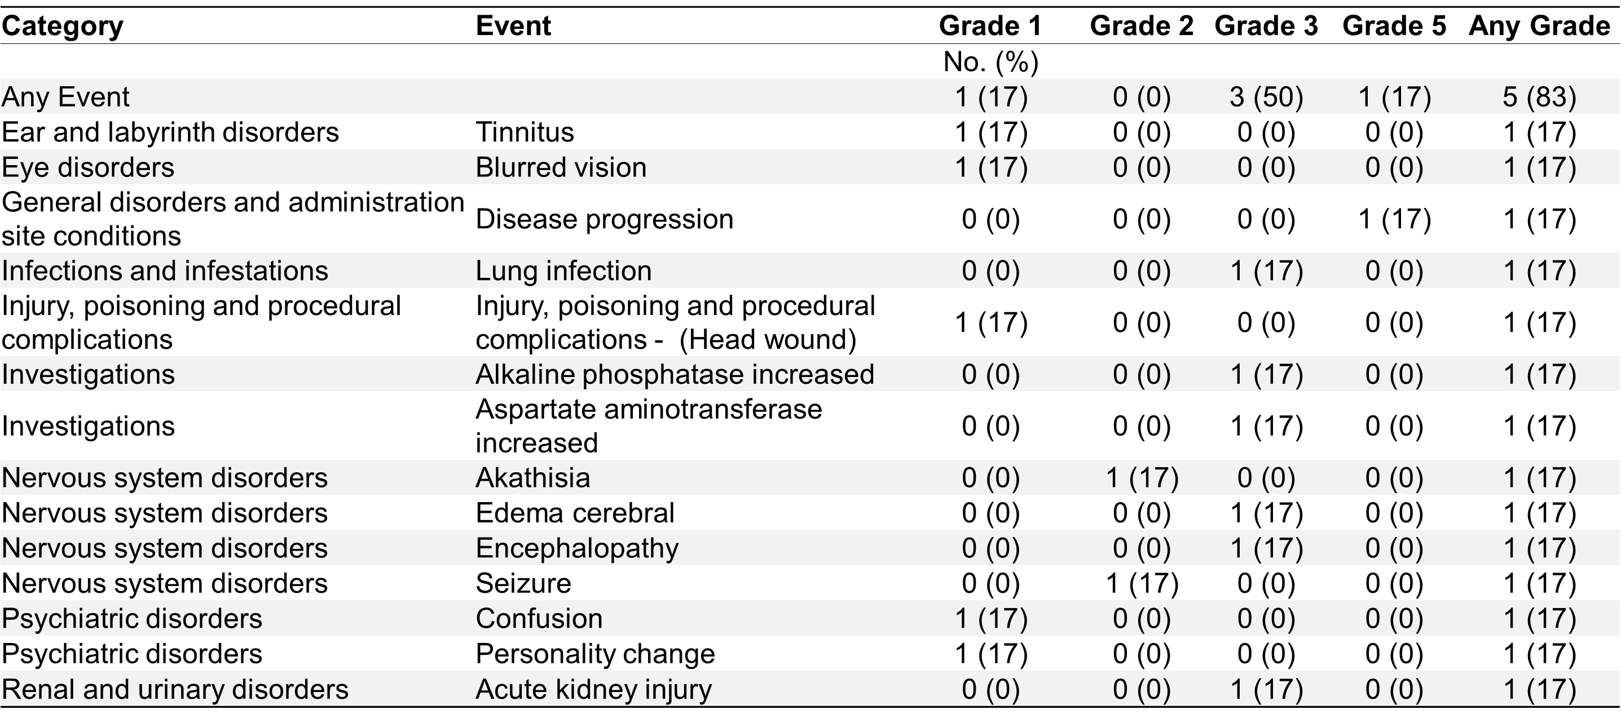
Supplementary Table S12. Summary of serious adverse events in patients of cohort B.

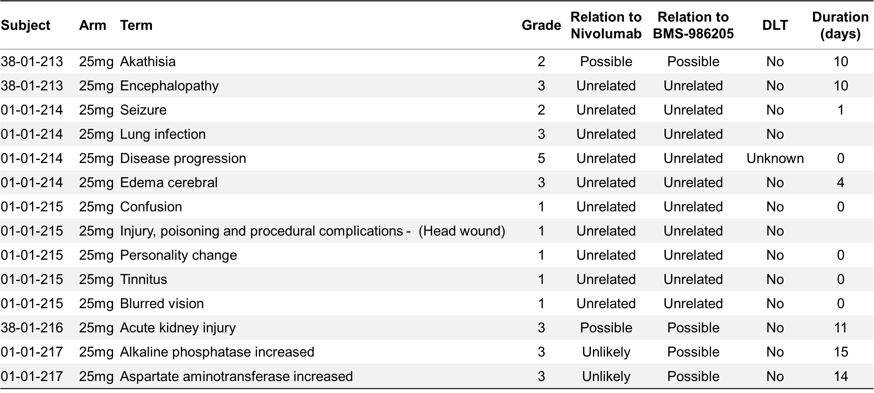
Supplementary Table S13. Listing of serious adverse events in cohort B.

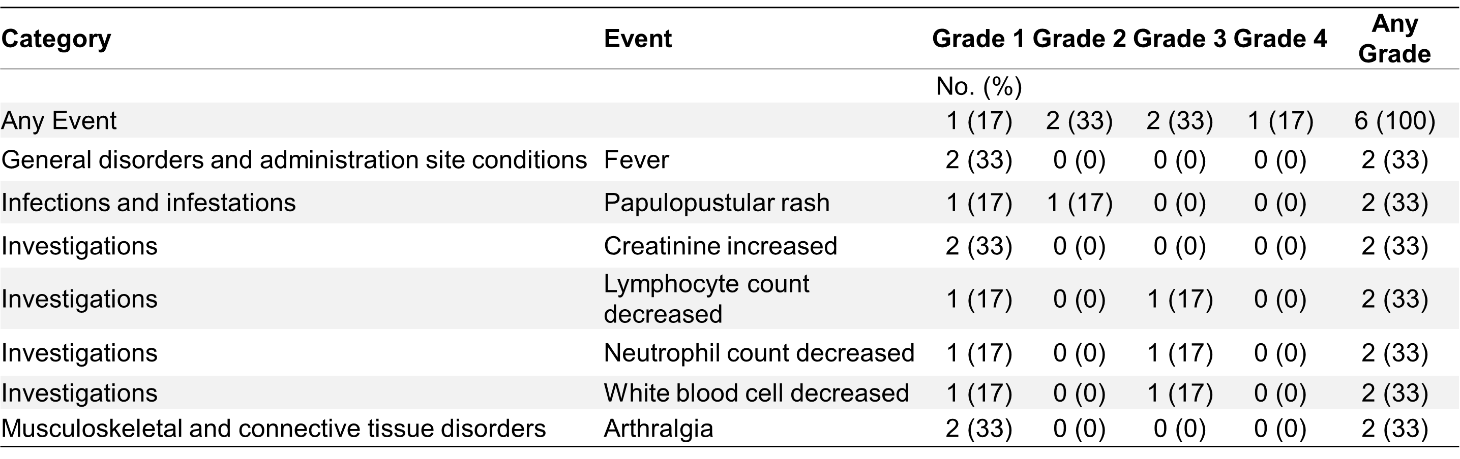
Supplementary Table S14. Overall worst grade toxicity adverse events related to nivolumab in cohort B.

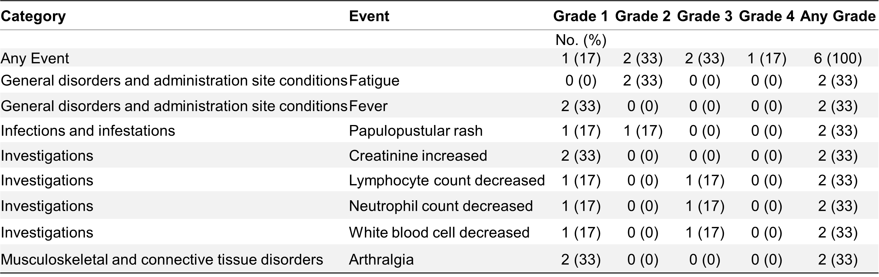
Supplementary Table S15. Overall worst grade toxicity adverse events related to BMS-986205 in cohort B.

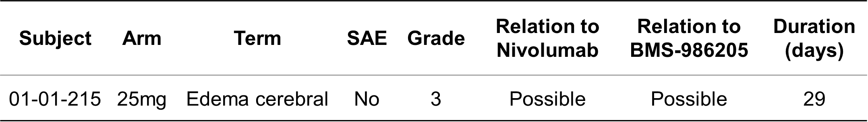
Supplementary Table S16. Dose-limiting toxicities in cohort B.

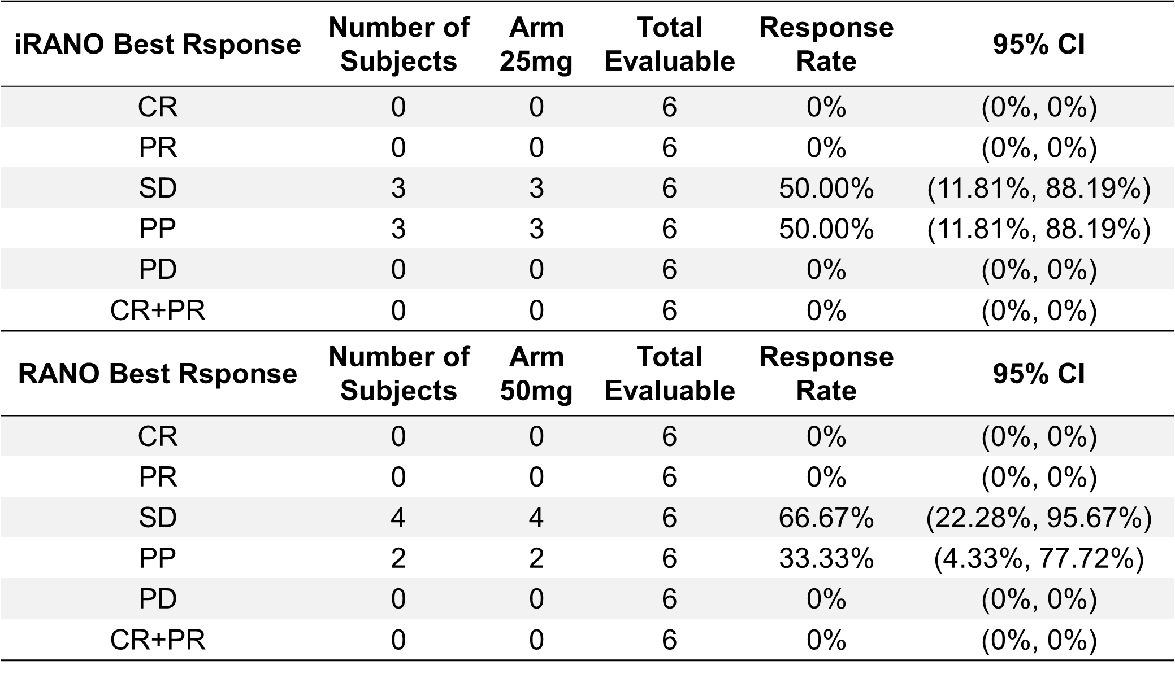
Supplementary Table S17. iRANO and RANO Response Rate in cohort B.

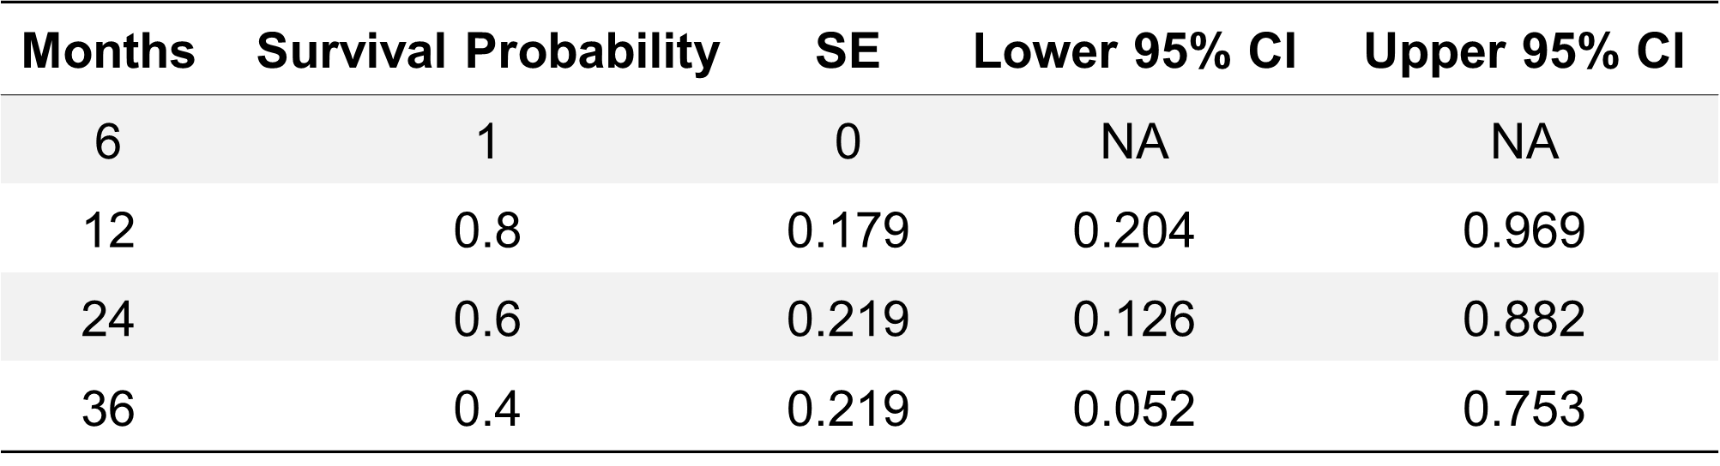
Supplementary Table S18. Overall survival probabilities of cohort B.

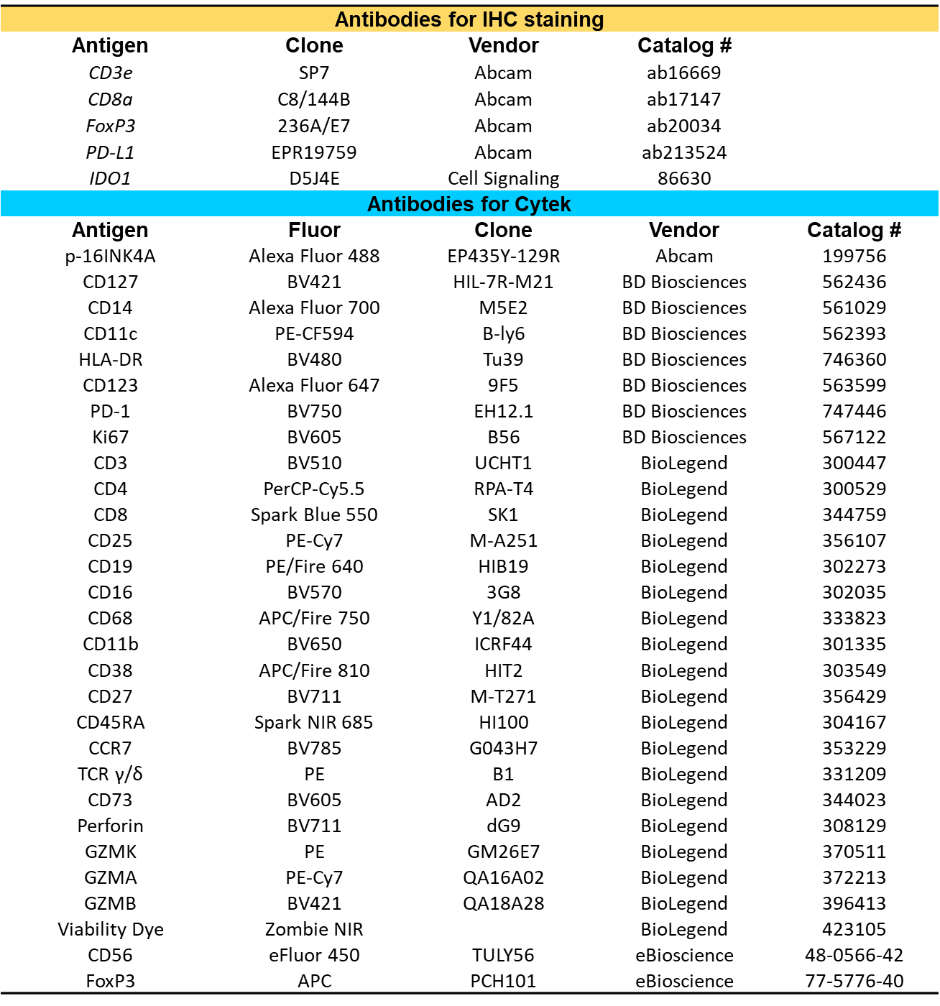
Supplementary Table S19. Antibodies used in current study.

SUPPLEMENTARY FIGURES
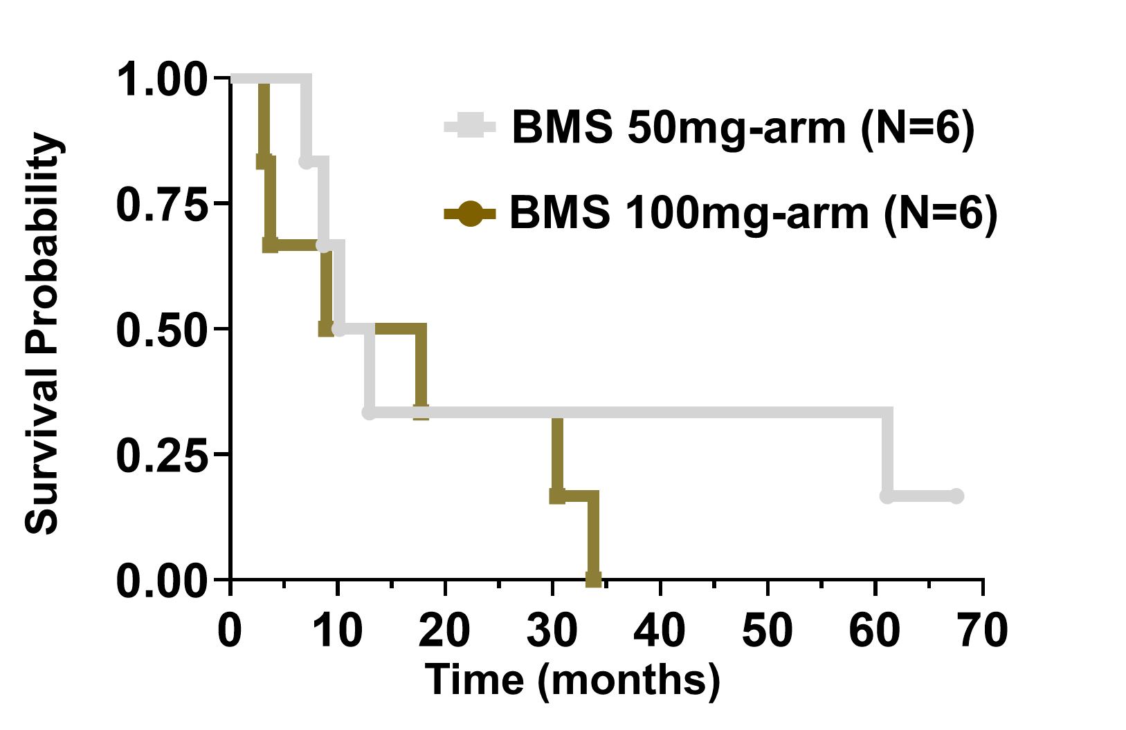
Supplementary Fig. S1. Kaplan-Meier curve of Cohort A stratified by BMS-986205 dosing arms. The overall survival of different BMS dosing groups in cohort A are presented in a Kaplan-Meier curve.

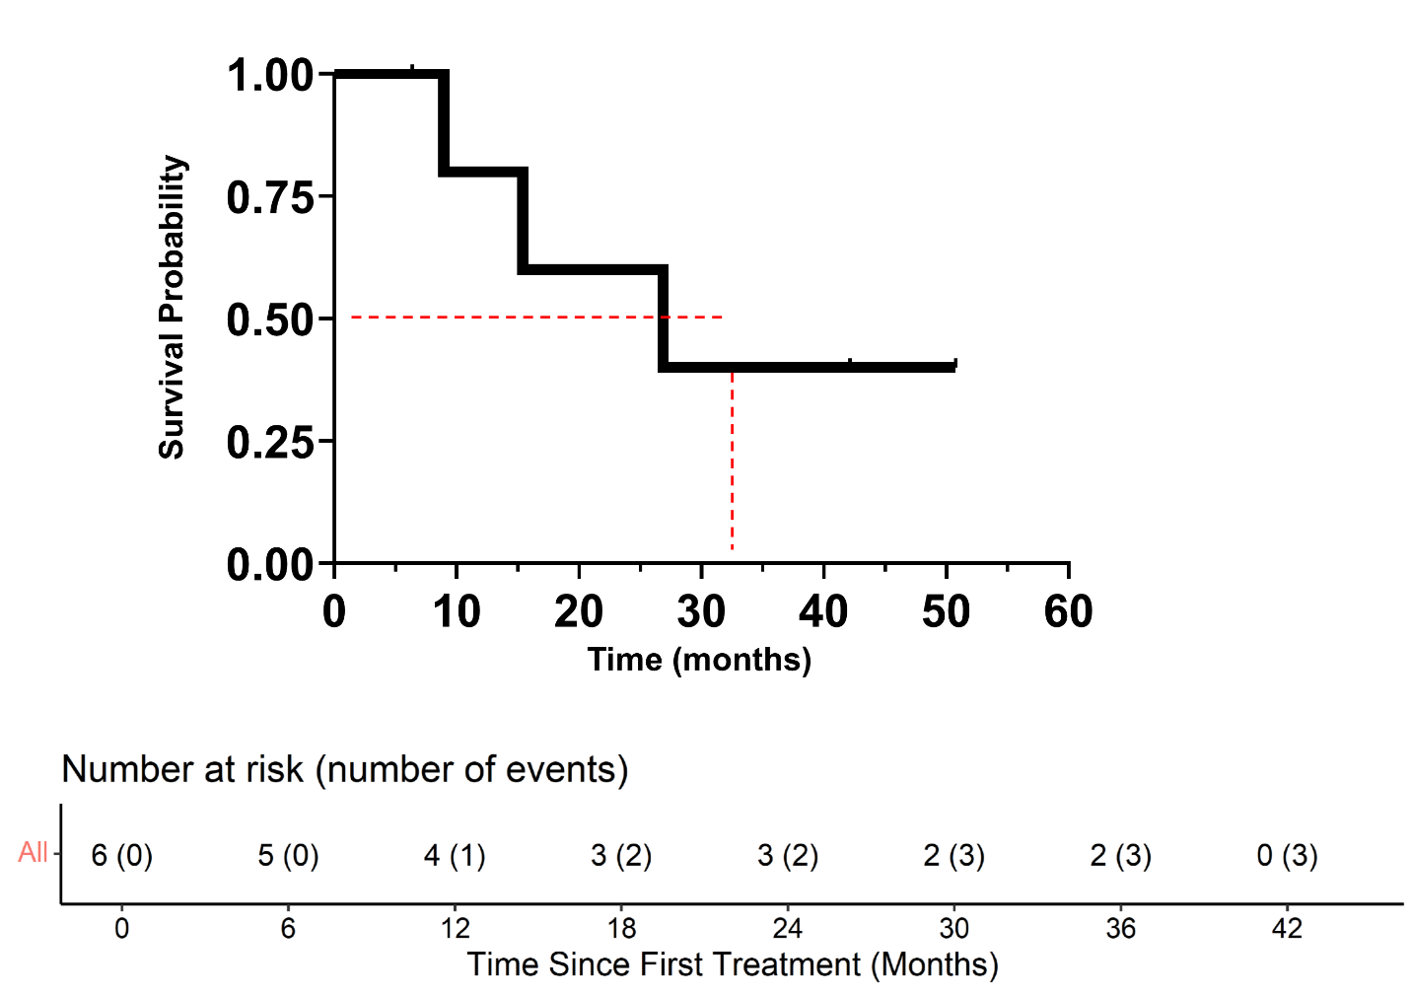
Supplementary Fig. S2 Kaplan-Meier curve of cohort B. The overall survival (OS) of cohort B patients was analyzed by Kaplan-Meier curve. Dashed line indicates the median OS.

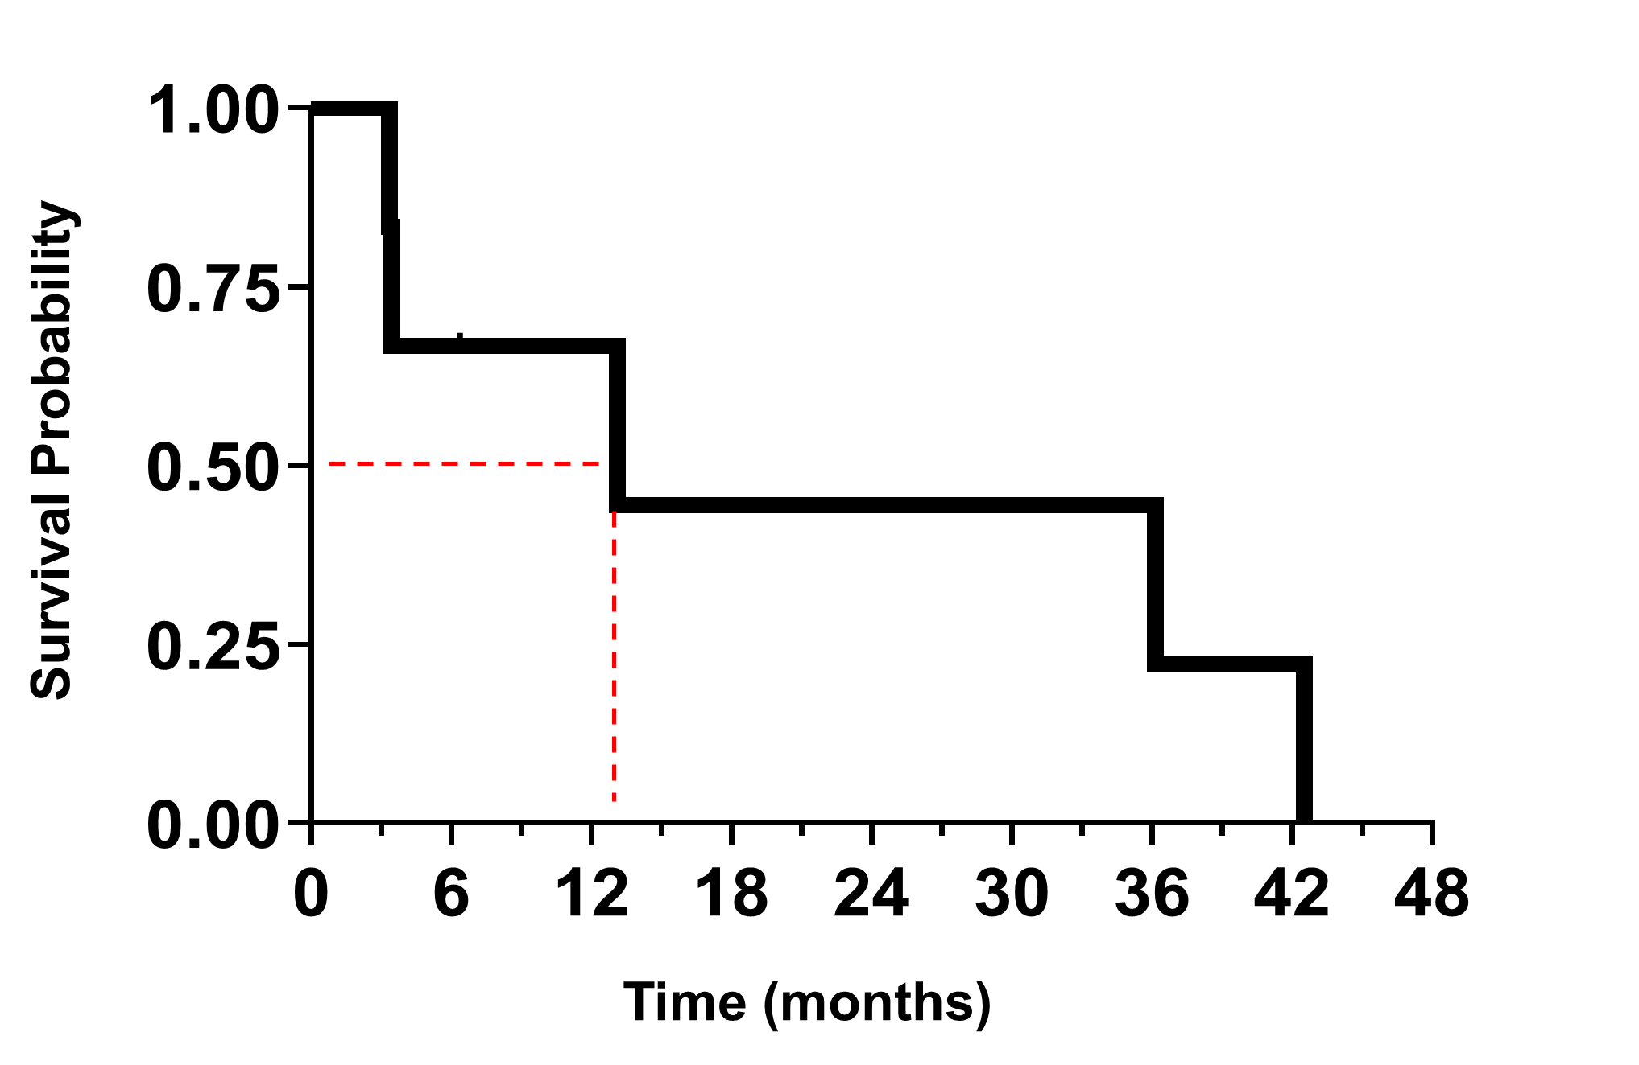
Supplementary Fig. S3. Progression free survival analysis of cohort B GBM patients. Progression-free survival (PFS) is defined as time from study enrollment to first progression or death, with censoring at date last known alive and not progressed. Dash line indicates the median PFS.

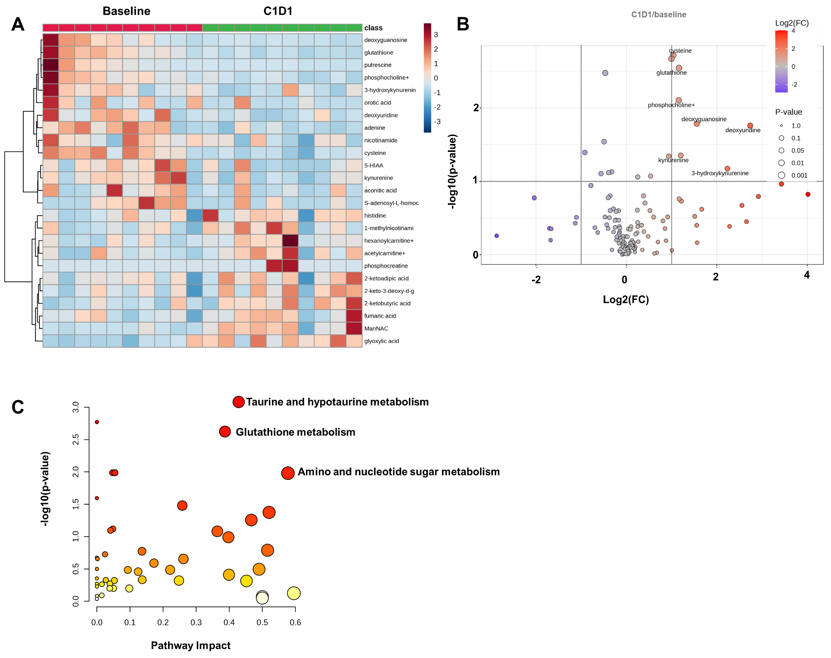
Supplementary Fig. S4 Untargeted LC-MS/MS profiling of cohort A plasma before and after treatment. (A) Heatmap of metabolites detected by untargeted LC-MS/MS at baseline and after beginning BMS-986205 treatment (C1). Metabolite abundance is scaled by row and shown for the top 25 differently measured metabolites based on P-value. (B) Volcano plot of differential metabolite abundance between C1 and baseline, plotted as log₂ fold change vs log₁₀ P-value. Significantly altered metabolites are highlighted. (C) Pathway impact analysis based on significantly changed metabolites, highlighting taurine and hypotaurine metabolism, glutathione metabolism, and amino/nucleotide sugar metabolism. Data were acquired using HPLC-MS/MS for semi-quantitation and analyzed for statistics and visualization in MetaboAnalyst (https://www.metaboanalyst.ca/). N=9 paired samples.

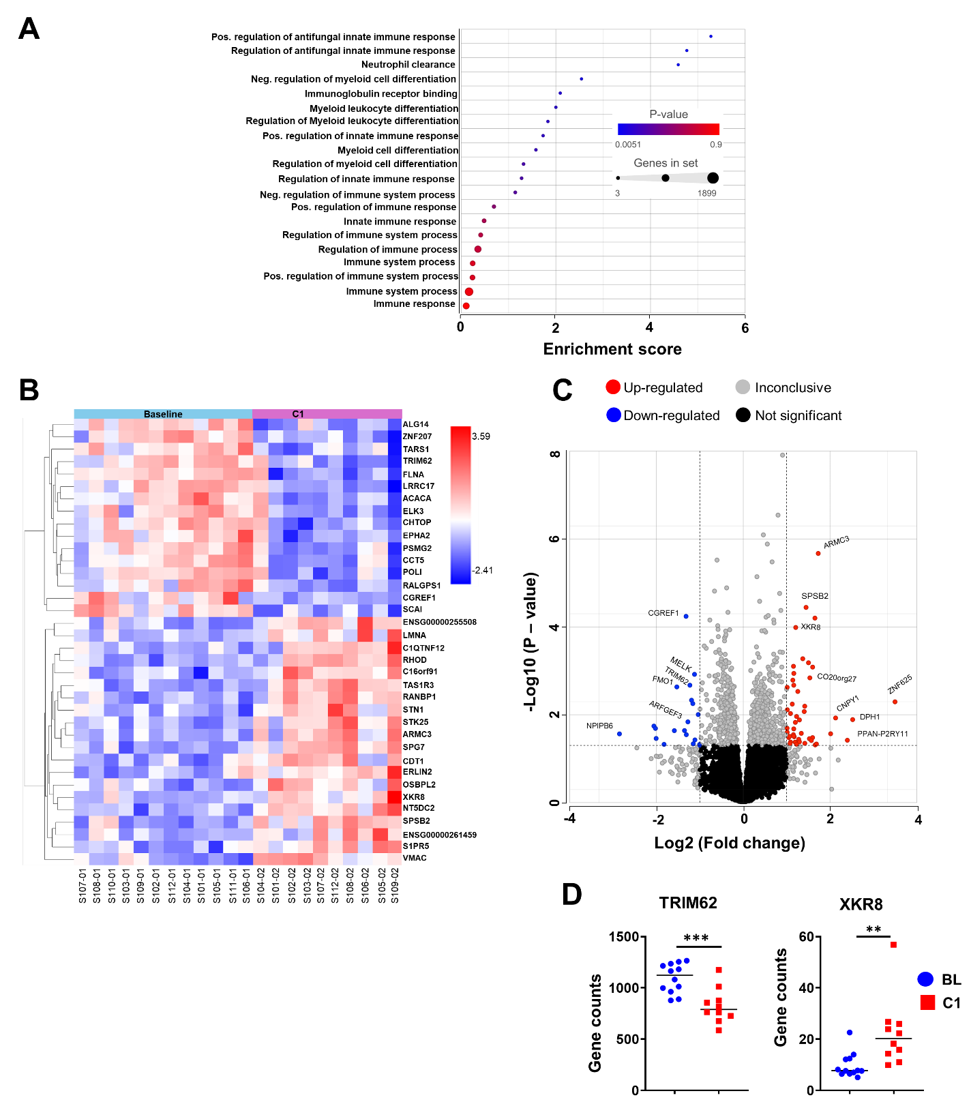
Supplementary Fig. S5. RNA-Seq analysis of cohort A PBMCs at baseline (BL) and on-treatment (C1) time points. (A) Significant immune-related GO pathways identified by Gene Set Enrichment with P<0.05. (B) Heatmap of differentially expressed genes between baseline (n=12) and on-treatment (n=10). (C) Volcano plot displaying differentially expressed gene. (D) Comparison of expression levels for immune-related GO genes identified from the Gene Set Enrichment analysis. **P<0.01; ***P<0.001

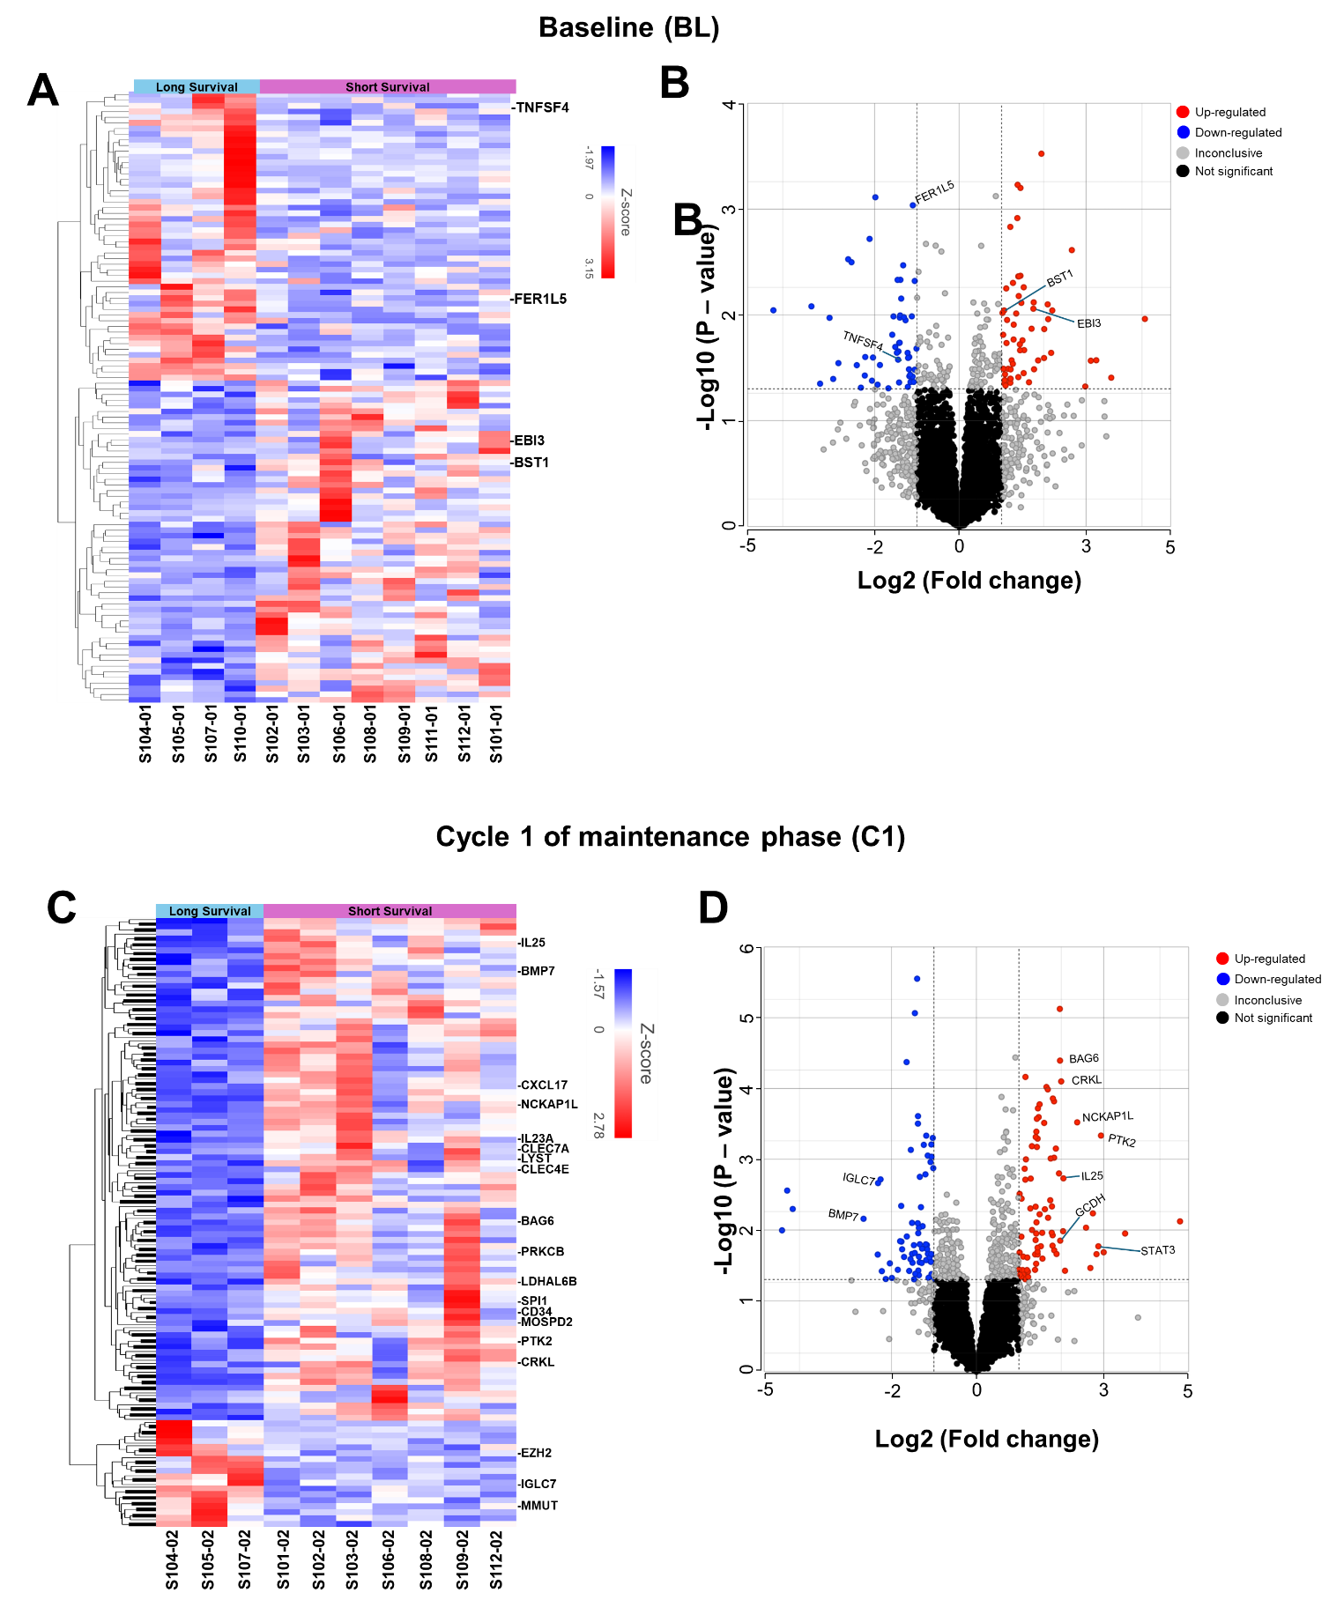
Supplementary Fig. S6. RNA-Seq analysis of cohort A PBMCs comparing short-term (<24 months) and long-term (≥24 months) survivors. (A) Heatmap and (B) volcano plot of differentially expressed genes between long- (n=4) and short-term (n=8) survivors at baseline. (C) Heatmap and (D) volcano plot of differentially expressed genes between long- (n=3) and short-term (n=7) survivors at the C1 time point.

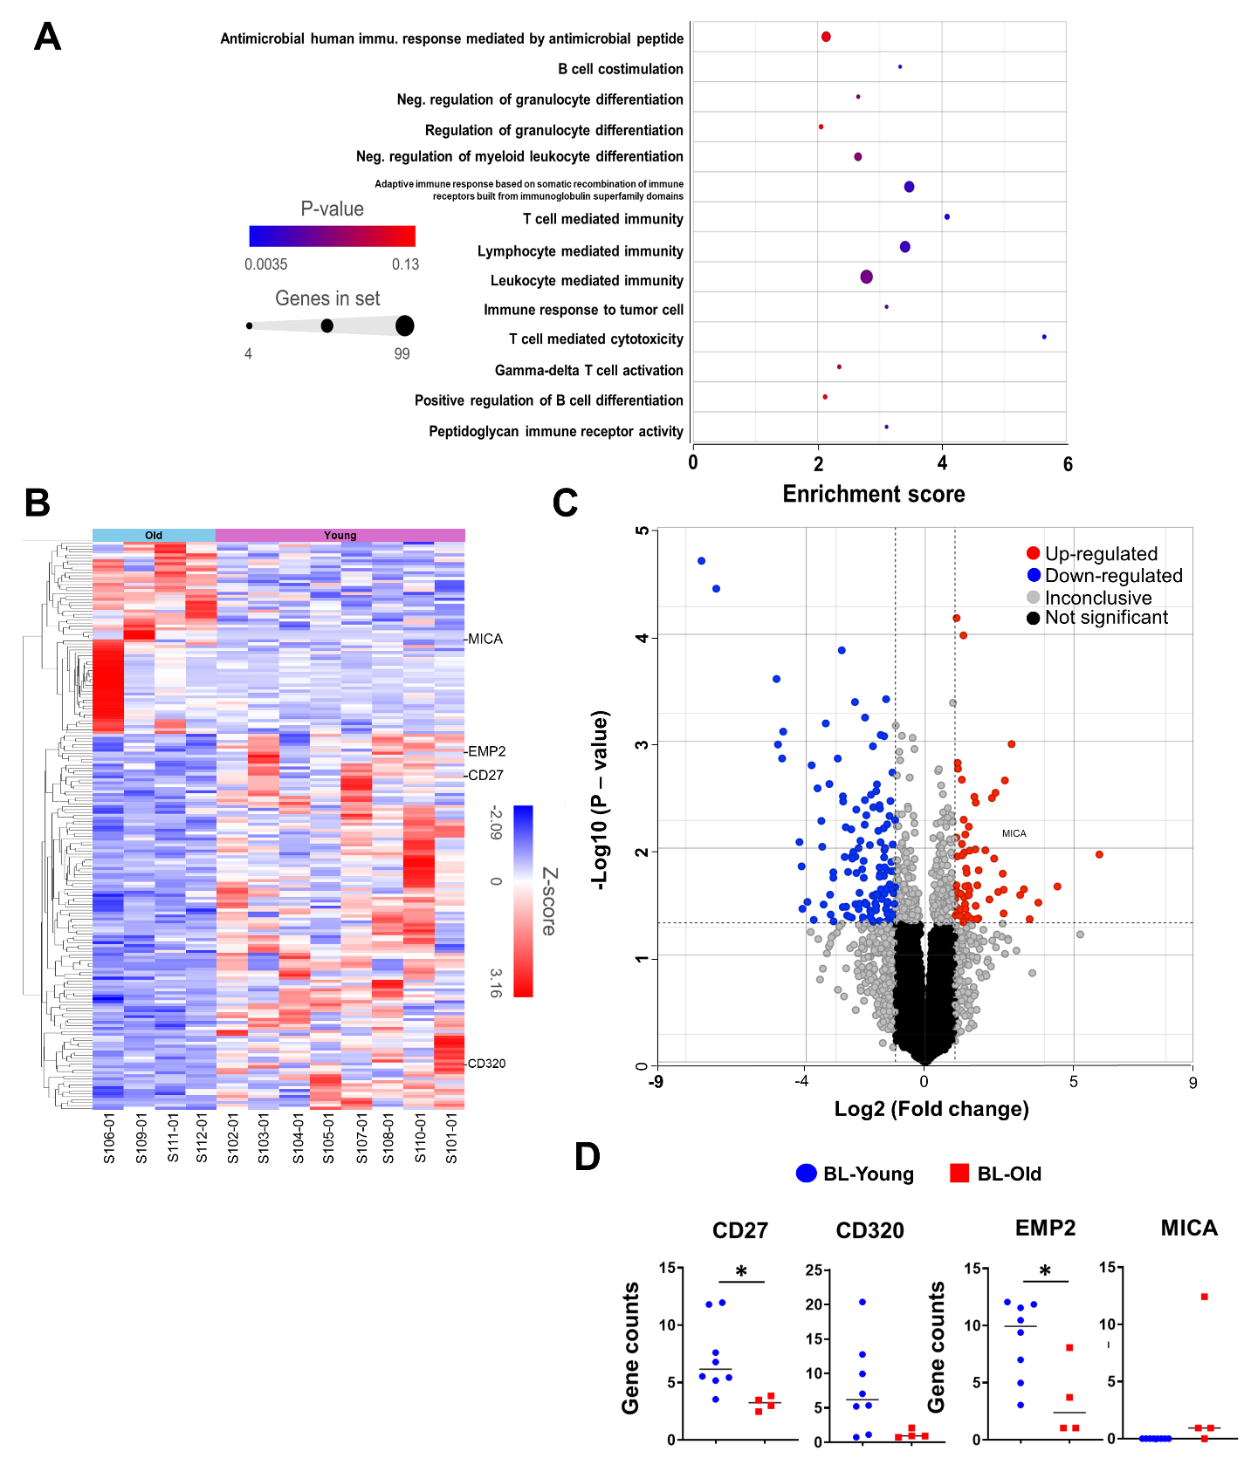
Supplementary Fig. S7. RNA-Seq analysis of cohort A PBMCs comparing older (≥65 years old) and younger (<65 years old) patients at baseline (BL). (A) Significant immune-related GO pathways identified by Gene Set Enrichment with P<0.05. (B) Heatmap of differentially expressed genes between young (n=8) and old (n=4) patients. (B) Volcano plot displaying differentially expressed genes between young (n=8) and old (n=4) patients. (D) Comparison of gene expression levels for immune-related GO genes identified from the Gene Set Enrichment analysis. *P<0.05.

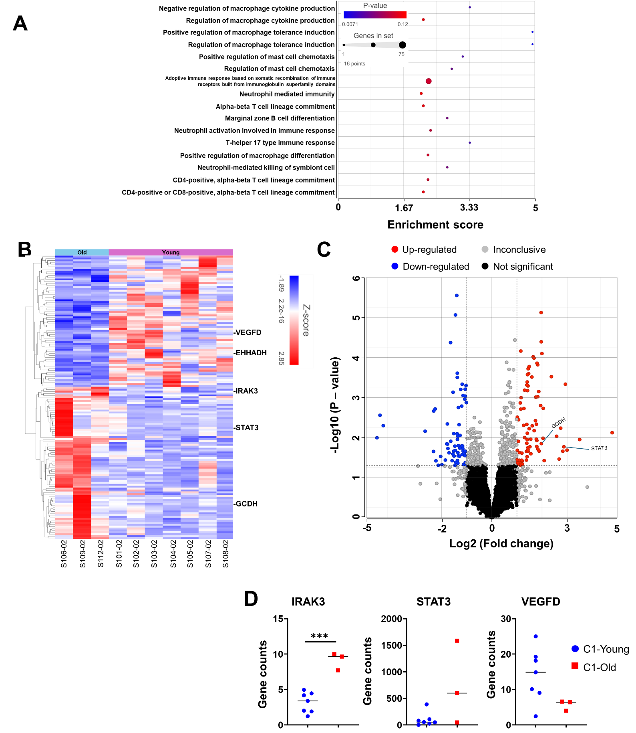
Supplementary Fig. S8. RNA-Seq analysis of cohort A PBMCs comparing older (≥65 years old) and younger (<65 years old) patients at the C1 time point. (A) Significant immune-related GO pathways identified by Gene Set Enrichment with P<0.05. (B) Heatmap of differentially expressed genes between young (n=7) and old (n=3) patients while on treatment. (C) Volcano plot displaying differentially expressed genes between young (n=7) and old (n=3) patients while on treatment. (D) Comparison of gene expression levels for immune-related GO genes identified from the Gene Set Enrichment analysis. ***P<0.001

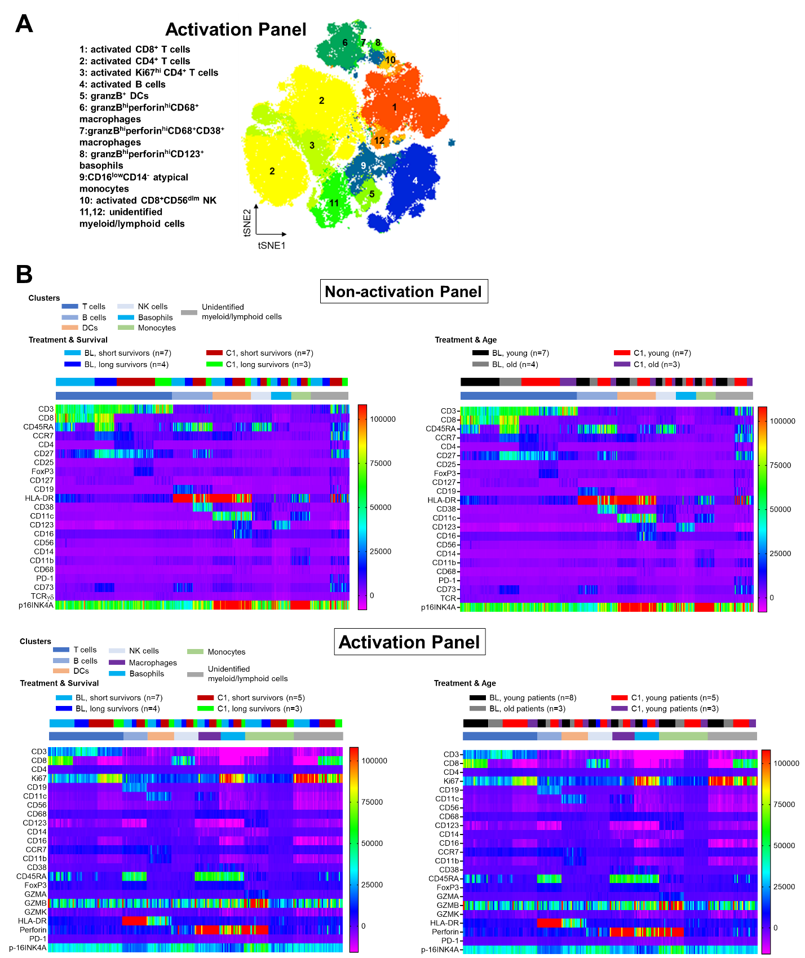
Supplementary Fig. S9. Flow cytometric analysis, tSNE projection, and heatmap cell clustering for cohort A patient PBMCs. PBMCs were isolated and underwent spectral flow cytometry. (A) t-SNE plot projection of activated immune cells in the peripheral blood via spectral flow cytometry analysis. (B) The heatmaps were generated from FlowJo and FlowSOM and color coded for different cell clusters and group conditions. BL=baseline; C1=first on treatment time point

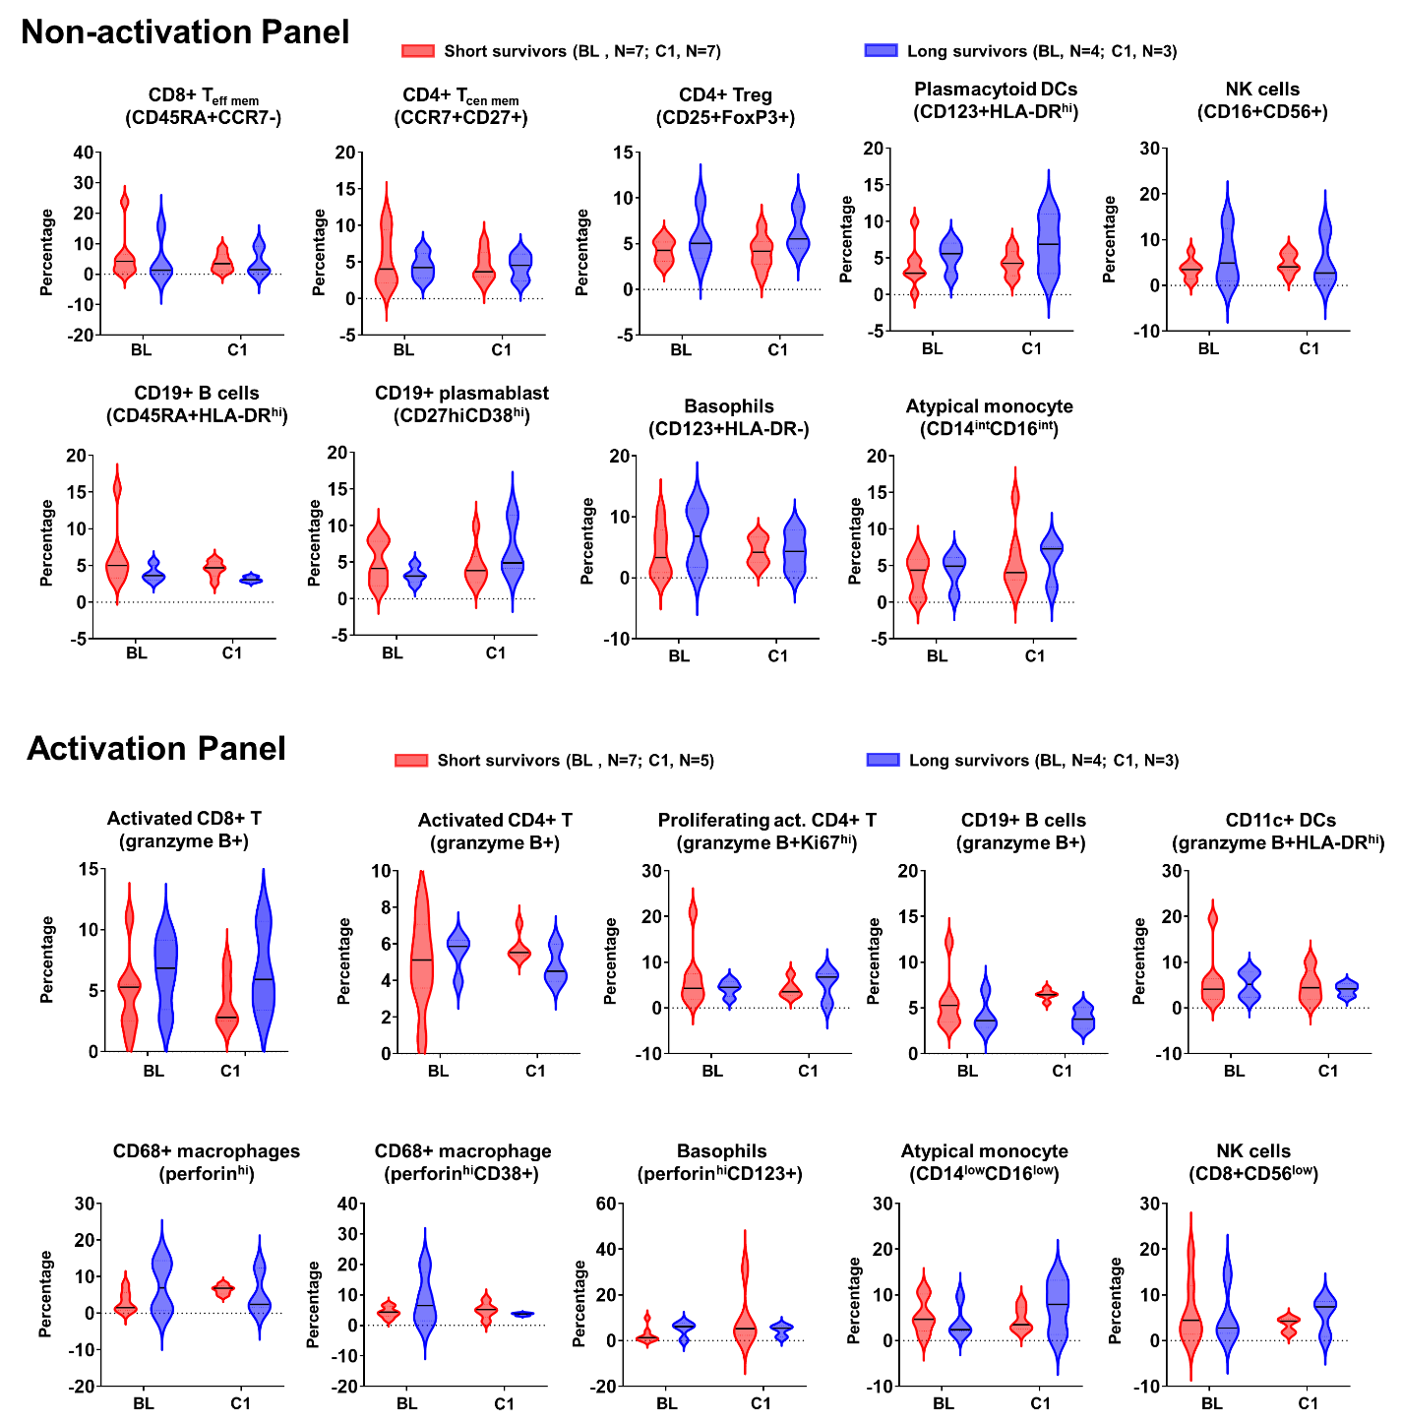
Supplementary Fig. S10. Immune cell levels between shorter (<24 months)- and longer (≥24 months)-surviving patients in cohort A. PBMCs were isolated and underwent spectral flow cytometry. Top panel: non-activation panel for immune cell phenotyping analysis; bottom panel: immune cell analysis for activation panel. BL=baseline; C1=first on treatment time point

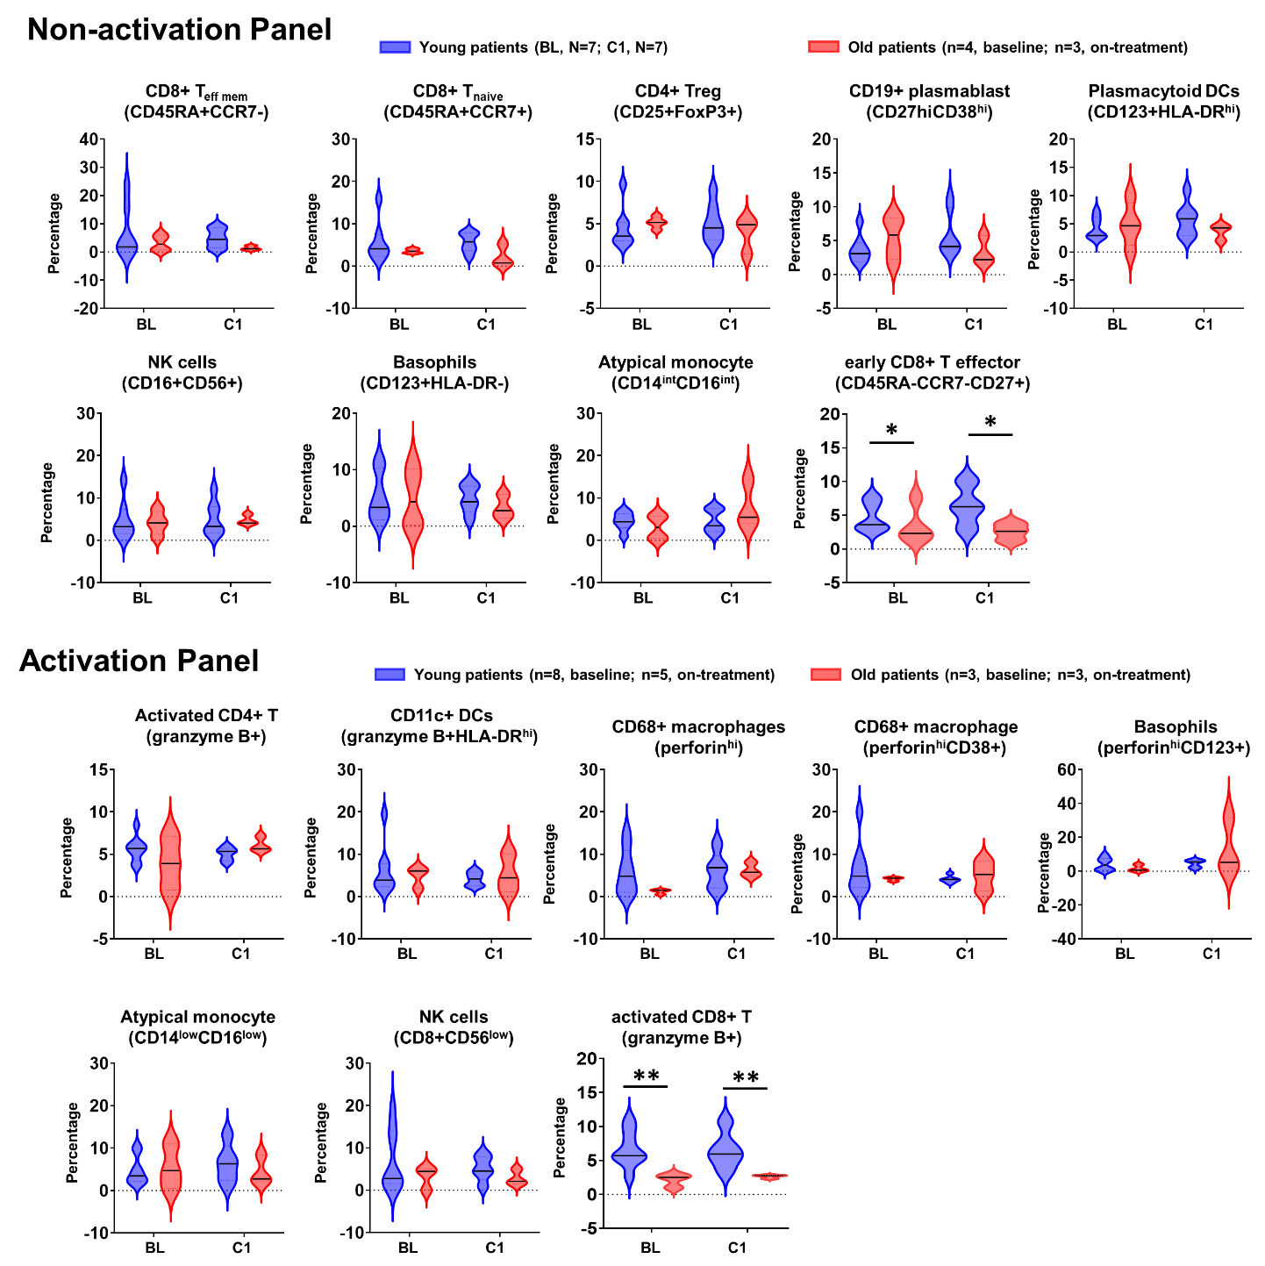
Supplementary Fig. S11. Immune cell levels between younger (<65 years of age)- and older (≥65 years of age) patients in cohort A. PBMCs were isolated and underwent spectral flow cytometry. Top panel: non-activation panel for immune cell phenotyping analysis; bottom panel: immune cell analysis for activation panel. BL=baseline; C1=first on treatment time point

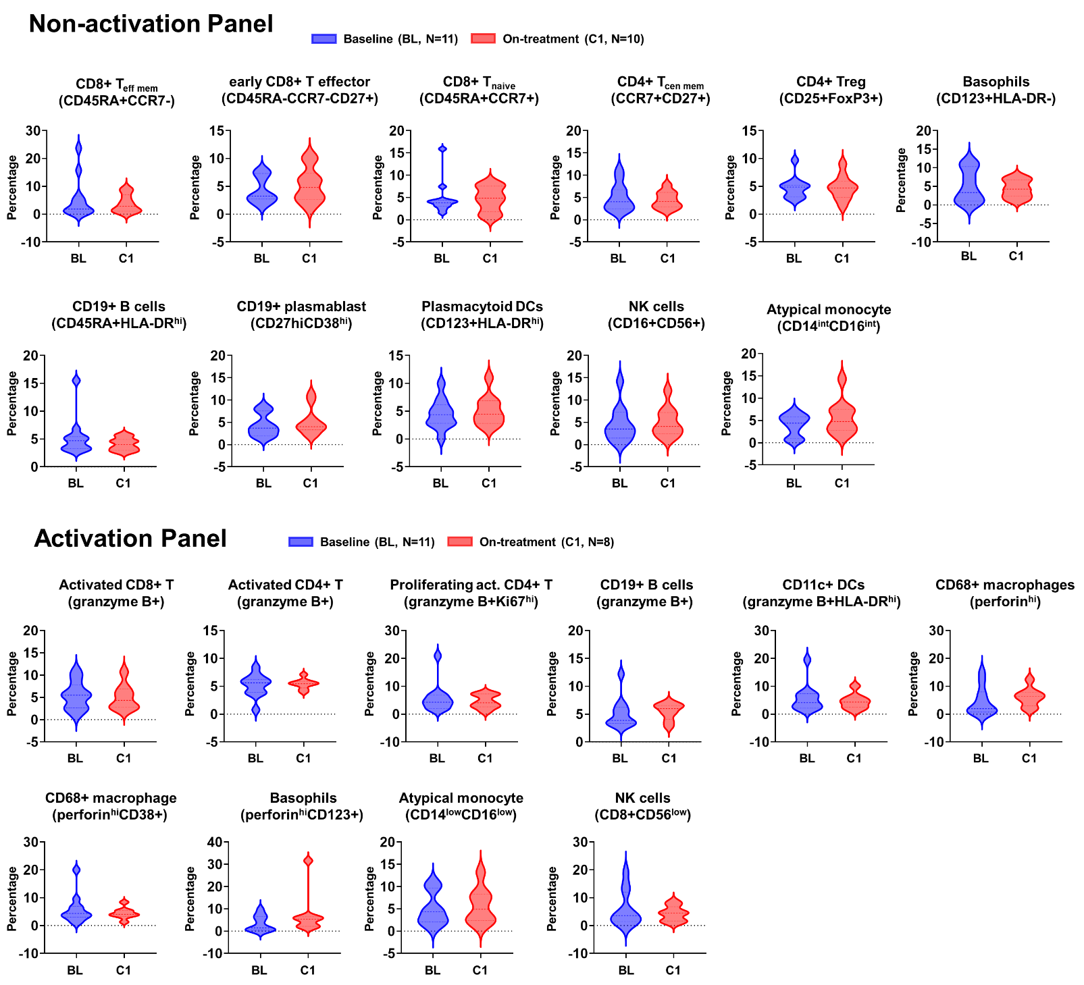
Supplementary Fig. S12. Comparison of immune cells between baseline (BL) and on-treatment (C1) timepoints for patients in cohort A. PBMCs were isolated and underwent spectral flow cytometry. Top panel: non-activation panel for immune cell phenotyping analysis; bottom panel: immune cell analysis for activation panel. BL=baseline; C1=first on treatment time point

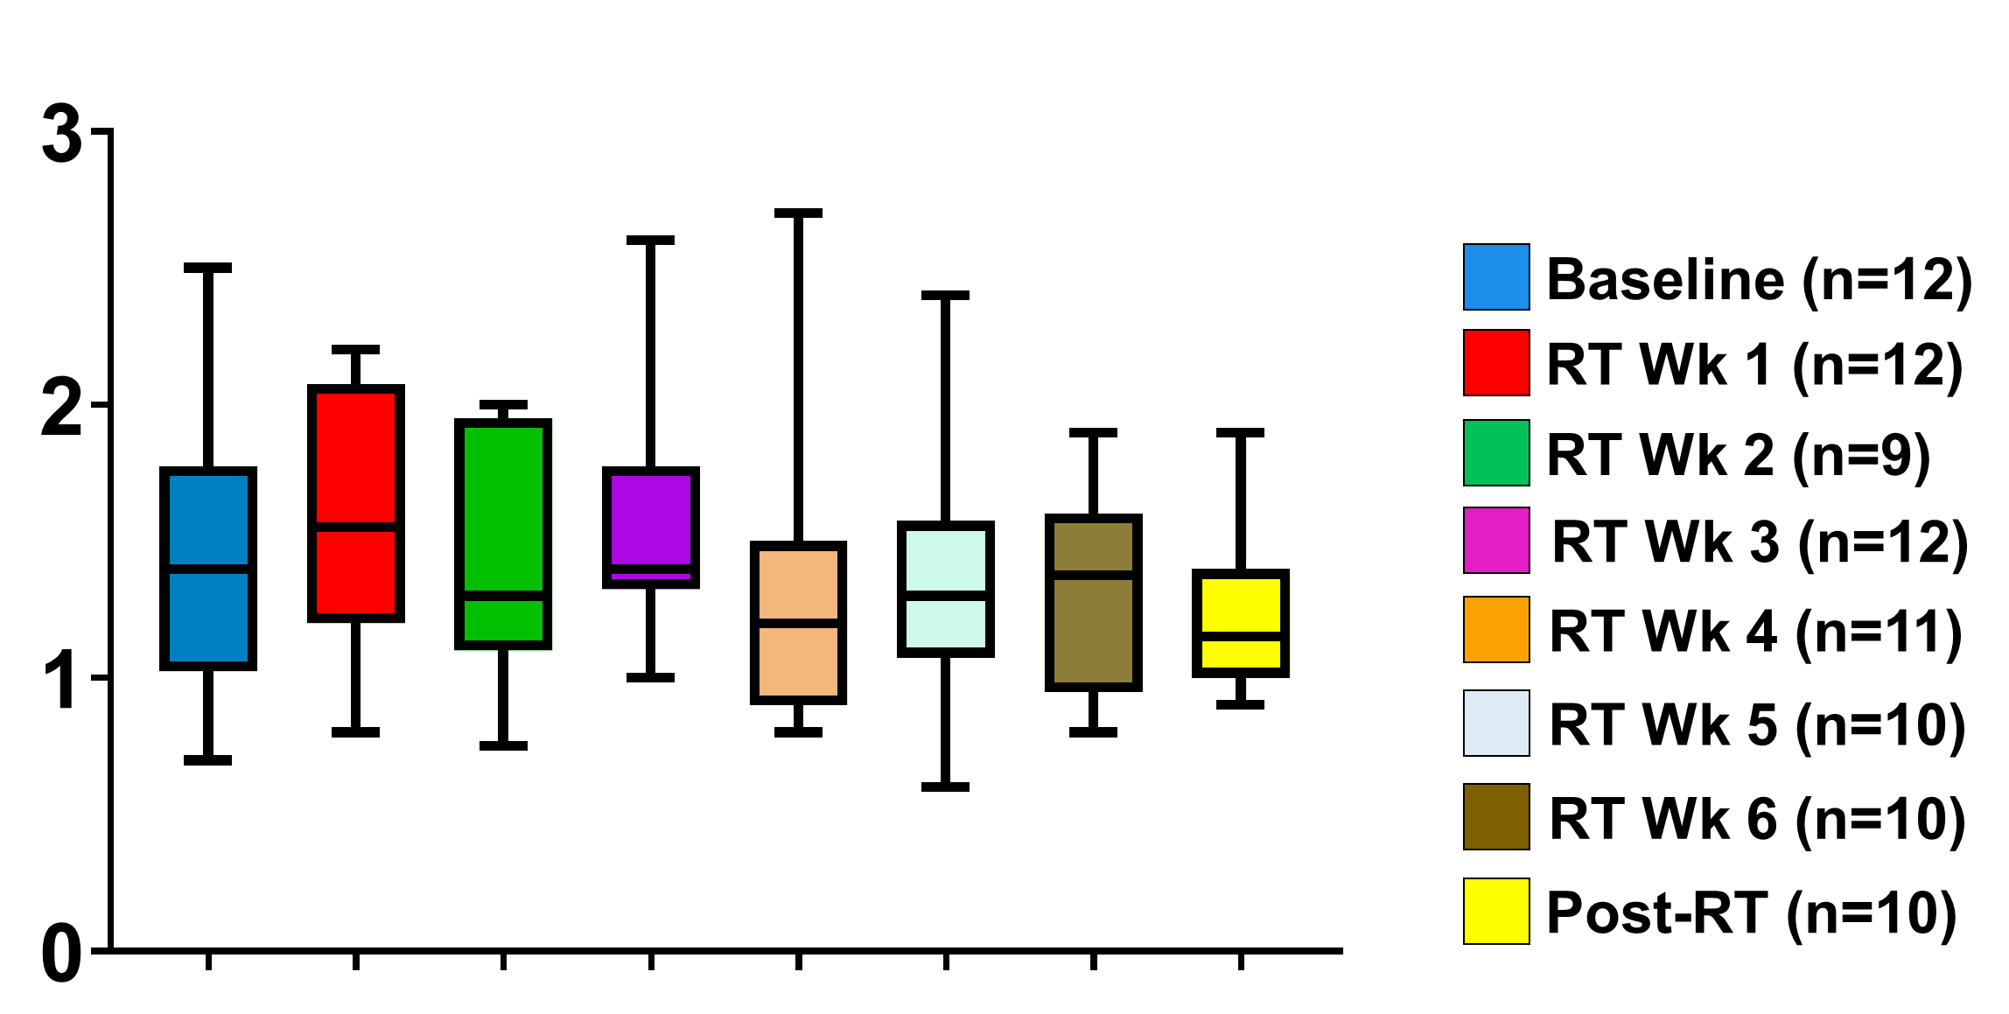
Supplementary Fig. S13. Absolute lymphocyte count (ALC) for PBMCs from cohort A GBM patients. Blood samples were drawn at the indicated time points and the ALC was performed as one of the routine blood tests. Box-whisker plot is used to display the min and max as well as median values.

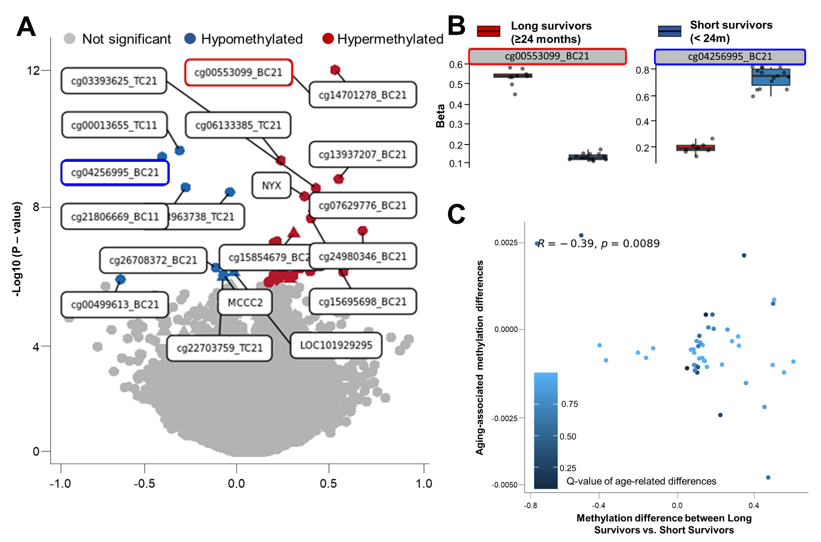
Supplementary Fig. S14. Correlation analysis between PBMC genomic DNA methylation and cohort A patient outcome. Genomic DNA was extracted and underwent methylation sequencing as described in the Methods. (A) The volcano plot shows differential methylation of CpG probes comparing longer- vs. shorter-survivors. The 10 most significant probes in each direction (hypermethylation vs. hypomethylation) are listed. The most significant probe in each direction is highlighted in a red or blue frame. Data points are colored by significance with grey indicating non-significant methylation differences, red indicating significant hypermethylation, and blue indicating significant hypomethylation. (B) Boxplots display the two most significantly differentially methylated probes as a function of long- vs. short-survivors. Red frame: hypermethylated; blue frame: hypomethylation. (C) A scatter plot comparing age-related methylation differences and methylation differences between long- and short-survivors. Points are colored by q-value, with darker colors indicating more significant associations.

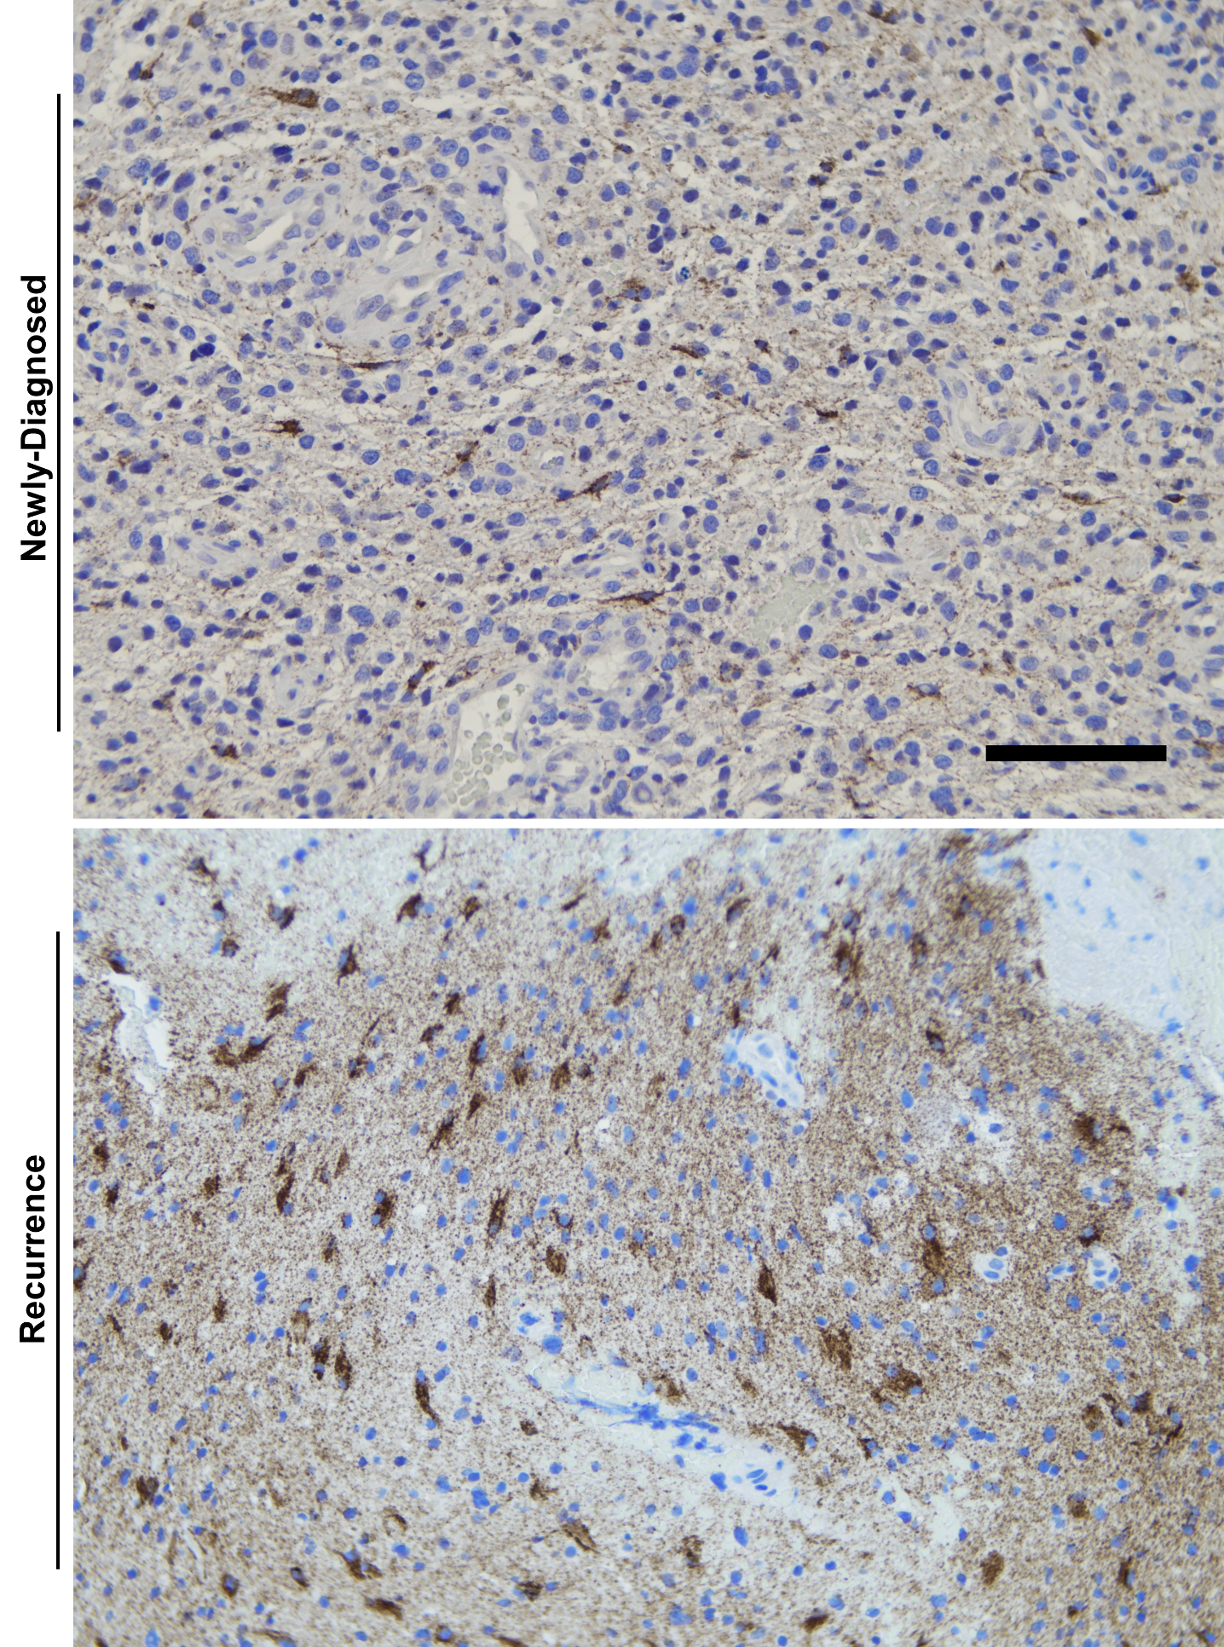
Supplementary Fig. S15. IDO1 immunoreactivity for patient #105 tumor at the time of initial tumor resection and at the time of tumor progression (recurrence). Photomicrographs for IDO1 immunoreactivity in GBM tissue specimens resected at the time of the initial diagnosis (top panel) or at tumor recurrence (bottom panel) for patient #105. Images are also shown in Figure 4. Scale bar: 100 μm.

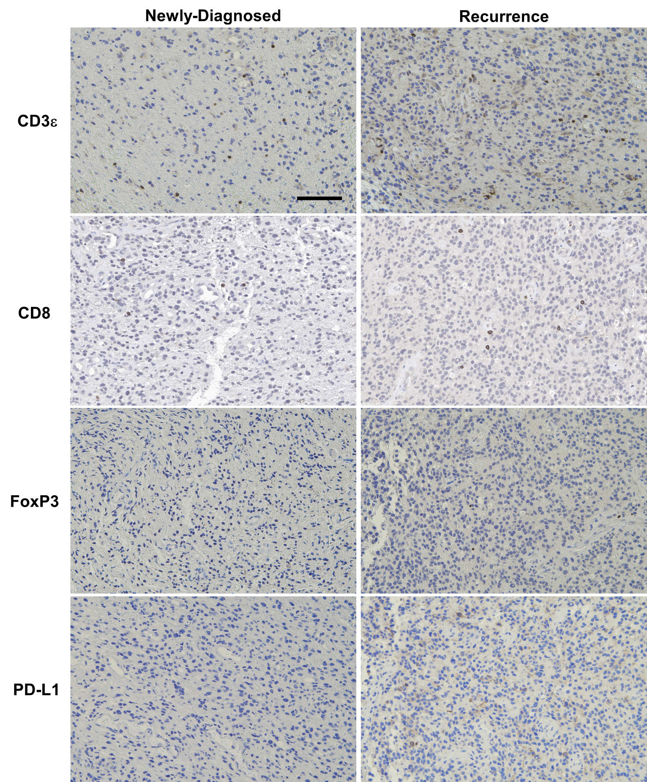
Supplementary Fig. S16. Immune cell marker immunoreactivity for patient #105 tumor at the time of initial tumor resection and at the time of tumor progression (recurrence). Photomicrographs for immunoreactivity of different immune cell markers in GBM tissue specimens resected at initial diagnosis (left panel) or at tumor recurrence (right panel) for patient #105. Scale bar: 100μm.

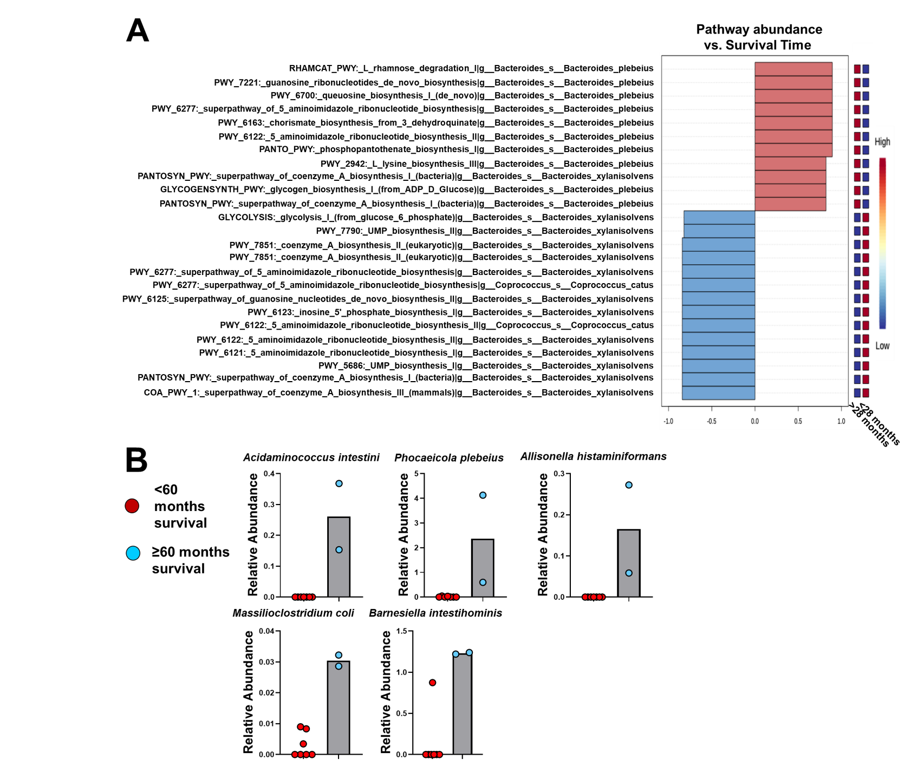
Supplementary Fig. S17. Metagenomic analysis of cohort A fecal microbiome. (A) Associations between microbial pathways and survival time as assessed through MaAsLin2 (q<0.10). (B) Differentially abundant bacterial species in GBM patients who survived >60 months vs < 60 months.

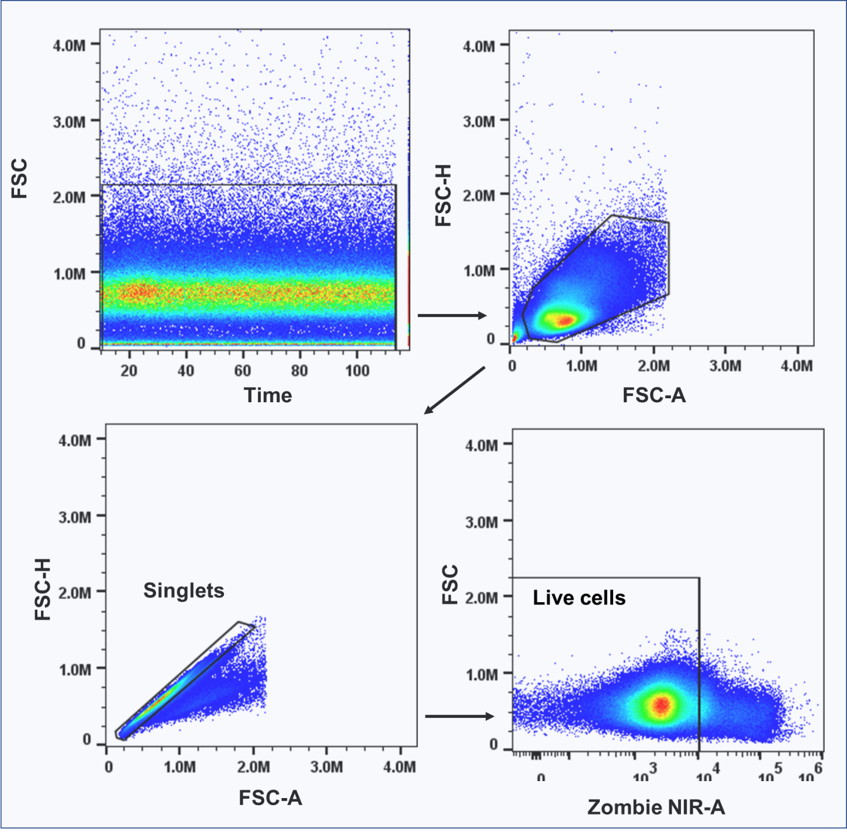
Supplementary Fig. S18. Gating strategy for spectral flow cytometry analysis. Patient-derived PBMCs were collected as described in Methods and underwent spectral flow cytometry. FCS files were loaded into FlowJo and live cells were manually gated for downstream analyses.

