Supplementary Online Content

Table S1. Corpus of studies included in meta-analysis (search closing date of 4 July 2020).
Appendix to Table S1: Publications included in the meta-analysis
Figure. S1: PRISMA flowchart.
Figure. S2: Funnel plots (A) mortality, (B) severity of COVID-19 disease, and (C) hospitalization

Table S1. Corpus of studies included in meta-analysis (search closing date of 4 July 2020; citations in Appendix to this Table).

Study | Country | Design | Study Period | ACEI/ARB | Non-ACEI/ARB | Outcomes of interest | Statistical adjustments | NOS
Bean et al¹ | UK | Multi-center retrospective study | 1st Mar to 13th Apr, 2020 | 399 | 801 | Mortality  Severity (death or organ support within 21-days of symptom onset) | Mortality: none  Severity: age, sex, comorbidities | 7
Bravi et al² | Italy | Population-based case-control retrospective study | Up to 24th Apr, 2020 | 450 | 1152 | Severity (requiring ICU or causing death) | Severity: age, gender, diabetes, major cardiovascular diseases, COPD, cancer, renal diseases | 7
Chen et al³ | China | Single-center retrospective study | Jan 1st to Mar 17th, 2020 | 32 | 39 | Mortality | None | 5
Conversano et al⁴ | Italy | Single-center retrospective study | Feb 27 to Mar 17, 2020 | - | - | Mortality | None | 5
Felice et al⁵ | Italy | Single-center retrospective study | Mar 9th to 31st Mar 2020 | 82 | 51 | Mortality  Severity (requiring semi ICU or ICU)  Hospitalization | Mortality, severity, hospitalization: age, gender, BMI, days with symptoms, previous cardiovascular | 8
Feng et al⁶ | China | Multi-center retrospective study | Jan 1st to Feb 15th 2020 | 35 | 62 | Severity (National Health Commission of China definition) | None | 5
Fosbøl et al⁷ | Denmark | National registry retrospective cohort study | Feb 1st to May 4th, 2020 | 895 | 3585 | Mortality  Severity (unclear definition) | Mortality, severity: age, sex, comorbidities | 9
Gao et al⁸ | China | Single-center retrospective observational study | Feb 5th to Mar 15th, 2020 | 183 | 527 | Mortality  Severity (unclear definition) | Mortality, severity: propensity score matched for age, sex, diabetes, insulin-treated diabetes, myocardial infarction, underwent PCI/CABG, renal failure, stroke, heart failure, COPD. | 8
Guo et al⁹ | China | Single-center retrospective study | Jan 23th to Feb 23th, 2020 | 19 | 168 | Mortality | None | 4
Huang et al¹⁰ | China | Single-center retrospective study | Feb 7th to Mar 3rd, 2020 | 20 | 30 | Mortality  Severity (National Health Commission of China definition) | None | 4
Jung et al¹¹ | Korea | Retrospective observational data from nationwide database | Up to Apr 8th, 2020. | 377 | 1577 | Mortality (in-hospital death) | Mortality: age, sex, Charlson Comorbidity Index, immunosuppression | 7
Li et al¹² | China | Single-center retrospective case series | Jan 15th to Mar 15th, 2020 | 115 | 247 | Mortality  Severity (National Health Commission of China definition) | None | 4
Liabeuf et al¹³ | France | Single-center retrospective study | Feb 28th to 30th Mar, 2020 | 96 | 172 | Mortality  Severity (admission to ICU) | Mortality: none  Severity: comorbidities | 4
Li Xiaochen et al¹⁴ | China | Single-center ambispective cohort study | Jan 26th to Feb 5th, 2020 | 42 | 503 | Severity (IDSA Pneumonia severity) | None | 4
Liu Y et al¹⁵ | China | Multi-center retrospective study | Jan 11th to Feb 5th, 2020 | 12 | 34 | Severity (National Health Commission of China definition) | Severity: sex | 6
Lopez-Otero¹⁶ | Spain | Single-center retrospective study | Mar 10th to April 6th, 2020 | 210 | 755 | Mortality  Severity (ICU admissions) | Mortality, severity: propensity score matching | 8
Mancia et al¹⁷ | Italy | Population-based case–control study | Feb 21th to Mar 11th, 2020 | 2896 | 12506 | Severity (defined as critical or fatal disease) | Severity: propensity score matching | 9
Mehta et al¹⁸ | USA | Multi-center retrospective study | Mar 8th to Apr 12th, 2020 | 211 | 1494 | Mortality  Severity (admission to ICU)  Hospitalization | Mortality: none  Severity, hospitalization: propensity score matching | 8
Meng et al¹⁹ | China | Single-center retrospective study | Jan 11th to Feb 23rd, 2020 | 17 | 25 | Mortality  Severity (National Health Commission of China definition) | None | 4
Richardson et al²⁰ | USA | Population-based retrospective case series study | Mar 1st to Apr 4th, 2020 | 413 | 953 | Mortality  Severity (ICU care) | None | 4
Rentsch et al²¹ | USA | Population-based retrospective cohort | Feb 8th and Mar 30th, 2020 | 1532 | 2247 | Severity (ICU admission)  Hospitalization | Severity, hospitalization: age, race, comorbid conditions, and Veterans Aging Cohort Study Index of physiologic injury | 9
Reynolds et al²² | USA | Multi-center retrospective cohort study | Mar 1st to Apr 15th, 2020 | 1774 | 439 | Severity (defined as intensive care, mechanical ventilation, or death) | Propensity score matching | 9
Rossi et al²³ | Italy | Population-based prospective cohort study | Feb 27th Up to Apr 8th | 818 | 4488 | Mortality  Hospitalization | Mortality, severity: age, sex, Charlson Comorbidity Index | 8
Tedeschi et al²⁴ | Italy | Multi-center prospective cohort study | Feb 1st to Apr 4th, 2020 | 175 | 136 | Mortality | Mortality: age, gender, presence of comorbidities | 8
Yang et al²⁵ | China | Single-center retrospective study | Jan 5th to Feb 22nd, 2020 | 43 | 83 | Mortality  Severity (National Health Commission of China definition) | None | 4
Yan et al²⁶ | China | Population-based retrospective case-control study | Jan 10th to Feb 28th, 2020 | - | - | Severity (National Health Commission of China definition) | Severity: age, sex, BMI | 4
Yu et al^{27*} | China | Multi-center retrospective cohort study | Jan 17th to Feb 19th, 2020 | 103 | 173 | Mortality | Mortality: sex, age, smoking, symptoms, chronic diseases | 9
Zeng et al²⁸ | China | Single-center retrospective study | Jan 5th to Mar 8th, 2020 | 28 | 47 | Mortality  Severity (IDSA Pneumonia severity)  Hospitalization | None | 4
Zhang et al²⁹ | China | Multi-center retrospective study | Dec 31st to Feb 20th, 2020 | 174 | 348 | Mortality  Severity (ARDS) | Mortality, severity: propensity score matching | 9
Zhou et al³⁰ | China | Single-center retrospective study | Jan 25th to Feb 20th, 2020 | 15 | 21 | Mortality | None | 4
* Data were not reported separately but merged into the Zhang et al (2020) meta-analysis. Data included here are as reported in the meta-analysis.
Abbreviations
ACEI: angiotensin converting enzyme inhibitors
ARB: Angiotensin II receptor blockers
ARDS: Acute respiratory distress syndrome
BMI: Body mass index
CABG: Coronary artery bypass surgery
COPD: Chronic obstructive pulmonary disease
ICU: Intensive care unit
IDSA: Infectious Diseases Society of America
PCI: Percutaneous coronary intervention
NOS: Newcastle–Ottawa Scale for cohort/case control studies

Appendix to Table S1: Publications included in the meta-analysis

1. Bean DM, Kraljevic Z, Searle T, et al. ACE-inhibitors and Angiotensin-2 Receptor Blockers are not associated with severe SARS-COVID19 infection in a multi-site UK acute Hospital Trust. Eur J Heart Fail. 2020.
2. Bravi F, Flacco ME, Carradori T, et al. Predictors of severe or lethal COVID-19, including Angiotensin Converting Enzyme inhibitors and Angiotensin II Receptor Blockers, in a sample of infected Italian citizens. PLoS One. 2020;15(6):e0235248.
3. Chen Y, Yang D, Cheng B, et al. Clinical Characteristics and Outcomes of Patients With Diabetes and COVID-19 in Association With Glucose-Lowering Medication. Diabetes Care. 2020;43(7):1399-1407.
4. Andrea C, Francesco M, Antonio N, et al. Renin-Angiotensin-Aldosterone System Inhibitors and Outcome in Patients With SARS-CoV-2 Pneumonia: A Case Series Study. Hypertension. 2020;76(2):e10-e12.
5. Felice C, Nardin C, Di Tanna GL, et al. Use of RAAS inhibitors and risk of clinical deterioration in COVID-19: results from an Italian cohort of 133 hypertensives. Am J Hypertens. 2020.
6. Feng Y, Ling Y, Bai T, et al. COVID-19 with Different Severities: A Multicenter Study of Clinical Features. Am J Respir Crit Care Med. 2020;201(11):1380-1388.
7. Fosbøl EL, Butt JH, Østergaard L, et al. Association of Angiotensin-Converting Enzyme Inhibitor or Angiotensin Receptor Blocker Use With COVID-19 Diagnosis and Mortality. JAMA. 2020.
8. Gao C, Cai Y, Zhang K, et al. Association of hypertension and antihypertensive treatment with COVID-19 mortality: a retrospective observational study. Eur Heart J. 2020;41(22):2058-2066.
9. Guo T, Fan Y, Chen M, et al. Cardiovascular Implications of Fatal Outcomes of Patients With Coronavirus Disease 2019 (COVID-19). JAMA Cardiol. 2020.
10. Huang Z, Cao J, Yao Y, et al. The effect of RAS blockers on the clinical characteristics of COVID-19 patients with hypertension. Ann Transl Med. 2020;8(7):430.
11. Jung SY, Choi JC, You SH, Kim WY. Association of renin-angiotensin-aldosterone system inhibitors with COVID-19-related outcomes in Korea: a nationwide population-based cohort study. Clin Infect Dis. 2020.
12. Li J, Wang X, Chen J, Zhang H, Deng A. Association of Renin-Angiotensin System Inhibitors With Severity or Risk of Death in Patients With Hypertension Hospitalized for Coronavirus Disease 2019 (COVID-19) Infection in Wuhan, China. JAMA Cardiol. 2020.
13. Liabeuf S, Moragny J, Bennis Y, et al. Association between renin-angiotensin system inhibitors and COVID-19 complications. Eur Heart J Cardiovasc Pharmacother. 2020.
14. Li X, Xu S, Yu M, et al. Risk factors for severity and mortality in adult COVID-19 inpatients in Wuhan. J Allergy Clin Immunol. 2020;146(1):110-118.
15. Liu Y, Huang F, Xu J, et al. Anti-hypertensive Angiotensin II receptor blockers associated to mitigation of disease severity in elderly COVID-19 patients. medRxiv. 2020:2003.2020.20039586.
16. López-Otero D, López-Pais J, Cacho-Antonio CE, et al. Impact of angiotensin-converting enzyme inhibitors and angiotensin receptor blockers on COVID-19 in a western population. CARDIOVID registry. Rev Esp Cardiol (Engl Ed). 2020.
17. Mancia G, Rea F, Ludergnani M, Apolone G, Corrao G. Renin–Angiotensin–Aldosterone System Blockers and the Risk of Covid-19. New England Journal of Medicine. 2020;382(25):2431-2440.
18. Mehta N, Kalra A, Nowacki AS, et al. Association of Use of Angiotensin-Converting Enzyme Inhibitors and Angiotensin II Receptor Blockers With Testing Positive for Coronavirus Disease 2019 (COVID-19). JAMA Cardiol. 2020.
19. Meng J, Xiao G, Zhang J, et al. Renin-angiotensin system inhibitors improve the clinical outcomes of COVID-19 patients with hypertension. Emerg Microbes Infect. 2020;9(1):757-760.
20. Richardson S, Hirsch JS, Narasimhan M, et al. Presenting Characteristics, Comorbidities, and Outcomes Among 5700 Patients Hospitalized With COVID-19 in the New York City Area. JAMA. 2020.
21. Rentsch CT, Kidwai-Khan F, Tate JP, et al. Covid-19 Testing, Hospital Admission, and Intensive Care Among 2,026,227 United States Veterans Aged 54-75 Years. medRxiv. 2020.
22. Reynolds HR, Adhikari S, Pulgarin C, et al. Renin-Angiotensin-Aldosterone System Inhibitors and Risk of Covid-19. N Engl J Med. 2020;382(25):2441-2448.
23. Giorgi Rossi P, Marino M, Formisano D, Venturelli F, Vicentini M, Grilli R. Characteristics and outcomes of a cohort of SARS-CoV-2 patients in the Province of Reggio Emilia, Italy. medRxiv. 2020:2020.2004.2013.20063545.
24. Tedeschi S, Giannella M, Bartoletti M, et al. Clinical Impact of Renin-angiotensin System Inhibitors on In-hospital Mortality of Patients With Hypertension Hospitalized for Coronavirus Disease 2019. Clinical Infectious Diseases. 2020.
25. Yang G, Tan Z, Zhou L, et al. Effects of Angiotensin II Receptor Blockers and ACE (Angiotensin-Converting Enzyme) Inhibitors on Virus Infection, Inflammatory Status, and Clinical Outcomes in Patients With COVID-19 and Hypertension: A Single-Center Retrospective Study. Hypertension. 2020;76(1):51-58.
26. Yan H, Valdes AM, Vijay A, et al. Role of Drugs Affecting the Renin-Angiotensin-Aldosterone System on Susceptibility and Severity of COVID-19: A Large Case-Control Study from Zheijang Province, China. medRxiv. 2020:2020.2004.2024.20077875.
27. Zhang X, Yu J, Pan LY, Jiang HY. ACEI/ARB use and risk of infection or severity or mortality of COVID-19: A systematic review and meta-analysis. Pharmacol Res. 2020;158:104927.
28. Zeng Z, Sha T, Zhang Y, et al. Hypertension in patients hospitalized with COVID-19 in Wuhan, China: A single-center retrospective observational study. medRxiv. 2020:2020.2004.2006.20054825.
29. Zhang P, Zhu L, Cai J, et al. Association of Inpatient Use of Angiotensin-Converting Enzyme Inhibitors and Angiotensin II Receptor Blockers With Mortality Among Patients With Hypertension Hospitalized With COVID-19. Circ Res. 2020;126(12):1671-1681.
30. Zhou X, Zhu J, Xu T. Clinical characteristics of coronavirus disease 2019 (COVID-19) patients with hypertension on renin-angiotensin system inhibitors. Clin Exp Hypertens. 2020;42(7):656-660.

Figure. S1: PRISMA flowchart

Identification

Eligibility

Included

Screening

Additional records identified from previous systematic reviews, meta-analyses, and other sources
(n=19)
Identified through medrxiv.org
(n=17)
Records identified from PubMed/Cochrane database
(n=200)

Records after duplicates removed
(n=205)

Records screened
(n=205)
Records excluded
(n=173)

Full-text articles assessed for eligibility
(n=32)
Abstracts only articles excluded
(n=2)

Studies included in quantitative synthesis (meta-analysis)
(n=30)

Figure Legend
Figure. S2: Funnel plots (A) mortality, (B) severity of COVID-19 disease, and (C) hospitalization.

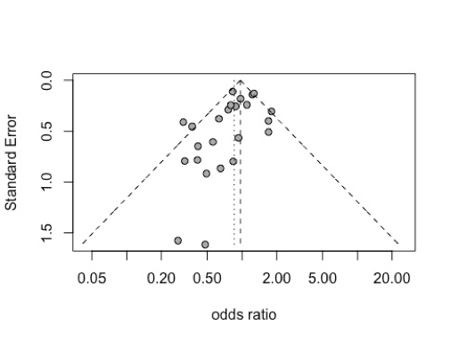
Panel A: Mortality

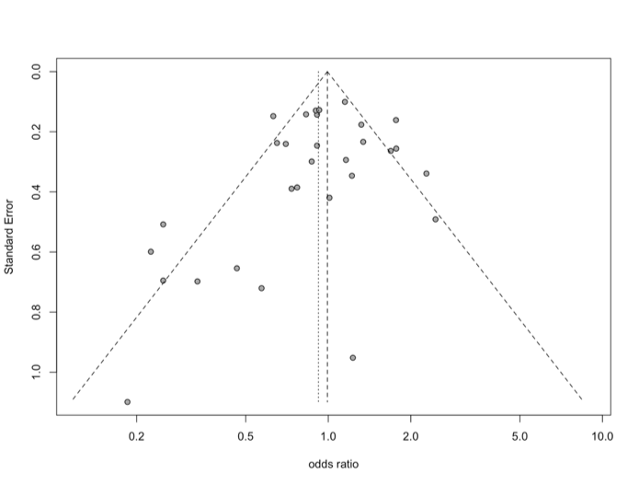
Panel B: Severity

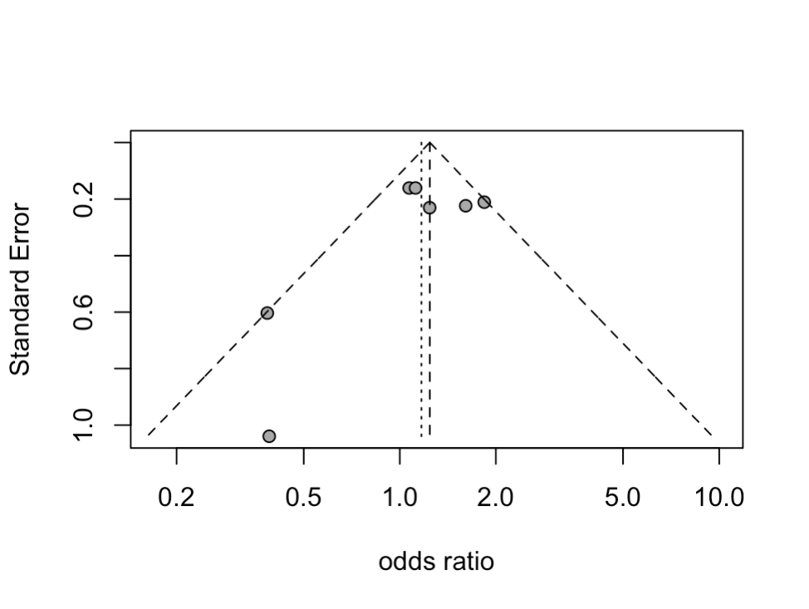
Panel C: Hospitalization

