Additional files

Antiplatelet therapy | Continuation of Aspirin.  Interruption of P2Y12 inhibitor :  - Ticagrelor and Clopidogrel : D-5 before surgery;  - Prasugrel : D-7 before surgery.  Bridging Clopidogrel with Aspirin.
Oral anticoagulation therapy | Interruption of NOAC :  - Apixaban, Rivaroxaban : D-3 before surgery;  - Dabigatran : D-4 (creatinine clearance ≥50mL/min) or D-5 (creatinine clearance <50mL/min) before surgery.  Interruption of VKA : D-5 before surgery without bridging and preoperative INR <1.5.  Exceptions requiring Heparin bridging for VKA interruption :  - Mechanical valve;  - Stroke or veinous thromboembolism within the past 3 months;  - Severe thrombophilia (Protein S, C or antithrombin III deficiency);  - Left ventricular thrombus;  - Atrial fibrillation with CHA₂DS₂-VASc score ≥7, embolic event within the past 3 months, or associated with mitral stenosis.
Heparin | LMWH prophylactic-dose : last injection at H-12;  LMWH therapeutic-dose : last injection at H-24.  UFH prophylactic-dose : stop at H-4;  UFH therapeutic-dose : last injection at H-12 (if subcutaneous) or stop at H-4 if intravenous.
Peroperative Heparin  management | UFH 300 UI/kg with a target ACT of 400–450 seconds before cannulation  This target may be lowered to 350–400 seconds for CABG procedures.  Antagonization with Protamine at a 0.6 :1 to 1 :1 ratio.
Table S1: Perioperative management of blood thinning therapies
Abbreviation: ACT= Activated Clotting Time, Hb= Hemoglobin, IV= Intravenous, LMWH= Low Molecular Weight Heparin, NOAC = Non-vitamin K antagonist Oral Anticoagulant, UFH= Unfractionated Heparin, VKA = Vitamin K Antagonist

Anemia correction according to the intervention – surgery delay
3 weeks or more | D-21: Day hospital  - Ferric carboxymaltose IV (Ferinject®): 1g if ≥ 50 kg, 500 mg if < 50 kg  - Epoetin alfa SC (Binocrit®): 40,000 IU  D-14: Home nurse  - Epoetin alfa SC (Binocrit®): 40,000 IU  D-5: Follow up CBC  If Hb <13 g/dL, erythropoietin administration at hospital admission (D-1 or surgery day)
Between 2 and 3 weeks | D-14: Day hospital  - Ferric carboxymaltose IV (Ferinject®): 1 g if ≥ 50kg, 500 mg if < 50 kg  - Epoetin alfa SC (Binocrit®): 40,000 IU  D-7: Home nurse  - Epoetin alfa SC (Binocrit®): 40,000 IU  D-1: Follow up CBC  If Hb < 13 g/dL, erythropoietin administration at hospital admission (D-1 or surgery day)
Between 1 and 2 weeks | D-7: Day hospital  - Ferric carboxymaltose IV (Ferinject®): 1g if ≥ 50kg, 500mg if < 50kg  - Epoetin alfa SC (Binocrit®): 40,000 IU  Erythropoietin administration at hospital admission (D-1 or same day)
Less than a week | Day hospital if possible, if not at hospital admission :  - Ferric carboxymaltose IV (Ferinject®): 1g if ≥ 50kg, 500mg if < 50kg  - Epoetin alfa SC (Binocrit®): 40,000 IU
Iron supplementation before and after surgery
Before surgery |  | Ferric carboxymaltose IV (Ferinject®): 500mg if ferritin <100 µg/L or transferrin saturation coefficient <20% with Hb ≥13 g/dL
After surgery |  | Ferric carboxymaltose IV (Ferinject®): 1000mg if Hb <12g/dL
Table S2: Anemia correction and iron supplementation before and after surgery
Abbreviations: CBC= Complete blood count, EPO= Erythropoietin, Hb= Hemoglobin, IV= Intravenous, SC= Subcutaneous.

General  characteristics | Age, sex, body mass index
Preoperative echocardiography | Left ventricular ejection fraction < 50%  Pulmonary hypertension  Right ventricular dysfunction  Left ventricular hypertrophy
Comorbidities | Coronary artery disease  Atrial fibrillation  Diabetes  Stroke  Chronic kidney disease (defined as creatinine clearance < 60 mL/min/1,73m² using the CK-EPI formula)
Treatment | Dual antiplatelet inhibition  Vitamin K antagonist  Direct oral anticoagulant
Laboratory data | Preoperative hemoglobin (g/dL)  Hemoglobin after iron and erythropoietin injection (g/dL)  Ferritin (µg/L) and transferrin saturation (%)  Lactate on ICU admission (mmol/L)  Postoperative serum creatinine peak (µmol/L)  Postoperative high-sensitivity troponin peak (µg/L)  Hemoglobin evolution (g/dL)
Surgical data | Type of surgery  Cardiopulmonary bypass duration  Norepinephrine administration and dose (µg/kg/min)  Dobutamine administration  Postoperative cardiac or respiratory support  Fuid management during cardiopulmonary and first postoperative day  Intraoperative administration of fibrinogen concentrates and prothrombin complex concentrates
Table S3: Data collected for each patient through electronic health record system

Figure S1: Distribution of the number of RBC units transfused until hospital discharge between PBM groups
Abbreviations: PBM= Patient blood management, RBC= Red blood cells.

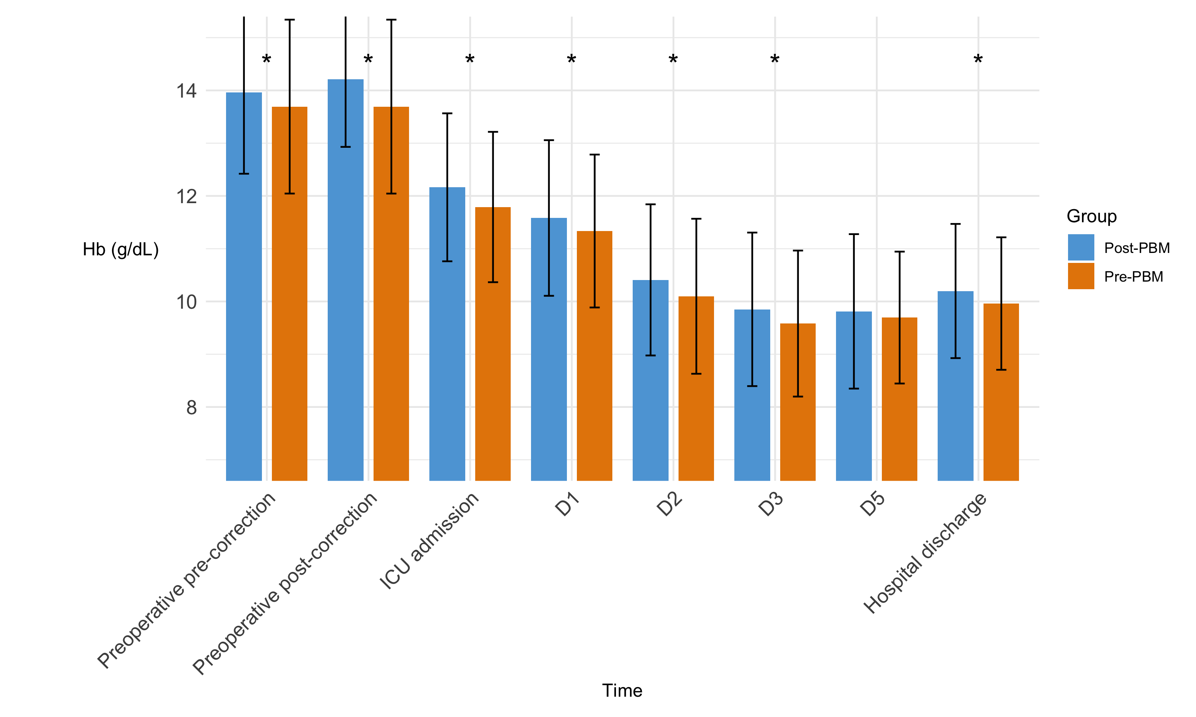
Figure S2: Hemoglobin evolution
Abbreviations: D= Day, ICU= Intensive care unit, PBM= Patient blood management.

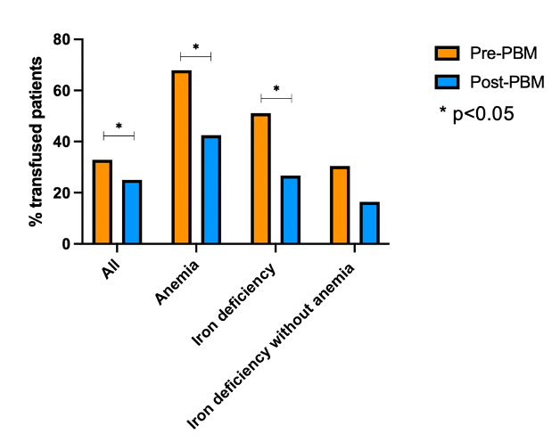
Figure S3: RBC transfusion in the subpopulation groups of preoperative anemia
Abbreviations: PBM= Patient blood management.

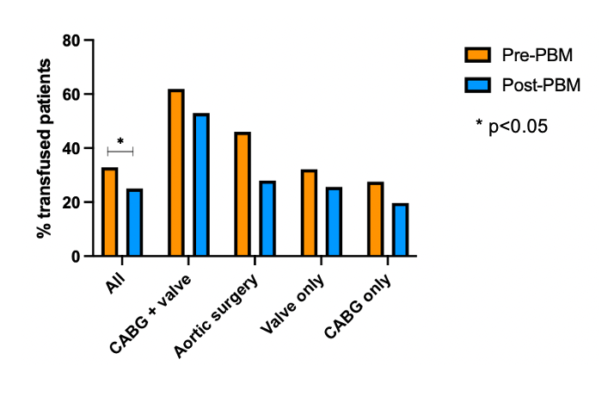
Figure S4: RBC transfusion depending on type of surgery
Abbreviations: CABG= Coronary artery bypass grafting, PBM= Patient blood management.

