Machine Learning-Driven Identification of Serotype-Independent Pneumococcal Vaccine Candidates using samples from Human Infection Challenge Studies
Authors:
Katerina S. Cheliotis^{1†}, Patricia Gonzalez-Dias^{1,2†}, Esther L. German¹, André N. A. Gonçalves^{1,2}, Elena Mitsi^{1,2}, Elissavet Nikolaou^{1,3,4}, Sherin Pojar^{1,5}, Eliane N. Miyaji⁶, Rafaella Tostes⁶, Jesús Reiné^{1,2}, Andrea M. Collins^{1,7}, Helder I. Nakaya^{8,9}, Stephen B. Gordon^{1,10}, Ying-Jie Lu¹¹, Shaun H. Pennington¹, Andrew J. Pollard², Richard Malley¹¹, Simon P. Jochems¹², Britta Urban^{1,2+}, Carla Solórzano^{1,2+}*, Daniela M. Ferreira^{1,2+}*
† Joint first authors
⁺ Joint senior authors
* Corresponding authors

Affiliations:
¹Department of Clinical Sciences, Liverpool School of Tropical Medicine, Liverpool, United Kingdom
²Oxford Vaccine Group, Department of Paediatrics, University of Oxford, Oxford, UK; NIHR Oxford Biomedical Research Centre, Oxford, UK
³Infection, Immunity and Global Health, Murdoch Children’s Research Institute, Melbourne, Victoria, Australia
⁴Department of Microbiology and Immunology, The University of Melbourne at the Peter Doherty Institute for Infection and Immunity, Melbourne, Victoria, Australia
⁵BioGrad Limited
⁶Laboratório de Bacteriologia, Instituto Butantan, São Paulo, Brazil
⁷Liverpool University Foundation Hospitals Trust
⁸Department of Clinical and Toxicological Analyses, School of Pharmaceutical Sciences, University of São Paulo, São Paulo, Brazil
⁹Hospital Israelita Albert Einstein, São Paulo, Brazil
¹⁰Centre for Inflammation Research, University of Edinburgh, Edinburgh, UK.
¹¹Boston Children's Hospital, Harvard Medical School, MA, USA
¹²Leiden University Center for Infectious Diseases (LUCID), Leiden University Medical Center, Leiden, Netherlands

Supplementary material:
Supplementary Table 1. Library of 75 highly conserved pneumococcal proteins used to develop a multiplex assay utilising Luminex xMAP technology.
Supplementary Text 1. Luminex assay methodology.
Supplementary Figure 1. AUC threshold determination based on retrospective EHPC data
Supplementary Figure 2. Carriage-associated cellular responses from supernatants of Spn6B stimulated human PBMCs.
Supplementary Figure 3. IL-17A secretion following ex-vivo protein stimulation for all 75 proteins.
Supplementary Table 2. The initial IL-17A screening, the data obtained from the susceptible and protected profile together with available data on immunisation with those antigens and protection against carriage in mice was used to down-select a limited number of antigens.
Supplementary Table 3. Correlation of protein-specific IgG concentration with colonising density (AUC).
Supplementary Table 4. Correlation of cytokine/chemokine responses with colonising density (AUC).
Supplementary Figure 4. Humoral and cellular responses across AUC groups for all proteins.

Supplementary Table 1. Library of 75 highly conserved pneumococcal proteins used to develop a multiplex assay utilising Luminex xMAP technology.
Protein | Function |  | Protein | Function
SP0043 | Competence factor transport protein ComB |  | SP1386 | Spermidine/putrescine ABC transporter
SP0079* | Potassium uptake protein, Trk family protein |  | SP1404 | Hypothetical protein
SP0084 | Sensor histidine kinase |  | SP1479 | Peptidoglycan N-acetylglucosamine deacetylase A
SP0092 | ABC^{[1]} transporter, substrate-binding protein |  | SP1500* | Amino acid ABC¹ transporter substrate-binding protein
SP0098 | Hypothetical protein |  | SP1545 | Hypothetical protein
SP0127 | Hypothetical protein |  | SP1560 | YbbR-like lipoprotein, putative
SP0149 | Lipoprotein |  | SP1652* | Efflux ABC transporter, permease protein
SP0191 | Lipoprotein, putative |  | SP1683* | Carbohydrate ABC transporter substrate-binding protein
SP0198 | Hypothetical protein |  | SP1826 | ABC transporter, substrate-binding protein
SP0249 | PTS^{[2]} system, IIB component |  | SP1872 | Iron-compound ABC transporter, iron-compound-binding protein
SP0321 | PTS system, IIA component |  | SP1897 | Sugar ABC transporter, sugar-binding protein
SP0346 | Capsular  polysaccharide  biosynthesis protein Cps4A |  | SP1942 | Transcriptional regulator, putative
SP0402 | Signal peptidase I |  | SP2083 | Sensor histidine kinase PnpS
SP0435* | Translation elongation factor P |  | SP2151 | Carbamate kinase
SP0564 | Hypothetical protein |  | SP2192 | Sensor histidine kinase
SP0582 | Hypothetical protein |  | SP2197 | ABC transporter, substrate-binding protein, putative
SP0601 | ABC transporter, transmembrane protein Vexp3 |  | SP2207* | Competence protein ComF, putative
SP0604 | Sensor histidine kinase VncS |  | SP2218 | Rod shape-determining protein MreC
SP0617 | Matrixin family protein |  | SP2145 | Cell wall surface anchor protein
SP0620 | Amino acid ABC transporter, amino acid-binding protein, putative |  | SP1534* | Manganese-dependent inorganic pyrophosphatase, putative
SP0629 | D-Ala-D-Ala carboxypeptidase, metallo peptidase |  | SP2070* | Glucose-6-phosphate isomerase
SP0648-1* | Beta-galactosidase |  | SP1002 | Adhesion lipoprotein
SP0648-2 | Beta-galactosidase |  | SP0148* | ABC transporter, substrate-binding protein
SP0648-3* | Beta-galactosidase |  | SP0314 | Hyaluronate lyase precursor
SP0659 | Thioredoxin family protein |  | SP0336* | Penicillin-binding protein
SP0662-2* | Sensor histidine kinase |  | SP0369 | Penicillin-binding protein 1A
SP0678 | Rhodanese-like domain |  | SP0930* | Choline binding protein E
SP0724 | Hypothetical protein |  | SP1492 | Cell wall surface anchor family protein
SP0742 | Hypothetical protein |  | SP1833 | Cell wall surface anchor family protein, metal binding
SP0757* | Cell division protein FtsX |  | SP2108* | Maltose/maltodextrin ABC transporter, maltose/maltodextrin-binding protein
SP0785* | HlyD family secretion protein |  | SP0662-1 | Sensor histidine kinase, putative
SP0787 | Antimicrobial peptide ABC transporter permease |  | SP2099* | Penicillin-binding protein 1B
SP0878 | SpoE family protein |  | PspC6 | Pneumococcal surface protein C (clade 6); binds complement factor H to evade C3 opsonization
SP0899* | Hypothetical protein |  | PspC9 | Pneumococcal surface protein C (clade 9); binds complement factor H to evade C3 opsonization
SP1032 | Iron-compound ABC transporter |  | PspA1 | Pneumococcal surface protein A (clade 1); cell wall-associated protein involved in inhibiting complement-mediated opsonization and preventing lactoferrin-mediated clearance
SP1069* | Hypothetical protein |  | PspA4 | Pneumococcal surface protein A (clade 4); cell wall-associated protein involved in inhibiting complement-mediated opsonization and preventing lactoferrin-mediated clearance
SP1154-2* | IgA1-specific metallopeptidase |  | PdB | Pneumolysin mutant
SP1376 | Shikimate 5-dehydrogenase

^{[1]} ATP-binding cassette
^{[2]} Phosphotransferase system

Supplementary Text 1. Luminex assay methodology
Proteins were randomly allocated to different microsphere regions. As 22 regions were available, proteins were divided across 4 panels. A ‘master-mix’ of each panel was made containing 250 beads/µl of each protein-coupled bead population (stored in wash buffer). These stocks were protected from light and stored at 4°C. From this stock solution, the required volume of stock microspheres was removed and diluted 1:5 in 1%BSA-PBS (assay buffer) to achieve 50 beads/µl of each protein-coupled bead population. 25µl of bead solution was added to each well on a 96 well plate. To this, 25µl of 1:20,000 serum diluted in an assay buffer was added. A stock of pooled sera taken 29 days post-challenge and diluted 1:50 in assay buffer was used as an internal positive control across all plates and assay buffer was used as a negative control to detect background median fluorescence intensity (MFI) values. The plate was covered to protect microspheres from light and incubated overnight at 4°C on a plate shaker (300rpm). Following incubation, the plate was clipped into place on the Luminex Magnetic Plate Separator and rapidly and forcefully inverted over a biohazard receptacle to expel the liquid from the wells. Microspheres were washed three times with 200µl assay buffer. Biotinylated human IgG Fc antibody (Invitrogen™ Novex™, catalogue number: A18821, lot: 62, 129, 090718) was diluted to 2µg/ml in assay buffer and 50µl was then added to each well. The plate was then incubated in the dark for 30 minutes at room temperature on a plate shaker. Following incubation, liquid was expelled from wells and microspheres were washed three times as previously. Streptavidin R-phycoerythrin conjugate (SA-PE) (Invitrogen, catalogue number: S866, lot: 1973501) was diluted idem as for the biotinylated secondary antibody and 50µl of SA-PE solution was added to each well. The plate was incubated as previously for 10 minutes. Liquid was expelled from wells and microspheres were then washed three times and re-suspended in 50µl of assay buffer. The plate was incubated for five minutes before analysing the contents of each well on the Luminex analyser. All samples were run in duplicate. Serum samples from two participant cohorts, as described above, were analysed. All data reported are in units of average net MFI (average of replicates) with background MFI subtracted (average net MFI - blank wells). It should be noted that the internal positive control both confirmed immunodetection as well as inter-assay variation of the panel of proteins against which serum IgG was being analysed. In the case of high variation between plates, experiments were repeated to ensure comparability of results (<25% CV for each analyte). Final inter-assay CV for all proteins as determined by the internal positive control was <20%. Thus, we deem results obtained across different assays to be comparable.

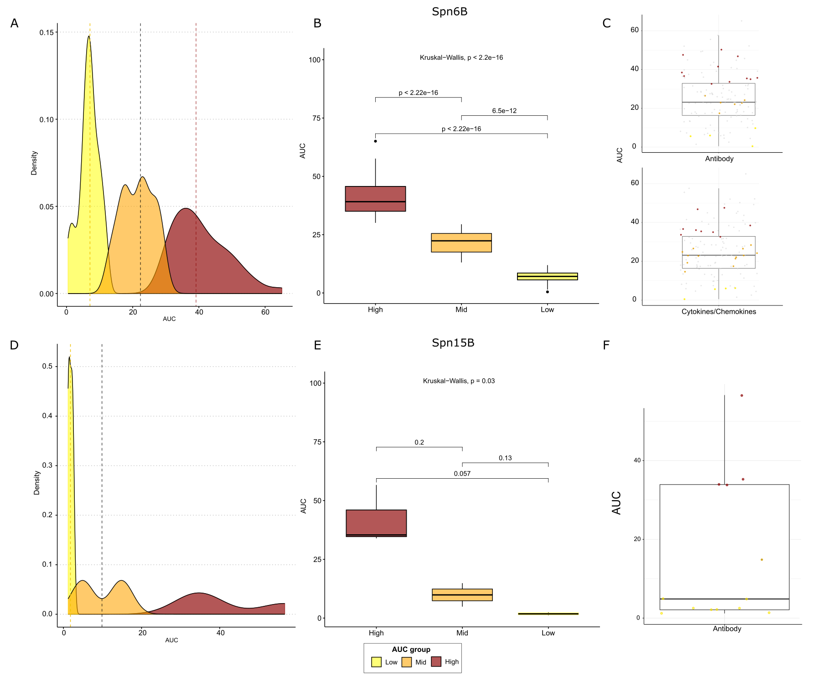
Supplementary Figure 1. AUC threshold determination based on retrospective EHPC data. (A) Density plot of AUC values categorized into three groups: Low (yellow), Mid (orange), and High (dark red). Vertical dashed lines indicate threshold values separating these groups. (B) Box plot comparing AUC distributions across Low, Mid, and High groups for Spn6B. Kruskal-Wallis p-value and pairwise comparisons are shown. (C) Box plots displaying AUC distributions for Antibody and Cytokines/Chemokines responses. Grey dots represent AUC values from retrospective studies, while coloured dots represent AUC values from Spn15B participants in this study. Participant data are categorized as follows: yellow (Low, below Q1), orange (Mid, Q1-Q3), and dark red (High, above Q3). (D) Density plot of AUC values for Spn15B, categorized into Low, Mid, and High groups, similar to (A). (E) Box plot comparing AUC distributions for Spn15B across Low, Mid, and High groups. Kruskal-Wallis p-value and pairwise comparisons are shown. (F) Box plot displaying AUC distribution for the Antibody response. Grey dots represent AUC values from retrospective studies, while coloured dots represent AUC values from Spn15B participants in this study. Participant data are categorised as follows: yellow (Low, below Q2), orange (Mid, Q2), and dark red (High, above Q3).

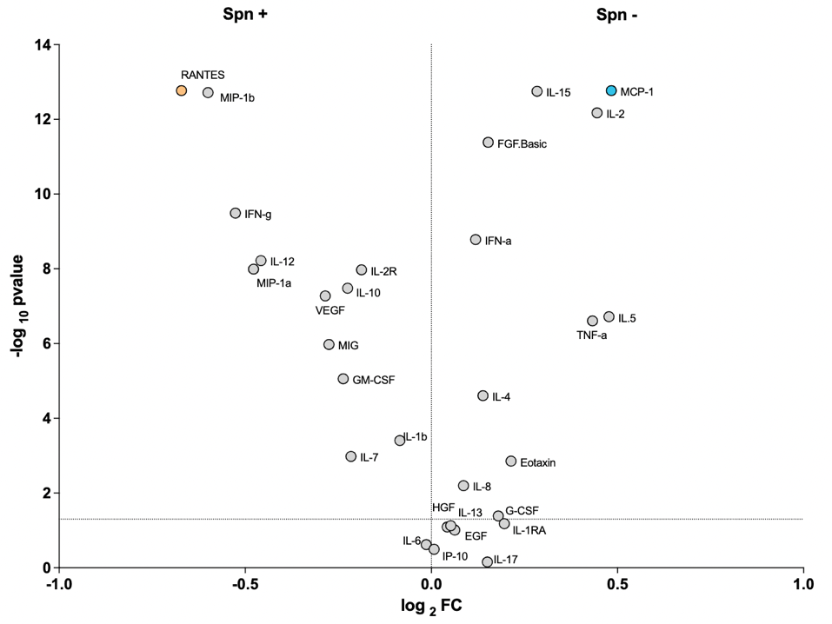
Supplementary Figure 2. Carriage-associated cellular responses from supernatants of Spn6B stimulated human PBMCs. Supernatants from PBMC cultures stimulated for 7 days with a protein library and heat-inactivated Streptococcus pneumoniae serotype 6B (Spn6B) were analyzed for cytokine and chemokine concentrations using a 30-plex human Luminex magnetic bead assay. Samples were derived from a pooled set of 12 carriage-negative (Spn–) and 11 carriage-positive (Spn+) healthy adult participants. Each dot represents an individual analyte, plotted by its log₂(fold change) (Spn– vs Spn+) on the x-axis and the –log₁₀(p-value) (Wilcoxon paired test) on the y-axis. The horizontal dashed line indicates the p = 0.05 threshold. Analytes to the right of the vertical axis (positive log₂FC) are elevated in the Spn– group, while those to the left are elevated in the Spn+ group.
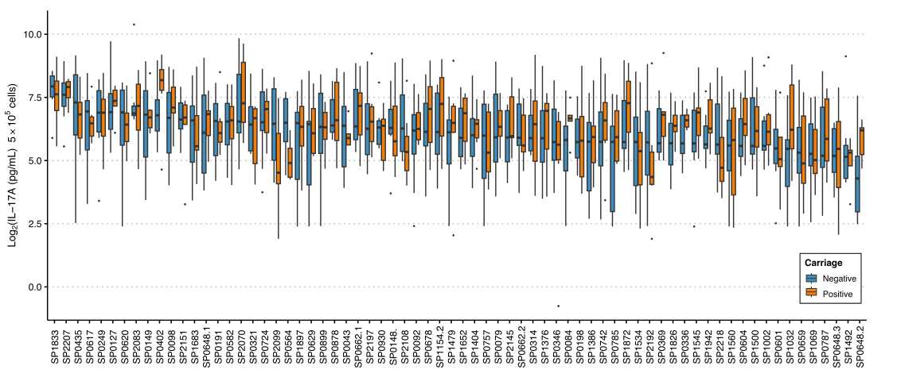
Supplementary Figure 3. IL-17A secretion following ex-vivo protein stimulation for all 75 proteins. Baseline levels of IL-17 produced by PBMCs stimulated with pneumococcal proteins in healthy adults aged 18-50. Spn6B carriage-negative (blue) n = 10, Spn6B carriage-positive (orange) n = 11.

Supplementary Table 2. The initial IL-17A screening, the data obtained from the susceptible and protected profile together with available data on immunisation with those antigens and protection against carriage in mice was used to down-select a limited number of antigens.
 |  | Correlations |  |  | High Neg >FC 0.5 | High Pos <FC -0.5
Gene name | Mice Data | D2 | D7 | AUC D2-D7 | MCP-1 | IFN-g | RANTES
SP0079 |  |  | -0.78 |  | 0.533 | -0.507
SP0148 | YES |  |  |  |  | -1.805 | -1.204
SP0336* |  |  |  |  |  |  | -0.575
SP0435 | YES | -1 |  |  | 0.480 |  | -0.930
SP0648-1 | YES |  |  |  | 0.680 |  | -0.829
SP0648-3 |  | -0.88 |  |  | 0.708 | -0.483 | -0.765
SP0662-2 | YES |  | -0.84 |  | 0.491 | -1.125 | -1.343
SP0757 | YES | no sig -0.82 |  |  |  | -1.449 | -1.020
SP0785 | YES | no sig -0.82 |  | -1 |  | -2.263 | -0.588
SP0899 | YES |  |  |  |  | -2.563 | -0.880
SP0930*
SP1069 | YES |  |  |  |  | -2.451 | -0.857
SP1154-2 | YES | -1 |  | no sig -0.82 |  | -1.485 | -0.715
SP1500 | YES |  |  |  |  | -2.418 | -0.901
SP1534 | YES |  |  | -0.94
SP1652 |  |  |  | -0.88 |  | -2.082 | -0.557
SP1683 | YES |  | -0.88 |  |  | -1.526 | -0.665
SP2070 | YES |  |  |  | 0.496 |  | -0.735
SP2099 |  |  | -0.78 | no sig -0.75 | 0.508 |  | -0.893
SP2108 | YES |  |  |  | 0.596 | -2.127 | -0.915
SP2207* |  |  |  |  |  | -0.850 | -0.589
*proteins that did not meet the criteria but were included as controls
*c- : carriage-negative, c+: carriage-positive, FC: Fold Change, AUC: Area under the curve

Supplementary Table 3. Correlation of protein-specific IgG concentration with colonising density (AUC).
IgG levels to: | Rho | p-value | BH adjusted p-value
SP0678 | -0.536 | 0.001 | 0.079
SP2192 | -0.487 | 0.003 | 0.122
SP0930 | -0.463 | 0.006 | 0.122
SP0321 | -0.455 | 0.007 | 0.122
SP1479 | -0.432 | 0.011 | 0.140
SP0092 | -0.419 | 0.014 | 0.140
SP1492 | -0.419 | 0.014 | 0.140
SP1545 | -0.400 | 0.019 | 0.172
SP0620 | -0.392 | 0.022 | 0.174
SP0617 | -0.378 | 0.027 | 0.197
SP0564 | -0.370 | 0.031 | 0.204
SP1942 | -0.328 | 0.058 | 0.324
SP2218 | -0.322 | 0.063 | 0.326
SP0659 | -0.290 | 0.096 | 0.430
SP0149 | -0.277 | 0.113 | 0.445
SP2197 | -0.269 | 0.124 | 0.445
SP0198 | -0.268 | 0.126 | 0.445
SP0757 | -0.262 | 0.134 | 0.445
SP0402 | -0.261 | 0.136 | 0.445
SP0582 | -0.242 | 0.168 | 0.525
SP0191 | -0.220 | 0.210 | 0.630
SP0314 | -0.216 | 0.219 | 0.632
SP1683 | -0.195 | 0.268 | 0.665
SP0785 | -0.195 | 0.268 | 0.665
SP1032 | -0.188 | 0.287 | 0.689
PspA1 | -0.177 | 0.315 | 0.712
SP0662.1 | -0.160 | 0.365 | 0.772
SP1872 | -0.156 | 0.378 | 0.775
SP0742 | -0.150 | 0.397 | 0.775
SP0878 | -0.146 | 0.409 | 0.775
SP0346 | -0.146 | 0.410 | 0.775
SP1560 | -0.142 | 0.423 | 0.775
SP2207 | -0.140 | 0.431 | 0.775
SP2099 | -0.133 | 0.454 | 0.795
SP0648.2 | -0.130 | 0.464 | 0.795
SP1404 | -0.119 | 0.502 | 0.841
SP0127 | -0.115 | 0.517 | 0.846
SP1376 | -0.103 | 0.563 | 0.879
SP2083 | -0.100 | 0.574 | 0.879
PspA4 | -0.096 | 0.588 | 0.882
SP1500 | -0.086 | 0.628 | 0.903
SP1534 | -0.070 | 0.694 | 0.903
SP0662.2 | -0.068 | 0.703 | 0.903
SP0724 | -0.062 | 0.727 | 0.903
PspC9 | -0.058 | 0.744 | 0.903
SP2108 | -0.054 | 0.760 | 0.903
SP0648.1 | -0.041 | 0.819 | 0.903
SP1826 | -0.039 | 0.827 | 0.903
PdB | -0.0004 | 0.998 | 0.998
SP0601 | 0.001 | 0.997 | 0.998
SP0899 | 0.007 | 0.968 | 0.996
SP0336 | 0.016 | 0.929 | 0.969
SP0435 | 0.029 | 0.870 | 0.922
SP0369 | 0.031 | 0.862 | 0.922
SP0648.3 | 0.044 | 0.805 | 0.903
SP0604 | 0.046 | 0.797 | 0.903
PspC6 | 0.050 | 0.778 | 0.903
SP1069 | 0.052 | 0.770 | 0.903
SP0249 | 0.056 | 0.746 | 0.903
SP0148 | 0.070 | 0.692 | 0.903
SP0098 | 0.074 | 0.678 | 0.903
SP1154.2 | 0.078 | 0.661 | 0.903
SP0079 | 0.081 | 0.649 | 0.903
SP1386 | 0.089 | 0.615 | 0.903
SP0787 | 0.100 | 0.572 | 0.879
SP0629 | 0.163 | 0.357 | 0.772
SP1002 | 0.177 | 0.317 | 0.712
SP2151 | 0.199 | 0.259 | 0.665
SP0043 | 0.200 | 0.256 | 0.665
SP1833 | 0.286 | 0.101 | 0.430
SP1652 | 0.295 | 0.091 | 0.430
SP1897 | 0.359 | 0.037 | 0.223

Supplementary Table 4. Correlation of cytokine/chemokine responses with colonising density (AUC).

Cytokine/Chemokine Levels to: | Rho | p-value | BH adjusted p-value
SP0079_RANTES | -0.569 | 0.002 | 0.147
SP1683_IFN | -0.451 | 0.021 | 0.351
SP0079_IFN | -0.434 | 0.027 | 0.351
SP0662_2_RANTES | -0.421 | 0.032 | 0.351
SP1154_2_RANTES | -0.402 | 0.042 | 0.351
SP2070_IFN | -0.383 | 0.054 | 0.351
SP0662_2_IFN | -0.378 | 0.057 | 0.351
SP2099_RANTES | -0.376 | 0.058 | 0.351
SP0648_1_RANTES | -0.375 | 0.059 | 0.351
SP1154_2_IFN | -0.375 | 0.059 | 0.351
SP0899_RANTES | -0.367 | 0.065 | 0.351
SP1683_RANTES | -0.356 | 0.074 | 0.351
SP0648_3_IFN | -0.353 | 0.077 | 0.351
SP1069_RANTES | -0.349 | 0.080 | 0.351
SP0648_1_IFN | -0.329 | 0.102 | 0.387
SP1500_RANTES | -0.313 | 0.119 | 0.408
SP0757_RANTES | -0.312 | 0.120 | 0.408
SP0899_IFN | -0.307 | 0.127 | 0.408
SP2099_IFN | -0.284 | 0.160 | 0.473
SP1500_IFN | -0.282 | 0.163 | 0.473
SP0648_3_RANTES | -0.268 | 0.184 | 0.489
SP1069_IFN | -0.232 | 0.254 | 0.578
SP0435_IL17 | -0.231 | 0.257 | 0.578
SP0648_1_MCP1 | -0.205 | 0.312 | 0.610
SP2108_RANTES | -0.203 | 0.320 | 0.610
SP0435_IFN | -0.183 | 0.372 | 0.657
SP2070_RANTES | -0.178 | 0.384 | 0.657
SP1069_MCP1 | -0.177 | 0.387 | 0.657
SP1534_IFN | -0.157 | 0.443 | 0.680
SP2108_IFN | -0.154 | 0.452 | 0.680
SP1534_IL17 | -0.153 | 0.457 | 0.680
SP0899_MCP1 | -0.140 | 0.497 | 0.721
SP0435_RANTES | -0.135 | 0.510 | 0.724
SP2070_MCP1 | -0.109 | 0.597 | 0.792
SP0079_IL17 | -0.086 | 0.673 | 0.838
SP0079_MCP1 | -0.072 | 0.727 | 0.878
GenderFemale | -0.067 | 0.746 | 0.878
SP1069_IL17 | -0.061 | 0.769 | 0.878
SP1500_IL17 | -0.054 | 0.792 | 0.878
SP0662_2_MCP1 | -0.037 | 0.858 | 0.899
SP0757_MCP1 | -0.036 | 0.863 | 0.899
SP1500_MCP1 | -0.034 | 0.870 | 0.899
SP1534_RANTES | -0.023 | 0.912 | 0.928
SP0757_IFN | -0.007 | 0.975 | 0.975
SP2070_IL17 | 0.046 | 0.823 | 0.896
SP0435_MCP1 | 0.057 | 0.782 | 0.878
SP0648_1_IL17 | 0.091 | 0.660 | 0.838
SP1683_MCP1 | 0.093 | 0.652 | 0.838
SP1154_2_MCP1 | 0.110 | 0.591 | 0.792
SP2099_IL17 | 0.130 | 0.528 | 0.732
SP0648_3_MCP1 | 0.162 | 0.430 | 0.680
SP2099_MCP1 | 0.165 | 0.422 | 0.680
SP0757_IL17 | 0.194 | 0.342 | 0.632
SP0648_3_IL17 | 0.214 | 0.292 | 0.593
SP1683_IL17 | 0.222 | 0.275 | 0.578
SP1652_IL17 | 0.225 | 0.269 | 0.578
SP0662_2_IL17 | 0.238 | 0.242 | 0.578
SP2108_IL17 | 0.264 | 0.192 | 0.489
SP0899_IL17 | 0.274 | 0.176 | 0.489
SP1154_2_IL17 | 0.341 | 0.088 | 0.358

Supplementary Figure 4. Humoral and cellular responses across AUC groups for all proteins.
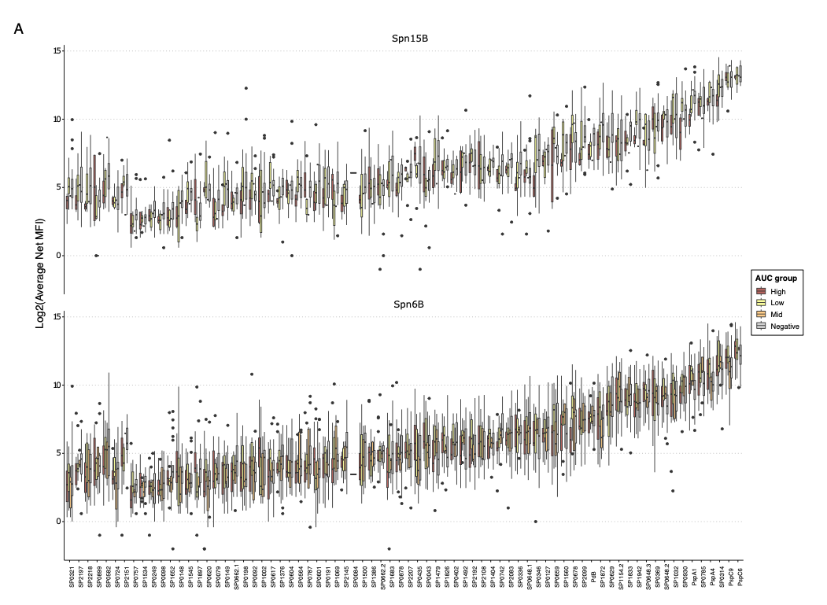
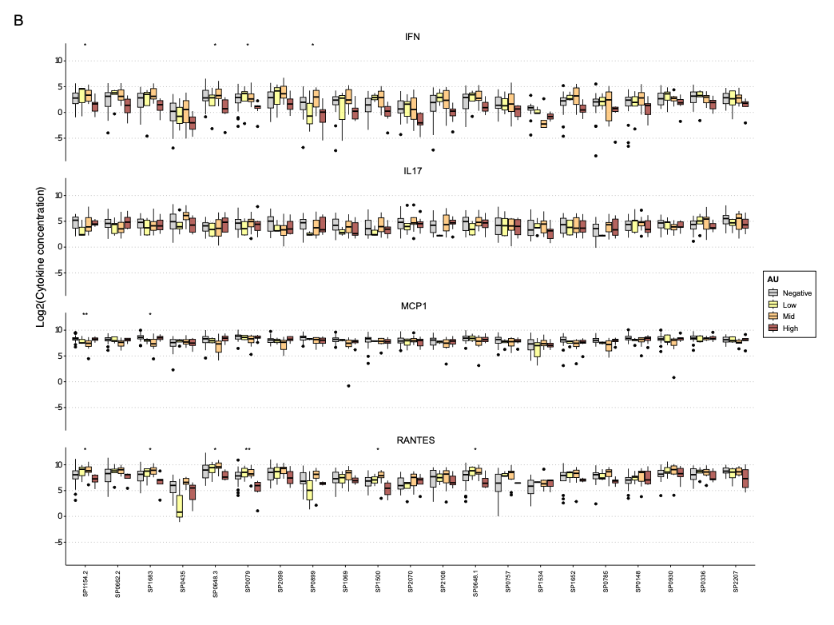
Supplementary Figure 4. Humoral and cellular responses across AUC groups for all proteins. (A) Baseline levels of anti-protein serum IgG in healthy adults aged 18-50, measured as average net median fluorescence intensity (MFI). Bars indicate interquartile range. Spn15B carriage-negative n = 15, Spn15B carriage-positive n = 13, low AUC n= 8, mid n= 1 and high n= 4; Spn6B carriage-negative n = 18, Spn6B carriage-positive n = 21, low AUC group n= 4, mid n= 6 and high n= 11. (B) Baseline levels of selected cytokines/chemokines produced by PBMCs from healthy adults aged 18-50 that were stimulated by pneumococcal proteins. Carriage-negative - grey; low AUC - yellow, mid AUC - orange; high AUC - red. Bars indicate interquartile range. Spn6B carriage-negative n = 18, Spn6B carriage-positive n = 27, low AUC group n= 4, mid n= 14 and high n= 9.

