Explainable GNN Framework Guided by Local Chemical Features to Predict Binding Energies in Bimetallic Alloys
A. F. Usugaª, C. S. Praveen^{b,c} and A. Comas-Vives^{a,d,*}
ª Department of Chemistry, Universitat Autònoma de Barcelona, 08193 Cerdanyola del Vallès, Catalonia, Spain
^{b} International School of Photonics, Cochin University of Science and Technology, University Road, South Kalamassery, Kalamassery, Ernakulam, Kerala, 682022, India
^{c} Inter University Centre for Nano Materials and Devices, Cochin University of Science and Technology, University Road, South Kalamassery, Kalamassery, Ernakulam, Kerala, 682022, India
^{d} Institute of Materials Chemistry, TU Wien, 1060 Vienna, Austria
E-mail: aleix.comas@tuwien.ac.at; aleix.comas@uab.cat

Table S1. Size of supercell of surface model for Ni-Ga-based alloys with their respective side view.
System | supercell | Side view
Ni(111) | 2x2x1 | 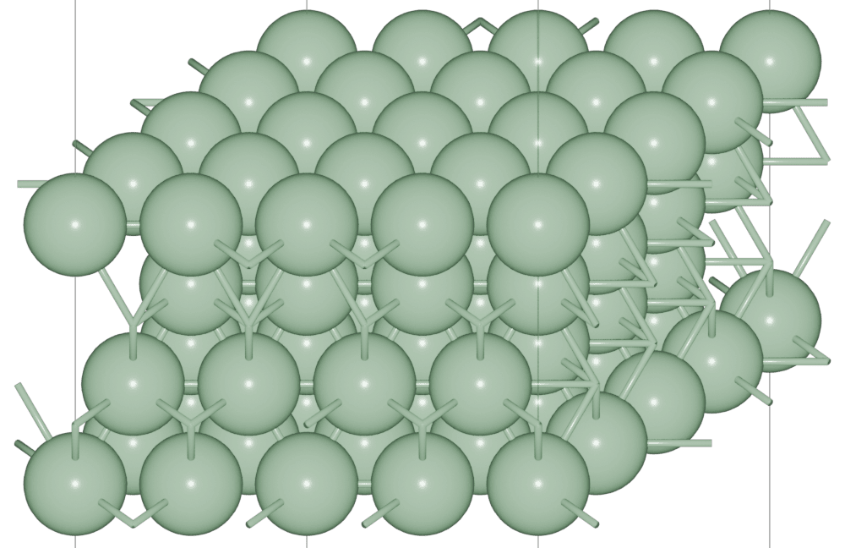
Ni(211) | 2x3x1 | 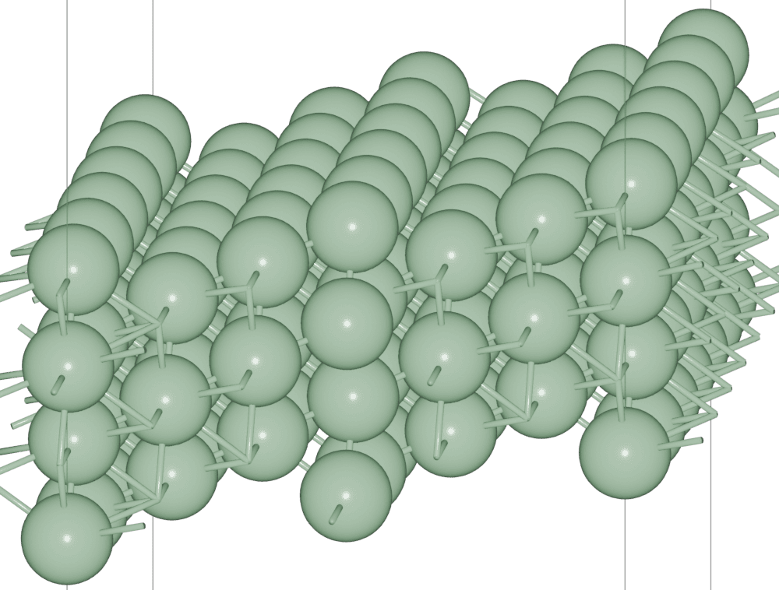
Ni₃Ga(111) | 2x2x1 | 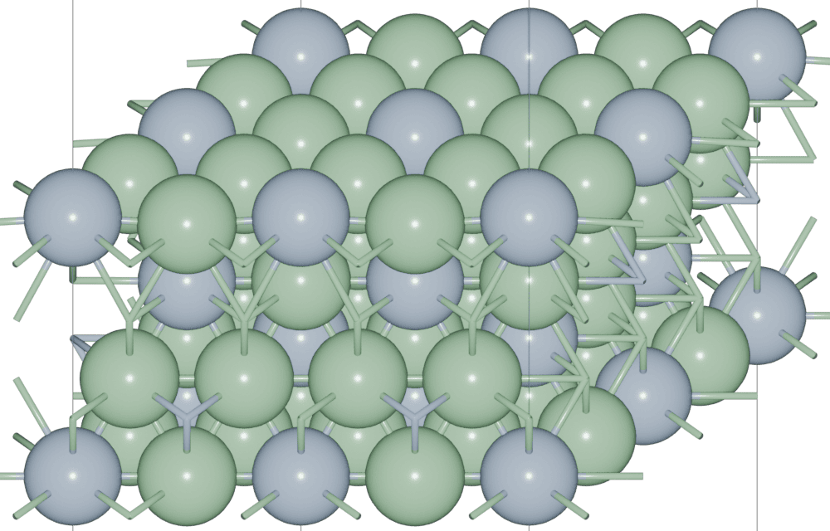
Ni₃Ga(211)_{Ni-step} | 2x3x1 | 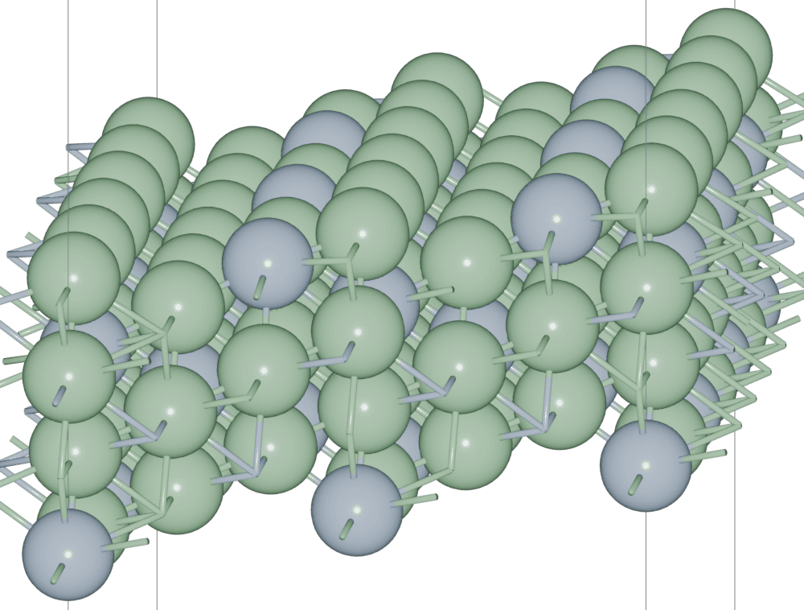
Ni₃Ga(211)_{Ga-step} | 2x3x1 | 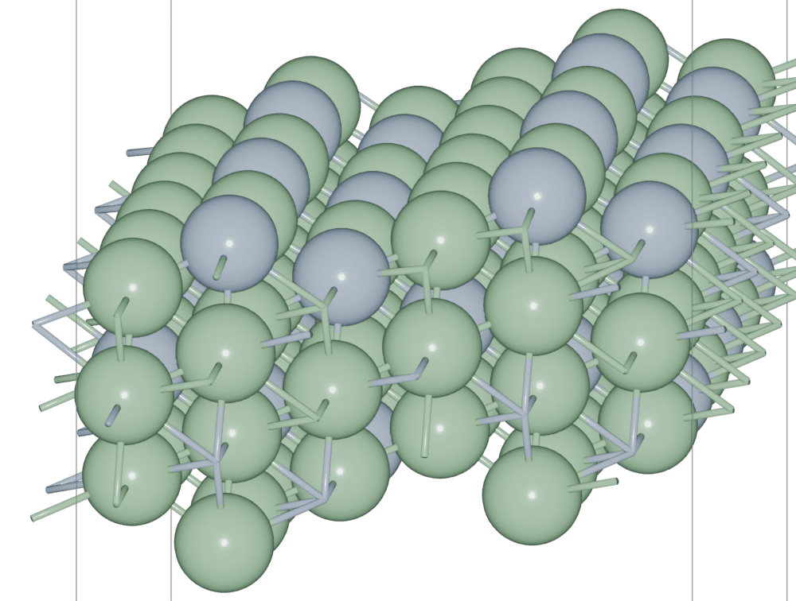
Ni₅Ga₃(221) | 1x1x1 | 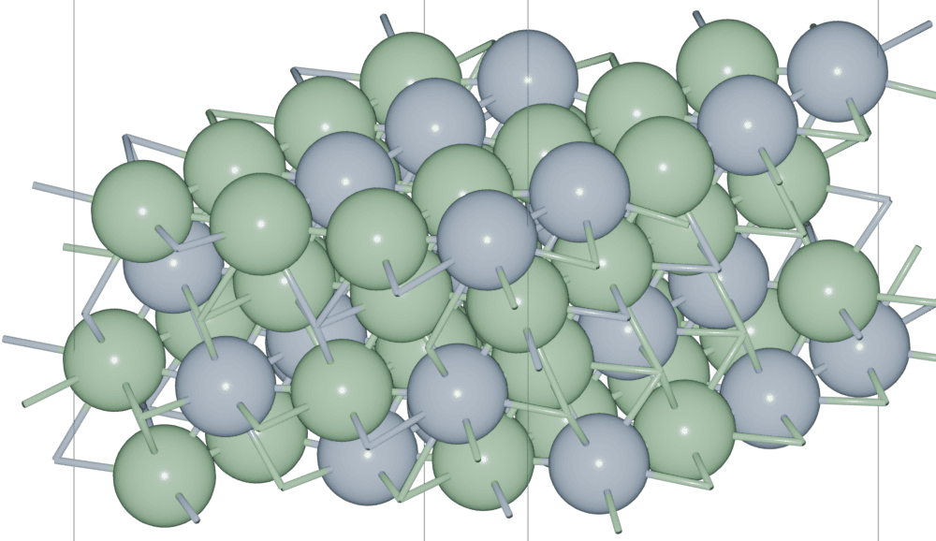
Ni₅Ga₃(211)_{Ni-step} | 1x1x1 | 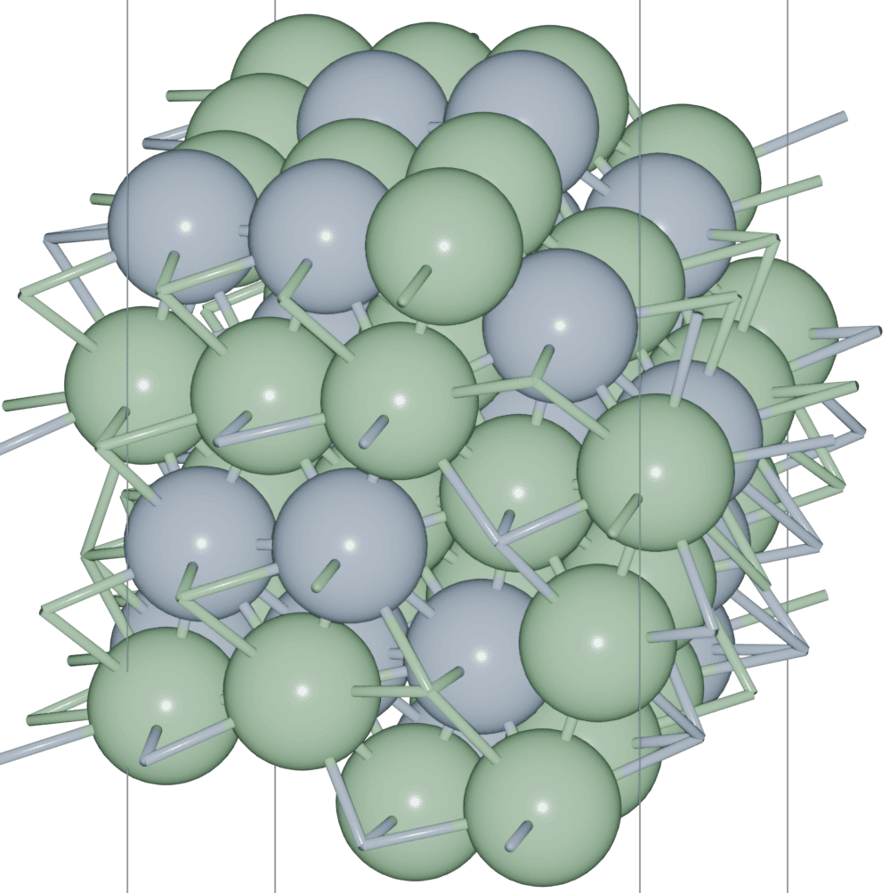
Ni₅Ga₃(211)_{Ga-step} | 1x1x1 | 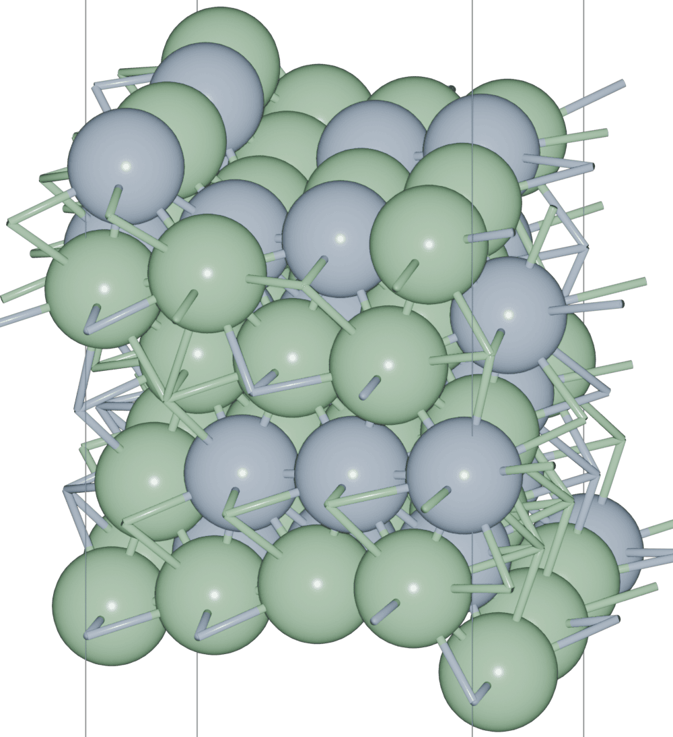

Table S2. Summary of the performance of different Graph Convolutional operators, this test was only performing a training of 100 epoch.
 | Training set |  |  | Test set
 | MSE [eV] | R2 | Total time [min] | MSE [eV] | R2
GCNConv | 0.03067 | 0.97588 | 1.8722 | 0.04894 | 0.95654
GraphConv | 0.02649 | 0.97914 | 1.5295 | 0.07317 | 0.93536
GATConv | 0.03463 | 0.97287 | 2.3889 | 0.12814 | 0.88759
GraphSAGE | 0.02615 | 0.97940 | 1.5610 | 0.04869 | 0.95715

Table S3. Summary of hyperparameter for each ML-based model implemented.
Algorithm | Parameters
GNN | - GraphSAGE  Dim_output: 512 (Alloys dataset)/256 (Ni-Ga dataset)  Agregation: 'mean'  Normalize: False  - Global_max_pool  Dim_output: 512 (Alloys dataset)/256 (Ni-Ga dataset)  - Dropout  Ratio of dropout: 0.1  - Optimizer  Algorithm: Adam  Learning rate: 0.001 (Alloys dataset)/0.0005 (Ni-Ga dataset)  Epoch: 1000  - Batch size  Alloys dataset  Training/validation/test set: 64  Ni-Ga dataset  Training/validation/test set: 32
GNNExplainer | Algorithm: GNNExplainer  Epochs: 1000  Explanation_type: 'phenomenon'  Node_mask_type: 'attributes'  Edge_mask_type: 'object'  Model_config: dict(mode='regression', task_level='graph', return_type='raw')
CatBoost | N_estimators: 1500  Learning_rate: 0.1  Depth: 9  Loss_function: 'LogCosh'  Silent: True  Min_data_in_leaf: 0  L2_leaf_reg: 0.2
UMAP | N_components: 2  N_neighbors: 10  Min_dist: 0

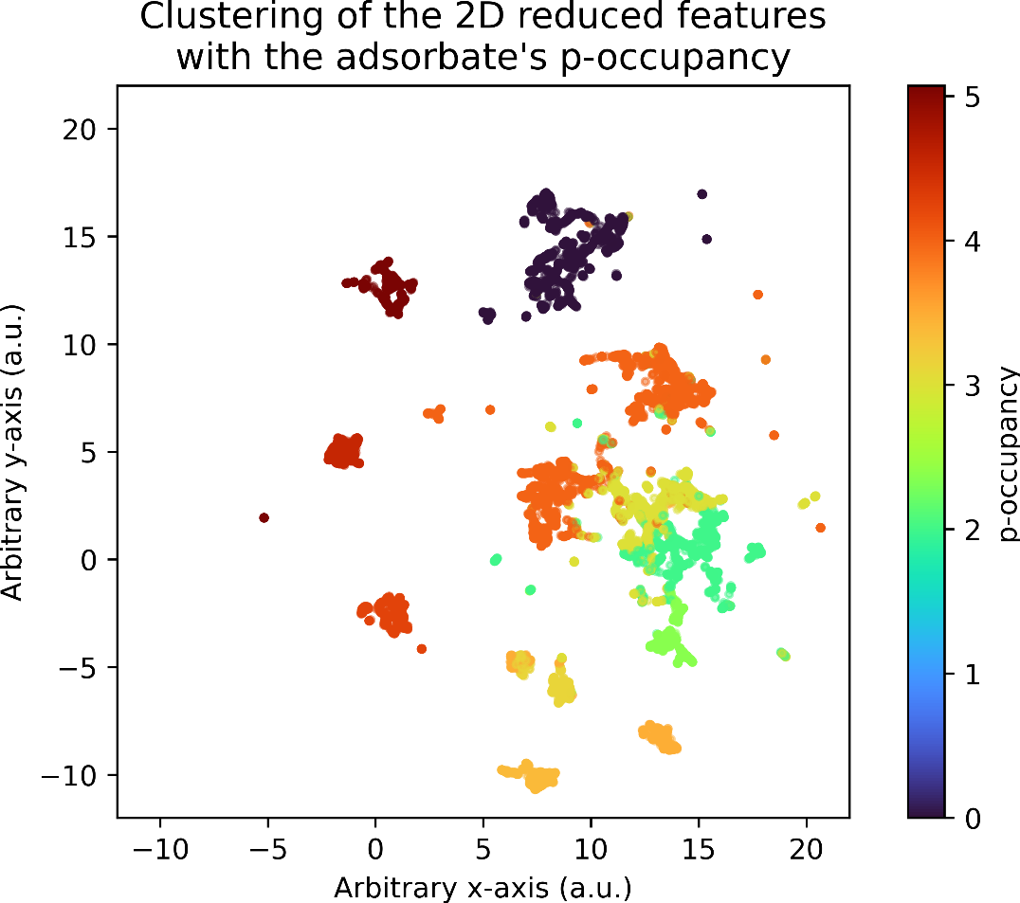
Figure S1. UMAP-based 2D dimensionality reduction of pooled graph embeddings on the training set. Visualization of 2D reduced dimension with p-orbital occupancy of the main adsorbate bonding atom on the surface.

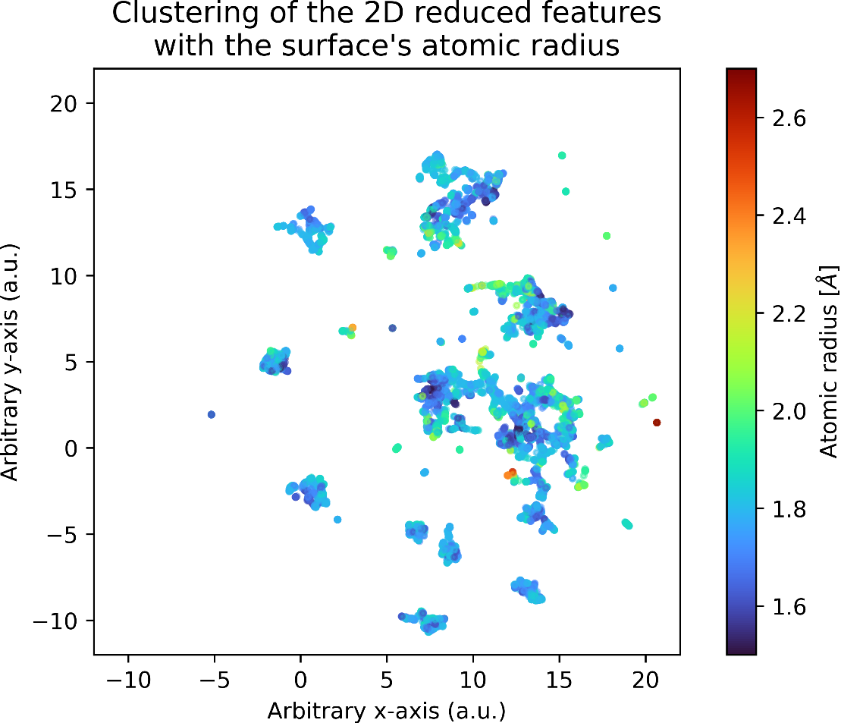
Figure S2. UMAP-based 2D dimensionality reduction of pooled graph embeddings on the training set. Visualization of 2D reduced dimension with average atomic radius of the surface atoms.

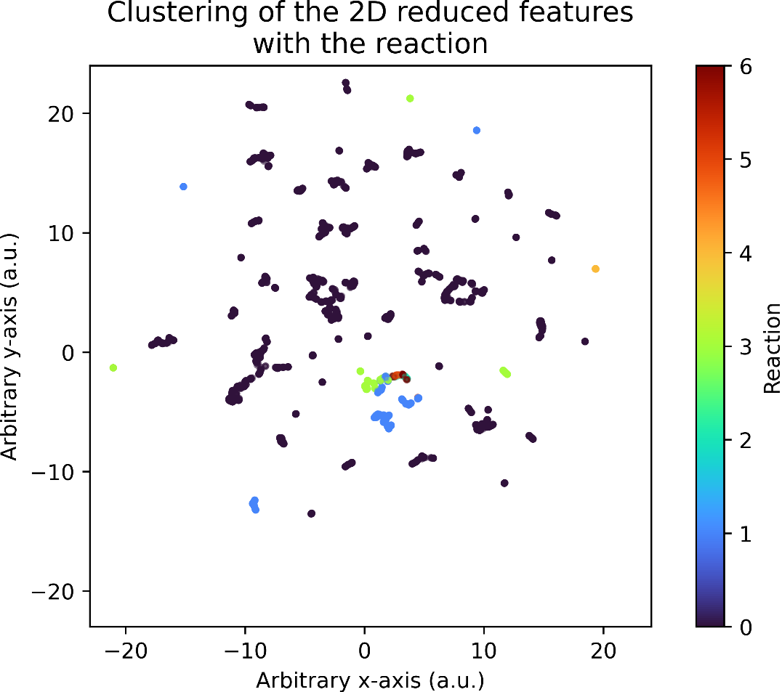
Figure S3. UMAP-based 2D dimensionality reduction of pooled graph embeddings on the training set. Visualization of 2D reduced dimension with the type of reaction (reaction 0 is for C* + 2O* formation).
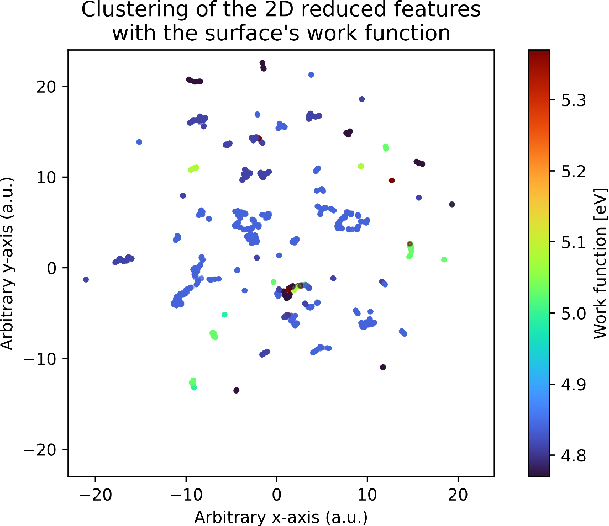
Figure S4. UMAP-based 2D dimensionality reduction of pooled graph embeddings on the training set. Visualization of 2D reduced dimension with the average work function of the surface atoms.
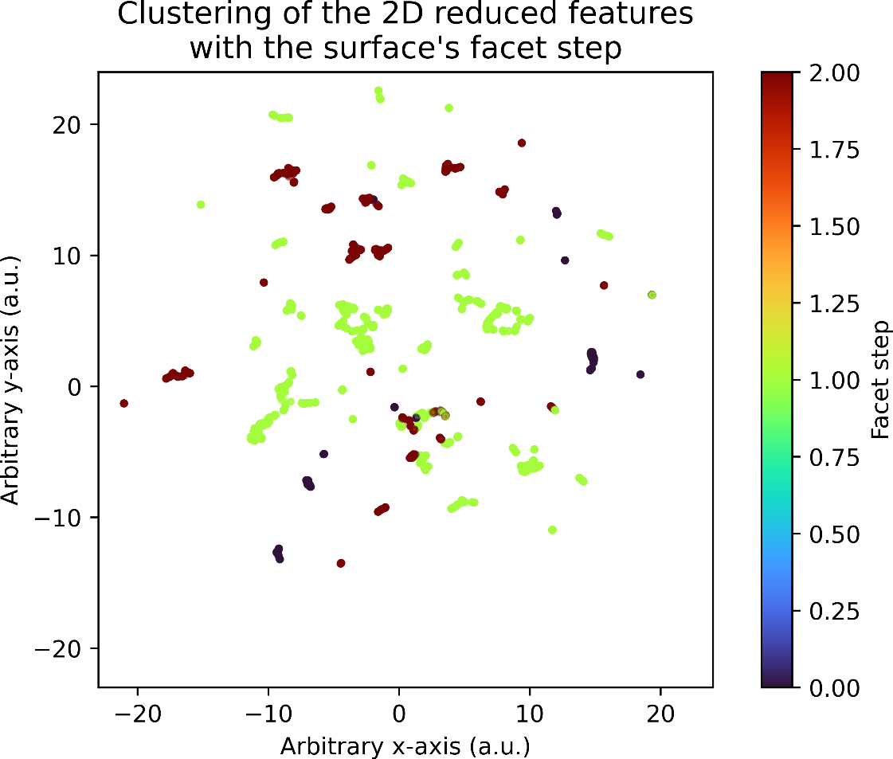
Figure S5. UMAP-based 2D dimensionality reduction of pooled graph embeddings on the training set. Visualization of 2D reduced dimension with the step termination of the surface atoms (0 for flat, 1 Ni-termination, and 2 for Ga-termination).
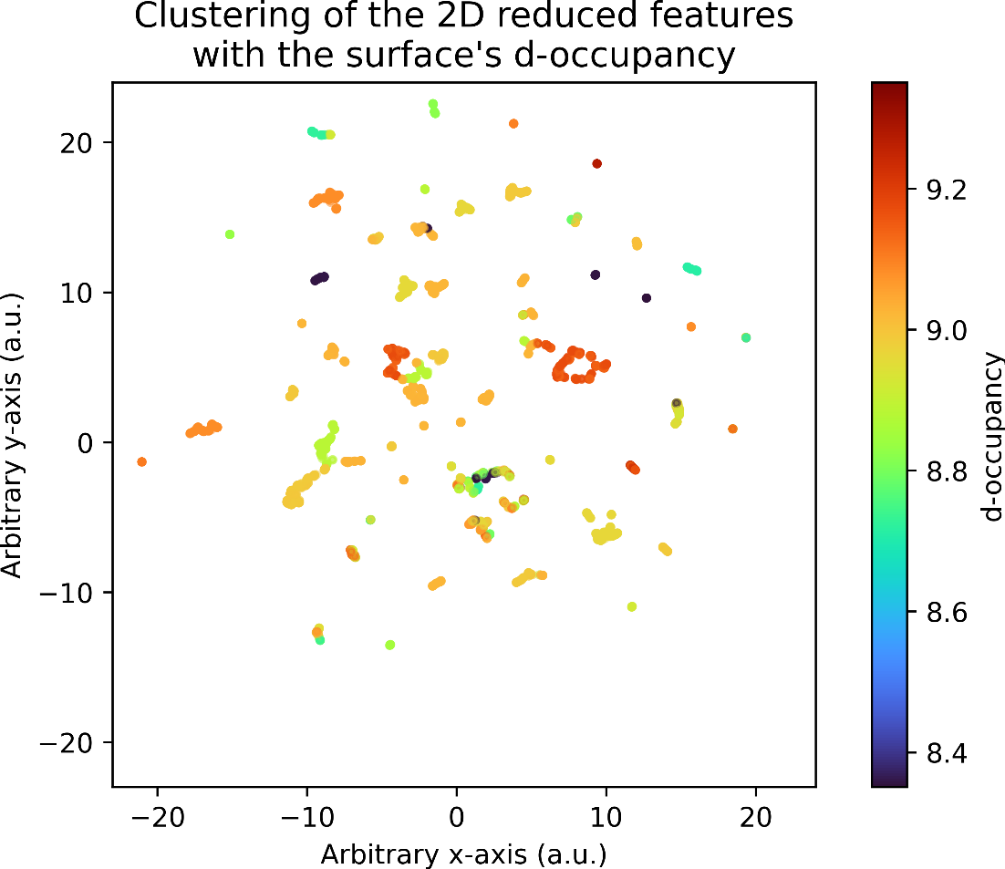
Figure S6. UMAP-based 2D dimensionality reduction of pooled graph embeddings on the training set. Visualization of 2D reduced dimension with d-orbital occupancy of the surface atoms.
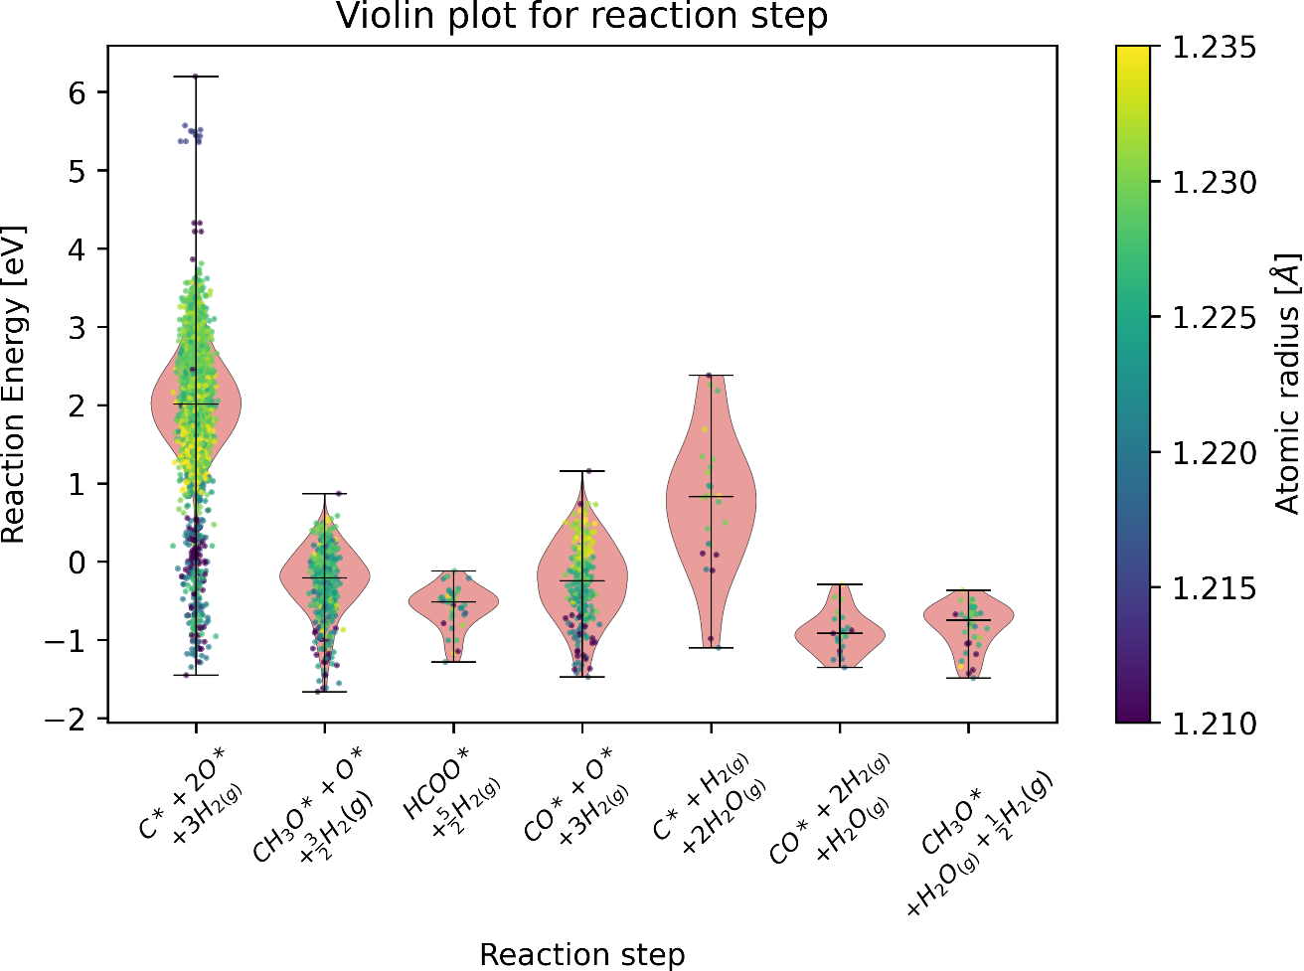
Figure S7. Violin plot showing the reaction energy for each reaction step alongside the atomic radius for the training set of the Ni-Ga dataset.

