Supplementary Information for

Interaction and transformation of metastable defects in intercalation materials

O. Yu. Gorobtsov¹, H. Hirsh², M. Zhang², D. Sheyfer³, S. D. Matson¹, D. Weinstock¹, R. Bouck¹, Z. Wang¹, W. Cha³, J. Maser³, R. Harder³, Y. Sh. Meng², A. Singer¹
1 – Materials Science and Engineering Department, Cornell University, Ithaca, NY 14853, USA
2 – Department of NanoEngineering, University of California, San Diego, La Jolla, California, 92093, USA
3 - Argonne National Laboratory, Argonne, Illinois 60439, USA

This PDF file includes:

Supplementary Note 1: Electron microscopy and XRD
For the two cathode materials P2-Na_{0.78}Ni_{0.23}Mn_{0.69}O₂ and P2- Na_{2/3}Ni_{1/3}Mn_{2/3}O₂ studied in this paper, we performed x-ray powder diffraction (XRD) to verify crystal structure and determine optimal peaks for the BCDI measurements. XRD results are shown in Supplementary Figure 1 and Supplementary Figure 2. We performed BCDI measurements on the (002) peak, as [002] direction is perpendicular to the layers of the material and the (002) peak has the highest intensity. We performed scanning electron microscopy on the pristine synthesized cathode particles to determine their typical morphology. The particles sizes vary from several hundred nanometers to several microns. The particles demonstrate a pronounced plate-like morphology.

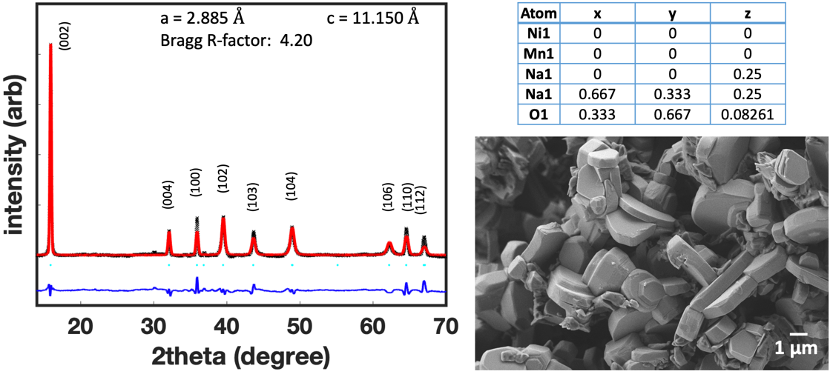
Supplementary Figure 1. Refined XRD data of P2-Na_{0.78}Ni_{0.23}Mn_{0.69}O₂ with refinement parameters and an SEM image of the pristine powder.

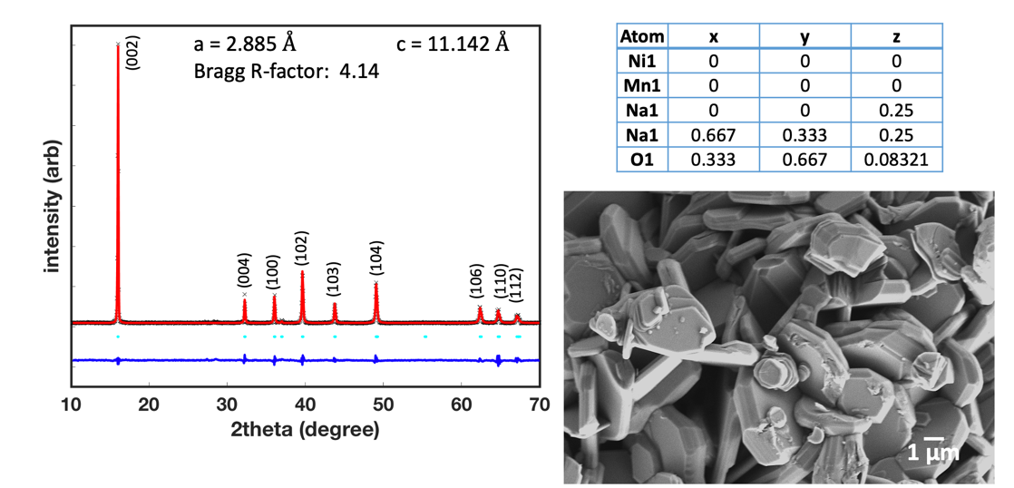
Supplementary Figure 2. Refined XRD data of P2- Na_{2/3}Ni_{1/3}Mn_{2/3}O₂ with refinement parameters and an SEM image of the pristine powder.

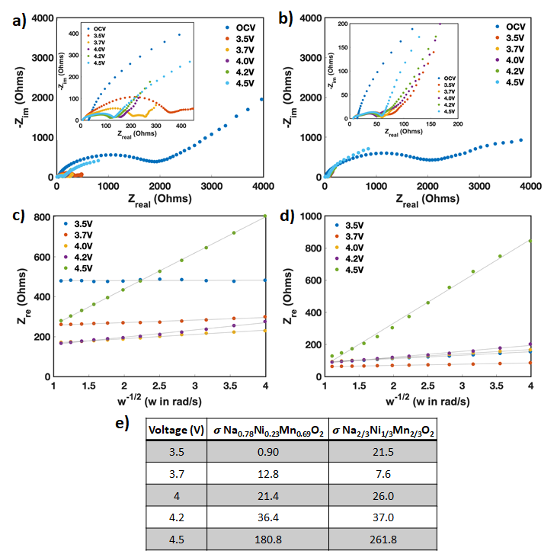
Supplementary Figure 3. a, b Nyquist plots at different states of charge for Na_{0.78}Ni_{0.23}Mn_{0.69}O₂ and Na_{2/3}Ni_{1/3}Mn_{2/3}O₂ during the first charge at a rate of C/10 and their respective c, d plots of Z_{re} vs. the inverse square root of angular frequency. The slope $σ$ represents the Warburg coefficient $Z_{re}∝ σω^{-1/2}$ which has the following relationship with the bulk diffusion constant: $D∝\frac{1}{σ^{2}}$ [1]. e, $σ$ at different states of charge is listed in the table.

Supplementary Note 2: Calculations of dislocation interaction energy and stress
Application of external stress to the material can cause formation of defects in the material. Nucleation Approximating in the interest of simplicity layered materials as transverse isotropic with respect to the axis perpendicular to the layers ($z$ for the purposes of this Supplementary), the compliance matrix is expressed as [2]
$$\left[\begin{matrix}ε_{xx} \\ ε_{yy} \\ \begin{matrix}ε_{zz} \\ ε_{yz} \\ \begin{matrix}ε_{zx} \\ ε_{xy}\end{matrix}\end{matrix}\end{matrix}\right]=\left[\begin{matrix}\frac{1}{Y_{p}} & -\frac{ν_{p}}{Y_{p}} & -\frac{ν_{zp}}{Y_{z}} & 0 & 0 & 0 \\ -\frac{ν_{p}}{Y_{p}} & \frac{1}{Y_{p}} & -\frac{ν_{zp}}{Y_{z}} & 0 & 0 & 0 \\ -\frac{ν_{pz}}{Y_{p}} & -\frac{ν_{pz}}{Y_{p}} & \frac{1}{Y_{z}} & 0 & 0 & 0 \\ 0 & 0 & 0 & \frac{1}{2G_{zp}} & 0 & 0 \\ 0 & 0 & 0 & 0 & \frac{1}{2G_{zp}} & 0 \\ 0 & 0 & 0 & 0 & 0 & \frac{1+ν_{p}}{2Y_{p}}\end{matrix}\right]\left[\begin{matrix}σ_{xx} \\ σ_{yy} \\ \begin{matrix}σ_{zz} \\ σ_{yz} \\ \begin{matrix}σ_{zx} \\ σ_{xy}\end{matrix}\end{matrix}\end{matrix}\right], (1)$$
where $ε$ and $σ$ are the strain and stress tensors, $Y_{p}$ and $ν_{p}$ are the Young modulus and Poisson ratio in the x-y symmetry plane, $Y_{z}$ and $ν_{zp}$ in the z-direction, and $G_{zp}$ is the shear modulus in the z direction. Here $\frac{ν_{pz}}{Y_{p}}=\frac{ν_{zp}}{Y_{z}}$.
Consider a pair of parallel screw dislocations (Supplementary Figure 4, a) oriented along z. The radial and tangential components of the interaction force per unit length between them are well known [3]

$$F_{r}=G_{zp}b^{2}/2πr, F_{θ}=0, \left(2\right)$$

where $b$ is the Burgers vector and r is the distance vector. $F_{r}$ is attractive for oppositely oriented screws. Elastic interaction energy per unit length, which is essentially an energy of introducing a second dislocation, is then

$$E_{int}=\int_{r_{0}}^{r}{G_{zp}b^{2}/2πr dr}=G_{zp}b^{2}\ln\left(r/r_{0}\right)/2π,\left(3\right)$$

where $r_{0}$ is the core dislocation radius. Considering the elastic energy per unit length of a single screw dislocation is $E_{el}(screw)=G_{zp}b^{2}\ln\left(R/r_{0}\right)/4π$ [3], where R is the outer radius, and that the stress fields of the two screw dislocations of opposite chirality will roughly cancel each other starting at the distances of $≈2r$ from the pair, the full elastic energy is then

$$E_{tot}=G_{zp}b^{2}\left(2\ln\left(r/r_{0}\right)+ln 2\right)/2π. \left(4\right)$$
Imagine now that such a dislocation pair is nucleated homogeneously under an applied shear stress $σ_{zp}$. The work per unit length done by the applied stress is then $A =rσ_{zp}b$, and the associated increase in energy per unit length is

$$E=G_{zp}b^{2}\left(2\ln\left(r/r_{0}\right)+ln 2\right)/2π - rσ_{zp}b, \left(5\right)$$

from which the critical radius $r_{c}$, at which the dislocation pair will be stable, and the corresponding activation energy per unit length $E_{c}$ are determined by differentiation as

$$r_{c}=G_{zp}b/πσ_{zp}, E_{c}=G_{zp}b^{2}\left(2\ln\left(r_{c}/r_{0}\right)-1+ln 2\right)/2π. \left(6\right)$$

The distance between dislocations and therefore critical radius in a nanocrystal is limited by the size of the nanocrystal, establishing a lower bound on the necessary shear stress. The plate-like nanocrystal shape with the size perpendicular to the layers approximately 3-5 times smaller than parallel makes formation of the pairs perpendicular to the layers significantly more energy efficient. Using the observed distance between the dislocations after formation $r_{c}=100 nm,$ the shear modulus estimate $G_{zp}\sim 50 GPa$ [4] [5] [6], and the Burgers vector b=0.5 nm we find the minimum stress necessary for the pair formation as $σ_{zp}≈80$ MPa. Core radius of a dislocation can be estimated as $r_{0}≈l_{p}/\left(1-ν\right)≈5 nm$ [7], where $l_{p}$ is the lattice period in the layer plane and $ν$ is the Poisson ratio, and the activation energy per unit length is then $E_{c}≈1.1∙{10}^{-8}\frac{J}{m}$.
A pair of screw dislocations with opposite Burgers vectors experiences an attractive force. Therefore, the drift of the pair away from each other to the borders of the particle observed in the experiment requires a continuous external stress, which can be estimated as $σ_{zp}≈G_{zp}b/2πr_{c}>40 MPa$. Note that a screw dislocation close to the particle surface experiences an image force (see Supplementary Figure 4, b) due to a missing part of displacement/strain field. The image force can be treated as an attractive force between a screw dislocation and its mirror image. The initial stress required to push the dislocation pair apart is therefore weakened ~2 times (initial distance from the dislocations to the surface is ~200 nm) and can be estimated as $σ_{zp}≈20 MPa$.

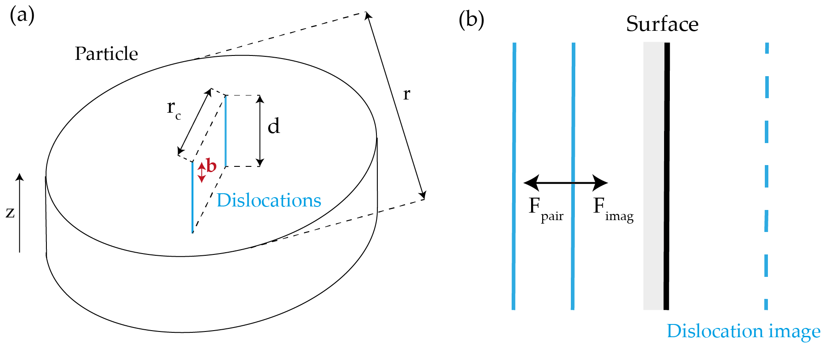
Supplementary Figure 4. Schematic representation of the variables in the Supplementary Note 2. a, Grain scheme. b, Image dislocation.

Supplementary Note 3: Additional illustrations of the domain boundary
During the charging process of the P2-Na_{0.78}Ni_{0.23}Mn_{0.69}O₂ cell, a domain of a homogeneous high displacement develops in the particle. The domain is visible throughout the whole particle in 3D (Supplementary Figure 5), with the border perpendicular to the layer direction, as expected for an antiphase or out-of-phase domain. As the P2-Na_{0.78}Ni_{0.23}Mn_{0.69}O₂ cathode is further charged, the nucleation of a pair of line defects happens clearly on the boundary of the former domain. While the domain boundary itself disappears, the location of the defect pair clearly matches the boundary location (Supplementary Figure 6).

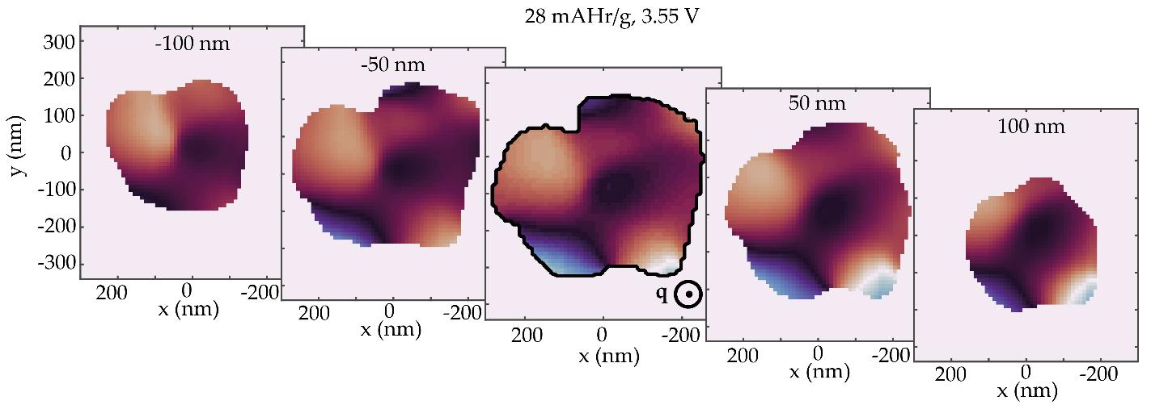
Supplementary Figure 5. Cross sections of displacement (similar to Figure 2) through the domain boundary at different $z$ positions in the nanocrystal.

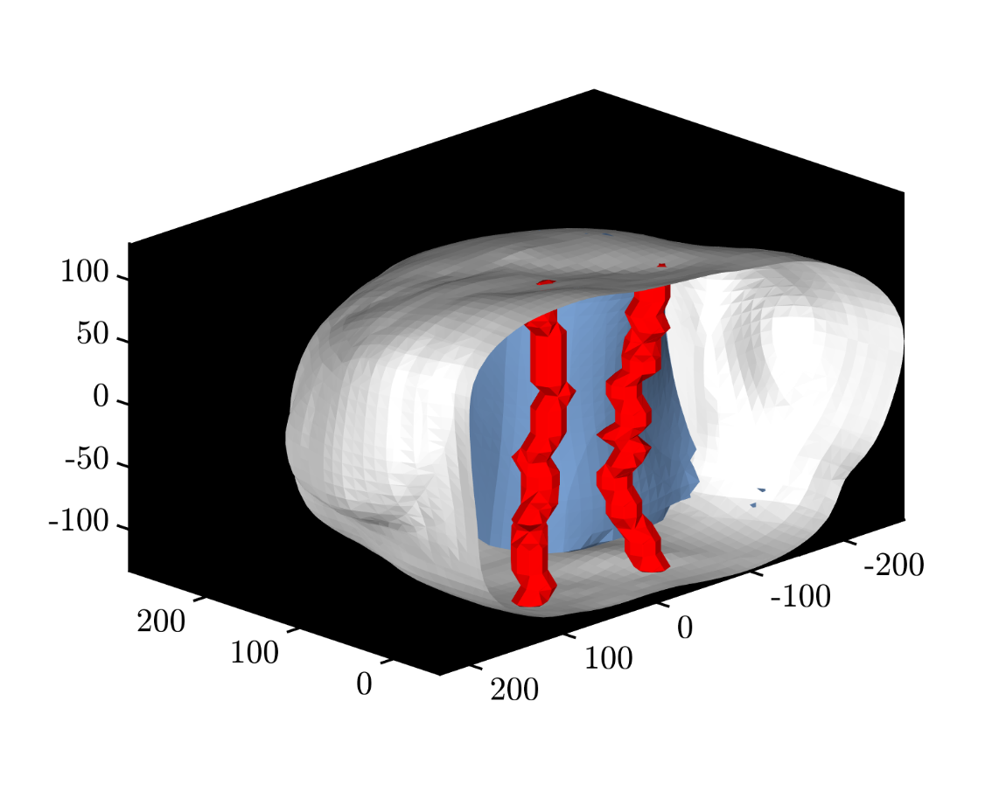
Supplementary Figure 6. Relative position of the domain boundary and the dislocation pair it generates. Blue - domain boundary (isosurface at $π/2$; red - dislocations. Merged from two subsequent measurements.
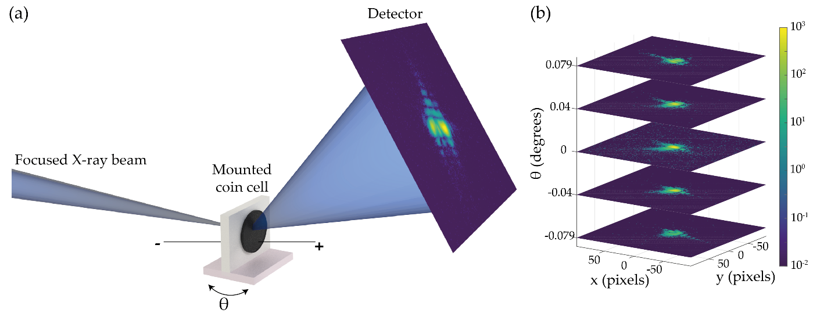Supplementary Figure 7: BCDI scheme. a, Charging coin cell mounted on a sample stage. Incident focused X-rays scatter from the particles in the cathode, and the scattering is observed on the detector. The sample stage can be rotated in the scattering plane. b, 3D diffraction pattern is collected by scanning the rocking curve and then used to reconstruct the 3D displacement field.

Supplementary References

[1] | H. Xia and L. Lu, "Li diffusion in spinel LiNi0.5Mn1.5O4thin films prepared by pulsed laser deposition," Physica Scripta, vol. T129, p. 43–48, 11 2007.
[2] | L. Zhang, H. Ding, W. Chen, H. Ding and W. Chen, Elasticity of Transversely Isotropic Materials, Springer-Verlag New York Inc., 2006.
[3] | D. Hull, Introduction to dislocations, Oxford: Butterworth-Heinemann, 2011.
[4] | M. Maksud, N. K. R. Palapati, B. W. Byles, E. Pomerantseva, Y. Liu and A. Subramanian, "Dependence of Young\textquotesingles modulus on the sodium content within the structural tunnels of a one-dimensional Na-ion battery cathode," Nanoscale, vol. 7, p. 17642–17648, 2015.
[5] | A. Jain, S. P. Ong, G. Hautier, W. Chen, W. D. Richards, S. Dacek, S. Cholia, D. Gunter, D. Skinner, G. Ceder and K. A. Persson, "Commentary: The Materials Project: A materials genome approach to accelerating materials innovation," APL Materials, vol. 1, p. 011002, 7 2013.
[6] | M. de Jong, W. Chen, T. Angsten, A. Jain, R. Notestine, A. Gamst, M. Sluiter, C. K. Ande, S. van der Zwaag, J. J. Plata, C. Toher, S. Curtarolo, G. Ceder, K. A. Persson and M. Asta, "Charting the complete elastic properties of inorganic crystalline compounds," Scientific Data, vol. 2, 3 2015.
[7] | R. Hertzberg, Deformation and fracture mechanics of engineering materials, Hoboken, NJ: John Wiley & Sons, Inc, 2012.
[8] | S. Allen, The structure of materials, New York: J. Wiley, 1999.

Note that the shear strain here is not the engineering shear strain.

