Supporting information for “Constraining near-term projections of the South Asian high and Afro-Asian summer monsoon rainfall”

Dapeng Zhang¹, Yanyan Huang^{1,2,3}, Botao Zhou^{1,3}, Qiaohong Sun¹, Huijun Wang^{1,2,3}

- Collaborative Innovation Center on Forecast and Evaluation of Meteorological Disasters/Key Laboratory of Meteorological Disaster, Ministry of Education, Nanjing University of Information Science and Technology, Nanjing 210044, China
- Southern Marine Science and Engineering Guangdong Laboratory (Zhuhai), Zhuhai 519080, China
- Nansen−Zhu International Research Centre, Institute of Atmospheric Physics, Chinese Academy of Sciences, Beijing 100029, China

Corresponding author: Yanyan Huang (huangyy@nuist.edu.cn)

Supplementary Table S1 | Details of the CMIP6 models used in this study.
Model | Country/Institution |  | lat×lon
ACCESS-CM2 |  | Australia/CSIRO |  | 144×192
ACCESS-ESM1-5 |  | Australia/CSIRO |  | 145×192
AWI-CM-1-1-MR |  | Germany/AWI |  | 192×384
BCC-CSM2-MR |  | China/BCC |  | 160×320
CanESM5 |  | Canada/CCCma |  | 64×128
CAS-ESM2-0 |  | China/CAS |  | 128×256
CESM2-WACCM |  | USA/NCAR |  | 192×288
CIESM |  | China/THU |  | 192×288
CNRM-CM6-1 |  | France/CNRM |  | 128×256
CNRM-ESM2-1 |  | France/CNRM |  | 128×256
EC-Earth3-Veg |  | EU/EC-Earth |  | 256×512
EC-Earth3 |  | EU/EC-Earth |  | 256×512
FGOALS-f3-L |  | China/CAS |  | 180×288
FGOALS-g3 |  | China/CAS |  | 80×180
FIO-ESM-2-0 |  | China/FIO-QLNM |  | 192×288
GFDL-ESM4 |  | USA/NOAA-GFDL |  | 180×288
GISS-E2-1-G |  | USA/NASA-GISS |  | 90×144
HadGEM3-GC31-LL |  | UK/MOHC |  | 144×192
INM-CM4-8 |  | Russia/INM |  | 120×180
INM-CM5-0 |  | Russia/INM |  | 120×180
IPSL-CM6A-LR |  | France/IPSL |  | 143×144
MIROC6 |  | Japan/MIROC |  | 128×256
MIROC-ES2L |  | Germany/MPI-M |  | 128×256
MPI-ESM1-2-HR |  | Germany/MPI-M |  | 160×320
MPI-ESM1-2-LR |  | Germany/MPI-M |  | 160×320
MRI-ESM2-0 |  | Japan/MRI |  | 160×320
NESM3 |  | China/NUIST |  | 96×192
NorESM2-LM |  | Norway/NCC |  | 96×144
NorESM2-MM |  | Norway/NCC |  | 192×288
UKESM1-0-LL |  | UK/MOHC |  | 144×192

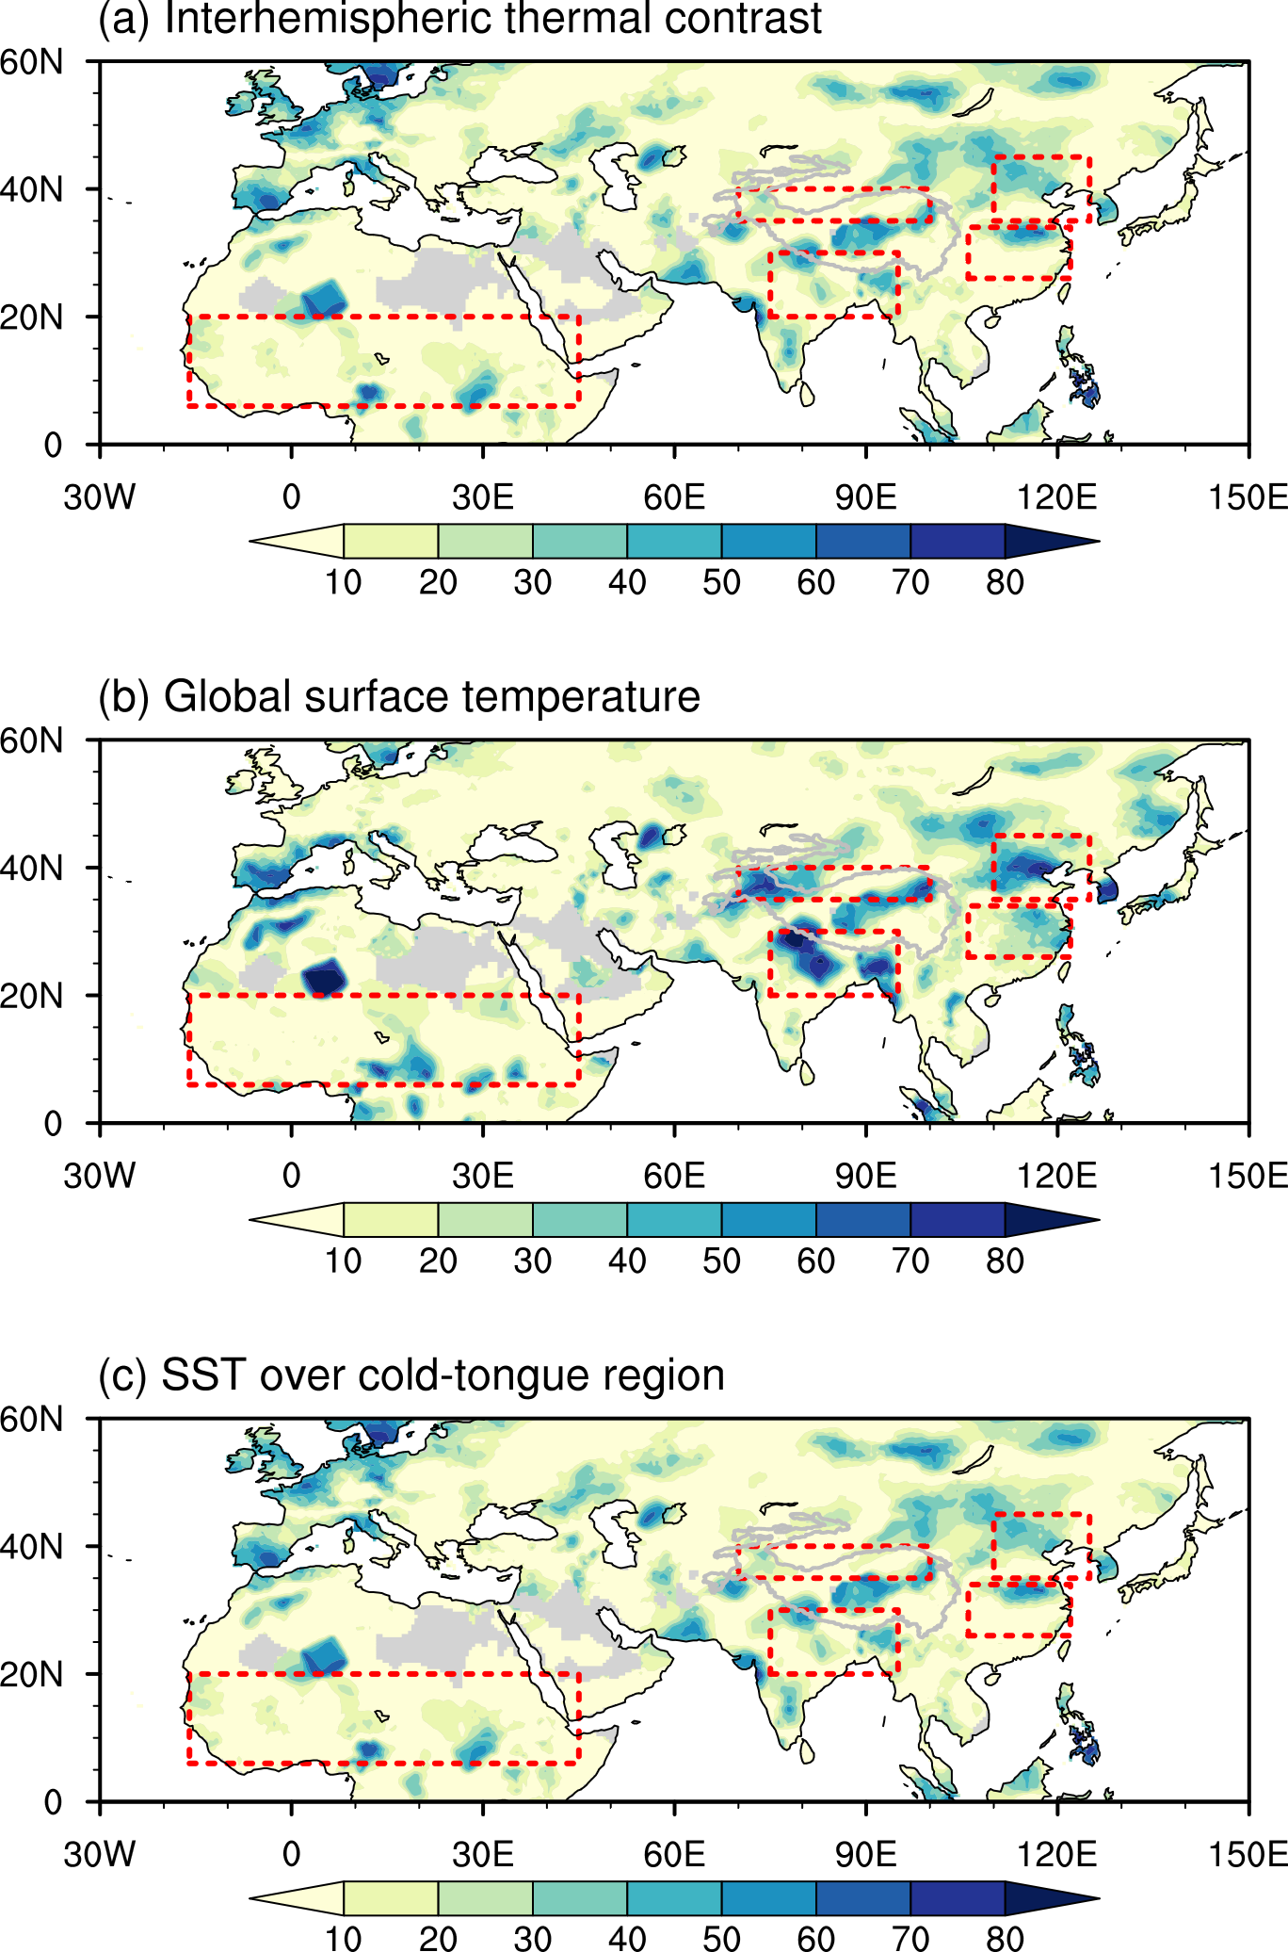
Supplementary Figure S1| The variance (%) of precipitation explained by different factors during 1950–2014. (a) Interhemispheric thermal contrast, defined as the difference of the area-averaged surface air temperature between (20°–50°N, 0–360°) and (20°–50°S, 0–360°). (b) Global surface temperature, which is the area-averaged surface air temperature over the globe. (c) The SST over the cold-tongue region (20°S–20°N, 120°E–80°W).

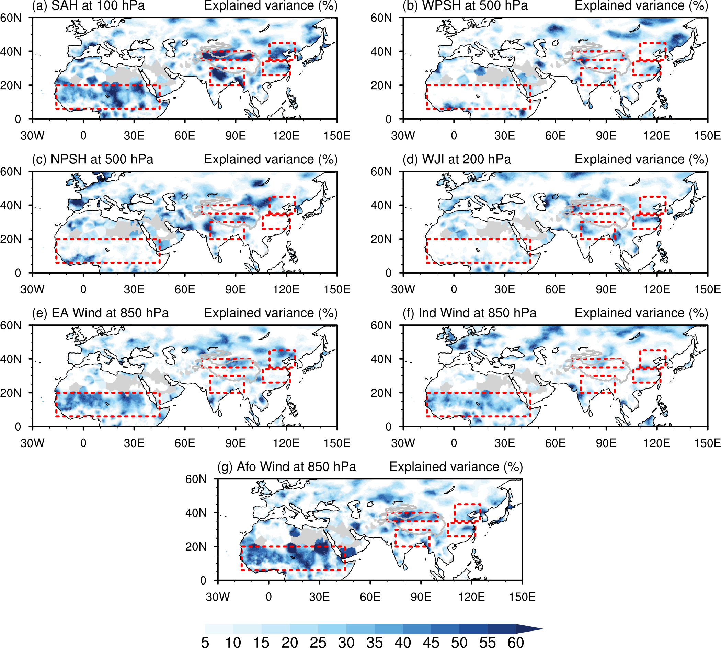
Supplementary Figure S2| The variance (%) of precipitation explained by different Afro-Asian summer monsoon circulations during 1950–2014. (a) The South Asian high (SAH), the definition of which is introduced in the Methods. (b) The western Pacific subtropical high (WPSH), which is the averaged means of eddy geopotential height over region of 0°–50°N and 100°–180°E at 500 hPa. (c) The North Atlantic subtropical high (NAPH), which is the averaged means of eddy geopotential height over the region of 0°–50°N and 0°–70°E at 500 hPa. (d) The westerly jet index (WJI), which is defined by the difference of 200 hPa zonal wind between the regions of (40°–55°N, 40°–150°E) and (25°–40°N, 40°–150°E). Panels (e), (f), and (g) show the wind speeds at 850 hPa in East Asia (EA: 20°–40°N, 110°–125°E), India (Ind: 0°–30°N, 60°–90°E), and North Africa (Afo: 5°–20°N, 15°W–45°E), respectively.
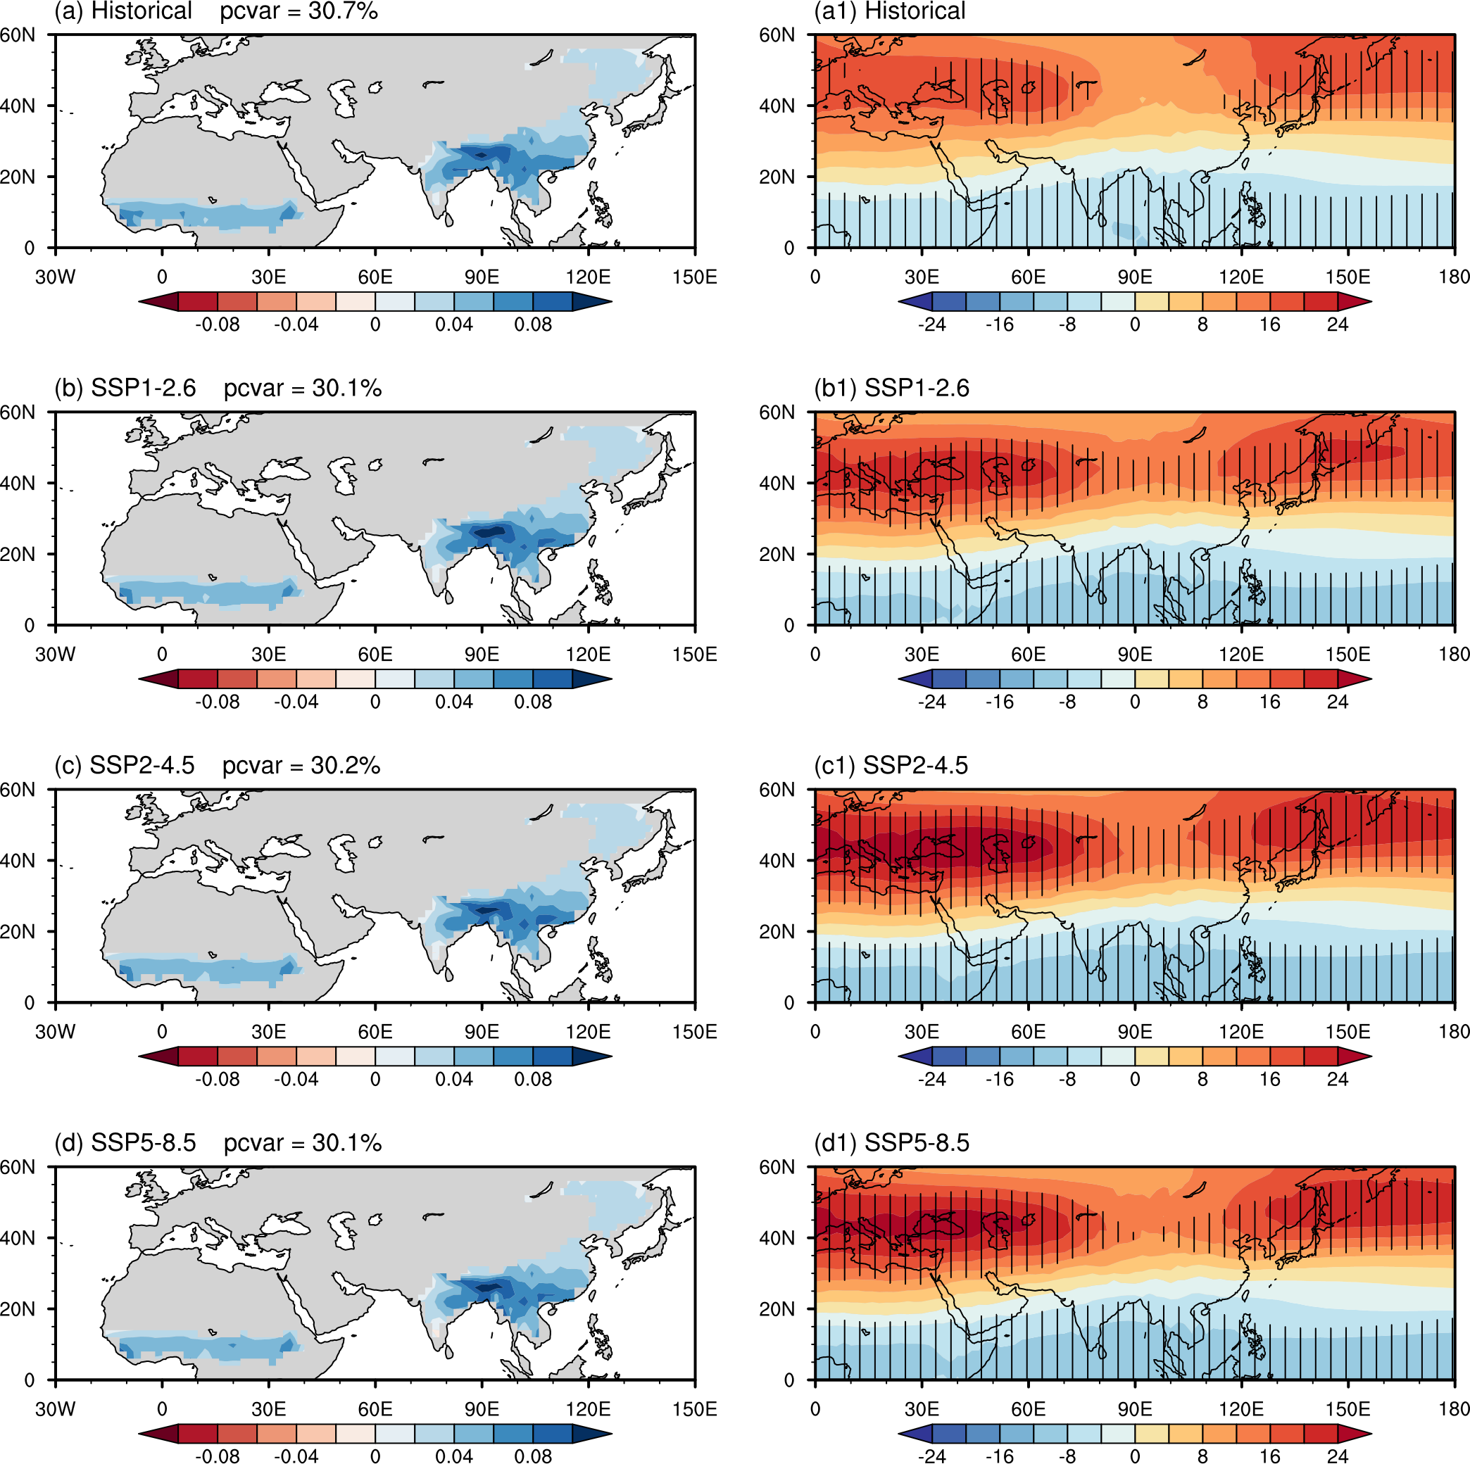
Supplementary Figure S3| Dominant pattern of Afro-Asian monsoon precipitation uncertainty and related circulation. (a) The leading model of historical uncertainty of Afro-Asian monsoon precipitation during 1950–2014. “pcvar” is the explained variance. Panels (b), (c), and (d) are the same as (a), but for the uncertainty under SSP1-2.6, SSP2-4.5, and SSP5-8.5, respectively. (a1) The historical eddy geopotential height (unit: m) across 30 CMIP6 models regressed onto the inter-model normalized leading principal component (PC1). Panels (b1), (c1), and (d1) are the same as (a1), but for the uncertainty under SSP1-2.6, SSP2-4.5, and SSP5-8.5, respectively.

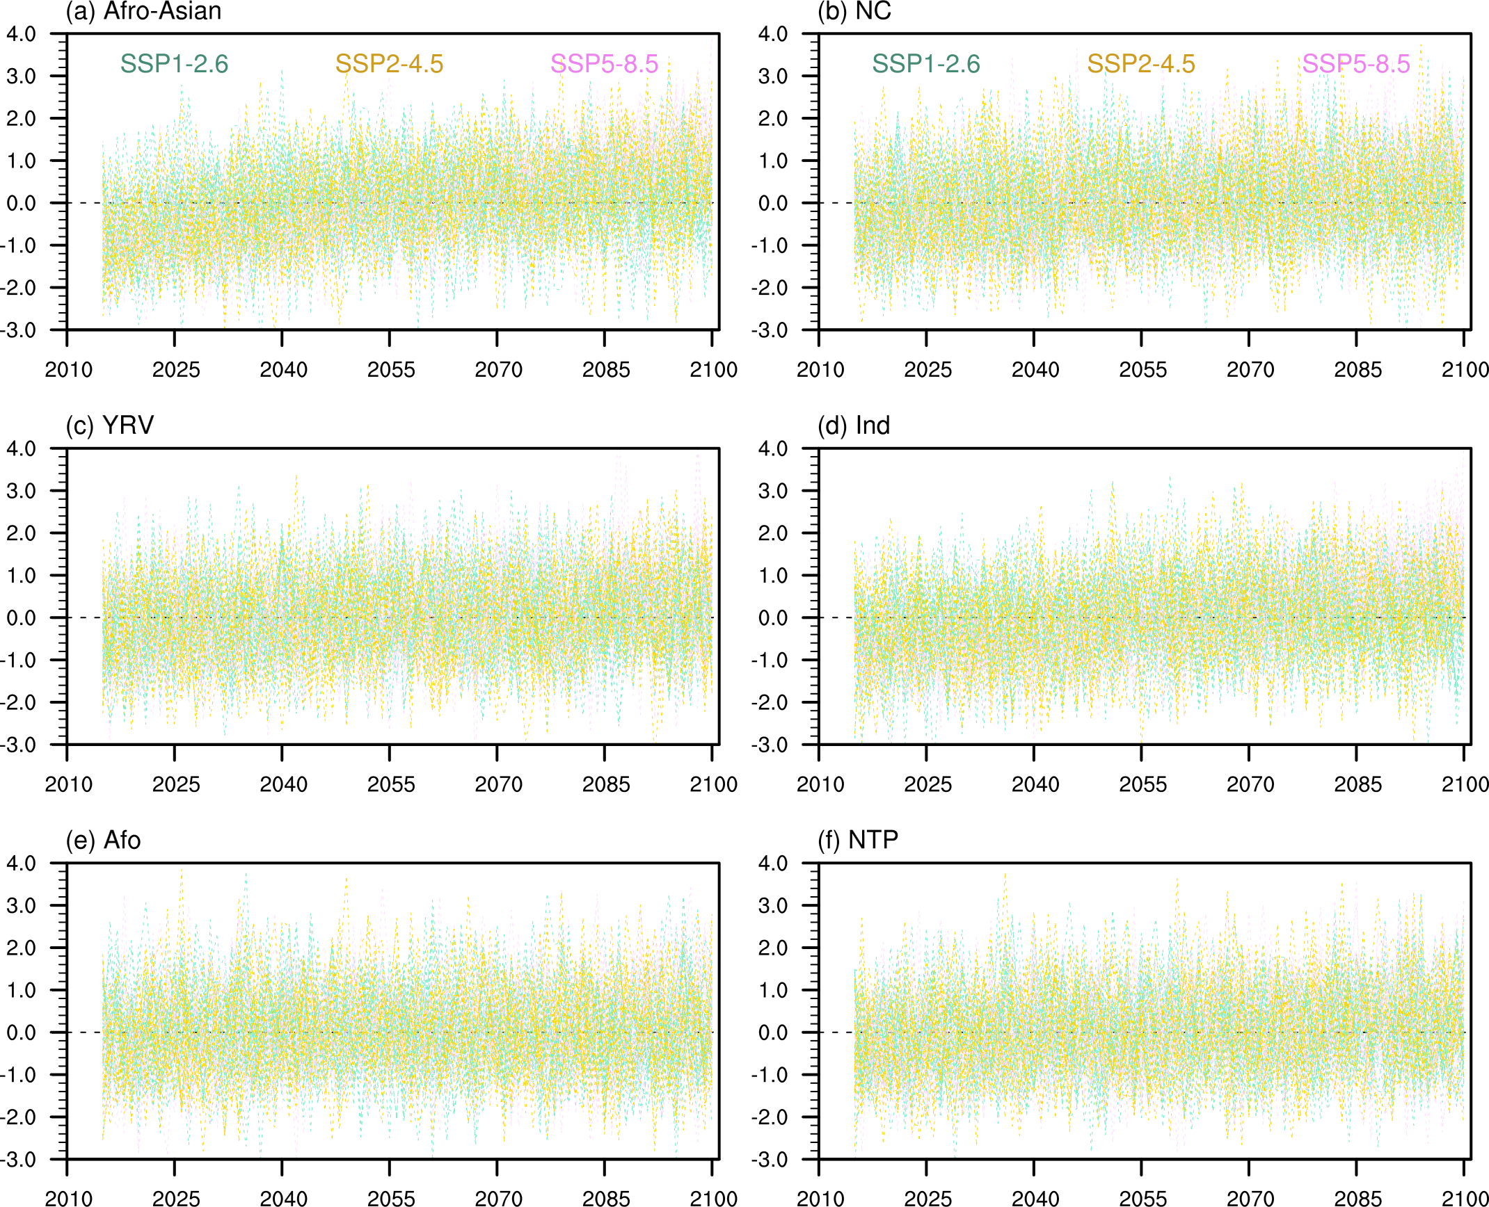
Supplementary Figure S4| The original projection of Afro-Asian summer monsoon precipitation during 1950–2100. Panel (a) shows the results for the entire monsoon region; (b) is for North China (NC); (c) is for the Yangtze River Valley (YRV); (d) is for India (Ind); (e) is for North Africa (Afo); and (f) is for the northern Tibetan Plateau (NTP).

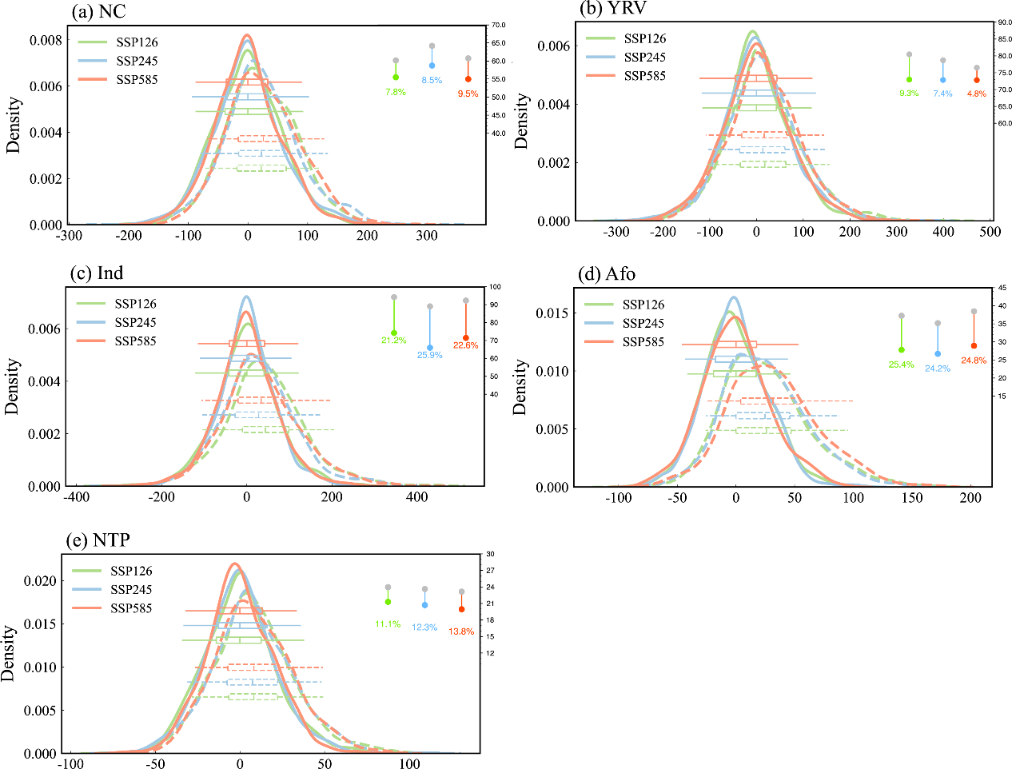
Supplementary Figure S5| Probability density function of precipitation with (dashed curves) and without SAH (solid curves). The regions are (a) North China (NC), (b) the Yangtze River Valley (YRV), (c) India (Ind), (d) North Africa (Afo) and (e) northern Tibetan Plateau (NTP). The dotes represent the standard deviations of precipitation projection. The lines and numbers are the reduced percentage of standard deviations of precipitation projection without SAH relative to that with SAH.

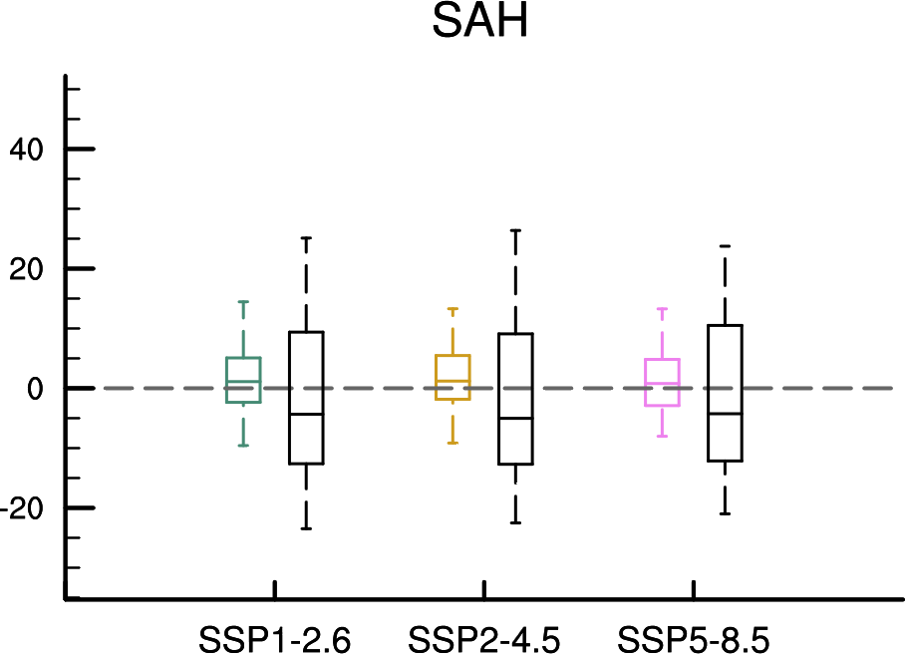
Supplementary Figure S7| The perfect model setup to evaluate weighting scheme. Statistical distributions of the biases of the original (black) and weighted (colored) SAH simulations to the “truth”. The boxes indicate the 30th and 70th percentiles; the line inside each box is the median; the whiskers represent the 10th and 90th percentiles.

Supplementary Figure S7| The reconstructed (blue) and observed (gray) precipitation based on SAH. It is calculated by a linear regression method based on the observed SAH and precipitation over North China (NC), the Yangtze River Valley (YRV), India (Ind), North Africa (Afo) and northern Tibetan Plateau (NTP). Shadings are the 95% confidence interval. “Cor” is the correlation coefficient between the reconstructed and observed precipitation index. All the correlation coefficients are significant at the 1% significance level.

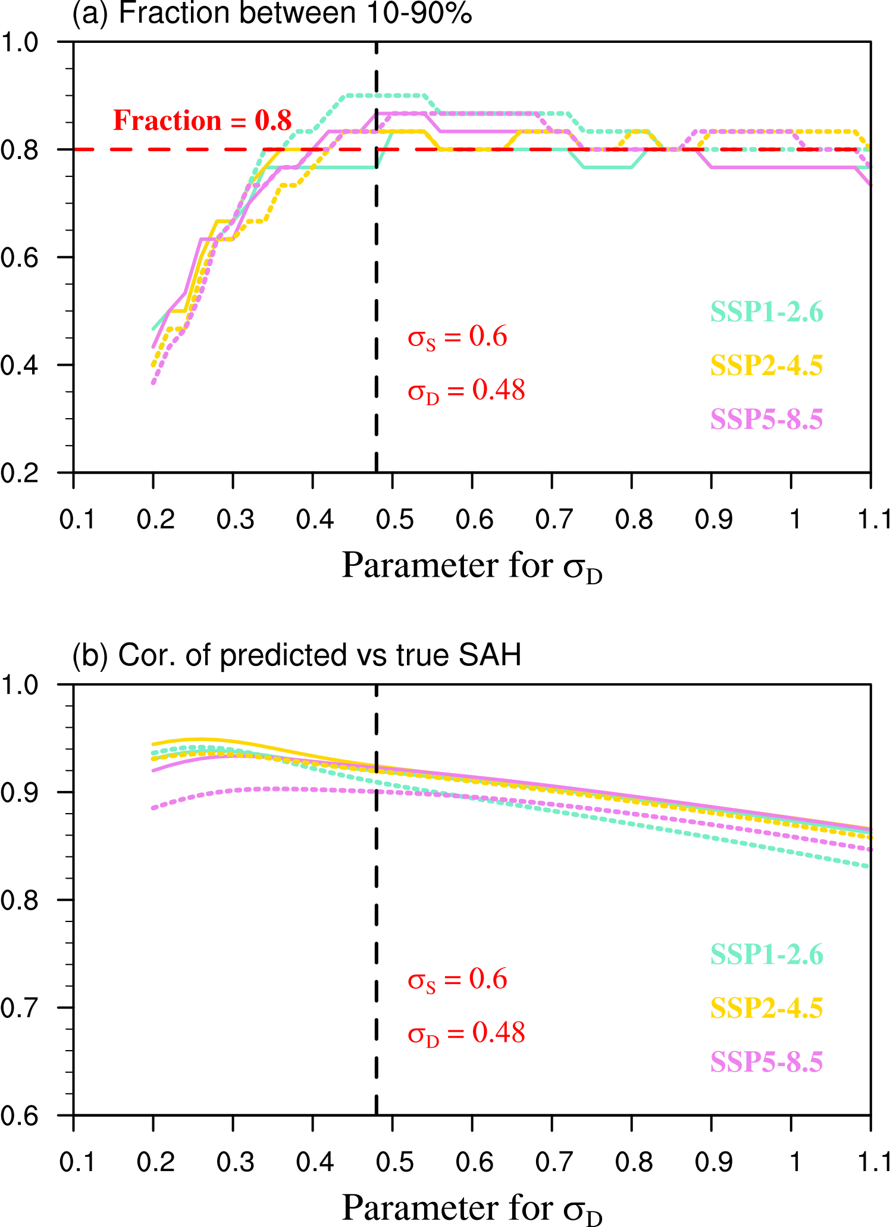
Supplementary Figure S8| Results of the perfect model setup. (a) Fraction of cases when the truth is successfully projected, i.e., the value of the truth falls between the 10th and 90th percentiles of the perfect model setup. The SAH changes for the near-term (2015–2050, solid lines) and long-term (2070–2100, dashed lines) under three scenarios are evaluated. The changes are relative to the SAH in 1950–2014. The vertical dashed line denotes the minimum value of $σ_{D}$ where the fraction exceeds 80%. (b) Dependence of correlation coefficients between the projected and truth of the SAH for the near-term (2015–2050, solid lines) and long-term (2070–2100, dashed lines) under three scenarios.

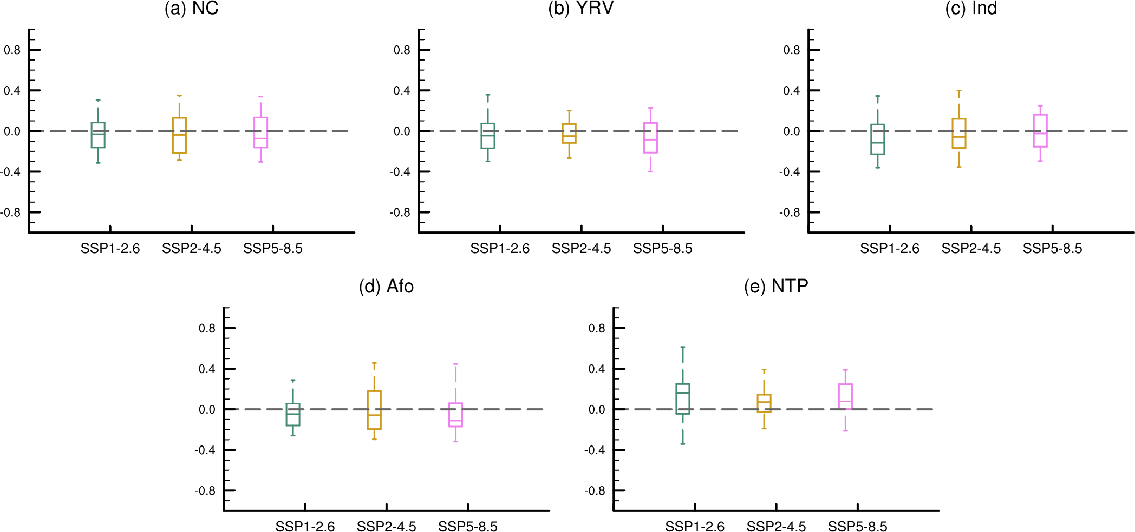
Supplementary Figure S9| Difference of relationships of SAH with monsoon precipitation between history and future. The regions are (a) North China (NC), (b) the Yangtze River Valley (YRV), (c) India (Ind), (d) North Africa (Afo) and (e) northern Tibetan Plateau (NTP). The relationship is the correlation coefficient between SAH and rainfall in the 30 CMIP6 models. The boxes indicate the 30th and 70th percentiles; the line inside each box is the median; the whiskers represent the 10th and 90th percentiles.

