Supplementary data
Putative Molecular Mechanisms of Neuroprotective Cerebrosides and their Docking studies on Acetyl Cholinesterase Enzyme Inhibition for the Treatment of Alzheimer’s disease

Shaik I. Khalivulla ^{a,}*, Kokkanti Mallikarjuna ^{b}

ª Faculty of Pharmaceutical Sciences, UCSI University, 56000 Cheras, Kuala Lumpur, Malaysia
^{b} Department of Botany and Microbiology, Acharya Nagarjuna University, Nagarjuna Nagar – 522 510, Andhra Pradesh, India

*Corresponding Author: Email.: sibrahimk@gmail.com & shaik@ucsiuniversity.edu.my; Tel.: +60 116 395 5713 (S.I.K)

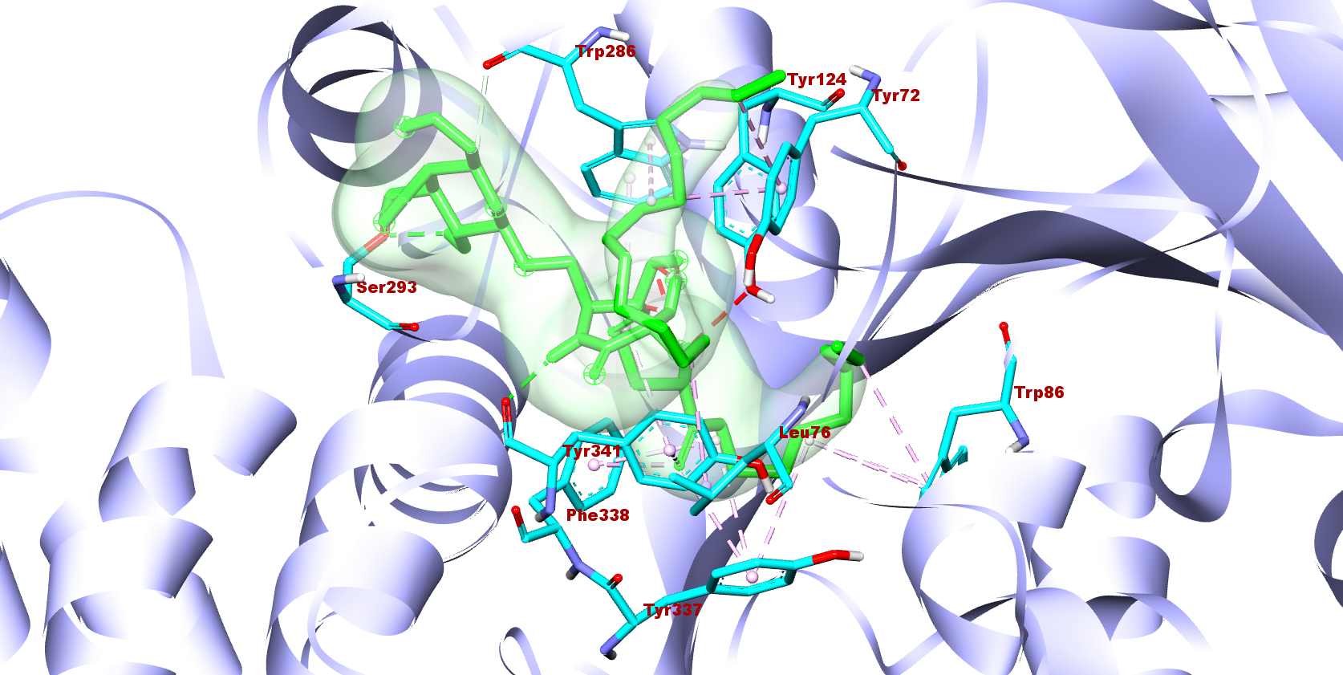
1
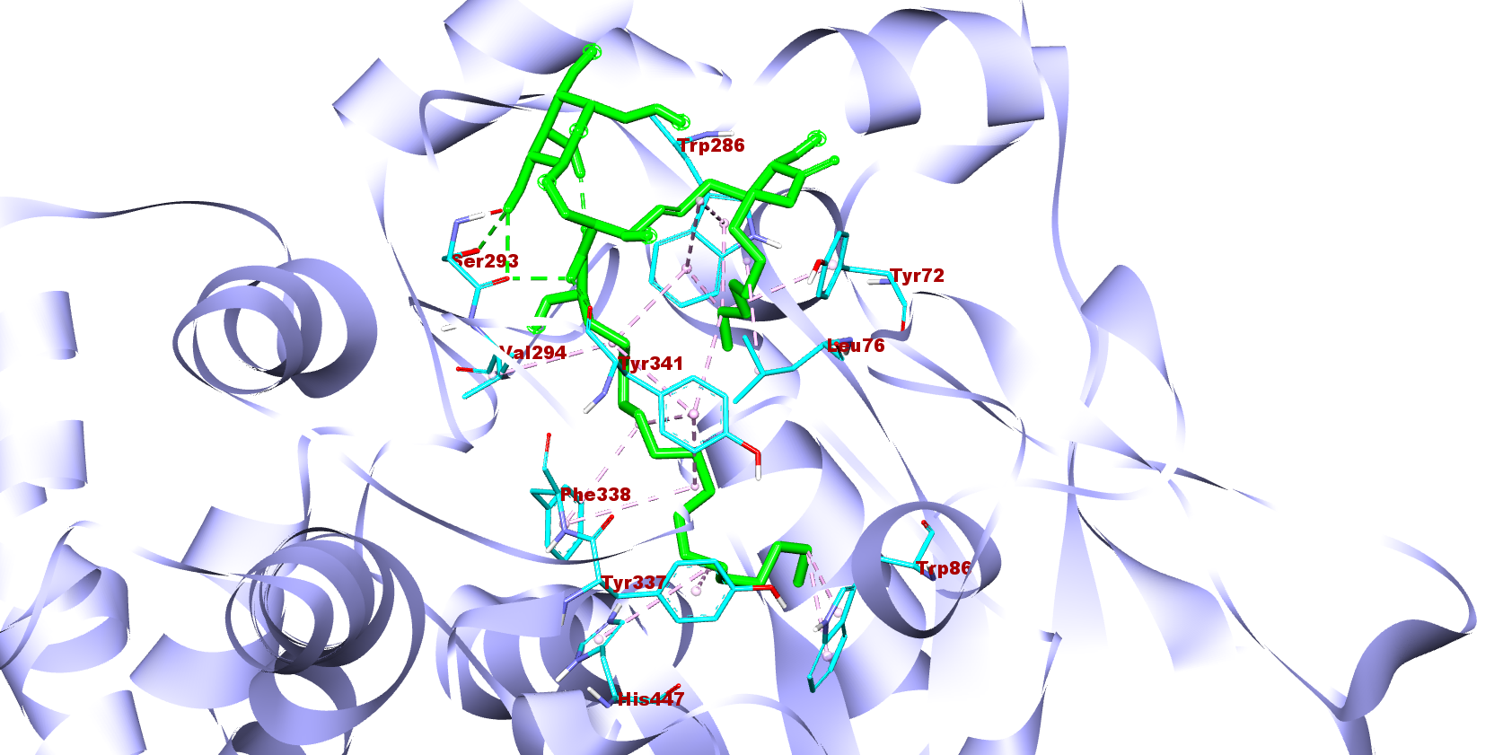
2
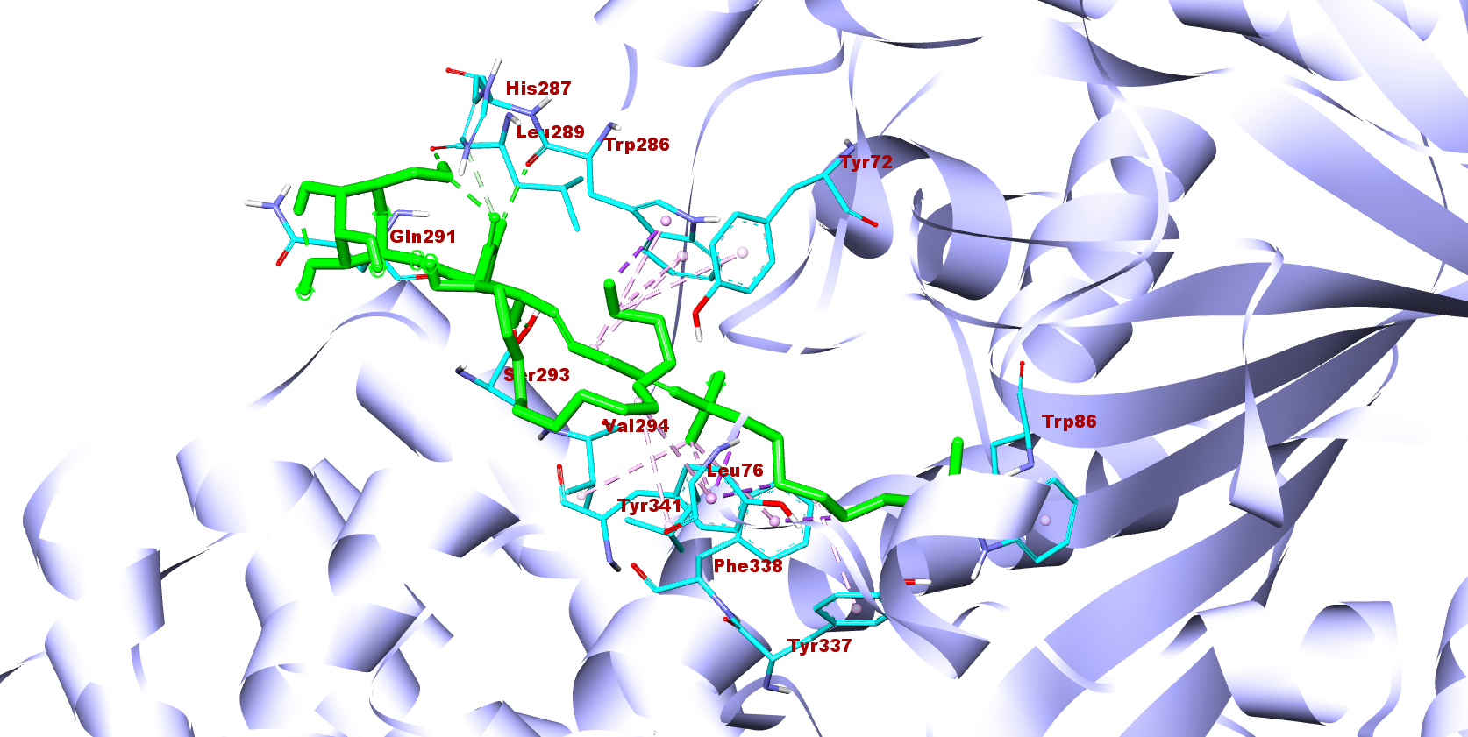
3
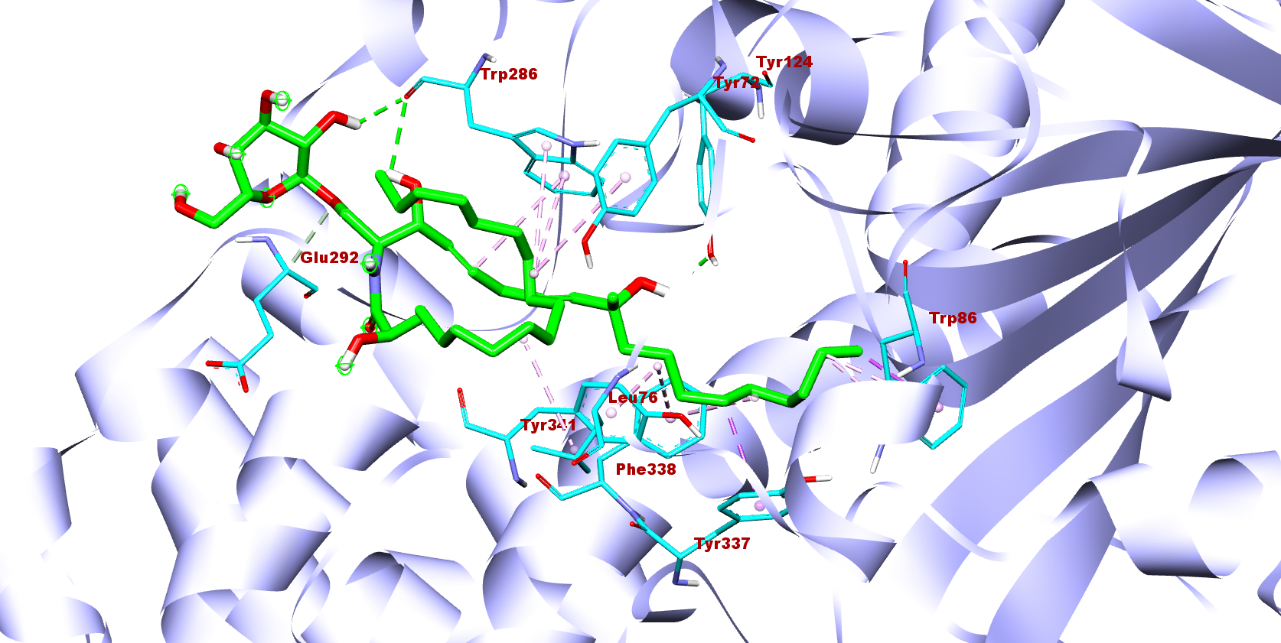
4
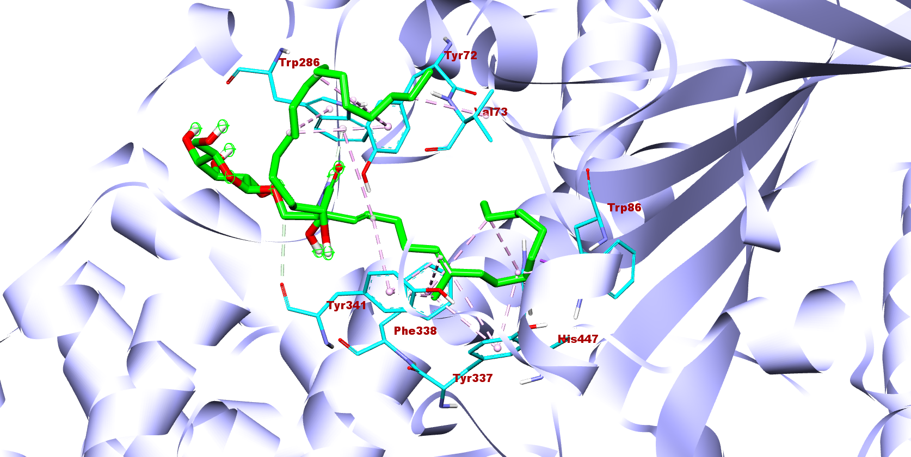
5
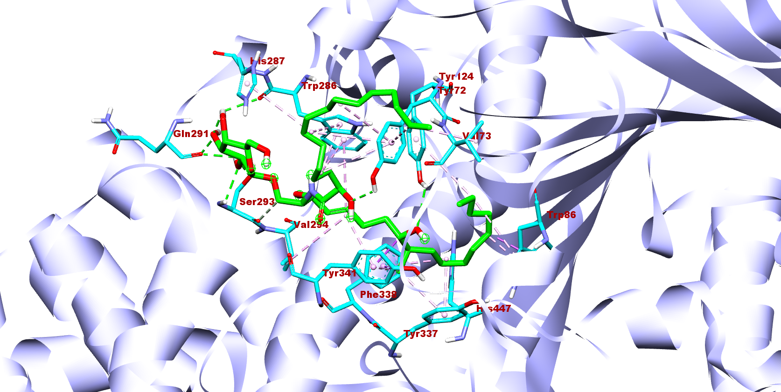
6
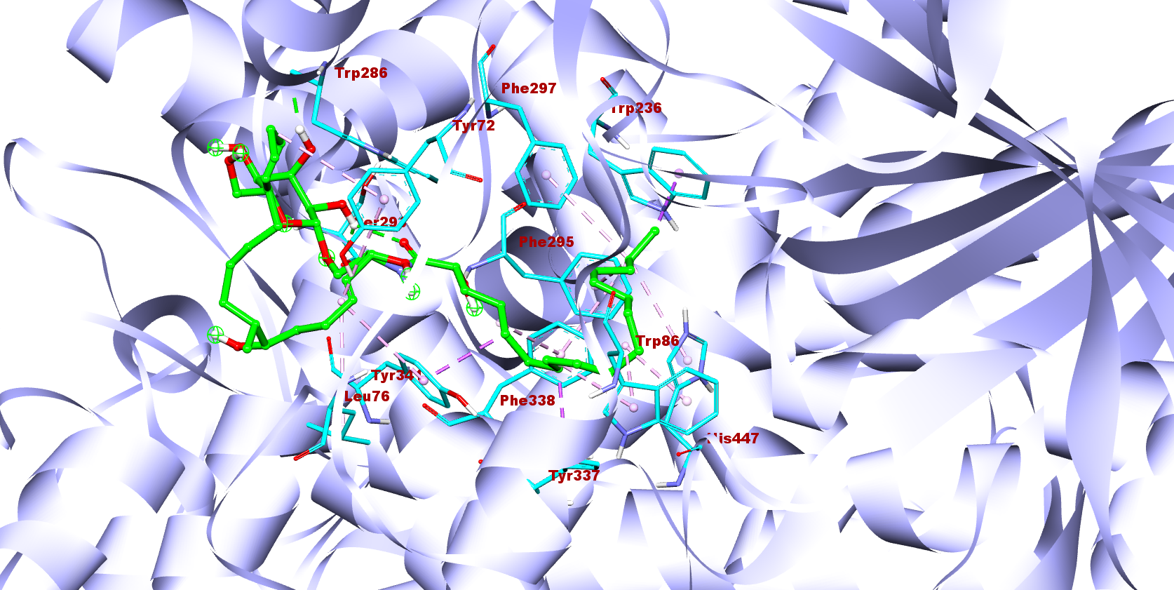
7
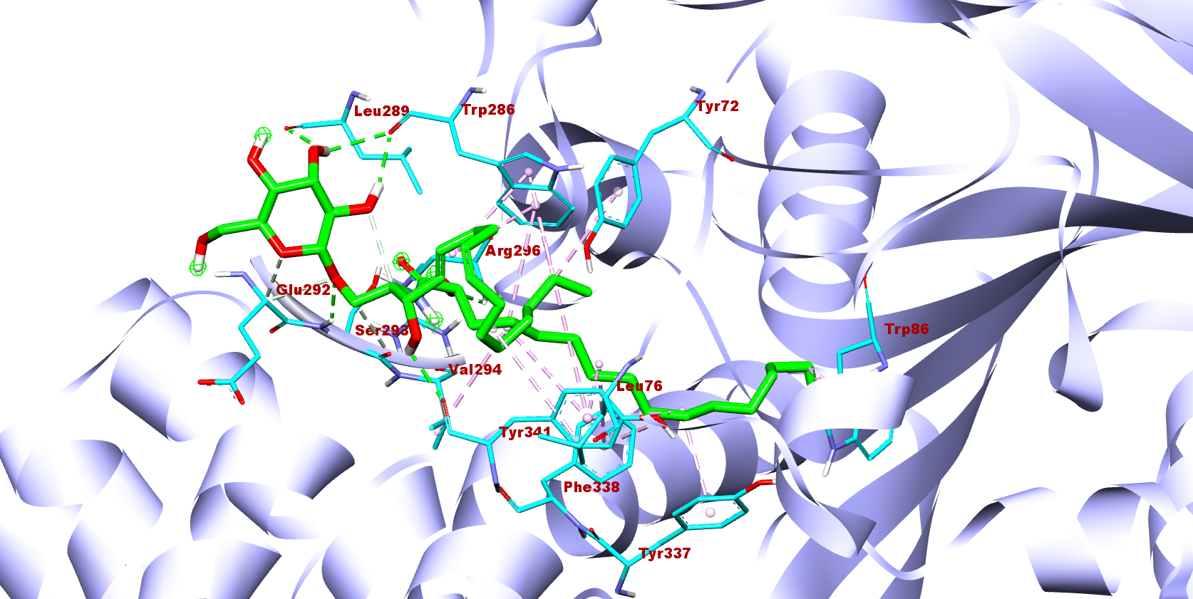
8
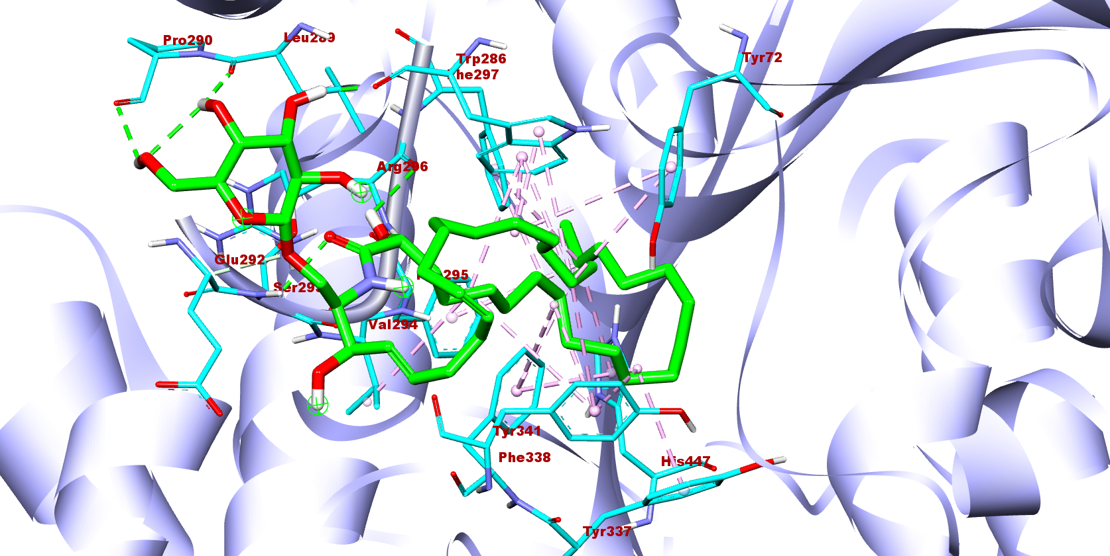
9
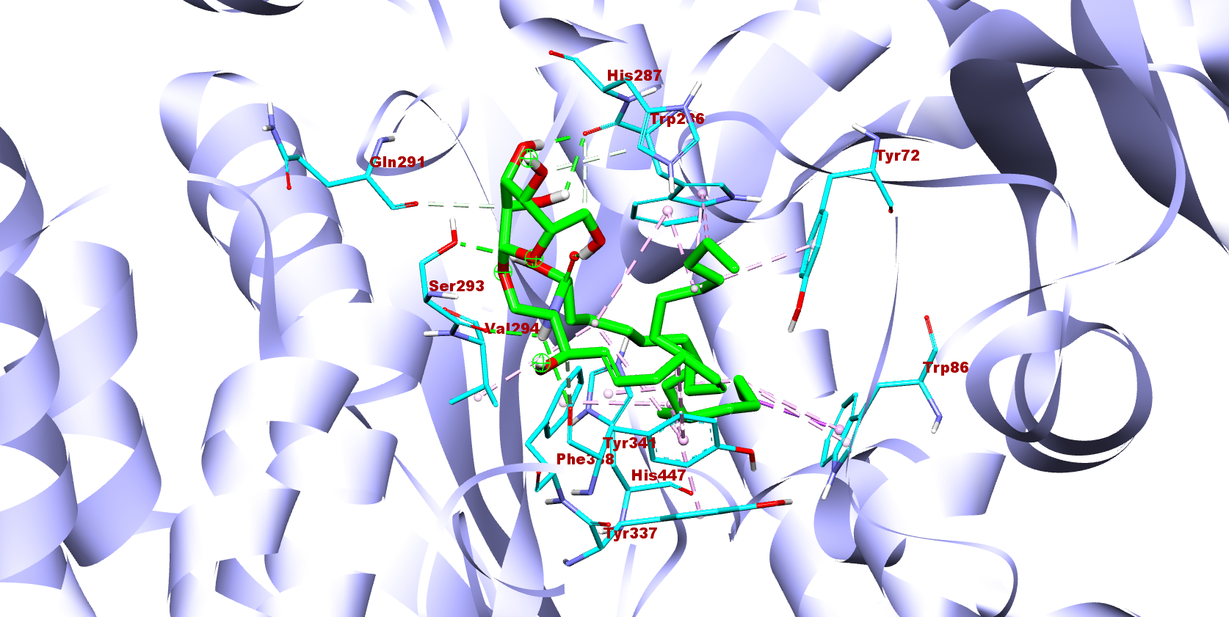
10
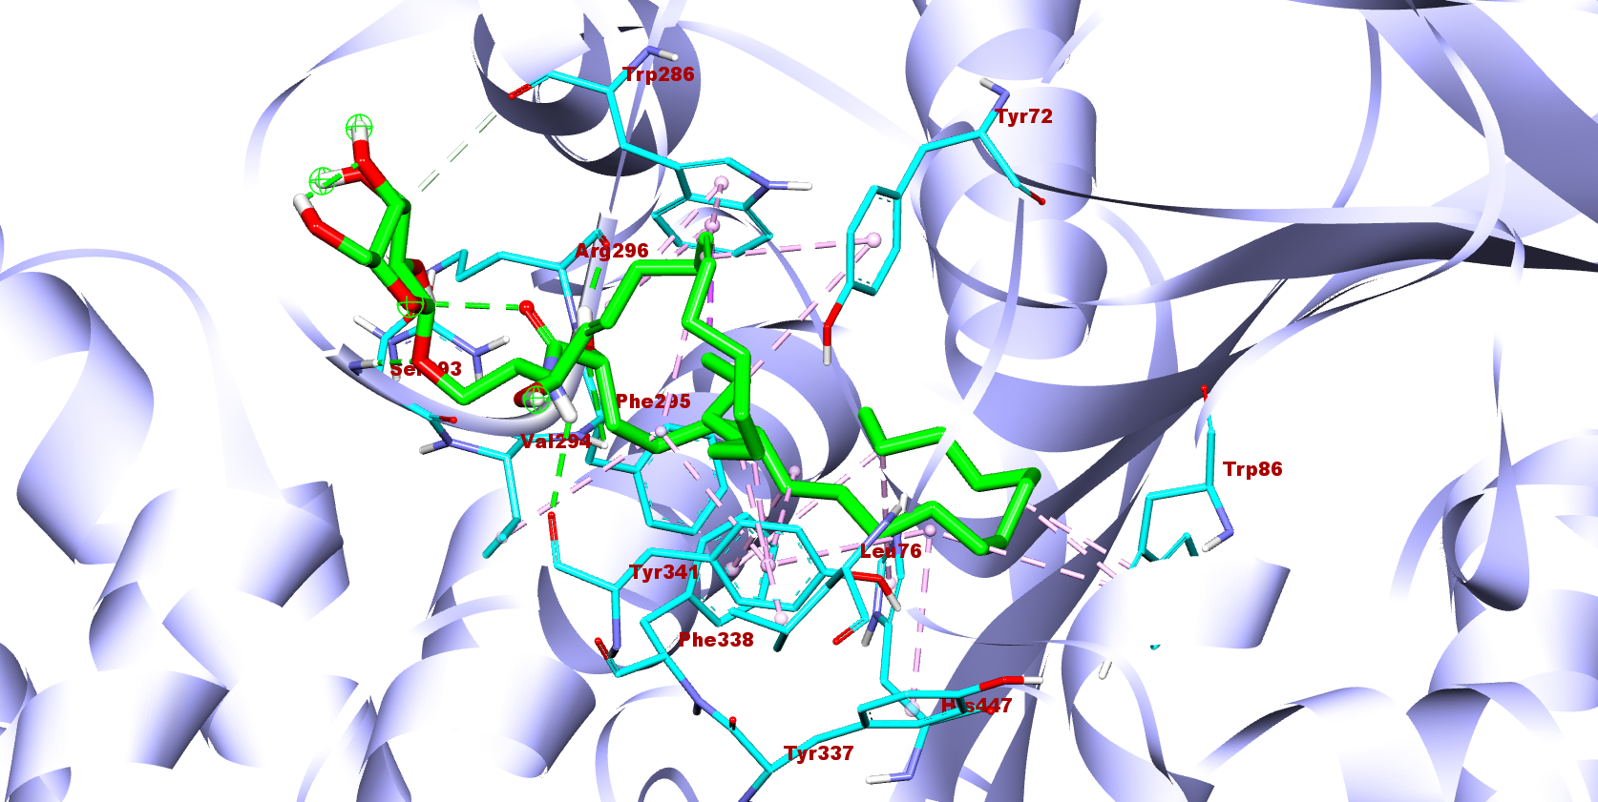
11
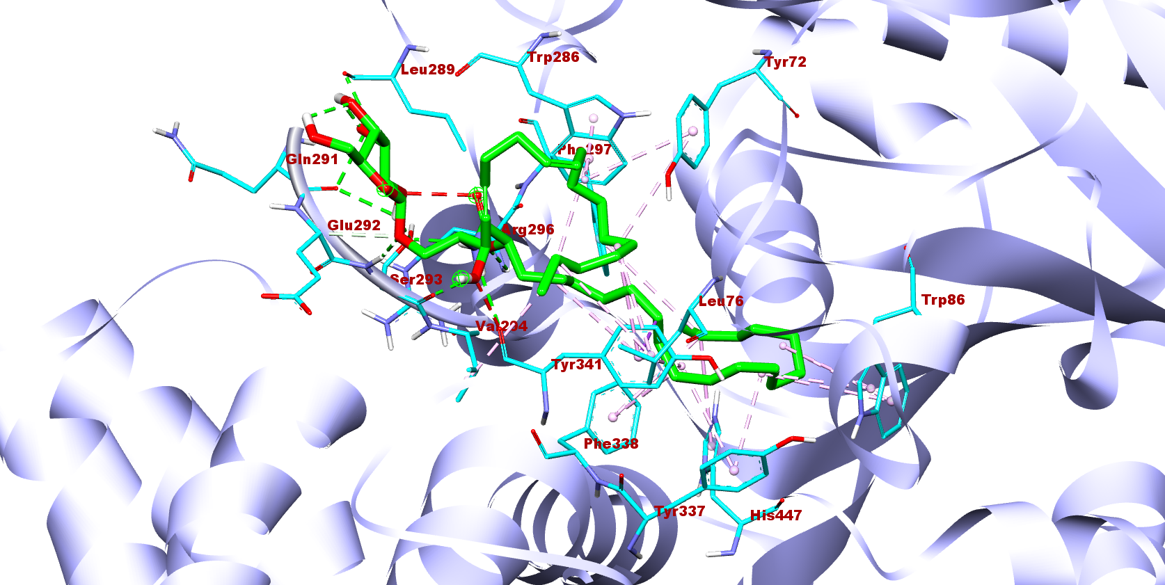
12
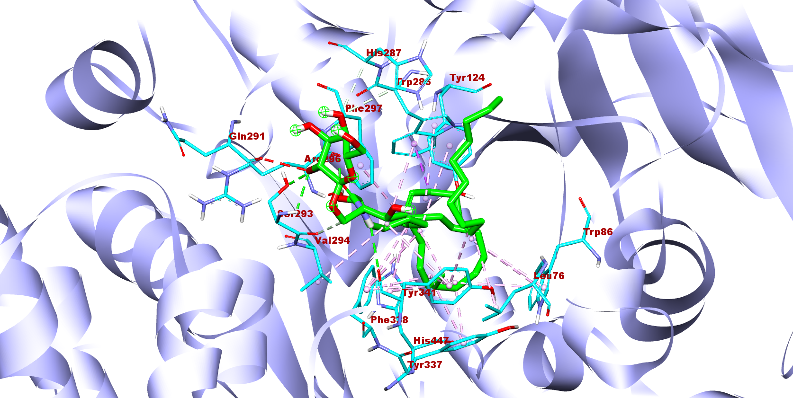
13
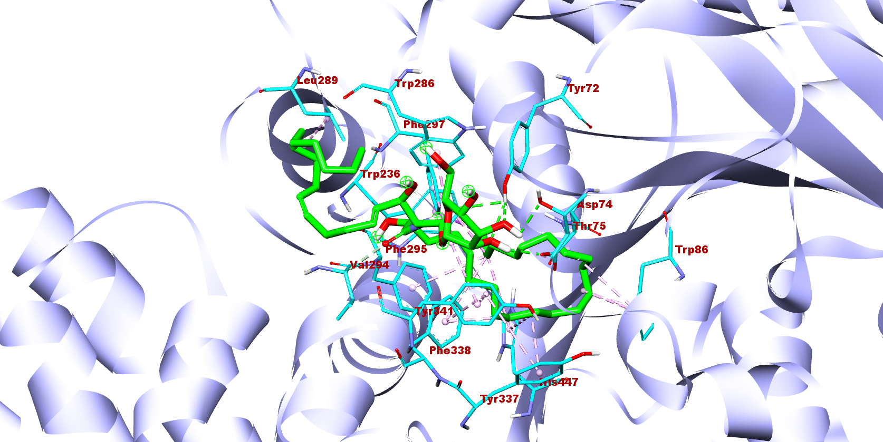
14
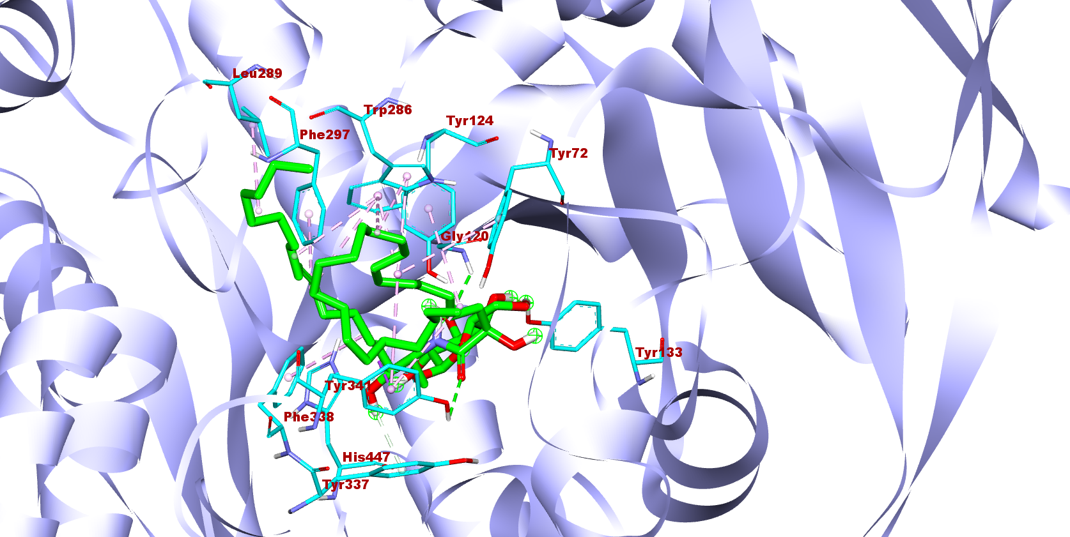
15
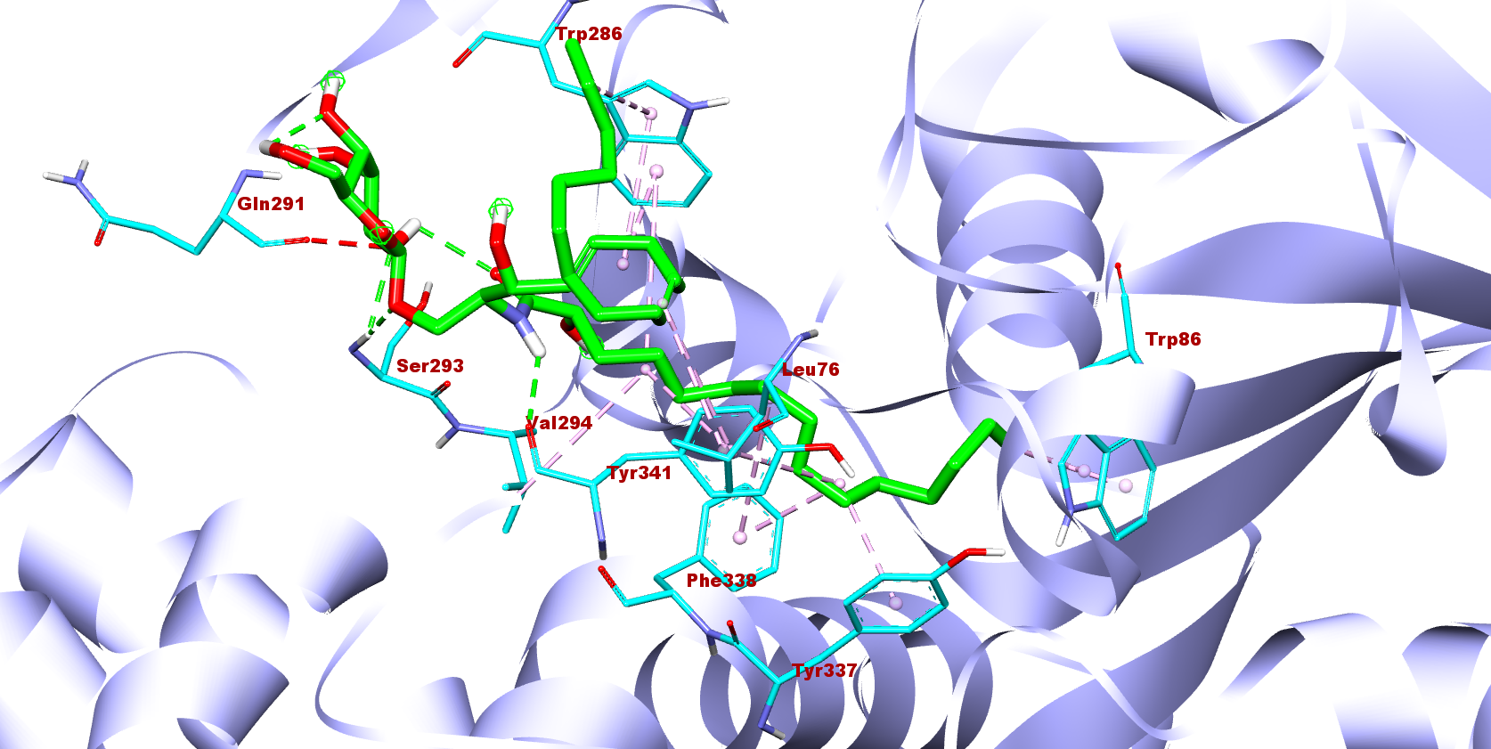
16
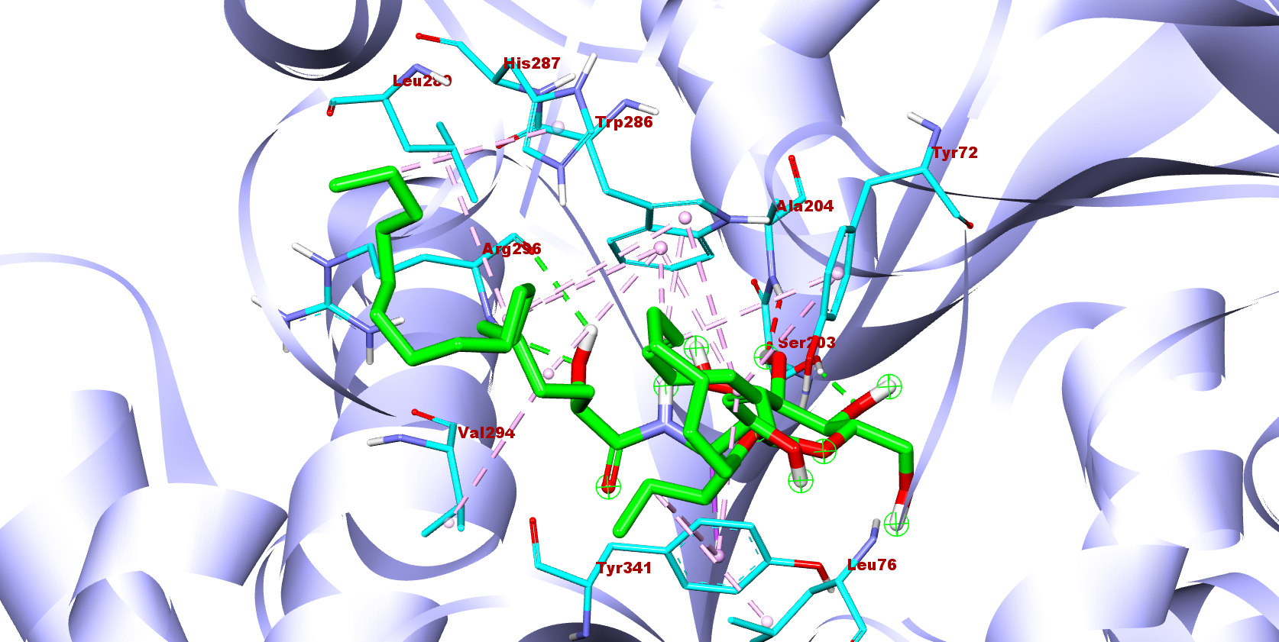
17
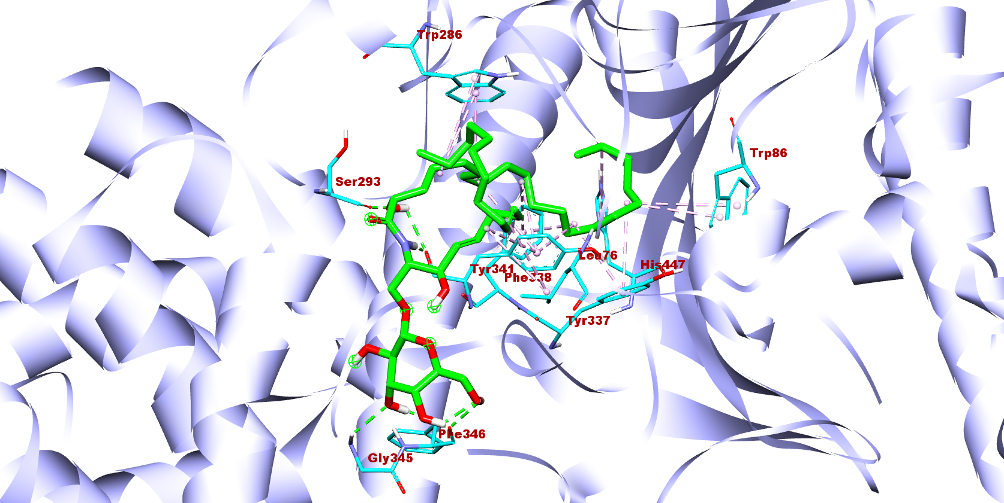
18
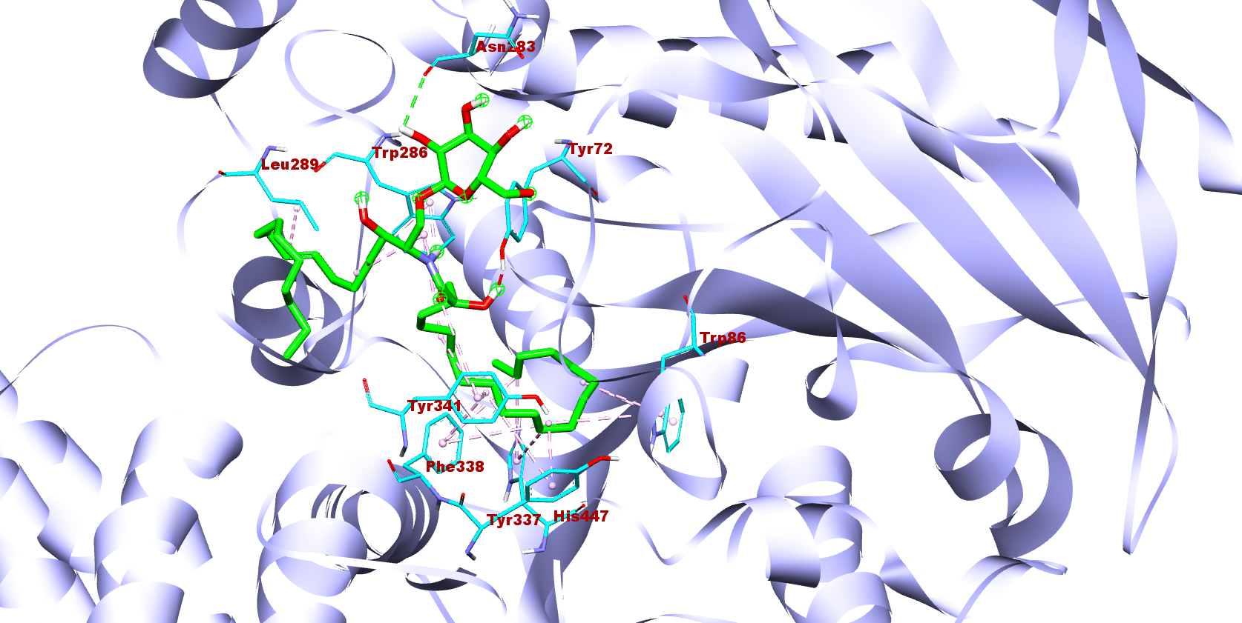
19
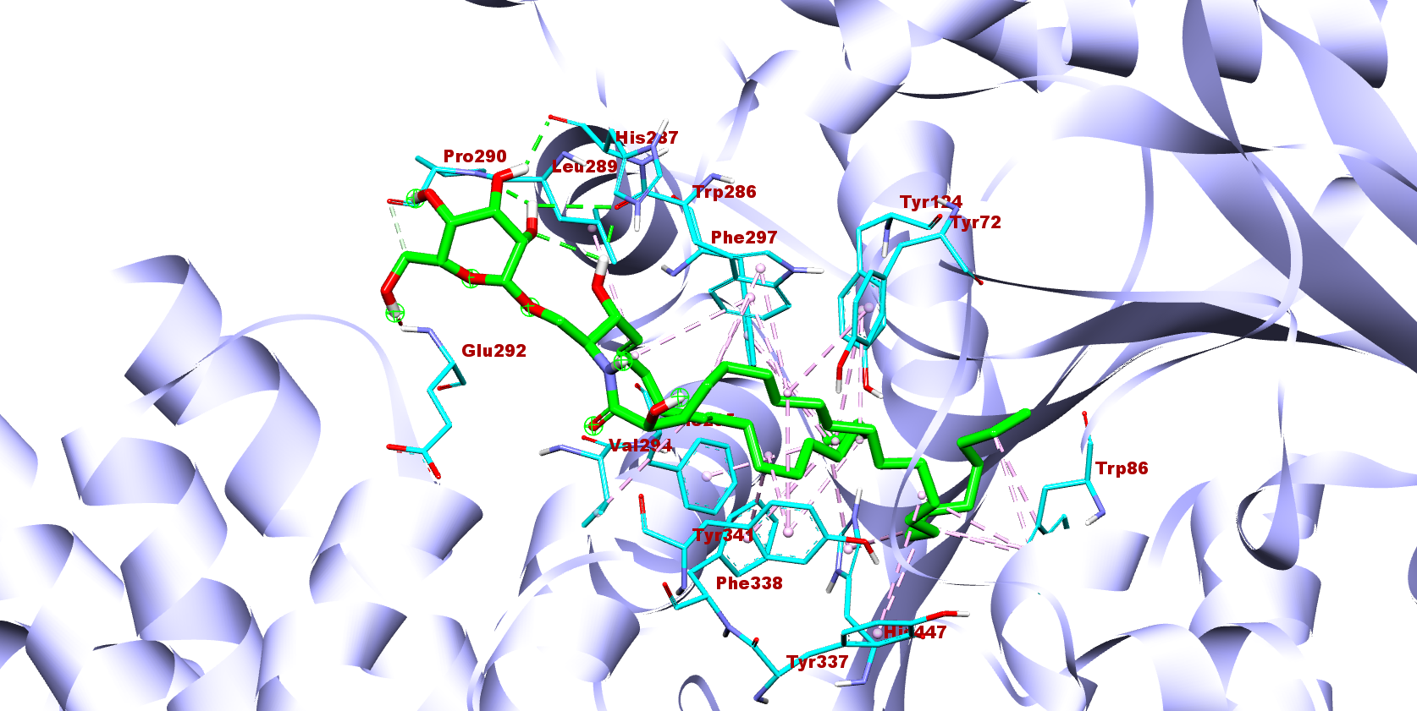
20
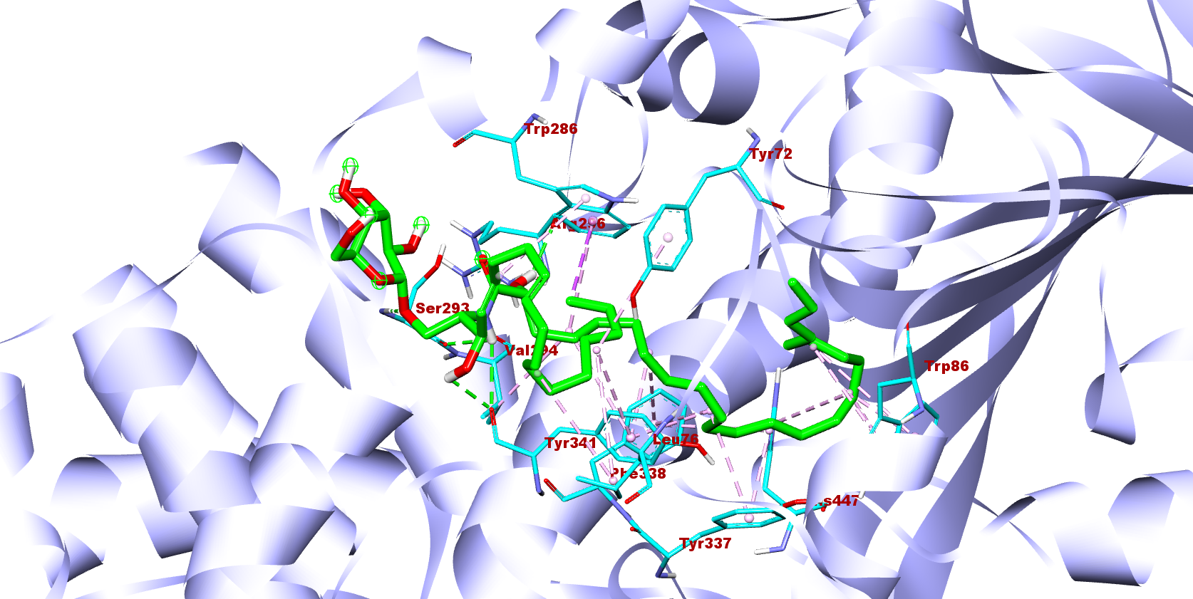
21
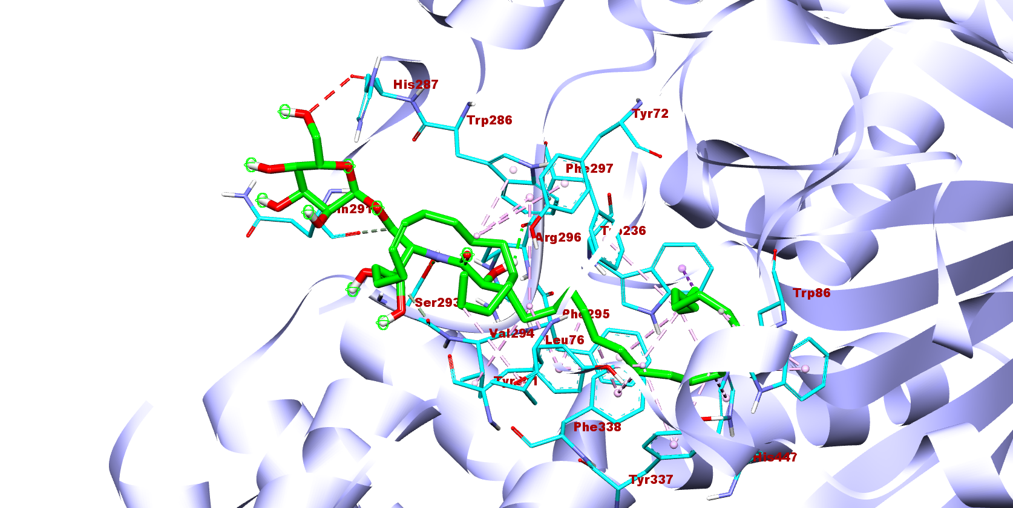
22
Supplementary data: The cerebrosides (1-22) interactions with the active site of PDB: 4EY7

