Supporting Information

Nature meets Metal: enhancing chrysin’s antidiabetic efficacy through Cu(II) and Co(II) coordination
Diogo Marinheiro,^{a,b} Cláudia Silva,^{b,c} Ricardo F. Mendes,^{a,d} Tânia Moniz,^{e,f} André Silva, ^{e,f} Maria Rangel,^{f} João Rocha,ª Ana L. Daniel-da-Silva,ª Fátima Martel,^{b,g}* and Bárbara J. M. Leite Ferreira^{a,h}*
- CICECO, Department of Chemistry, University of Aveiro, 3810-193 Aveiro, Portugal
- Biochemistry Unit, Department of Biomedicine, Faculty of Medicine, University of Porto, 4200-319 Porto, Portugal
- LAQV-REQUIMTE, Department of Chemical Sciences, Faculty of Pharmacy, University of Porto, 4050-313 Porto, Portugal
- CiQUS, Centro Singular de Investigación en Química Bioloxica e Materiais Moleculares, Departamento de Química-Física, University of Santiago de Compostela, 15782 Santiago de Compostela, Spain
- LAQV-REQUIMTE, Department of Chemistry and Biochemistry, Faculty of Sciences, University of Porto, Rua do Campo Alegre, s/n 4169-007 Porto, Portugal
- LAQV-REQUIMTE, Instituto de Ciências Biomédicas de Abel Salazar, University of Porto, Rua de Jorge Viterbo Ferreira, 228, 4050-313 Porto, Portugal
- Instituto de Investigação e Inovação em Saúde (i3S), University of Porto, 4200-135 Porto, Portugal
- INSIGHT – Piaget Research Center for Ecological Human Development, 1950-157 Lisboa, Portugal
* Corresponding authors: fmartel@med.up.pt (F.M.), barbaraferreira@ua.pt (B.J.M.L.F.)

3.1. Physicochemical characterization and solution behaviour

3.1.1 Synthesis, crystallinity and solid-state morphology
. 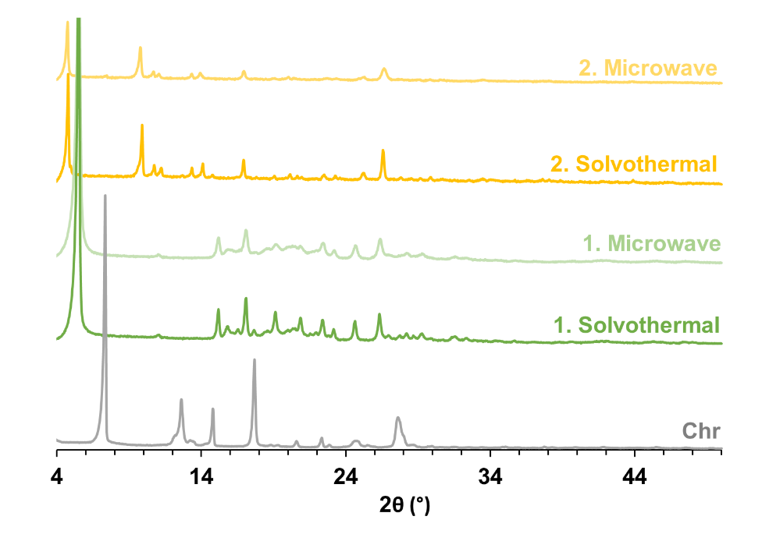
Fig. S1 – Powder XRD patterns of complexes 1 and 2 synthesized via SVT and MWAS, compared with the diffraction pattern of Chr.

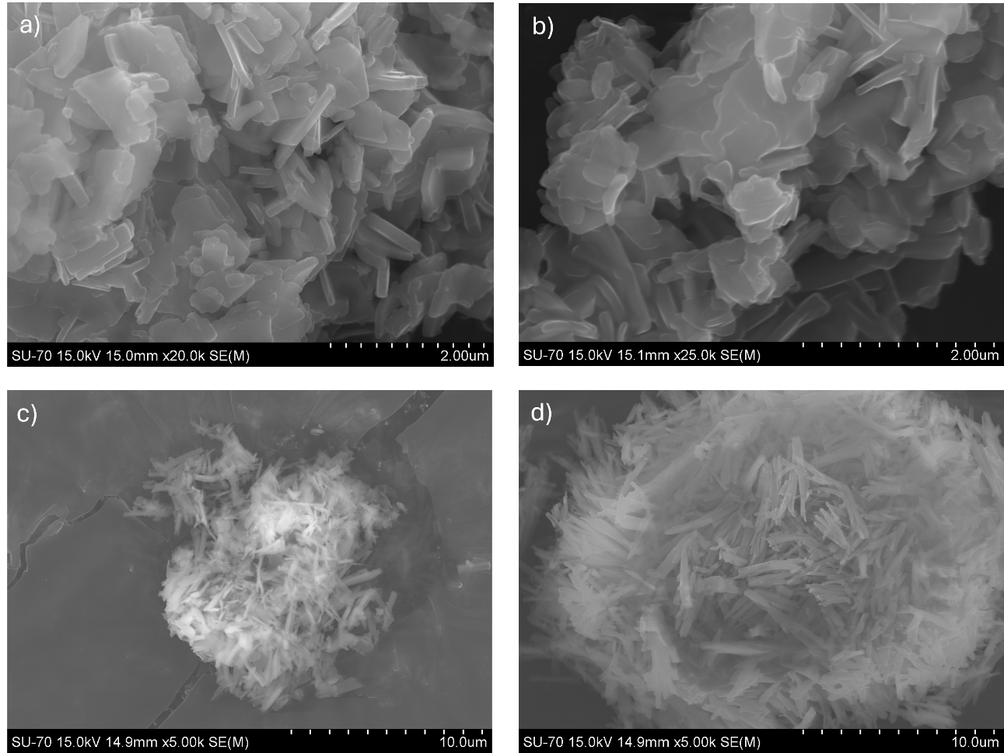
Fig. S2 – SEM images of the powders obtained. Complex 1 obtained by SVT synthesis (a) and MWAS (b); complex 2 obtained by SVT (c) and MWAS (d).

3.1.2 Spectroscopic and analytical characterization

3.1.2.1 FTIR and coordination modes
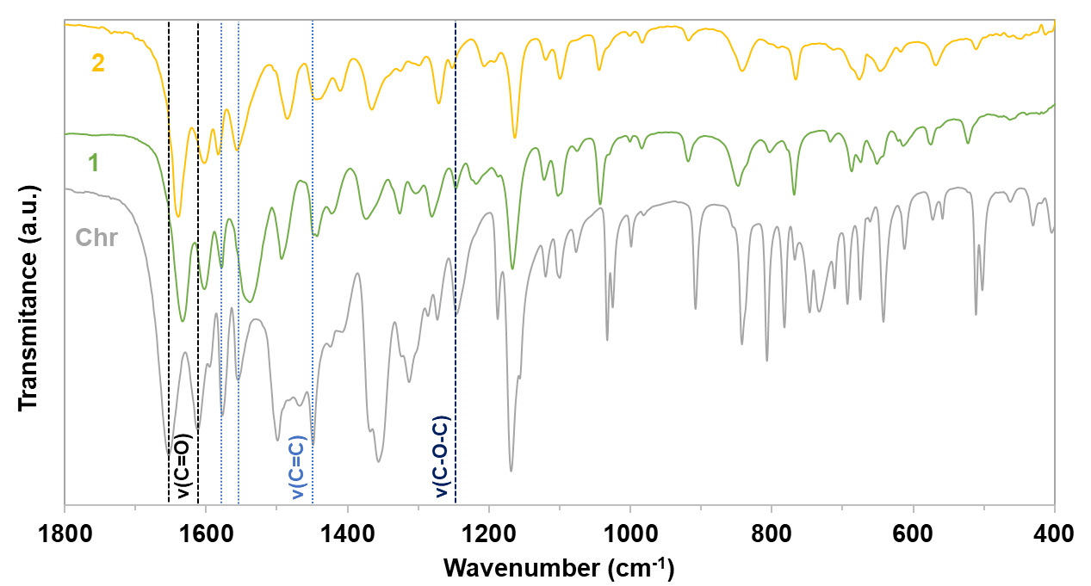
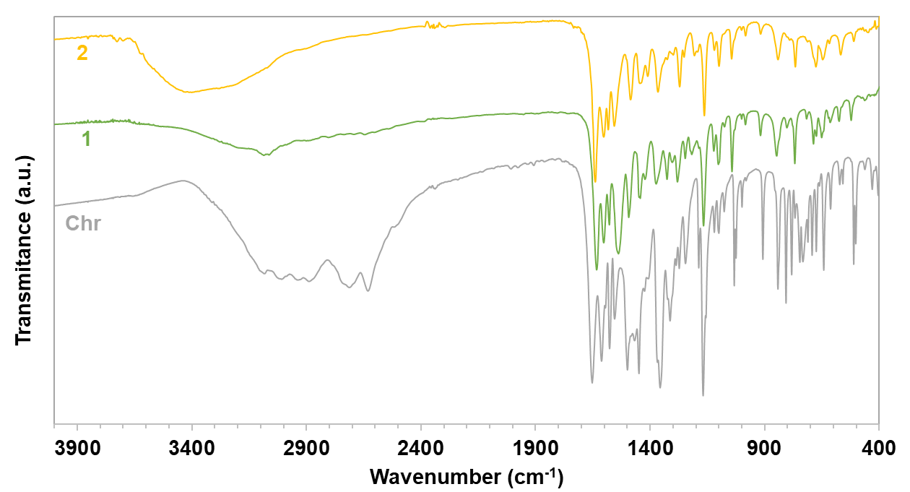
Fig. S3 – (a) FTIR spectra of Chr (grey), complex 1 (green) and complex 2 (yellow). The C=O stretching bands are indicated with black dashed lines, the C=C stretching vibrations with light-blue dotted lines, and the C–O–C stretching band with a dark-blue dashed line. (b) Full FTIR spectra.
a)
b)

Table S1 – Assigned vibrational modes and corresponding FTIR band positions for Chr and complexes 1 and 2. All wavenumbers are reported in cm⁻¹. ν: stretching; δ: in-plane bending.
 | Chr | 1. | 2.
ν(C=O) | 1652/1609 | 1632/1601 | 1639/1601
v_{ring}(C=C) | 1448 | 1445 | 1447
v_{ring}(C=C) | 1555 | 1556 | 1555
v_{ring}(C=C) | 1576 | 1577 | 1581
 | 1609 | 1601 | 1601
v(C-O) | 1362 | 1372 | 1365
v(C-O-C) | 1247 | 1245 | 1250
v(C-H), v(O-H) | 3472-2300 | 3340-2945 | 3381-2884
δ(O-H) | 1119 | 1123 | 1119

3.1.2.2 TGA analysis

Fig. S4 - TGA curves of chrysin and complexes 1 and 2.
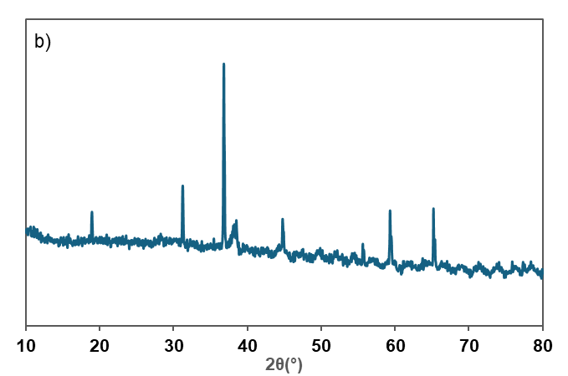
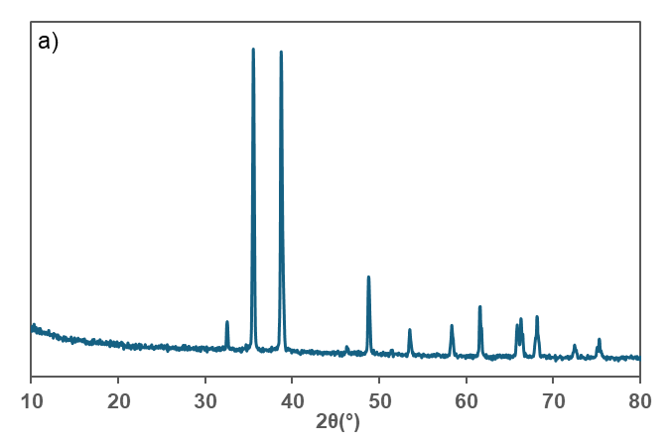
Fig. S5 - Powder XRD patterns of the residues obtained after TGA, compared with the PDF-5+ 2025 database from the International Centre for Diffraction Data (ICDD). (a) CuO – residue from complex 1; (b) CoO – residue from complex 2.

Table S2 – Thermal degradation steps of complexes 1 and 2, with experimental (Exp.) and theoretical (Theo.) mass losses. The observed mass losses correspond to the stepwise removal of coordinated and non-coordinated species, leaving metal oxides as final residues.
 | Water |  | 2 Chr |  | Metal oxide
 | Exp. | Theo. | Exp. | Theo. | Exp. | Theo.
1 | - | - | 88.4 | 88.9 | 11.6 | 13.9
2 | 12.5 | 13.7 | 75.0 | 77.5 | 12.5 | 11.4

3.1.2.4 EPR studies
Fig. S6 – EPR spectra of complexes 1 and 2. (a) Complex 1 at 5mM; (b) Complex 1 at 0.5mM (zoom); (c) Complex 2 at 5mM; (d) comparison of EPR spectra of complexes 1 and 2 at 5mM and DMSO (zoom in inset).
NOTE: ICP analysis of the cobalt precursor and of the final Co(II) complexes obtained by SVT and MWAS revealed the presence of copper at low levels. The commercial Co(II) acetate tetrahydrate contained 7–8 µg g⁻¹ of Cu (≈0.0007%), a value below the maximum impurity level specified by the supplier (0.05% Cu), which is consistent with normal batch-to-batch variability. In the final Co(II) complexes, Cu levels ranged from 23 µg g⁻¹ (0.0023%) in the MWAS sample to 959 µg g⁻¹ (0.0959%) in the SVT material. These slightly higher values are compatible with trace contamination from laboratory equipment, including the solvothermal autoclave and microwave reactors used during synthesis. Such low-level impurities are sufficient to account for the weak Cu(II) EPR signal observed for complex 2 and do not imply copper incorporation into the cobalt complex, whose spectroscopic behavior remains fully consistent with a Co(II) system.

3.1.2.5 ESI-HRMS
(a) Cu in DCM-1

(b) Cu in DCM ZOOM-1

(c) Cu in MeOH-2

(d) Cu in MeOH ZOOM-2

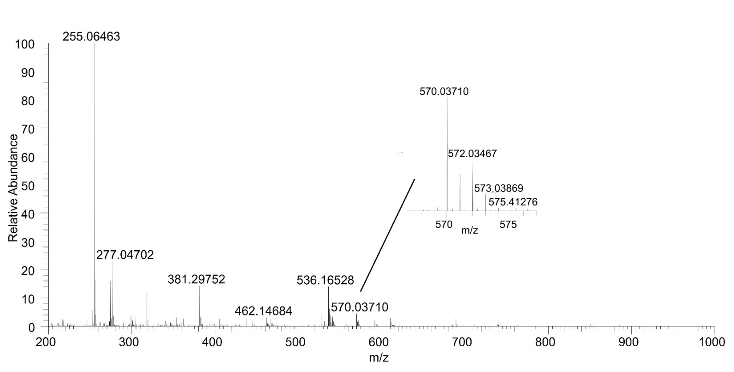
(e) Cu in 20% H2O/MeOH-3

Fig. S7 – Positive-ion ESI-HRMS spectra of complex 1 acquired in dichloromethane (a, b), MeOH (c, d) and 20% H₂O/MeOH (e).

(a) Co in MeOH-1

(b) Co in MeOH ZOOM-1

(c) Co in 20%H2O/MeOH-2

(d) Co in 20%H2O/MeOH ZOOM-2

Fig. S8 – Positive-ion ESI-HRMS spectra of complex 2 acquired in MeOH (a, b) and 20% H₂O/MeOH (c, d).

