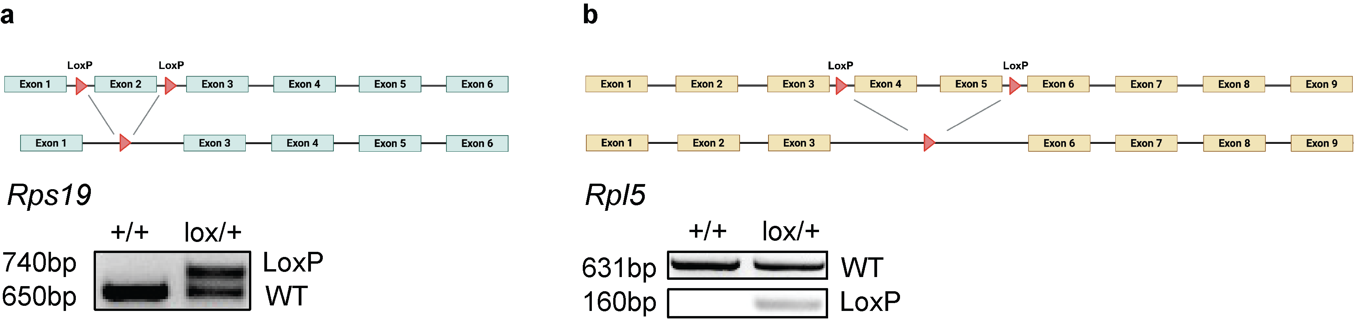
Figure S1. CRISPR/Cas9 generation of Rps19^{lox/lox} and Rpl5^{lox/lox} mice. (a) Upper panel: sequence of mouse Rps19 along with the 2 loxP sites flanking exon 2, before and after deletion. Bottom panel: genotyping after Vav-cre excision. (b) Upper panel: sequence of mouse Rpl5 along with the 2 loxP sites flanking exons 4 and 5, before and after deletion. Bottom panel: genotyping after Vav-cre excision.

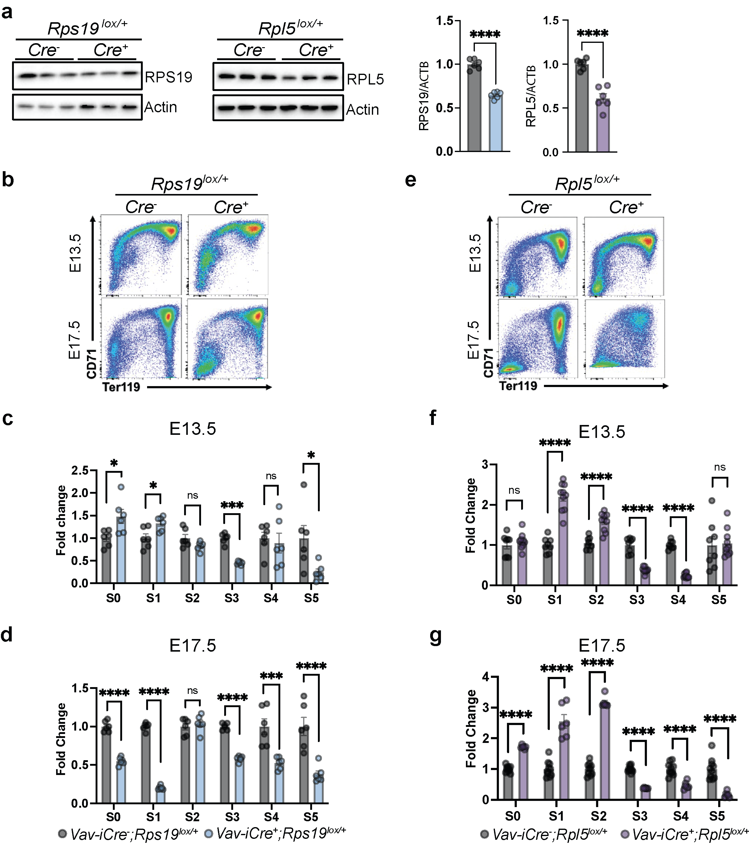
Figure S2. Hematopoiesis in Rps19^{lox/+} and Rpl5^{lox/+} models. (a) Western blot analysis and quantification of RPS19, RPL5 or �-actin in fetal liver (FL) cells from E15.5 control, Rps19^{lox/+} or Rpl5^{lox/+} embryos. (b) Representative flow cytogram of erythropoiesis in E13.5 and E17.5 control and Rps19^{lox/+}embryos. (c) Erythroid populations from S0 to S5 in E13.5 control and Rps19^{lox/+} embryos expressed as a fold change relative to control. (d) Erythroid populations from S0 to S5 in E17.5 control and Rps19^{lox/+} embryos expressed as a fold change relative to control. (e) Representative flow cytogram of erythropoiesis in E13.5 and E17.5 control and Rpl5^{lox/+}embryos. (f) Erythroid populations from S0 to S5 in E13.5 control and Rpl5^{lox/+} embryos expressed as a fold change relative to control. (g) Erythroid populations from S0 to S5 in E17.5 control and Rpl5^{lox/+} embryos expressed as a fold change relative to control. All data are presented as mean ± standard deviation (n.s.: not significant, *p<0.05, ***p<0.001, ****p<0.0001).

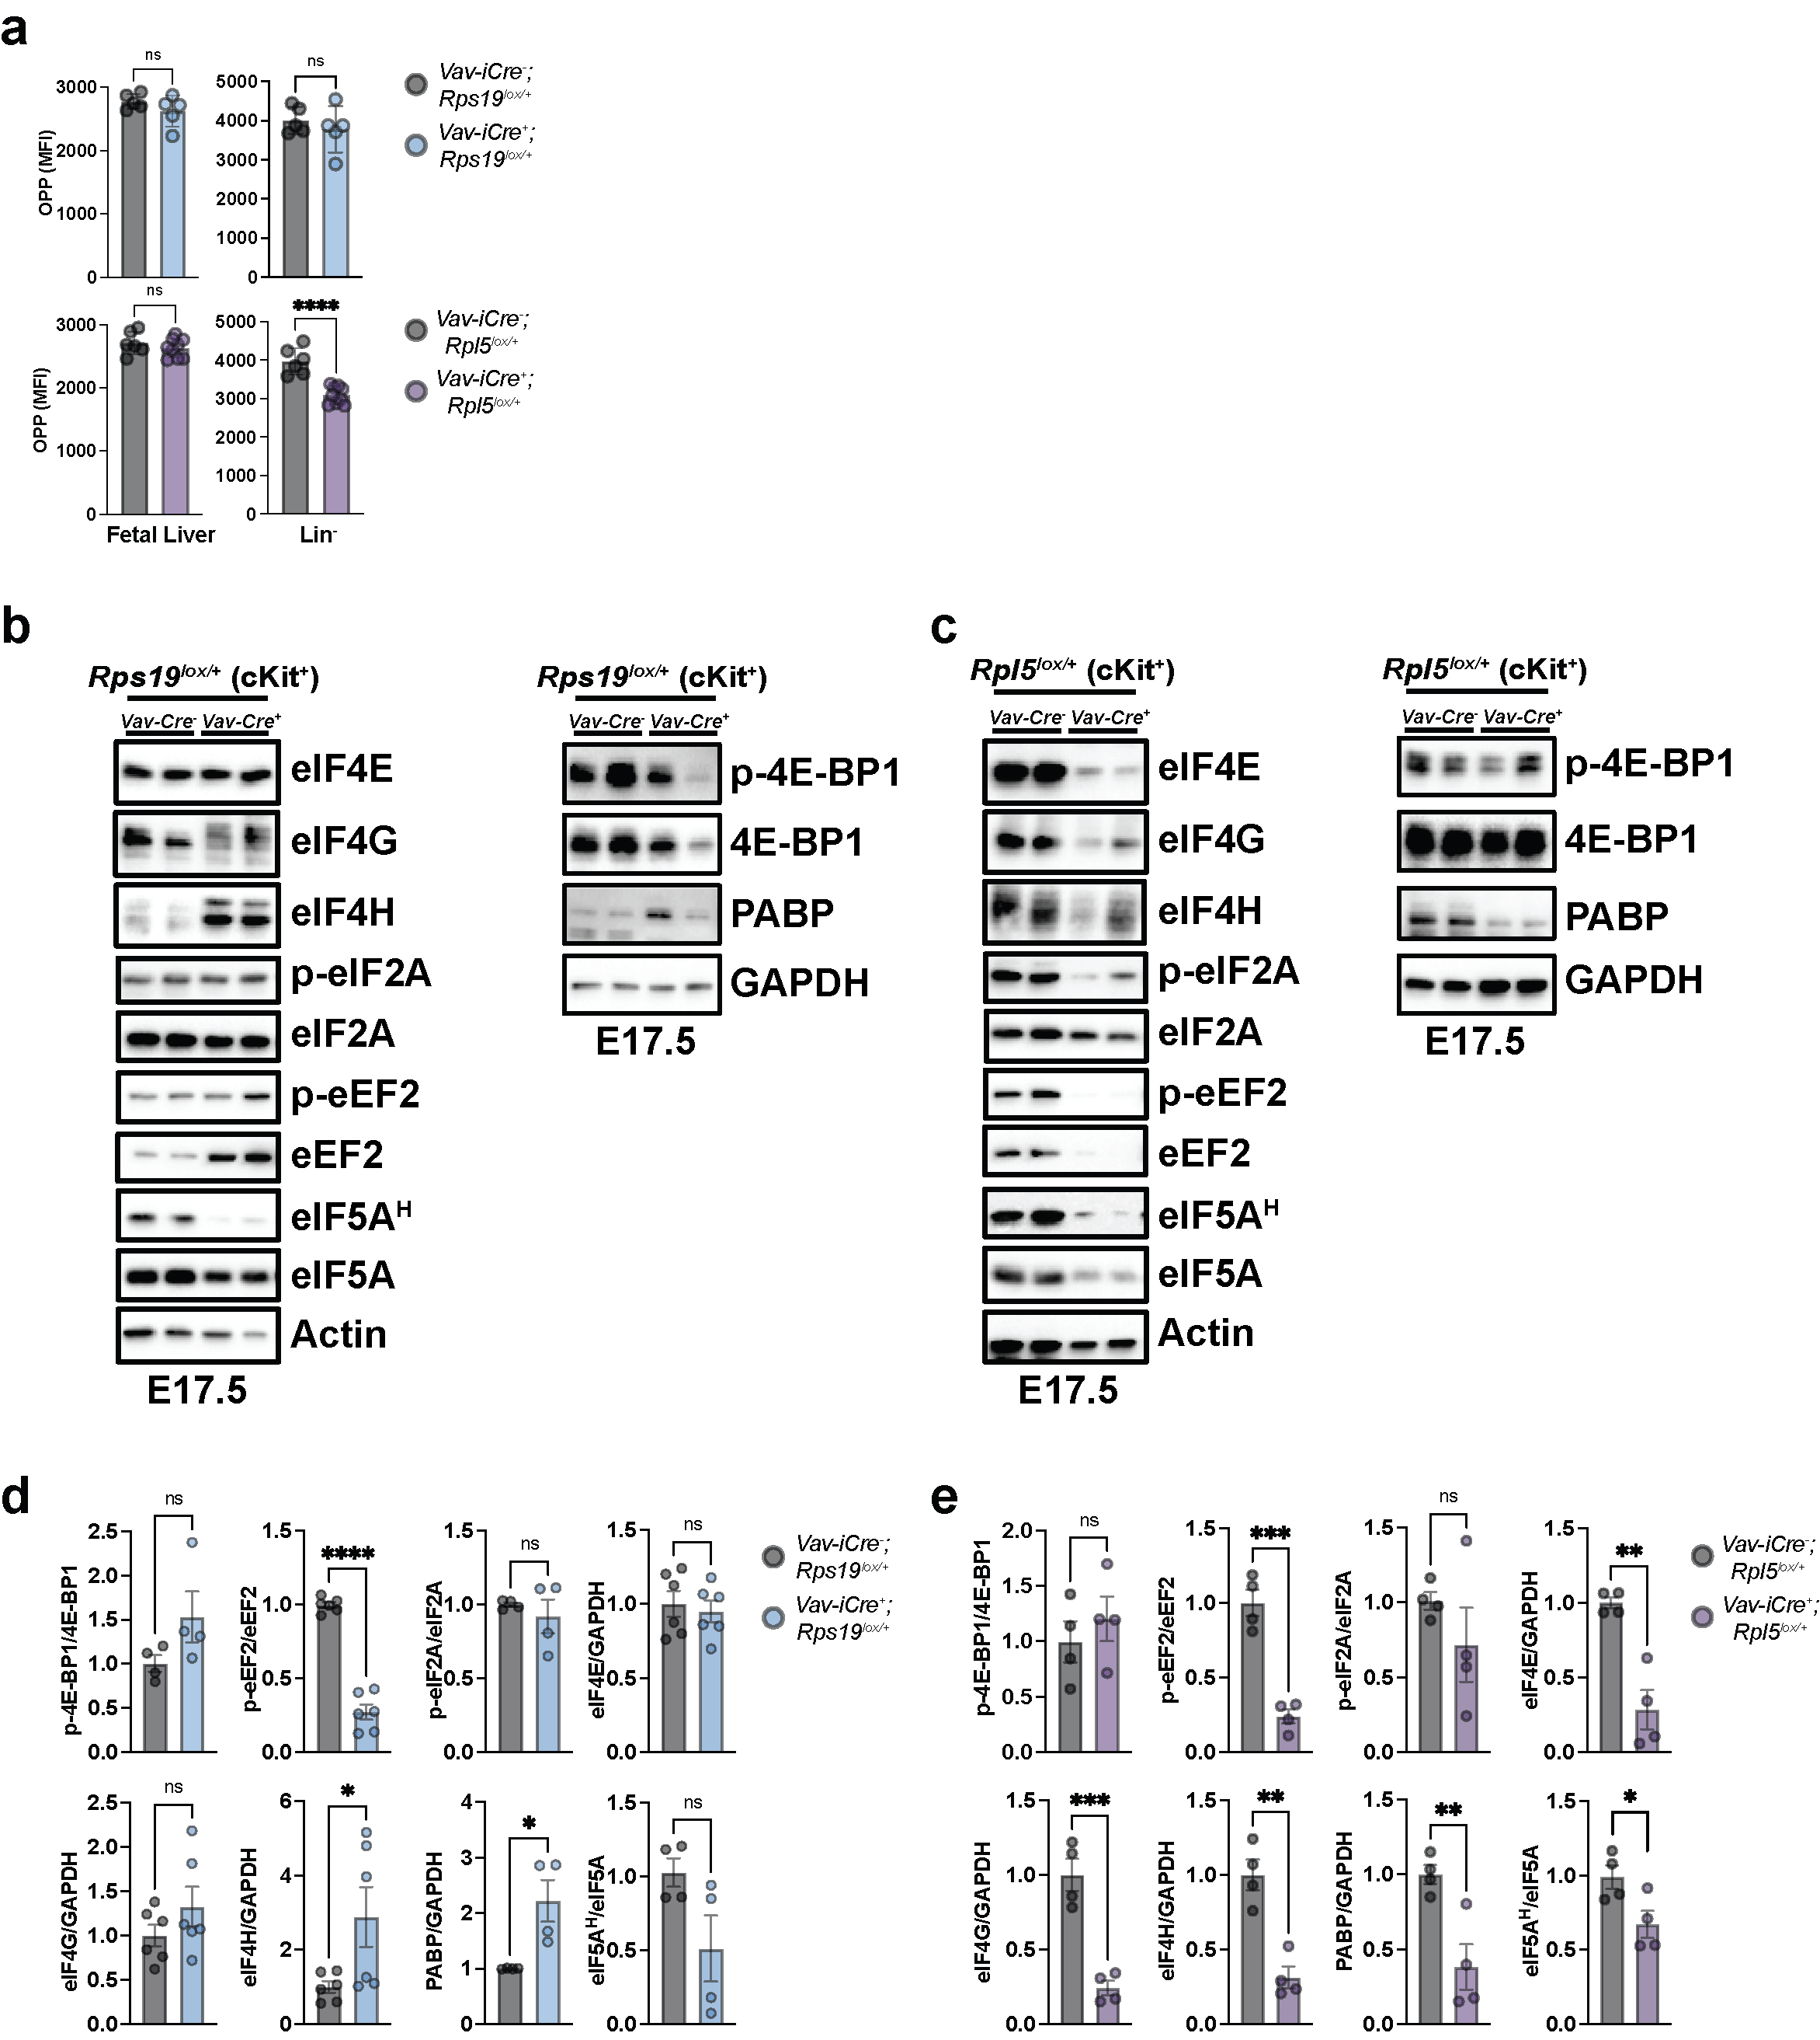
Figure S3. Translational regulation at E17.5 in Rps19^{lox/+} and Rpl5^{lox/+} mice. (a) Quantification of global translation in total fetal livers and Lin⁻ populations as measured by OPP in E13.5 control, Rps19^{lox/+} or Rpl5^{lox/+} embryos. (b) Western blot analysis of regulators of translation in FL-derived ckit⁺ cells from E17.5 control versus Rps19^{lox/+} embryos. (c) Western blot analysis of regulators of translation in FL-derived ckit⁺ cells from E17.5 control versus Rpl5^{lox/+} embryos. (d) Quantification of the western blots for the regulators of translation in FL-derived ckit⁺ cells from E17.5 control versus Rps19^{lox/+} embryos. (e) Quantification of the western blots for the regulators of translation in FL-derived ckit⁺ cells from E17.5 control versus Rpl5^{lox/+} embryos. All data are presented as mean ± standard deviation (*p<0.05, **p<0.01, ***p<0.001, ****p<0.0001).

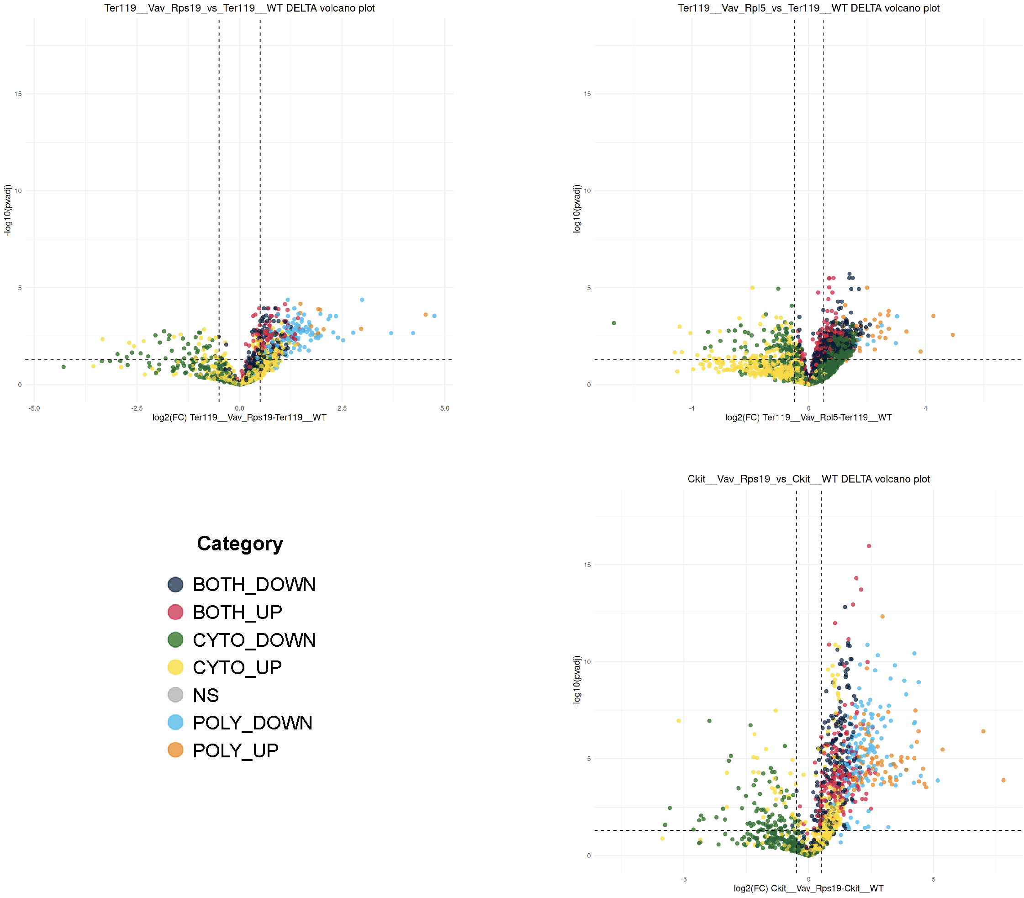

Figure S4. Statistical evaluation of translational regulation. Variation in translational expression (Δ-poly) and transcriptional expression (Δ-cyto) in Ter119⁺ cell populations in E15.5 control, Rps19^{lox/+} or Rpl5^{lox/+} and in cKit⁺ cell population from Rps19^{lox/+} embryos.

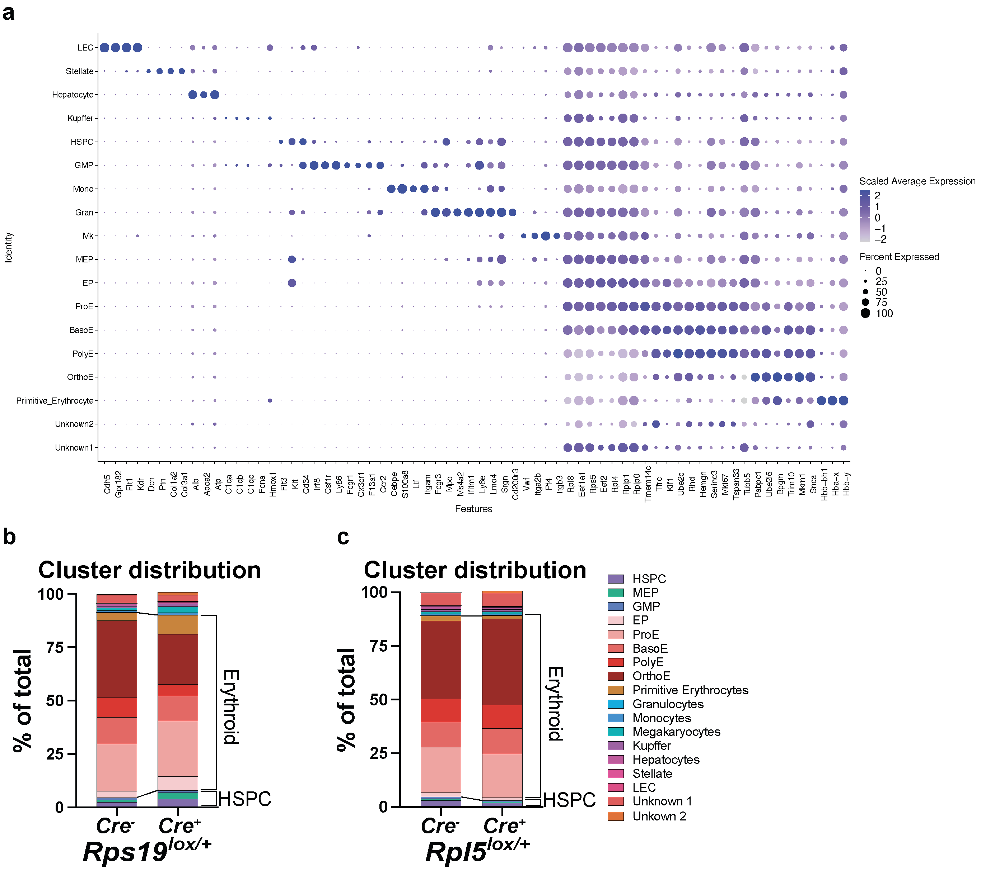

Figure S5. Identification of cell populations. (a) Bubble plots showing the expression of marker genes for cell annotation in each cell type. (b) Distribution of clusters from Rps19^{lox/+} FL hematopoietic cells. (c) Distribution of clusters from Rpl5^{lox/+} FL hematopoietic cells.

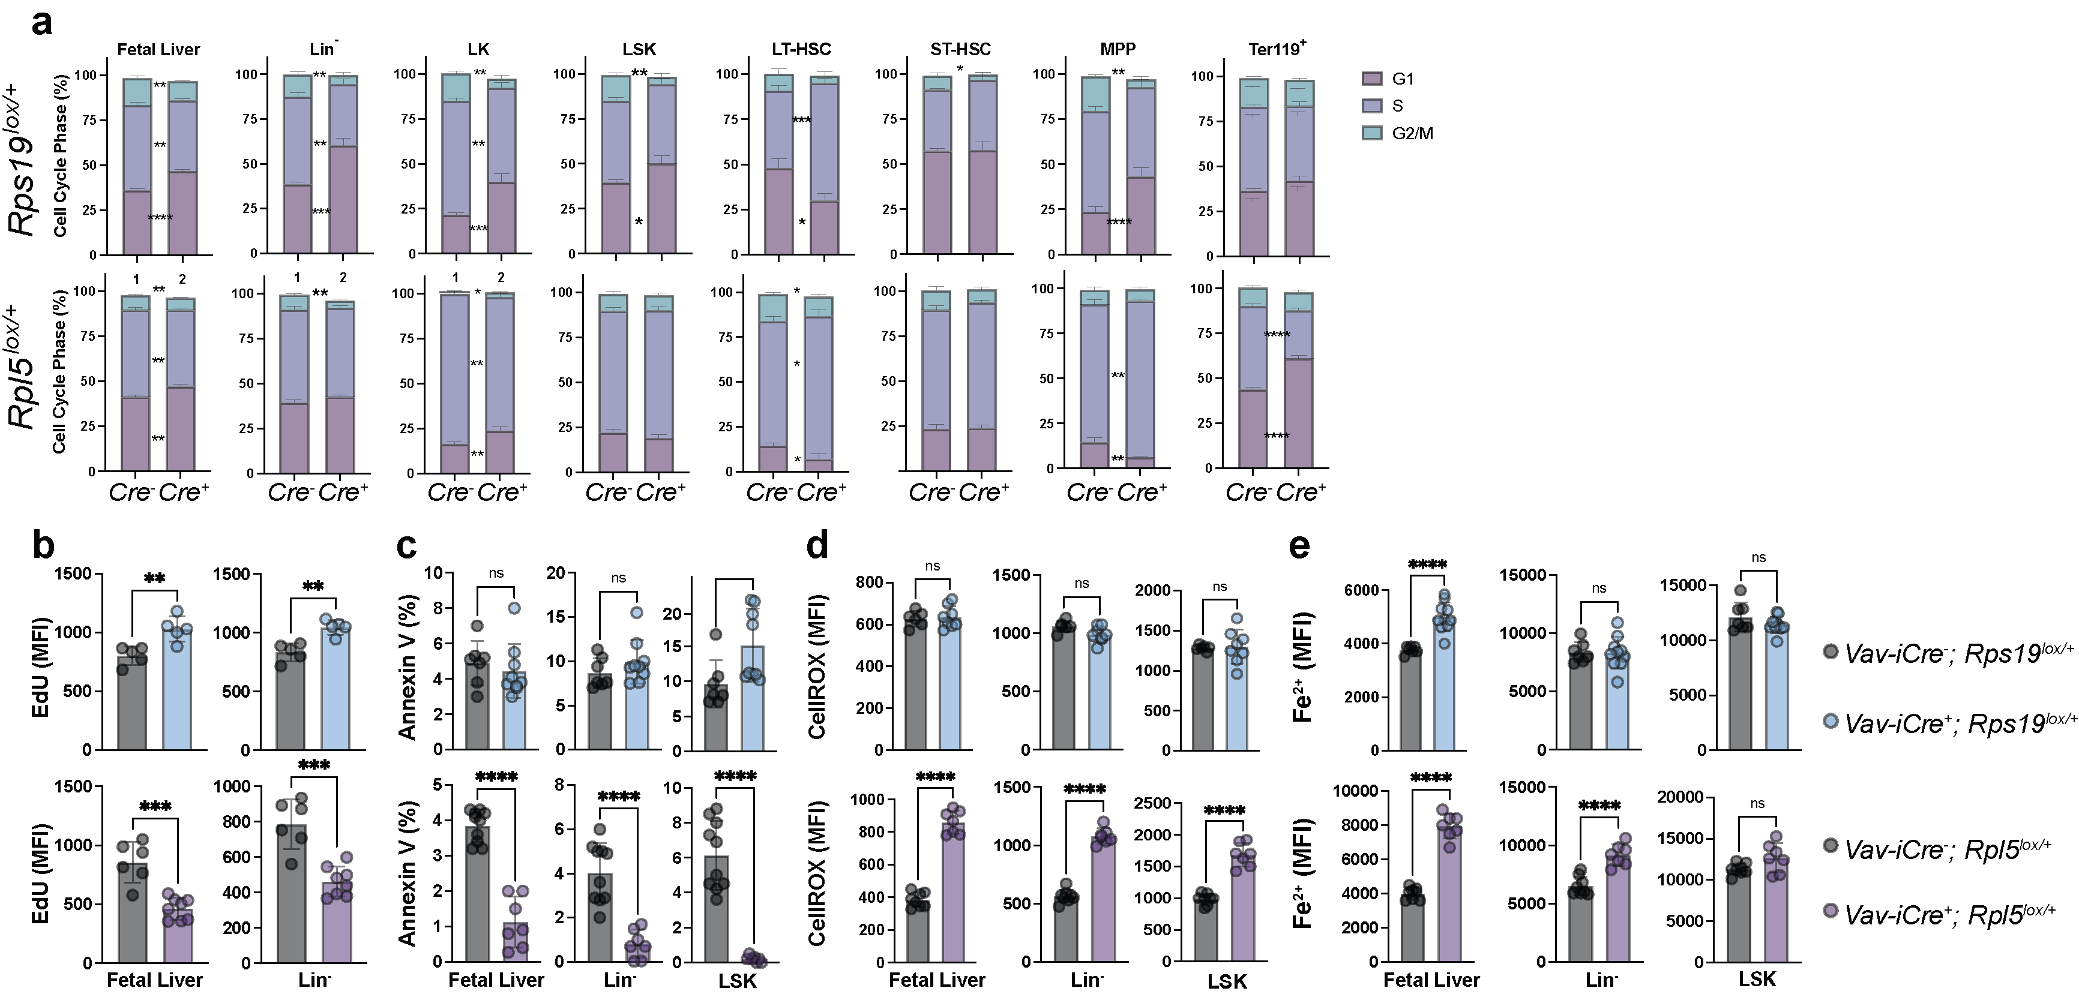

Figure S6. Cell cycle phase distribution and quantification of apoptosis and oxidative stress in HSPC populations. (a) G1, S and G2/M phase distribution in total FL cells and all different HSPC populations in E13.5 control, Rps19^{lox/+} or Rpl5^{lox/+} embryos. (b) Quantification of the cell cycle speed by measuring the S phase (EdU⁺) MFI in the total FL cells and among the indicated HSPC populations in E13.5 control, Rps19^{lox/+} or Rpl5^{lox/+} embryos. (c) Percentage of Annexin V⁺ cells as marker of apoptosis in E15.5 control, Rps19^{lox/+} or Rpl5^{lox/+} embryos. (d) Quantification of cellular ROS levels of FL cells and HSPC populations as measured by CellROX dye in E15.5 control, Rps19^{lox/+} or Rpl5^{lox/+} embryos. (e) Quantification of ferrous iron levels of FL cells and HSPC populations measured as by Fe²⁺ biotracker dye in E15.5 control, Rps19^{lox/+} or Rpl5^{lox/+} embryos. All data are presented as mean ± standard deviation (*p<0.05, **p<0.01, ***p<0.001, ****p<0.0001).

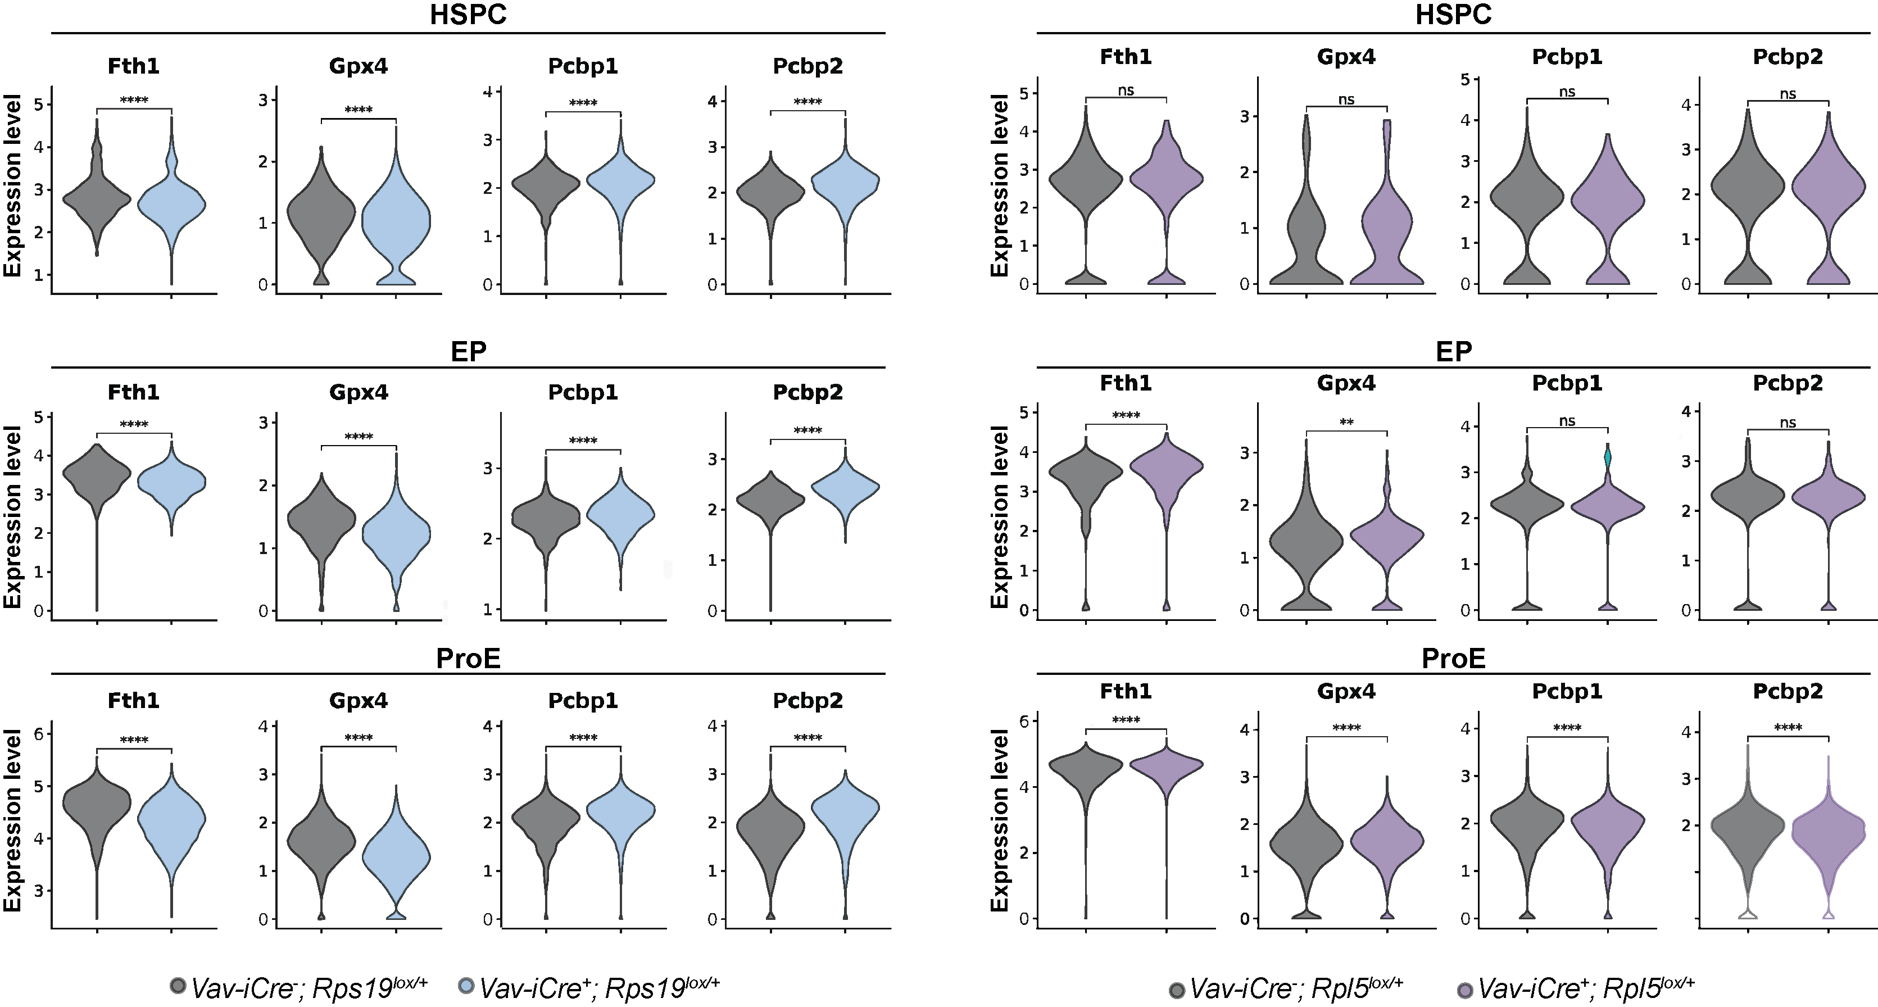

Figure S7. Expression of genes related to ferroptosis in RPS19 and RPL5 haploinsufficient HSPCs, erythroid progenitors (EP) and ProErythroblasts (ProE).

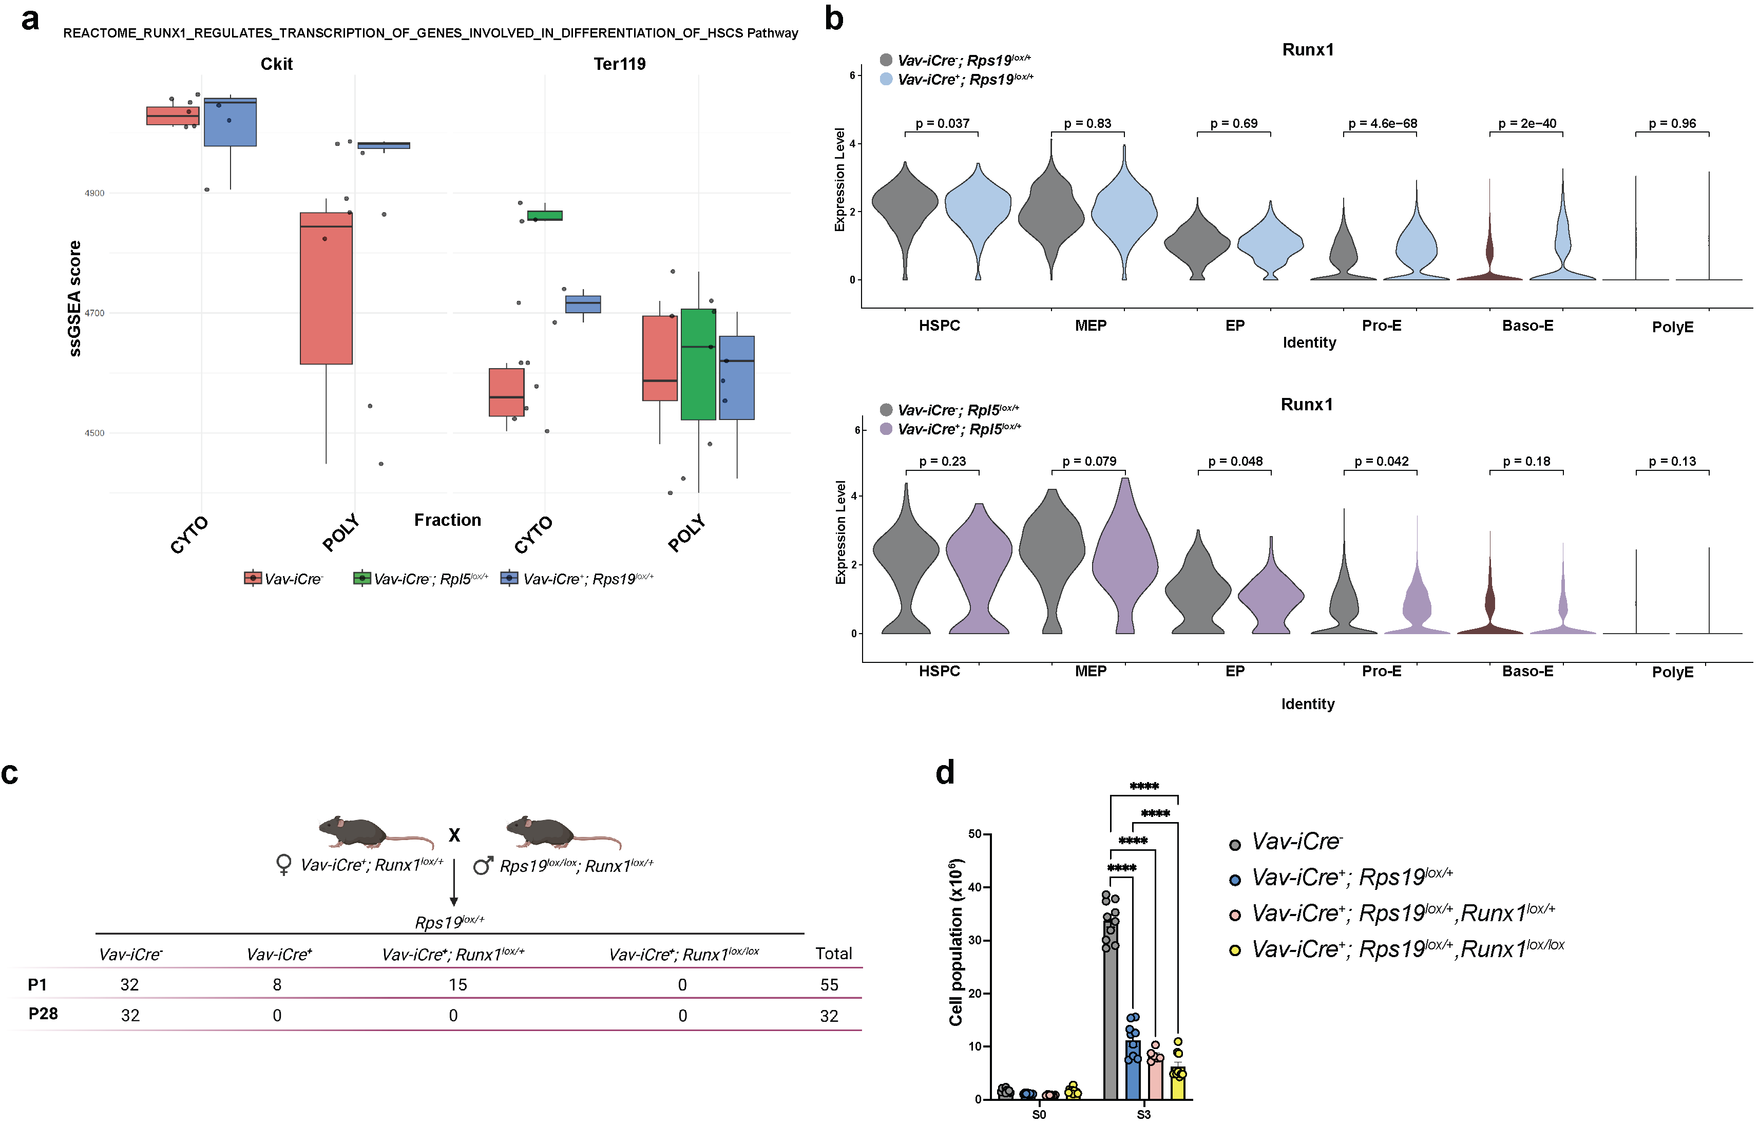
Figure S8. Runx1 expression in RPS19 and RPL5 haploinsufficient mice and knockout in Rps19^{lox/+} mice. (a) pathM2 ssGSEA analysis highlighting RUNX1 transcriptional regulation of genes involved in differentiation of HSCs in polysome sequencing performed on ckit+ population from E15.5 control and Rps19^{lox/+} embryos. (b) Violin plot from scRNA-seq presented in Figure 4 plots showing the expression of Runx1 in each cell type from Rps19^{lox/+} and Rpl5^{lox/+} embryos. (c) Genotype from Rps19^{lox/+}; Runx1^{lox/lox} intercrossing. (d) Quantification of cells in S0 and S3 in E17.5 control, Rps19^{lox/+}, Rps19^{lox/+}; Runx1^{lox/+} and Rps19^{lox/+}; Runx1^{lox/lox} embryos. All data are presented as mean ± standard deviation (****p<0.0001).

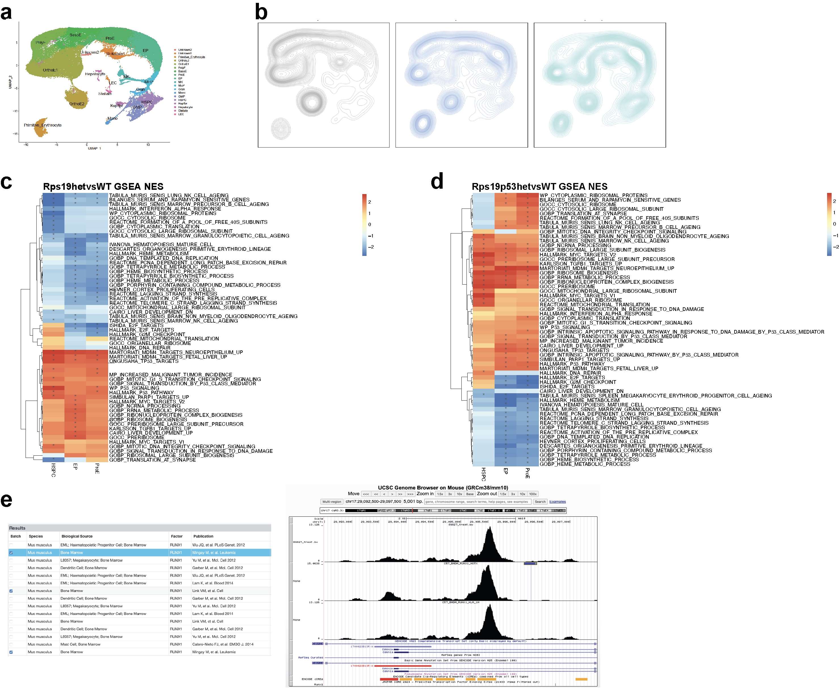
Figure S9. scRNAseq analyses from control, Rps19^{lox/+} and Rps19^{lox/+}; p53^{lox/+} embryos at E13.5. (a) scRNA-seq UMAP of integrated FL from control, Rps19^{lox/+} and Rps19^{lox/+}; p53^{lox/+} cells with clusters identified by marker genes. (b) Density projection of cells on UMAP from control, Rps19^{lox/+} and Rps19^{lox/+}; p53^{lox/+} FL cells. (c) Heatmap showing gene set enrichment analysis (GSEA) normalized enrichment scores (NES) for selected modules significantly enriched in hematopoietic stem and progenitor cell (HSPC), erythroid progenitor (EP) or proerythroblast (ProE) populations from control and Rps19^{lox/+} embryos. Asterisk (*) indicates FDR < 0.05. (d) Heatmap showing gene set enrichment analysis (GSEA) normalized enrichment scores (NES) for selected modules significantly enriched in hematopoietic stem and progenitor cell (HSPC), erythroid progenitor (EP) or proerythroblast (ProE) populations from control and Rps19^{lox/+}; p53^{lox/+} embryos. Asterisk (*) indicates FDR < 0.05. (e) Data from the ENCODE project showing RUNX1 binding region on Cdkn1a detected by ChIP- seq.

