Supplementary Information for

Substrate specificity and shuttling mechanism in DnaK-GroEL mediated cooperative protein folding
Varsha^{1,2}, Siraj Fatima^{2,3}, Uddipan Das⁴, Smriti Priya^{2,3}, Sandeep K. Sharma^{1,2*}
¹Food Toxicology Group, CSIR-Indian Institute of Toxicology Research, Vishvigyan Bhawan, 31, Mahatma Gandhi Marg, Lucknow-226001, Uttar Pradesh, India.
²Academy of Scientific and Industrial Research (AcSIR), Ghaziabad, 201002, India.
³System Toxicology Group, CSIR-Indian Institute of Toxicology Research, Vishvigyan Bhawan, 31, Mahatma Gandhi Marg, Lucknow-226001, Uttar Pradesh, India.
⁴Department of Biophysics, PC Block, All India Institute of Medical Sciences, Ansari Nagar, New Delhi 110029, India.

*Corresponding Author
Dr. Sandeep K. Sharma
CSIR-Indian Institute of Toxicology Research
31, Mahatma Gandhi Marg
Lucknow - 226 001
Uttar Pradesh, India
E-mail: sharma.sandeep@iitr.res.in
Phone: +91-522-2217497-767

Dr. Smriti Priya
CSIR-Indian Institute of Toxicology Research
31, Mahatma Gandhi Marg
Lucknow - 226 001
Uttar Pradesh, India
E-mail: spriya@iitr.res.in
Phone: +91-522-2217497-657
This file includes:
Supplementary Figure S1…………………………………………………………………............3
Supplementary Figure S2………………………………………………………………………….4
Supplementary Figure S3………………………………………………………………….............5
Supplementary Figure S4………………………………………………………………….............6
Supplementary Figure S5………………………………………………………………….............7
Supplementary Figure S6………………………………………………………………….............8
Supplementary Figure S7………………………………………………………………….............9
Supplementary Figure S8…………………………………………………………………...........10
Supplementary Figure S9…………………………………………………………………...........11
Supplementary Figure S10………………………………………………………………….........12
Supplementary Figure S11……………………………………………………………….............13
Supplementary Figure S12………………………………………………………………….........14
Supplementary Figure S13………………………………………………………………….........15

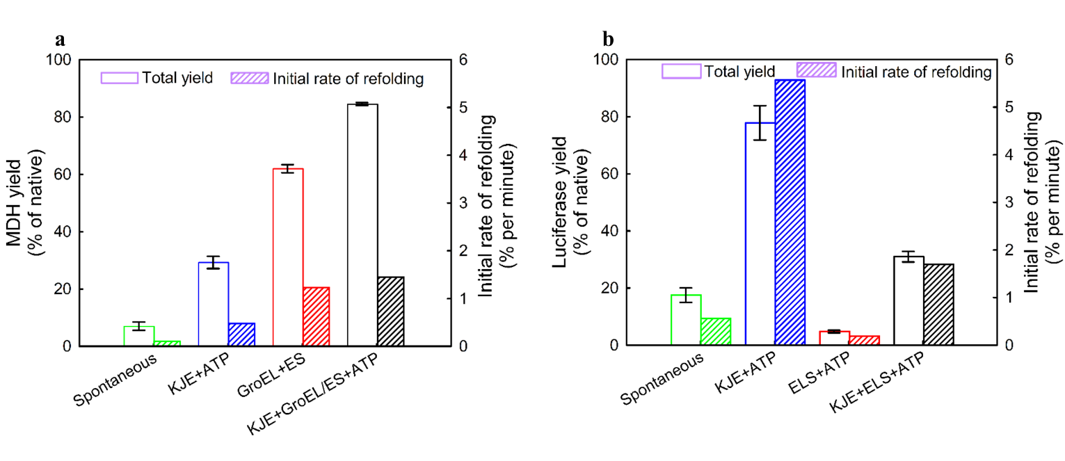
Fig. S1. Net refolding yield and initial rate of refolding of spontaneous and chaperone-mediated refolding of chemically denatured substrates at 25 °C with DnaK (3.5 μM), DnaJ (0.7 μM), GrpE (1.4 μM), GroEL (3.5 μM), and GroES (3.5 μM) in the presence of ATP (5 mM). a, Refolding yield of MDH (700 nM) after 120 min. b, Refolding yield of luciferase (50 nM) after 60 min. The activity of native MDH (700 nM) and luciferase (50 nM) was set to 100%. Data are presented as mean ± SEM from three independent experiments.

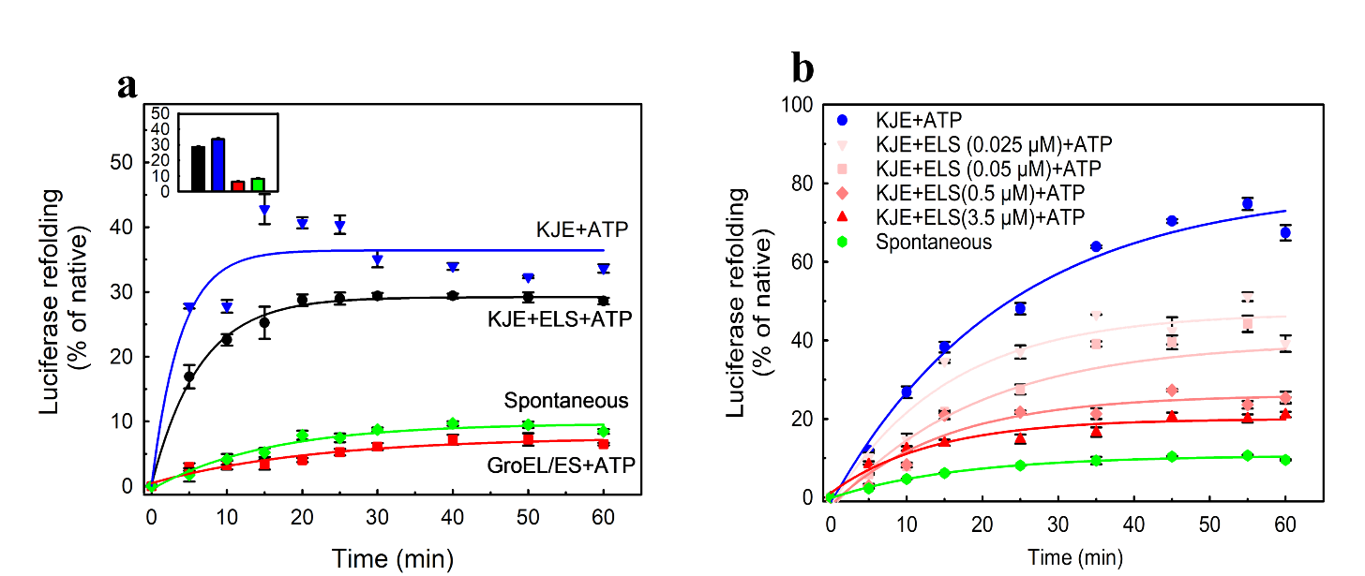

Fig. S2. Luciferase (50 nM) refolding at 25 °C. a, Refolding of heat-denatured luciferase for 60 min (the inset representing the net yield of fig. a). b, Refolding of luciferase (50 nM) mediated by various concentrations of the ELS system (3.5, 0.5, 0.05, 0.025 μM) in the presence of ATP (5 mM) and constant concentrations of DnaK (3.5 μM), DnaJ (0.7 μM), GrpE (1.4 μM). The activity of luciferase (50 nM) was set as 100%. Luciferase (50 nM) was set to 100%. Data are presented as mean ± SEM from three independent experiments.

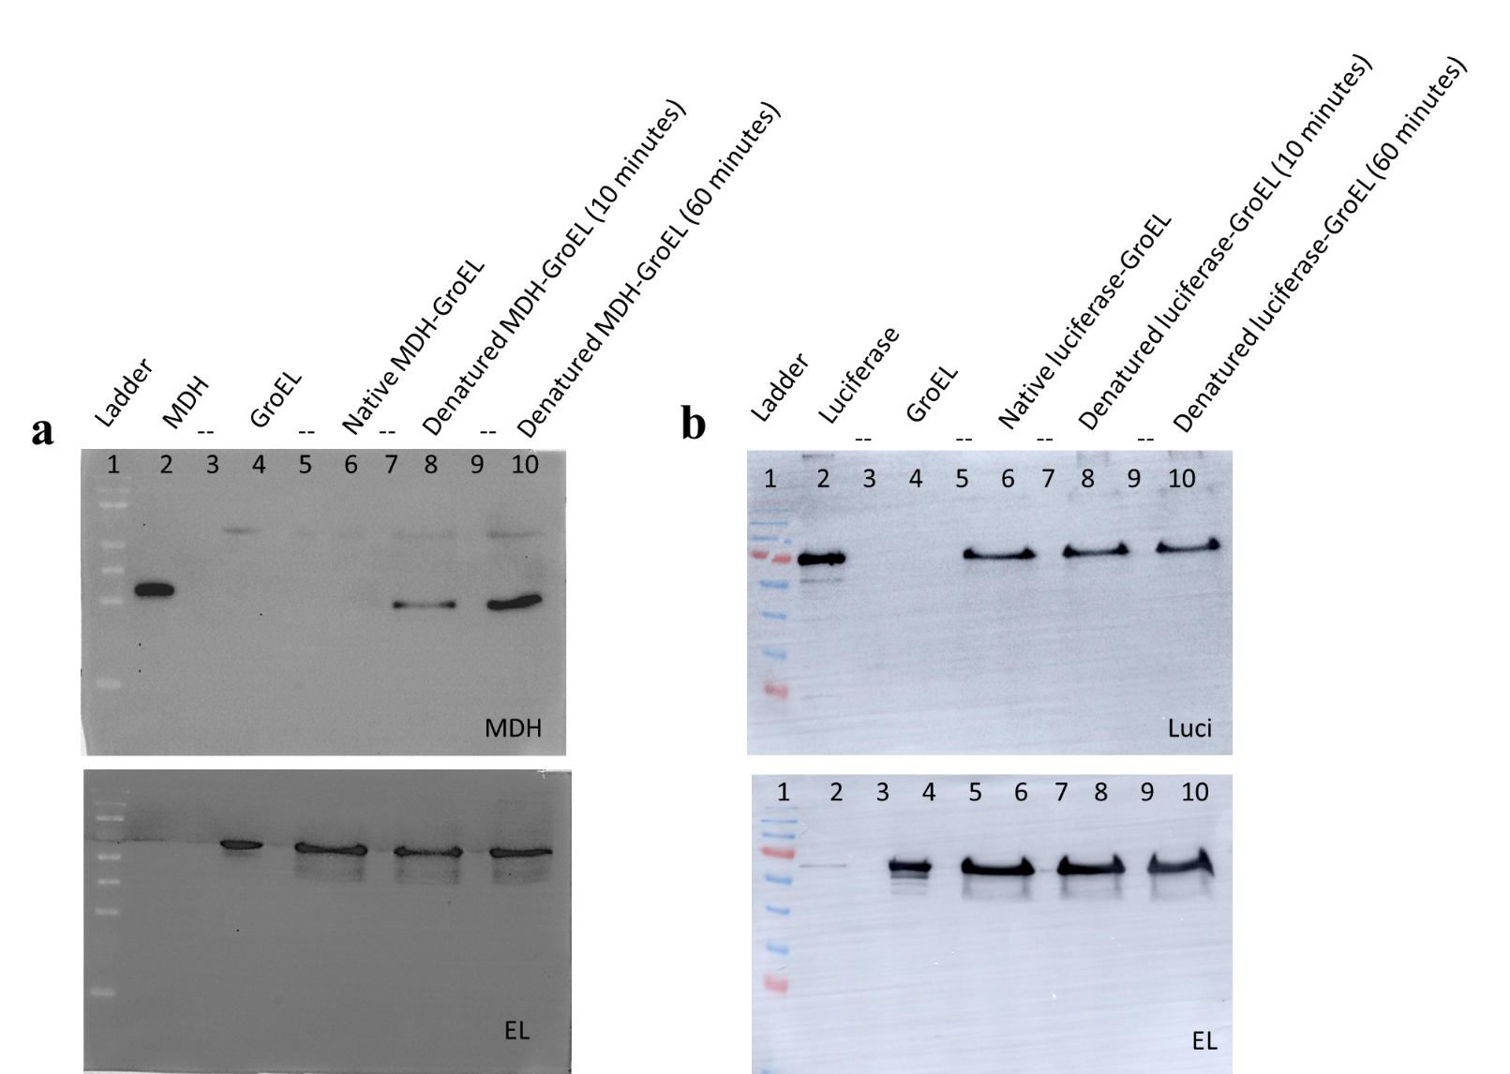

Fig. S3. Full blots are presented in figure 3b and c. a, Immunoprecipitated GroEL–MDH complexes. b, Immunoprecipitated GroEL–luciferase complexes

Fig. S4. CryoEM data processing workflow for GroEL (alone). a, The data-processing workflow. b, Electron micrograph of ice-embedded GroEL. c, Averaged 2D projections showing top and side views of GroEL. d, Gold-standard Fourier shell correlation (GS-FSC) curves present the resolution. e, Posterior precision directional distribution of all particles used in the final 3D reconstruction generated by cryoSPARC.

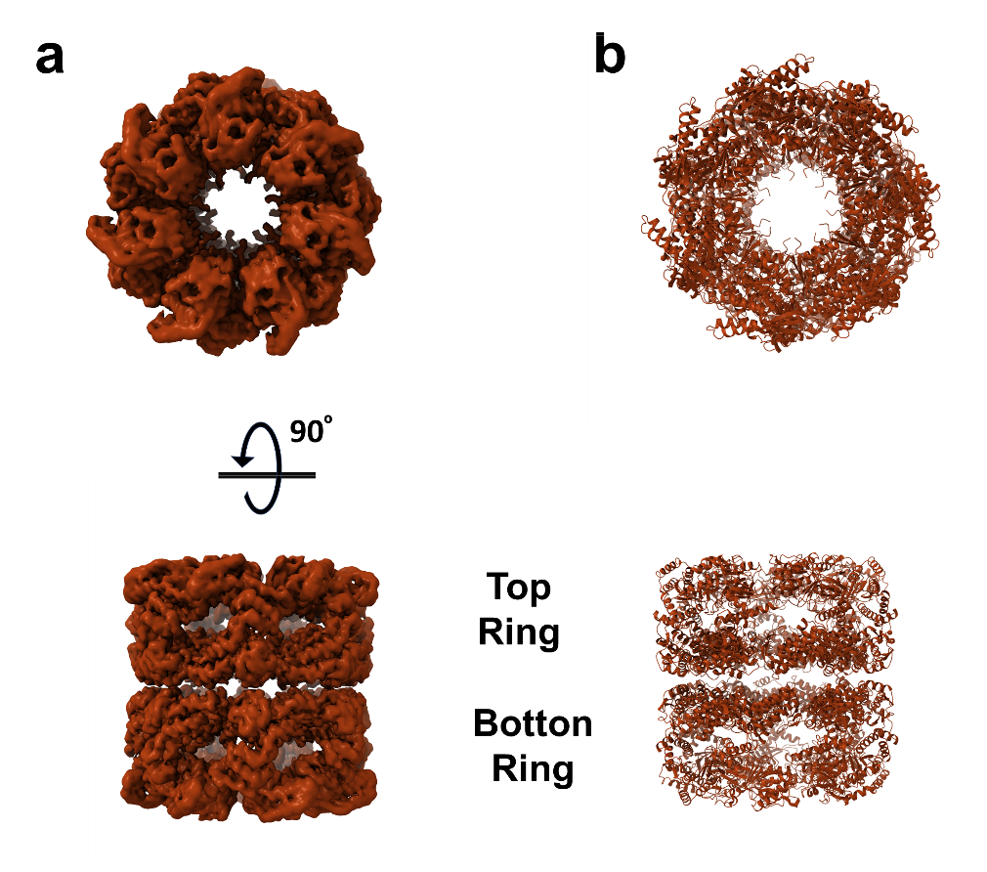

Fig. S5. Cryo-EM structure of GroEL. a, Cryo-EM density map of the GroEL resolved at 2.93 Å, b, Refined atomic model of GroEL shown in red.

Fig. S6. Cryo-EM data processing workflow for GroEL with native luciferase related to figure S5. a, The data-processing workflow. b, Electron micrograph of ice-embedded GroEL-native luciferase complex. c, Averaged 2D projections showing top and side views of GroEL-native luciferase. d, Gold-standard Fourier shell correlation (GS-FSC) curves present the resolution. e, Posterior precision directional distribution of all particles used in the final 3D reconstruction generated by cryoSPARC.

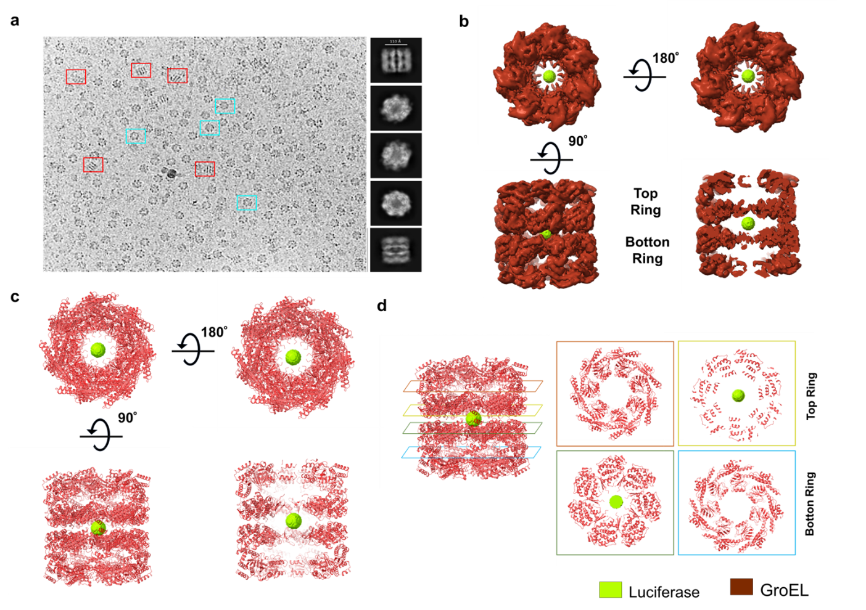
Fig. S7. CryoEM structure of GroEL-native luciferase complex. a, Representative motion-corrected micrograph of vitrified GroEL particles acquired using a Gatan K2 direct electron detector. b, Cryo-EM density map of the GroEL–luciferase complex resolved at 3.01 Å, with GroEL shown in pink and the bound luciferase substrate in blue. c, Refined atomic model of GroEL shown in pink (GroEL) and blue (luciferase). d, Central cross-sections through the GroEL–luciferase complex overlaid with the corresponding cryo-EM density. GroEL is shown as pink, while luciferase density is shown in blue. Lateral sections through individual GroEL rings are shown in colored panels: orange (first ring), yellow (second ring), green (third ring), and cyan (fourth ring).

Fig S8. Cryo-EM data processing workflow for GroEL with denatured luciferase related to figure 3. a, The data-processing workflow. b, Electron micrograph of ice-embedded GroEL-denatured luciferase complex. c, Averaged 2D projections showing top and side views of GroEL-denatured luciferase. d, Gold-standard Fourier shell correlation (GS-FSC) curves present the resolution. e, Posterior precision directional distribution of all particles used in the final 3D reconstruction generated by cryoSPARC.

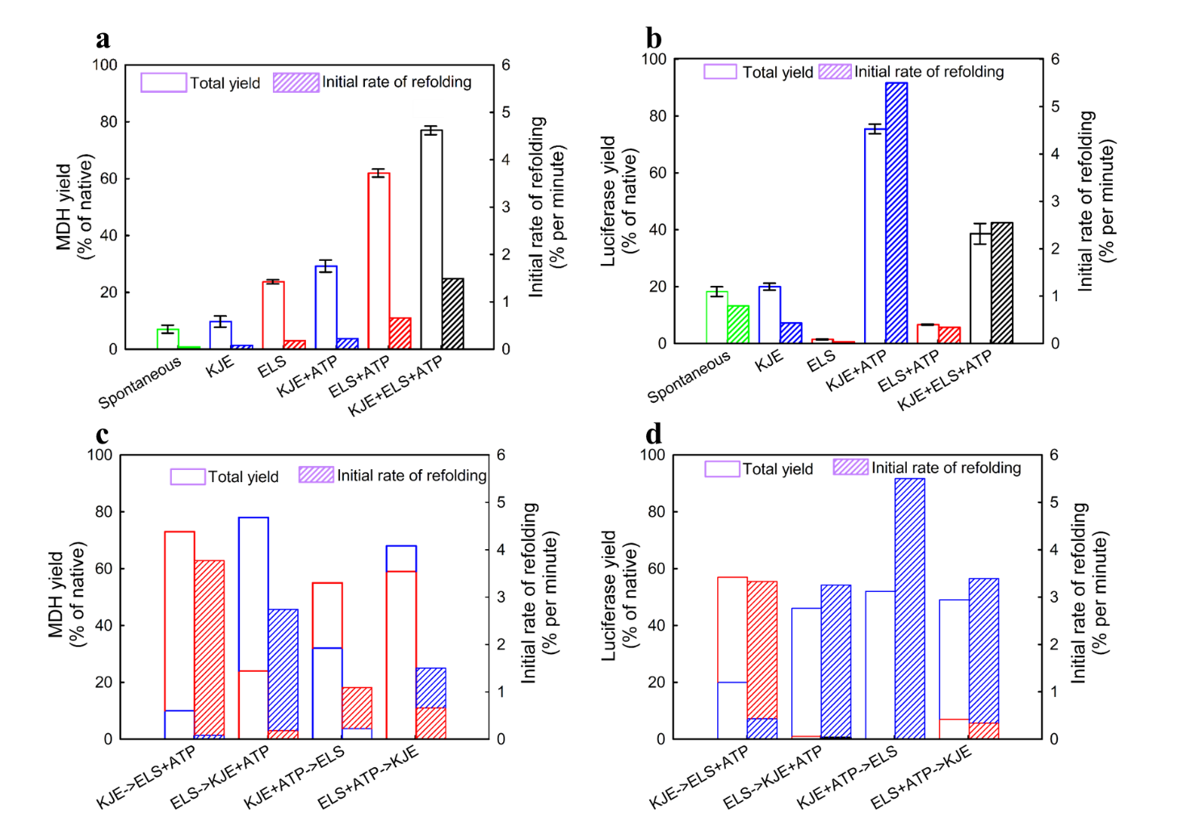
Fig S9. Chaperone-mediate refolding and chaperone addition effect at 25 °C with DnaK (3.5 μM), DnaJ (0.7 μM), GrpE (1.4 μM), GroEL (3.5 μM), and GroES (3.5 μM) in the presence of ATP (5 mM). a, Bar graph of end points of yield of spontaneous and chaperone-mediated refolding of chemically denatured MDH and rate. b, Bar graph of end points of yield of spontaneous and chaperone-mediated refolding of chemically denatured luciferase and rate. c, Stacked bar graph of end points of yield and rate by primary chaperone and addition of complementary chaperone system for MDH refolding. d, Stacked bar graph of end points of yield and rate by primary chaperone and addition of complementary chaperone system for MDH refolding.

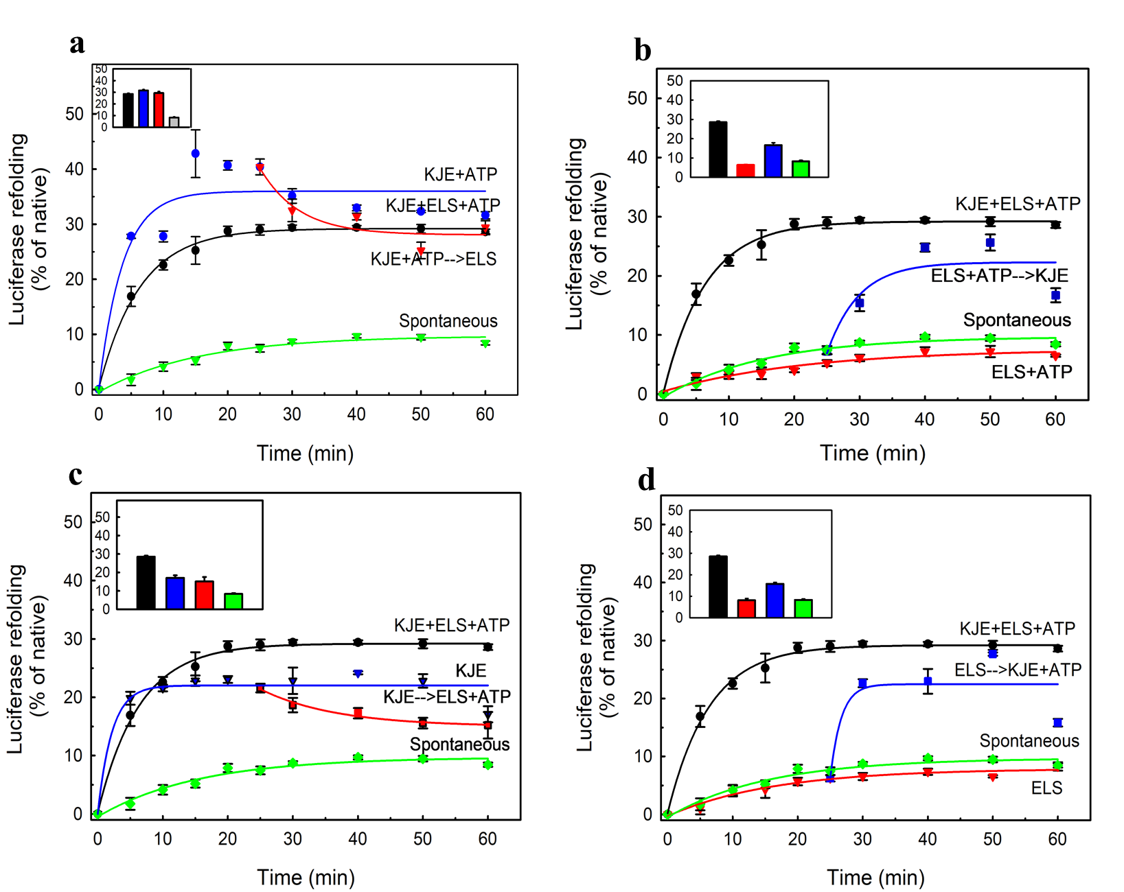
Fig S10. Refolding of heat-denatured luciferase at 25 °C with concentrations of DnaK (3.5 µM), DnaJ (0.7 µM), GrpE (1.4 µM), GroEL (3.5 µM), and GroES (3.5 µM) with ATP (5 mM) over 60 minutes. a, Addition of ELS to the luciferase folding intermediate mediated by KJE in the presence of ATP (inset: endpoint representation of plot a). b, Addition of KJE to luciferase folding intermediate mediated by ELS in the presence of ATP (inset: endpoint representation of plot b). (inset: endpoint representation of plot b). c, Addition of ELS and ATP to the luciferase folding intermediate mediated by KJE (inset: endpoint representation of plot c). d, Addition of KJE and ATP to the luciferase folding intermediate mediated by ELS (inset: endpoint representation of plot d). The experiments shown in Figures S2a and S10a–d were performed simultaneously; therefore, the data points for spontaneous, KJE–ATP, ELS–ATP, and KJE–ELS–ATP are identical. Data are presented as mean ± s.d. of three independent experiments.

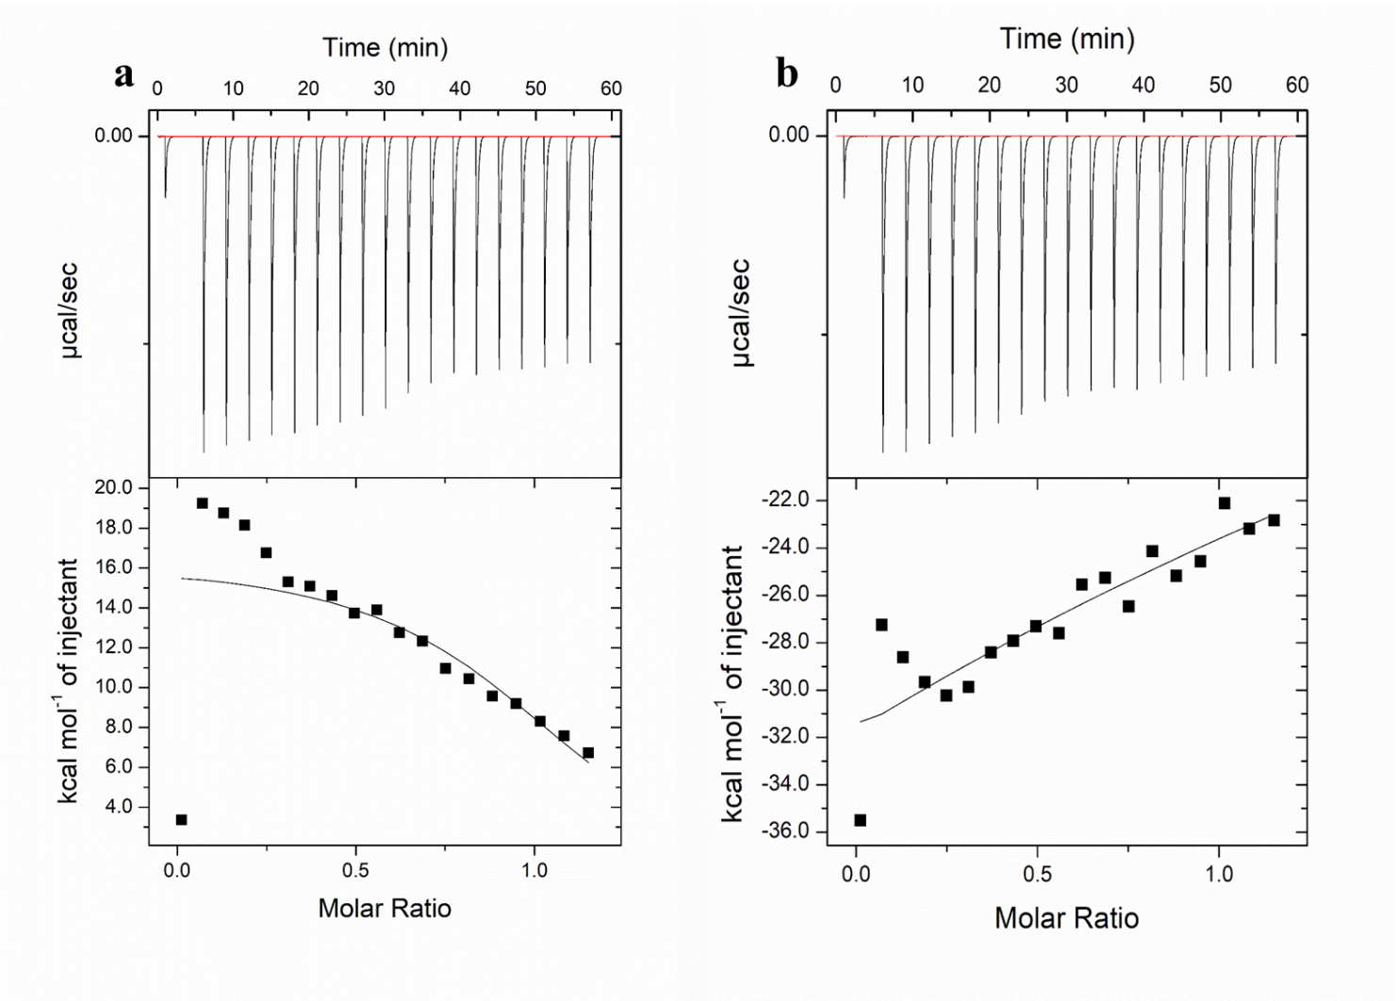
Fig S11. ITC profile showing binding of native MDH (10 µM) at 25 °C with a, DnaJ (60 µM). b, GroEL (60 µM).

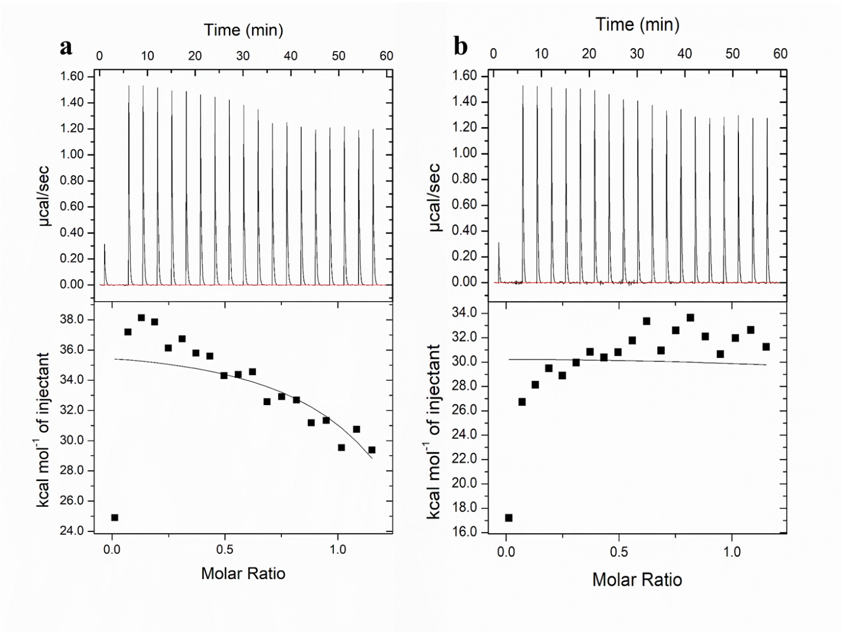
Fig S12. ITC profile showing binding of native luciferase (10 µM) at 25 °C with. a, DnaJ (60 µM). b, GroEL (60 µM).

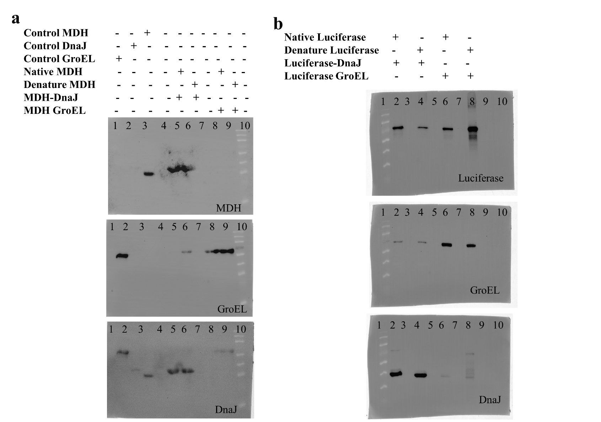

Fig S13. Full blots are presented in figure 5 b,d. a, Western blot analysis of collected and eluted samples of MDH, MDH control (lane 1), DanJ control (lane 2), GroEL control (lane 3), native and denatured luciferase transferred to DanJ (lanes 3 and 4), native and denatured luciferase remaining complexed with GroEL (lanes 5 and 6). b, Western blot analysis of collected and eluted samples of luciferase, native and denatured luciferase transferred to DanJ (lanes1 and 2), native and denatured luciferase remain complexed with GroEL (lanes 3 and 4).

