Supporting Information
Synthesis of 4,6-Diphenyl-3-cyanopyridine Derivatives Based on 3D-QSAR: Unveiling Their Potential as Survivin Protein Inhibitors

JiaHao Lu^{a,b},ChenHao Zhao^{b}, YingQI Qiu^{b}, Miao Zhang^{a*}, Hua Zhu^{a*},Li-Qun Shen^{b*}

ªGuangxi Key Laboratory of Zhuang and Yao Ethnic Medicine, Guangxi University of Chinese Medicine, 530200, Nanning, Guangxi, China
^{b}College of Chemistry and Chemical Engineering, Guangxi Minzu University, Key Laboratory of Chemistry and Engineering of Forest Products, State Ethnic Affairs Commission, Guangxi Key Laboratory of Chemistry and Engineering of Forest Products, Guangxi Collaborative Innovation Center for Chemistry and Engineering of Forest Products, Nanning 530006, China.

*Miao Zhang, Guangxi Key Laboratory of Zhuang and Yao Ethnic Medicine, Guangxi University of Chinese Medicine, 530200, 17535764888@163.com
*Hua Zhu, Guangxi Key Laboratory of Zhuang and Yao Ethnic Medicine, Guangxi University of Chinese Medicine, 530200, zhuhuagx@163.com
*Liqun Shen, College of Chemistry and Chemical Engineering, Guangxi Minzu University, Nanning 530006, China. liqunshen@126.com

Contents
1. 3D-QSAR materials supplementary instruction
2. Synthesis Procedures
3. Molecular docking supplementary instruction
4. Protein-ligand interaction fingerprint supplementary instruction
5. Partial spectrogram of compounds

1. 3D-QSAR materials supplementary instruction
In the study, the data samples for 3D-QSAR were derived from a consistent source, namely the experimental accumulations of the research group, ensuring uniformity in the dataset's provenance. The compounds were constructed into three-dimensional structures within the MOE software suite and optimized using the MMFF94X force field. Each structure was then saved as an individual MOL2 file, which was directly imported into the SYBYL-X software. Subsequently, 3D-QSAR models were built employing both PLS (Partial Least Squares) and LOO (Leave-One-Out) methods. This process culminated in the generation of experimental 3D-QSAR models, accompanied by tri-dimensional potential analysis maps that included electrostatic fields, van der Waals volume fields, hydrophobic fields, hydrogen bond donor-acceptor interactions, and receptor fields.
The relationship between pIC₅₀ and IC₅₀ is mathematically expressed as:
pIC₅₀=−lg(IC₅₀)

2. Synthesis Procedures
Experiment
The synthetic route of compound in this subject. As shown in figure .
Scheme 1. Synthesis Route of 4,6-Bisphenyl-3-Cyanopyridine
Experimentally, various benzaldehyde derivatives (6 mmol), acetophenone derivatives (6 mmol), malononitrile (6 mmol), and ammonium acetate (48 mmol) were introduced into a 100 mL round-bottom flask. An appropriate amount of toluene was added as the reaction solvent under a protective nitrogen atmosphere. The mixture was refluxed for 12 hours to ensure complete reaction. Following this, ethyl acetate was added, and toluene was removed via azeotropic distillation. Finally, the resulting product was separated using gradient column chromatography with a solvent system consisting of petroleum ether to ethyl acetate in a ratio gradient from 30:1 to 2:1. The purified products were characterized by nuclear magnetic resonance spectroscopy and high-resolution mass spectrometry; the specific spectra can be found in Supplementary File section 5.

3. Molecular docking supplementary instruction
In MOE software, compound structures were pre-built and subjected to energy minimization using the MMFF94x force field, with the energy minimization threshold set to less than 0.0001 kcal/mol/A^{^2}. Optimized structures were subsequently saved as MOL2 files, thus creating a ligand database. The crystallographic data for the survivin protein was downloaded and imported into MOE (PDB ID: 3uih); the native ligand and water molecules were removed. Under the AMBER99 force field conditions, the protein was further minimized with an energy convergence criterion set to less than 0.01 kcal/mol/A^{^2}. Using SiteFinder, potential active sites were identified, and it was observed that the optimal binding site resides within the BIR (baculoviral IAP repeat) domain of the survivin protein. This location was selected as the binding site for molecular docking. Next, molecular docking was performed, with small molecules undergoing ten different conformer searches before being docked into the chosen binding site.

4. Protein-ligand interaction fingerprint supplementary instruction
A single best docking pose does not adequately represent the binding model of a small molecule with its protein target. To address this, the docking results of all 36 compounds in the training set and 19 synthesized compounds in the test set were integrated. For each compound, ten distinct conformations were generated during the molecular docking process. Subsequently, PLIF (Protein-Ligand Interaction Fingerprints) analysis was directly conducted on these docking poses using the software, a step that can be directly visualized within the MOE software environment.

5. Partial spectrogram of compounds
The ¹H NMR and ¹³C NMR spectra were recorded on Bruker ACANCEIIIHD-400 and 100 spectrometers (Bruker, Karlsruhe, Germany), respectively, using DMSO-d6 and TMS as an internal standard. The following abbreviations indicate the spin multiplicity: singlet(S), doublet (D), triplet (T), multiplet (M). High-resolution mass spectrometry (HRMS) measurements were performed on LC-MS QE Focus (Thermo Fisher Scientific, MMAS, USA).The infrared spectrum was obtained by the Nicolet IS10 Fourier transform infrared spectrometer (KBr disk)
D1: 2-amino-6-(4-phenoxyphenyl)-4-phenylnicotinonitrile
¹H NMR (400 MHz, DMSO-d₆) δ 8.21 – 8.14 (m, 2H), 7.67 (dt, J = 7.0, 2.7 Hz, 2H), 7.59 – 7.52 (m, 2H), 7.48 – 7.41 (m, 2H), 7.41 – 7.36 (m, 1H), 7.26 (s, 1H), 7.23 – 7.17 (m, 1H), 7.14 – 7.05 (m, 4H), 7.00 (s, 2H). ¹³C NMR (101 MHz, DMSO-d₆) δ 161.30, 159.19, 158.40, 156.31, 155.32, 137.51, 132.90, 130.70, 130.04, 129.83, 129.69, 129.20, 129.12, 128.80, 124.61, 119.84, 118.44, 109.29. IR (KBr) σ/cm⁻¹: 3474.04, 3295.82, 3152.05, 2203.14, 1626.12, 1587.73, 1572.29, 1546.76, 1509.39, 1487.86, 1452.91, 1431.66, 1370.30, 1198.15, 1168.25, 870.32, 837.40, 800.51, 782.23, 757.22, 749.62, 527.65. HR-ESI-MS (pos. ion mode): m/z=364.1438, [M+H]⁺(anal. calcd. for C₂₄H₁₇N₃O=363.13716).
D2: 2-amino-4-(4-(benzyloxy)phenyl)-6-(2,4-difluorophenyl)nicotinonitrile
¹H NMR (400 MHz, DMSO-d₆) δ 8.00 (td, J = 8.9, 6.8 Hz, 1H), 7.66 – 7.57 (m, 2H), 7.53 – 7.44 (m, 2H), 7.46 – 7.36 (m, 3H), 7.40 – 7.32 (m, 1H), 7.31 – 7.21 (m, 1H), 7.22 – 7.14 (m, 2H), 7.09 – 7.00 (m, 3H), 5.20 (s, 2H). ¹³C NMR (101 MHz, DMSO-d₆) δ 161.34, 160.09, 154.75, 137.25, 130.23, 129.46, 128.98, 128.44, 128.26, 117.44, 115.56, 113.59 – 111.46 (m), 105.91 – 104.53 (m), 69.87. IR (KBr) σ/cm⁻¹: 3474.10, 3317.32, 3201.36, 3077.21, 2210.69, 1632.51, 1610.37, 1600.70, 1582.32, 1557.73, 1547.32, 1510.84, 1489.98, 1452.80, 1372.09, 1293.45, 1250.92, 1225.48, 1181.48, 1144.61, 1101.12, 975.74, 946.51, 866.07, 826.02, 739.98, 515.27. HR-ESI-MS (pos. ion mode): m/z=414.1411, [M+H]⁺(anal. calcd. for C₂₅H₁₇F₂N₃O=413.13397).
D3: 2-amino-6-(4-phenoxyphenyl)-4-(4-(trifluoromethyl)phenyl)nicotinonitrile
¹H NMR (400 MHz, DMSO-d₆) δ 8.22 – 8.12 (m, 2H), 7.92 (q, J = 8.4 Hz, 4H), 7.79 (d, J = 8.0 Hz, 1H), 7.62 (d, J = 7.9 Hz, 1H), 7.32 (s, 1H), 7.21 (td, J = 7.3, 1.1 Hz, 1H), 7.15 – 7.04 (m, 6H). ¹³C NMR (101 MHz, DMSO-d₆) δ 161.20, 158.99 (d, J = 66.2 Hz), 130.71, 129.87, 129.75, 126.09, 124.65, 119.86, 118.45, 109.30. IR (KBr) σ/cm⁻¹: 3412.23, 3302.96, 3179.60, 2209.90, 1639.49, 1608.62, 1586.15, 1566.41, 1508.08, 1487.98, 1454.36, 1366.59, 1263.92, 1197.00, 1127.89, 1114.19, 1018.62, 870.51, 756.95, 692.47. HR-ESI-MS (pos. ion mode): m/z=432.1318，[M+H]⁺(anal. calcd. for C₂₅H₁₆F₃N₃O=431.12455).
D4: 2-amino-6-(3,5-bis(trifluoromethyl)phenyl)-4-(4-(trifluoromethyl)phenyl)nicotinonitrile
¹H NMR (400 MHz, DMSO-d₆) δ 8.80 (s, 2H), 8.22 (s, 1H), 7.95 (d, J = 8.0 Hz, 1H), 7.86 (t, J = 7.7 Hz, 1H), 7.77 (t, J = 7.9 Hz, 1H), 7.71 (d, J = 1.5 Hz, 1H), 7.58 (d, J = 7.6 Hz, 1H), 7.35 (s, 2H). ¹³C NMR (101 MHz, DMSO-d₆) δ 160.08, 154.82, 154.65, 140.12, 136.01, 133.16, 131.52, 131.28, 131.20, 130.22, 128.16, 126.75 (d, J = 5.0 Hz), 125.11, 122.39, 115.95, 110.98, 90.93. IR (KBr) σ/cm⁻¹: 3500.28, 3374.12, 2222.27, 1625.45, 1578.62, 1560.74, 1452.30, 1342.50, 1314.65, 1061.09, 1035.40, 900.72, 859.94, 844.58, 772.34, 699.34, 682.18. HR-ESI-MS (pos. ion mode): m/z=476.0806, [M+H]⁺(anal. calcd. for C₂₁H₁₀F₉N₃=475.07310).
D5: 2-amino-6-(3,5-bis(trifluoromethyl)phenyl)-4-(4-hydroxyphenyl)nicotinonitrile
¹H NMR (400 MHz, DMSO-d₆) δ 9.98 (s, 1H), 8.85 – 8.72 (m, 2H), 8.21 (s, 1H), 7.68 – 7.56 (m, 3H), 7.13 (s, 2H), 6.94 (d, J = 8.7 Hz, 1H).¹³C NMR (101 MHz, DMSO-d₆) δ 161.37, 159.61, 156.09, 155.01, 140.69, 131.37, 131.04, 130.64, 128.23, 127.48, 117.53, 115.91, 110.12, 88.38. IR (KBr) σ/cm⁻¹: 3492.15, 3376.86, 2217.51, 1626.47, 1577.65, 1558.45, 1540.34, 1516.50, 1464.24, 1391.56, 1341.52, 1237.21, 1178.48, 1131.64, 903.02, 834.07, 698.04, 682.96. HR-ESI-MS (pos. ion mode): m/z=424.0882, [M+H]⁺(anal. calcd. for C₂₀H₁₁F₆N₃O=423.08063).
D6: 2-amino-6-(4-hydroxyphenyl)-4-(2,3,4-trimethoxyphenyl)nicotinonitrile
¹H NMR (400 MHz, DMSO-d₆) δ 9.91 (s, 1H), 8.15 – 8.01 (m, 1H), 7.99 – 7.87 (m, 2H), 7.74 (s, 0H), 7.10 – 7.02 (m, 2H), 6.99 – 6.89 (m, 1H), 6.88 – 6.82 (m, 2H), 6.80 (s, 2H), 3.87 (d, J = 2.2 Hz, 3H), 3.81 (s, 3H), 3.71 (s, 3H). ¹³C NMR (101 MHz, DMSO-d₆) δ 160.60, 159.92, 158.50, 154.82, 152.63, 151.06, 142.08, 129.27, 128.86, 124.91, 124.56, 115.89, 109.69, 108.24, 88.11, 61.62, 61.01, 56.44. IR(KBr）σ/cm-1：3460.33, 3401.97, 3241.03, 3049.65, 2541.52, 1848.43,1642.95, 1585.77, 1573.25, 1555.69, 1530.41, 1500.48,1468.07, 1426.94, 1333.28, 1316.90, 1246.5, 1192.094, 1166.31, 1111.37, 1062.00, 1036.69, 986.09, 915.56, 796.73, 739.33, 700.09, 684.09, 659.09, 560.62. HR-ESI-MS (neg. ion mode): m/z=376.1315, [M-H]⁻(anal. calcd. for C₂₁H
D7: 2-amino-6-(4-(methylsulfonyl)phenyl)-4-(2-(trifluoromethyl)phenyl)nicotinonitrile
¹H NMR (400 MHz, DMSO-d₆) δ 8.39 – 8.28 (m, 2H), 8.13 – 8.06 (m, 1H), 8.05 – 8.01 (m, 2H), 7.98 – 7.91 (m, 1H), 7.85 (ddd, J = 9.5, 7.2, 1.8 Hz, 2H), 7.76 (t, J = 7.5 Hz, 1H), 7.59 (d, J = 7.3 Hz, 1H), 7.36 (s, 1H), 7.27 (s, 2H), 3.27 (s, 3H). ¹³C NMR (101 MHz, DMSO-d₆) δ 160.22, 156.49, 154.31, 142.30 (d, J = 9.2 Hz), 133.22, 131.33, 130.26, 128.47, 127.90 (d, J = 3.8 Hz), 126.84, 116.11, 110.97, 90.34, 43.88. IR (KBr) σ/cm⁻¹: 3446.41, 3347.58, 3226.35, 2959.49, 2926.94, 2213.96, 1632.59, 1572.36, 1551.69, 1493.95, 1451.48, 1396.13, 1363.38, 1276.14, 1255.20, 1188.94, 1178.56, 1084.01, 1063.10, 1036.18, 955.09, 838.74, 769.86, 650.97, 569.58, 543.73, 532.57. HR-ESI-MS (pos. ion mode): m/z=440.0706, [M+Na]⁺(anal. calcd. for C₂₀H₁₄F₃N₃O₂S=417.07588).
D8: 2-amino-4-(4-hydroxyphenyl)-6-(4-(methylsulfonyl)phenyl)nicotinonitrile
¹H NMR (400 MHz, DMSO-d₆) δ 9.33 (s, 0H), 8.63 – 8.56 (m, 1H), 8.42 – 8.32 (m, 2H), 8.13 – 8.07 (m, 1H), 8.07 – 7.97 (m, 3H), 7.61 – 7.56 (m, 2H), 7.36 (s, 1H), 7.09 – 7.01 (m, 3H), 6.95 (dd, J = 12.3, 8.7 Hz, 2H), 6.74 – 6.65 (m, 1H), 3.28 (s, 3H). ¹³C NMR (101 MHz, DMSO-d₆) δ 161.45, 159.56, 156.89, 155.67, 142.83, 142.08, 130.46, 128.98 – 127.08 (m), 115.81 (d, J = 36.3 Hz), 110.21, 87.90, 43.92. IR (KBr) σ/cm⁻¹: 3453.74, 3348.44, 2923.89, 2210.42, 1691.18, 1611.36, 1578.23, 1559.24, 1547.19, 1517.96, 1496.94, 1440.98, 1364.47, 1307.30, 1276.15, 1220.48, 1176.73, 1146.93, 1087.54, 961.43, 834.51, 774.33, 569.60, 530.52. HR-ESI-MS (pos. ion mode): m/z=364.0771, [M-H]⁻(anal. calcd. for C₁₉H₁₅N₃O₃S=365.08341).
D9: 2-amino-6-(2-fluoro-4-hydroxyphenyl)-4-(2-(trifluoromethyl)phenyl)nicotinonitrile
¹H NMR (400 MHz, DMSO-d₆) δ 10.43 (s, 1H), 7.96 – 7.85 (m, 2H), 7.82 (td, J = 7.6, 1.4 Hz, 1H), 7.73 (tt, J = 7.7, 1.1 Hz, 1H), 7.55 (d, J = 7.6 Hz, 1H), 7.09 (s, 2H), 6.90 (d, J = 1.6 Hz, 1H), 6.76 (dd, J = 8.7, 2.4 Hz, 1H), 6.64 (dd, J = 13.7, 2.4 Hz, 1H). ¹³C NMR (101 MHz, DMSO-d₆) δ 161.32 (d, J = 12.5 Hz), 160.14, 154.98, 153.21, 133.20, 132.28 (d, J = 4.6 Hz), 131.34, 130.16, 126.79, 116.73, 116.40, 103.73, 103.47, 88.31. IR (KBr) σ/cm⁻¹: 3460.05, 3344.22, 3241.58, 2228.57, 1642.32, 1513.77, 1499.59, 1499.59, 1450.55, 1425.07, 1373.15, 1274.55, 1245.94, 1154.23, 1062.98, 1036.70, 972.75, 960.77, 951.18, 852.26, 815.31, 658.75, 647.15, 467.57. HR-ESI-MS (pos. ion mode): m/z=472.0777, [M-H]⁻(anal. calcd. for C₁₉H₁₁F₄N₃O=373.0838).
D10: 2-amino-3',5'-dibromo-6-(2-fluoro-4-hydroxyphenyl)-[4,4'-bipyridine]-3-carbonitrile
¹H NMR (400 MHz, DMSO-d6) δ 10.31 (d, J = 1.0 Hz, 1H), 9.00 – 8.72 (m, 1H), 7.27 (t, J = 8.8 Hz, 1H), 6.82 (s, 2H), 6.77 – 6.66 (m, 3H), 6.51 (s, 1H). ¹³C NMR (101 MHz, DMSO) δ 162.42, 160.81, 160.74, 149.42, 131.83, 131.78, 117.19, 113.49, 112.48, 103.53, 103.29, 87.09. IR (KBr) σ/cm⁻¹: 3317.87, 3161.16, 2958.17, 2919.70, 2850.42, 2217.85, 1714.31, 1653.56, 1625.01, 1585.11, 1557.61, 1514.94, 1492.13, 1465.74, 1397.26, 1362.68, 1315.58, 1244.68, 1208.28, 1181.40, 1154.35, 1108.68, 1079.12, 970.67, 842.79, 809.30, 646.64. HR-ESI-MS (pos. ion mode): m/z=463.8883, [M-H]⁻(anal. calcd. for C₁₇H₉Br₂FN₄O=464.9140).
D11: 2-amino-4-(2-bromophenyl)-6-(4-(methylsulfonyl)phenyl)nicotinonitrile
¹H NMR (400 MHz, DMSO-d6) δ 8.61 – 8.52 (m, 1H), 8.40 – 8.32 (m, 2H), 8.21 – 8.15 (m, 2H), 8.09 (d, J = 2.0 Hz, 3H), 7.35 (s, 1H), 7.28 – 7.19 (m, 3H), 3.29 (s, 3H). ¹³C NMR (101 MHz, DMSO) δ 160.55, 157.05, 155.63, 144.78, 133.29, 129.53, 128.49, 127.84, 121.70, 110.94, 90.19, 43.67. IR (KBr) σ/cm⁻¹: 3449.35, 3350.07, 3350.07, 2919.05, 2213.81, 1633.41, 1592.85, 1571.04, 1549.63, 1491.41, 1481.80, 1450.16, 1362.67, 1303.34, 1290.57, 1273.29, 1256.09, 1179.85, 1146.69, 1130.10, 1081.63, 965.48, 955.09, 833.84, 775.62, 760.74, 544.54, 530.50. HR-ESI-MS (pos. ion mode): m/z=430.0034, [M+H]⁺(anal. calcd. for C₁₉H₁₄BrN₃O₂S=428.9970).
D12: 2-amino-6-(3,5-bis(trifluoromethyl)phenyl)-4-(2-bromophenyl)nicotinonitrile
¹H NMR (400 MHz, DMSO-d₆) δ 8.87 – 8.75 (m, 2H), 8.23 (s, 1H), 7.83 (dd, J = 8.0, 1.2 Hz, 1H), 7.68 (s, 1H), 7.57 (td, J = 7.4, 1.2 Hz, 1H), 7.53 – 7.43 (m, 2H), 7.33 (s, 2H). ¹³C NMR (101 MHz, DMSO) δ 160.42, 156.12, 155.21, 140.19, 138.44, 133.20, 131.53, 131.00, 128.44, 128.18, 125.13, 123.95, 122.42, 121.72, 116.11, 110.88, 90.77. IR (KBr) σ/cm⁻¹: 3506.70, 3377.87, 3221.83, 2217.93, 1634.06, 1592.33, 1574.86, 1555.11, 1482.18, 1463.43, 1449.54, 1431.13, 1392.85, 1339.24, 1284.09, 1239.29, 1179.29, 1121.61, 1028.44, 900.53, 854.47, 845.23, 779.54, 758.21, 728.37, 713.40, 699.25, 683.36. HR-ESI-MS (pos. ion mode): m/z=486.0038, [M+H]⁺(anal. calcd. for C₂₀H₁₀BrF₆N₃=484.99623).
D13: 2-amino-6-(3,5-bis(trifluoromethyl)phenyl)-4-(2,3,4-trimethoxyphenyl)nicotinonitrile
¹H NMR (400 MHz, DMSO-d6) δ 8.88 – 8.73 (m, 2H), 7.58 (s, 1H), 7.18 – 7.08 (m, 3H), 7.05 (d, J = 8.5 Hz, 1H), 6.96 (d, J = 8.7 Hz, 1H), 6.82 (d, J = 8.6 Hz, 1H), 3.88 (s, 3H), 3.82 (s, 3H), 3.76 (s, 3H). ¹³C NMR (101 MHz, DMSO) δ 160.51, 155.09, 154.03, 151.03, 142.02, 140.55, 125.42, 125.05, 124.05, 120.12, 116.87, 114.66, 111.55, 108.26, 108.06, 91.39, 61.63, 61.05, 56.51. IR (KBr) σ/cm⁻¹: 3459.17, 3351.01, 3226.32, 2938.23, 2838.31, 2225.32, 1629.67, 1603.21, 1560.31, 1499.40, 1469.05, 1345.78, 1299.10, 1280.86, 1260.53, 1173.30, 1139.54, 1120.37, 1102.14, 1048.29, 1018.02, 983.23, 918.82, 906.24, 894.79, 843.93, 805.03, 711.37, 698.02, 681.85, 514.45. HR-ESI-MS (pos. ion mode): m/z=498.1245, [M+H]⁺(anal. calcd. for C₂₃H₁₇F₆N₃O₃=497.1174).
D14: 2-amino-6-(2,4-difluorophenyl)-4-(2,3,4-trimethoxyphenyl)nicotinonitrile
¹H NMR (400 MHz, DMSO-d6) δ 8.02 (td, J = 8.9, 6.8 Hz, 1H), 7.38 (tt, J = 9.3, 2.5 Hz, 1H), 7.31 – 7.21 (m, 1H), 7.08 (d, J = 8.6 Hz, 1H), 7.02 (s, 2H), 6.99 – 6.90 (m, 2H), 3.87 (s, 3H), 3.81 (s, 3H), 3.73 (s, 3H). ¹³C NMR (101 MHz, DMSO) δ 160.69, 155.08, 153.97, 152.83, 151.02, 142.07, 132.97, 132.93, 132.83, 124.94, 123.86, 117.00, 114.25, 114.15, 112.45, 108.31, 105.51, 105.25, 89.89, 61.64, 61.01, 56.44. IR (KBr) σ/cm⁻¹: 3466.91, 3360.70, 3230.86, 2939.62, 2216.28, 1633.52, 1597.57, 1497.73, 1469.77, 1366.64, 1297.81, 1267.57, 1216.97, 1141.24, 1130.40, 1099.47, 1054.92, 1014.66, 981.55, 963.07, 853.32, 805.47, 731.30, 492.82. HR-ESI-MS (pos. ion mode): m/z=398.1305, [M+H]⁺(anal. calcd. For C₂₁H₁₇F₂N₃O₃=397.1238).
D15:2-amino-4-(2-bromophenyl)-6-(2,6-dichloro-3-fluorophenyl)nicotinonitrile
¹H NMR (400 MHz, DMSO-d6) δ 8.61 (s, 2H), 7.98 (dd, J = 7.7, 1.8 Hz, 2H), 7.87 (dd, J = 7.9, 1.4 Hz, 2H), 7.60 (dtd, J = 22.4, 7.5, 1.6 Hz, 4H). ¹³C NMR (101 MHz, DMSO) δ 160.96, 135.22, 134.03, 131.99, 130.62, 128.95, 124.83, 113.85, 112.75, 87.26. IR (KBr) σ/cm⁻¹: 3446.58, 3043.83, 2231.56, 1635.57, 1585.08, 1560.21, 1460.44, 1437.90, 1287.22, 1218.34, 1042.66, 1029.38, 966.07, 954.30, 931.02, 747.01, 706.62, 673.49, 616.04, 463.78. HR-ESI-MS (pos. ion mode): m/z=454.0247, [M+H₃O]⁺(anal. calcd. For C₁₈H₉BrC_{l2}FN₃=434.93409).
D16: 2-amino-4-(2-bromophenyl)-6-(2-fluoro-4-hydroxyphenyl)nicotinonitrile
¹H NMR (400 MHz, DMSO-d₆) δ 10.42 (s, 1H), 7.90 (dd, J = 9.5, 8.7 Hz, 1H), 7.85 – 7.77 (m, 1H), 7.58 – 7.49 (m, 1H), 7.50 – 7.42 (m, 2H), 7.07 (s, 2H), 6.88 (d, J = 1.7 Hz, 1H), 6.76 (dd, J = 8.7, 2.4 Hz, 1H), 6.65 (dd, J = 13.8, 2.3 Hz, 1H). ¹³C NMR (101 MHz, DMSO) δ 160.42, 154.61, 138.62, 133.33, 132.29, 131.46, 130.87, 128.52, 121.62, 116.50, 112.96, 112.71, 103.73, 88.20. IR (KBr) σ/cm⁻¹: 3476.79, 3364.45, 2223.07, 1740.39, 1621.25, 1592.85, 1573.41, 1549.96, 1511.16, 1451.70, 1361.49, 1309.19, 1269.72, 1243.53, 1155.23, 1110.12, 971.92, 843.14, 757.79. HR-ESI-MS (pos. ion mode): m/z=384.0144, [M+H]⁺(anal. calcd. For C₁₈H₁₁BrFN₃O=383.0070).

D1
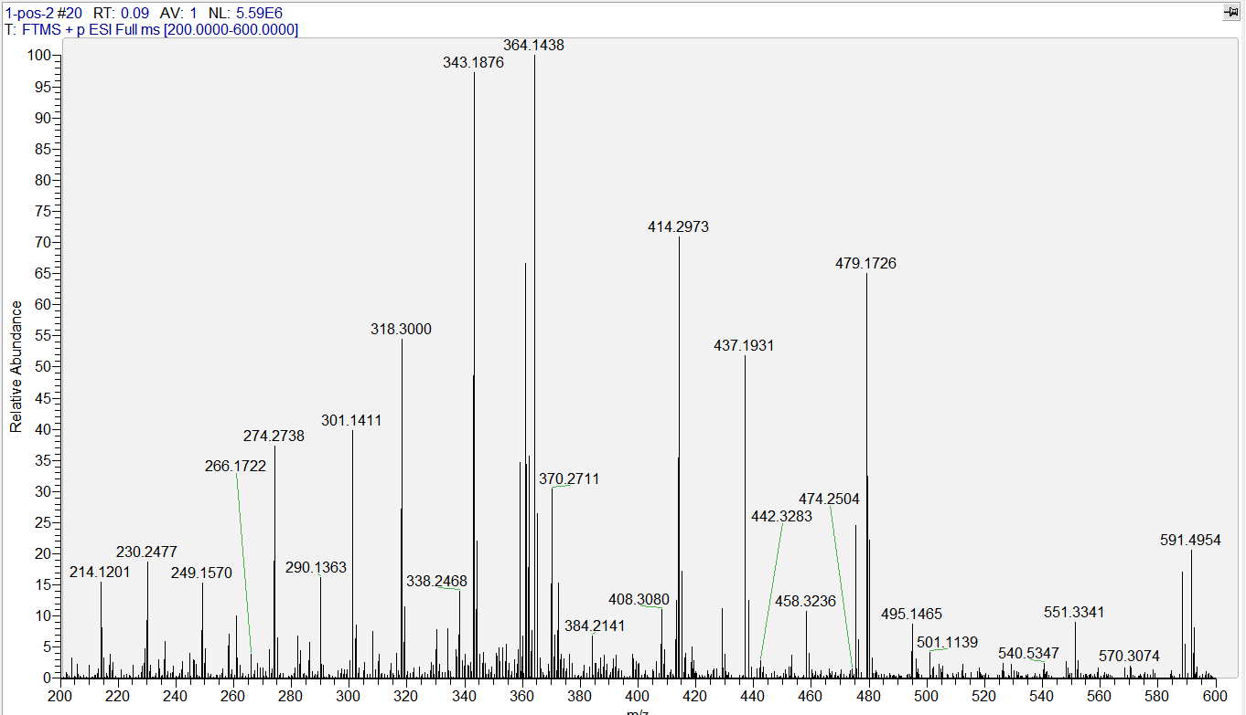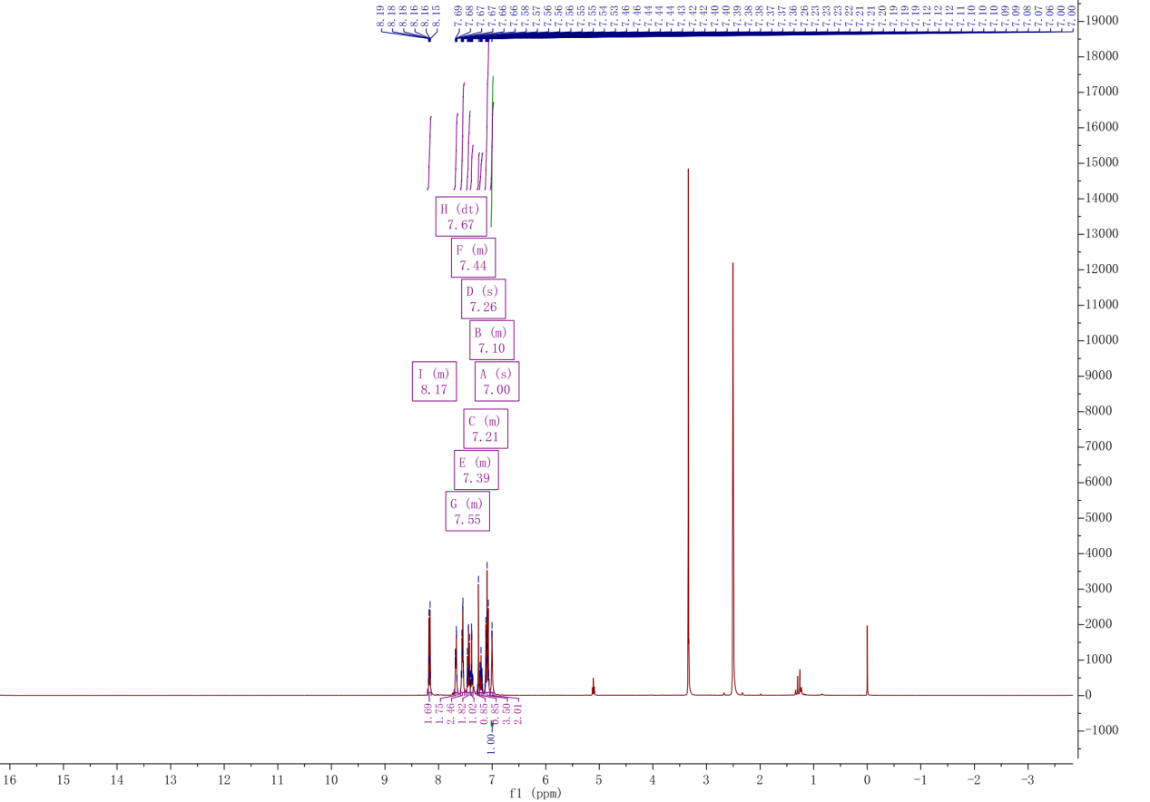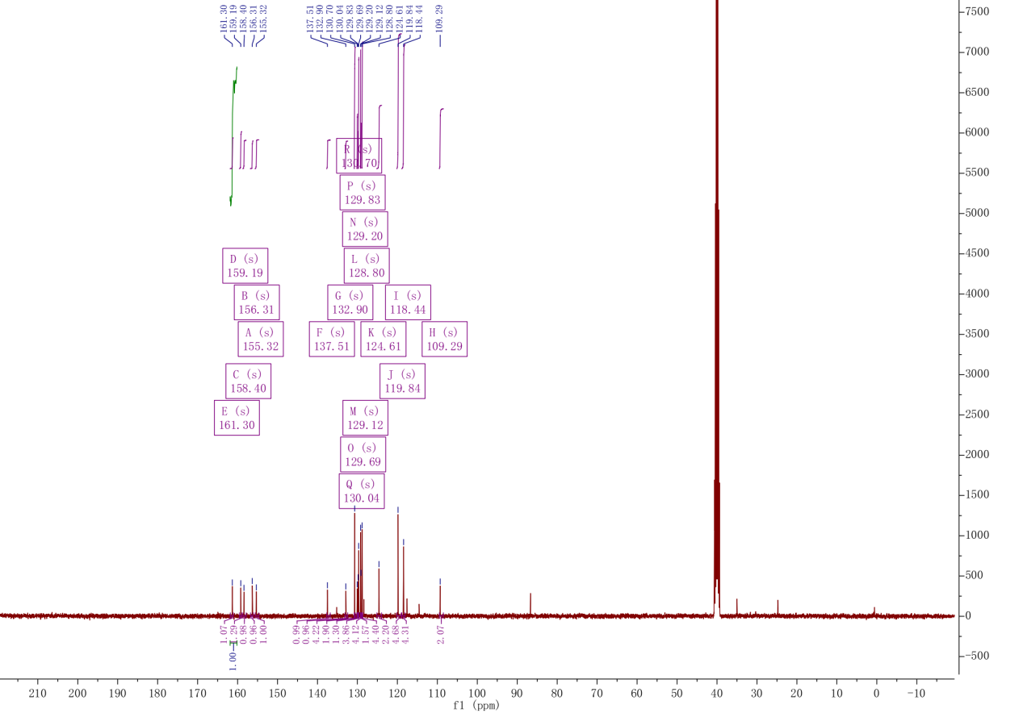

D2
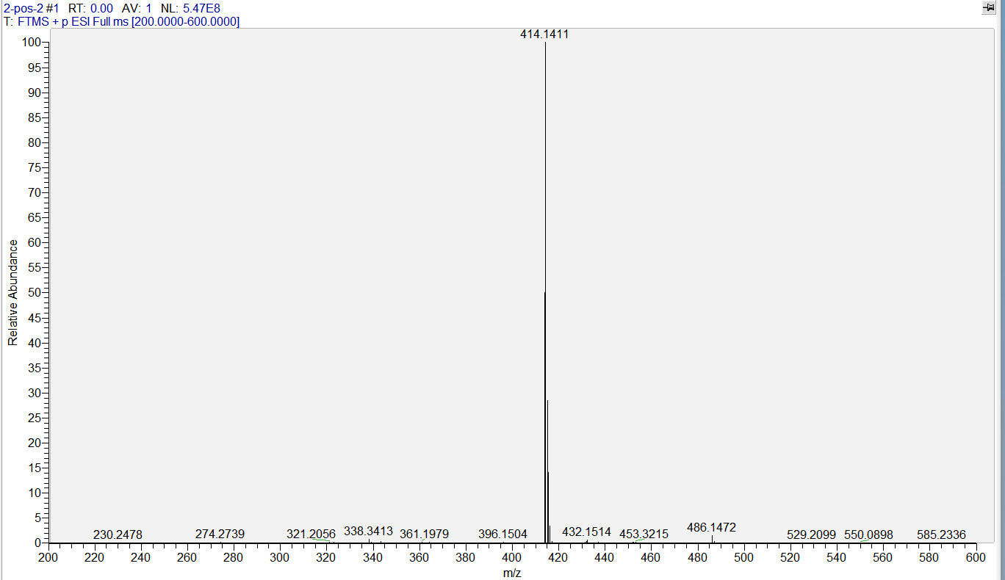

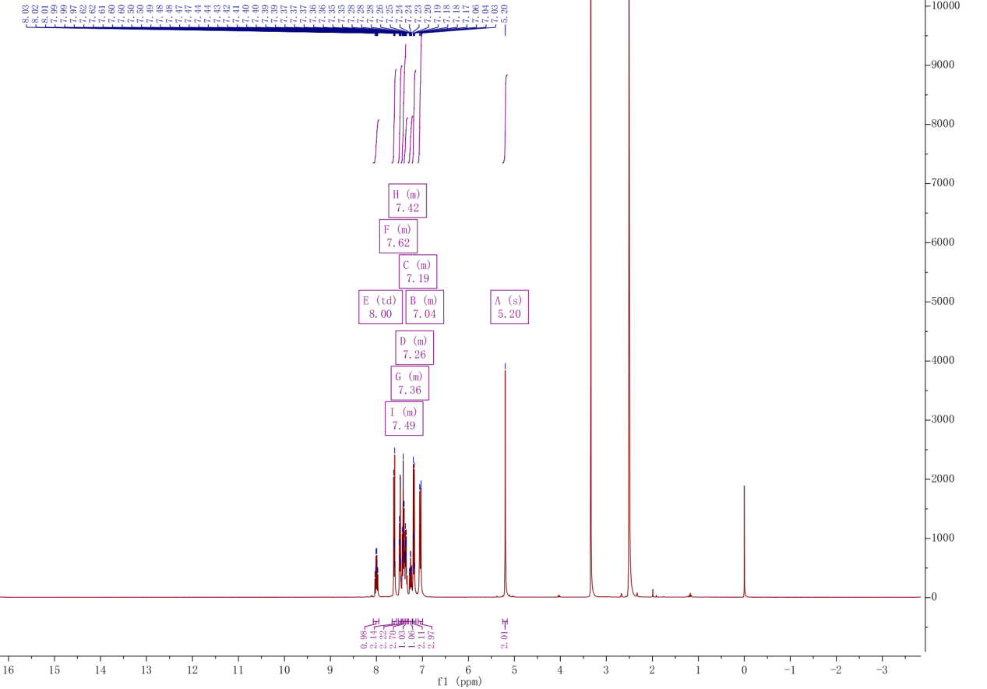
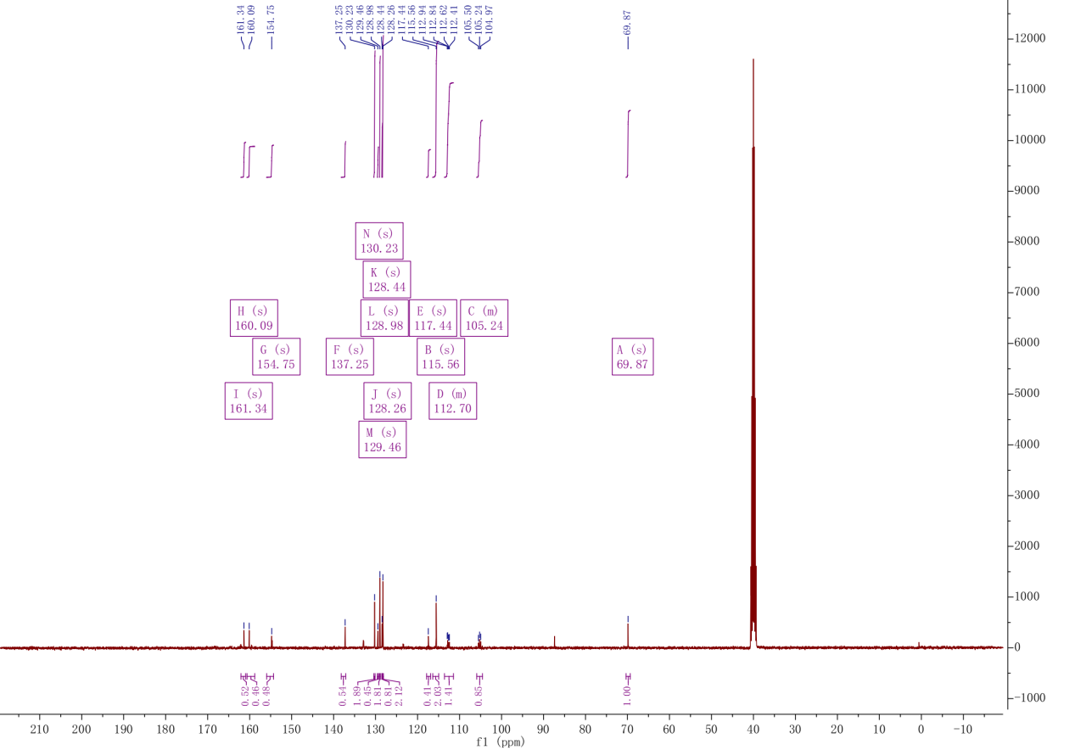

D3

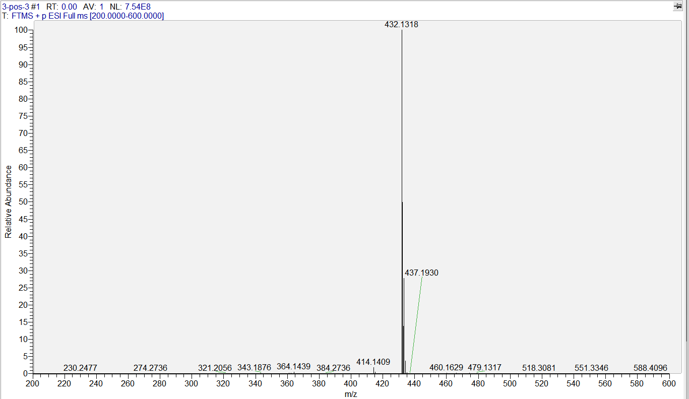
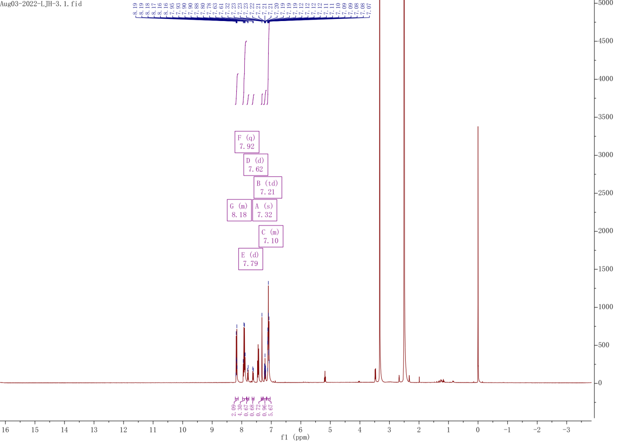
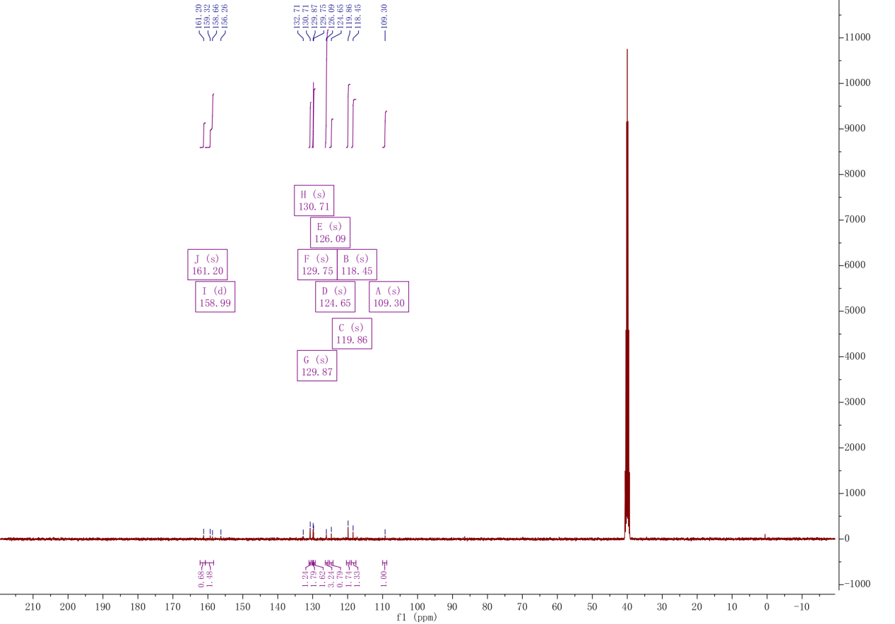

D4
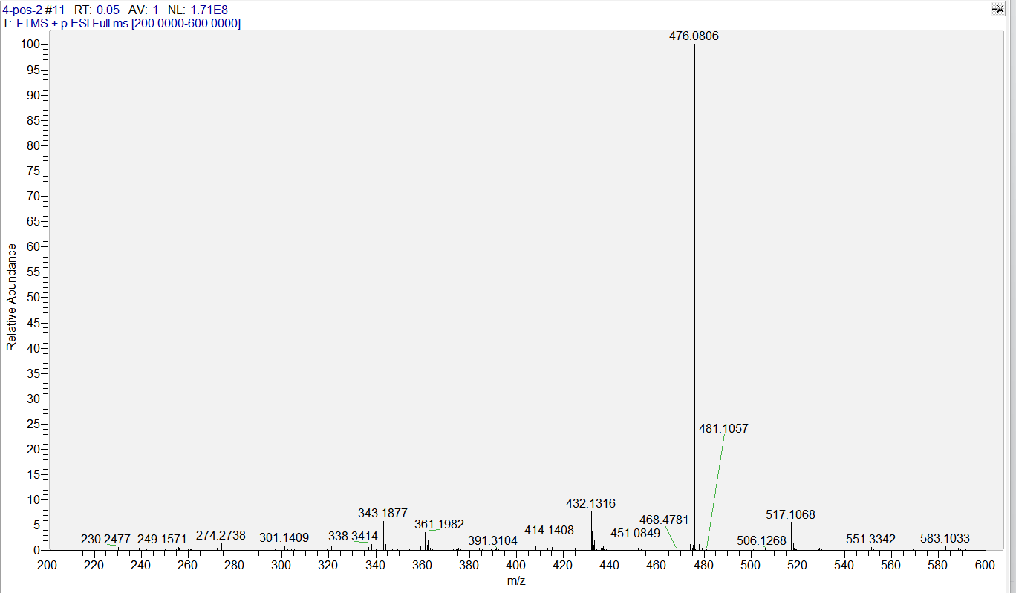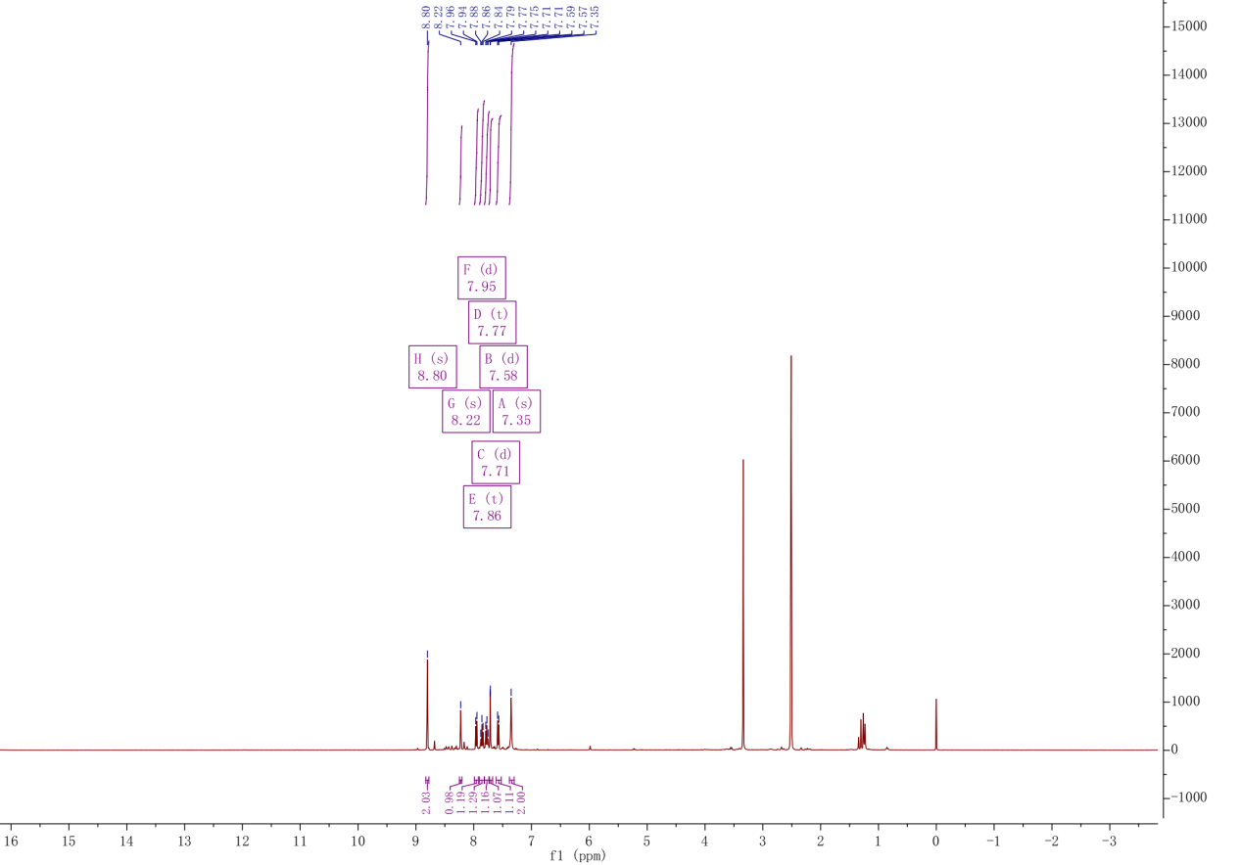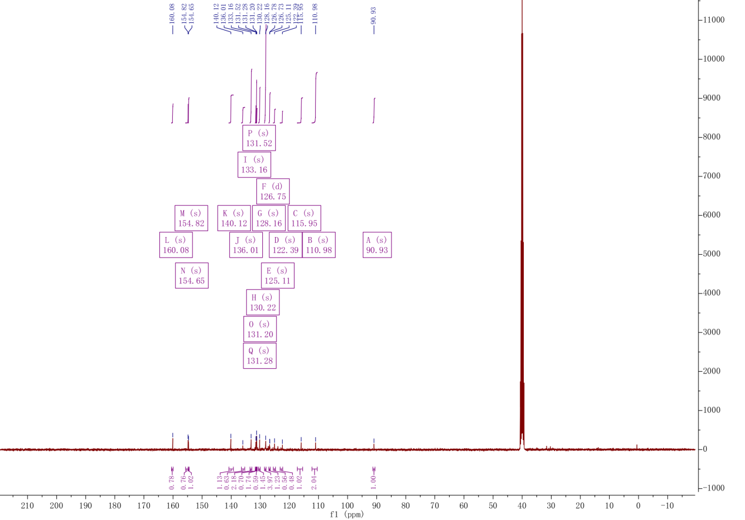

D5
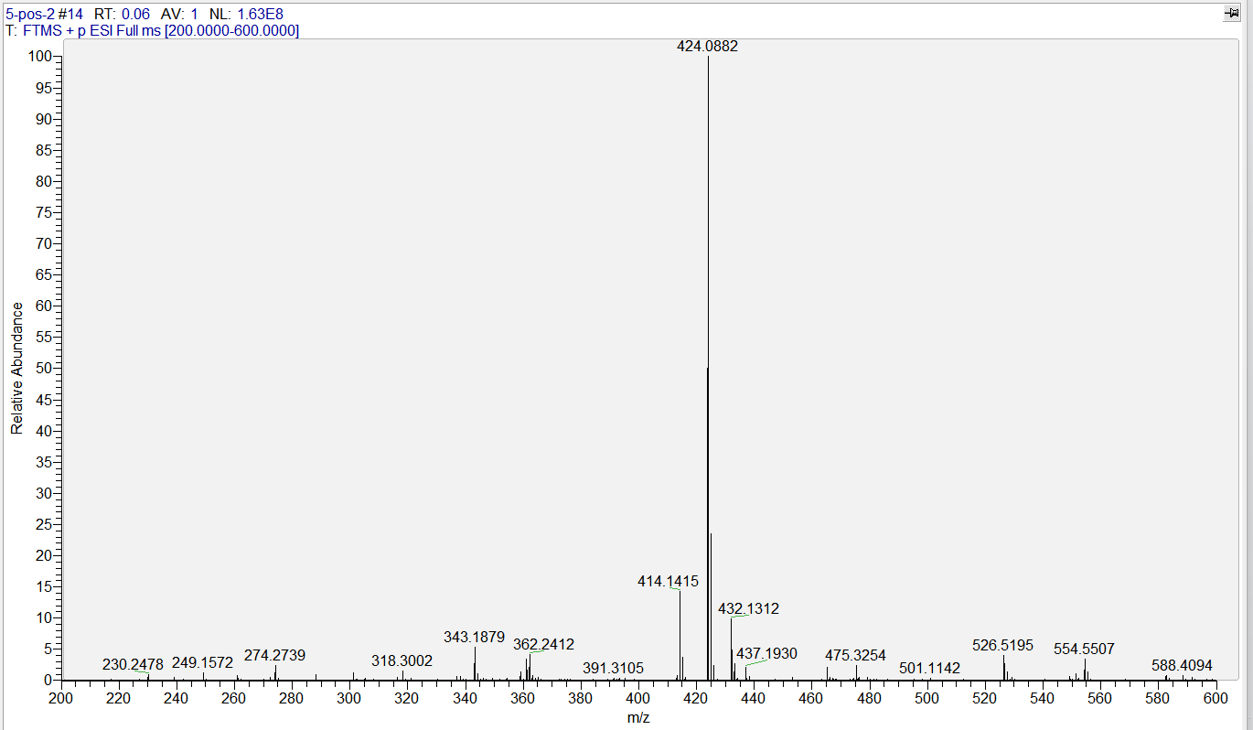
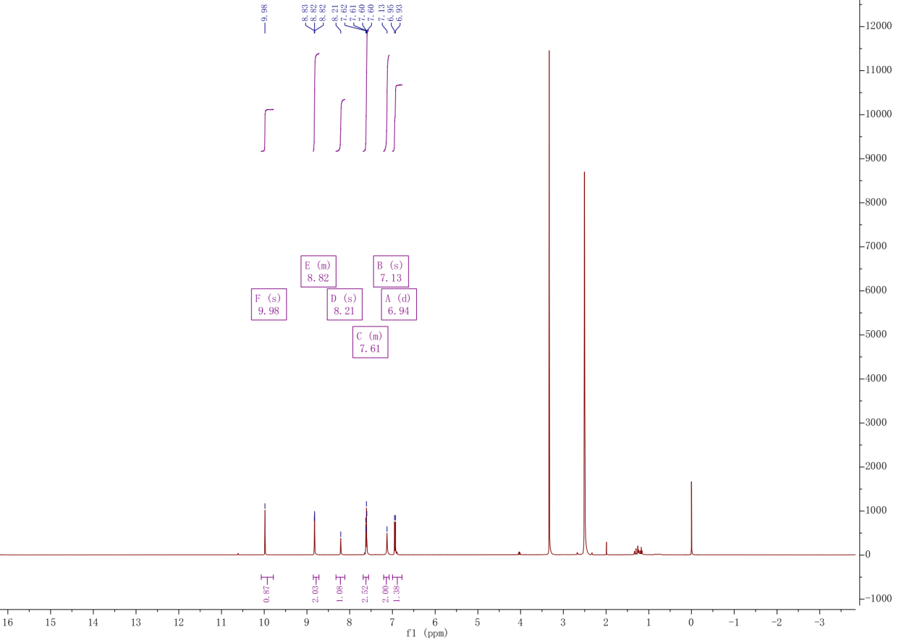
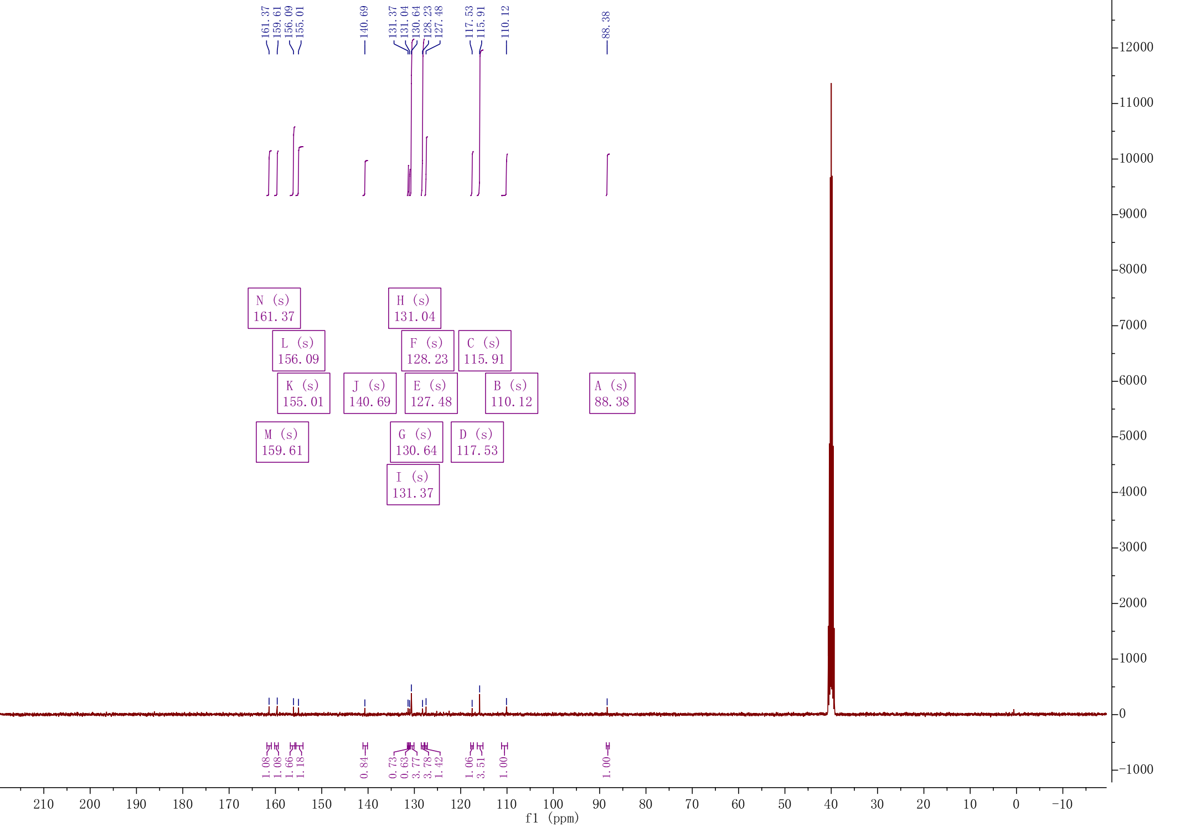
D6
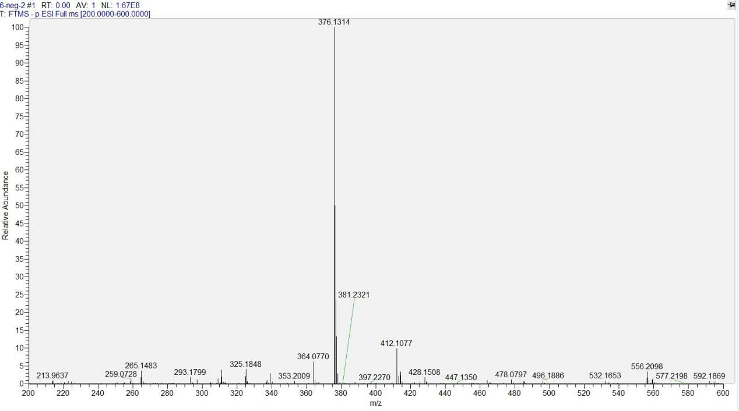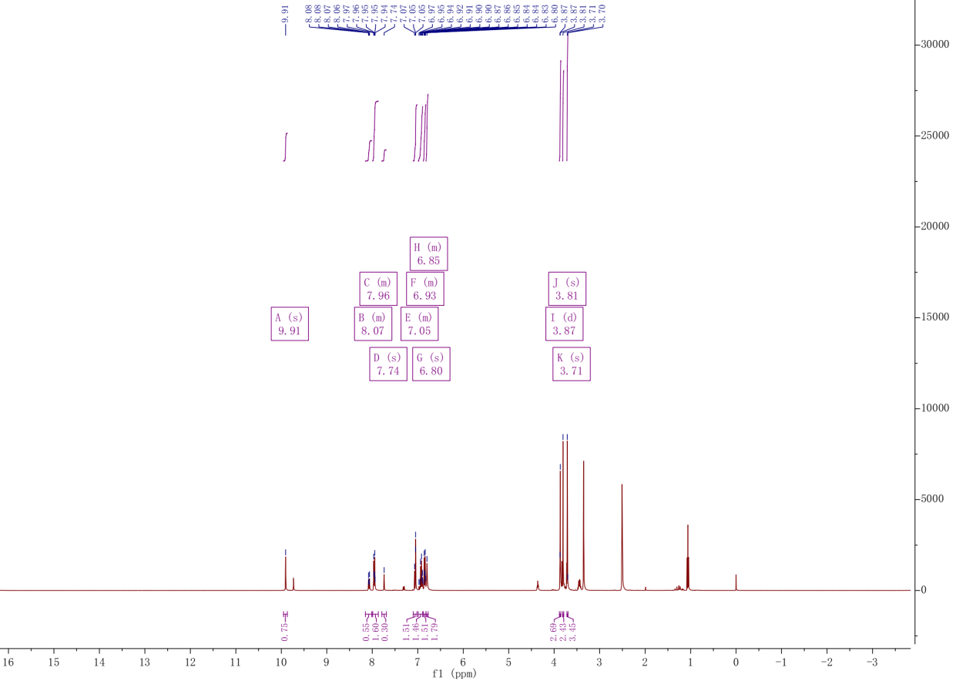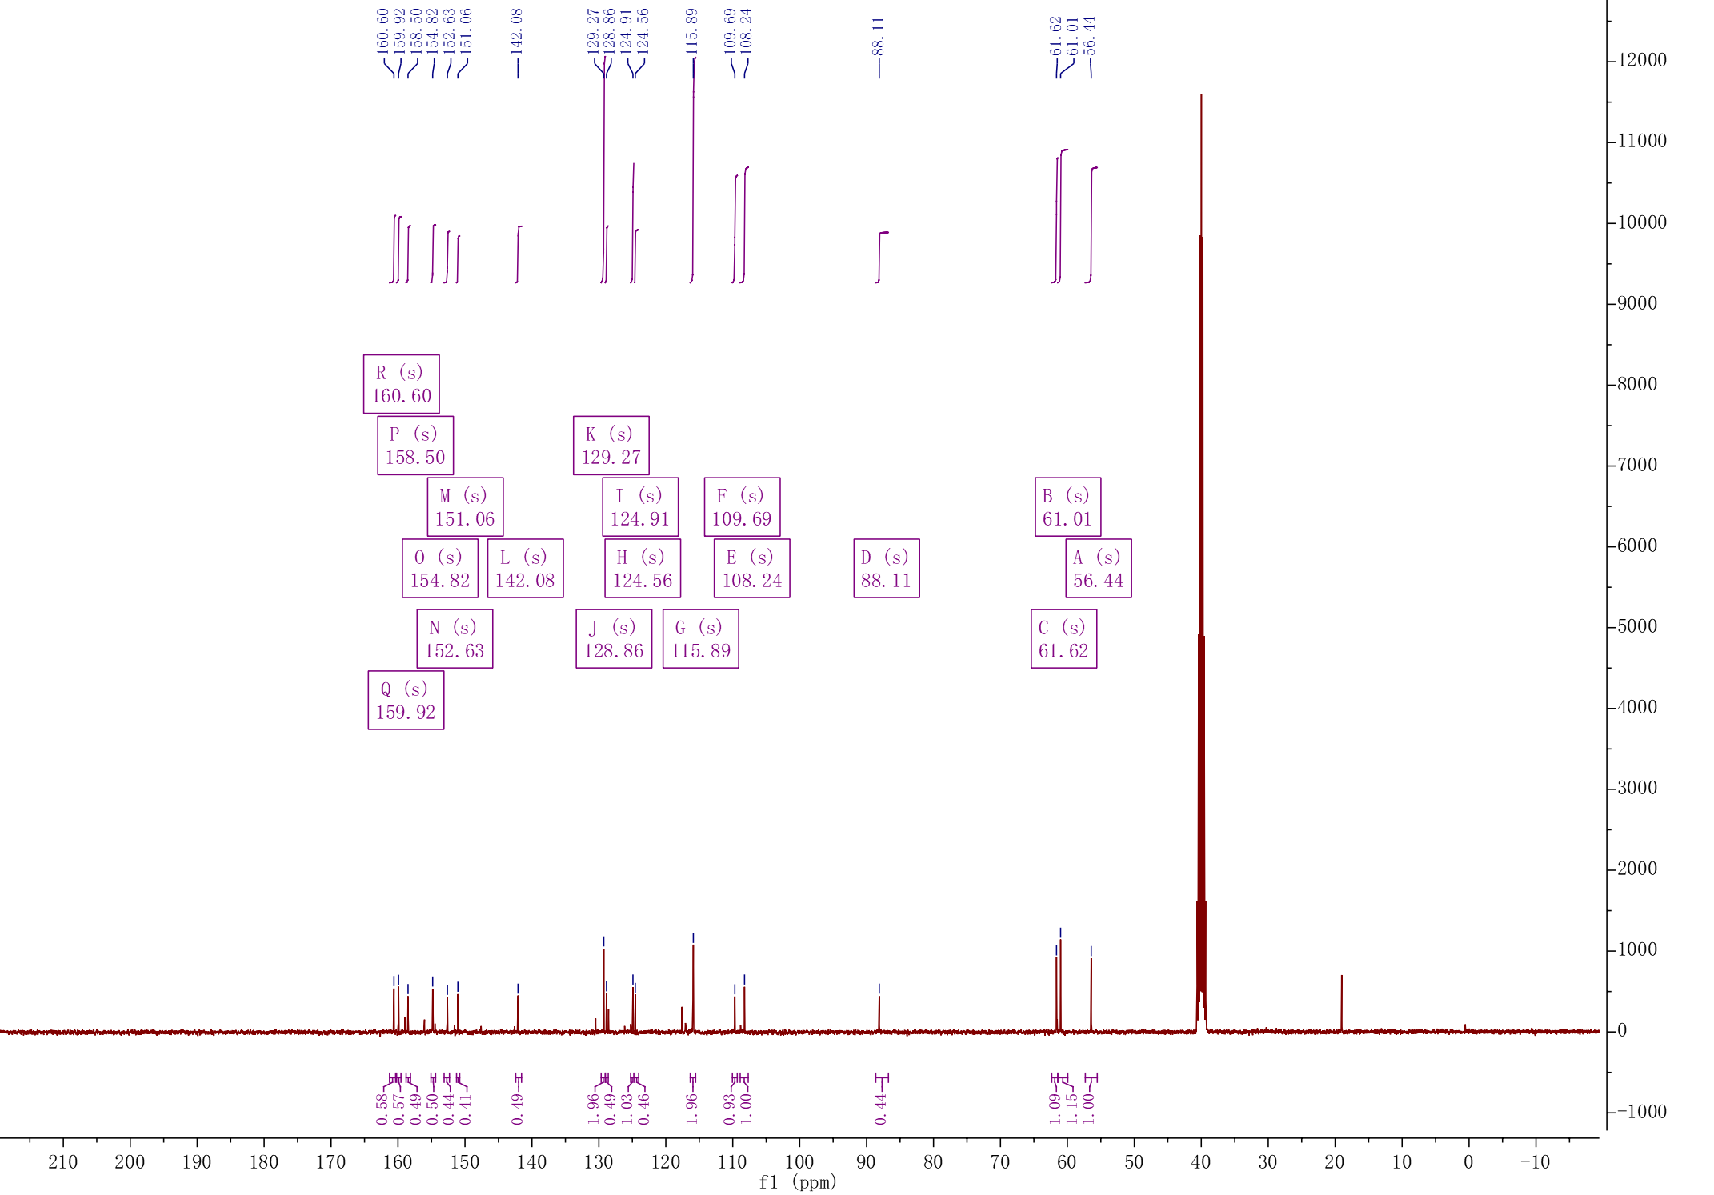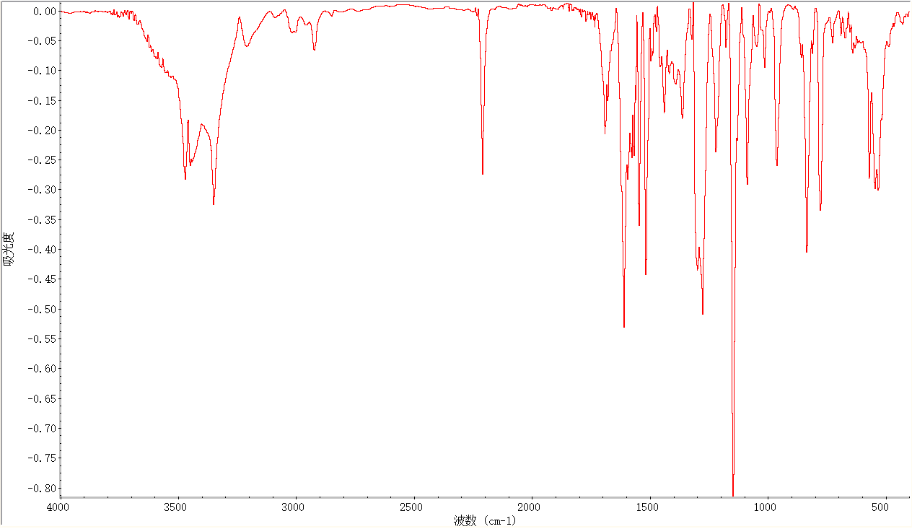
D7
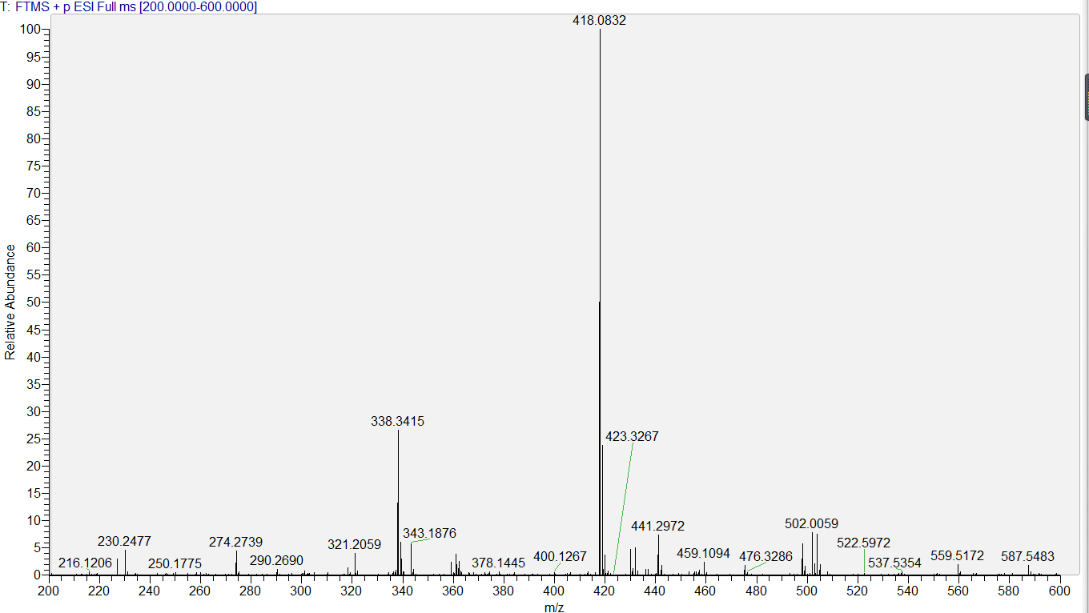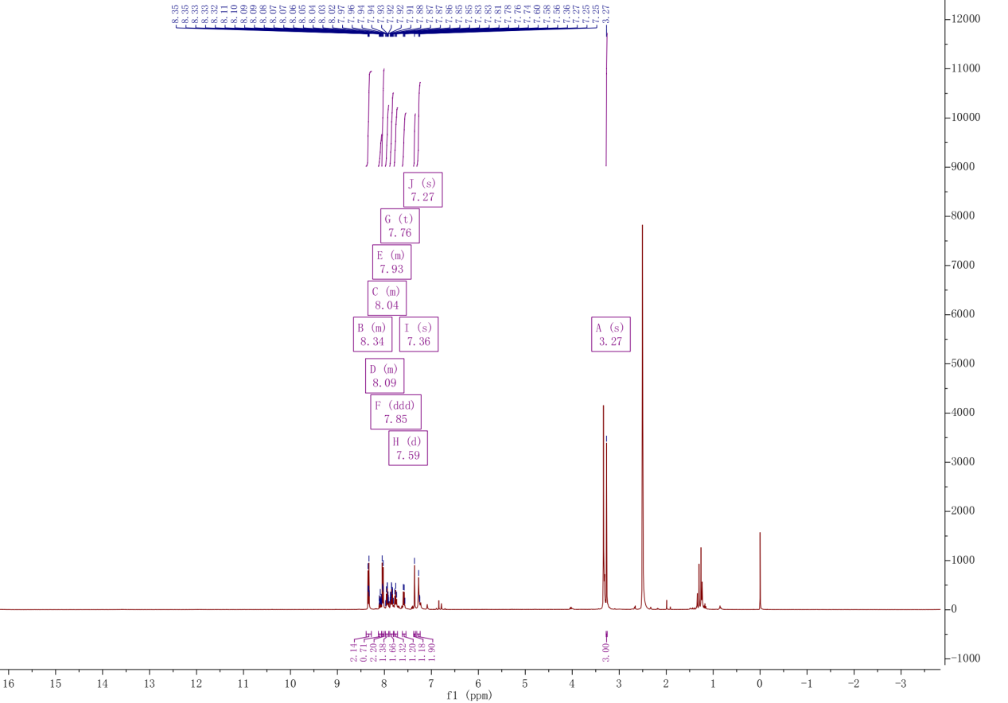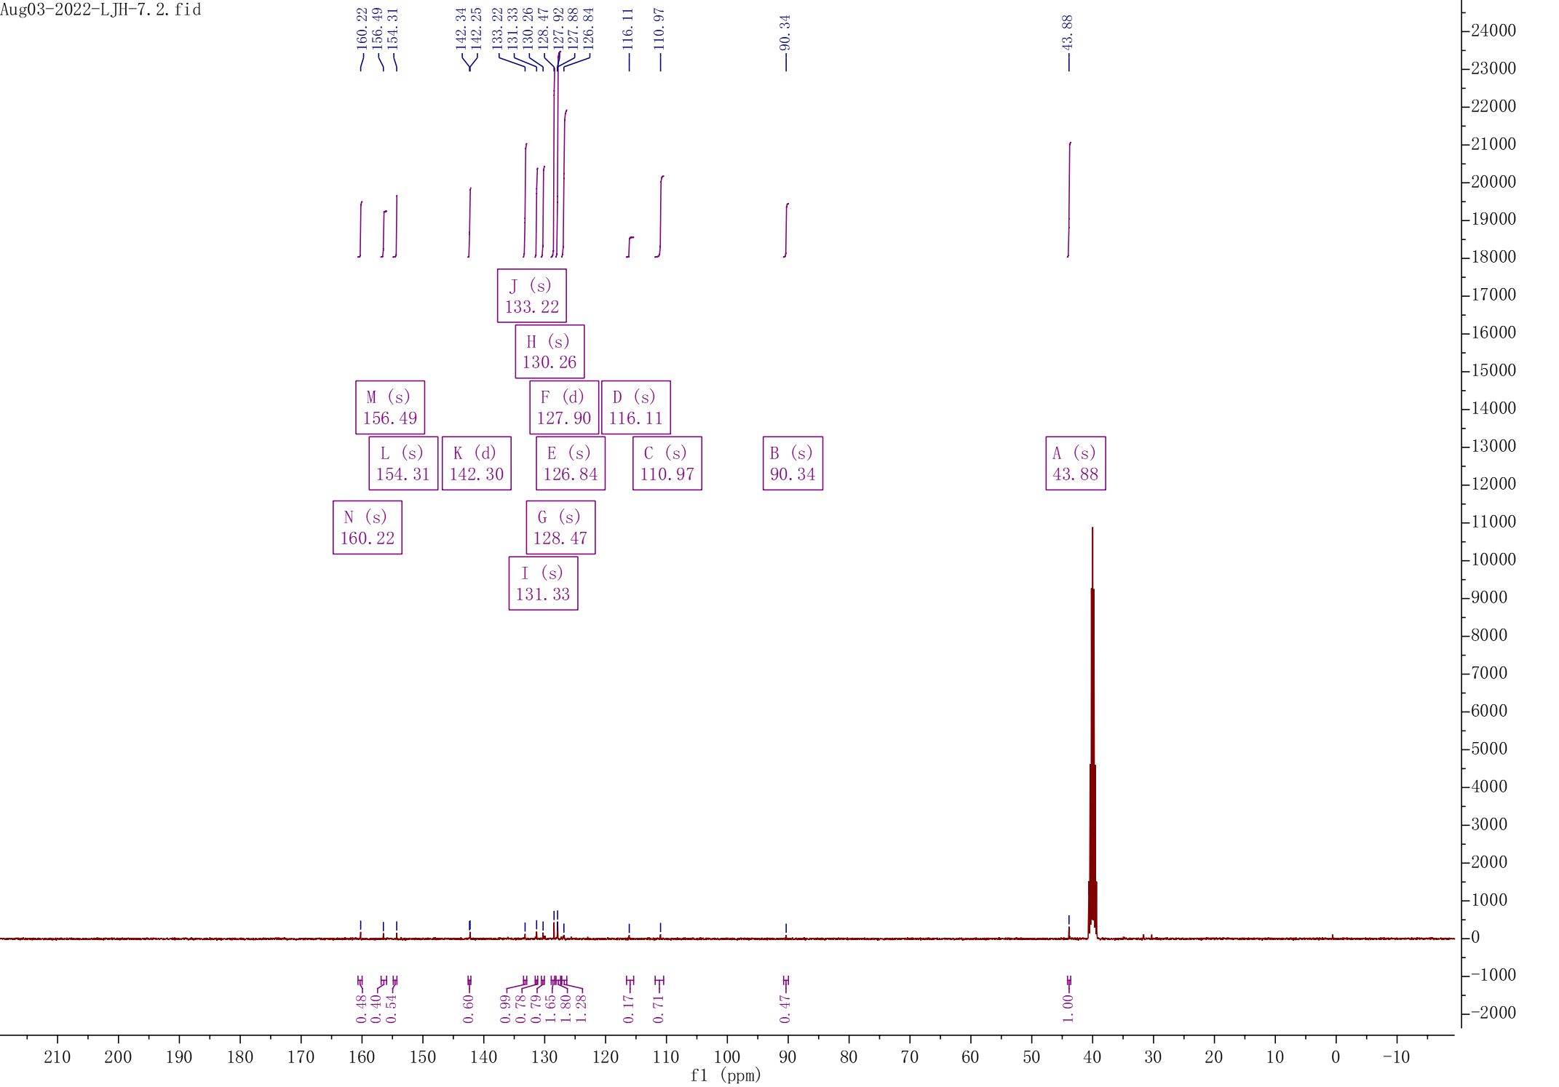

D8
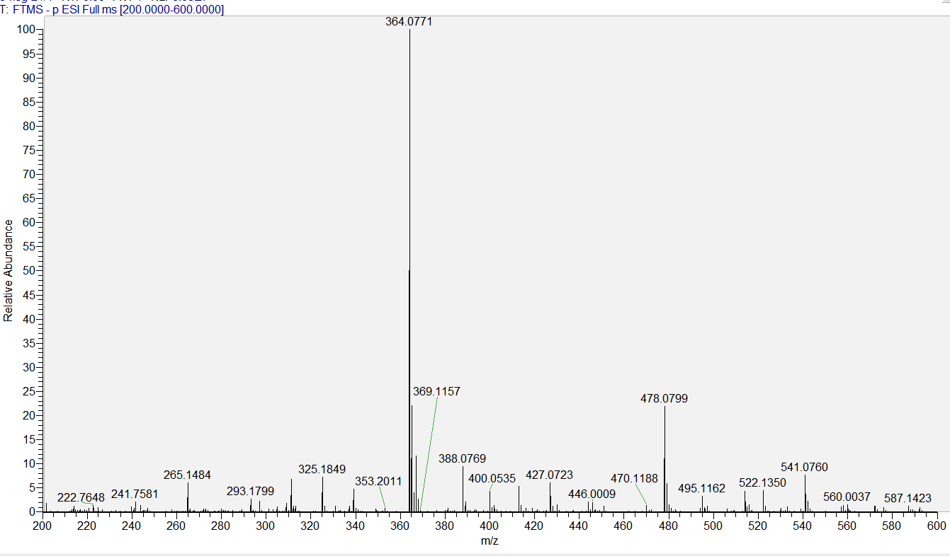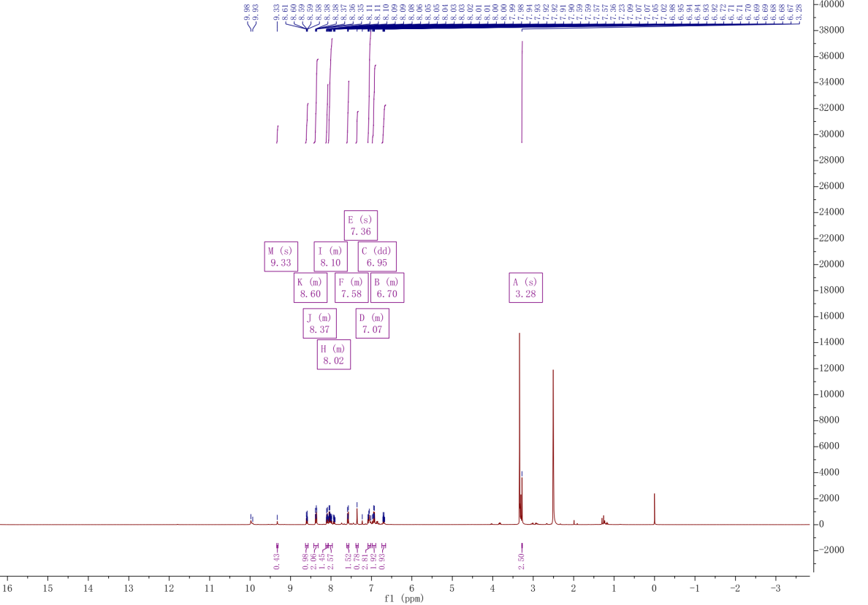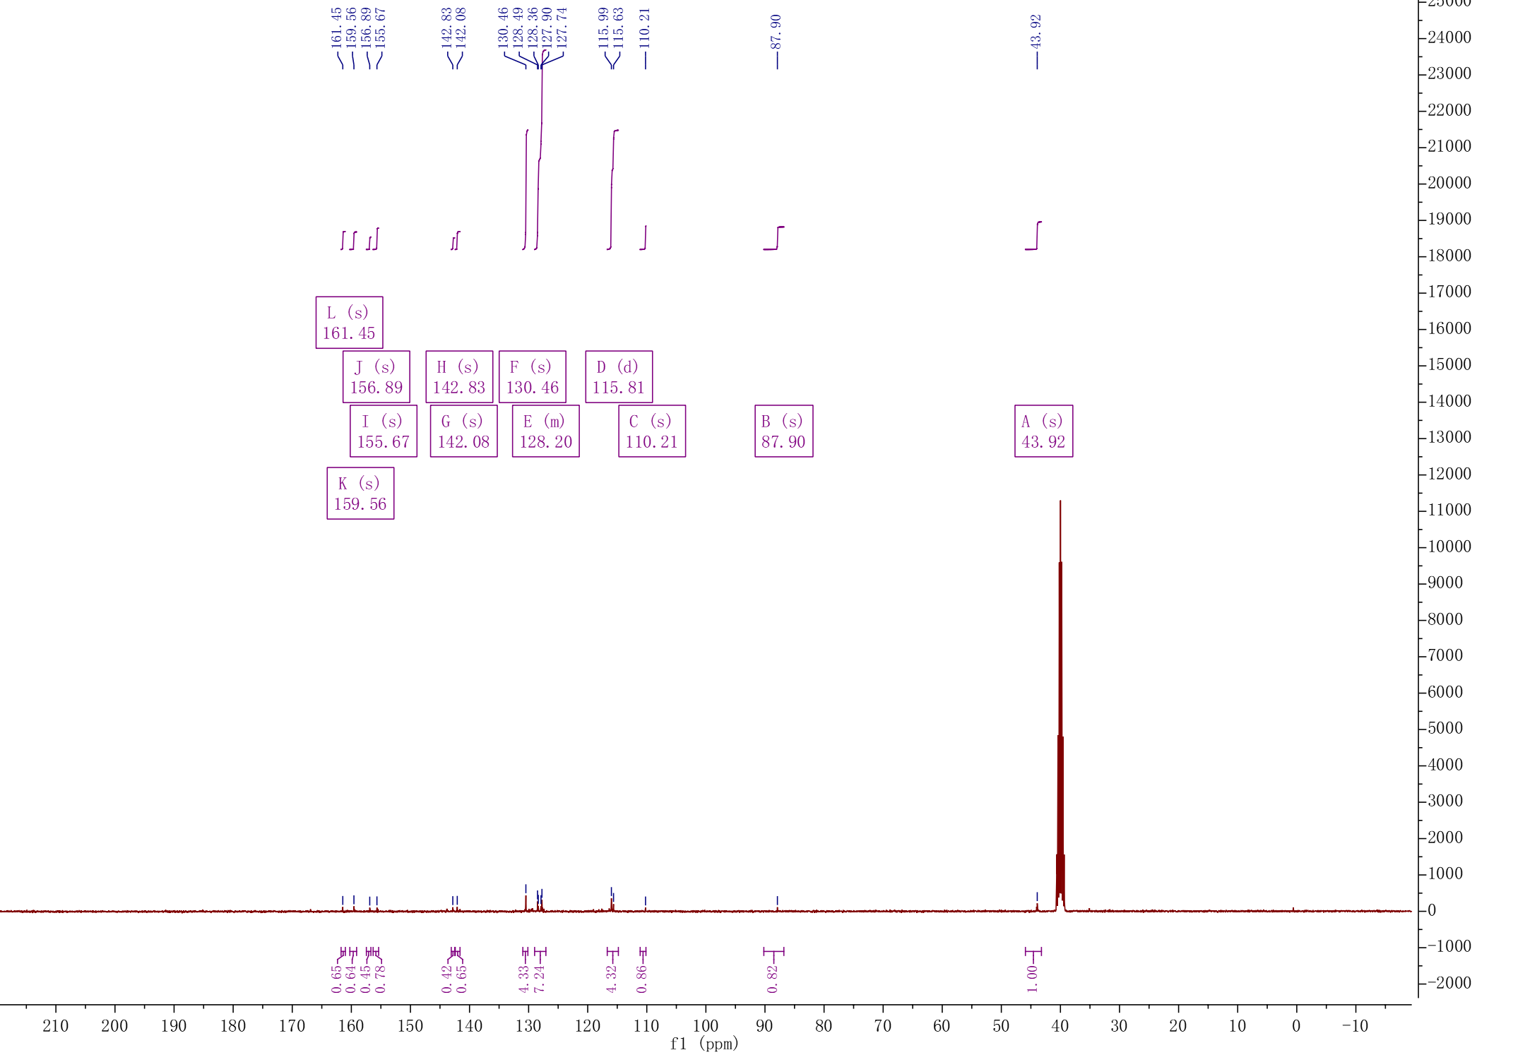

D9
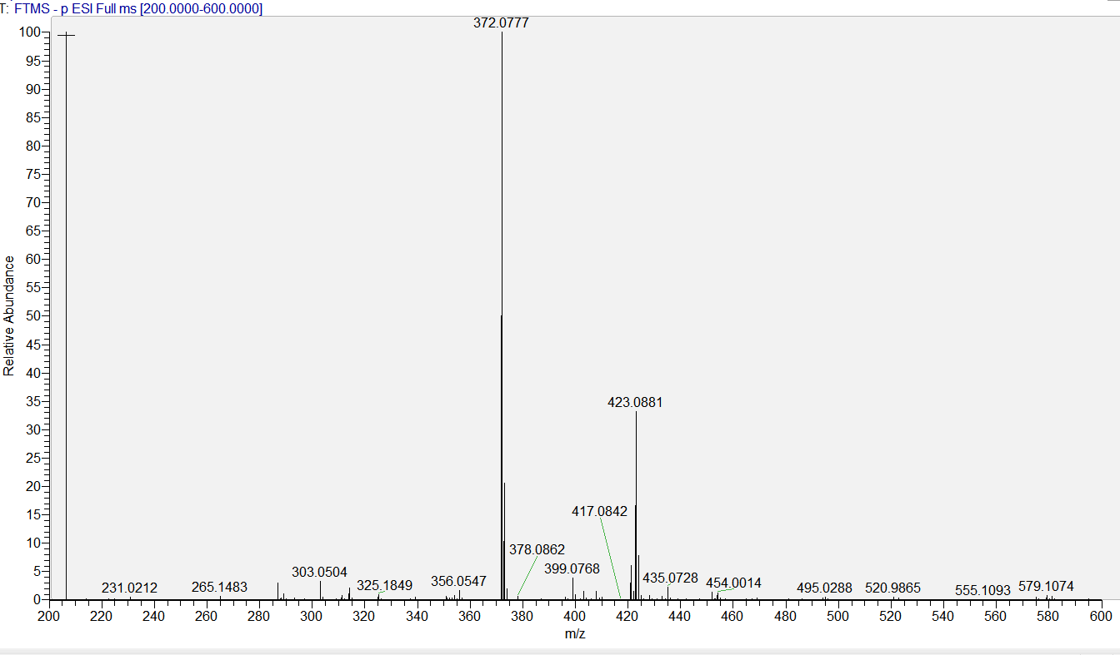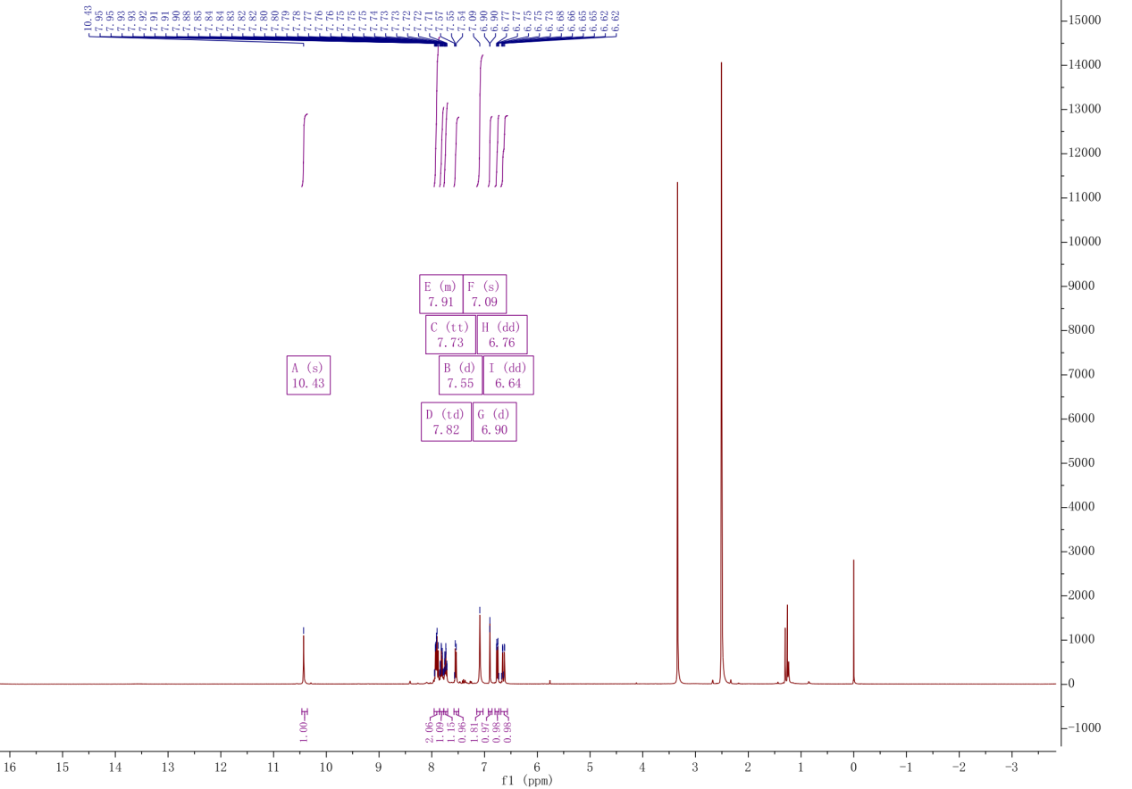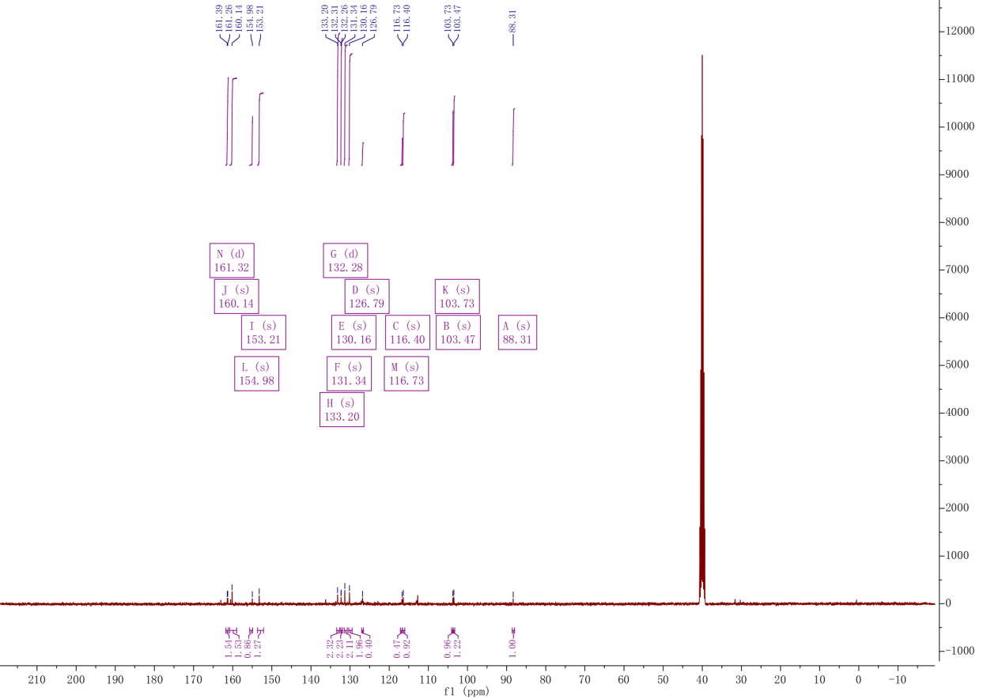

D10
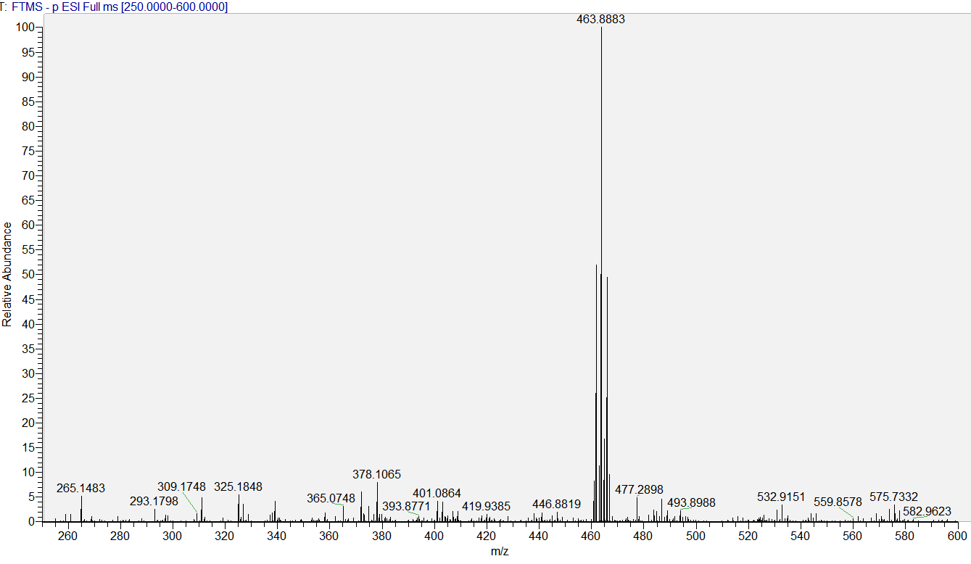
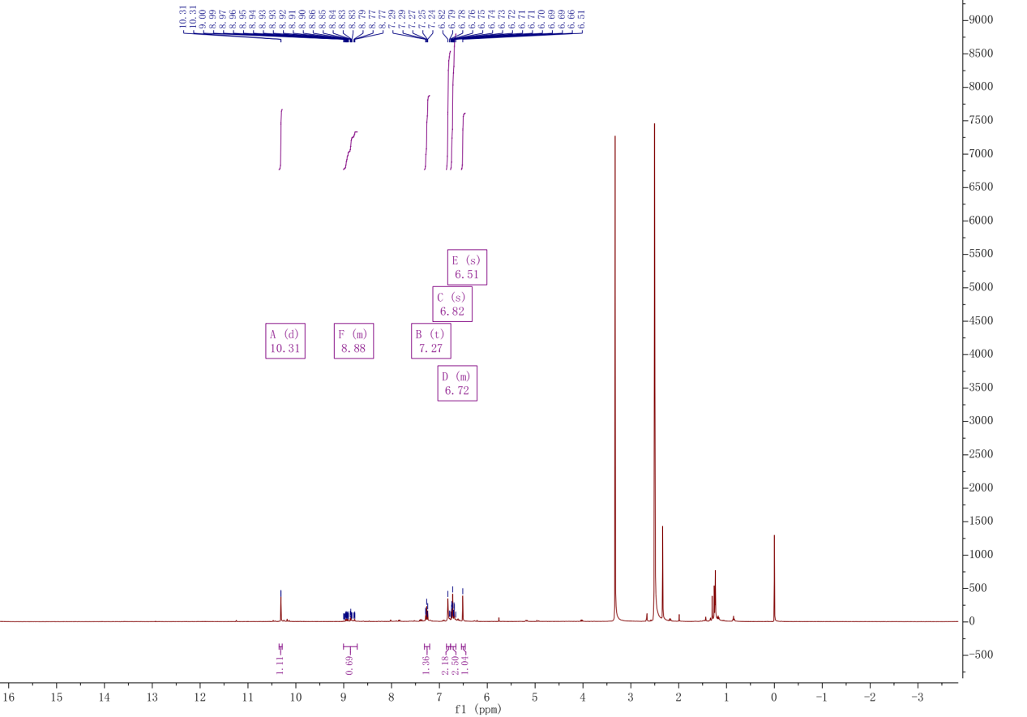

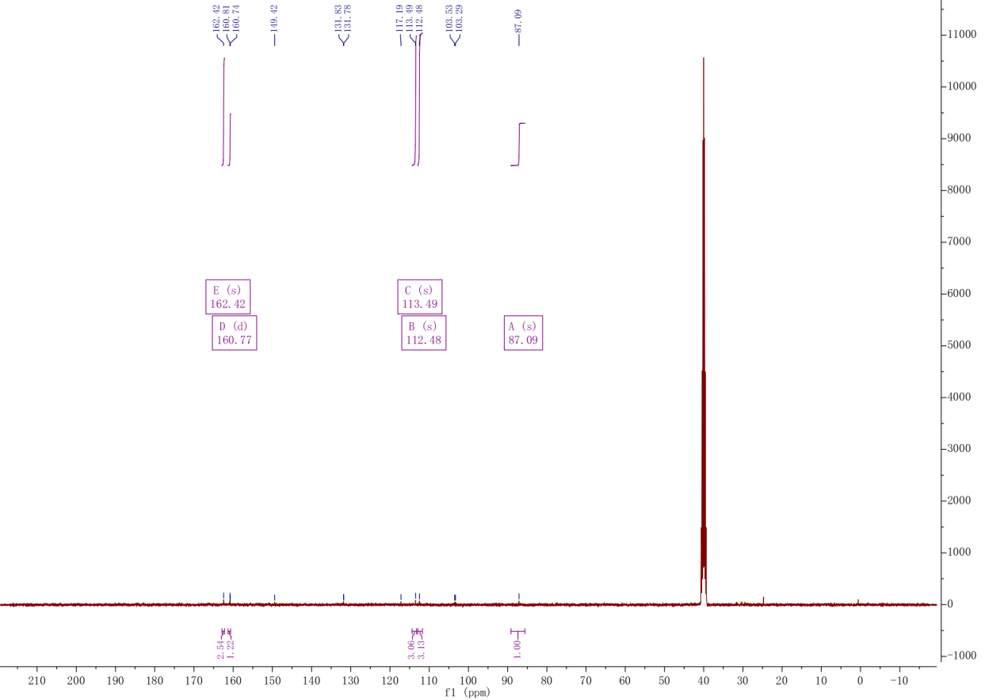

D11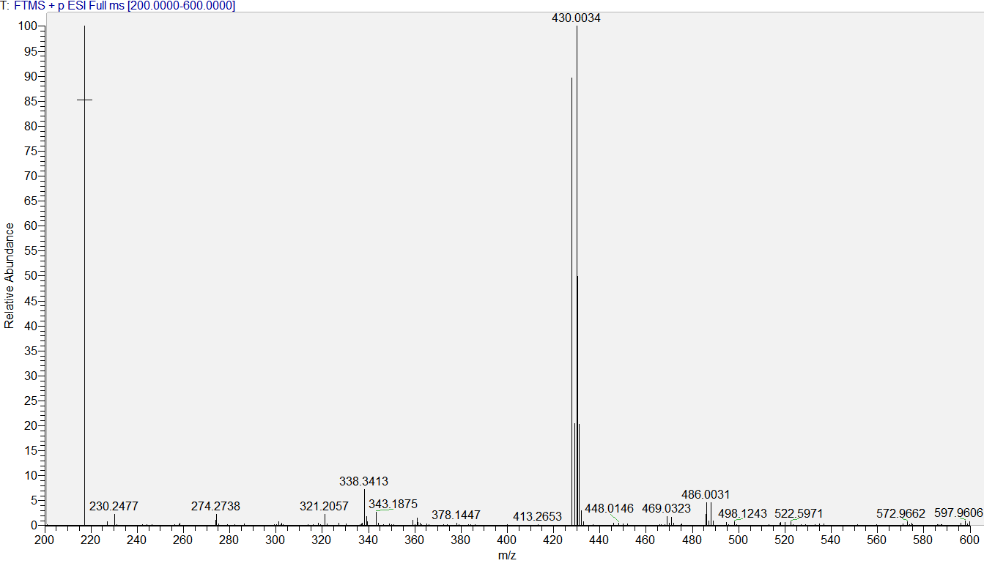

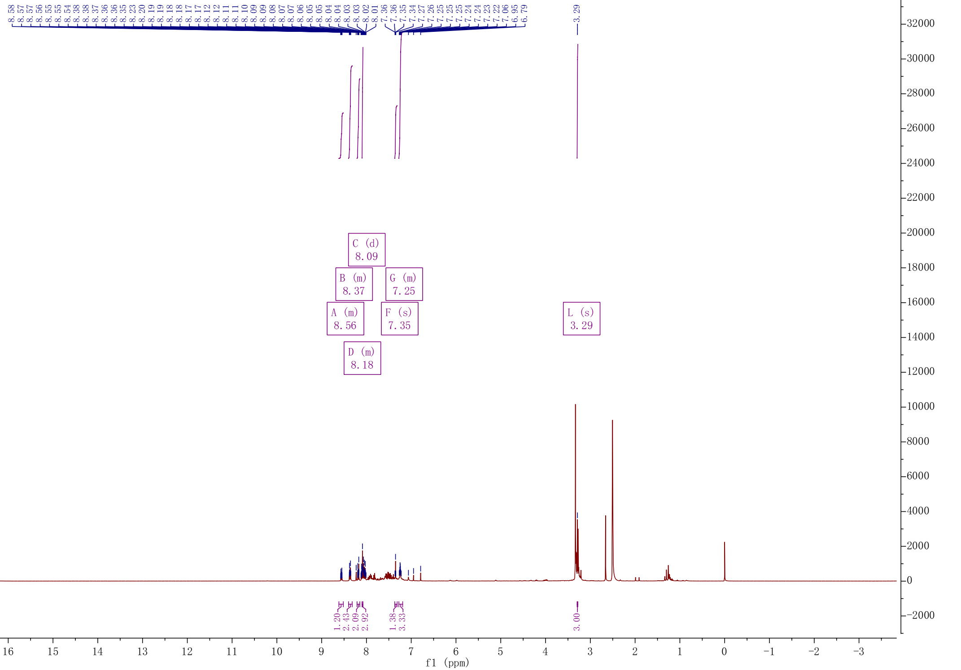
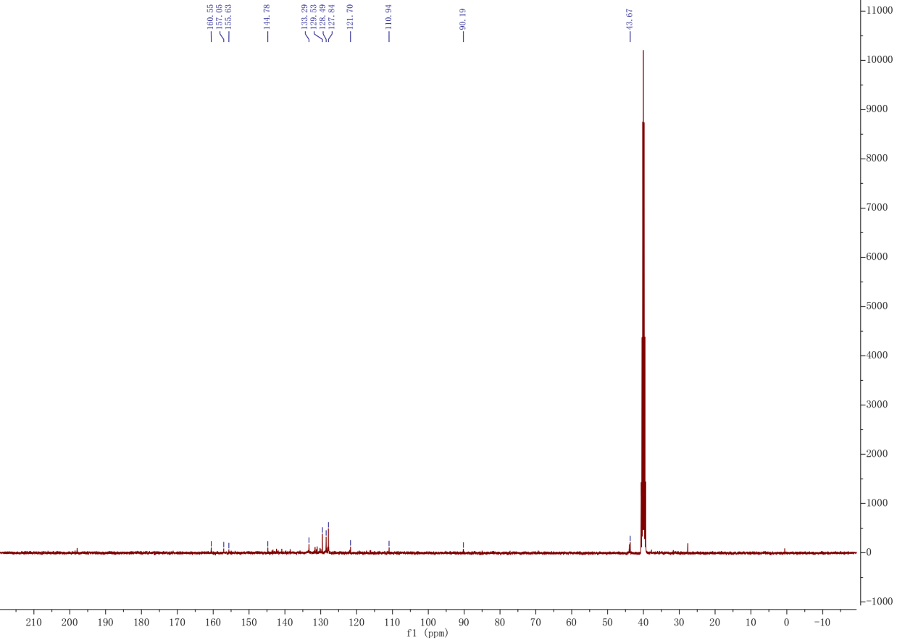

12D
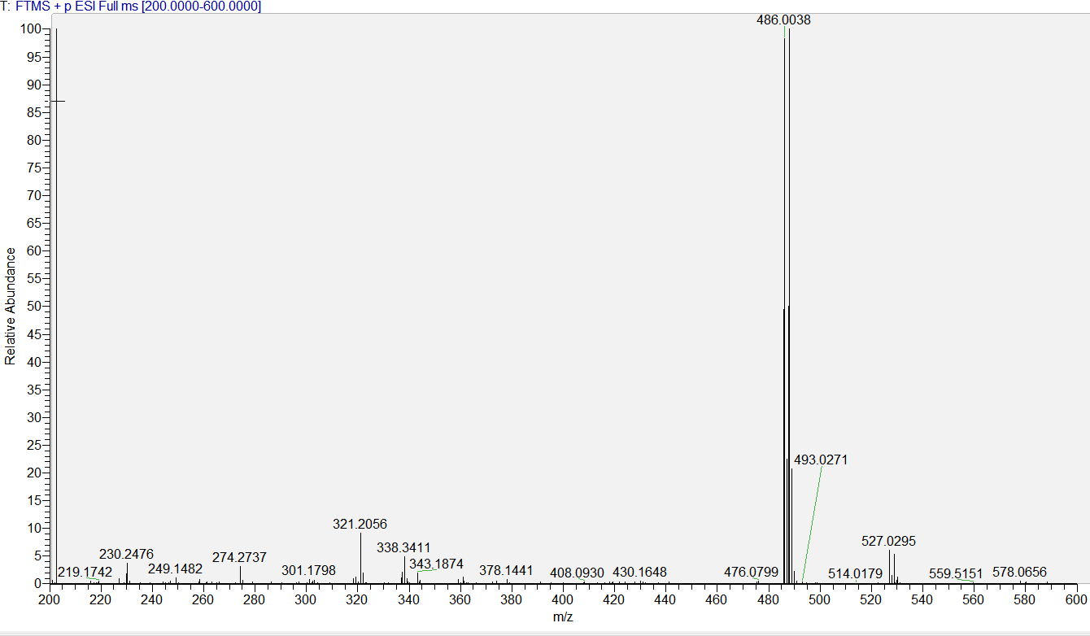
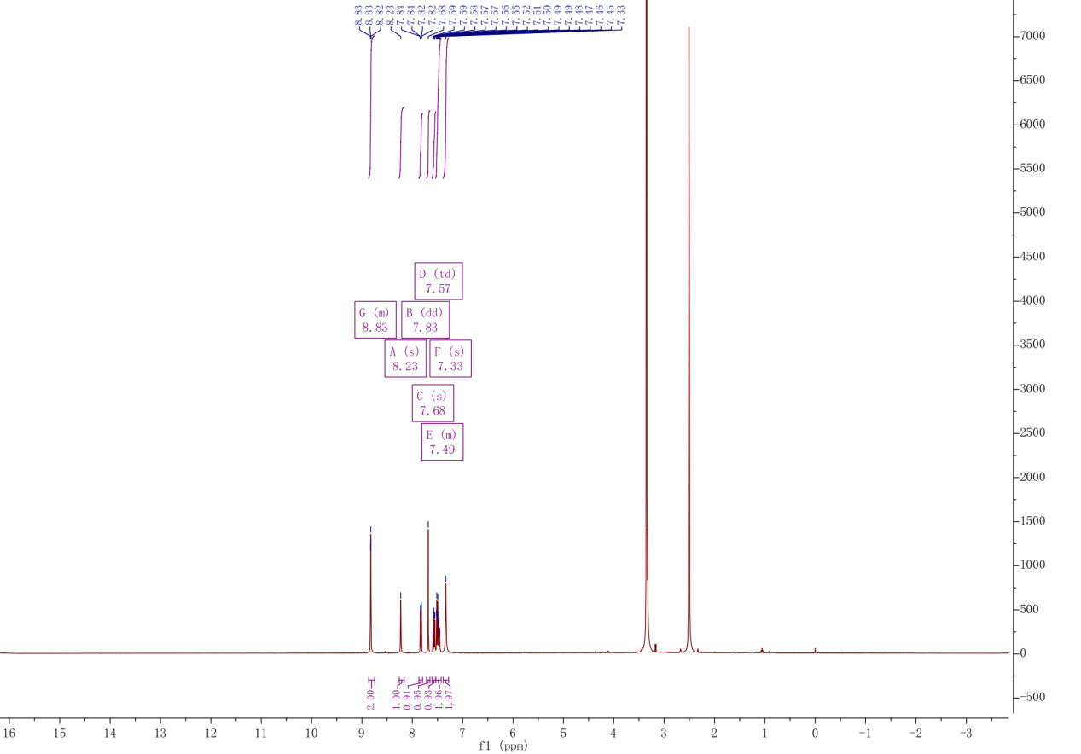
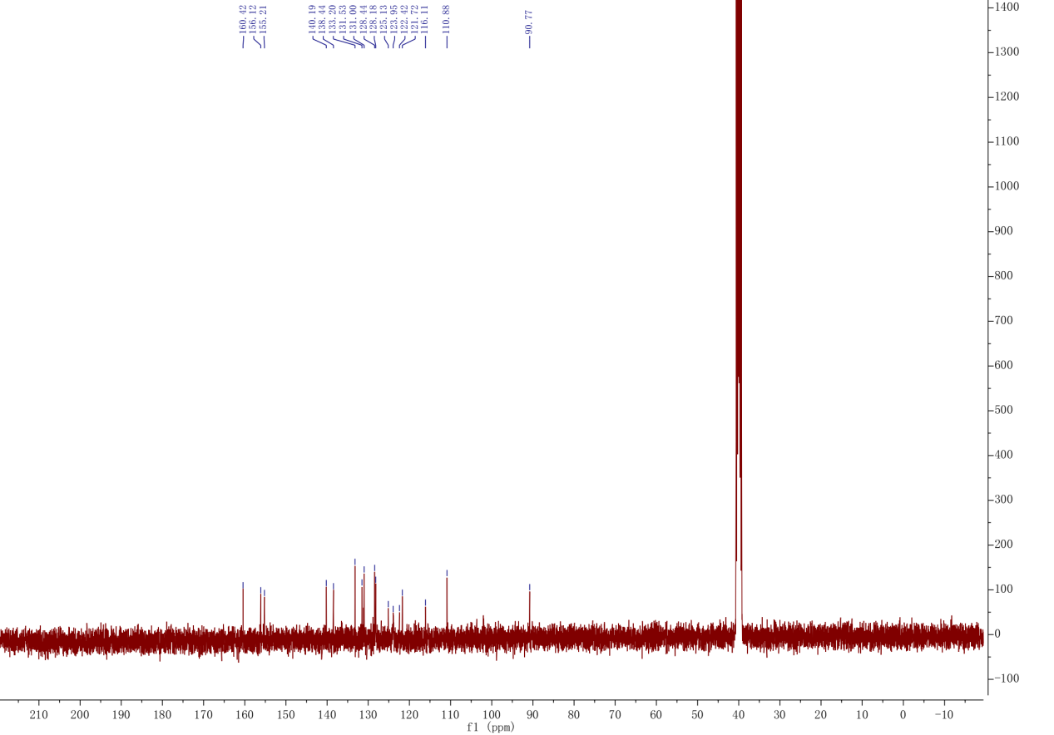

D13
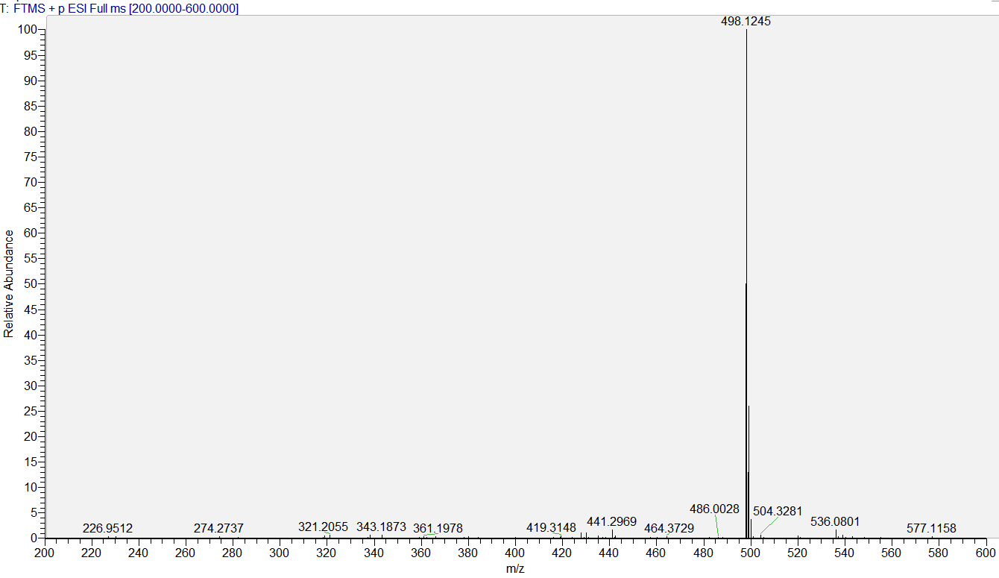
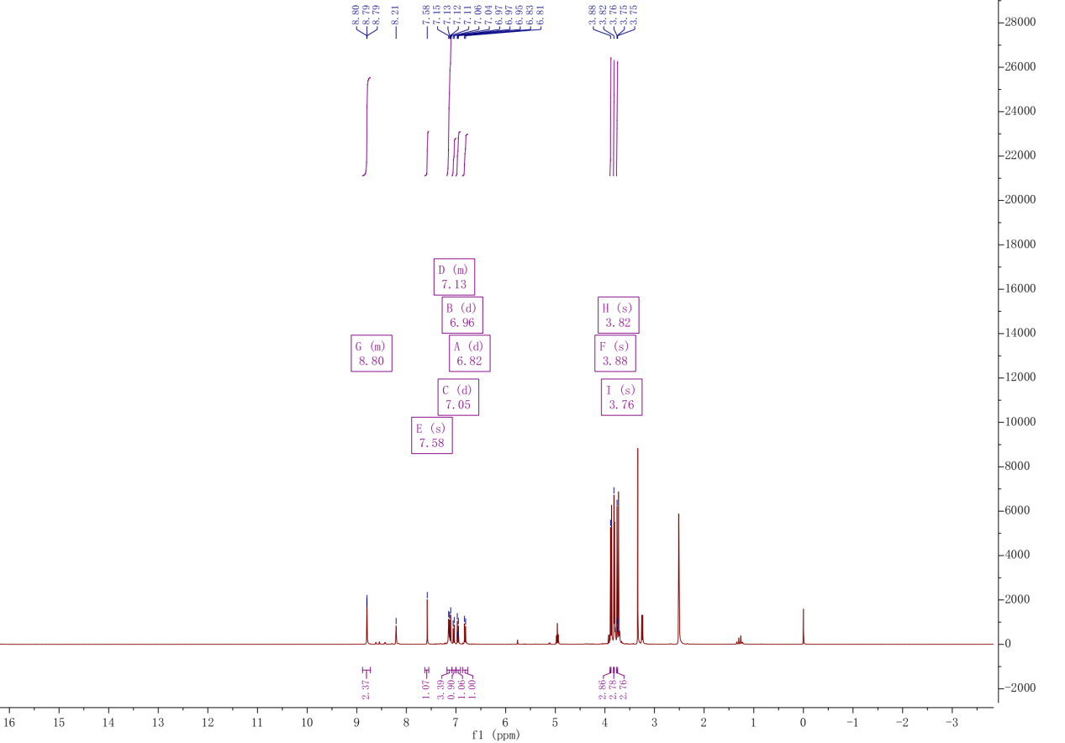

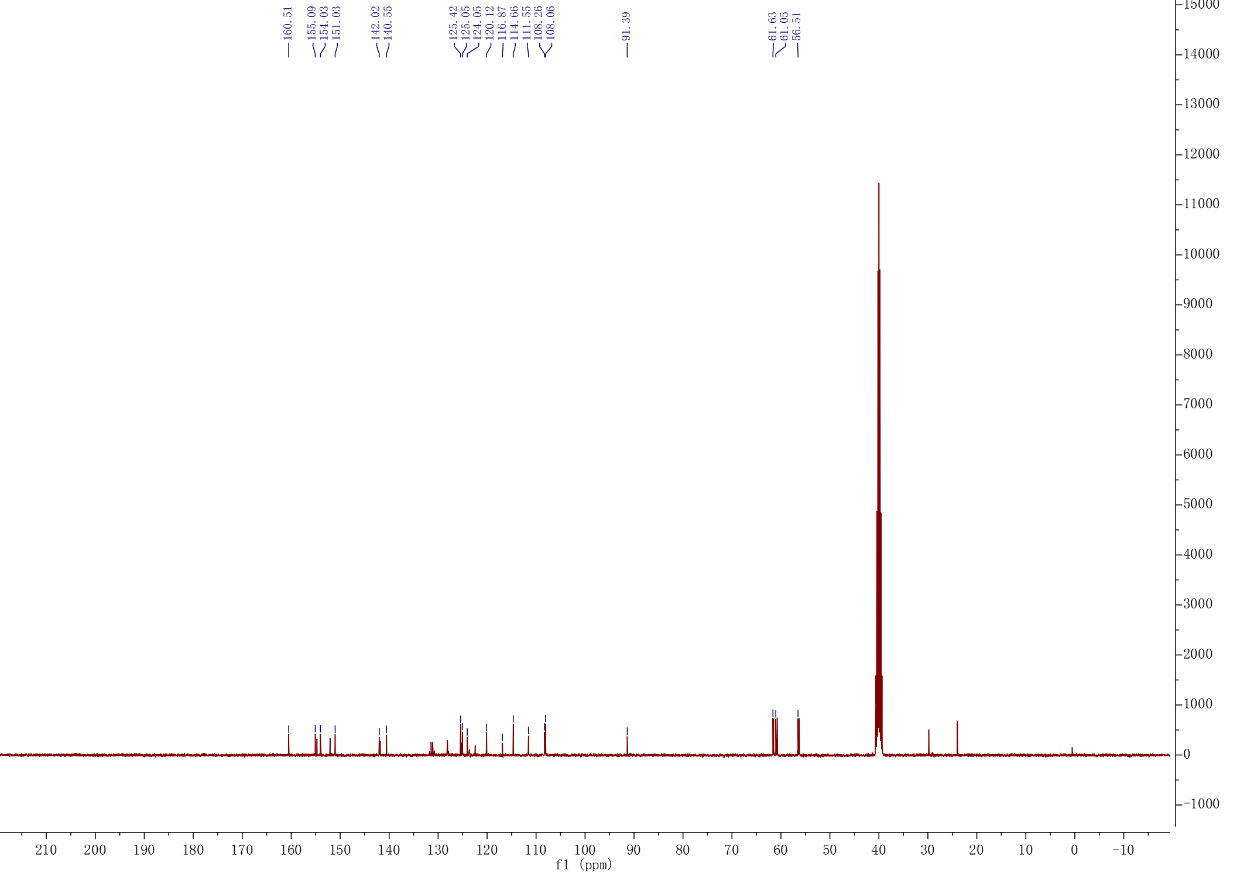

D14

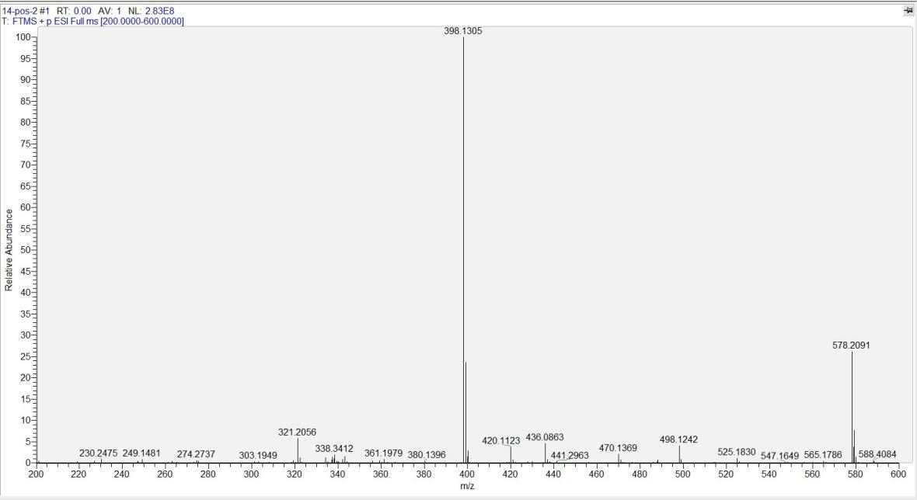
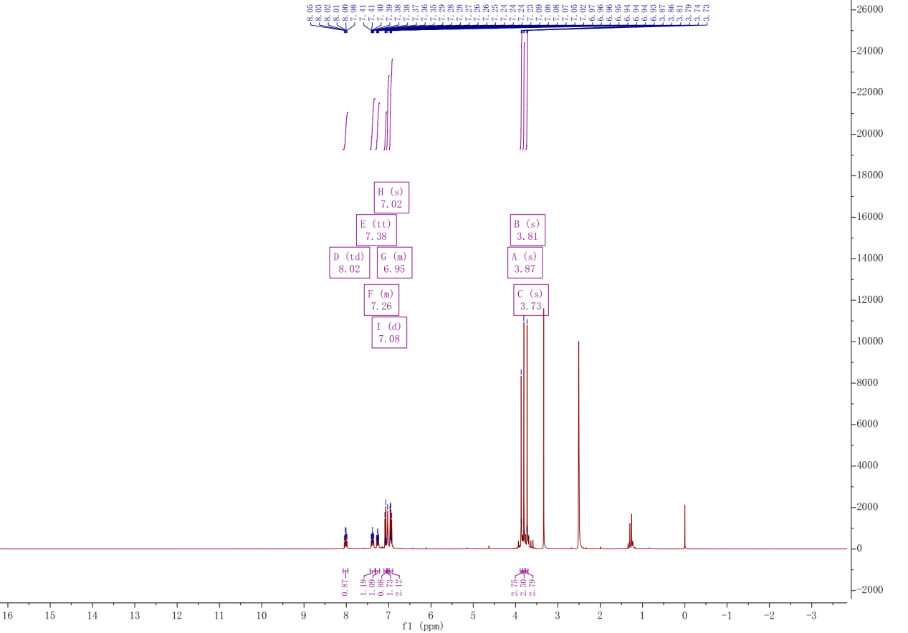

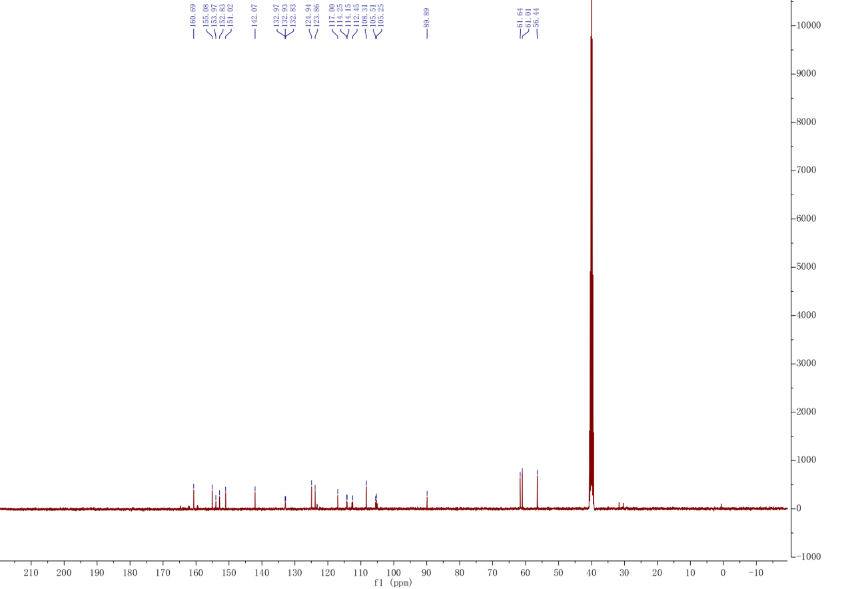

D15
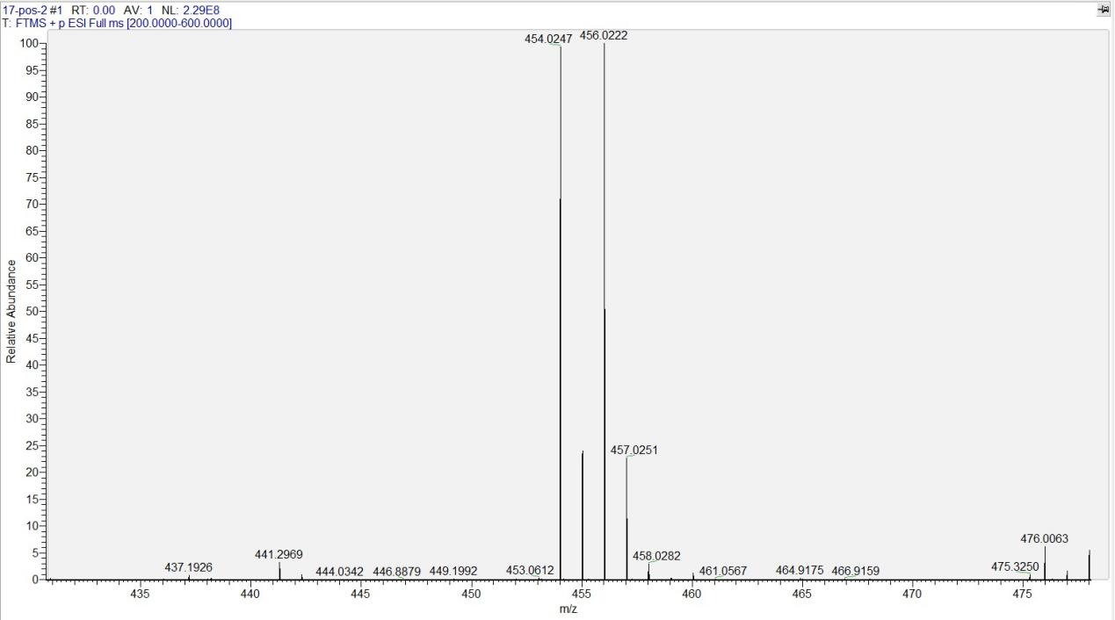
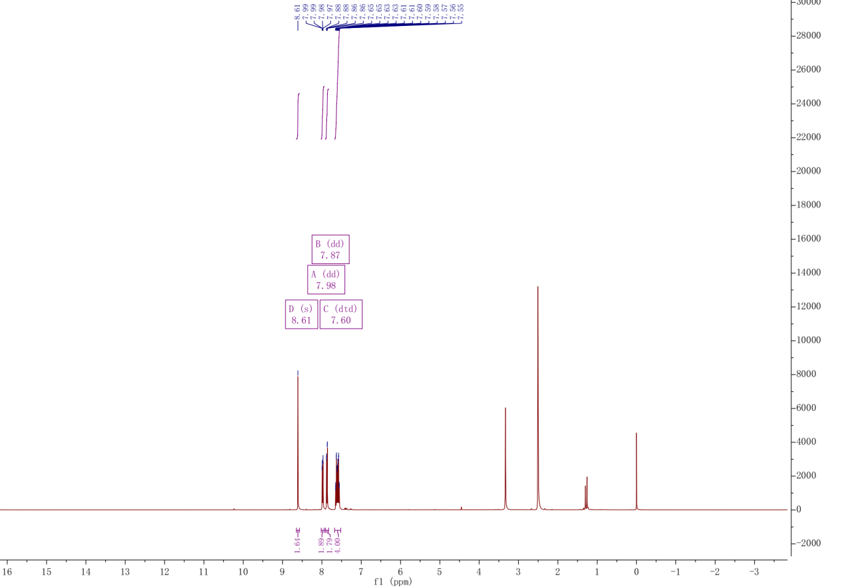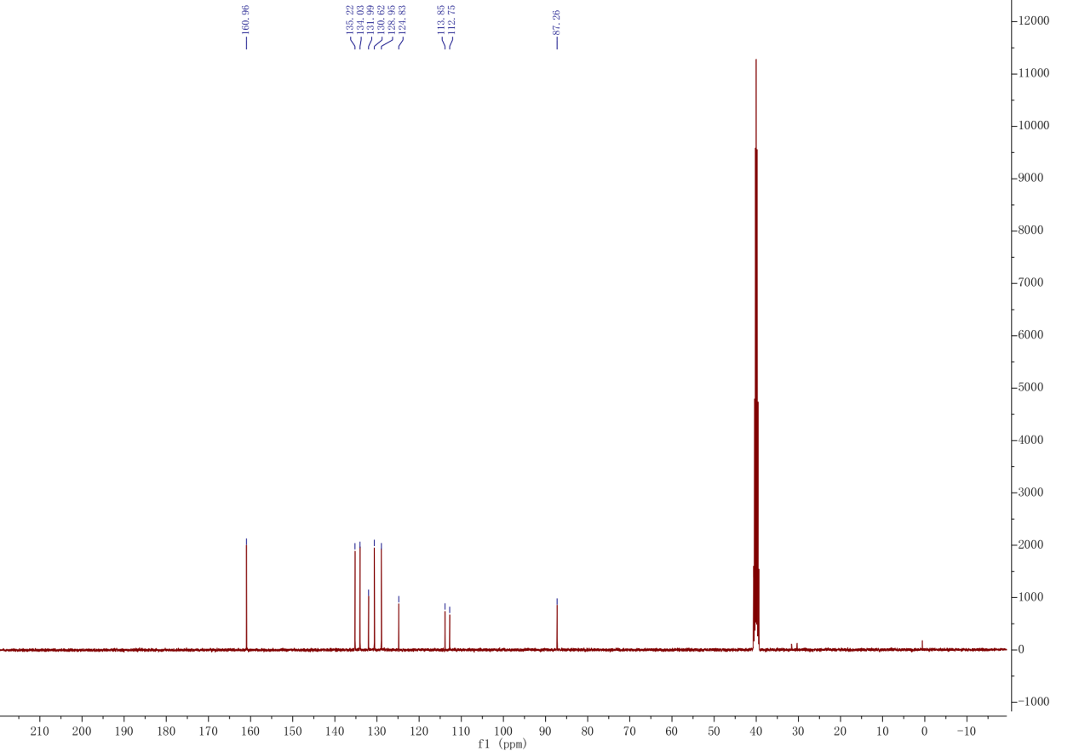

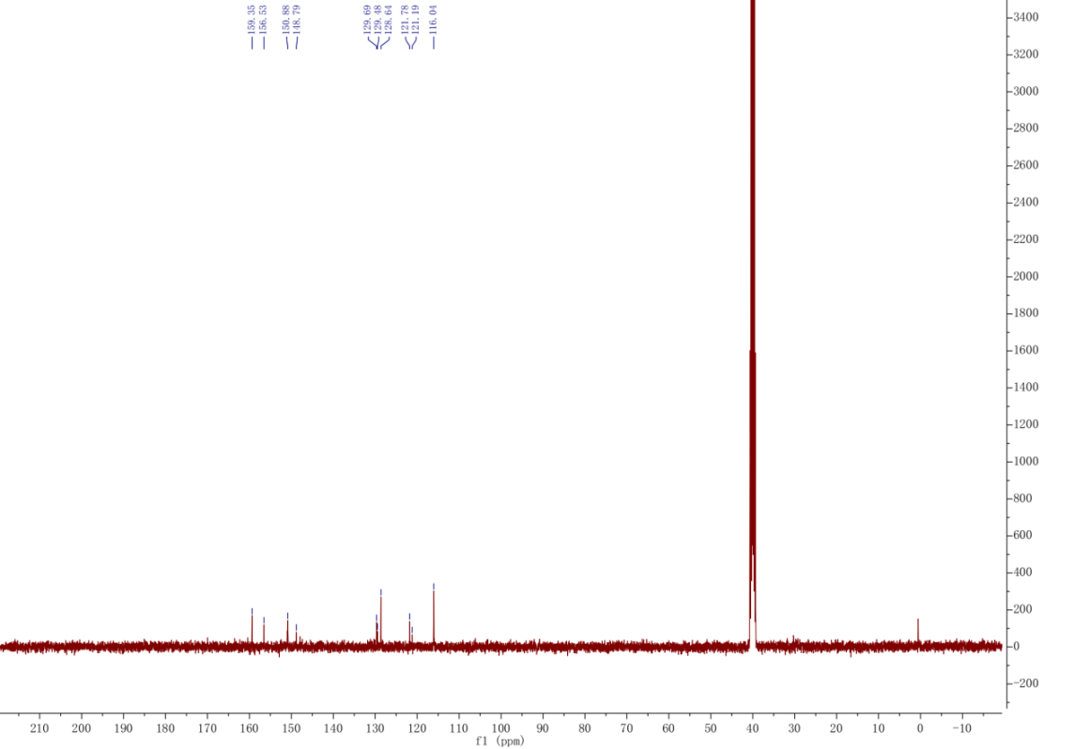

D16
