[Supplementary Information]
Plant Growth Benefits by the Coalition Function of Plant Microbiome
Sang-Moo Lee^{1Ϯ}, Jungwook Park^{2,3Ϯ}, Hyun-Hee Lee^{2Ϯ}, Ju Hui Kim^{4Ϯ}, Hyojun Seo⁴, Eunjin Kim⁴, Hyejung Jung^{2,3}, Sang Eun Jun¹, Kantika Nopphakhun⁴, Pyeong An Lee⁴, Jong Uk Son⁴, So Eon Kim⁴, Adenia Arih Utarini⁴, Gil Han², Soo Yeon Choi⁴, Kihyuck Choi^{1,4}, Jaeyoung Choi^{5,6}, Gyung-Tae Kim^{1,4}, Young-Su Seo^{2,7}* and Seon-Woo Lee^{1,4}*

¹Institute of Agricultural Life Sciences, Dong-A University, Busan 49315, Republic of Korea
²Department of Integrated Biological Science, Pusan National University, Busan 46241, Republic of Korea
³Biotechnology Research Division, National Institute of Fisheries Science, Busan 46083, Republic of Korea
⁴Department of Applied Bioscience, Dong-A University, Busan 49315, Republic of Korea
⁵ Department of Convergent Biotechnology and Advanced Materials Science, Kyung Hee University, Yongin 17104, Republic of Korea
⁶ BK21 Interdisciplinary Program in IT-Bio Convergence System, Kyung Hee University, Yongin 17104, Republic of Korea
⁷Institute of System Biology, Pusan National University, Busan 46241, Republic of Korea

*Address correspondence to
Seon-Woo Lee,
Department of Applied Bioscience
Dong-A University, Busan 49315
Republic of Korea
E-mail: seonlee@dau.ac.kr

Young Su Seo,
Department of Integrated Biological Science
Pusan National University, Busan 46241
Republic of Korea
E-mail: yseo2011@pusan.ac.kr

^{Ϯ}These authors contributed equally to this work.

METHODS

Microorganisms, SynCom preparation and culture condition
F. dauae TCH3-2 was cultivated at the 1/2 tryptic soy agar (TSA) medium (Becton Dickinson, USA) for 2 days at 30℃, as previously described¹. Using the National Center for Biotechnology Information (NCBI), Kyoto Encyclopedia of Genes and Genomes (KEGG), and UniProt database, we selected bacteria isolated from native soil, or type strains, expected to possess genes related to BR synthesis based on our transcriptomic and metatranscriptomic data. The list of all 7 SynCom members is presented in the table S22. Priestia megaterium strain UR39, Novosphingobium guangzhouense strain UR4, Gordonia polyisoprenivorans strain UT158, and Dyella japonica strain FT133 were cultivated at ½ TSA medium for 2 days at 30℃. Fluviicola taffensis RW262^{T} was grown at Reasoner’s 2A agar (R2A) medium (MB cell, USA) for 5 days at 25℃. Archangium gephyra ATCC 25201^{T} was grown 432 SP agar medium (0.0025% casitone, 0.001% galactose, 0.00025% K₂HPO₄, 0.0005% MgSO₄·7H₂O, 0.001% raffinose, 0.001% sucrose, 0.005% soluble starch, 1.5% agar) for 14 days at 30℃ (DSMZ, https://bacdive.dsmz.de/). Ketobacter alkanivorans KCTC52659^{T} was cultivated at ½ Marine Broth agar medium (MA) (pH 7.6) (Condalab, Spain) for 14 days at 25℃.
For plant growth assay by SynCom treatment under soil conditions, the suspension of seven SynCom strains and TCH3-2 in SDW (OD₆₀₀=0.2) were mixed in equal volumes, and the mixture was 10-fold diluted. In case of individual treatment of SynCom members, each suspension of single strains was prepared with same cell concentration. For treating SynCom to tomato plants grown in hydroponic cultivation, the suspension of seven SynCom strains and TCH3-2 (OD₆₀₀=0.2) were mixed in equal volumes in 2.5 mM 2-(n-morpholino) ethanesulfonic acid (MES) monohydrate buffer (pH 5.7, Sigma-Aldrich, USA) and the mixture were incubated for 3 days at 200 rpm, 30℃. Bacterial suspension to treat to tomato plants both in soil condition and hydroponic cultivation was applied as stated in following plant growth assay.

Plant growth and assay
Surface sterilized seeds of tomato cultivar Hawaii7996 (H7996), Moneymaker, and Micro-Tom were used. Tomato seeds were surface-sterilized first with 70% ethanol in 0.1% Triton X-100 for 1 min and secondly with 0.5% NaOCl in 0.1% Triton X-100 for 15 min. The seeds were germinated in petri dishes containing 5 ml sterilized distilled water (SDW) or the cell suspension of F. dauae TCH3-2 (OD₆₀₀=1.0, 10⁹ CFU/ml) on sterilized filter paper (ADVANTEC, Tokyo, Japan) for 7 days. Both germination and plant growth conditions followed 14 h/10 h of light/dark regime at 28ºC for all experiments. To investigate the growth promotion of tomato plant, the soil and hydroponic method were used.
For tomato cultivation in soil, the germinated tomato seedlings were planted to a pot containing 17 g of upland soil or sterilized commercial horticultural nursery soil (Punong Co., Ltd, Gyeongju, Korea) with 4 ml the cell suspension of TCH3-2 (OD₆₀₀=0.2, 2×10⁸ CFU/ml). The nursery soils were sterilized by autoclave twice (121ºC for 40 min) with an interval to enable the soil to reach ambient temperature before the second run. In case of the treatment of upland soil microbial fraction (UpMF) and synthetic community (SynCom), 20 ml of soil MF or 10 ml SynCom mixture were inoculated on each pot containing 17g of autoclaved nursery soil before 3 days transplantation. The upland soil were harvested at Dong-A University Agricultural Experimental Station, Busan, Korea (N35.239°, E128.978°). The UpMF was prepared and inoculated on sterilized nursery soils as previously described². At 3 weeks or 5 weeks post transplantation, the fresh weight, dry weight, and height of tomato plants were measured.
For hydroponic cultivation of tomato plants, germinated tomato seedlings were planted in 7 ml glass tubes containing 6 ml of pre-incubated SynCom mixture, sealed with transparent petri-seal. For drop-out experiment, the mixture of SynCom and TCH3-2 suspensions was prepared with same cell concentration (OD₆₀₀: 0.2), excluding specific single strains. To evaluate the PGP activity of minimized SynCom, the drop-in experiment tested stepwise additions of a minimal SynCom assembled from rank-classified strains: Rank 1 (K. alkanivorans, A. gephyra, and P. megaterium), Rank 2 (F. taffensis), and Rank 3 (G. polyisoprenivorans). Inocula for drop-out and drop-in experiments were prepared by mixing strains at equal volumes per strain; where a strain was not included, an equal volume of 2.5 mM MES buffer replaced the missing suspension. At 2 weeks post transplantation, the fresh weight, hypocotyl length, and root length of tomato plants were measured.

Metatranscriptome analysis of rhizosphere microbiota
RNA extraction and sequencing
Total RNA was extracted from 2 g of rhizosphere soil in each tomato sample using the RNA PowerSoil® total RNA isolation kit (MO BIO Laboratories, Inc., CA, USA) according to the manufacturer’s instructions. Total RNA was then DNase treated using the RNase-free DNase set (Qiagen, Hilden, Germany) resulting in 50 μl of total RNA extract. Next, the bacterial rRNA was depleted using the MICROBExpressTM bacterial mRNA enrichment kit (Ambion, CA, USA). Construction of metatranscriptome datasets based on the NGS technology was performed on the Illumina MiSeq system by national instrumentation center for environmental management (NICEM, Seoul, South Korea). Briefly, the enriched mRNAs were fragmented and reverse-transcribed. The RNA-seq libraries were prepared using the TruSeq stranded mRNA sample prep kit (Illumina, CA, USA), and paired-end 251 bp reads were generated for a total of six libraries. The raw data of FASTQ format was deposited at NCBI’s sequence read archive database accession no. SRR6387607−12 under the bioproject accession no. PRJNA422732.

Metatranscriptome analysis
The Illumina universal adapter sequences of raw reads were trimmed by the Cutadapt program³. The length of trimmed reads was set to be at least 50 bp in order to account for sequencing error. Trimmed reads were quality filtered using the FASTX-Toolkit (http://hannonlab.cshl.edu/fastx_toolkit), once the average quality within 50% of read sequences falls below a threshold (set to 28 Phred score). Following this, reads from paired FASTQ files were checked to remove unpaired reads using an in-house script with the cluster coordinates in a read header. The prokaryotic and eukaryotic rRNA sequences of pre-processed reads surviving quality control were mapped against the SILVA LSU/SSU reference databases⁴ in SortMeRNA v2.1 program⁵ with seed length of 18 bp. The read was discarded if it matched to the expected rRNA gene based on the SILVA annotation. The tRNA reads were also removed by genomic tRNA database⁶ using the cutoff of a 10⁻¹⁰ E-value.
The putative mRNA reads were in silico normalized to 50× coverage using the digital normalization script in the Trinity program v2.3.2^{7,8}. The normalized reads were then de novo assembled into contigs with minimum contig length = 300 bp^{7,8}. Considering the various lengths of possible subsequences, we chose a k-mer length of 25 bp to yield optimal de novo assembly results. The other settings of Trinity assembler remained at the default parameters. To prevent cross-assembling reads between all individual genes, an only longest isoform in each assembly result was considered as a representative contig. In an effort to increase the efficiency of functional annotation, a custom bacterial consortium database (taxonomy ID = 2) containing 5,443,130 proteins with 9506 KEGG Orthology (KO) informations were built from existing amino acid sequences in UniProt database⁹. All non-redundant contigs derived from de novo assembly were translated and searched by the DIAMOND program¹⁰, with significant parameters query-gencode = 11, E-value <10⁻¹⁰ and more-sensitive mode, against the custom bacterial consortium database. The top 100 matches were combined to determine a reciprocal best-hit result with a bitscore ≥80. Non-matched contigs were re-analysed against archaea (taxonomy ID = 2157), fungi (taxonomy ID = 4751), and viridiplantae (taxonomy ID = 33090) databases in UniProt⁹. Finally, the consensus annotation of bacterial proteins within searched contigs was saved as a unigene with protein description, taxonomic information and KO ID.

Differentially expressed genes analysis
The functional contigs with bacterial proteins derived from the DIAMOND search were used as the reference transcripts by the INDEX algorithm of BWA tool v0.7.5¹¹. Positional information of annotations was formatted as a SAF file for the background of read counting step. The putative mRNA reads were mapped into the indexed reference with the MEM algorithm of BWA tool. Reads mapping to each gene were counted using the featureCounts tool v1.5.0¹² with following parameters: -F SAF -O -M -p. The relative abundance of read counts was normalized in the RPKM (reads per kilobase per million mapped reads) procedure¹³. The DEGseq package based on the R statistical environment was used to validate differentially expressed genes (DEGs)¹⁴. The DEGseq package employs MA-plot-based method with random sampling model (MARS method) and a FDR P-value (determined by the Benjamini and Hochberg multiple-testing correction)¹⁵. We established our definition of DEGs to only those that had a |log2(treatment expression/control expression, FC)| ≥1 and FDR P-value <0.05.

Weighted gene co-expression network analysis
Prior to the co-expression network analysis, the mapping data of control and treatment samples in all transcripts was compiled with the KO information. Reads compiled in each KO entry were normalized using a trimmed mean of M-values method implemented in R packages edgeR¹⁶, and then transformed to log₂(normalized expression) resulting in clear co-expression patterns of similar variation. The R packages WGCNA was used to conduct the signed weighted gene co-expression network analysis according to the WGCNA’s tutorials¹⁷. A matrix of pair-wise Pearson correlations between all KOs was calculated and transformed into a pair-wise adjacency matrix by a soft power threshold (β) derived from the network topology analysis. In this step, the β of 12 power (a R² value=0.895) was selected for fit to a scale-free topology using the pickSoftTreshold algorithm¹⁷. The pair-wise adjacency matrix was re-transformed into a topological overlap measure (TOM) and a topological overlap dissimilarity measure (dissTOM, 1 − TOM) in order to improve the accuracy of downstream analyses and reduce the occurrence of spurious correlations. To construct the signed network, signed hybrid and signed parameters were used in the adjacency and TOMsimilarity algorithms, respectively.
Modules as groups of co-expressed genes were defined using the cutreeDynamic algorithm (deepSplit = 2) with a minimum module size of 150¹⁷. Briefly, the WGCNA used an average linkage hierarchical clustering algorithm based on the dissTOM to cluster smaller modules, and computed module eigengenes summarizing the first principal component of expression patterns. We merged some modules with similar expression patterns using the mergeCloseModules algorithm, if the eigengene dissimilarities of modules is <0.3. Merged modules were assigned to a unique color label. Subsequently, a module-trait relationship for each module was defined to identify interesting modules which are significantly correlated with the experimental trait. Once the interesting modules were identified, we validated their stabilities by a permutation procedure as previously described¹⁸. If the interesting module truly and statistically represents a group of co-expressed genes, its average TOM would be higher than that of random groups¹⁸. Thus, we randomly selected genes of same size for each interesting module with 1000 replicates, and computed average TOMs of random groups. Based on the one-tailed Student’s t-test, it was evaluated whether the average TOM of interesting module was higher than most random groups of genes. In addition, we compared the network density between the interesting modules and entire network through a hard-thresholding procedure¹⁹; the proportions of nodes connected to more than 10% of the total size and edges were determined using the Pearson correlation coefficients for different cutoffs ranging from 0 to 1 at 0.01 intervals per each network.

Enrichment analysis of biological functions
GO terms and KEGG categories (pathways and modules) for all KOs that make up the entire co-expression network were acquired using the UniProt retrieve/ID mapping tool (http://www.uniprot.org/uploadlists) and KEGG mapping tool by the KO system (http://www.genome.jp/kegg/ko.html), respectively. GO enrichment analysis was carried out separately in three aspects: biological process (the larger processes or biological programs), cellular component (the locations relative to cellular structures), and molecular function (molecular activities of gene products)²⁰. To determine if any high-level functions and biological systems were enriched in the module, lists of enriched GO terms and KEGG categories from each module were compared to all categories in the gene set. Then, the statistical verification of enrichment analyses was evaluated by a hypergeometric distribution using the phyper() function based on the R statistical environment²¹. The computational inputs for this hypothesis test are as follows: N, the number of all KOs with GO terms or KEGG categories; n, the number of KOs within each module in N; M, the number of all KOs annotated to a certain category; m, the number of KOs within each module in M. A calculated P-value of ≤0.01 was used as a significant threshold. Also, in the KEGG category enrichment, we excluded incomplete pathways consisting of ≤5 KOs to prevent false positive results.

Identification and visualization of hub KOs
To identify hub KOs, a module membership, which is a correlation of expression profiles with the module eigengene, and a gene significance quantifying an association with the experimental trait were calculated for each KO entry. As potential hubs, we selected some KOs which have the strong levels of >0.8 in both module membership and gene significance with a P-value <0.05. Among these candidates, we applied a strict filter criterion that only KOs directly connected with up-regulated DEGs were considered to be high-confidence intramodular hubs. The Cytoscape program v3.6.0 (http://www.cytoscape.org/) was used to visualize the hub network based on the TOM and the biological functions (GO term and KEGG pathway) to which the hubs belong. In this step, we excluded metabolic pathways (ko01100) of biological functions, because it is a very broad pathway consisting of 2810 genes.

Pangenome analysis
Genome sequences were obtained from the NCBI RefSeq database (accessed on May 15, 2025). Pangenome analysis was carried out using the PPanGGOLiN (v2.1.0)²² to characterize the pangenomes across 13 selected Flavobacterium genomes. The scatter plot representing pan- and core genomes were created by using PanGP (v1.0.1)²³ with the 0/1 table converted from the presence and absence table of the PPanGGOLiN analysis. The partitioned pangenome graph of the PPanGGOLiN analysis was displayed by using Gephi (v0.10.1)²⁴ with the ForceAtlas2 algorithm²⁵. eggNOG-mapper (v2.1.8 with database v5.0.2)^{26,27} was used for functional annotation, including Gene Ontology, KEGG orthology, COG categories, and protein domains, of protein sequences encoded by the 622 TCH3-2-specific genes.

Microbiome analysis
To investigate the effect of Flavobacterium dauae TCH3-2 on the rhizosphere and root endosphere microbiome of tomato grown at upland soil, we harvested the rhizosphere soil and surface-sterilized root tissue of tomato plant for 16S rRNA amplicon sequencing. At 3- and 5-weeks post transplantation, firstly, the rhizosphere soil was harvested from plant roots using a sonicator (Branson 5500DTH, Danbury, USA) as previously described²⁸. The root tissues were then sterilized twice using 10 ml of 80% ethanol for 30 seconds and 10 ml of 3% sodium hypochlorite (Alfa Aesar, USA) for 30 seconds, respectively. The sterilized roots were rinsed more than 10 times with sterile distilled water (SDW) to remove any remaining ethanol and sodium hypochlorite.
Total DNA was extracted from 200 mg of rhizosphere soil by using the FastDNATM SPIN for soil kit (MP Biomedicals, Solon, USA) or 10 mg of sterilized root samples with CTAB method²⁹. The extracted DNA was adjusted to 5 ng/μl using NanoDrop 2000 (Thermo Scientific, MA, USA). The V3-V4 region of 16S rRNA gene was amplified using dual indexed primers (341F,5’-TCGTCGGCAGCGTCAGATGTGTATAAGAGACAGCCTACGGGNGGCWGCAG-3’; 805R,5’-GTCTCGTGGGCTCGGAGATGTGTATAAGAGACAGGACTACHVGGGTATCTAATC-3’) with Illumina adapter overhang nucleotide sequences (bold text in the primers)^{30,31}. Polymerase chain reaction (PCR) was conducted using 2.5 μl of total DNA (5 ng/μL), 5 μl of each forward and reverse primer (1 μM), and 12.5 μl of the 2X KAPA HiFi Hotstart Ready Mix PCR Kit (Kapa Biosystems, MA, USA). Thermocycler parameters used for PCR were as follows: an initial denaturation at 95°C for 5 min, followed by 25 cycles at 95°C for 30 s, 55°C for 30 s, 72°C for 30 s, and a final extension at 72°C for 5 min. The amplified products were cleaned up using AMPure XP beads (Beckman Coulter Genomics, IN, USA). The quality of the amplicons was evaluated through agarose gel electrophoresis using a 0.7% gel. Sequencing was conducted on an Illumina MiSeq platform (NICEM, Seoul, Korea, and Macrogen Inc., Seoul, Korea) based on the instructions provided, resulting in a set of paired end sequences of the 16S rRNA gene fragments.
The 16S rRNA gene amplicons were analyzed using Quantitative Insights into Microbial Ecology 2 (QIIME2 version 2021.11)³², following the available standard protocol, with slight modifications³³. Demultiplexing and quality filtering were performed on the raw fastq sequences of 16S rRNA amplicons. De-noising, de-replication, and chimera filtering of the sequence data were conducted using DADA2³⁴ and clustered into groups sharing 99% identity within the VSEARCH³⁵. The dataset was filtered using the QIIME "taxa filter-table" command to remove singletons and nonbacterial species, including archaea, mitochondria, chloroplasts, and Cyanobacteria. To assign taxonomy to clustered Operational Taxonomic Units (OTUs), a Naïve-Bayes classifier was trained on the SILVA (v.138.1) database using the classify-sklearn command within the feature-classifier plug-in³⁶. A phylogenetic tree was generated based on 16S rRNA gene fragments using MAFFT-aligned representative OTU sequences in FastTree, with the tree rooted at the midpoint. This phylogeny was used in both alpha and beta diversity analyses³⁷.
Bacterial alpha and beta diversity metrics were employed for comparison of the bacterial community using a rarefied OTU table. To standardize the depth of reads after subsampling, the rarefyeven_depth function of the Phyloseq package was used to employ the OTU table. The alpha and beta diversities were plotted by importing the required normalized OTU table and phylogeny using Phyloseq in R program (version 4.1.3) and graphed with ggplot2^{38,39}. Bacterial alpha diversity across TCH3-2 treatments and nontreatments was calculated using two metrics (observed OTUs and evenness). Principal coordinate analysis (PCoA) was performed using weighted UniFrac distance for inter-sample analysis. Relative abundance analysis was performed by normalizing OTUs, expressing the taxonomic composition of each sample as the ratio of individual OTU counts to the total counts of all OTUs within that sample. Additionally, Random Forest⁴⁰ were performed using the R program to select important bacteria using the OTU table obtained from the microbiome analysis.

Tomato transcriptome analysis

RNA extraction and sequencing
Stems and roots of the tomato promoted by treatment of the F. dauae TCH3-2 culture and those of the control tomato were harvested with each four replicates for RNA extraction. Harvested stems and roots tissues were frozen in liquid nitrogen and roughly ground under cooling with liquid nitrogen in a mortar and a pestle. The crushed tissues were than submitted to extraction with a tissue lyser (TissueLyser II; Qiagen, Hilden, Germany) for quick pulverization. The tissues were ground into a fine powder while frozen in a vial containing metal ball bearings by conducting lysis at 30 Hz for 2 min. Tissue lysed powders were transferred to tubes containing TRIzol Reagent (Thermo Fisher Scientific, MA, USA) for homogenization and total RNA was extracted according to the manufacturer’s instruction. The total RNA was then DNase treated using the RNase-free DNase set (Qiagen) resulting in 50 μl of total RNA extract. DNase-treated total RNA was visualized on 1% agarose gels using the Mupid®-One (Takara) and quantified using the NanoDropTM 2000 spectrophotometer (ThermoScientific). The eight transcriptome libraries consisted of the control and the treatment samples with four replicates was constructed using the TruSeq Stranded Total RNA LT with Ribo-Zero Plant kit (Illumina Inc., San Diego, CA, USA). Finally, sequencing of libraries was performed by a HiSeq 3000–4000 sequencing protocol and a TruSeq 3000–4000 SBS Kit v3 reagent, following a paired-end 101 bp strategy on Illumina HiSeq 4000 platform by Macrogen (Macrogen Inc.).

Transcriptome profiling and differentially expressed genes analysis
After the RNA sequencing, adapter sequences were trimmed by the Cutadapt program³, and then unreliable low quality reads were ﬁrstly removed from the raw reads using the FASTX-Toolkit, if the average quality within 50% of read sequences falls below a threshold (set to 28 Phred score). Filtered clean reads were then mapped to S. lycopersicum reference genome sequences (SL3.0 version) downloaded from the NCBI by using the BWA program. Generated SAM ﬁles were subsequently sorted by chromosomal coordinates using the SAMtools program for counting steps, after which the mapped reads per gene were counted by the featureCounts tool v1.5.0¹². To analyze a gene expression level, RPKM values per sample for all genes were calculated¹³. Then, the DEGs analysis was implemented via the software package edgeR in the R statistical environment¹⁴. A q-value was adjusted using the method described in Benjamini and Hochberg¹⁵. A FDR P-value <0.05 and an absolute value of |log2(treatment expression/control expression, FC)| ≥1 were used as a threshold to determine the signiﬁcance of gene expression diﬀerence.

Interspecies antagonistic and growth-promoting interaction assay
To assess antagonistic and growth-promoting interactions among SynCom strains and TCH3-2 in pairwise combinations, we employed the soft-agar overlay assay and the V-shape assay. Each strain was prepared at an OD₆₀₀ of 0.2, except for A. gephyra and F. taffensis, which were adjusted to OD₆₀₀ = 1.0 due to poor colony formation or slow growth.
For testing interspecies interactions at close proximity, a soft-agar overlay assay was performed. The bottom layer consisted of TRM agar medium with 1.5% agar, and the top layer contained TRM agar medium with 0.6% agar. Cells of each strain were mixed into the top layer at the designated OD₆₀₀. After pouring the top layer onto the solidified bottom agar, 3 μl of a second strain’s cell suspension was spotted onto the surface. Plates were incubated at 30°C until visible colony formation. The colony size of each bacterial strain dropped onto the agar surface was measured using the ImageJ software(https://imagej.net/ij/).
To evaluate the influence of physical proximity between strains, a V-shape assay was conducted by co-inoculating 5 μl of cell suspensions in a diagonal pattern on TRM agar, progressively decreasing the distance between inoculation points. Plates were incubated at 30°C until colonies became visible.

RT-qPCR analysis for investigation of PGP activity by SynCom and TCH3-2 in tomato roots
Total root RNA was extracted from roots tissues of SynCom and TCH3-2 treated tomato plants grown at autoclaved nursery soil for 3 weeks. Total RNA was isolated from root samples using TRIzol Reagent (Molecular Research Inc., OH, USA) and first-strand cDNA was synthesized using M-MLV Reverse Transcriptase (Promega Inc., WI, USA), according to the manufacturer's instructions. Then, quantitative real-time PCR (qRT-PCR) was performed on the Chromo4 Real-Time PCR System (Bio-Rad, Hercules, CA, USA) using the cDNA template, iQTM SYBR® Green Supermix (Bio-Rad), and 10-pM sequence-specific primers for brassinosteroid-related genes and auxin-related, gibberellic acid-related marker genes (Supplementary Table 24) under the following conditions: initial polymerase activation at 95 °C for 10 min, followed by 40 cycles of denaturation at 95 °C for 30 s, annealing at 60 °C for 30 s, and extension at 72 °C for 30 s. The expression level of each gene was calibrated and normalized relative to that of Ubiquitin3 mRNA. All qRT-PCR experiments were performed using 3 biological replicates per treatment in triplicate.

RT-qPCR analysis for investigation of sterol synthesis-related genes in SynCom member.
The bacterial cell suspension were harvested at 30 mins and 5 days post transplantation under hydroponic condition. To harvest the cell pellet, 15 mL of bacterial cell suspension from each of three plants was pooled at 0 and 5 days post transplantation and centrifuged at 8,500 rpm for 15 minutes. Total bacterial RNA was extracted from cell pellets using TRIzol Max Bacterial RNA isolation kit (Molecular Research Inc., OH, USA) as manufacture protocols and first-strand cDNA was synthesized using M-MLV Reverse Transcriptase (Promega Inc., WI, USA), according to the manufacturer's instructions. Then, quantitative real-time PCR (qRT-PCR) was performed on the Chromo4 Real-Time PCR System (Bio-Rad, Hercules, CA, USA) using the cDNA template, iQTM SYBR® Green Supermix (Bio-Rad), and 10-pM sequence-specific primers for sterol synthesis-related genes for SynCom members (Supplementary Table 24) under the following conditions: initial polymerase activation at 95 °C for 10 min, followed by 40 cycles of denaturation at 95 °C for 30 s, annealing at 60 °C for 30 s, and extension at 72 °C for 30 s. The expression level of each gene was calibrated and normalized relative to that of reference genes including 16s rRNA and gyrB genes. All qRT-PCR experiments were performed in triplicate.

Arabidopsis mutants assay
Arabidopsis wild type Columbia-0 (Col-0), BL-deficient mutants, dwf1 (SALK_006932)⁴¹, as well as the insensitive mutant bri1-301⁴², stigmasterol and dolichosterone-deficient mutants, cyp710a1 (SALK_014626) and cyp710a2 (SALK_001175)⁴³ were utilized in this study. Plants were germinated in Murashige-Skoog (MS) media containing 0.43% MS medium salt mixture, 2% sucrose, and 0.2% gellan gum (pH 6.3) under light conditions (16 hours light/8 hours dark) or in the dark at 22 ℃. SynCom suspension solution were applied to 1/2 MS without sucrose medium containing 1.6% agar. Seedlings of 3 days after sowing (DAS) were transferred to prepared SynCom plates. The seedlings were then cultivated under either light or dark conditions at 22 ℃.
For measuring hypocotyl length, seedlings grown in the dark condition were collected at 10 DAS/7 days post inoculation (DPI). For measuring shoot fresh weight, seedling grown in the light condition collected at18 DAS/15 DPI. Hypocotyl length was measured using the ImageJ program. Data obtained from at least eight plants were subjected to statistical analysis using the R program.

Biofilm formation assay and quantification of total bacterial population in multispecies biofilms
Bacterial colonies were picked from agar plates and inoculated into 5 ml of TRM liquid medium (1/2 TSA + 1/2 R2A + 1/4 MA), followed by overnight incubation at 30 °C and 200 rpm in a shaking incubator. The bacterial cultures were adjusted to an OD₆₀₀ of 0.2 using a spectrophotometer (DU730, Beckman Coulter, USA) with fresh TRM broth. Equal volumes of eight bacterial suspensions were mixed to assess multispecies biofilm formation. To apply tomato root exudates for biofilm assay, the exudates were collected from tomato plants at 14 days post-transplantation using 2.5 mM MES buffer, following the same hydroponic assay protocol. To eliminate bacterial contamination, the exudates were centrifuged at 8,500 rpm for 15 minutes and filtered through a 0.2 µm syringe filter (Sartorius AG, Germany). The filtered exudates were then mixed with TRM broth at a 1:1 ratio (50%). For dropout assays, TRM broth was added in place of the omitted strain. For single-species and pairwise biofilm assays, cultures were diluted seven-fold and six-fold, respectively, in TRM broth. A total of 180 µl of each bacterial mixture was transferred into a Nunc™ 96-well microplate (Fisher Scientific, USA) with Nunc™ Immuno TSP lids and incubated at 25 °C for 48 h without shaking. Plates were sealed with Parafilm and sealing tape. After incubation, planktonic cells were removed by rinsing twice with 0.85% NaCl. Biofilms were stained with 0.1% crystal violet (Sigma-Aldrich, USA) for 30 min, then washed twice again with 0.85% NaCl. Stained biofilms were de-stained with 200 µl of absolute ethanol for 15 min and quantified at 590 nm using a Multiskan SkyHigh microplate spectrophotometer (Thermo Scientific™, USA).

Estimation of bacterial population dynamics using qPCR
The preparation of bacterial strains and tomato plants followed the same hydroponic assay protocol used for the plant growth experiment. Rhizosphere biofilms were harvested from tomato roots at 0, 5, and 10 days after transplantation. At each time point, two individual tomato plants were pooled, and their roots were collected into a 1.5 ml tube containing 1 ml SDW. Biofilms on the root surfaces were detached by sonication for 15 min using a sonicator (DanburyTM, USA). For estimation of planktonic bacterial population, ST-K culture solution were harvested at 0 and 2 days after inoculation in TRM broth medium. The resulting bacterial suspension was centrifuged at 13,300 rpm for 20 min at 4 °C (Thermo Scientific™, USA) to collect the bacterial pellet.
Genomic DNA (gDNA) was extracted from the rhizosphere biofilm using the CTAB method. The abundance of each target strain was quantified by qPCR using strain specific primers (Supplementary Table 25). For standard curve construction, gDNA was extracted from serially diluted bacterial cultures (ranging from 10² to 10⁵ CFU/ml) using the same CTAB method, and the cycle threshold (CT) values were correlated with known CFU counts. In case of Archangium, cell numbers were used instead of CFUs. Strain-specific primers were used for each target⁴⁴. Each qPCR reaction (20 µl total volume) contained 3 µl of gDNA (100 ng/µl), 10 µl of GoTaq® Green Master Mix (Promega, USA), 1 µl each of forward and reverse primers (1 µM), and 5 µl of nuclease-free water. The thermal cycling conditions were as follows: initial denaturation at 95 °C for 5 min, followed by 30 cycles of 95 °C for 30 s, 62 °C for 30 s, and 72 °C for 30 s, with a final extension at 72 °C for 5 min.
To normalize the population size, CFU values or cell number were divided by the total root length and expressed as log (CFU or cell number per mm of root). The bacterial abundance in each rhizosphere biofilm sample was calculated based on CT values using linear regression of the standard curve and converted to CFU per mm of root length (Supplementary Fig. 25)⁴⁴.

Functional trait-based classification of SynCom members
To classify functional division in SynCom member, a hierarchical clustering heatmap was constructed based on the standardized values of six traits. For hierarchical clustering, Euclidean distance and Ward’s minimum variance method (ward.D2) were used for clustering⁴⁵. Cluster stability was assessed using multiscale bootstrap resampling implemented in the pvclust R package (n = 1000 bootstrap replicates), yielding approximately unbiased (AU) p-values and bootstrap probability (BP) p-values for each cluster⁴⁶. In addition, principal coordinates analysis (PCoA) was conducted using the same trait data to visualize the functional distribution of the seven SynCom strains in two-dimensional space.
To evaluate the functional division among SynCom member strains, we quantified and compared six phenotypic traits. Strain-specific sterol-related genes were identified by excluding sterol-related genes shared with other strains. PGP activity was scored from 0 to 4 based on the statistical significance of hypocotyl length changes observed in drop-out experiments, in which individual strains were selectively removed from the ST to assess their contribution to the overall PGP effect, as determined by ANOVA and Tukey’s HSD post hoc test. The scoring criteria were as follows: 0, increased length; 1, non-significant reduction (P ≥ 0.05); 2, significant reduction (0.01 ≤ P < 0.05); 3, highly significant reduction (P < 0.01); and 4, most pronounced and statistically robust reduction (P < 0.001). A higher score indicates a greater loss of PGP activity upon strain removal, and thus a more critical role of the omitted strain in PGP. Root colonization effect was assessed under hydroponic conditions at day 10 by comparing the population of each SynCom strain in the root-associated biofilm between ST and S treatments, and scored as follows: 0, no significant difference; 1, significant increase (P < 0.05); 2, highly significant increase (P < 0.01); and 3, most significant and robust increase (P < 0.001). Biofilm formation activity was scored from 0 to 2 based on the statistical significance of changes observed in drop-out experiments, in which individual strains were selectively removed from the ST to evaluate their contribution to the overall biofilm formation, as determined by ANOVA and Tukey’s HSD post hoc test. The scoring criteria were as follows: 0, no effect; 1, non-significant reduction; and 2, significant reduction (P < 0.05). A higher score indicates a greater loss of biofilm formation upon strain removal, and thus a more critical role of the omitted strain in biofilm formation. The growth-promoting effect on TCH3-2 was also scored from 0 to 4, based on the strength and spatial range of the effect: 0, no effect; 1, weak promotion at close proximity; 2, promotion at close proximity; 3, promotion at a distance; and 4, strong promotion at both close proximity and a distance. Inter-strain growth promotion was quantified by counting the number of SynCom strains whose growth was enhanced by each strain.

Statistics
All the statistical details of the experiments can be found in the figure legends. Statistical analyses were performed using the R program and QIIME2.

Data and materials availability
16S rRNA gene amplicon sequences have been deposited in the NCBI Sequence Read Archive (SRA) database (PRJNA1129298). Metatranscriptome data and tomato transcriptome data have been deposited in the NCBI SRA (PRJNA422732) and Gene Expression Omnibus database (GSE270832), respectively. Reprints and permissions information is available at www.nature.com/reprints. Correspondence and requests for materials should be addressed to SWL (seonlee@dau.ac.kr) or YSS (yseo2011@pusan.ac.kr).

References

1 Jung, E. J. et al. Flavobacterium dauae sp. nov., isolated from rhizosphere soil of a tomato plant. Int. J. Syst. Evol. Microbiol. 71, 005033 (2021).
2 Choi, K. et al. Alteration of bacterial wilt resistance in tomato plant by microbiota transplant. Front. Plant Sci. 11, 1186 (2020).
3 Martin, M. Cutadapt removes adapter sequences from high-throughput sequencing reads. EMBnet J. 17, 10-12 (2011).
4 Quast, C. et al. The SILVA ribosomal RNA gene database project: improved data processing and web-based tools. Nucleic Acids Res. 41, D590-D596 (2012).
5 Kopylova, E., Noé, L. & Touzet, H. SortMeRNA: fast and accurate filtering of ribosomal RNAs in metatranscriptomic data. Bioinformatics 28, 3211-3217 (2012).
6 Lowe, T. M. & Eddy, S. R. tRNAscan-SE: a program for improved detection of transfer RNA genes in genomic sequence. Nucleic Acids Res. 25, 955-964 (1997).
7 Grabherr, M. G. et al. Full-length transcriptome assembly from RNA-Seq data without a reference genome. Nat. Biotechnol. 29, 644-652 (2011).
8 Haas, B. J. et al. De novo transcript sequence reconstruction from RNA-seq using the Trinity platform for reference generation and analysis. Nat. Protoc. 8, 1494-1512 (2013).
9 Consortium, U. UniProt: a hub for protein information. Nucleic Acids Res. 43, D204-D212 (2015).
10 Buchfink, B., Xie, C. & Huson, D. H. Fast and sensitive protein alignment using DIAMOND. Nat. Methods 12, 59-60 (2015).
11 Li, H. & Durbin, R. Fast and accurate short read alignment with Burrows–Wheeler transform. Bioinformatics 25, 1754-1760 (2009).
12 Liao, Y., Smyth, G. K. & Shi, W. featureCounts: an efficient general purpose program for assigning sequence reads to genomic features. Bioinformatics 30, 923-930 (2014).
13 Mortazavi, A., Williams, B. A., McCue, K., Schaeffer, L. & Wold, B. Mapping and quantifying mammalian transcriptomes by RNA-Seq. Nat. Methods 5, 621-628 (2008).
14 Wang, L. & Wang, X. DEGseq: identify differentially expressed genes from RNA-seq data. R package version 1, 10.1093 (2016).
15 Benjamini, Y. & Hochberg, Y. Controlling the false discovery rate: a practical and powerful approach to multiple testing. J. R. Stat. Soc. Ser. B-Stat. Methodol. 57, 289-300 (1995).
16 Robinson, M. D., McCarthy, D. J. & Smyth, G. K. edgeR: a Bioconductor package for differential expression analysis of digital gene expression data. Bioinformatics 26, 139-140 (2010).
17 Langfelder, P. & Horvath, S. WGCNA: an R package for weighted correlation network analysis. BMC Bioinformatics 9, 1-13 (2008).
18 Iancu, O. D. et al. Utilizing RNA-Seq data for de novo coexpression network inference. Bioinformatics 28, 1592-1597 (2012).
19 Verk, M. V., Bol, J. F. & Linthorst, H. J. Linthorst, Prospecting for genes involved in transcriptional regulation of plant defenses, a bioinformatics approach. BMC Plant Biol. 11, 1-12 (2011).
20 Ashburner, M. et al. Gene Ontology: tool for the unification of biology. Nat. Genet. 25, 25-29 (2000).
21 Qureshi, R. & Sacan, A. Weighted set enrichment of gene expression data. BMC Syst. Biol. 7, 1-11 (2013).
22 Gautreau, G. et al. PPanGGOLiN: depicting microbial diversity via a partitioned pangenome graph. PLoS comput. Biol. 16, e1007732 (2020).
23 Zhao, Y. et al. PanGP: a tool for quickly analyzing bacterial pan-genome profile. Bioinformatics 30, 1297-1299 (2014).
24 Bastian, M., Heymann, S. & Jacomy, M. In Proceedings of the international AAAI conference on web and social media 3, 361-362.
25 Jacomy, M., Venturini, T., Heymann, S. & Bastian, M. ForceAtlas2, a continuous graph layout algorithm for handy network visualization designed for the Gephi software. PloS One 9, e98679 (2014).
26 Cantalapiedra, C. P. et al. eggNOG-mapper v2: functional annotation, orthology assignments, and domain prediction at the metagenomic scale. Mol. Biol. Evol. 38, 5825-5829 (2021).
27 Huerta-Cepas, J. et al. eggNOG 5.0: a hierarchical, functionally and phylogenetically annotated orthology resource based on 5090 organisms and 2502 viruses. Nucleic Acids Res. 47, D309-D314 (2019).
28 Tang, Q. et al. Microbial interactions and metabolisms in response to bacterial wilt and black shank pathogens in the tobacco rhizosphere. Front. Plant Sci. 14, 1200136 (2023).
29 Möller, E., Bahnweg, G., Sandermann, H. & Geiger, H. A simple and efficient protocol for isolation of high molecular weight DNA from filamentous fungi, fruit bodies, and infected plant tissues. Nucleic Acids Res. 20, 6115 (1992).
30 Herlemann, D. P. et al. Transitions in bacterial communities along the 2000 km salinity gradient of the Baltic Sea. ISME J. 5, 1571-1579 (2011).
31 Naylor, D., DeGraaf, S., Purdom, E. & Coleman-Derr, D. Drought and host selection influence bacterial community dynamics in the grass root microbiome. ISME J. 11, 2691-2704 (2017).
32 Bolyen, E. et al. Reproducible, interactive, scalable and extensible microbiome data science using QIIME 2. Nat. Biotechnol. 37, 852-857 (2019).
33 Hall, M. & Beiko, R. G. 16S rRNA gene analysis with QIIME2. Microbiome analysis: methods and protocols, 113-129 (2018).
34 Callahan, B. J. et al. DADA2: High-resolution sample inference from Illumina amplicon data. Nat. Methods 13, 581-583 (2016).
35 Rognes, T., Flouri, T., Nichols, B., Quince, C. & Mahé, F. VSEARCH: a versatile open source tool for metagenomics. PeerJ 4, e2584 (2016).
36 Bokulich, N. A. et al. Optimizing taxonomic classification of marker-gene amplicon sequences with QIIME 2’s q2-feature-classifier plugin. Microbiome 6, 1-17 (2018).
37 Price, M. N., Dehal, P. S. & Arkin, A. P. FastTree 2–approximately maximum-likelihood trees for large alignments. PloS One 5, e9490 (2010).
38 McMurdie, P. J. & Holmes, S. phyloseq: an R package for reproducible interactive analysis and graphics of microbiome census data. PloS One 8, e61217 (2013).
39 Wickham, H. In Ggplot2: elegant graphics for data analysis 241-253 (Springer, 2016).
40 Liaw, A. & Wiener, M. Classification and regression by randomForest. R news 2, 18-22 (2002).
41 Youn, J. H. et al. Function and molecular regulation of DWARF1 as a C-24 reductase in brassinosteroid biosynthesis in Arabidopsis. J. Exp. Bot. 69, 1873-1886 (2018).
42 Li, J. & Nam, K. H. Regulation of brassinosteroid signaling by a GSK3/SHAGGY-like kinase. Science 295, 1299-1301 (2002).
43 Seo, C. et al. Cytochrome P450 710A1/A2 as Brassinosteroid C24-Desaturases to Connect C27-and C28-Brassinosteroids Biosynthesis in Arabidopsis thaliana. J. Plant Biol. 67, 59-70 (2024).
44 Kwak, M. J. et al. Rhizosphere microbiome structure alters to enable wilt resistance in tomato. Nature Biotechnol. 36, 1100-1109 (2018).
45 Murtagh, F. & Legendre, P. Ward’s hierarchical agglomerative clustering method: which algorithms implement Ward’s criterion? J. Classif. 31, 274-295 (2014).
46 Suzuki, R. & Shimodaira, H. Pvclust: an R package for assessing the uncertainty in hierarchical clustering. Bioinformatics. 22, 1540-1542 (2006).

[Supplementary Data]
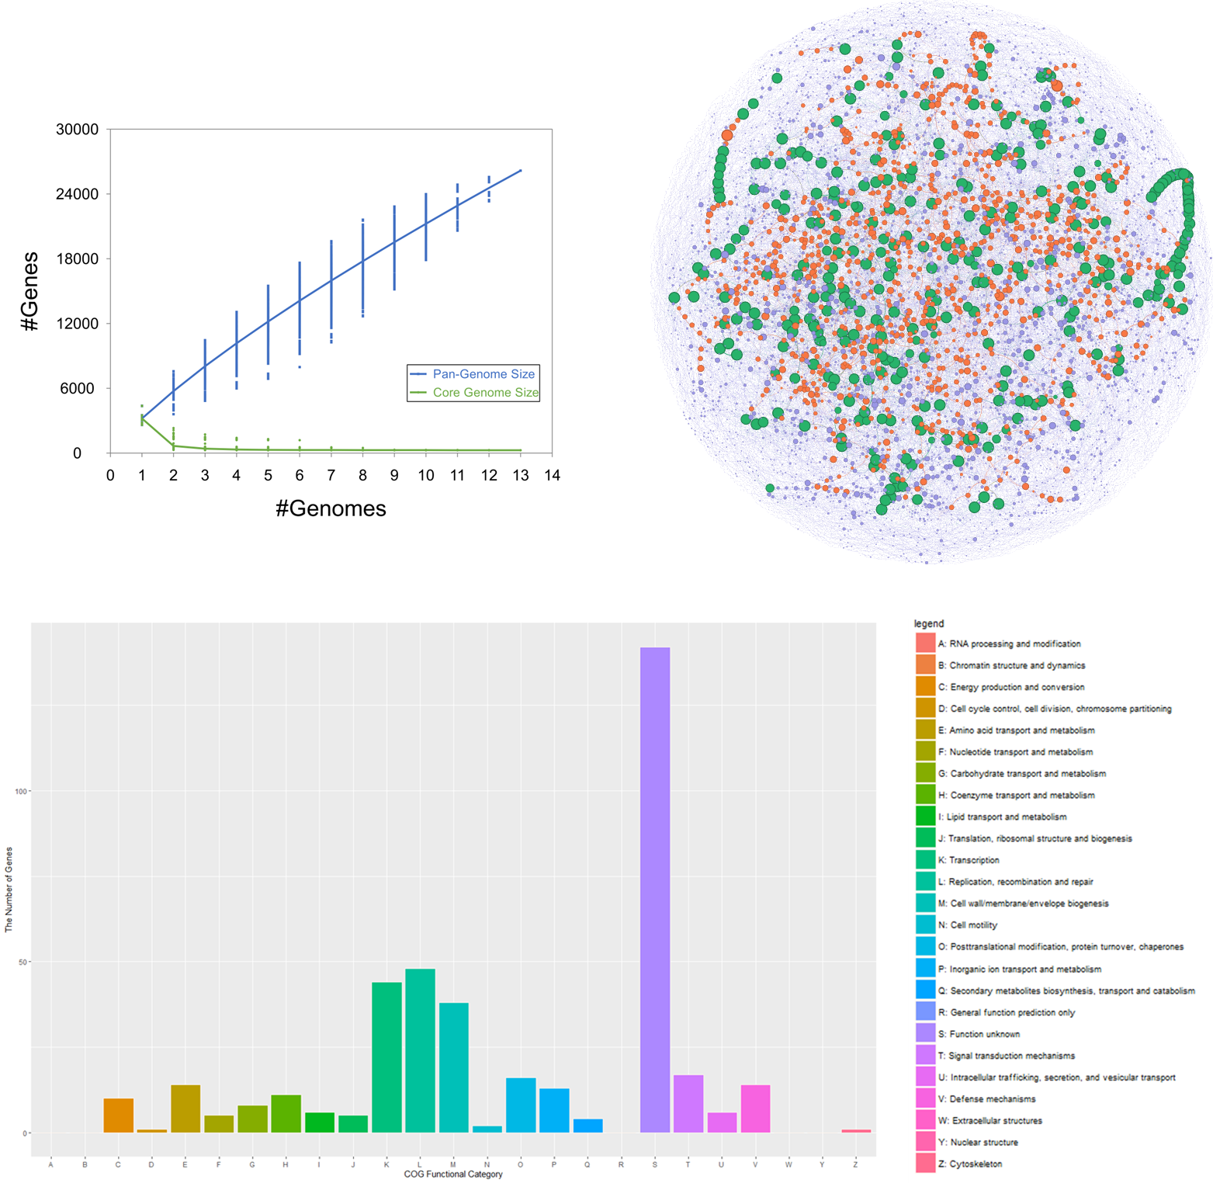
b
c
a
Figure S1: Pangenome analysis of Flavobacterium species (a) Scatter plot of the number of genes in the core and pan-genomes as a function of the number of genomes included. (b) Partitioned pangenome graph of 13 genomes. This partitioned pangenome graph of PPanGGOLiN displays the overall genomic diversity of 13 selected genomes. Edges correspond to genomic colocalization and nodes correspond to gene families. The thickness of the edges is proportional to the number of genomes sharing that link. The size of the nodes is proportional to the total number of genes in each family. The edges between persistent, shell and cloud nodes are colored in orange, green and blue, respectively. Nodes are colored in the same way. The Gephi software with the ForceAtlas2 algorithm was used to compute the graph layout with the following parameters: Scaling = 500, Stronger Gravity = True, Gravity = 2.0, Edge Weight influence = 1.0. (c) COG functional annotation of the TCH3-2-specific sequences. A total of 376 protein-coding genes were annotated and assigned to 20 COGs. The x-axis indicates the functional categories, and y-axis shows the number of genes.

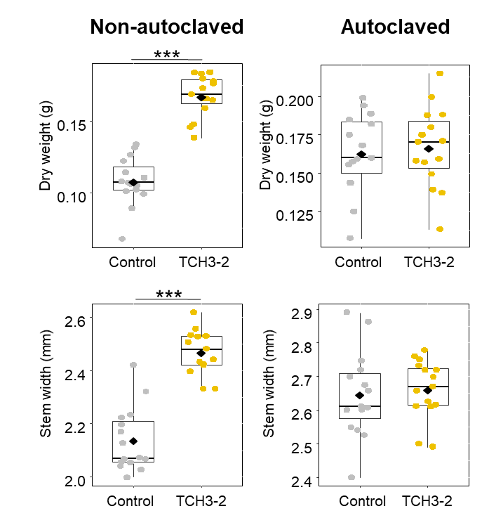

Figure S2: Growth promotion of tomato cv. Hawaii7996 plants grown at upland soil treated with TCH3-2. The dry weight and stem width of tomato plants increased by TCH3-2 treatment in upland soil at 3 weeks post transplantation. The experiment was conducted in triplicate with 15 plants per treatment and repeated three times with similar results. Significant difference was noticed by two-sample T test (*** P < 0.001). Diamonds and bolded lines of the boxplot are the average and median of indicated values, respectively. Control, sterilized distilled water, negative control; TCH3-2, treatment of TCH3-2 suspension.

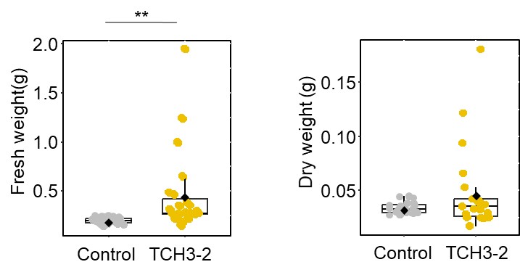

Figure S3: Growth promotion of tomato cv. Hawaii7996 plants grown at forest soil treated with TCH3-2. Germinated tomato seedlings treated with Flavobacterium dauae TCH3-2 were transferred to non-sterilized forest soil, both fresh weight and dry weight of tomato plants were measured 5 weeks after transplantation. Fresh weight and dry weight were measured for 24 plants in control group and 23 plants in the TCH3-2 treated group. Means of each treatment are different by two-sample T-test (**P<0.01).

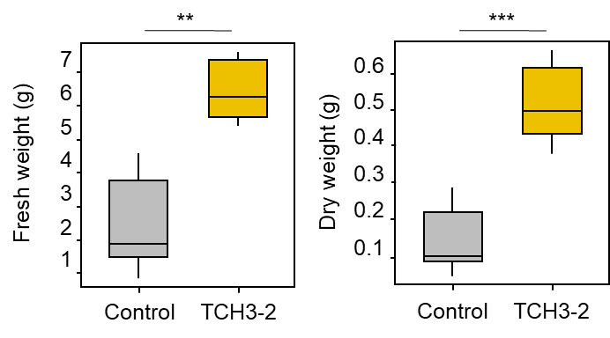
Figure S4: Growth promotion of tomato cv. Moneymaker plants grown at upland soil treated with TCH3-2. Germinated tomato seedlings (cv. Moneymaker) treated with Flavobacterium dauae TCH3-2 were transferred to non-sterilized upland soil, both fresh weight and dry weight of tomato plants were measured 5 weeks after transplantation. Means of 10 plants are different by two sample T-test (**P<0.01, ***P<0.001).

b
a
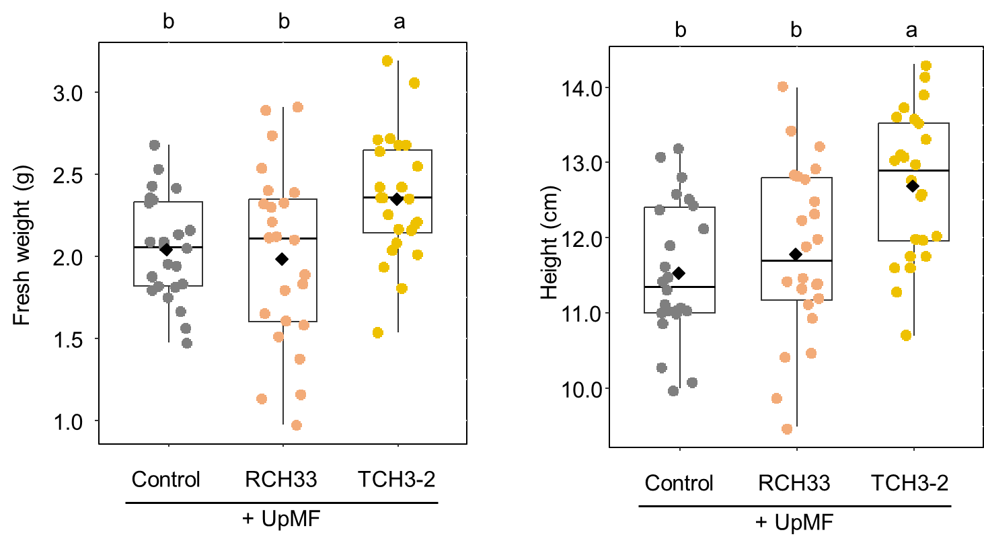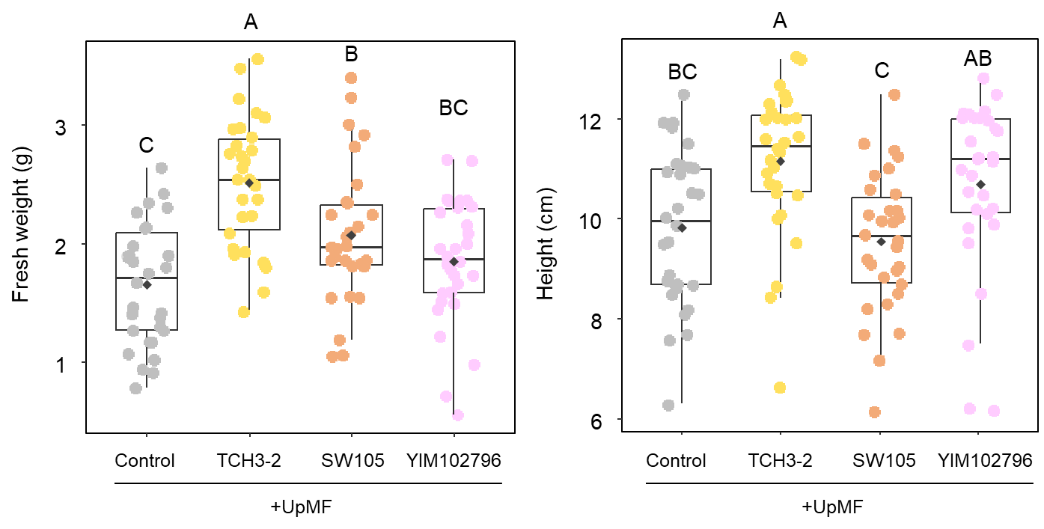
d
c
Figure S5: Comparison of plant growth promoting activity between F. dauae TCH3-2 and other closely related Flavobacterium strains with native soil microbiota. a,b, Plant growth promoting activity between natural isolates F. daejenense RCH33 and TCH3-2 with UpMF. The fresh weight and height of tomato plant were measured at 3 weeks post transplantation. The experiment was conducted in triplicate with 8 plants per treatment (n = 24 plants). c,d, Plant growth promoting activity between closely-related F. marinum SW105, F. viscosus YIM102796, and TCH3-2 with UpMF. The fresh weight and height of tomato plant were measured at 3 weeks post transplantation. The experiment was conducted in triplicate with 10 plants per treatment (n = 30 plants). Different letters on the box plot represent significant difference among means of each treatment by one-way univariate analysis of variance (ANOVA) and Tukey’s honestly significant difference (HSD) post hoc test (P<0.05). Diamonds and bolded lines of the boxplot are the average and median of indicated values, respectively. Control+UpMF, upland soil microbial fraction (UpMF) treatment; RCH33+UpMF, the co-treatment of RCH33 suspension and UpMF; TCH3-2+UpMF, the co-treatment of TCH3-2 suspension and UpMF. SW105+UpMF, the co-treatment of SW105 suspension and UpMF; YIM102796+UpMF, the co-treatment of YIM102796 suspension and UpMF.
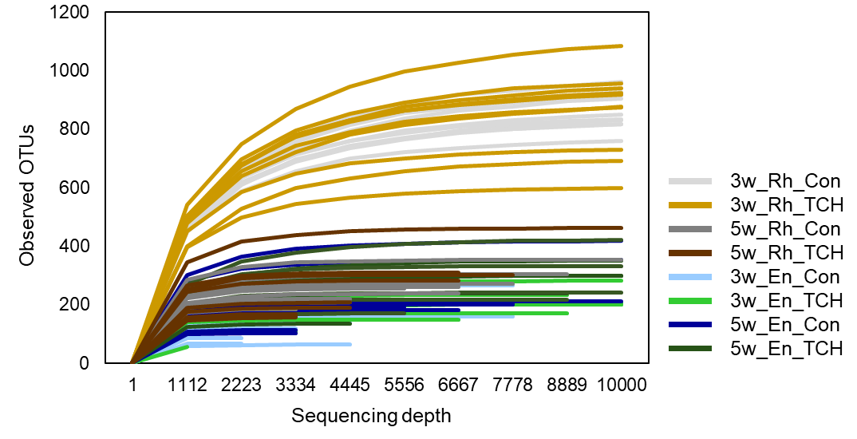
Figure S6: Rarefaction curves for microbial community comparison between TCH3-2 treatment and non-treated control by 16S rRNA gene amplicon sequencing. 3w and 5w, 3- and 5-weeks post transplantation; Rh, rhizosphere soil; En, root endosphere; Con, upland soil without TCH3-2 (negative control); TCH, TCH3-2 treated upland soil.

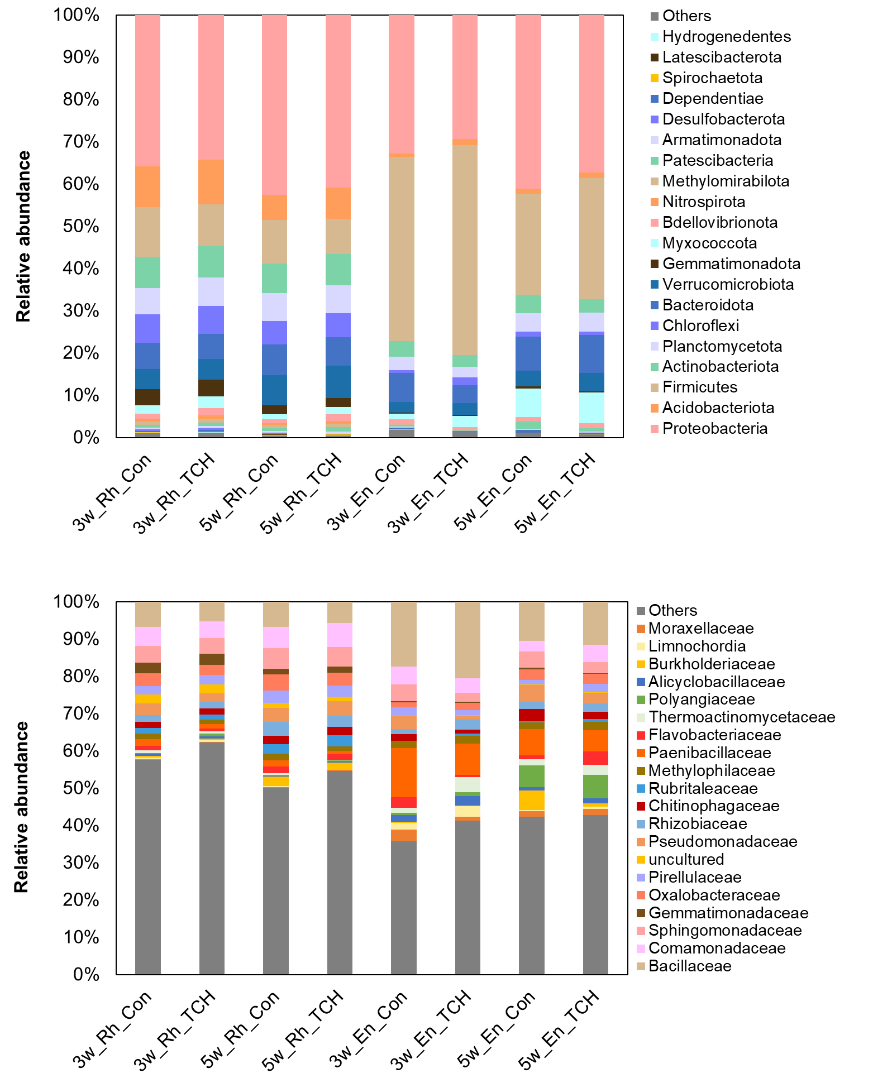
b
a
Figure S7: The relative abundance of OTUs from rhizosphere and root endosphere microbiota between TCH3-2 treatment and non-treated control at (a) phylum and (b) family level. 3w and 5w, 3- and 5-weeks post transplantation; Rh, rhizosphere soil; En, root endosphere; Con, upland soil without TCH3-2 (negative control); TCH, TCH3-2 treated upland soil.

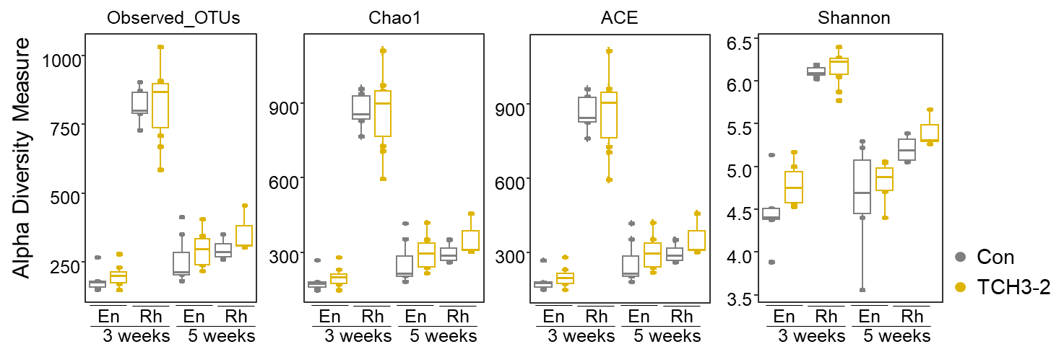
Figure S8: The alpha diversity of rhizosphere and root endosphere microbiota between TCH3-2 treatment and non-treated control in tomato grown at upland soil. 3 weeks and 5 weeks, 3- and 5-weeks post transplantation; Rh, rhizosphere soil; En, root endosphere; Con, upland soil without TCH3-2, negative control; TCH3-2, TCH3-2 treated upland soil.

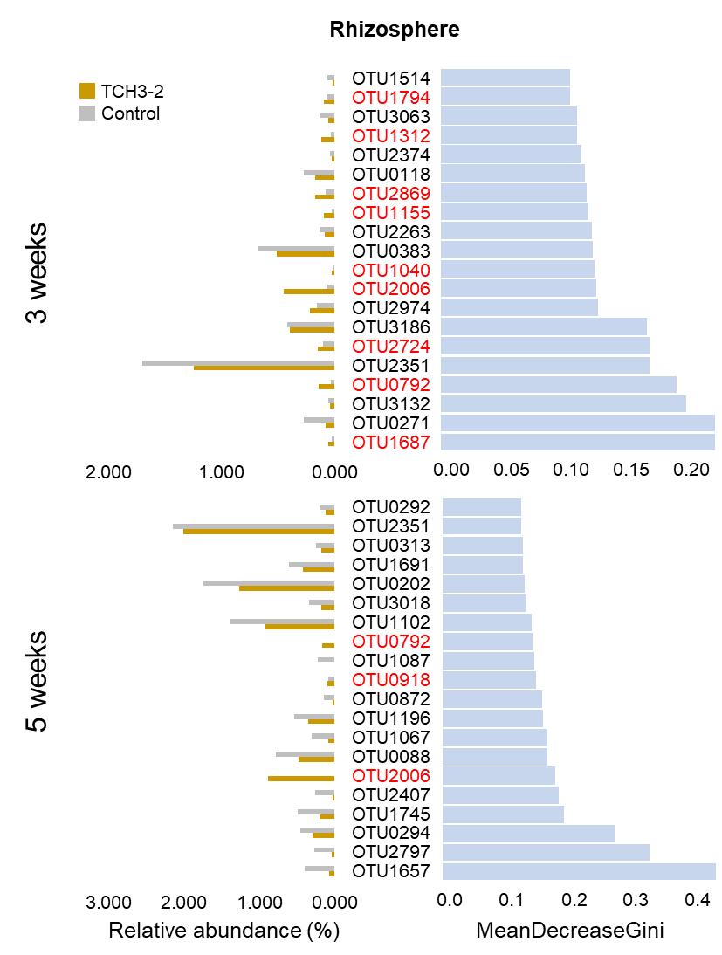
Figure S9: The top 20 differential OTUs in rhizosphere treated with TCH3-2 and selected by the Random Forest analysis. (Left side) The average relative abundance of signature OTUs in rhizosphere of TCH3-2 treatment and control sample. (Right side) MeanDecreaseGini values of signature OTUs analyzed by random forest. TCH3-2, TCH3-2 treated upland soil; Control, upland soil without TCH3-2, negative control. Red colored OTUs indicate the OTUs enriched by TCH3-2 treatment.

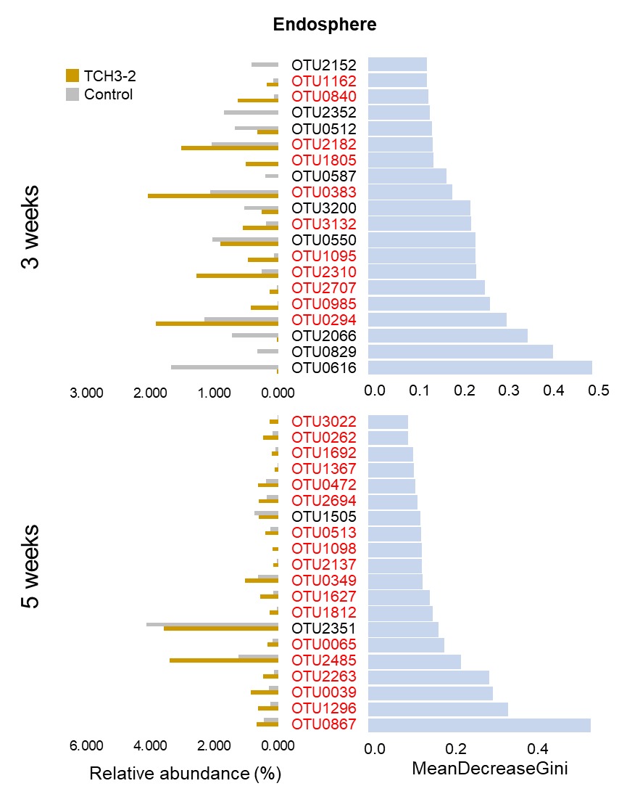
Figure S10: The top 20 differential OTUs in root endosphere treated with TCH3-2 and selected by the Random Forest analysis. (Left side) The average relative abundance of signature OTUs in root endosphere of TCH3-2 treatment and control sample. (Right side) MeanDecreaseGini values of signature OTUs analyzed by random forest. TCH3-2, TCH3-2 treated upland soil; Control, upland soil without TCH3-2, negative control. Red colored OTUs indicate the OTUs enriched by TCH3-2 treatment.

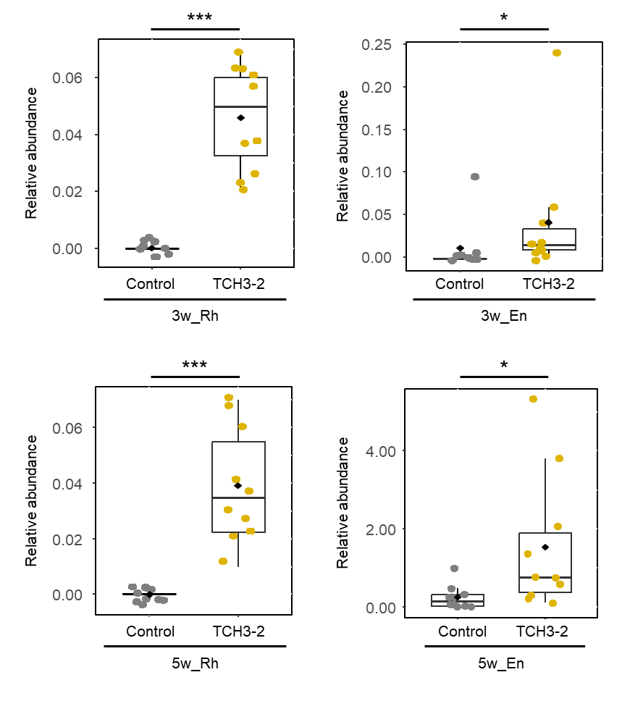
Figure S11: The population of TCH3-2 in tomato rhizosphere and endosphere analyzed by mapping pipeline based on BWA and SAMtools. TCH3-2, TCH3-2 treated upland soil; Control, upland soil without TCH3-2. 3w and 5w, 3 weeks and 5 weeks, 3 and 5 weeks post transplantation; En, Endosphere; Diamonds and bolded lines of the boxplot are the average and median of relative abundance, respectively. Significant difference by two-sample T-test was recognized (*P<0.05, **P<0.01, ***P<0.001).

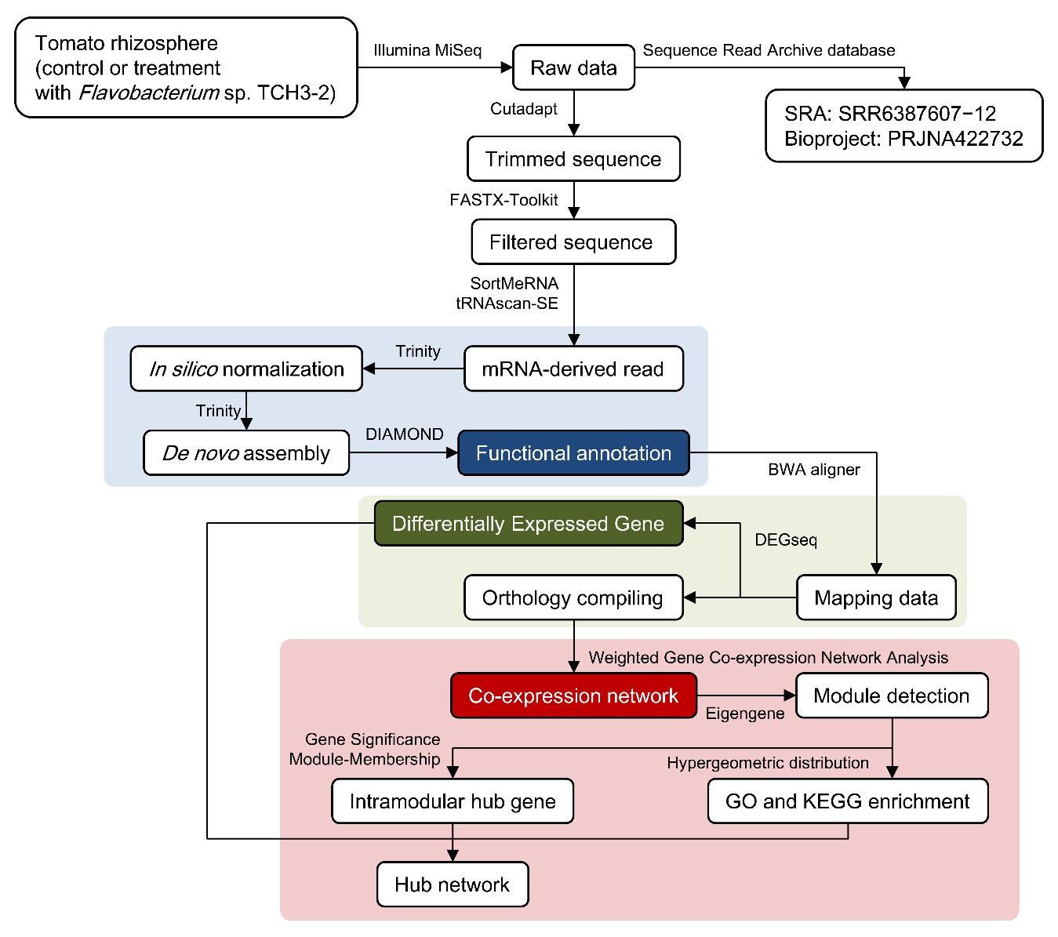
Figure S12: The flow diagram of metatranscriptome analyses in tomato rhizosphere

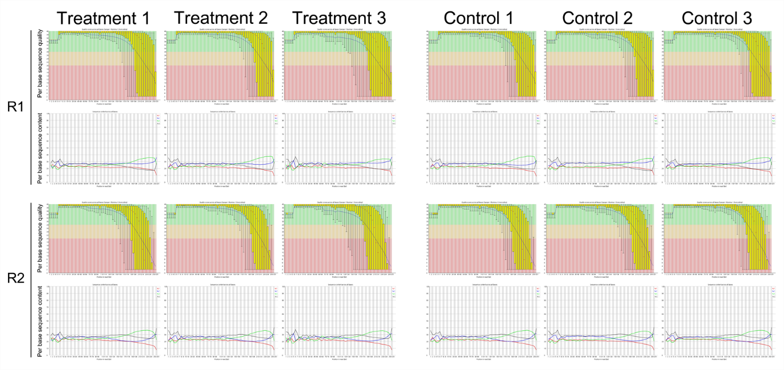
Figure S13: Quality distribution and base composition of metatranscriptome libraries. Quality and quantity statistics for each metatranscriptome library was plotted by the FastQC program. The upper panel displays a box and Whisker plot for the Phred scores per base of reads. The lower panel represents the percentage of the four bases for each position in the reads. Treatment 1–3: TCH3-2–inoculated rhizosphere soil from tomato plants grown in upland soil. Control 1–3: SDW-treated rhizosphere soil from tomato plants grown in upland soil.

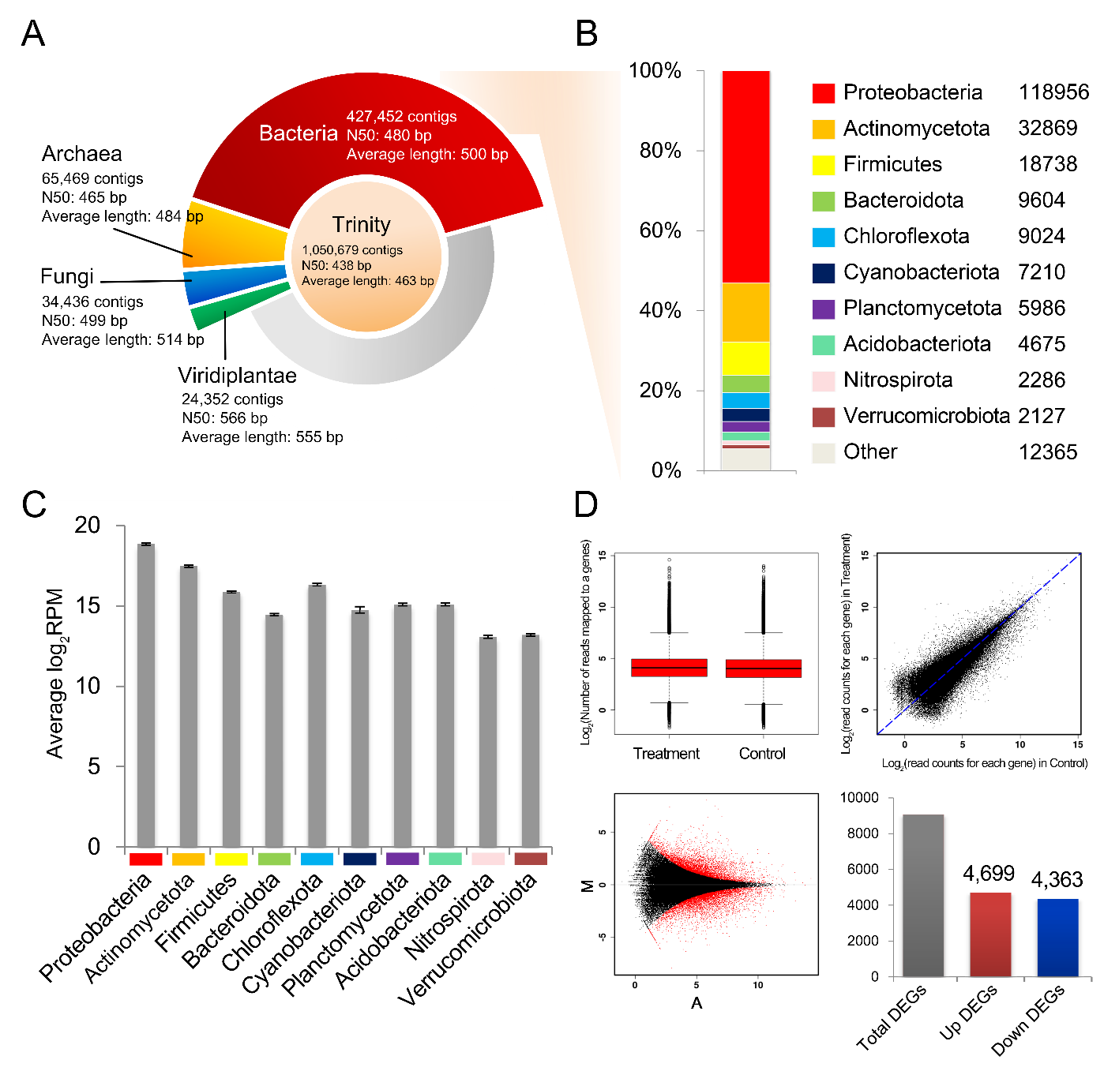
d
c
a
b
Figure S14: Summary of functional annotation and DEGs analysis in de novo assembled contigs. a, A summary of the assembly statistics of contigs. A center of the doughnut chart shows the statistic of de novo Trinity assembly of mRNA reads and an outer ring indicates taxon distributions for translated proteins of the contigs annotated by the DIAMOND search. b, Taxonomy profiles of contigs annotated in major ten bacterial phyla. Contigs annotated through the bacterial protein database are presented in a bar chart and the numbers to the right of each label indicate the number of contigs. c, Frequency of reads expressed from the major ten bacterial phyla. The number of all reads derived from each bacterial phylum is represented as log₂(Reads per million mapped reads, RPM) values. d, Differentially expressed gene (DEG) analysis. DEGs were identified using DEGseq with |log2FC| ≥1 and FDR P-value <0.05. The upper-left panel displays boxplots for the number of reads mapped to genes in control and TCH3-2 conditions. The upper-right panel shows a scatterplot comparing the expression of each gene between the two conditions. The lower-panel includes an MA-plot with all identified transcripts (black dots) and DEGs (red dots), and a bar graph indicating the number of DEGs with upregulation (red) or downregulation (blue) in the TCH3-2 treatment.

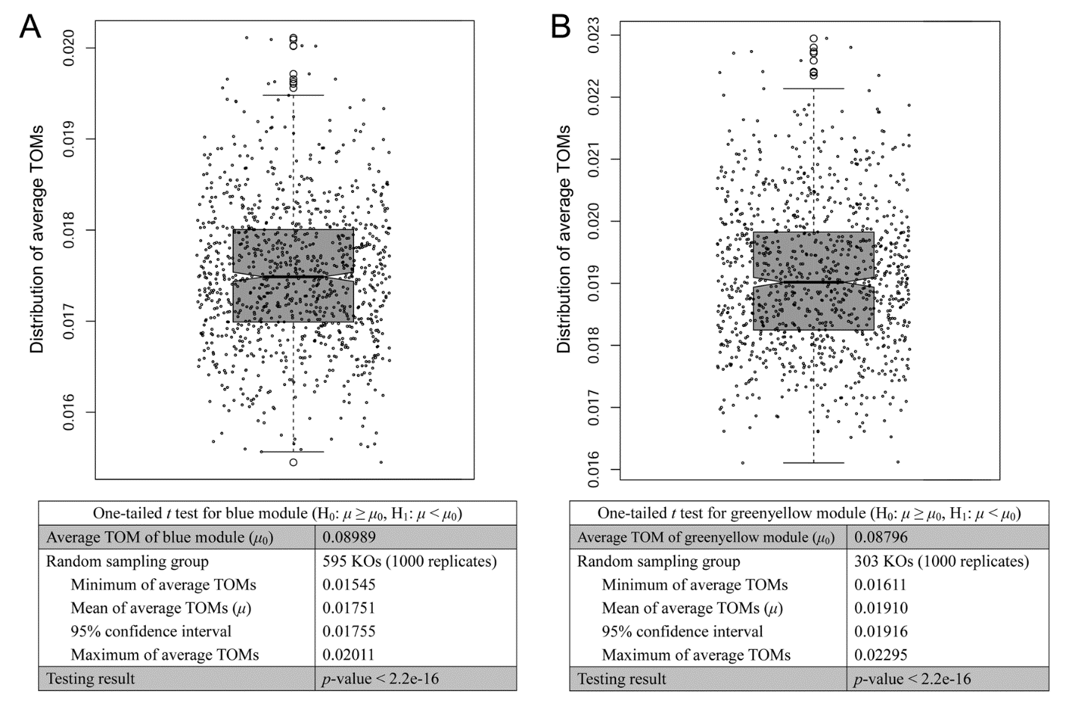
c
a
d
b
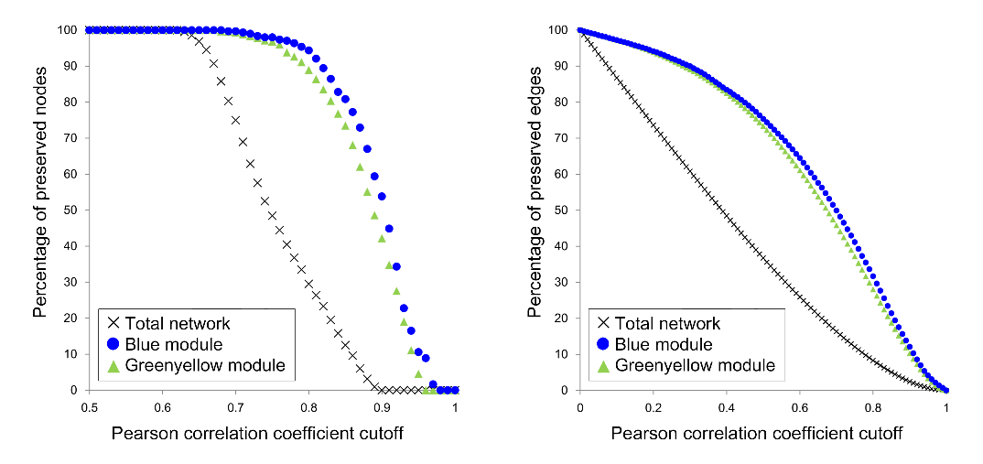
Figure S15: The comparison of module stability between interesting modules and random groups. a, one-tailed T-test for the blue module. b, one-tailed T-test for the greenyellow module. The distributions of average TOMs in each module are displayed by black dots using notched plot boxes, and the outliers are marked using hollow circles. A statistic of the one-tailed T-test according to each module is shown in a table below each the figure. c,d, Network density of the blue and greenyellow modules via a hard-thresholding procedure. The graphs represent the results of a network comparison between each module and the entire module according to a correlation cutoff from 0 to 1. Nodes and edges of the blue module are represented by blue colored circles. Those of greenyellow module are presented by greenyellow colored regular triangles.

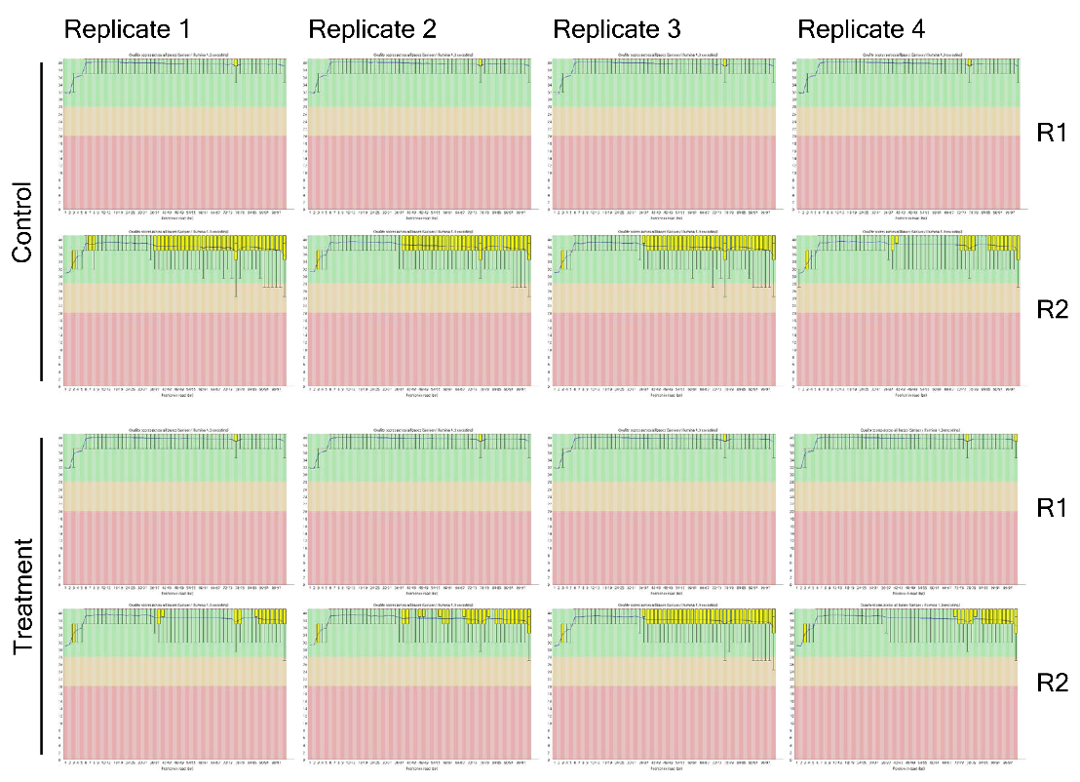
Figure S16: Quality assessment and control of RNA-seq libraries of Solanum lycopersicum. For each position a box and Whisker plot is plotted by the FastQC program to present the Phred quality scores per base of reads produced after trimming adapter sequences. A yellow box shows the inter-quartile range (25-75%). The upper and lower whiskers represent the 10 and 90% points.

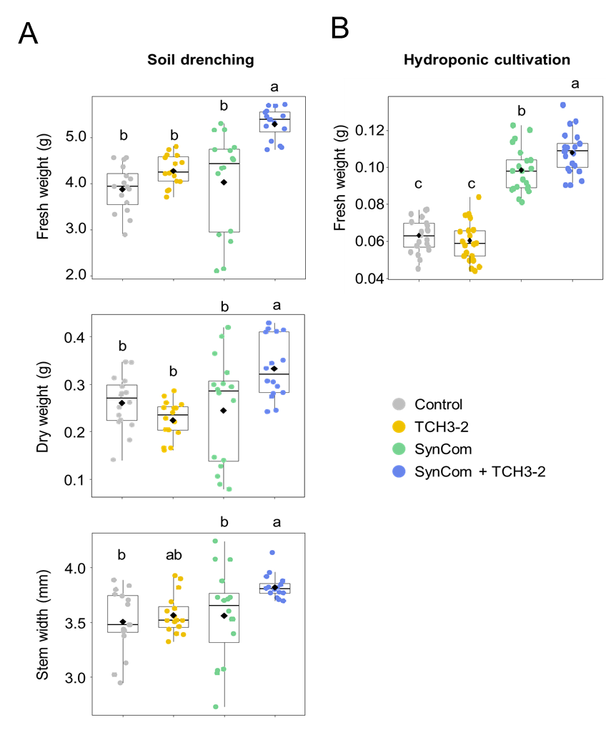
a
b
Figure S17: Plant growth promotion by combination of SynCom and TCH3-2. a, The fresh weight, dry weight, and stem width of tomato plants were measured at 5 weeks post transplantation in autoclaved nursery soil. The experiment was conducted in triplicate with 15 plants per treatment and repeated three times with similar results. b, The fresh weight of tomato seedlings was measured at 2 weeks post transplantation under hydroponic condition. The experiment was conducted in triplicate with 12 plants per treatment (n=36). The experiment was conducted in triplicate with 9 plants per treatment (n=27). Different letters on the box plot represent significant difference among means of each treatment by one-way univariate analysis of variance (ANOVA) and Tukey’s honestly significant difference (HSD) post hoc test (P<0.05). Diamonds and bolded lines of the boxplot are the average and median of indicated values, respectively. Control, (a) sterile distilled water treatment, (b) MES buffer; TCH3-2, the treatment of TCH3-2 suspension; SynCom, the treatment of SynCom; SynCom + TCH3-2, the co-treatment of of SynCom and TCH3-2.
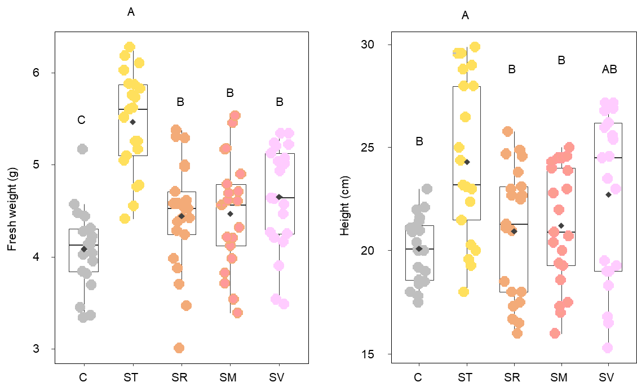
b
a
Figure S18: Comparison of plant growth promoting activity between TCH3-2 with SynCom and other closely related Flavobacterium strains with SynCom. a, The fresh weight and b, the height of tomato plant was measured at 5 weeks post transplantation. The experiment was conducted in triplicate with 7 plants per treatment (n = 21 plants). Different letters on the box plot represent significant difference among means of each treatment by ANOVA and Tukey’s HSD post hoc test (P<0.05). Diamonds and bolded lines of the boxplot are the average and median of indicated values, respectively. C, SDW treatment; ST, the co-treatment of TCH3-2 suspension and SynCom; SR, the co-treatment of F. daejenense RCH33 suspension and SynCom; SM, the co-treatment of F. marinum SW105 suspension and SynCom; SV, the co-treatment of YIM10279643 suspension and SynCom.

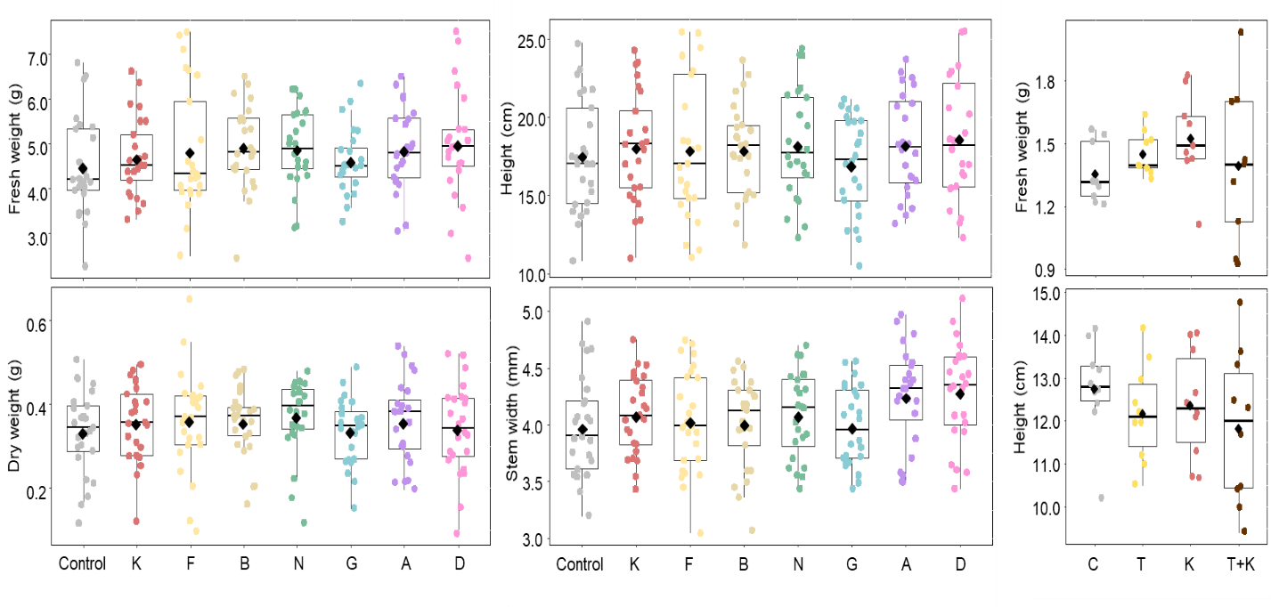
b
a

Figure S19: Assessment of plant growth promoting activity by single SynCom members. a, The fresh weight, dry weight, height, and stem width of tomato plant was measured at 5 weeks post transplantation. The experiment was conducted in triplicate with 10 plants per treatment (n = 30 plants). b, The single treatment of keystone bacterium K. alkanivorans or the combination treatment of K. alkanivorans and TCH3-2 did not promote the growth of tomato plant. The experiment was conducted in triplicate with 3 plants per treatment (n = 9 plants). Different letters on the box plot represent significant difference among means of each treatment by ANOVA and Tukey’s HSD post hoc test (P<0.05). Diamonds and bolded lines of the boxplot are the average and median of indicated values, respectively. C, SDW treatment; K, F, P, N, G, A, D, and T, the individual treatment of K. alkanivorans, F. taffensis, P. megaterium, N. guangzhouense, G. polyisoprenivorans, A. gephyra, D. japonica, and F. dauae TCH3-2 respectively; T+K, the combination treatment of K. alkanivorans and F. dauae TCH3-2.

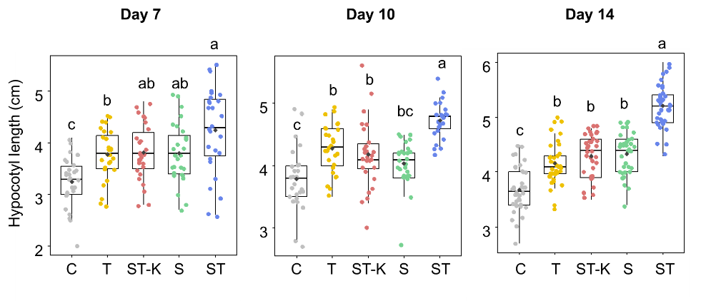

Figure S20: Cumulative effect of ST treatment on tomato plant growth. The hypocotyl length of tomato seedlings was measured at 7-, 10-, and 14-days post transplantation under hydroponic condition. The experiment was conducted in triplicate (Day 7 and 10, n = 27; Day 14, n = 36). Different letters on the box plot represent significant difference among means of each treatment by ANOVA and Tukey’s HSD post hoc test (P<0.05). Diamonds and bolded lines of the boxplot are the average and median of indicated values, respectively. C, 2.5 mM MES buffer; T, the treatment of TCH3-2 suspension; S, the treatment of SynCom mixture; ST, the co-treatment of SynCom and TCH3-2; ST-K, the suspension of ST mixtures lacking K. alkanivorans.

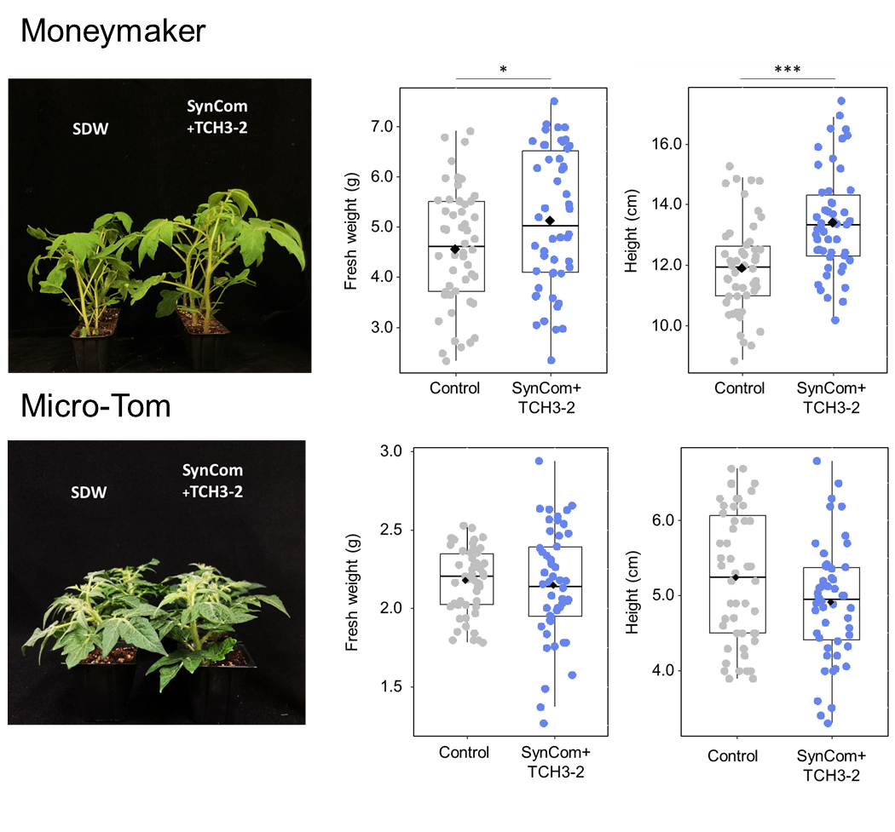
a
b
Figure S21: Measurement of plant growth efficacy of TCH3-2 and SynCom in Moneymaker or Micro-Tom cultivar. The photograph was taken at 5 weeks post inoculation of SynCom and TCH3-2 (ST). a, Compared to the SDW treated control, the ST treatment promoted plant growth in Moneymaker. b, Compared to the SDW treated control, the ST treatment did not promote plant growth in a BR-deficient tomato cultivar, Micro-Tom. SDW: sterilized distilled water; ST: the co-treatment of SynCom + TCH3-2. Statistical analysis was conducted by Student’s T-test (n = 45, *P<0.05, ** P<0.01, ***P<0.001).

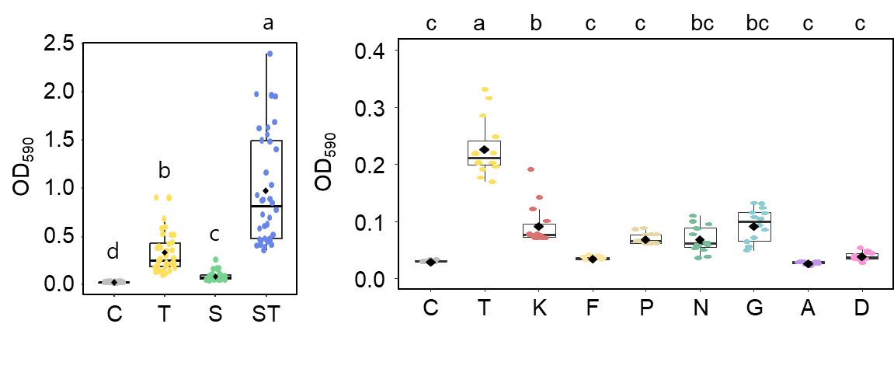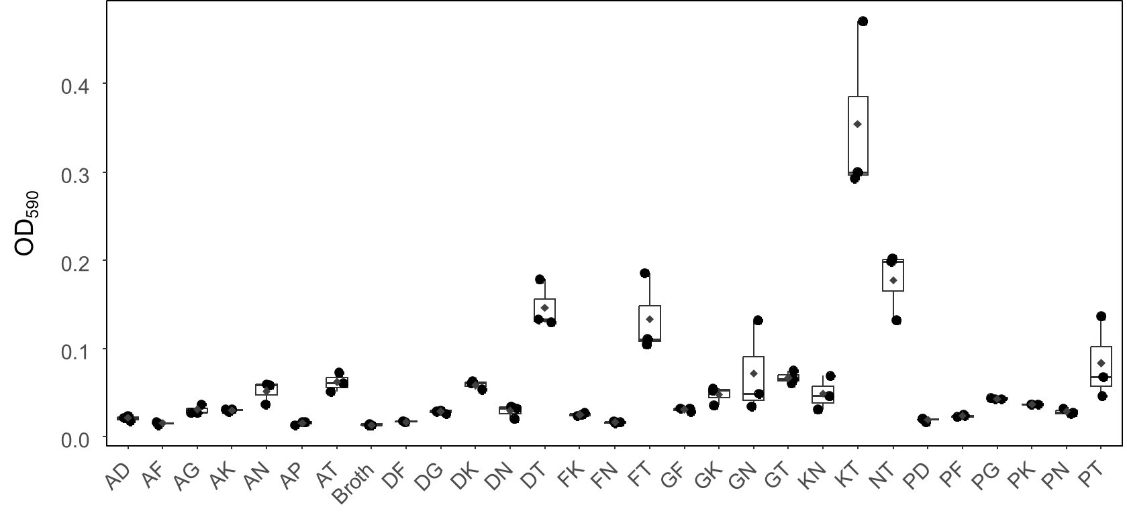
c
a
b
Figure S22: Biofilm formation activity of SynCom and TCH3-2 in TRM broth medium. a, Biofilm formation by SynCom and TCH3-2 combination in TRM medium. b, The assessment of biofilm forming activity by single SynCom members. The biofilm assay was in triplicates with 6 wells per treatment. c, The assessment of biofilm forming activity by pair-wise combination of SynCom members and TCH3-2 in TRM medium. Different letters on the box plot represent significant difference among means of each treatment by ANOVA and Tukey’s HSD post hoc test (n = 18 samples). C or Broth, TRM broth without bacterial cell; T, the treatment of TCH3-2 suspension; S, the treatment of SynCom mixture; ST, the co-treatment of of SynCom and TCH3-2. K, F, P, N, G, A, and D, the individual treatment of K. alkanivorans, F. taffensis, P. megaterium, N. guangzhouense, G. polyisoprenivorans, A. gephyra, and D. japonica, respectively.
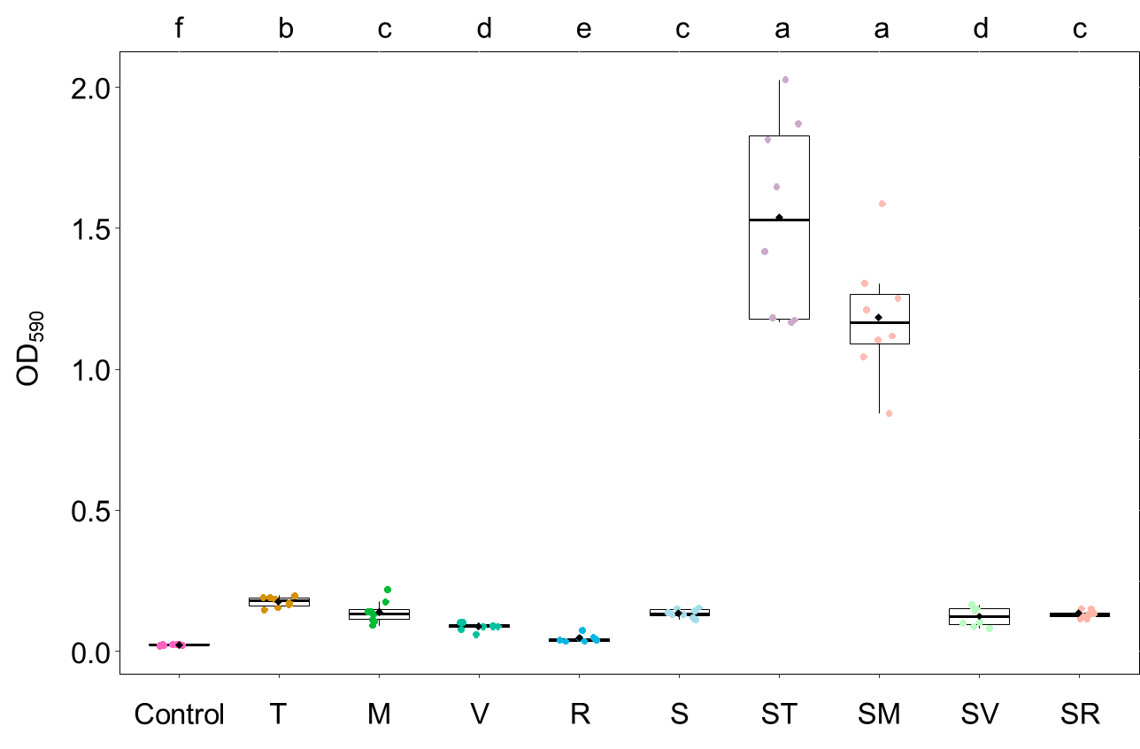
Figure S23: Comparison of biofilm formation activity between TCH3-2 with SynCom and other closely related Flavobacterium stains with SynCom. Biofilm formation by SynCom and TCH3-2 combination in TRM broth medium. The biofilm assay was in triplicates with the 6 wells per treatment. Different letters on the box plot represent significant difference among means of each treatment by ANOVA and Tukey’s HSD post hoc test (n = 9 samples). Control, TRM broth without bacterial cell; T, the treatment of TCH3-2 suspension; M, the treatment of F. marinum SW10543 suspension; V, the treatment of F. viscosus YIM10279643 suspension; R, the treatment of F. daejenense RCH33 suspension; S, the treatment of SynCom mixture; ST, the co-treatment of of SynCom and TCH3-2; SM, the co-treatment of of SynCom and F. marinum SW10543; SV, the co-treatment of of SynCom and F. viscosus YIM10279643; SR, the co-treatment of of SynCom and F. daejenense RCH33.

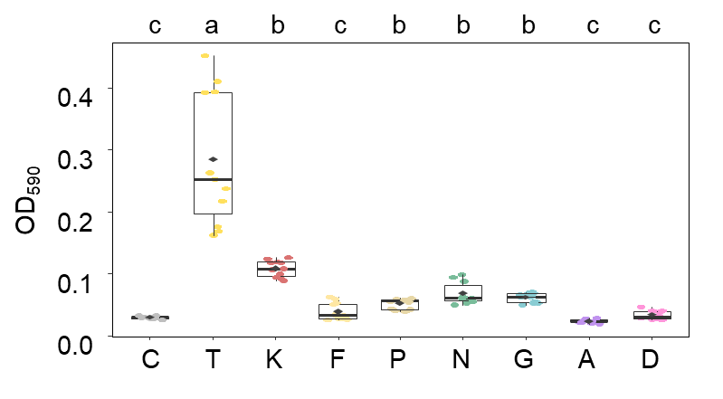
Figure S24: Biofilm formation produced by single inoculation of SynCom and TCH3-2 combination in TRM broth with root exudates. The assessment of biofilm forming activity by single species in TRM medium containing root exudate. The biofilm assay was in triplicates with the 6 wells per treatment. Different letters on the box plot represent significant difference among means of each treatment by ANOVA and Tukey’s HSD post hoc test (n = 18 samples). C, TRM broth with root exudates without bacterial cell; T, the treatment of TCH3-2 suspension; S, the treatment of SynCom mixture; ST, the co-treatment of of SynCom and TCH3-2. K, F, P, N, G, A, and D, the treatment of K. alkanivorans, F. taffensis, P. megaterium, N. guangzhouense, G. polyisoprenivorans, A. gephyra, and D. japonica, respectively.

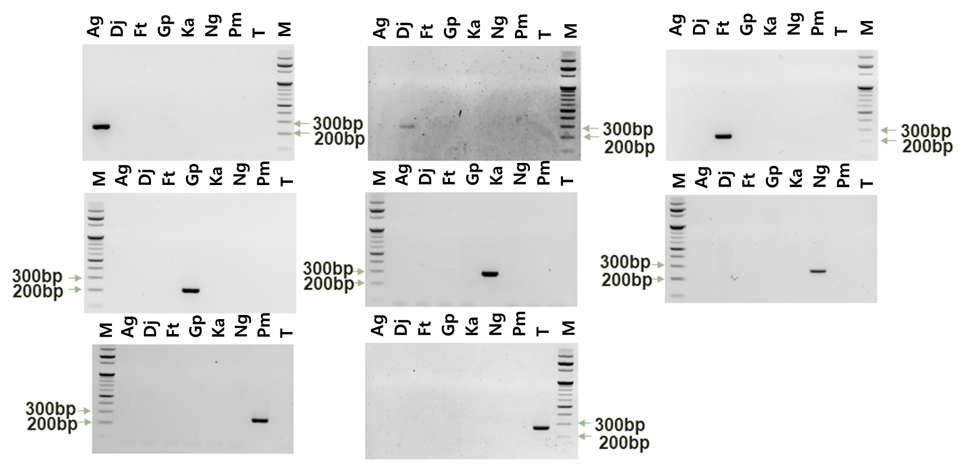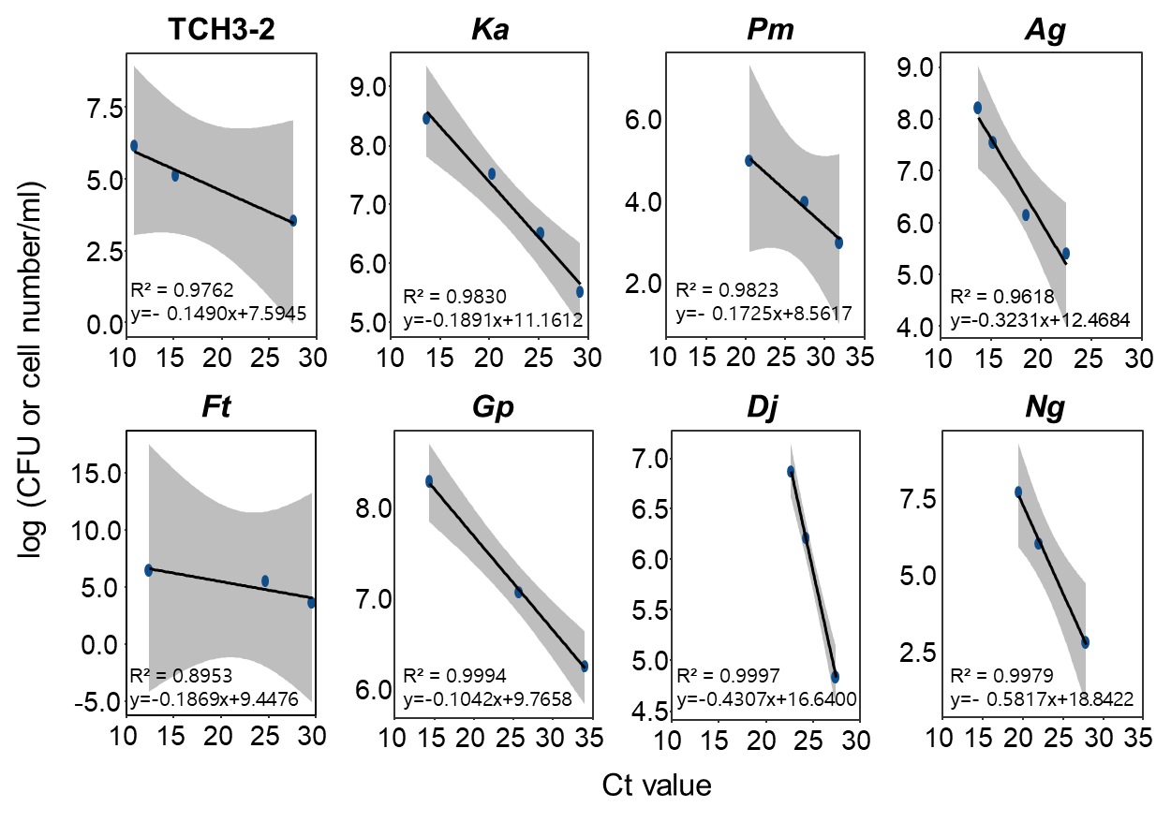
b
a
Figure S25: Design of specific primers for quantifying the bacterial population of SynCom and TCH3-2. a, Specific amplification of target bacterial gene (red color) by each primer set. b, Standard curves showing the relationship between log(CFU or cell number/ml) (y-axis) and Ct value (x-axis) for TCH3-2 and SynCom members. Because Ag cannot form bacterial colonies, cell numbers were used to estimate its population by hemocytometer. TCH3-2 or T, F. dauae TCH3-2; Ka, K. alkanivorans; Ag, A. gephyra; Pm, P. megaterium; Ft, F. taffensis; Ng, N. guangzhouense; Dj, D. japonica; Gp, G. polyisoprenivorans, M, DNA ladder Marker

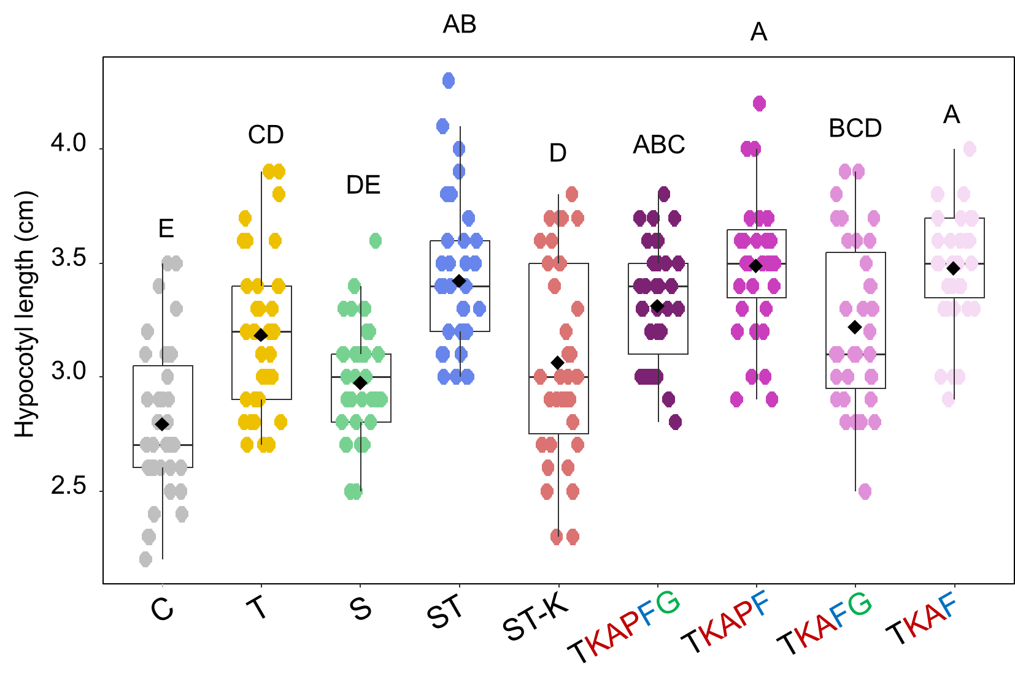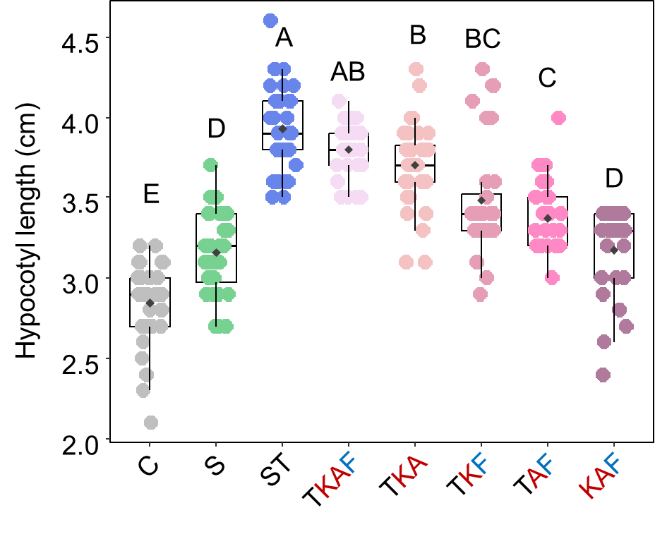
b
a
Figure S26: The drop-in experiment to define minimal SynCom and keystone taxa in SynCom and TCH3-2. a, Identification of minimal SynCom combinations. Hypocotyl length of tomato seedlings was measured at 2 weeks post transplantation under hydroponic condition. The experiment was conducted in triplicate with 12 plants per treatment (n=36). b, Deconstruction of the TKAF SynCom to evaluate reduced combinations. To determine whether fewer members could sustain this effect, reduced subsets (TKA, TKF, TAF, and KAF) were tested. The hypocotyl length of tomato seedlings was measured at 2 weeks post transplantation under hydroponic condition. The experiment was conducted in triplicate with 8 plants per treatment (n=24). Different letters on the box plot represent significant difference among means of each treatment by ANOVA and Tukey’s HSD post hoc test (P < 0.05). C, control; T, TCH3-2; S, SynCom; ST, SynCom + TCH3-2; ST-K, ST without K. alkanivorans; K, K. alkanivorans; A, A. gephyra; P, P. megaterium; F, F. taffensis; G, G. polyisoprenivorans. Colors indicate functional rank: red, rank 1; blue, rank 2; green, rank 3.

