Synchronized CVD Growth of Iron Carbide Nanocatalysts within Carbon Nanotube Networks for Stable Lithium–Sulfur Batteries
Dipsikha Ganguly^{a,e}, Abhijitha V G^{a,b,d}, Tanwir Ansari ª, Anamika Ghoshª, Ravi N^{c}, B. R. K. Nanda^{b,d}, Seeram Ramakrishna*^{,e} and Sundara Ramaprabhu^{*a}
ªAlternative Energy and Nanotechnology Laboratory, Department of Physics,
IIT Madras, Chennai- 600036, India
^{b}Condensed Matter Theory and Computational Lab, Department of Physics
IIT Madras, Chennai- 600036, India
^{c.} Physics Department, Spelman College
Atlanta, GA 30314
^{d}Center for Atomistic Modelling and Materials Design, IIT Madras, Chennai- 600036, India
^{e}Department of Mechanical Engineering,
National University of Singapore, Singapore- 117575

Synthesis Optimization of Fe₅C₂/CNT Composite
An appropriate amount of commercial Fe₂O₃ powder was taken as a catalyst to grow iron carbide-CNT composites using the CVD technique. In a typical procedure, through thermal decomposition of acetylene gas over the catalyst at 700 ºC for 5,10 and 30 minutes in the presence of argon as carrier gas. Argon flow (0.16 L/min) was maintained constant throughout the reaction, and hydrogen flow was allowed during 500-700 ºC at a flow rate of 0.05 L/min. The synthesized samples are termed as FeC-5, FeC-10 and FeC-30 (Fe₅C₂/CNT).

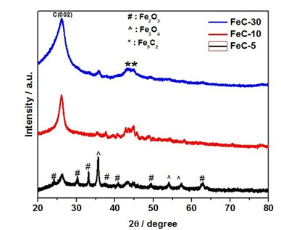
Figure S1. XRD studies of Fe₅C₂/CNT at different deposition time (5 min, 10 min, 30 min)
XRD studies of Fe₅C₂/CNT composite interlayer are shown in figure S1. The diffraction peak at ~26.3º corresponds to the carbon nanotube's C(002) plane, which is present in all three samples. For 5 min samples, mostly a mixture of Fe₂O₃ and Fe₃O₄ phases (as marked) are only observed^{1,2}. However, with increasing time, the reduction in the oxide phases and domination of the carbide phase can be seen. For the 30 min sample, the mostly Fe₅C₂ phase is observed with a trace amount of Fe₃O₄ ^{3,4}. Also, the change in the FWHM of C (002) substantiates the change in the diameters of the nanotubes with increasing time.

Microscopic study:
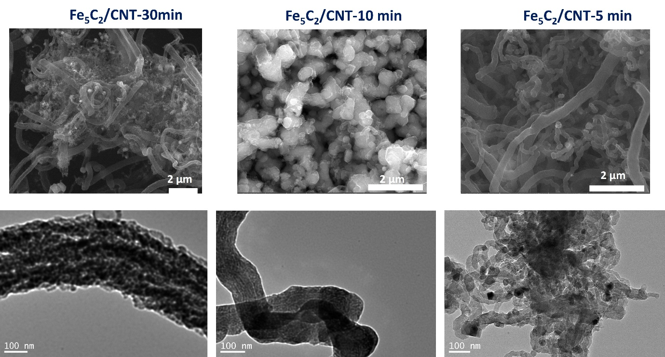
Figure S2. SEM and TEM micrograph of Fe₅C₂/CNT at different deposition tim

References
1. Ghosh, A., Srinivas, V. & Sundara, R. Comprehensive structural and magnetic properties of iron oxide nanoparticles synthesized through chemical routes. J. Alloys Compd. 818, 152931 (2020).
2. Ganguly, D., Ajay, A. P., Ghosh, A. & Ramaprabhu, S. Magnetic field assisted high capacity durable Li-ion battery using magnetic α-Fe2O3 nanoparticles decorated expired drug derived N-doped carbon anode. Sci. Rep. 10, 14–18 (2020).
3. Zhang, H. et al. Fe3O4-doped mesoporous carbon cathode with a plumber’s nightmare structure for high-performance Li-S batteries. Nat. Commun. 15, 5451 (2024).
4. Ansari, T., Ghosh, A., Ganguly, D., Muthiah, B. & Sundara, R. Expediting Polysulfide Anchoring by Fe₃ O₄ /Reduced Graphene Oxide Composite for High‐Performance Lithium‐Sulfur Batteries. Batter. Supercaps 8, e202400716 (2025).

