Supplementary Figures
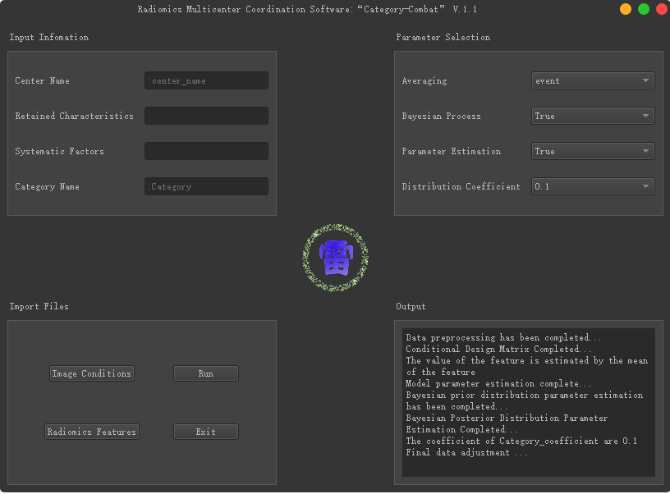
Figure S1. The user interface of Category-Combat algorithm.

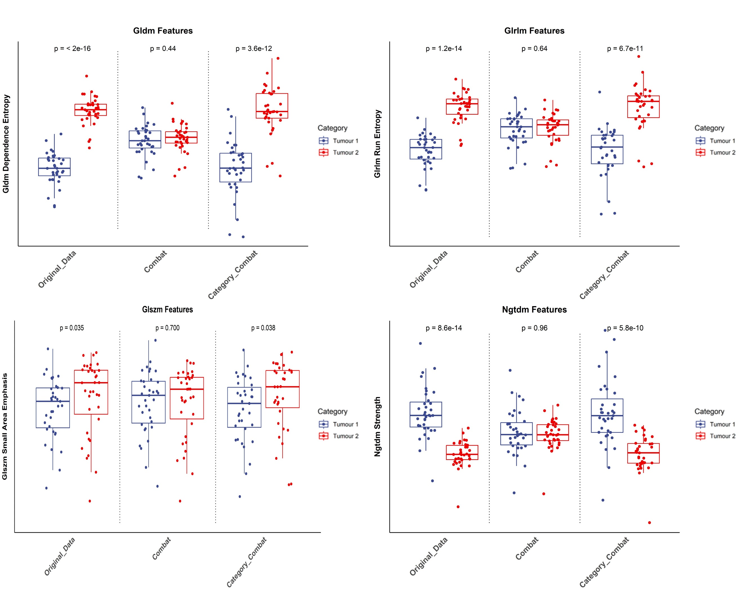
Figure S2. Box plots of the distribution of Gldm, Glrlm, Glszm, Ngtdm features extracted from nodules of two categories after harmonization, and the differences were tested using the Wilcoxon test.

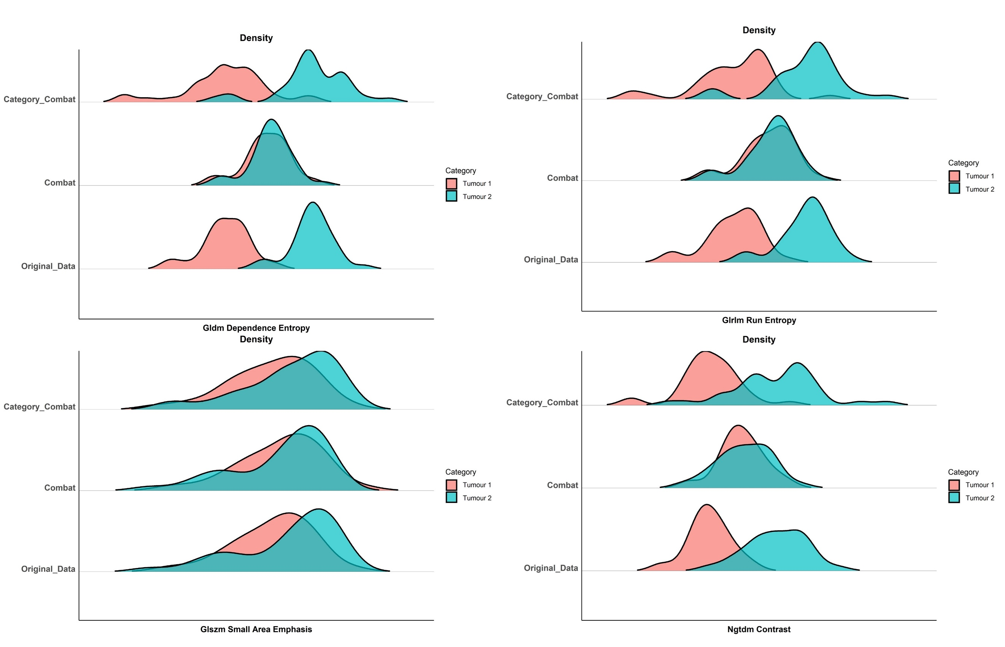
Figure S3. Probability Density Distribution Plot of the distribution of Gldm, Glrlm, Glszm, Ngtdm features extracted from nodules of two categories before and after harmonization using Combat and Category-Combat methods.

Figure S4. Phantom dataset 2: box plots comparing the distribution of Glcm features extracted from nodules of two categories before and after harmonization using Combat and Category-Combat methods, with differences between features assessed by Wilcoxon test.

Figure S5. Phantom dataset 2: probability Density Distribution Plot comparing the distribution of Glcm features extracted from nodules of two categories before and after harmonization using Combat and Category-Combat methods.

