Supplementary Materials for

Three parsimonious spatiotemporal patterns in cerebellum reveal individual traits in function and behavior

Shuo Lv et al.

*Corresponding author: Guoyuan Yang, yanggy@bit.edu.cn

This PDF file includes:

Figs. S1 to S11
Tables S1

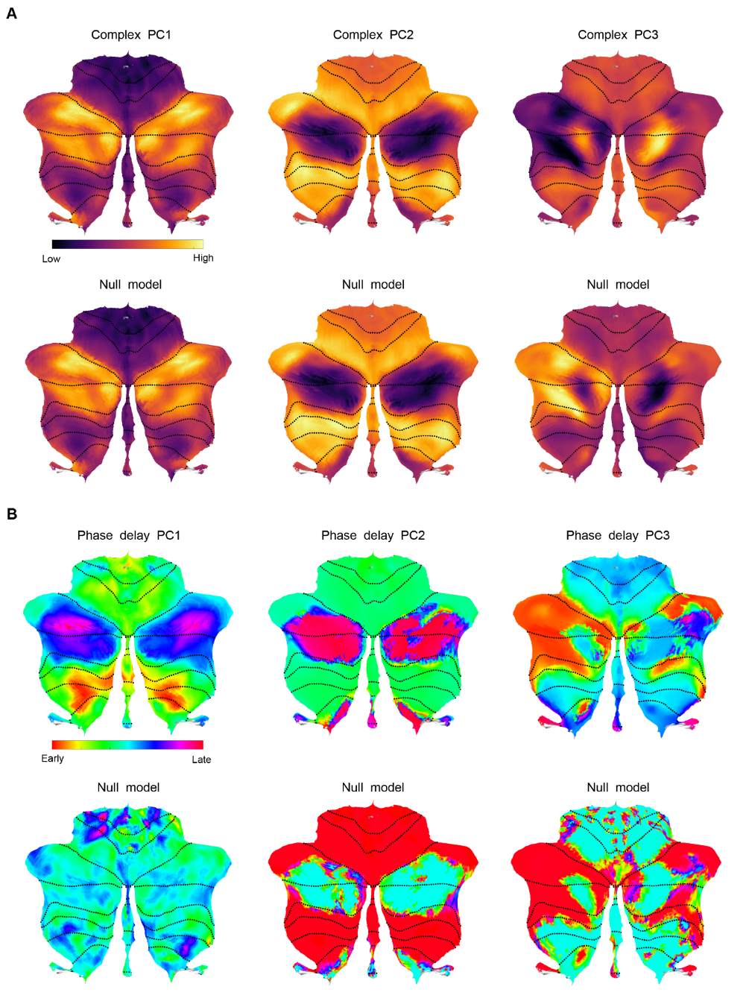

Fig. S1. Null model of CPCA-derived patterns. To assess the specificity and temporal structure, we constructed null models by randomly shuffling the time points of the BOLD signals 1,000 times. For each permuted signal, we recomputed the complex principal components using the same CPCA pipeline. Panels (A) and (B) respectively show the complex and phase delay maps for the first three complex PCs derived from the original signals (top row) and the permuted signals (bottom row). (A) The similarity between the original and permuted real-valued maps suggests that the amplitude largely reflect zero-lag structure, which is preserved despite temporal reordering. (B) In contrast to the real-valued patterns, the phase delay maps derived from the shuffled data reveal substantial disruptions. For phase delay PC1, the characteristic posterior-to-anterior propagation gradient observed in the empirical data is almost abolished after time-shuffling, indicating that this component captures a time-lag structure. Phase delay PC2 and PC3 exhibit relatively minor differences between the original and permuted signals.

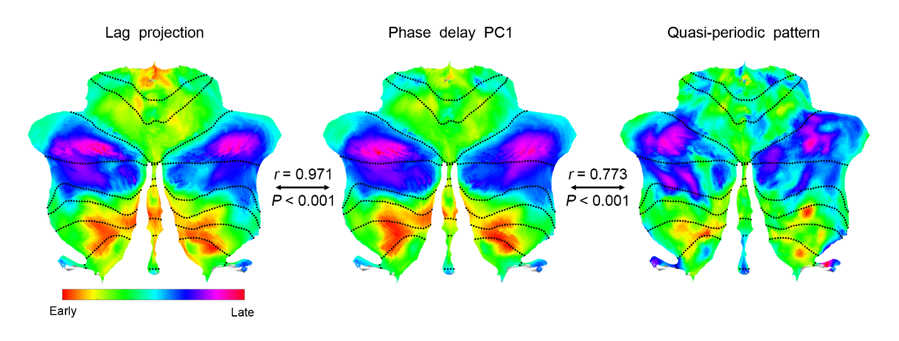

Fig. S2. Comparison of phase delay PC1 with QPP and lag projection patterns. To evaluate the biological validity of the phase delay PCs, we compared phase delay PC1 to two widely-used characterizations of intrinsic brain dynamics, lag projection and quasi-periodic patterns. These three maps show cerebellar time-lag structures derived from these distinct approaches, all aligned to the same color scale. The left panel shows the lag projection, computed by averaging voxel-wise time delays relative to the global BOLD signal, reflecting the dominant intrinsic temporal flow of activity. The middle panel shows the phase delay PC1, and the right panel shows the temporal centroid of QPP. Map of phase delay PC1 closely resembles both the lag projection (r = 0.971, P < 0.001) and QPP (r = 0.773, P < 0.001), demonstrating high consistency across methods. These results suggest that the phase delay PC1 exacted from CPCA captures a canonical spatiotemporal propagation pattern in the cerebellum that is shared across multiple analytic frameworks, including lag-based and pattern-matching techniques.

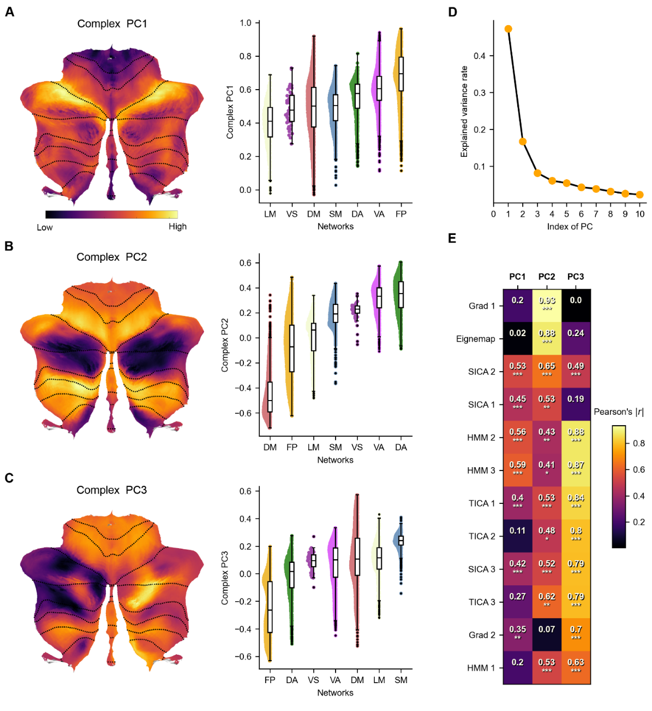

Fig. S3. Replication of complex PCs in the HCP-D dataset. Each panel (A–C) shows CPCA-derived complex PCs (left) and weight distributions across the 7 network parcellations (right), replicating the patterns observed in the HCP-YA dataset. (A) Complex PC1 captures widespread transmodal amplitude fluctuations. (B) Complex PC2 reflects reciprocal dynamics between association and sensorimotor-attention systems. (C) Complex PC3 highlights hemispheric asymmetry, where patterns mainly differed in transmodal regions. (D) The variance explained by the top 10 complex PCs. The first three PCs accounted for a cumulative 72.23% of the explainable variance (47.31%, 16.75%, 8.17% for the first three PCs, respectively), capturing the dominant spatiotemporal modes of cerebellar BOLD dynamics. (E) Spatial similarity matrix comparing the first three complex PCs to each resting-state functional connectivity (rsFC) topography obtained from multiple zero-lag methods. Most rsFC topographies exhibited strong spatial correlations (Pearson’s correlation) with one (or two) of complex PCs.

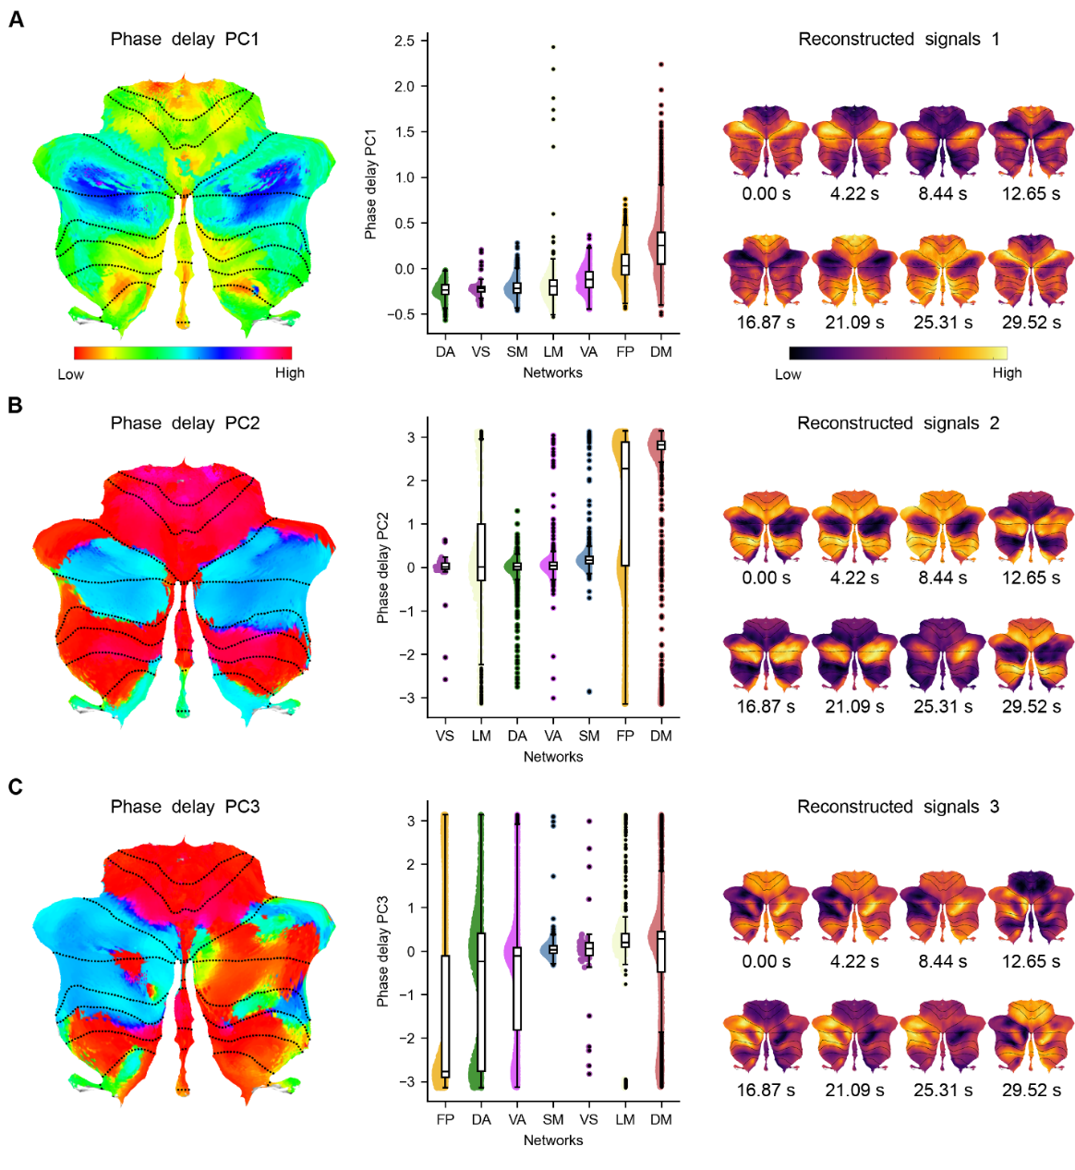

Fig. S4. Replication of phase delay PCs in the HCP-D dataset. Each panel (A–C) shows CPCA-derived phase delay PCs (left), phase value distributions across the 7 network parcellations (middle), and reconstructed BOLD signal dynamics (right), illustrating how each phase pattern translates into coherent and cyclical spatiotemporal propagation of neural activity across cerebellar regions consistent with the HCP-YA dataset. (A) Phase delay PC1 revealed a posterior-to-anterior propagation consistent with established cortical hierarchies with unimodal-to-transmodal pattern arranged along the functional gradient. (B) Phase delay PC2 reflected an anti-synchronous mode between association and sensorimotor regions. (C) Phase delay PC3 exhibited a lateralized temporal progression, suggesting hemispheric asymmetries in cerebellar information flow.

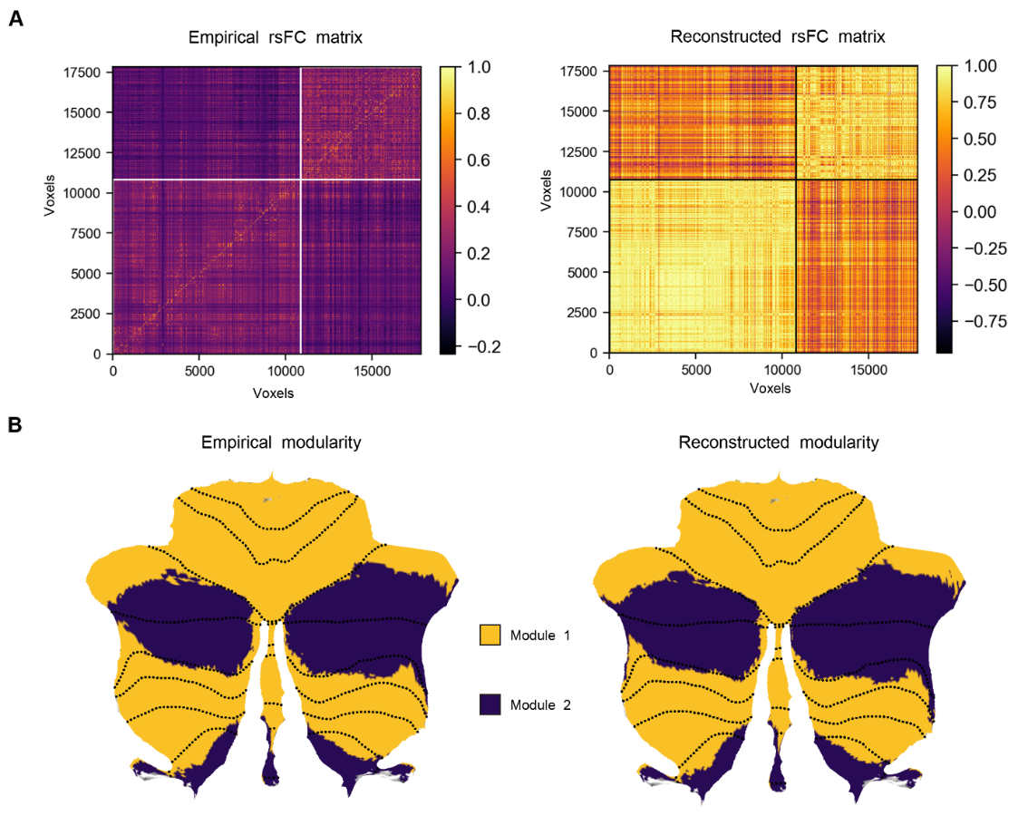

Fig. S5. CPCA-based BOLD signal reconstructions in the HCP-D dataset. The CPCA-based BOLD signal reconstructions from the HCP-D dataset exhibit similar rsFC and modularity to those observed in the HCP-YA data. (A) rsFC computed from the empirical BOLD signals (left) and CPCA-reconstructed BOLD signals (right) from the HCP-D dataset. The reconstructed rsFC matrix not only retained the core modular structure observed in the empirical data (Pearson’s r = 0.676) but also exhibited higher overall connectivity values, indicating the robustness of the CPCA-derived patterns in the HCP-D dataset. (B) Modularity partition maps derived from the empirical (left) and reconstructed (right) rsFC matrices in the HCP-D dataset. Despite the dimensionality reduction, the reconstructed signals faithfully reproduced the major functional subdivisions of the cerebellum (NMI = 0.94).

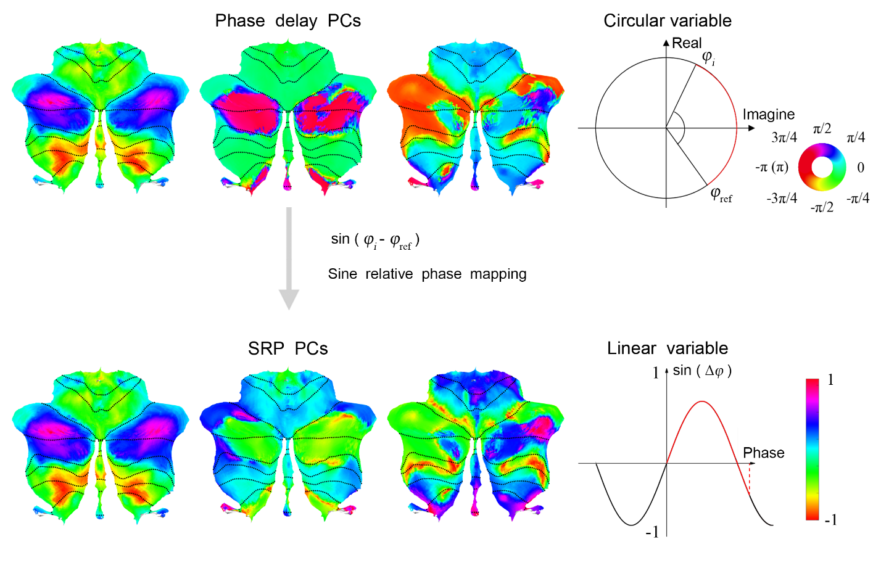

Fig. S6. Schematic illustration of reference-based sine relative phase (SRP) mapping. Each voxel’s BOLD signal is transformed into its analytic representation using the Hilbert transform, allowing instantaneous phase extraction. The diagram shows how the phase of a voxel is geometrically represented on the complex plane. This sine-based transform resolves the circularity of phase values and yields a bounded measure in , emphasizing the direction of phase delay: positive values indicate voxel lags behind the reference, negative values indicate voxel leads the reference, and values near 0 imply either aligned or opposite phases. The reference point indicates the cerebellar voxel chosen as the phase origin, serving to anchor propagation timing and directionality across the map. This representation removes phase circularity and preserves fine-grained relative timing information across the spatial domain.

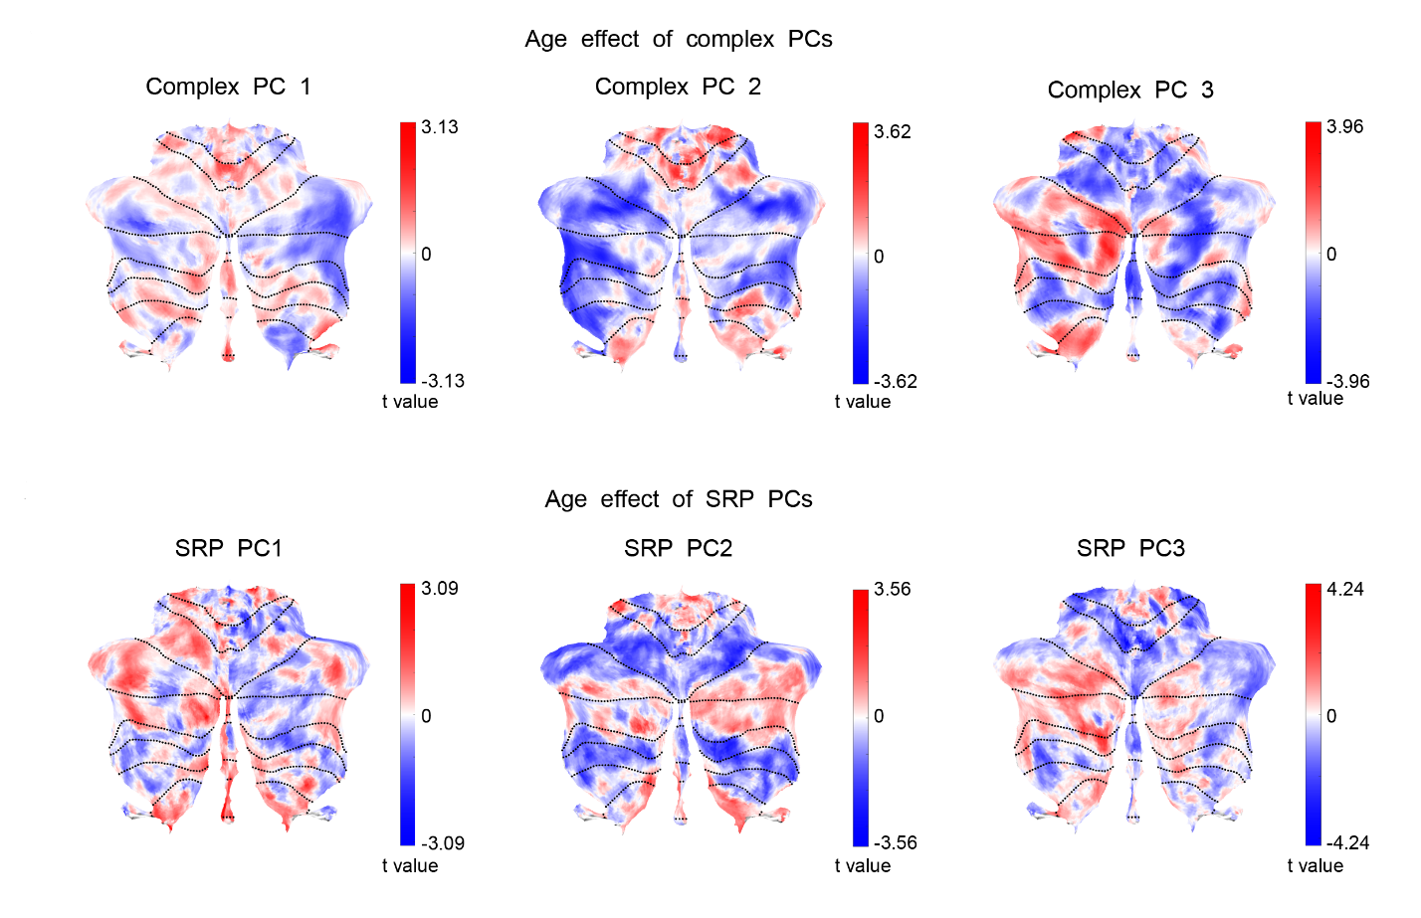

Fig. S7. Age-related effects in CPCA-derived patterns. Age-related effects were examined using linear mixed-effects models (LMM) including age, sex, head motion, and education background as fixed effects with a random intercept. Analyses were conducted within the HCP-D dataset. Results revealed a marked effect of age with the direction of association aligning across principal components. These findings indicate that even after accounting for demographic and neuroimaging covariates, subtle age-related modulations persist during the developmental period captured by the HCP-D dataset.

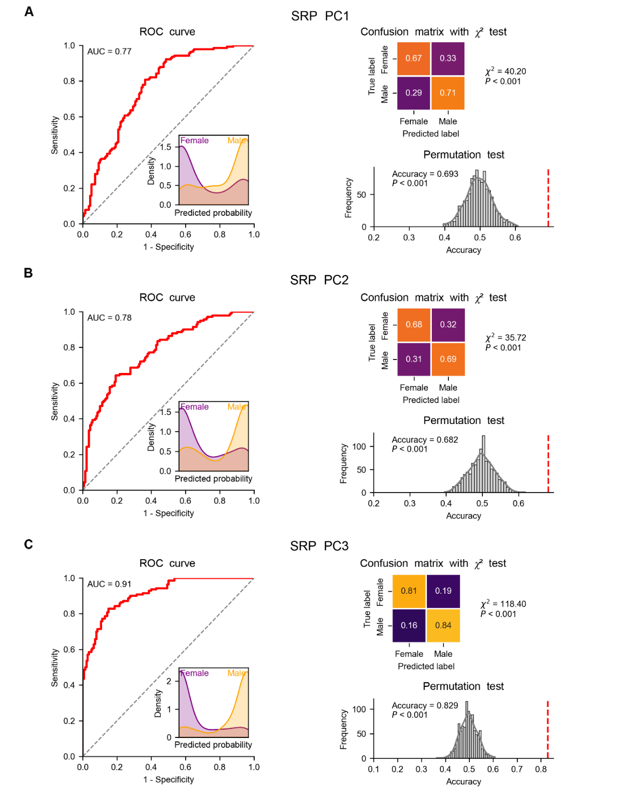

Fig. S8. Classification performance of artificial neural network trained on the first three SRP PCs. We evaluated the performance of artificial neural network (ANN) in predicting sex using leave-one-out cross-validation (LOOCV) and underwent grid optimization. Each row in the figure corresponds to a different SRP PC (from top to bottom: SRP PC1, SRP PC2, SRP PC3). In each panel among (A–C), we displayed the receiver operating characteristic (ROC) curves with predicted probability distributions, confusion matrices and permutation-based null model. All classifiers significantly outperformed null model (P < 0.001).

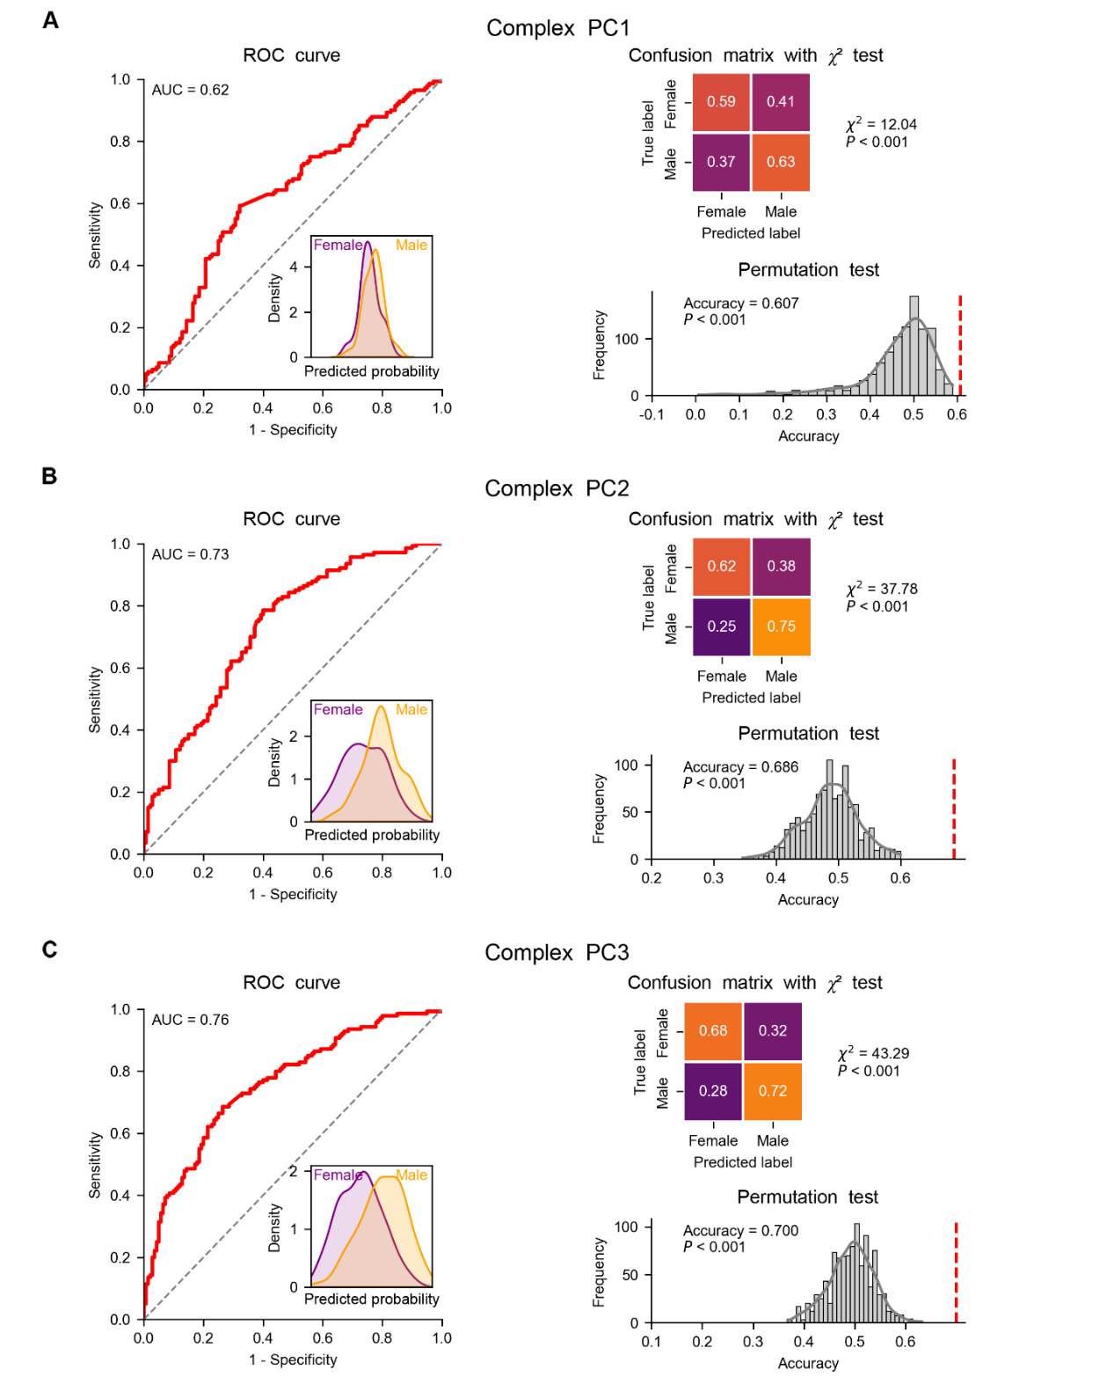

Fig. S9. Classification performance of linear support vector machine trained on the first three complex PCs. We evaluated the performance of linear support vector machine (LSVM) in predicting sex using LOOCV and underwent grid optimization. Each row in the figure corresponds to a different complex PC (from top to bottom: complex PC1, complex PC2, complex PC3). In each panel among (A–C), we displayed the ROC curves with predicted probability distributions, confusion matrices and permutation-based null model. All classifiers significantly outperformed null model (P < 0.001).

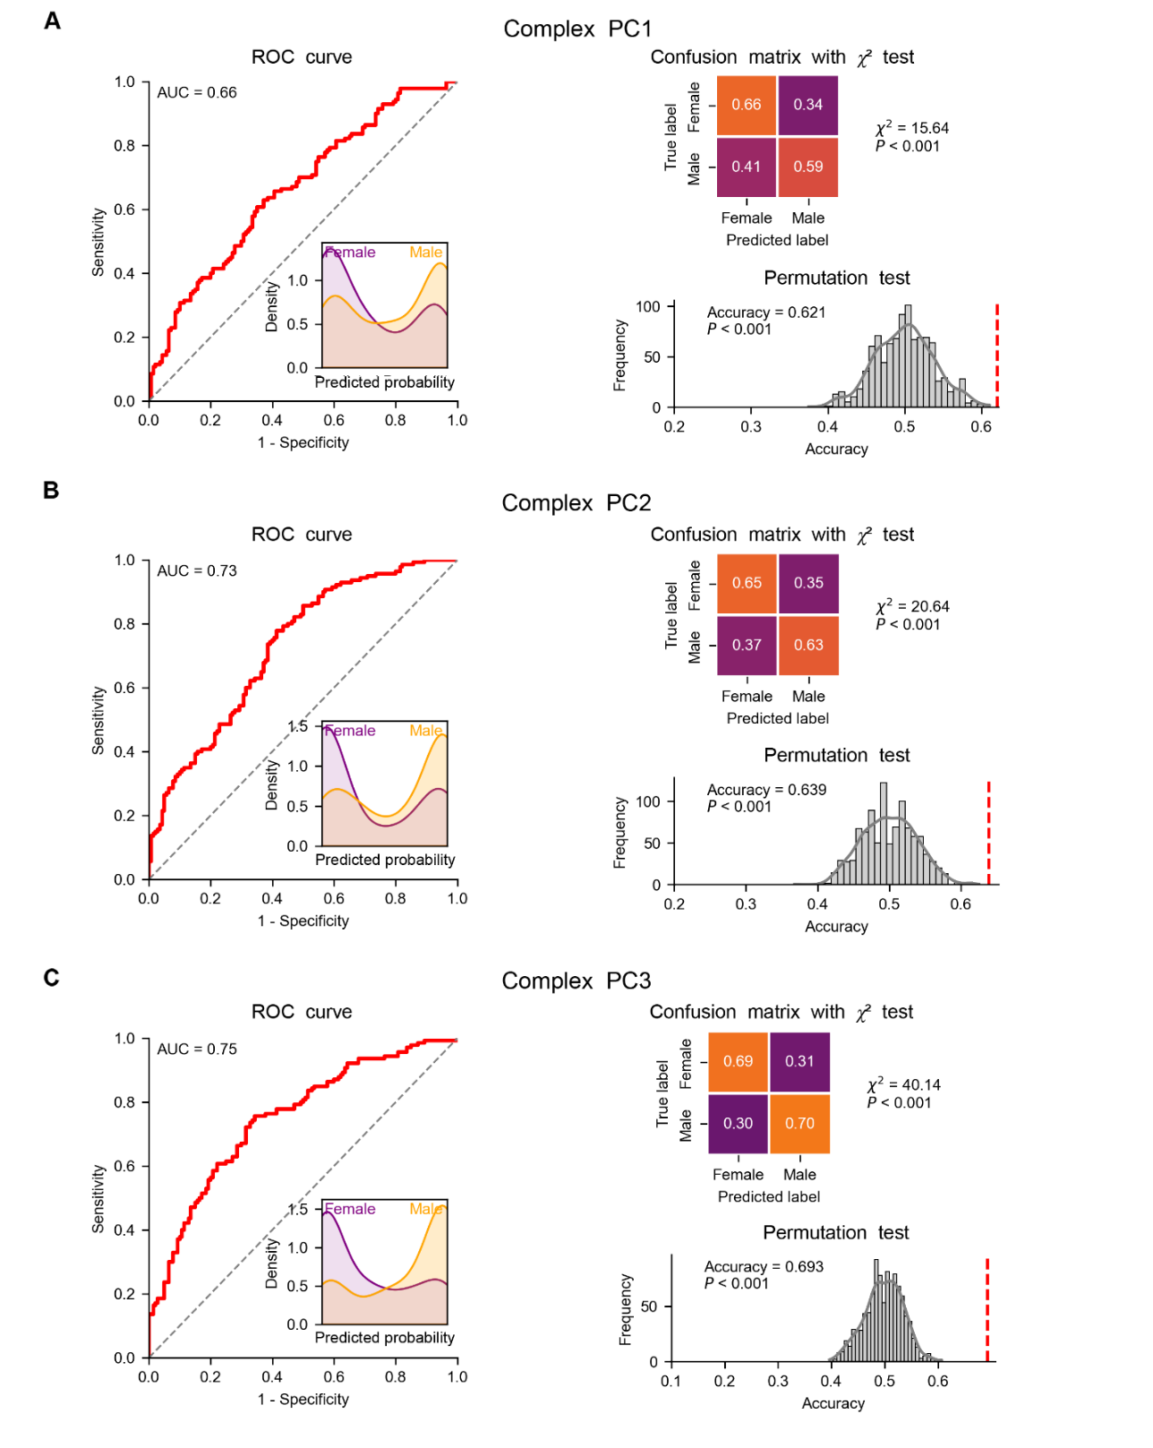

Fig. S10. Classification performance of artificial neural network trained on the first three complex PCs. We evaluated the performance of ANN in predicting sex using LOOCV and underwent grid optimization. Each row in the figure corresponds to a different complex PC (from top to bottom: complex PC1, complex PC2, complex PC3). In each panel among (A–C), we displayed the ROC curves with predicted probability distributions, confusion matrices and permutation-based null model. All classifiers significantly outperformed null model (P < 0.001).

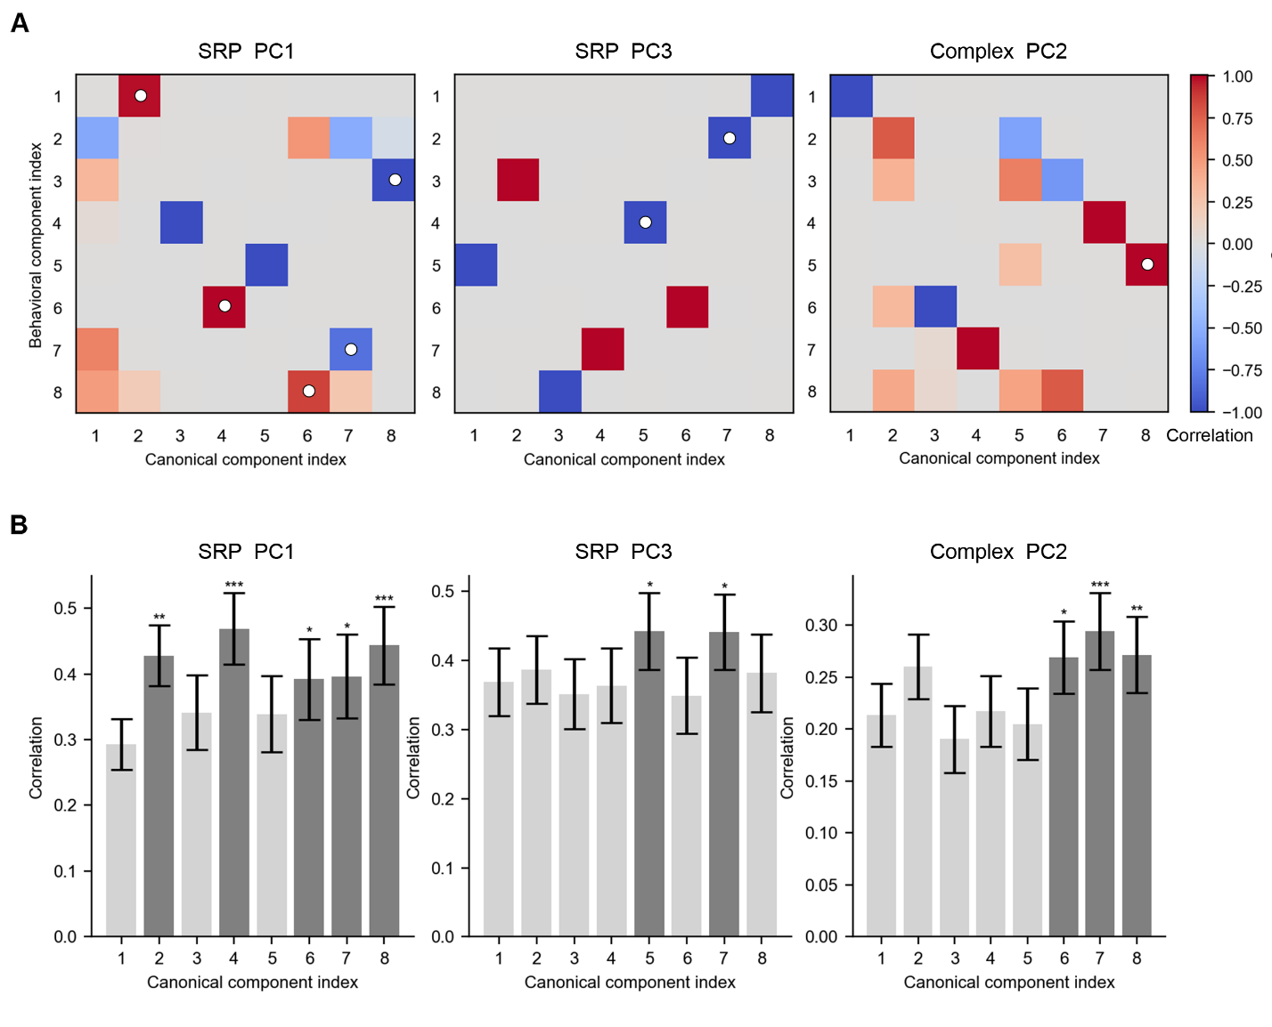

Fig. S11. Identification of behaviorally relevant canonical components across CPCA-derived spatiotemporal patterns. (A) Heatmaps show the correlation between canonical components (x-axis) derived from sCCA and behavioral components (y-axis) derived via PCA on 35 behavioral measures for each pattern (left: SRP PC1, middle: SRP PC3, right: complex PC2). White circles mark the canonical components selected for further analysis. Specifically, for each behavioral component, the canonical component showing the strongest and statistically significant correlation was selected. Only correlations with absolute values exceeding 0.5 were highlighted in color. (B) Bar plots show the absolute values of canonical correlation coefficients for all eight canonical components, corresponding to the heatmaps in panel (A) (left: SRP PC1, middle: SRP PC3, right: complex PC2). Error bars represent the standard deviation of canonical correlation values estimated from 100 null permutations. Significance was determined by comparing observed correlations to the null distribution generated from 1000 permutations and asterisks denote significance levels (*P < 0.05, **P < 0.01, ***P < 0.001). These results indicate that specific CPCA-derived spatiotemporal components are selectively aligned with interpretable behavioral domains.

Table S1. Behavioral phenotypes used in the paper. This table lists the 35 behavioral phenotypes used in the prediction analyses. Measures were selected from the HCP-YA dataset to represent a broad range of cognitive, emotional, and personality domains. Behaviors were grouped into five categories:
- Alertness: Including MMSE (Mini-Mental State Examination) and PSQI (Pittsburgh Sleep Quality Index) scores.
- Cognition: Covering executive function, memory, processing speed, language, and composite cognitive scores (e.g., ListSort, Flanker, ProcSpeed, CogTotalComp).
- Emotion: Including affective traits and self-reported emotional well-being measures (e.g., Sadness, Anger, Loneliness, Stress).
- Personality: Represented by the five-factor NEO personality inventory (NEOFAC A, O, C, N, E).
All measures were used in regression-based prediction analyses, in which cerebellar spatiotemporal patterns were used as input features.
Category | Behavioral phenotype | Category | Behavioral phenotype
Alertness | MMSE_Score | Emotion | Sadness_Unadj
Alertness | PSQI_Score | Emotion | LifeSatisf_Unadj
Cognition | PicSeq_Unadj | Emotion | MeanPurp_Unadj
Cognition | CardSort_Unadj | Emotion | PosAffect_Unadj
Cognition | Flanker_Unadj | Emotion | Friendship_Unadj
Cognition | ReadEng_Unadj | Emotion | Loneliness_Unadj
Cognition | PicVocab_Unadj | Emotion | PercHostil_Unadj
Cognition | ProcSpeed_Unadj | Emotion | PercReject_Unadj
Cognition | ListSort_Unadj | Emotion | EmotSupp_Unadj
Cognition | CogFluidComp_Unadj | Emotion | InstruSupp_Unadj
Cognition | CogEarlyComp_Unadj | Emotion | PercStress_Unadj
Cognition | CogTotalComp_Unadj | Emotion | SelfEff_Unadj
Cognition | CogCrystalComp_Unadj | Personality | NEOFAC_A
Emotion | AngAffect_Unadj | Personality | NEOFAC_O
Emotion | AngHostil_Unadj | Personality | NEOFAC_C
Emotion | AngAggr_Unadj | Personality | NEOFAC_N
Emotion | FearAffect_Unadj | Personality | NEOFAC_E
Emotion | FearSomat_Unadj

