Supporting information

Heparin’s Inhibition Capability on DNA Polymerase Enables Probe-Free Heparin Quantitative Detection Assay

Yi Xie^{1, 2}, Yi Li², Xiong Ding^{3*}, Meilin Weng^{2*}, Kun Yin^{1*}

1School of Global Health, Chinese Center for Tropical Diseases Research, Shanghai Jiao Tong University School of Medicine, Shanghai, 200025, People’s Republic of China 2One Health Center, Shanghai Jiao Tong University-The University of Edinburgh, Shanghai, 200025, People’s Republic of China
2Department of Anesthesiology, Zhongshan Hospital, Fudan University, Shanghai 200032, China
3Key Laboratory of Environmental Medicine and Engineering, Ministry of Education, School of Public Health, Southeast University, Nanjing 210009, P. R. China; Department of Nutrition and Food Hygiene, School of Public Health, Southeast University, Nanjing 210009, P. R. China

Methods/Experimental Sections
Materials
Heparin, heparan sulfate, (NH4)2SO4, Tween 20, KCl, glycerol, and KOH were purchased from Sigma-Aldrich (Shanghai, China). Sterile molecular biology-grade water was purchased from Thermo Fisher Scientific Inc (USA). Eva Green dye was purchased from Yeason Biotechnology Co., Ltd. (Shanghai, China), Bst 2.0 Warmstart DNA Polymerase (8000 U/mL), Bst 3.0 DNA Polymerase (8,000 U/mL), 10 × NEB isothermal amplification buffer, 10 × NEB isothermal amplification buffer 2, and 10 × ThermoPol @ reaction buffer, magnesium sulfate (MgSO4) Solution (100 nM), dATPs (100 nM), dCTPs (100 nM), dUTPs (100 nM), and dGTPs (100 nM) were purchased from New England BioLabs (NEB) Inc (USA). 10 × DNA Loading Buffer and GelStain were obtained from TransGen Biotech Co., Ltd (China). Biowest regular agarose was provided by Baygene Biotech Co., Ltd (China).

Construction and purification of Zst polymerase
The construction and purification of this engineered Zst polymerase has been reported in our previous work ¹.

Three-dimensional structure construction of the Zst protein and energy minimization
Protein structure prediction of Zst protein was performed on a local install of Colab-Fold with ‘‘AlphaFold2’’ parameters using A100 GPUs, where MSA search was done by MMseqs2 on Uniref. 100 database ². For SWISS-MODEL predictions, protein sequences were input into the web-based tool via Expasy web server ³⁻⁶. The models obtained from different servers were subjected to energy minimization using the YASARA tool (http://www.yasara.org/minimizationserver.php) ⁷.

Quality assessment of Zst modeled structures
The energy-minimized 3-D structures predicted by servers, namely, AlphaFold2 and Swiss-Model, were assessed for the quality of the modeled structure using the UCLA (USA) SAVES v6.0 tool ⁸. This assessment included Ramachandran plot analysis of the homology modeled structures by PROCHECK ⁹ and PROSA ¹⁰ by Z-score analysis. The Z-score analysis by PROSA uses the knowledge of currently available X-ray crystallographic and NMR structures of proteins. The 3D-1D average score by the Verify-3D tool and the percentage of error-free residues were derived by ERRAT of UCLA SAVES v6.0. Structural figures were prepared using Chimera or Pymol (https://pymol.org/2/).

Molecular Dynamics Simulation of Zst-Heparin complex
All-atom molecular dynamics simulations were performed based on the Zst-heparin complex obtained by docking as the initial structure. The simulations were performed using GROMACS 2020.6. Heparin and Zst were described using the GAFF force field and the AMBER14SB protein force field respectively. Use the pdb2gmx subroutine to add hydrogen atoms to the system, add a truncated cubic TIP3P solvent box ¹¹ at a distance of 10 Å to the system, and add Na+ and Cl- to the system to balance the charge of the system, and finally output it for simulation topology and parameter files.
Molecular dynamics simulations were performed using GROMACS 2020.6 software ¹², and the simulation time was 50 ns. Before the simulation, the energy of the system was optimized, using the mdrun command and the steepest descent method for energy minimization (canonical ensemble). The starting step size was set to 0.01 nm, and the maximum allowable force value was 1000 kJ/mol·nm. After the energy optimization of the system is completed, a 100 ps NVT (isothermal isotherm) system simulation is performed on the system at a fixed volume and constant heating rate to slowly increase the system temperature from 0 K to 310.15 K to further homogenize the solvent molecules. is distributed in the solvent box. Subsequently, a Berendsen barostat was used to perform a 100 ps NPT (isobaric and equal volume) ensemble simulation to balance the pressure of the solvent and composite system, raising the system pressure to 1 bar. During the MD simulation process, all hydrogen bonds involved were constrained using the LINCS (Linear Constraint Solver) algorithm ¹³, and the integration step was 2 fs. Electrostatic interactions were calculated using the PME (Particle-mesh Ewald) method, with the cutoff value set to 1.2 nm. The nonbonded interaction cutoff is set to 10 Å and updated every 10 steps. The simulated trajectories are periodically eliminated. Subsequently, the quality of the receptor-ligand complex was analyzed by root-mean-square deviation (RMSD) and root-mean-square fluctuation (RMSF) plots. The number of hydrogen bonds formed during the simulation was calculated using g_hbond utility of GROMACS.

MM-PBSA Binding Free Energy Calculation
MM-PBSA approach is one of the most widely used binding free energy calculation methods combined with MD simulation. It has been successfully applied to various protein-ligand or protein-protein / peptide complexes ^{14, 15}. This method also helps to understand biomolecular associations in detail by decomposing the total binding energy into a series of components. This module estimates Gibb’s free energy of binding using the MM-PBSA method as described by the equations below:

$${ΔG}_{bind}={ΔG}_{complex} - ({ΔG}_{receptor}+ {ΔG}_{ligand})$$
$$={ΔE}_{internal}+{ΔE}_{VDW}+{ΔE}_{elec}{+ΔG}_{GB}+{ΔG}_{SA}$$ | (1)

Where In formula (1), ${ΔE}_{internal }$represents internal energy, ${ΔE}_{VDW}$represents van der Waals interaction, and ${ΔE}_{elec}$represents electrostatic interaction. The internal energy includes bond energy (Ebond), angular energy (Eangle), and torsion energy (Etorsion); ${ΔG}_{GB}$ and ${ΔG}_{GA}$ are collectively referred to as solvation free energy. Among them, GGB is the polar solvation free energy and GSA is the non-polar solvation free energy. For ${ΔG}_{GB}$, this paper uses the GB model developed by Nguyen et al. ¹⁶ for calculation (igb = 2). The nonpolar solvation free energy (${ΔG}_{SA}$) is calculated based on the product of surface tension (γ) and solvent accessible surface area (SA) ¹⁷

${ΔG}_{SA}=0.0072×∆SASA.$ (2)

Entropy change is ignored in this study due to high computational resource consumption and low accuracy ¹⁸.

Figures
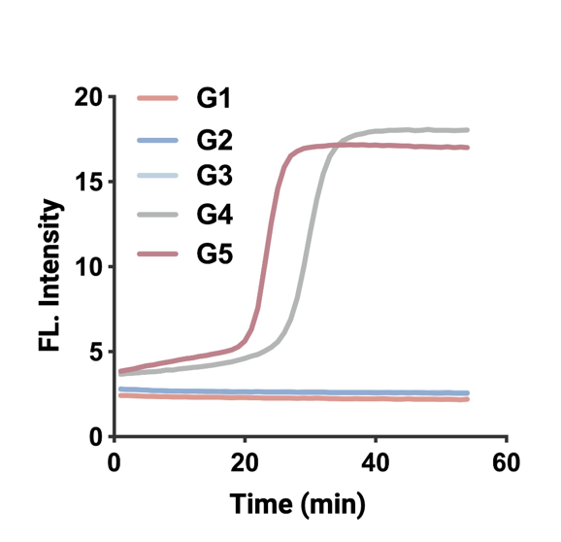
Figure S1. Inhibitory effect of heparin on the ZE-LAMP reaction at varying concentrations. Heparin concentrations: G1: 2.5 × 10⁻² g/mL, G2 and G3: 2.5 × 10⁻³ g/mL, G4: 2.5 × 10⁻⁴ g/mL, G5: no template control (NTC). DNA template concentration was 10⁵ copies/mL.
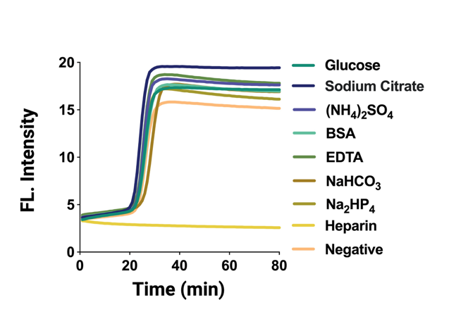
Figure S2 Analysis of detection specificity performance.
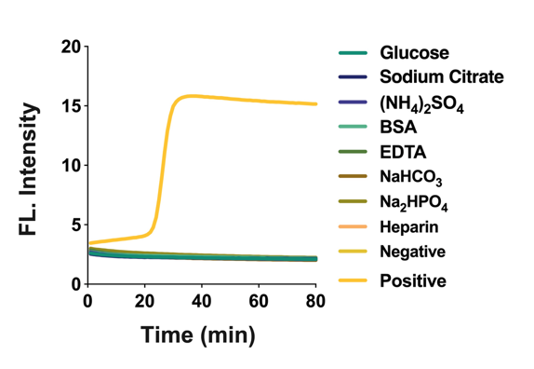
Figure S3 Analysis of anti-interference performance.

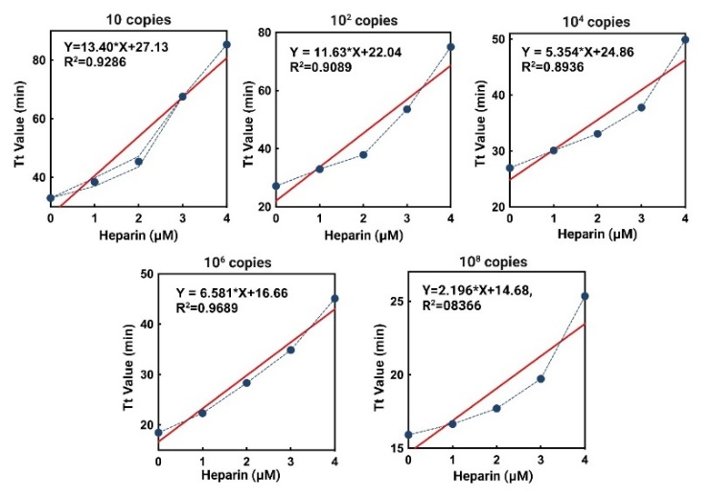
Figure S4 Optimization of DNA substrate concentration in this heparin detection assay.

Tables
Table S1 Gibbs Free Energy analysis of ZST-Heparin complex
Name | Energy Value（Kilocalorie per mole，kcal/mol）
△G^{VDWAALS} | -158.59^{b}
△G^{EEL} | -5.25
△G^{ESURF} | 24.73
△G^{EGB} | -18.72
△G^{GGas} | -163.83
△G^{GSOLV} | 6.01
△G^{TOTAL,a} | -157.82
Note: ªVDWAALS, van der Waals force; EEL, electric potential energy; EGB: polar component of the solvation energy (in this case is calculated using Generalized Born model); ESURF: no polar component of the solvation energy (proportional to the Solvent Accessible Surface Area of the solute); GGAS: Total Gas-Phase Free Energy; GSOLV: Total Solvation Free Energy; TOTAL: GSOLV + GGAS. ^{b} kcal/mol.

(1) Xie, Y.; Jiang, K.; Zhang, Y.; Cao, L.; Guo, X.; Shi, J.; Ding, X.; Yin, K. Enhanced Two-Step LAMP-CRISPR Assay with an Engineered Zst Polymerase for Contamination-Free and Ultrasensitive DNA Detection. Analytical Chemistry 2024, 96 (38), 15493-15502.
(2) Mirdita, M.; Schütze, K.; Moriwaki, Y.; Heo, L.; Ovchinnikov, S.; Steinegger, M. ColabFold: making protein folding accessible to all. Nature Methods 2022, 19 (6), 679-682. DOI: 10.1038/s41592-022-01488-1.
(3) Waterhouse, A.; Bertoni, M.; Bienert, S.; Studer, G.; Tauriello, G.; Gumienny, R.; Heer, F. T.; de Beer, T. A. P.; Rempfer, C.; Bordoli, L. SWISS-MODEL: homology modelling of protein structures and complexes. Nucleic acids research 2018, 46 (W1), W296-W303.
(4) Guex, N.; Peitsch, M. C.; Schwede, T. Automated comparative protein structure modeling with SWISS‐MODEL and Swiss‐PdbViewer: A historical perspective. Electrophoresis 2009, 30 (S1), S162-S173.
(5) Bertoni, M.; Kiefer, F.; Biasini, M.; Bordoli, L.; Schwede, T. Modeling protein quaternary structure of homo-and hetero-oligomers beyond binary interactions by homology. Scientific reports 2017, 7 (1), 10480.
(6) Bienert, S.; Waterhouse, A.; De Beer, T. A.; Tauriello, G.; Studer, G.; Bordoli, L.; Schwede, T. The SWISS-MODEL Repository—new features and functionality. Nucleic acids research 2017, 45 (D1), D313-D319.
(7) Land, H.; Humble, M. S. YASARA: a tool to obtain structural guidance in biocatalytic investigations. Protein engineering: methods and protocols 2018, 43-67.
(8) Kumar, K.; Singh, S.; Sharma, K.; Goyal, A. Computational modeling and small-angle X-ray scattering based structure analysis and identifying ligand cleavage mechanism by processive endocellulase of family 9 glycoside hydrolase (HtGH9) from Hungateiclostridium thermocellum ATCC 27405. Journal of Molecular Graphics and Modelling 2021, 103, 107808.
(9) Laskowski, R.; MacArthur, M.; Thornton, J. PROCHECK: validation of protein-structure coordinates. 2006.
(10) Wiederstein, M.; Sippl, M. J. ProSA-web: interactive web service for the recognition of errors in three-dimensional structures of proteins. Nucleic acids research 2007, 35 (suppl_2), W407-W410.
(11) Mark, P.; Nilsson, L. Structure and dynamics of the TIP3P, SPC, and SPC/E water models at 298 K. The Journal of Physical Chemistry A 2001, 105 (43), 9954-9960.
(12) Salomon‐Ferrer, R.; Case, D. A.; Walker, R. C. An overview of the Amber biomolecular simulation package. Wiley Interdisciplinary Reviews: Computational Molecular Science 2013, 3 (2), 198-210.
(13) Hess, B.; Bekker, H.; Berendsen, H. J.; Fraaije, J. G. LINCS: A linear constraint solver for molecular simulations. Journal of computational chemistry 1997, 18 (12), 1463-1472.
(14) Genheden, S.; Ryde, U. The MM/PBSA and MM/GBSA methods to estimate ligand-binding affinities. Expert opinion on drug discovery 2015, 10 (5), 449-461.
(15) Wang, E.; Sun, H.; Wang, J.; Wang, Z.; Liu, H.; Zhang, J. Z.; Hou, T. End-point binding free energy calculation with MM/PBSA and MM/GBSA: strategies and applications in drug design. Chemical reviews 2019, 119 (16), 9478-9508.
(16) Nguyen, H.; Roe, D. R.; Simmerling, C. Improved generalized born solvent model parameters for protein simulations. Journal of chemical theory and computation 2013, 9 (4), 2020-2034.
(17) Weiser, J.; Shenkin, P. S.; Still, W. C. Approximate atomic surfaces from linear combinations of pairwise overlaps (LCPO). Journal of Computational Chemistry 1999, 20 (2), 217-230.
(18) Hou, T.; Wang, J.; Li, Y.; Wang, W. Assessing the performance of the MM/PBSA and MM/GBSA methods. 1. The accuracy of binding free energy calculations based on molecular dynamics simulations. Journal of chemical information and modeling 2011, 51 (1), 69-82.

