Supporting Information
Fibroblast-derived CCL2 orchestrates immune responses and defends against Staphylococcus aureus skin infection

Authors: Tatsuya Dokoshi^{1,2}†, Marta Palomo-Irigoyen^{1,3}, Michelle Bagood¹, Hung Chan¹, Samia Almoughrabie¹, Yoshiyuki Nakamura^{1,4}, Kellen J. Cavagnero¹, Teruaki Nakatsuji¹, Richard L. Gallo¹

Affiliations:
¹ Department of Dermatology, University of California, San Diego, La Jolla, CA 92037, United States.
² Department of Internal Medicine Division of Gastroenterology, Asahikawa Medical University, Asahikawa, Hokkaido, Japan
³Genes and Disease Laboratory, Department of Dermatology, Medical University of Vienna, Vienna, Austria
⁴Department of Dermatology, University of Tsukuba: Tsukuba, Ibaraki, JAPAN

* Dr. Tatsuya Dokoshi,
Department of Internal Medicine Division of Gastroenterology
Asahikawa Medical University, Asahikawa,
2-1-1-1 midorigaoka higashi, Asahikawa, Hokkaido, 078-8510
Telephone: 0166-68-2462
Fax: 0167-45-4578
Email: ta1983@asahikawa-med.ac.jp

This PDF file includes:

Figures S1 to S8
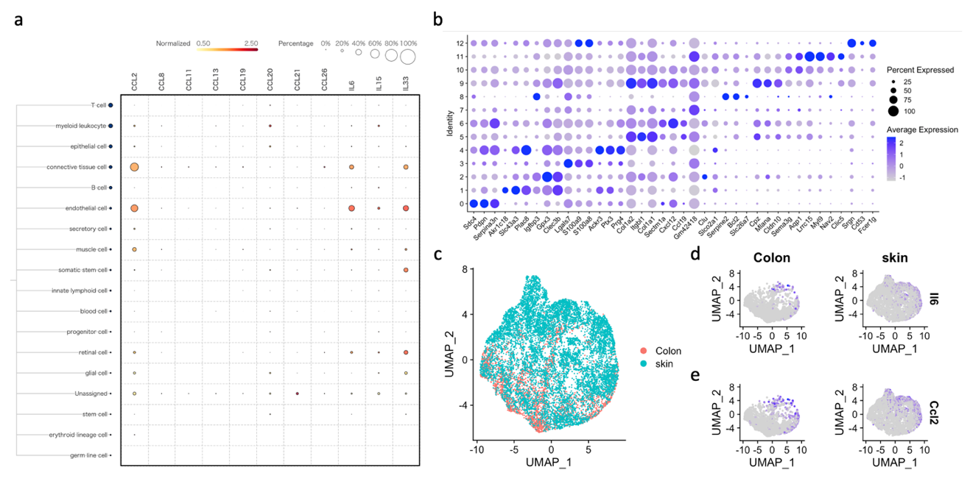
Tables S1
Fig. S1. Chemokine expression analysis in a multi-organ scRNAseq data set.
(a) Percentage of cells expressing candidate cytokines and chemokines across multiple cell types in a human scRNA-seq dataset. (b) Marker genes of mouse fibroblast clusters. (c) UMAP plot of fibroblasts from mouse skin and colon. (d, e) Expression levels of IL6 (d) and CCL2 (e) in skin and colon fibroblasts shown on UMAP plots

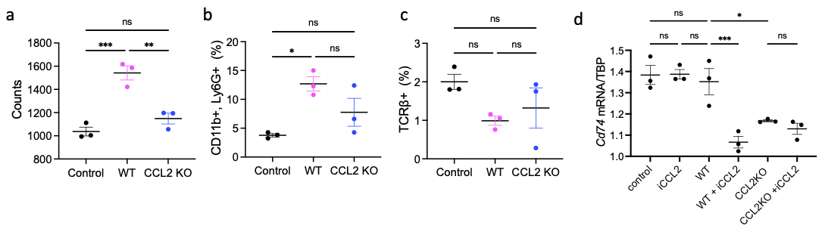
Fig. S2. Flow cytometry analysis of cells recruited by fibroblast-conditioned medium.
(a) Total number of recruited cells per 5000 cells. (b, c) Relative abundance of Neutrophils(b) and Lymphocytes(c). (d) Expression levels of Cd74 of MHS cells treated with CCL2 inhibitor. Statistical significance was determined using ordinary one-way ANOVA and Tukey’s multiple comparison two-sided test. Error bars indicate mean ± SEM; * P<0.05, ** P < 0.01, *** P<0.001. Each experiment was repeated at least 3 times

Fig. S3. Chemokine expression analysis in a multi-organ scRNAseq data set.
(a) IVIS imaging of S. aureus on mouse back skin 3 days after injection. (b) luminescence intensity of S. aureus showing bacterial abundan in Pdgfra/Ccl2^{fl/fl} mice. (c) Relative abundance of cell types based on scRNASeq from Control and Pdgfra/Ccl2^{fl/fl}. (d) Ranking of significant signaling pathways based on differences in overall information flow within inferred networks between control and Pdgfra/Ccl2^{fl/fl}. The top signaling pathways colored red are more enriched in control, gene pathways in black are equally enriched in control and Pdgfra/Ccl2^{fl/fl}, and gene pathways in green are more enriched in Pdgfra/Ccl2^{fl/fl}. (e) Heatmap showing the summary of the signaling pathways that contribute to outgoing or incoming communication in control and Pdgfra/Ccl2^{fl/fl}. The color bar represents the relative signaling strength of a signaling pathway across cell types. The bars indicate the sum of the signaling strength of each cell type or pathway. (f) All significant signaling pathways were ranked based on their differences of overall information flow within the inferred networks between S. aureus infection (control SA) and Pdgfra/Ccl2^{fl/fl} infection (Pdgfra/Ccl2^{fl/fl}_SA). The top signaling pathways colored red are more enriched in control SA, the middle ones colored black are equally enriched in control SA and Pdgfra/Ccl2^{fl/fl}_SA, and the colored green are more enriched in Pdgfra/Ccl2^{fl/fl}_SA. (g) Heatmap showing the summary of the signaling pathways that contribute to outgoing or incoming communication in control and Pdgfra/Ccl2^{fl/fl} after infection by SA. Statistical significance was determined using ordinary one-way ANOVA and Tukey’s multiple comparison two-sided test. Error bars indicate mean ± SEM; * P<0.05, ** P < 0.01, *** P<0.001. Analysis by IVIS was repeated 3 times.

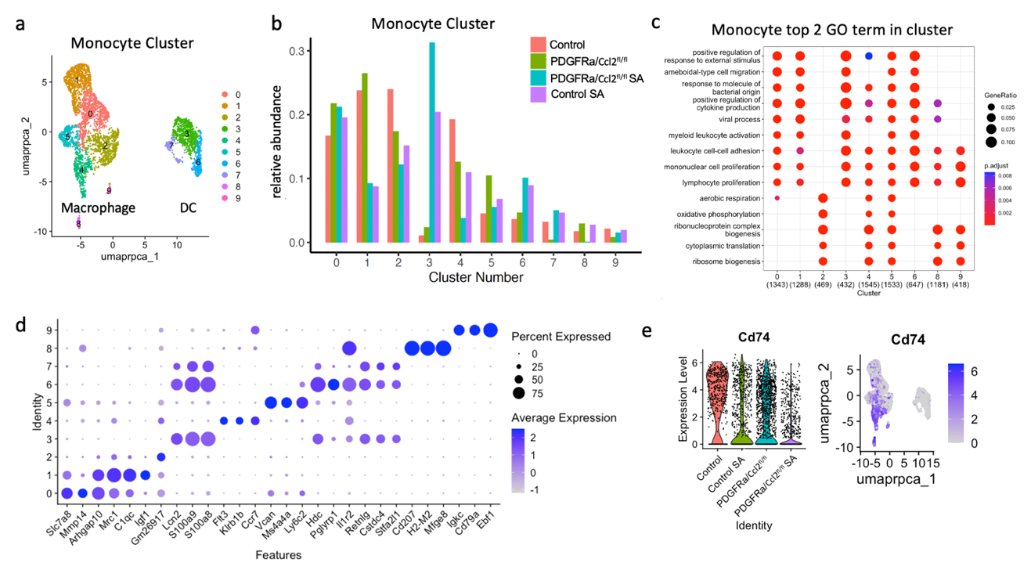
Fig. S4. Transcriptomic analysis of monocyte populations.
(a) UMAP plot of extracted monocyte cluster. (b) Relative abundance of Control, PDGFRa/Ccl2^{fl/fl}, S. Aureus infection (control SA), and PDGFRa/Ccl2^{fl/fl} SA in Monocyte Cluster. (c) Top 2 GO terms of each cluster. (d) Top 3 differentially expressing genes of each cluster. (e) Violin plot and UMAP plot of Cd74 expression.

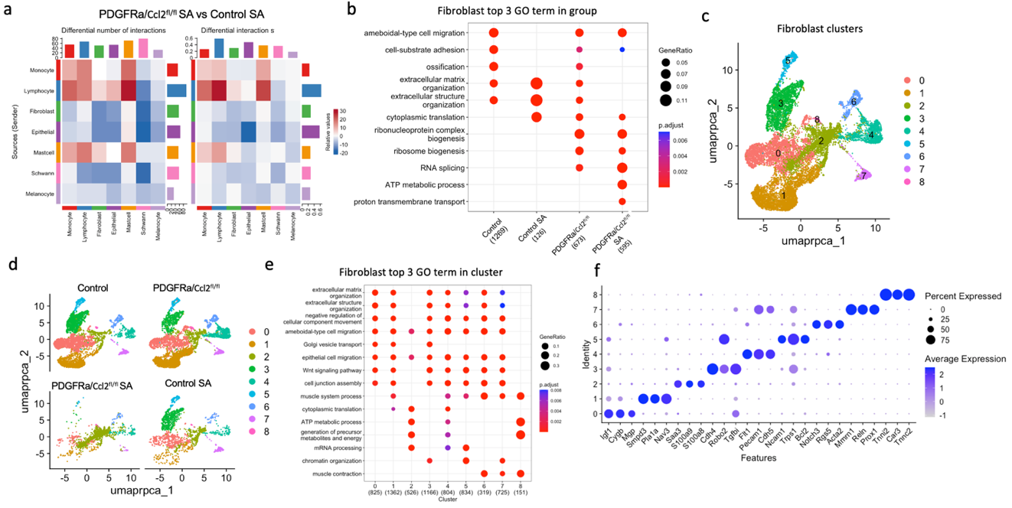
Fig. S5. scRNASeq analysis of control and Pdgfra/Ccl2^{fl/fl} mice during S. aureus skin infection.
(a) Heatmap showing the putative ligand–receptor interactions between cell types in control SA and Pdgfra/Ccl2^{fl/fl} mice after SA infection. The color bar represents the relative signaling strength of a signaling pathway across cell types. The bars indicate the sum of the signaling strength of each cell type or pathway. (b) Top 3 GO terms of each group. (c) UMAP plot of pooled groups with extracted fibroblast clusters. (d) UMAP plot of extracted fibroblast clusters in each experimental group. (e) Top 3 GO terms of each fibroblast cluster. (f) Top 3 differentially expressing genes of each cluster.

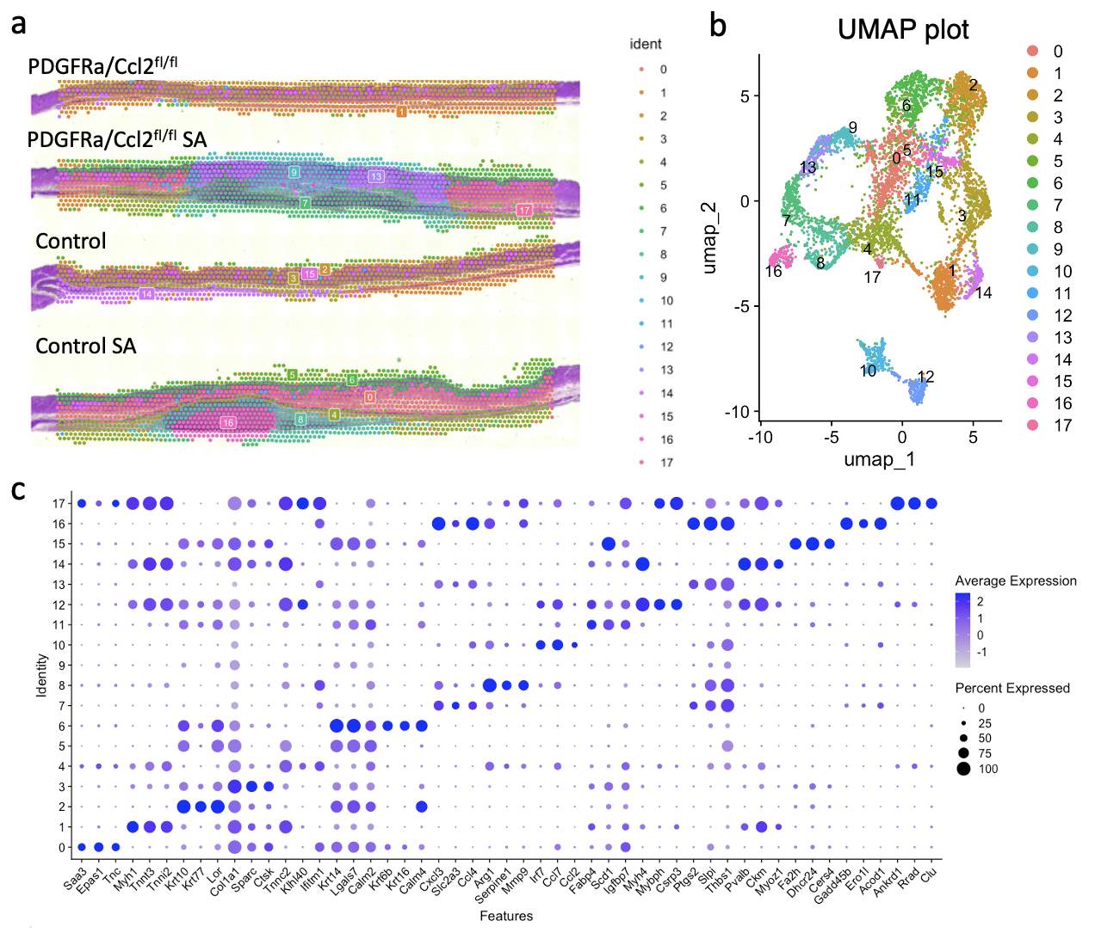
Fig. S6. Spatial transcriptomic analysis of control and Pdgfra/Ccl2^{fl/fl} mice during S. aureus skin infection.
(a) The spatial representation of clusters in control, Pdgfra/Ccl2^{fl/fl}, S. aureus infection (control SA), and Pdgfra/Ccl2^{fl/fl} SA. (b) UMAP plot of spatial sequencing from control, Pdgfra/Ccl2^{fl/fl}, S. aureus infection (SA), and Pdgfra/Ccl2^{fl/fl} SA. (c) Top 3 genes of each cluster.

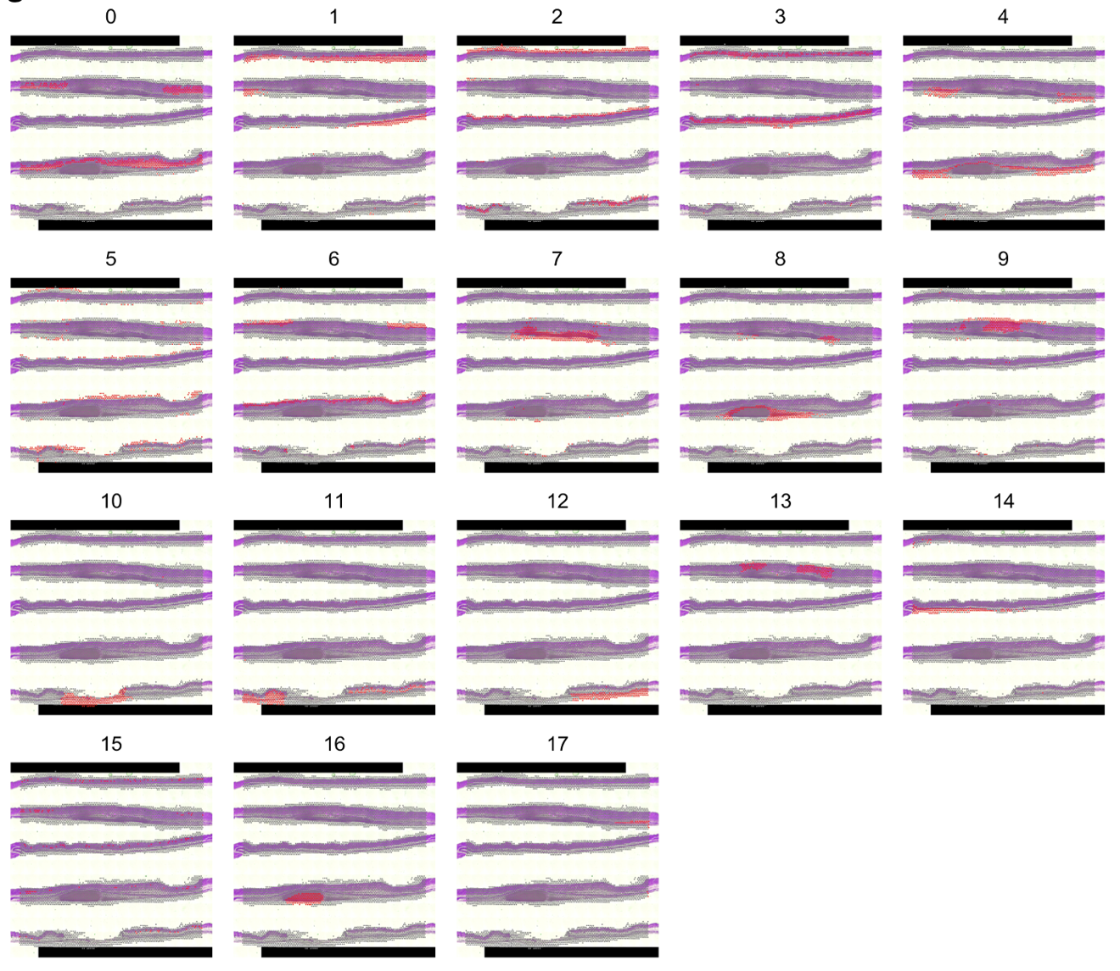
Fig. S7. Spatial mapping of transcriptomic clusters.
Spatial plot showing the localization of identified clusters from the UMAP plot onto the corresponding spatial transcriptomic sequencing slide.

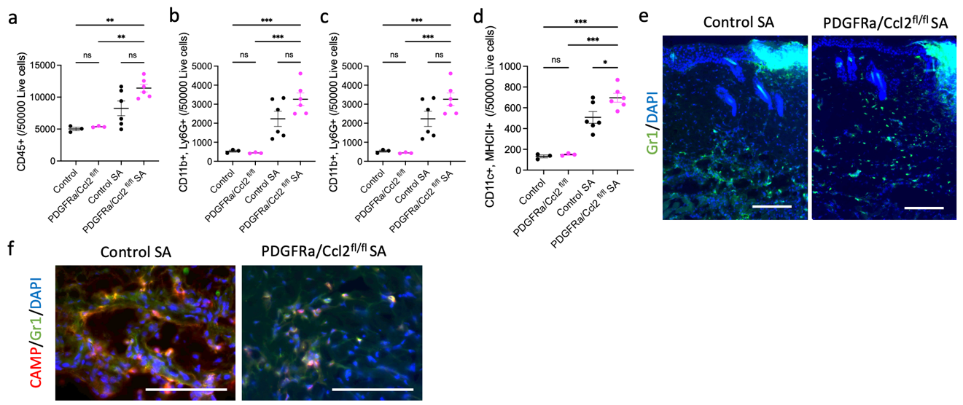
Fig. S8. Flow cytometry and immunostaining analysis of mouse back skin following S. aureus infection.
(a) The number of CD45+ cells in 50000 live cells. (b) CD11b+ and Ly6G+ Neutrophils. (c) CD11b+ and F4/80+ Macrophages. (d) CD11c+ and MHCII+ Dendritic Cells. (e) Immunofluorescence staining of Gr1 after 3 days of infection. (f) Immunofluorescence staining of Camp/Gr1/DAPI after 3 days of infection at high magnification of dermis. (Scale bar: 25 microns. Camp: Red, Gr1: Green, DAPI: Blue) Statistical significance was determined using ordinary two-way ANOVA and Sidak’s multiple comparisons two-sided test. Error bars indicate mean ± SEM * P<0.05, ** P < 0.01, *** P<0.001. Each experiment was repeated at least 3 times.

