Supplementary Information

Selective phenyl-oxime algicides with low non-target acute toxicity: efficacy against green microalgae vs glutaraldehyde
Jun Young Lee^{1,2}, Yeo Jin Kim^{2,3}, Bong Gyu Choi⁴, Jin-Seog Kim^{4,5}, Hasoo Seong⁴, Chul Min Park², Hyun Suk Yeom⁴, Seok Ki Min⁶, Hyeung-geun Park^{1,*}, Joon-Ho Lee^{2,*}

¹Research Institute of Pharmaceutical Sciences, College of Pharmacy, Seoul National University, Seoul 08826, Republic of Korea
²Infectious Diseases Therapeutics Research Center, Korea Research Institute of Chemical Technology, 141 Gajeong-ro, Yuseong-gu, Daejeon 34114, Republic of Korea
³School of Pharmacy, Sungkyunkwan University, Suwon 16419, Republic of Korea
⁴Eco-Friendly New Materials Research Center, Korea Research Institute of Chemical Technology, 141 Gajeong-ro, Yuseong-gu, Daejeon 34114, Republic of Korea
⁵Research Development Division, Daeseungbiofarm Co. Ltd, Daejeon 34127, Republic of Korea
⁶Korea Testing & Research Institute, Jeonju-si, Jeollabuk-do, Republic of Korea

*Corresponding Authors: E-mail: hgpk@snu.ac.kr (H.-g. Park), Tel: +82-2-880-7871, Fax: +82-2-872-9129, E-mail: jh_k@krict.re.kr (J.-H. Lee), Tel: +82-42-860-7693

Table of contents:
1. ¹H NMR and ¹³C NMR data for intermediates……………………………………..………S3
2. ¹H NMR and ¹³C NMR data for title compounds…………………………………………S18
3. Figure S1. Pictures of growth inhibition responses of Scenedesmus rotundus (Scero) and Lemna paucicostata (LEMPA) treated with 3 concentrations of (A) KH04, (B) KH08, and (C) KH21……………………………………………………………………………………….S49

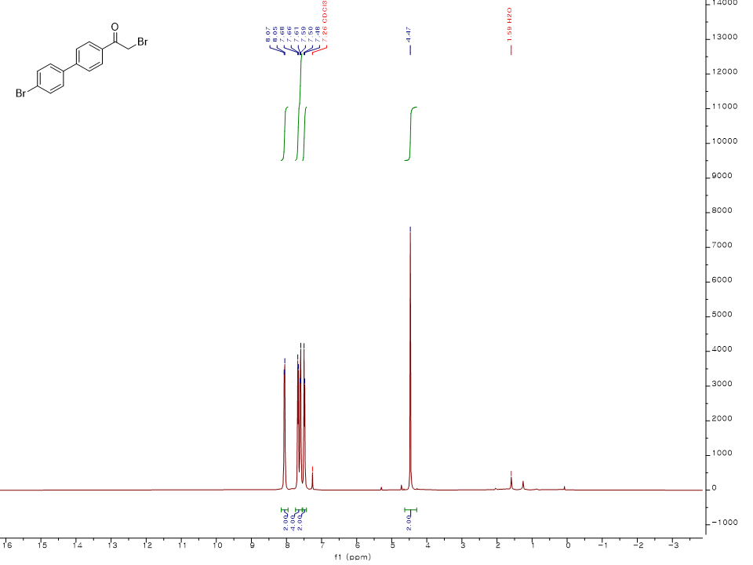
¹H NMR spectrum (400 MHz, CDCl₃) of 2
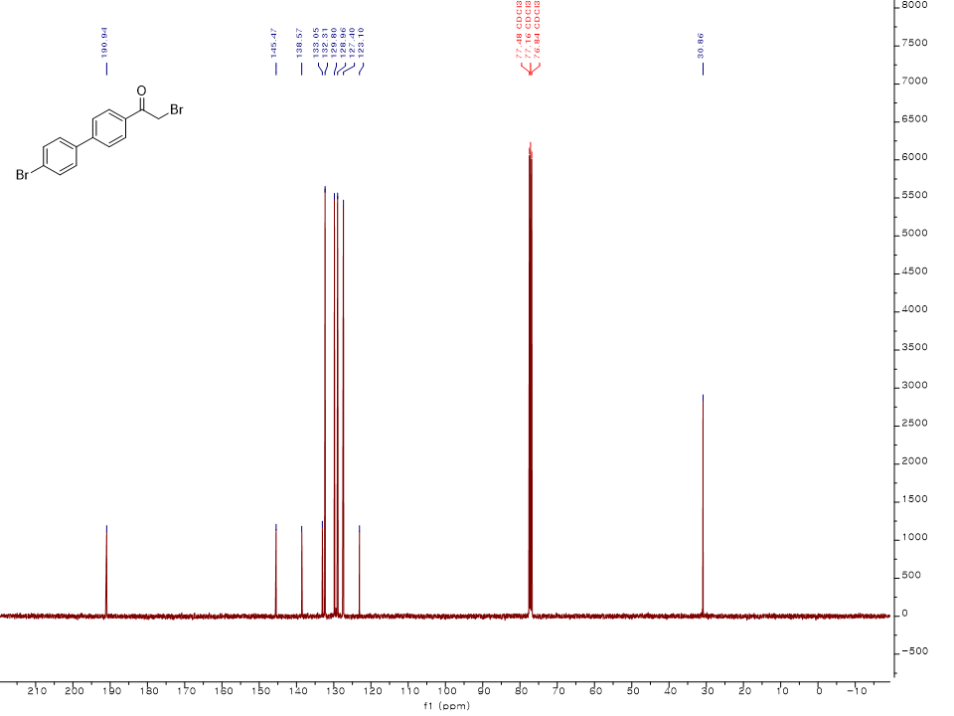
¹³C NMR spectrum (100 MHz, CDCl₃) of 2
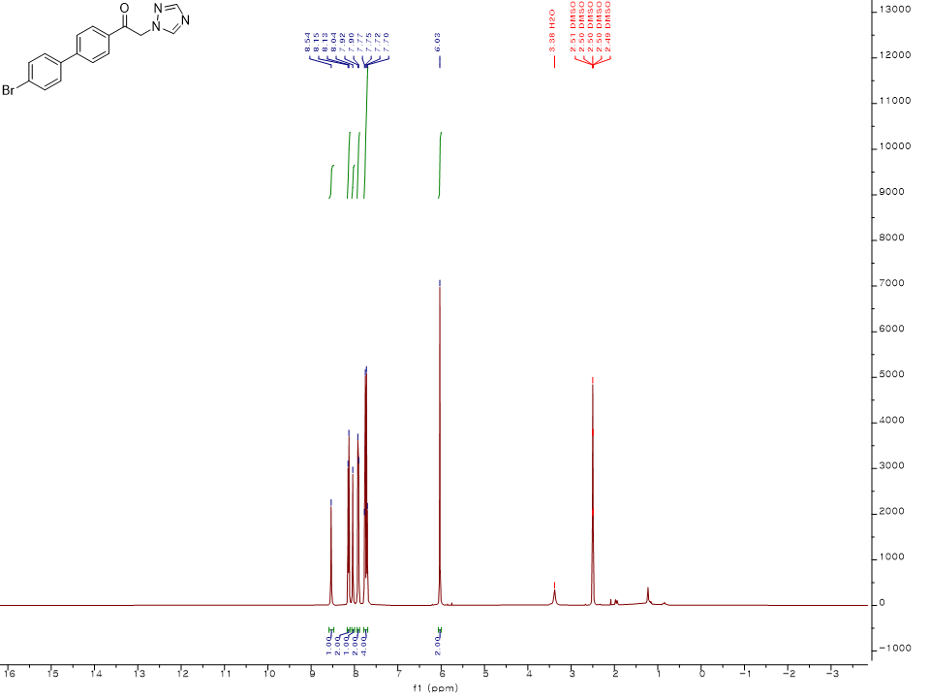
¹H NMR spectrum (400 MHz, DMSO-d₆) of 3
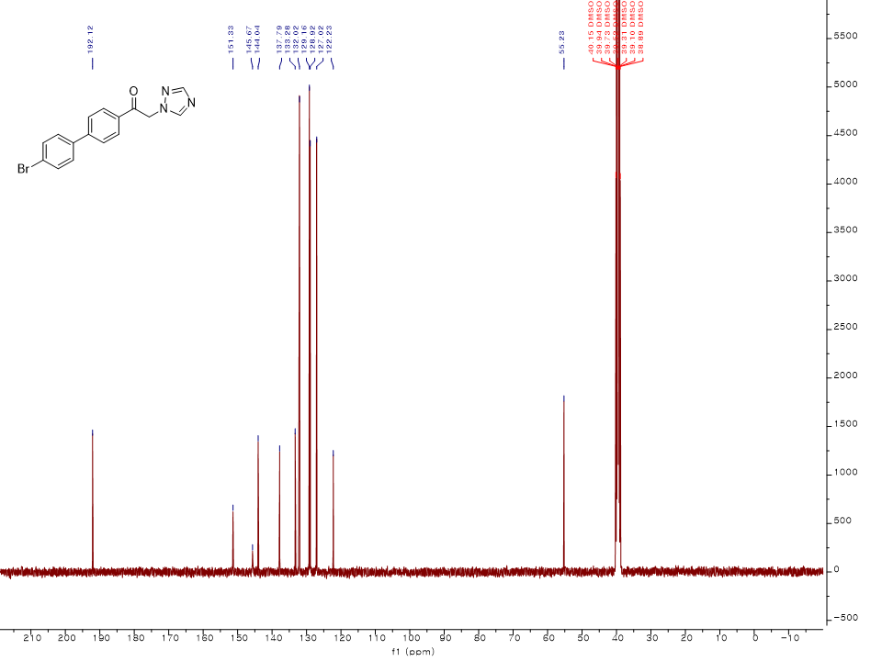
¹³C NMR spectrum (100 MHz, DMSO-d₆) of 3
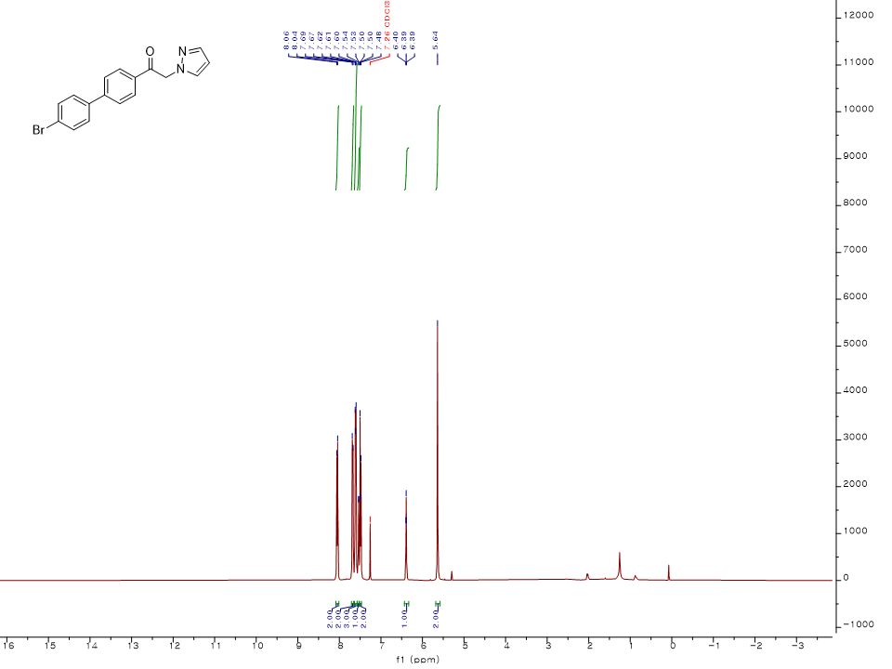
¹H NMR spectrum (400 MHz, CDCl₃) of 4
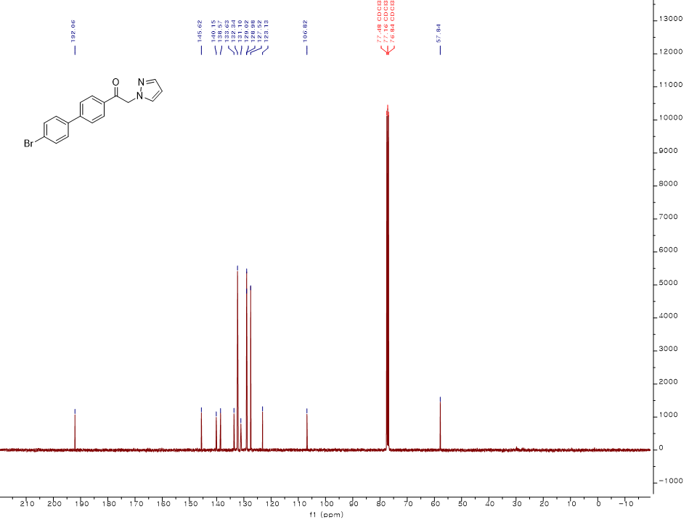
¹³C NMR spectrum (100 MHz, CDCl₃) of 4
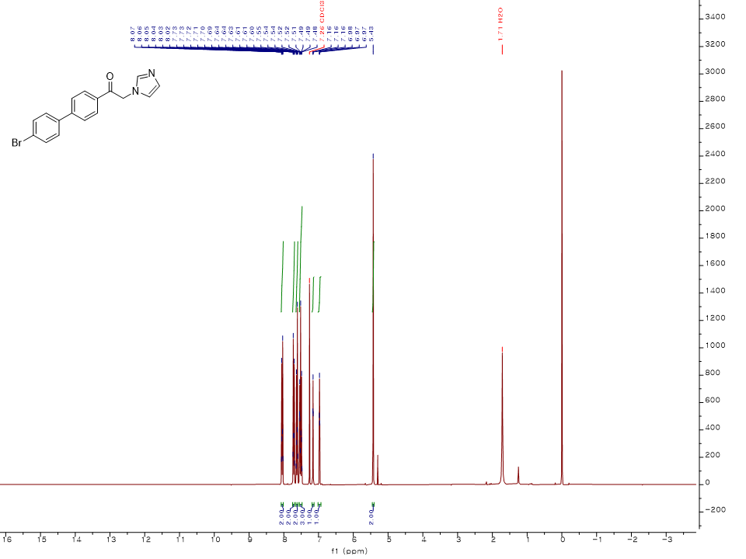
¹H NMR spectrum (300 MHz, CDCl₃) of 5
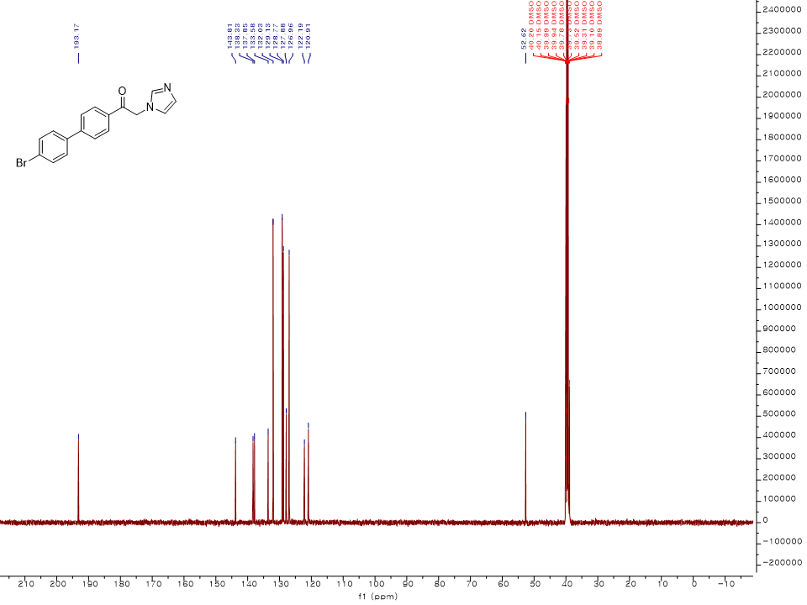
¹³C NMR spectrum (100 MHz, DMSO-d₆) of 5
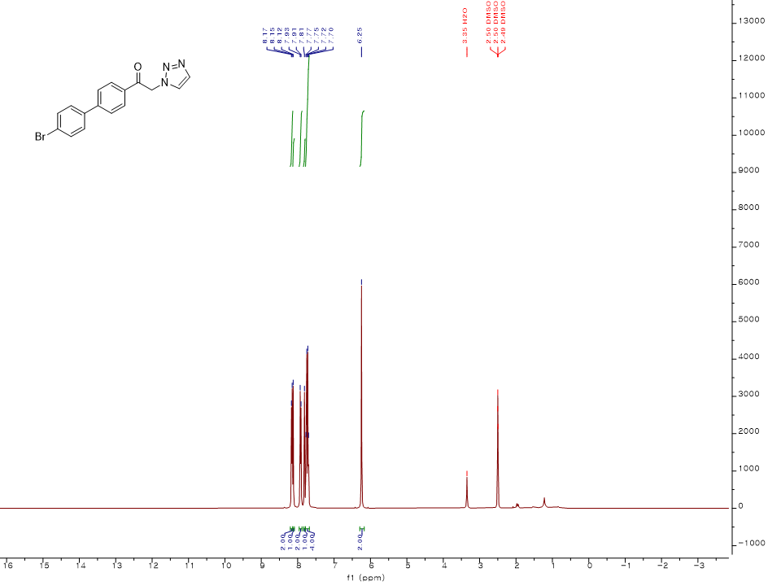
¹H NMR spectrum (400 MHz, DMSO-d₆) of 6
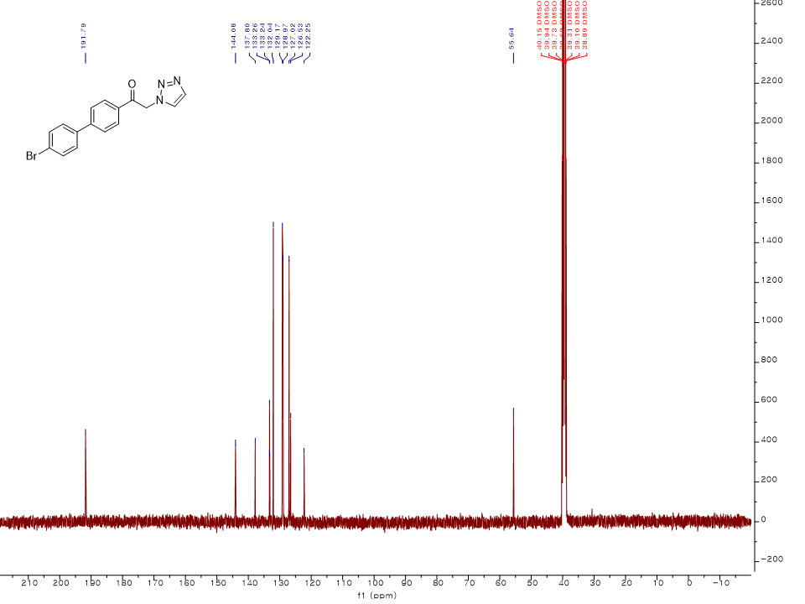
¹³C NMR spectrum (100 MHz, DMSO-d₆) of 6
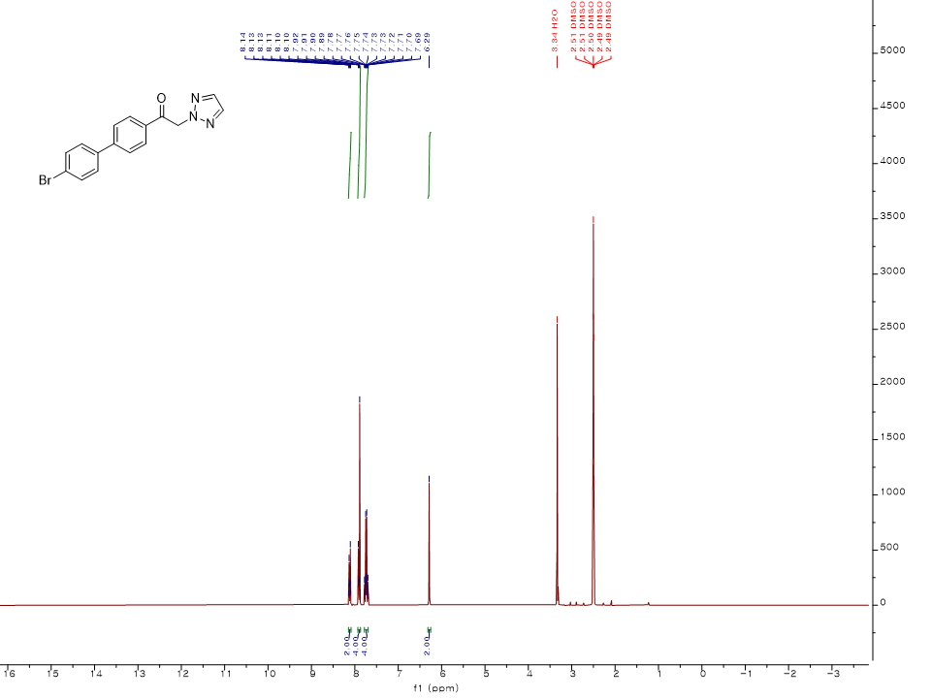
¹H NMR spectrum (300 MHz, DMSO-d₆) of 7
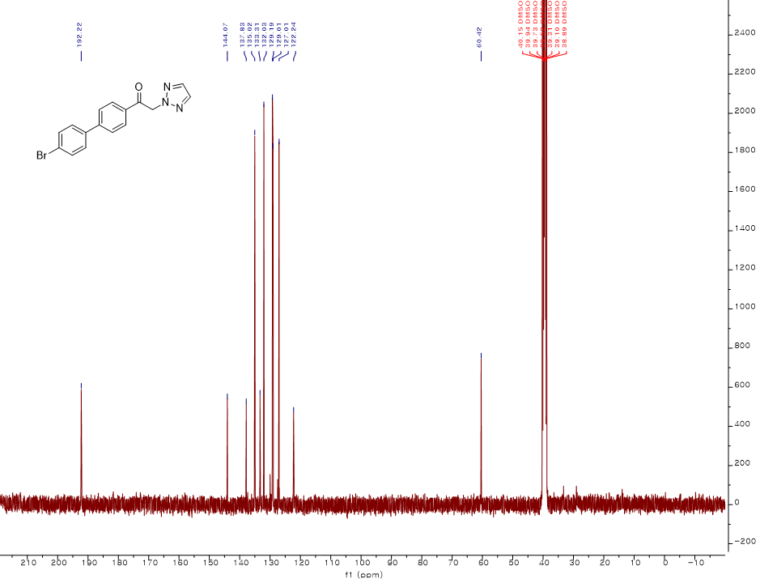
¹³C NMR spectrum (100 MHz, DMSO-d₆) of 7
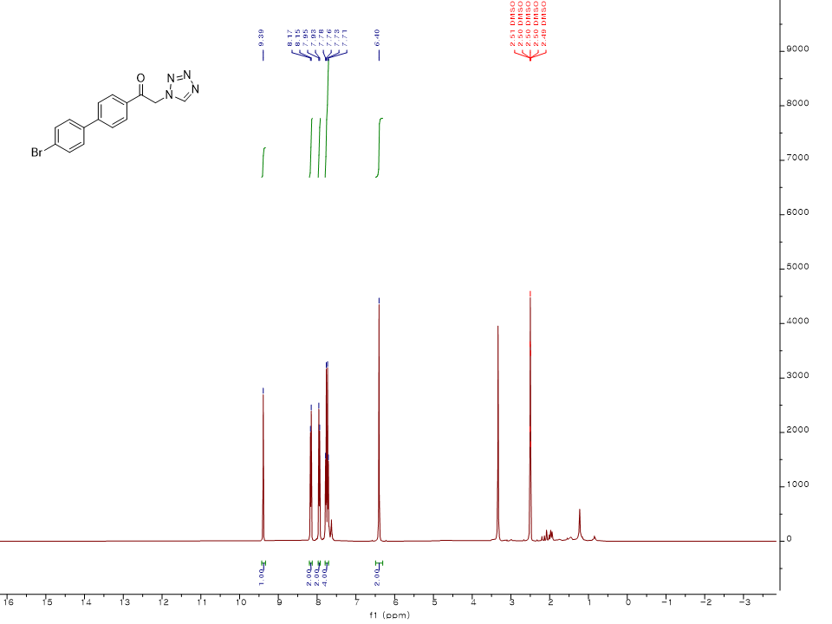
¹H NMR spectrum (400 MHz, DMSO-d₆) of 8
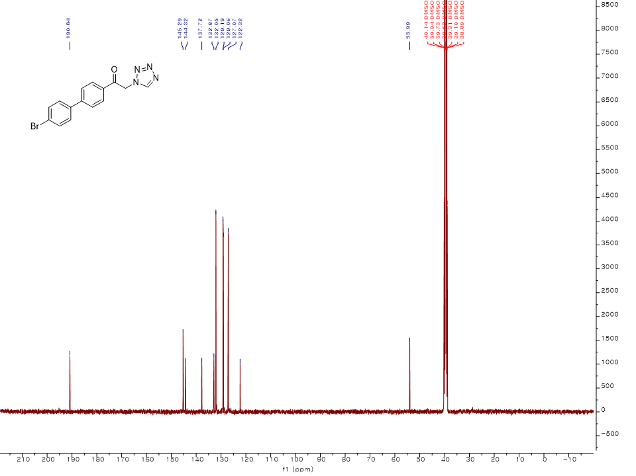
¹³C NMR spectrum (100 MHz, DMSO-d₆) of 8
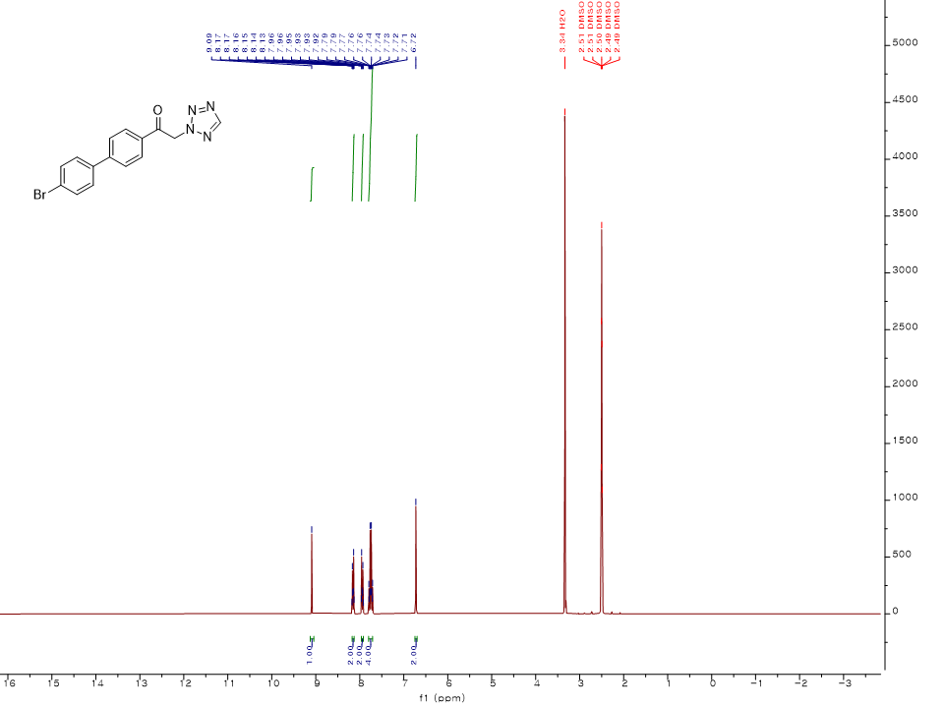
¹H NMR spectrum (300 MHz, DMSO-d₆) of 9
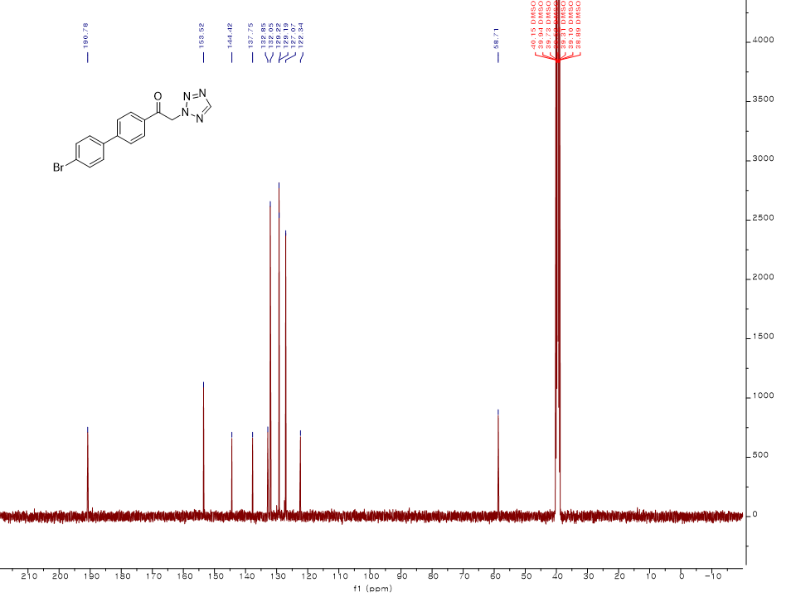
¹³C NMR spectrum (100 MHz, DMSO-d₆) of 9
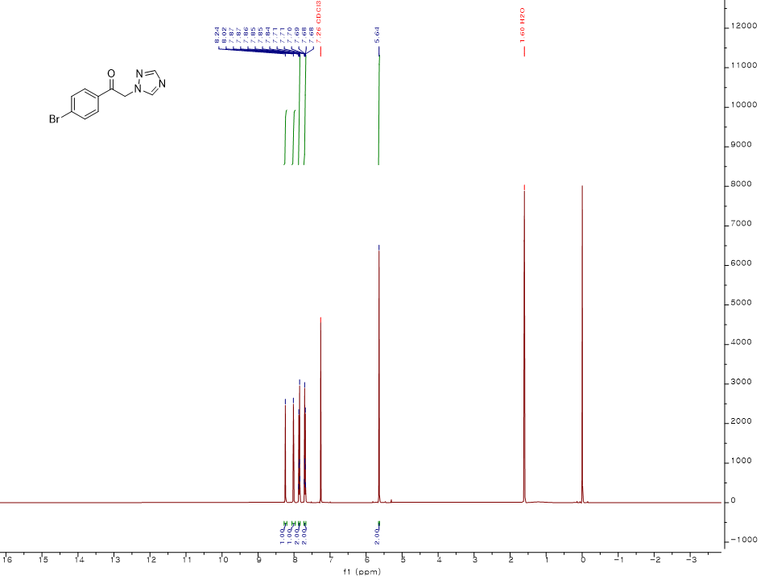
¹H NMR spectrum (400 MHz, CDCl₃) of 11
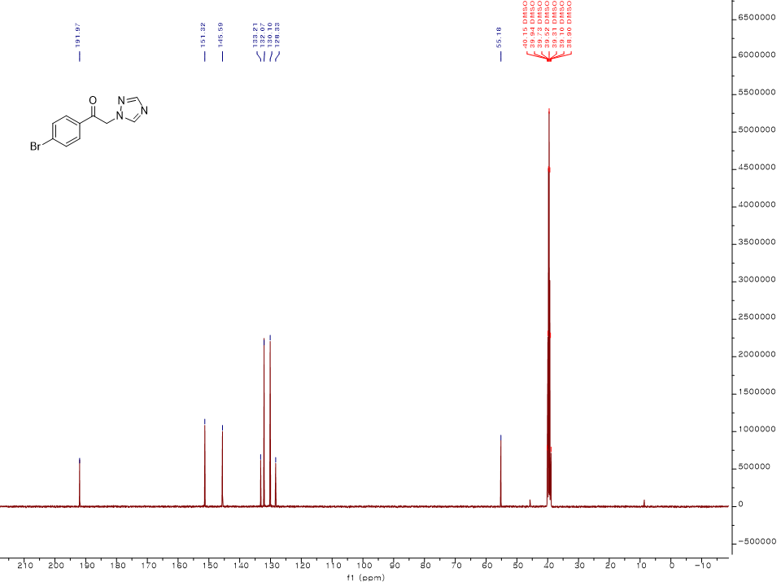
¹³C NMR spectrum (100 MHz, DMSO-d₆) of 11
¹H NMR spectrum (400 MHz, DMSO-d₆) of 12
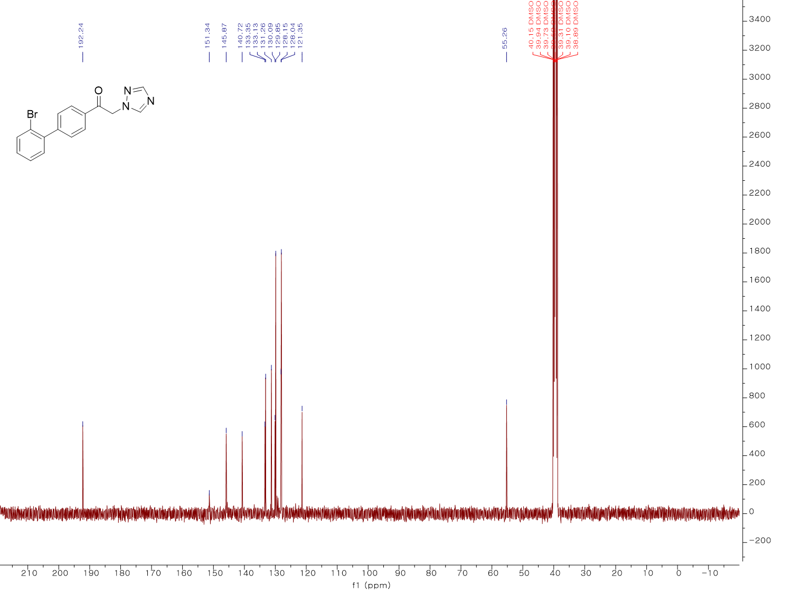
¹³C NMR spectrum (100 MHz, DMSO-d₆) of 12
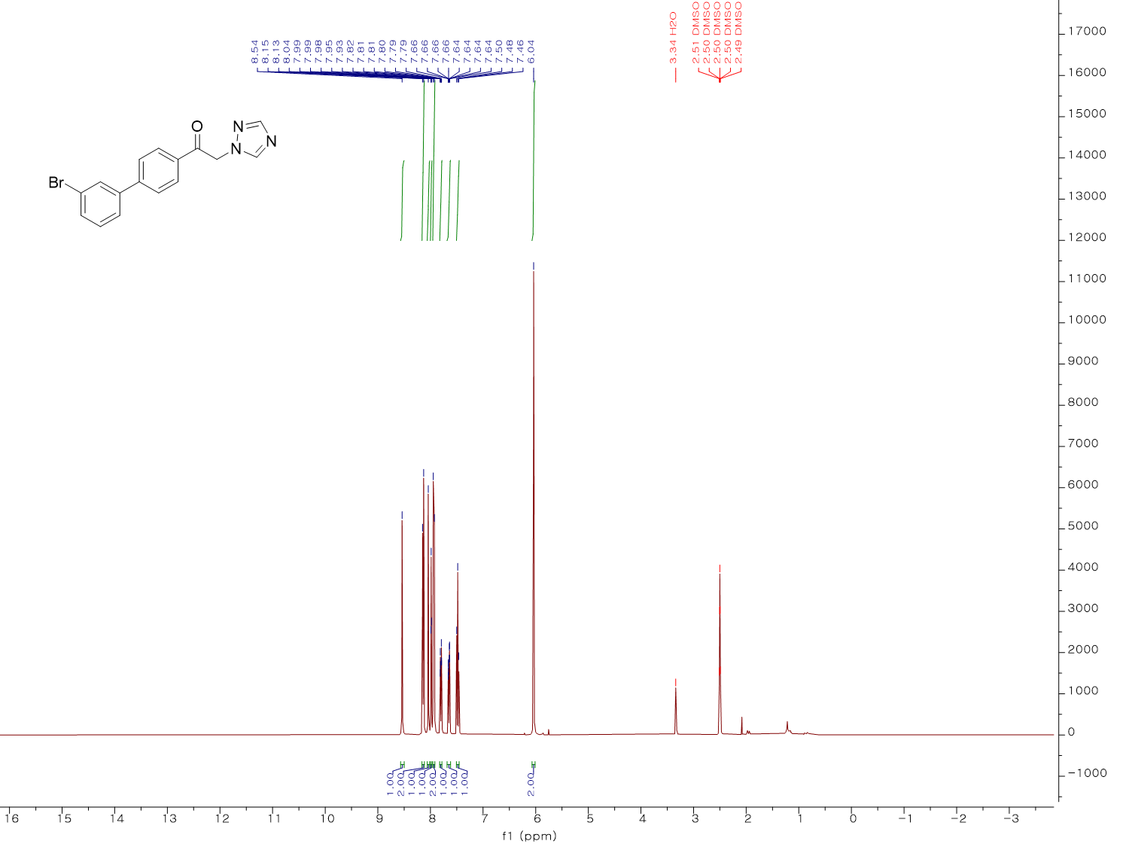
¹H NMR spectrum (400 MHz, DMSO-d₆) of 13
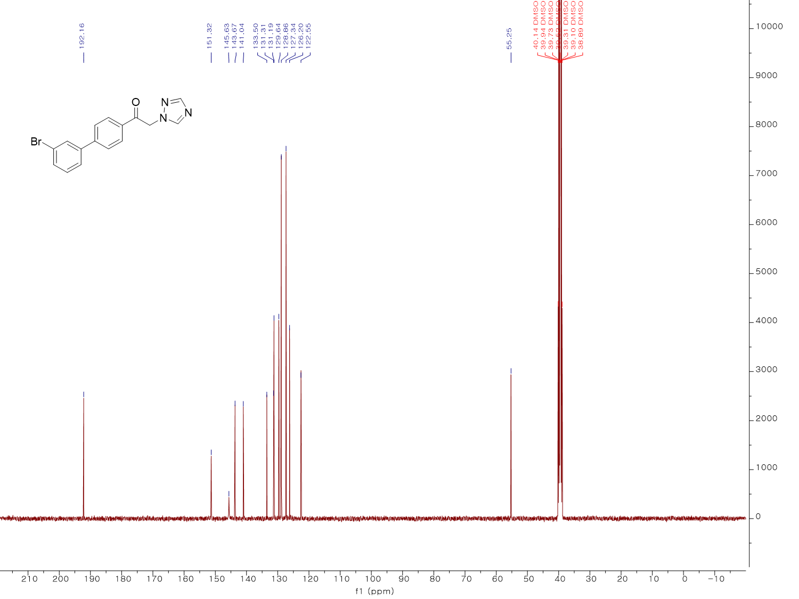
¹³C NMR spectrum (100 MHz, DMSO-d₆) of 13
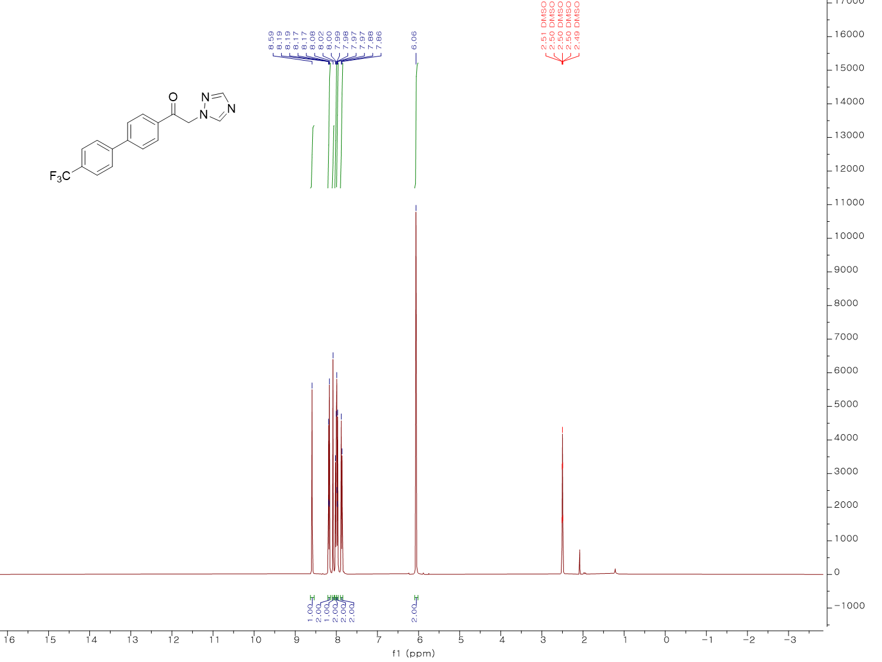
¹H NMR spectrum (400 MHz, DMSO-d₆) of 14
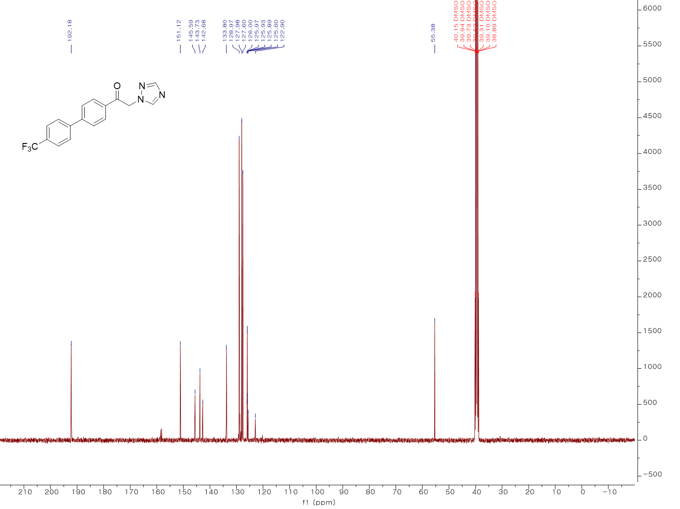
¹³C NMR spectrum (100 MHz, DMSO-d₆) of 14
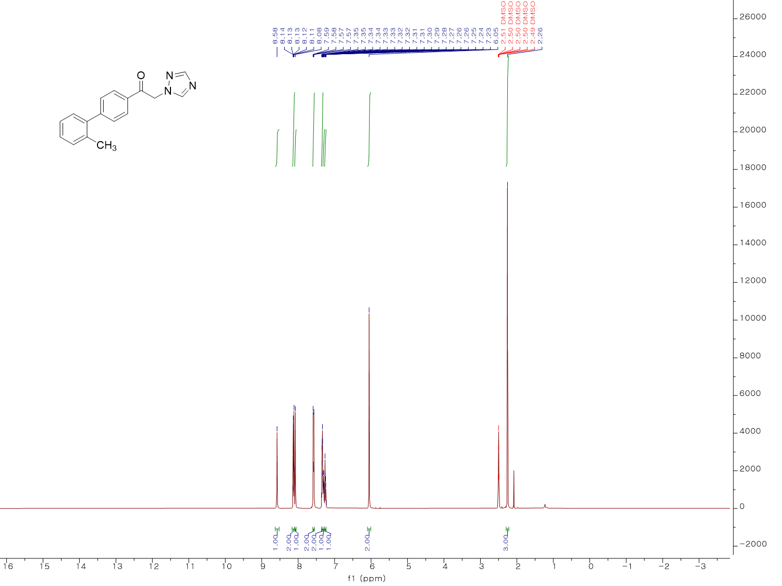
¹H NMR spectrum (400 MHz, DMSO-d₆) of 15
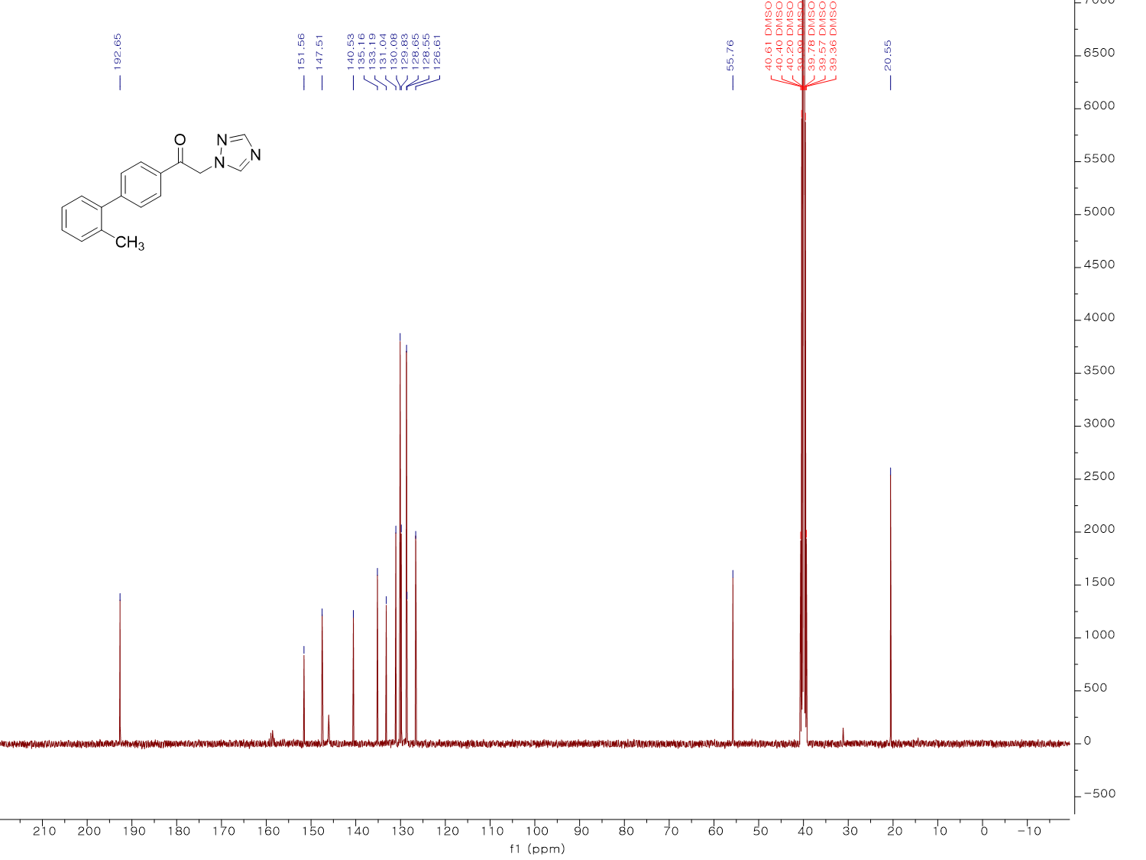
¹³C NMR spectrum (100 MHz, DMSO-d₆) of 15
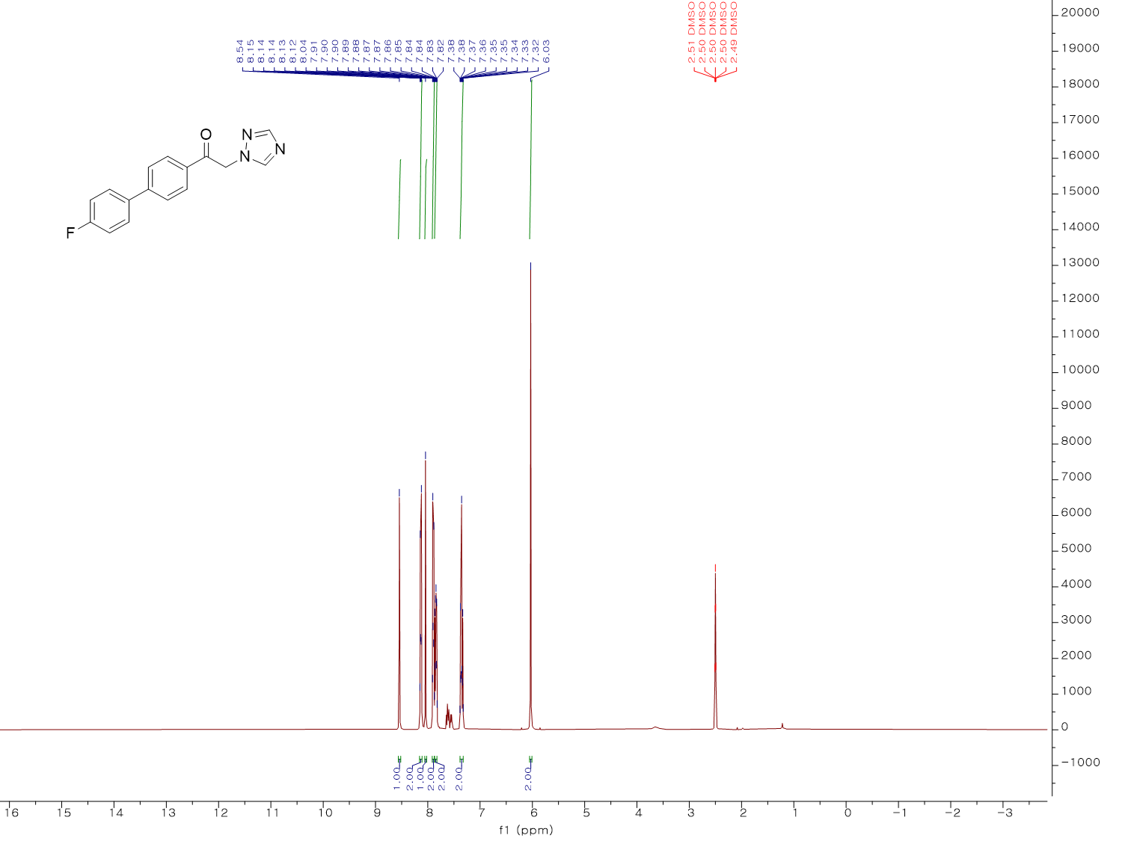
¹H NMR spectrum (400 MHz, DMSO-d₆) of 16
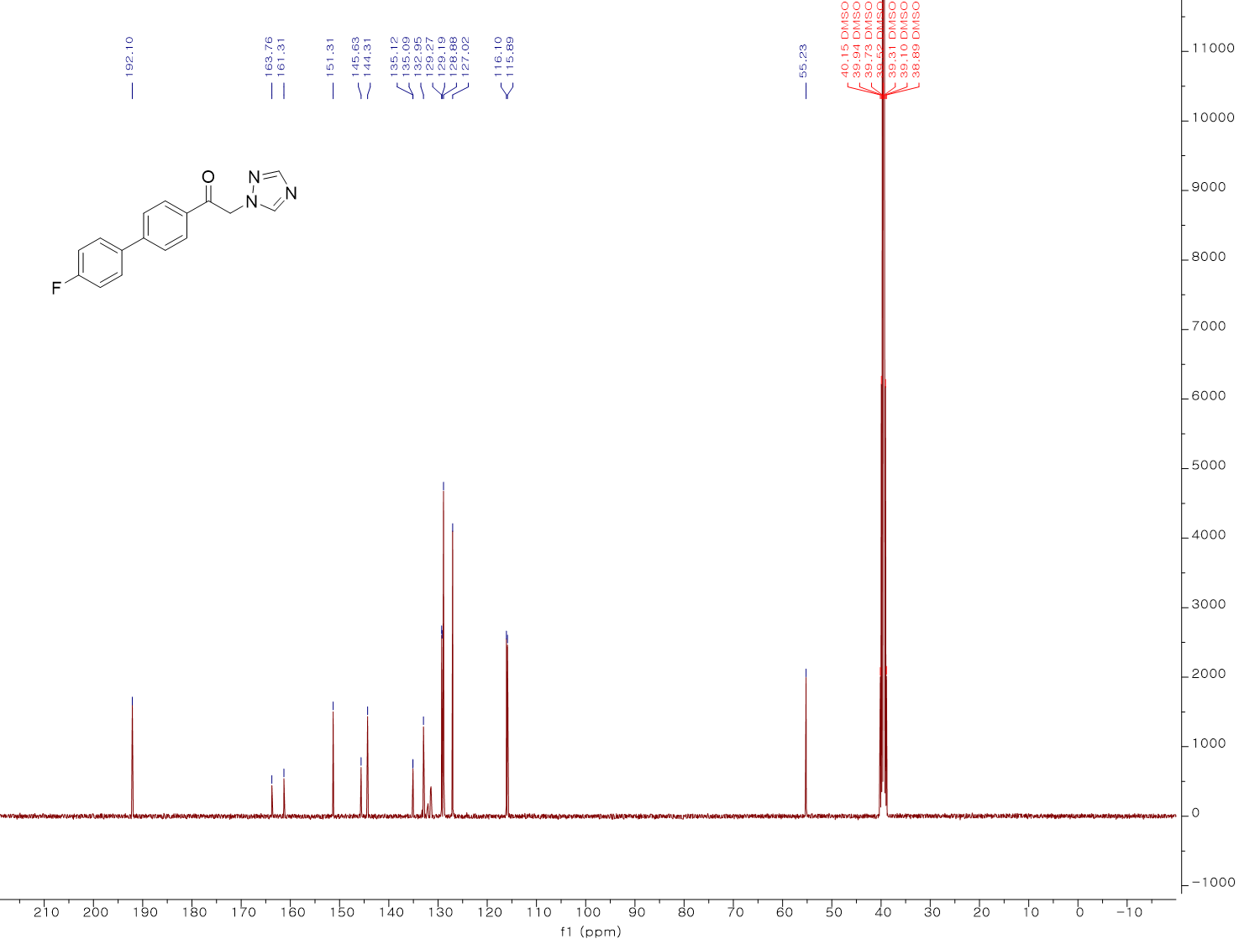
¹³C NMR spectrum (100 MHz, DMSO-d₆) of 16
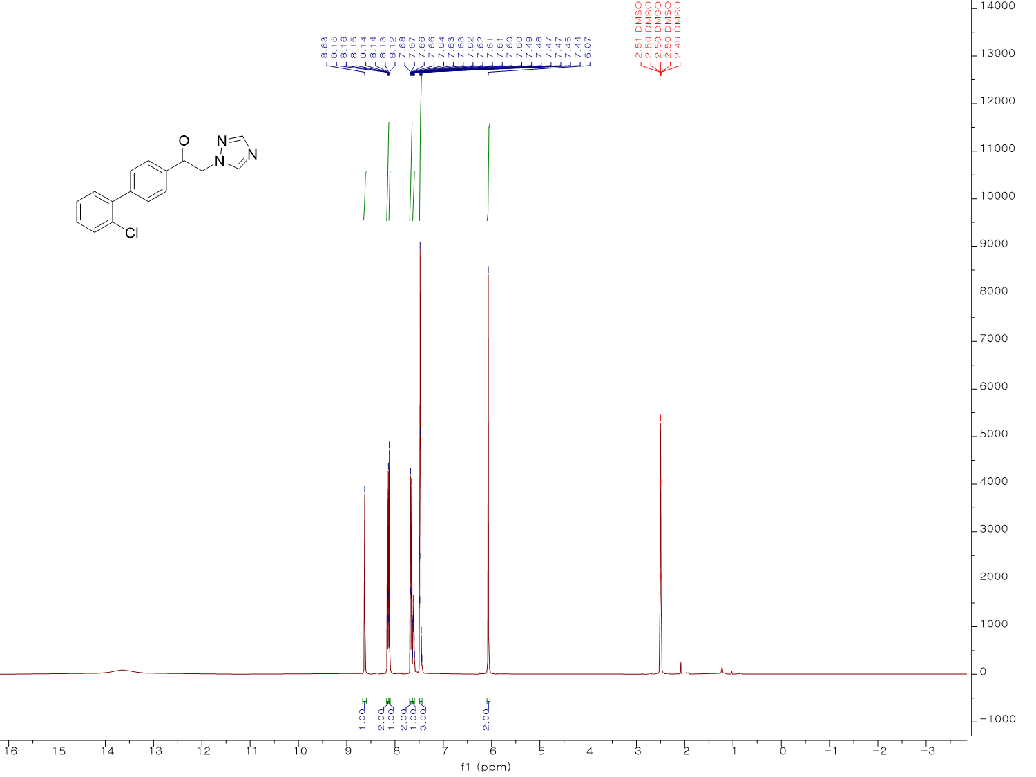
¹H NMR spectrum (400 MHz, DMSO-d₆) of 17
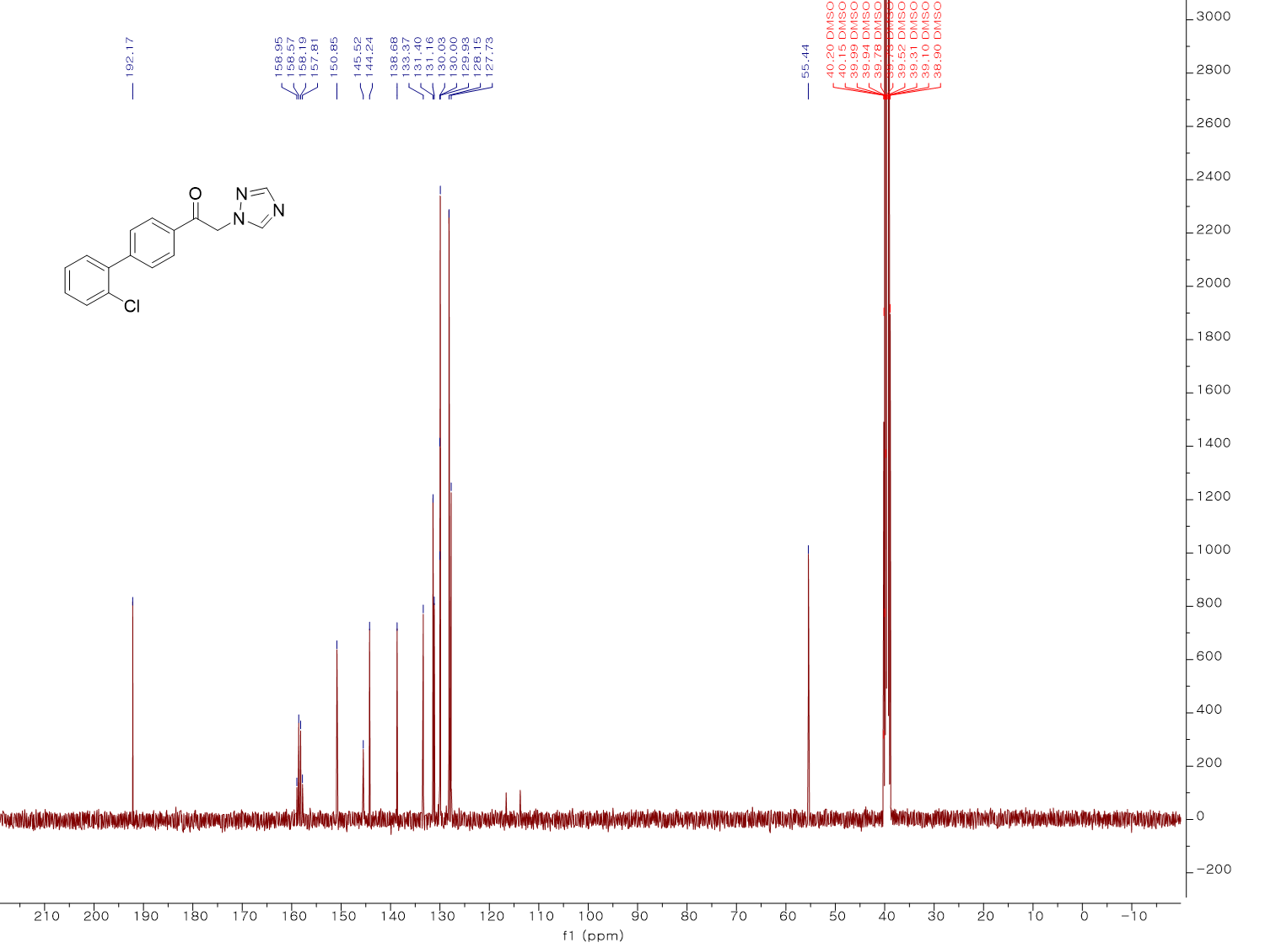
¹³C NMR spectrum (100 MHz, DMSO-d₆) of 17
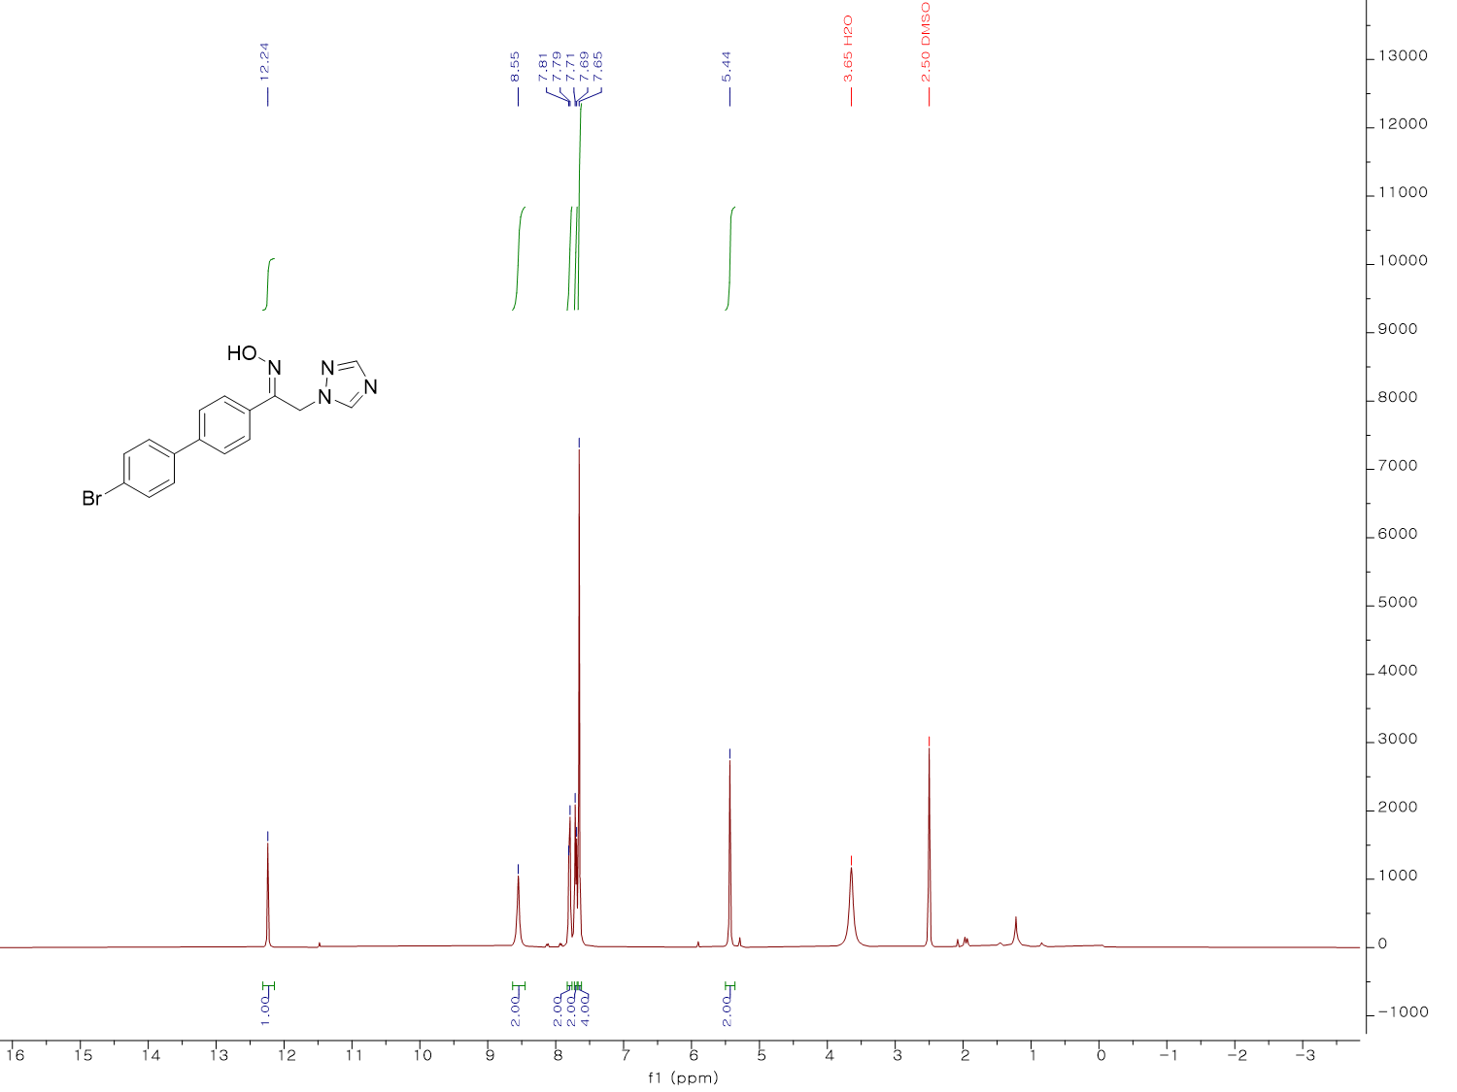
¹H NMR spectrum (400 MHz, DMSO-d₆) of KH01
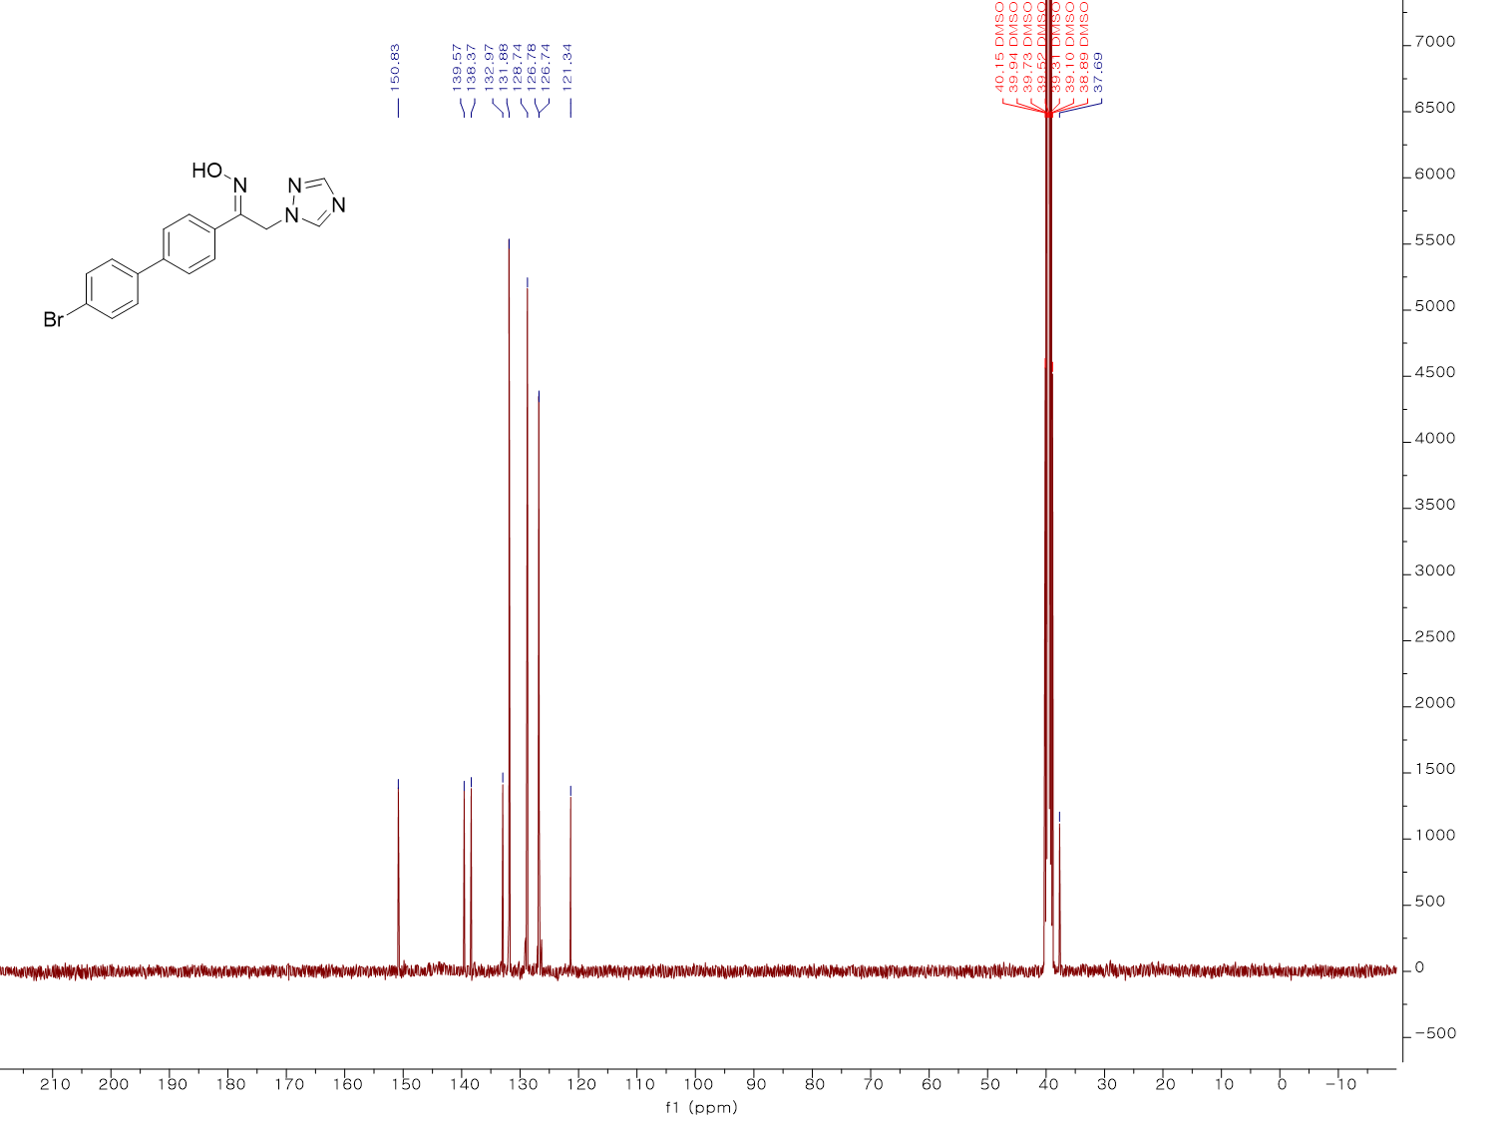
¹³C NMR spectrum (100 MHz, DMSO-d₆) of KH01
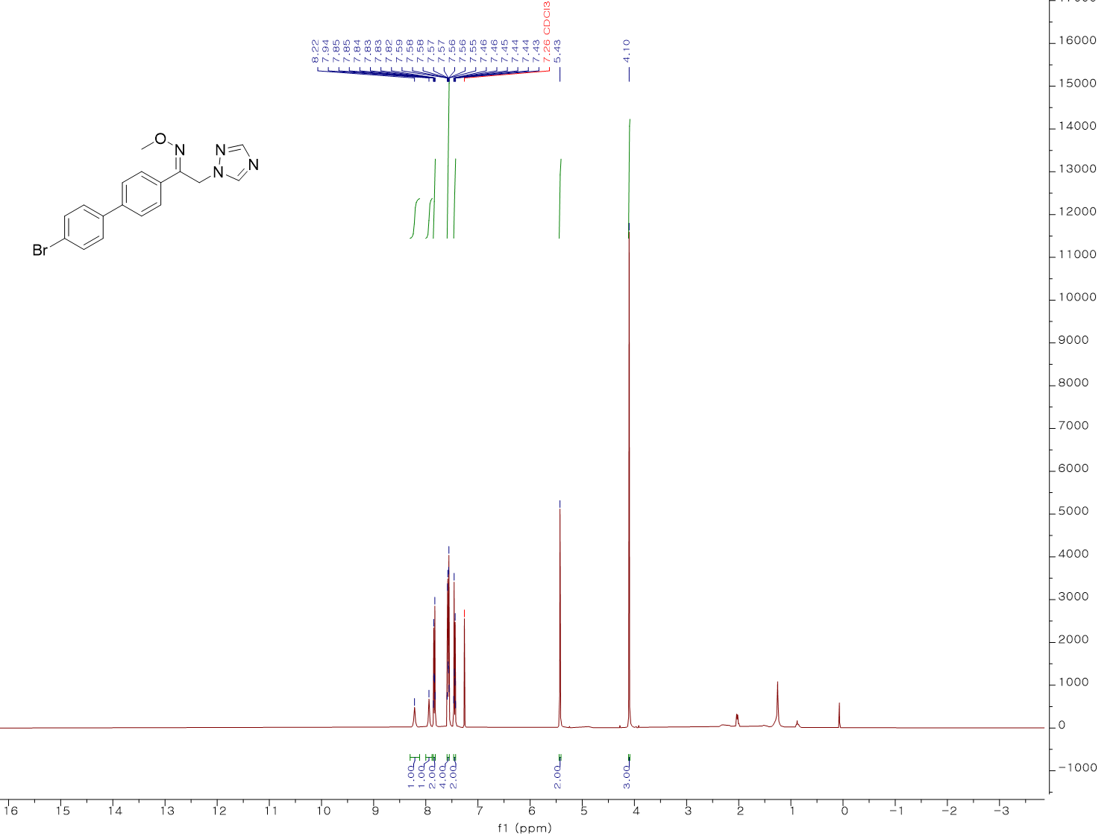
¹H NMR spectrum (400 MHz, CDCl₃) of KH02
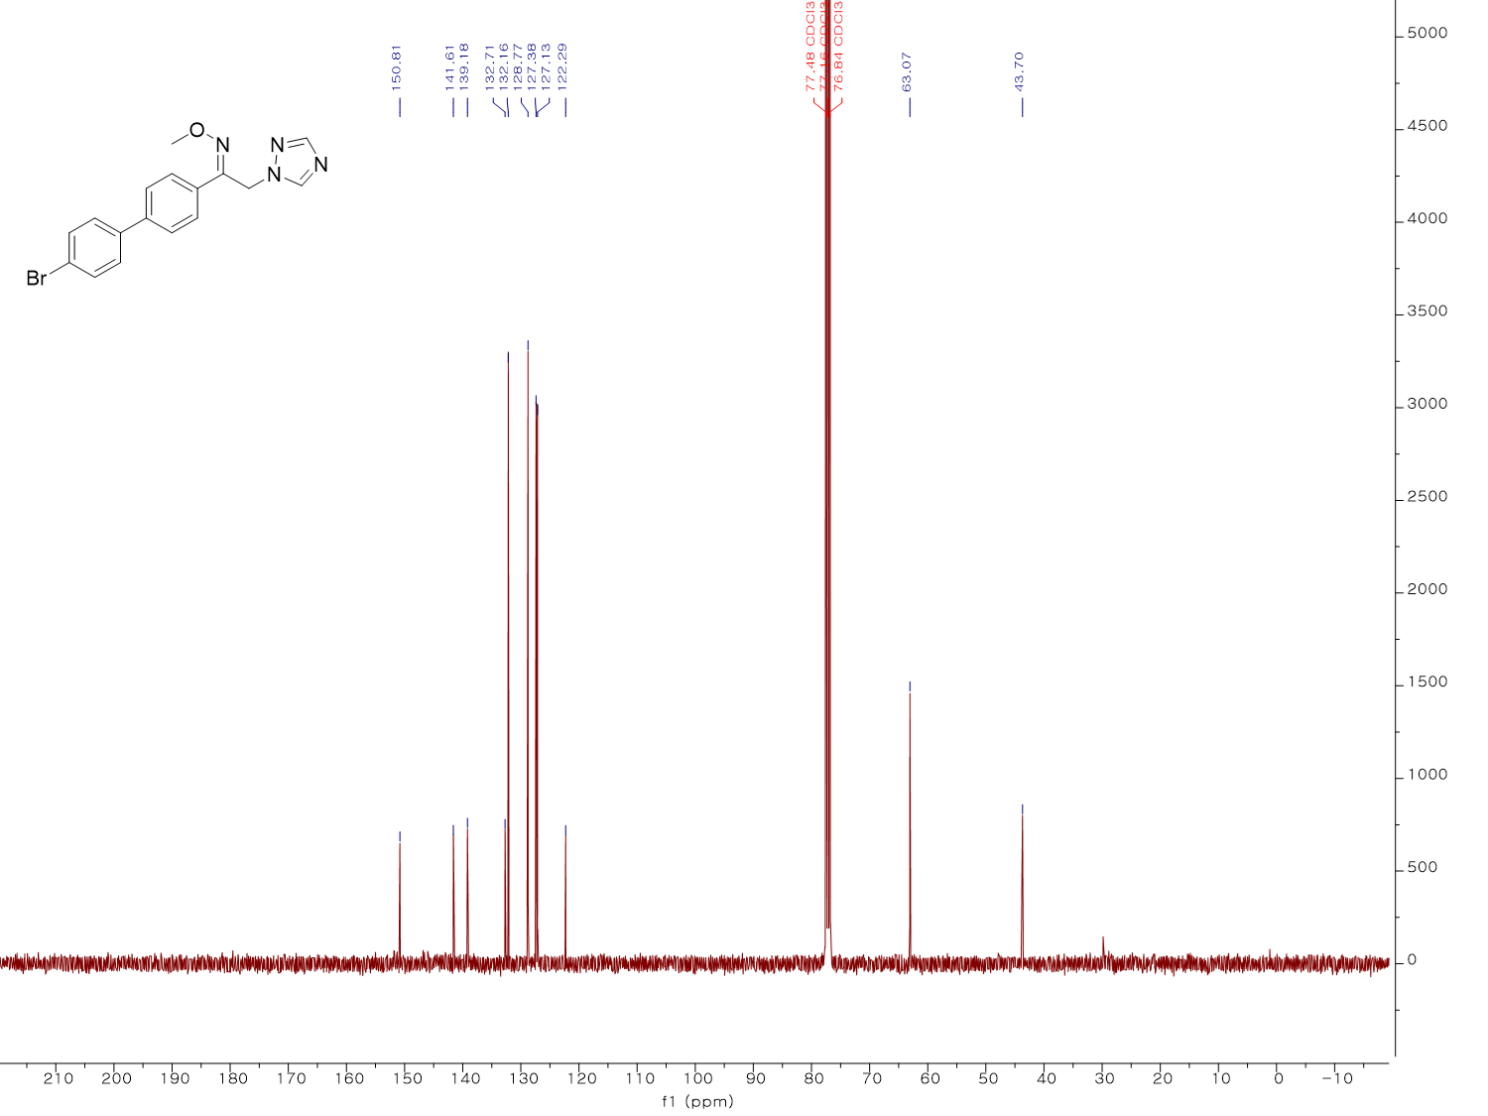
¹³C NMR spectrum (100 MHz, CDCl₃) of KH02
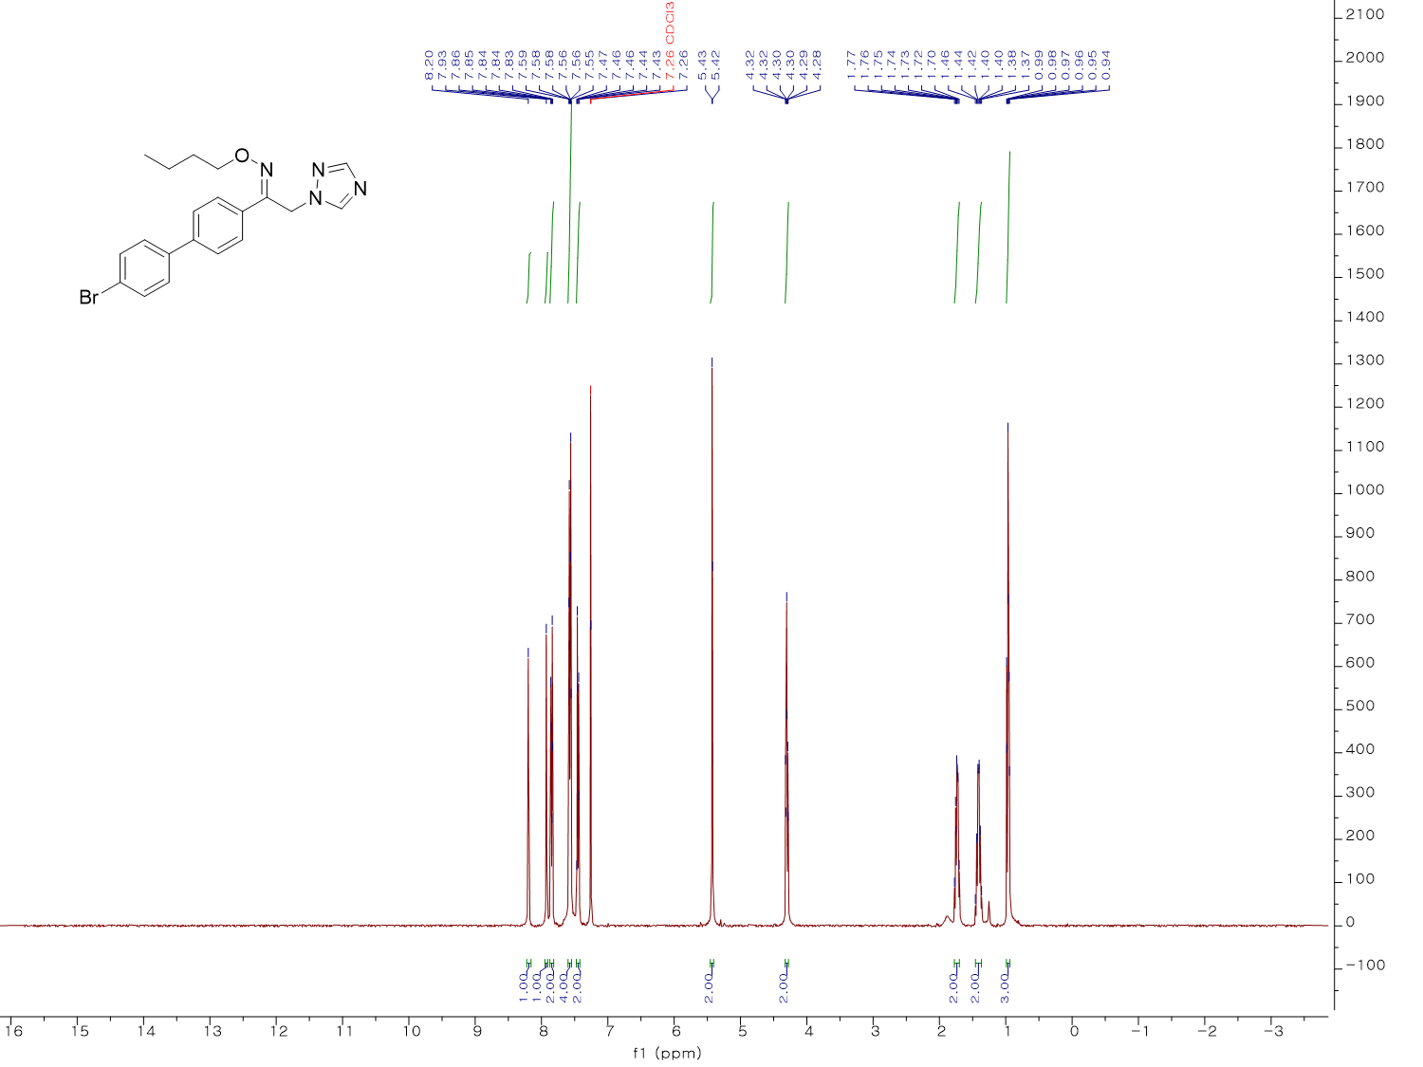
¹H NMR spectrum (400 MHz, CDCl₃) of KH03
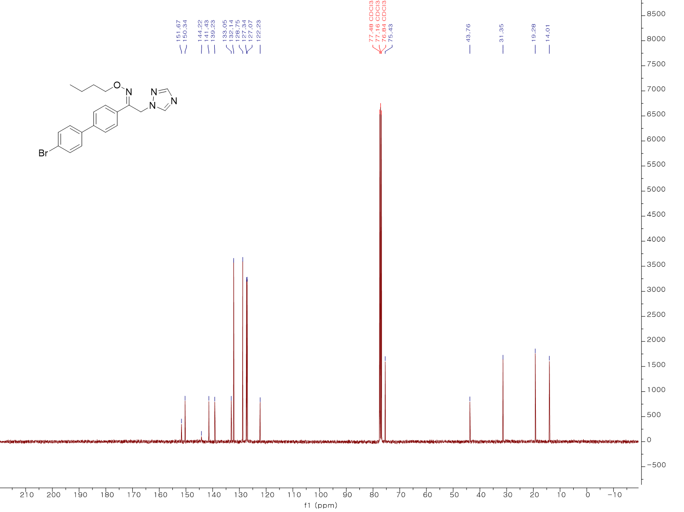
¹³C NMR spectrum (100 MHz, CDCl₃) of KH03
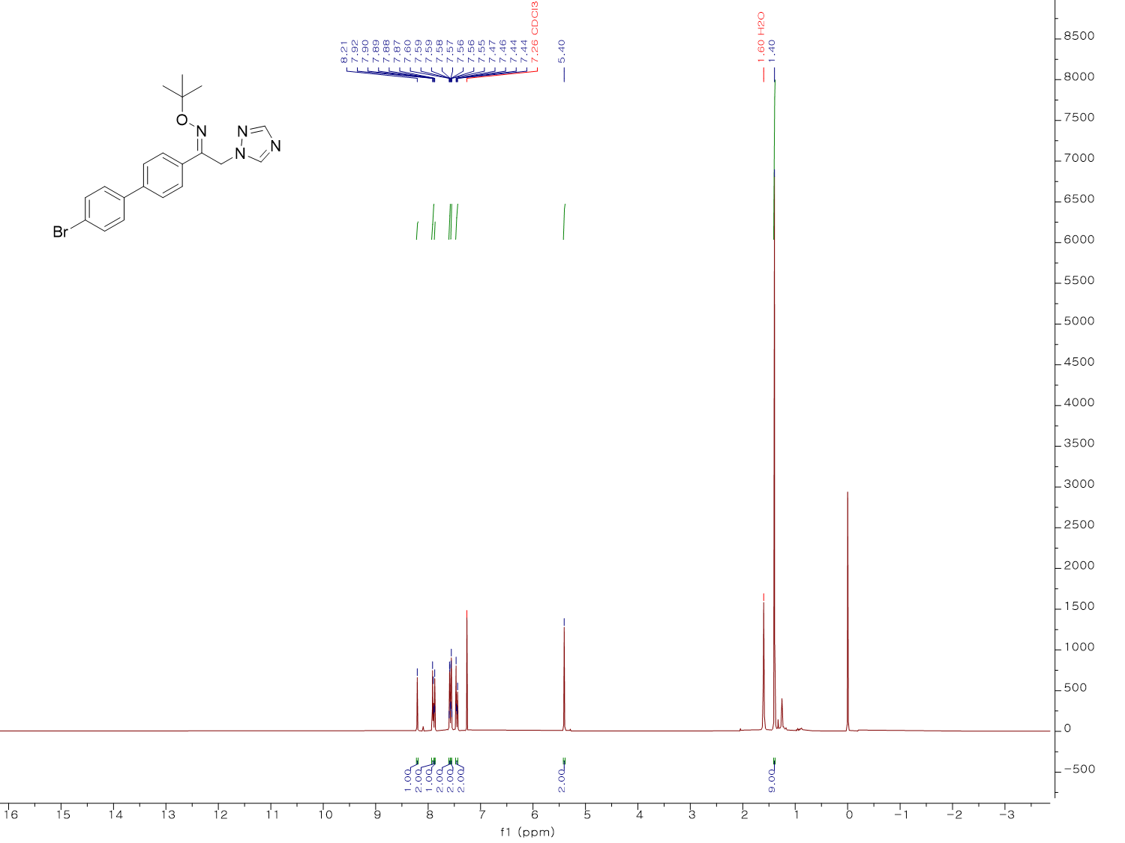
¹H NMR spectrum (400 MHz, CDCl₃) of KH04
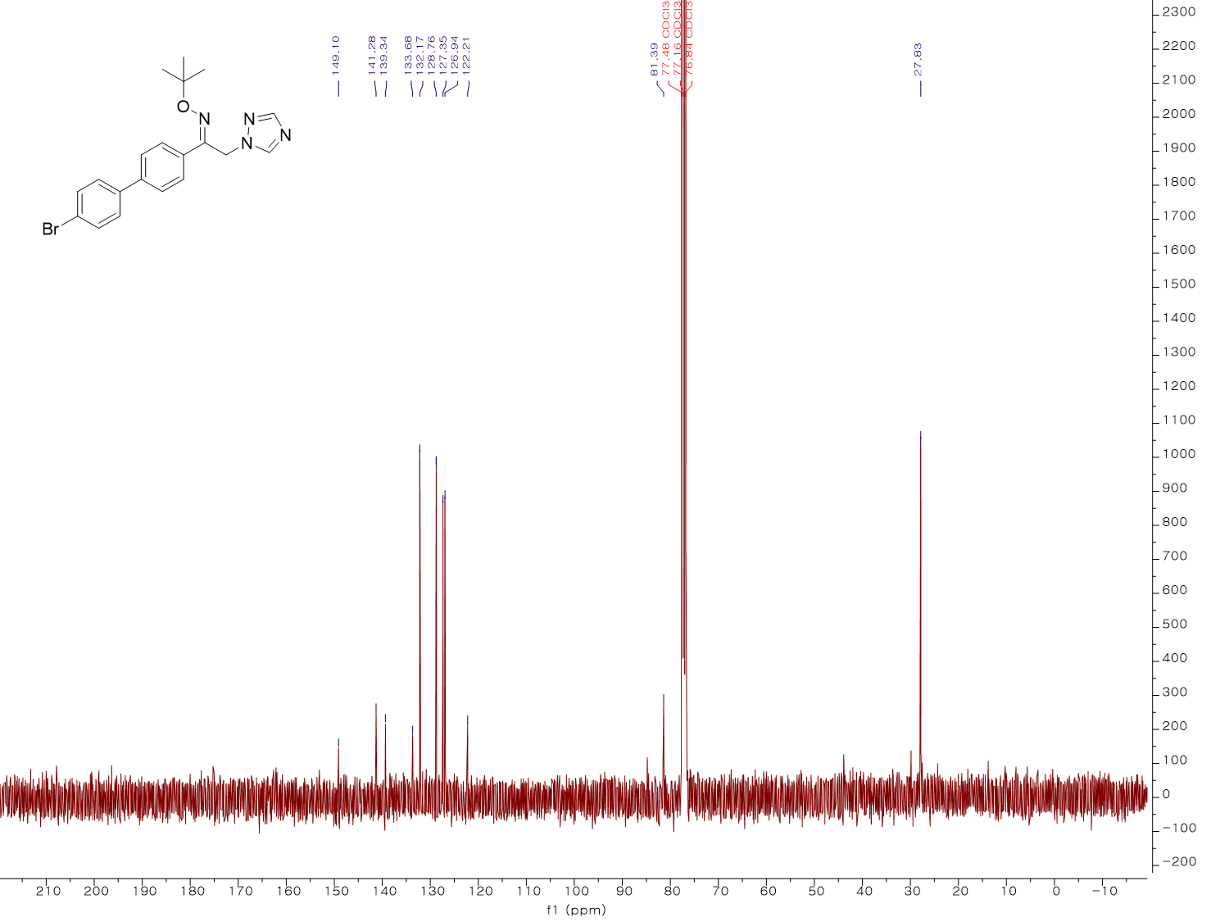
¹³C NMR spectrum (100 MHz, CDCl₃) of KH04
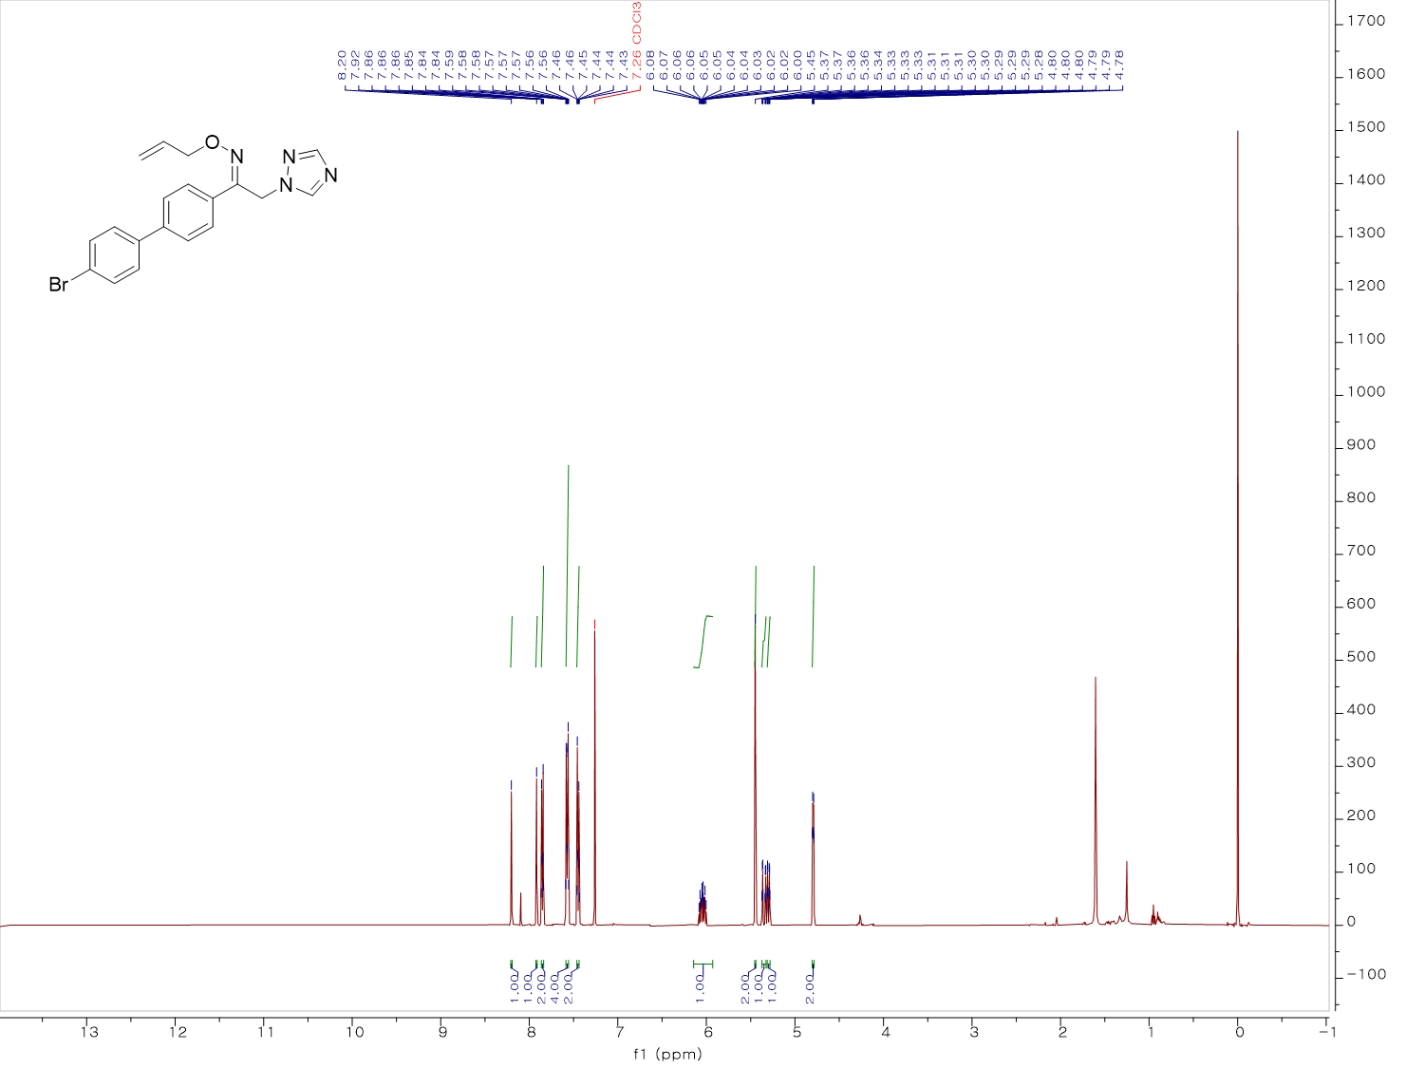
¹H NMR spectrum (500 MHz, CDCl₃) of KH05
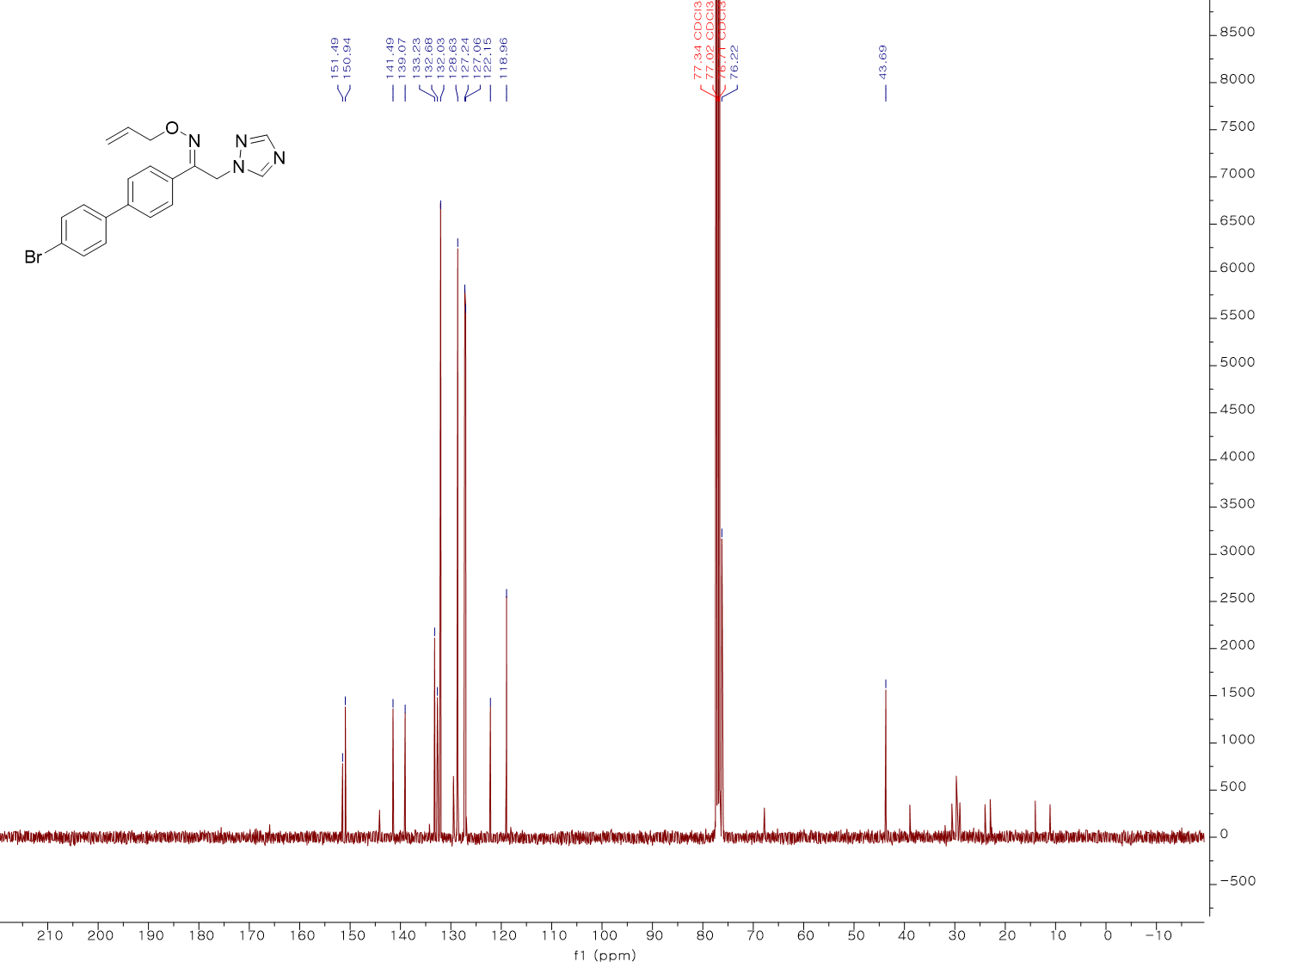
¹³C NMR spectrum (100 MHz, CDCl₃) of KH05
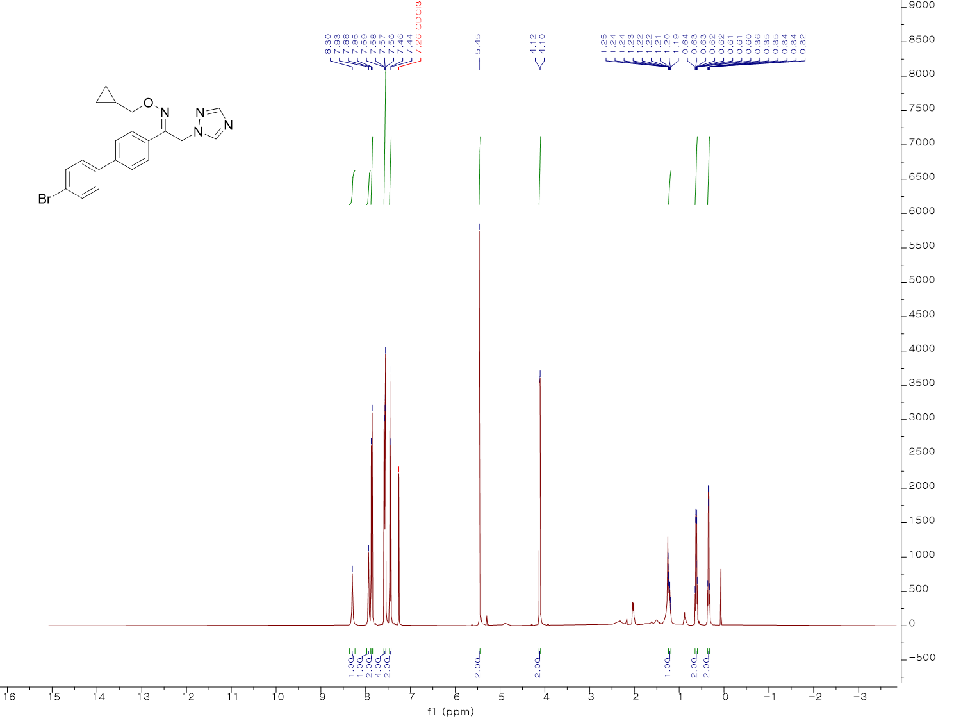
¹H NMR spectrum (400 MHz, CDCl₃) of KH06
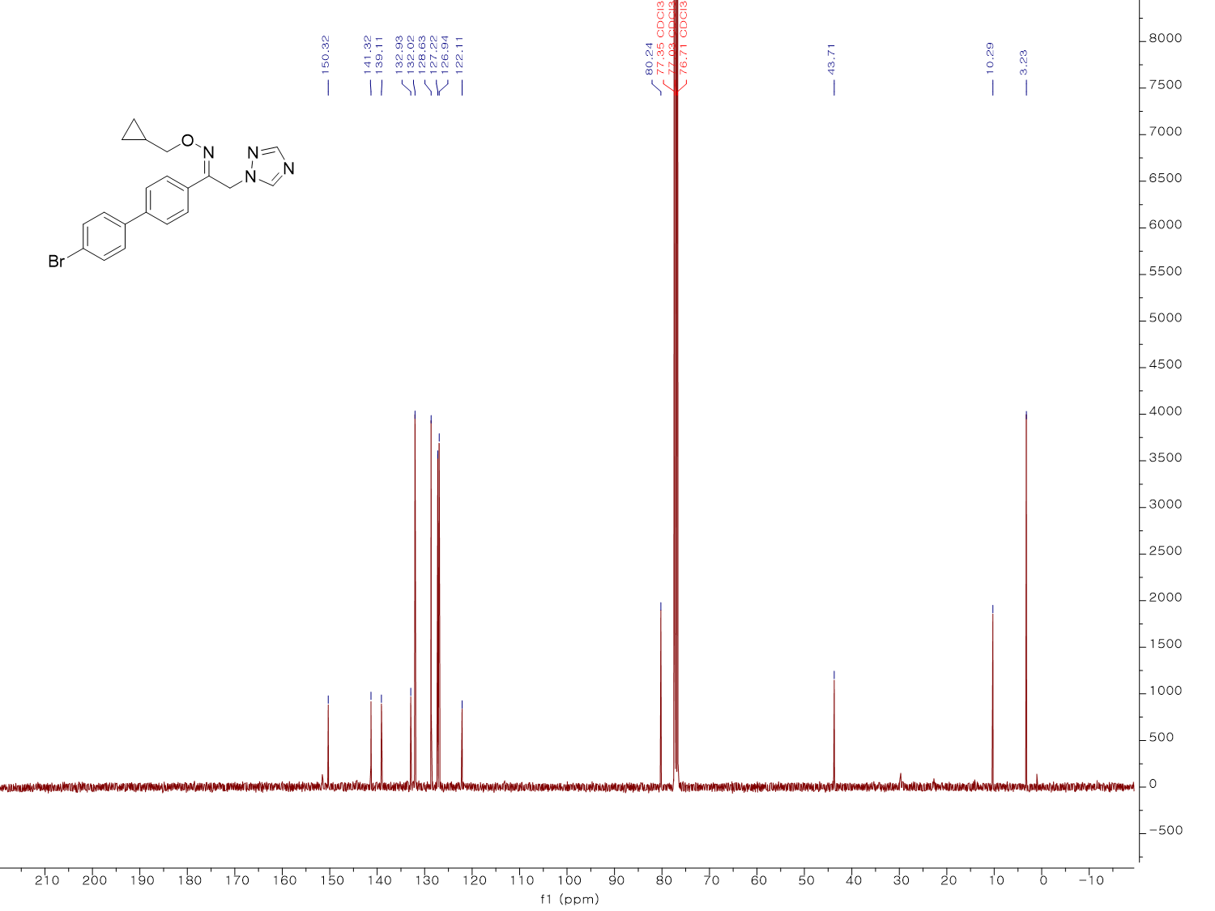
¹³C NMR spectrum (100 MHz, CDCl₃) of KH06
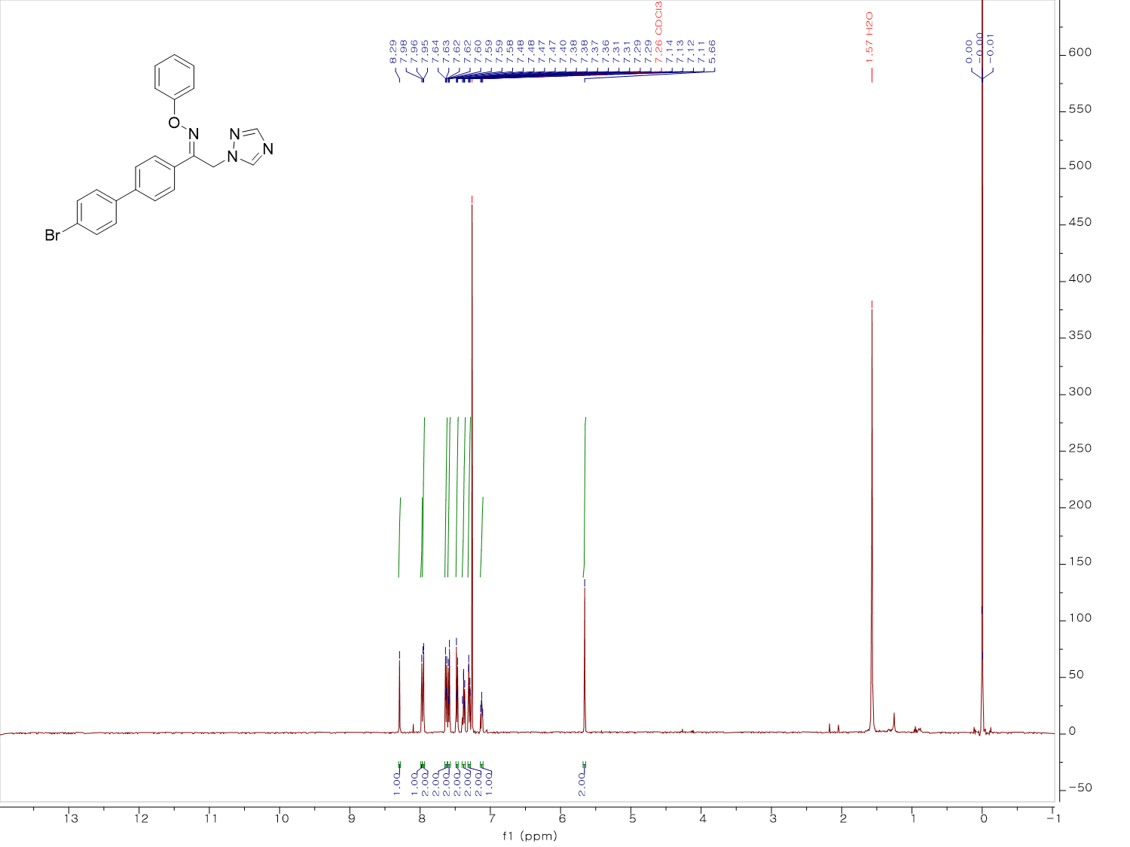
¹H NMR spectrum (500 MHz, CDCl₃) of KH07
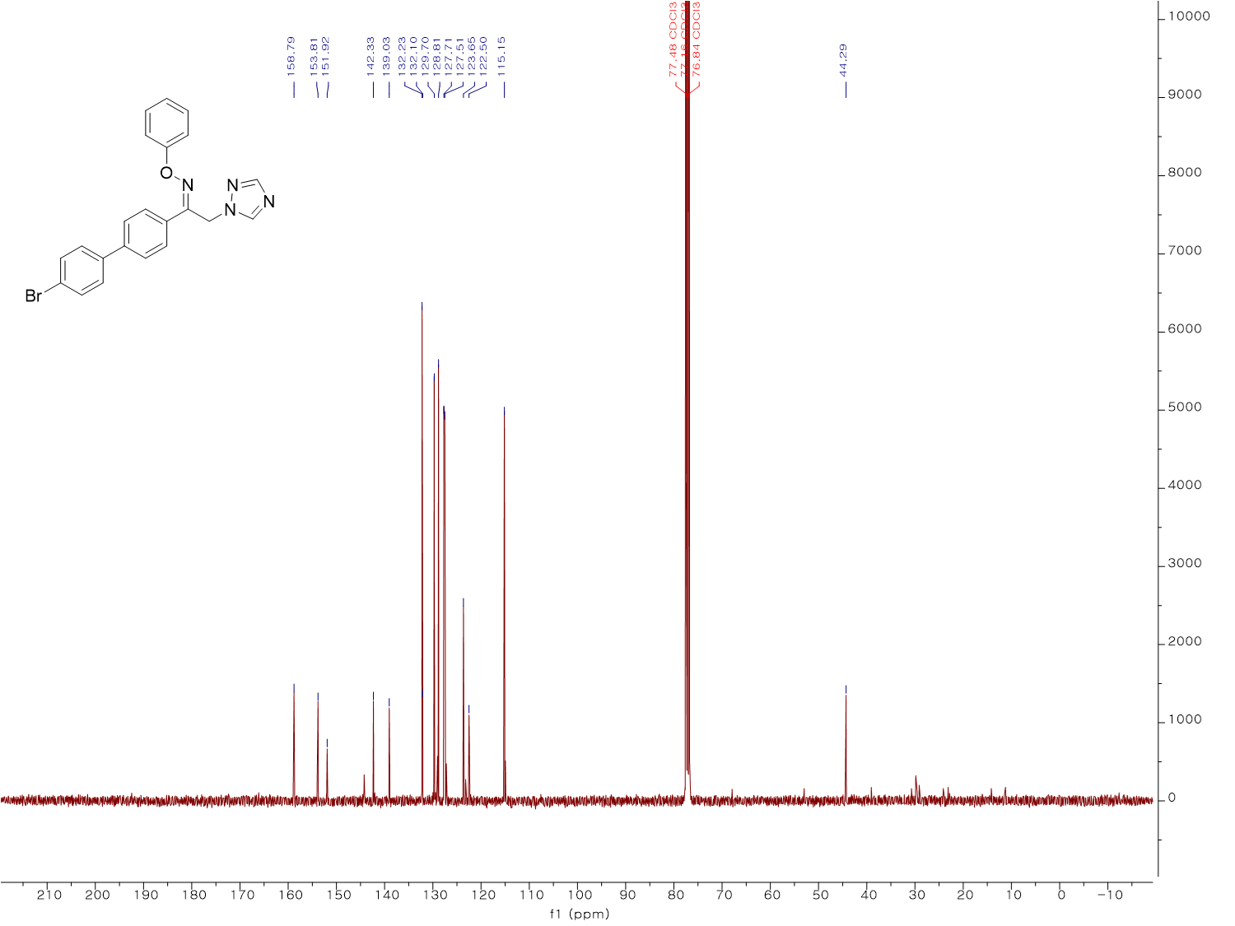
¹³C NMR spectrum (100 MHz, CDCl₃) of KH07
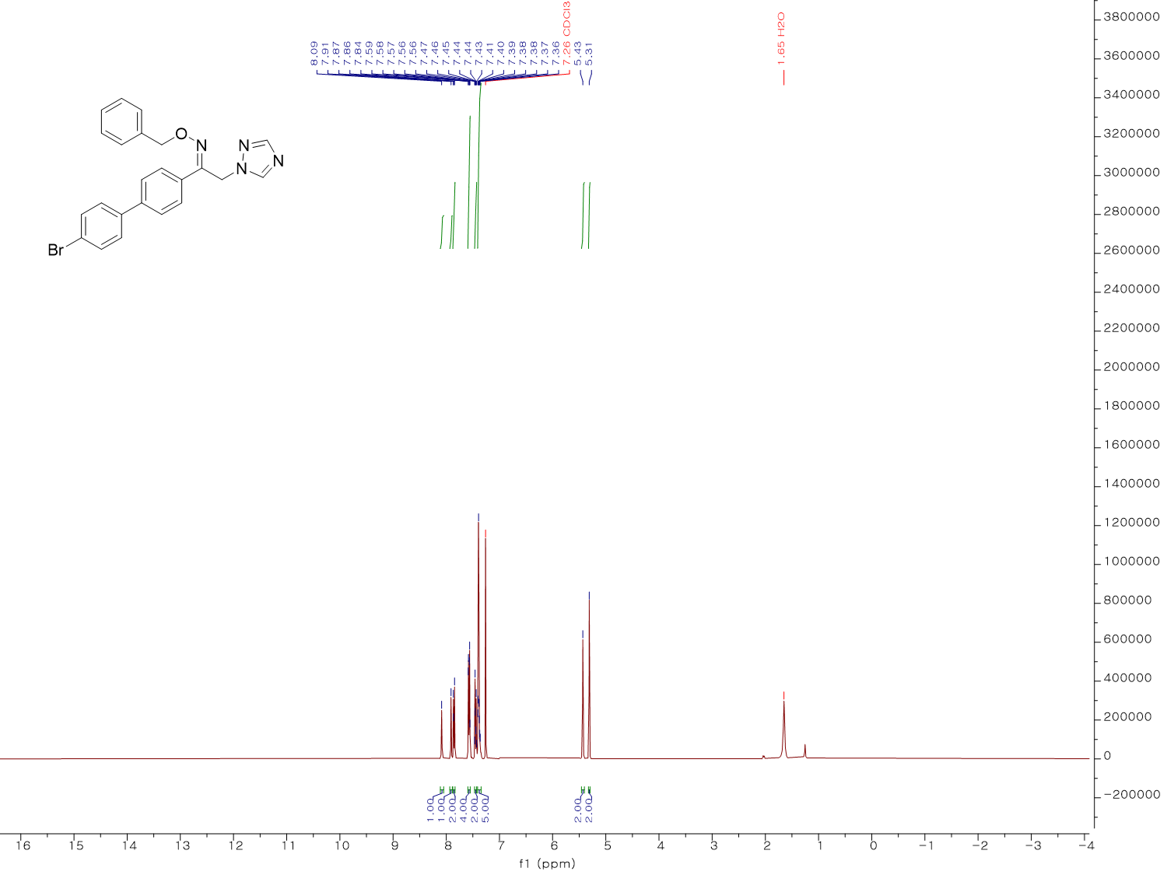
¹H NMR spectrum (400 MHz, CDCl₃) of KH08
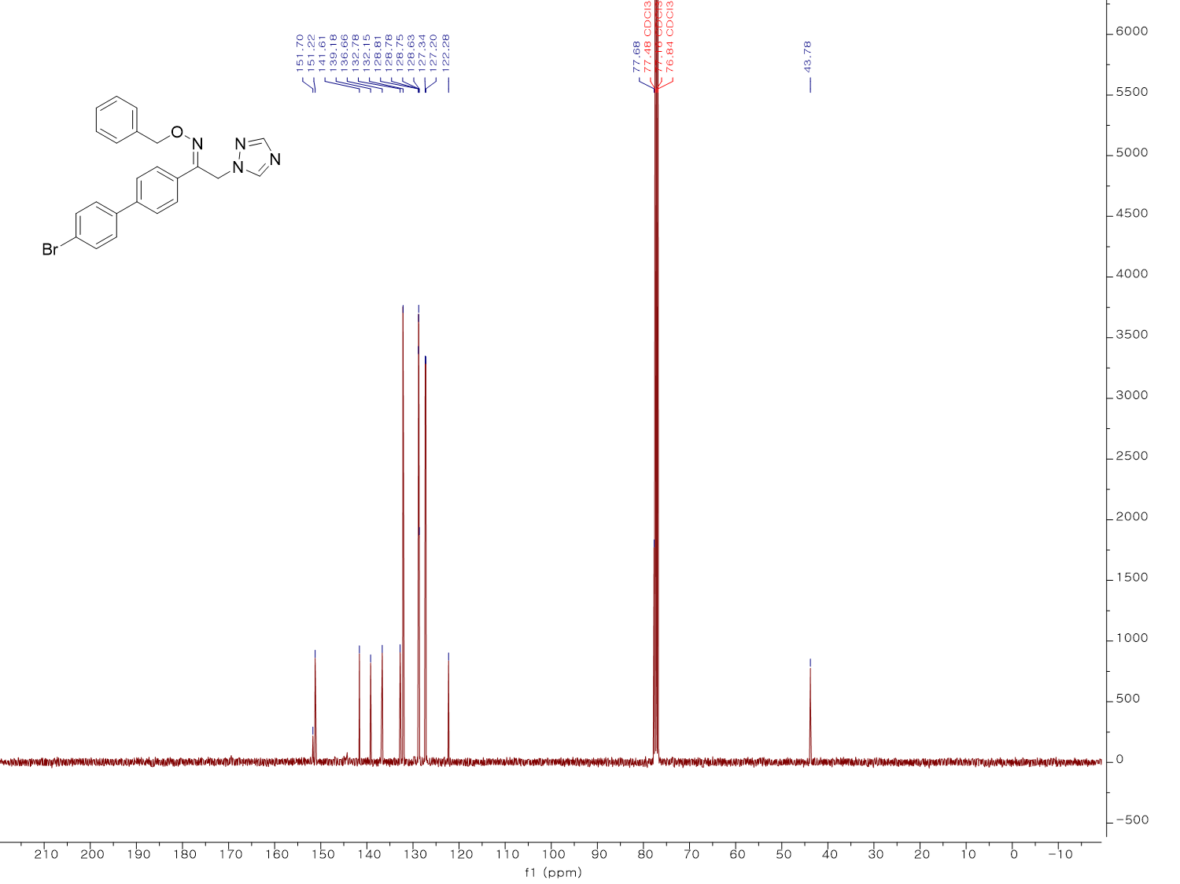
¹³C NMR spectrum (100 MHz, CDCl₃) of KH08
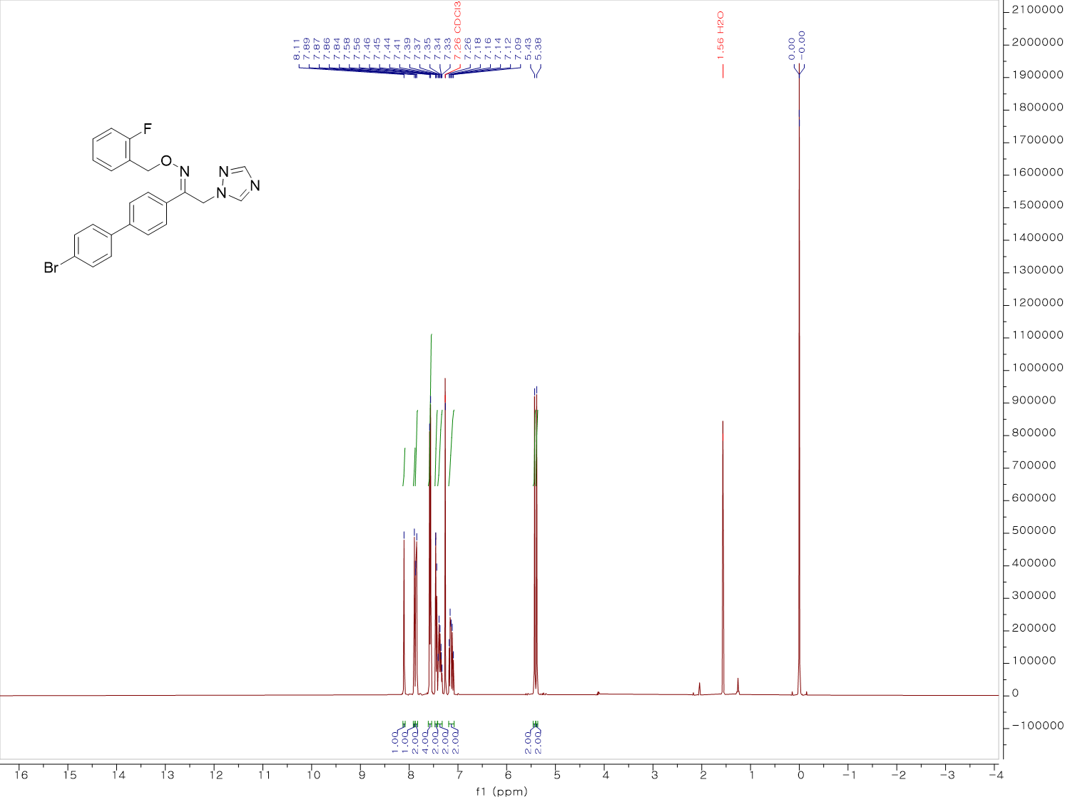
¹H NMR spectrum (400 MHz, CDCl₃) of KH09
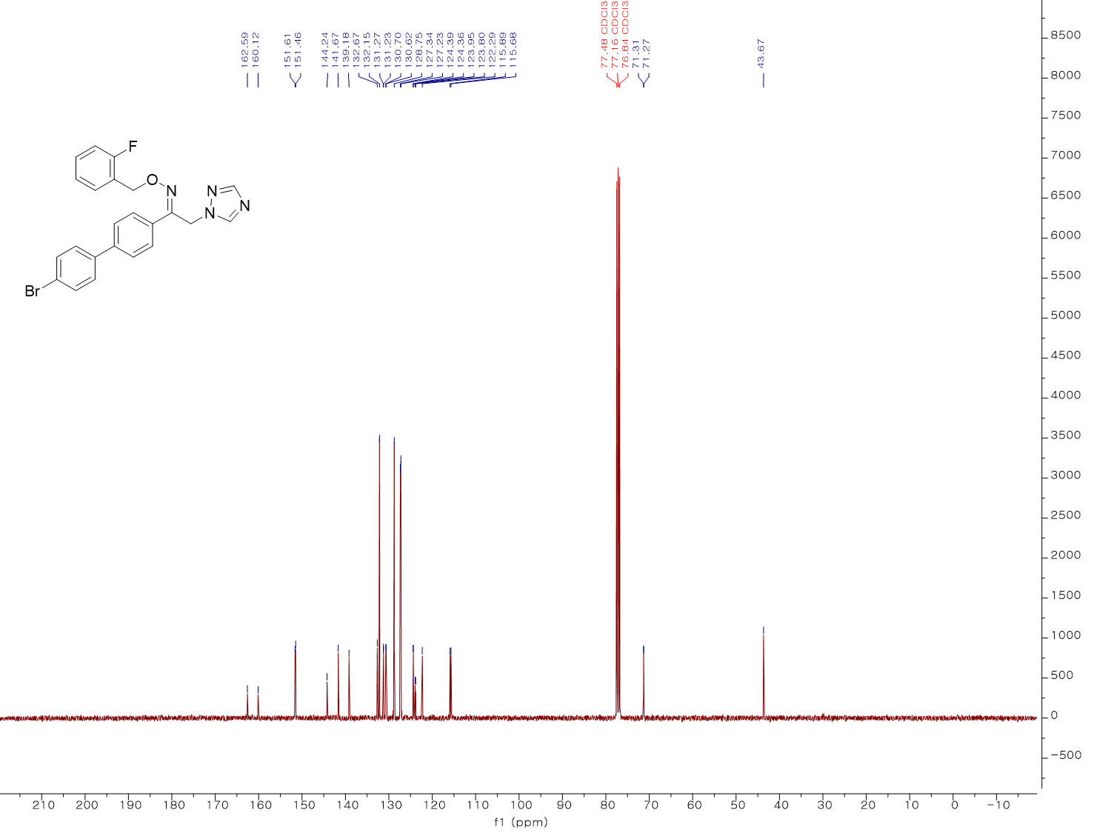
¹³C NMR spectrum (100 MHz, CDCl₃) of KH09
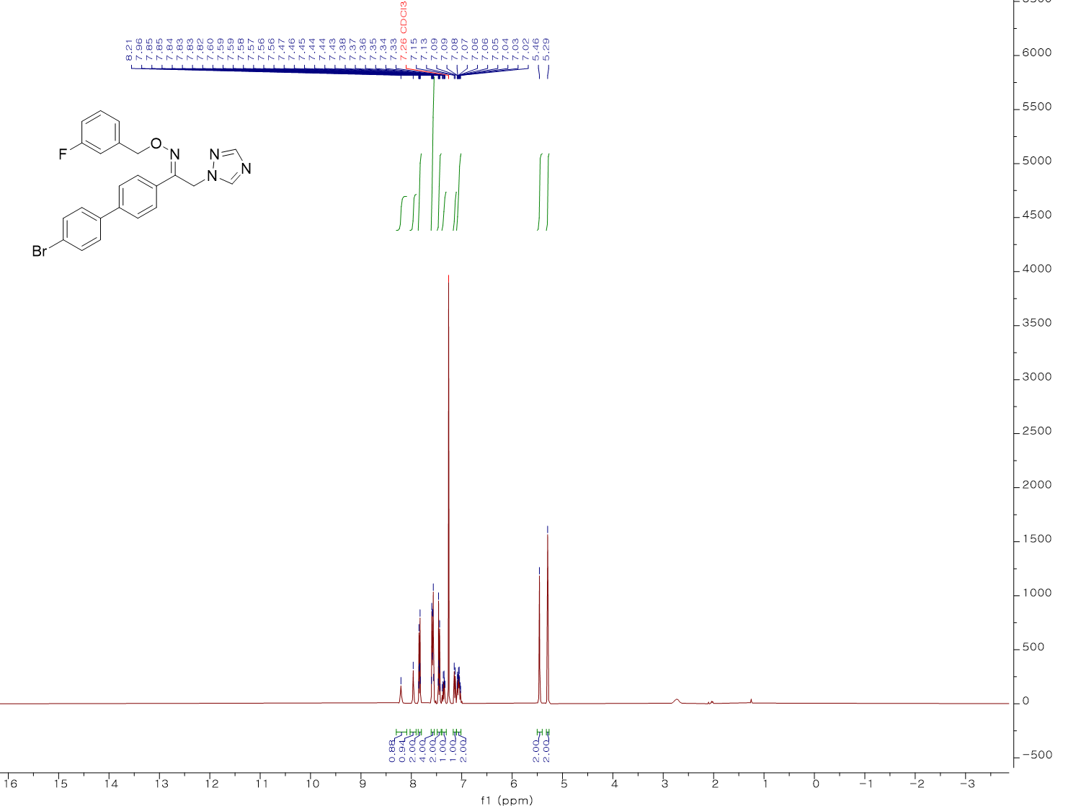
¹H NMR spectrum (400 MHz, CDCl₃) of KH10
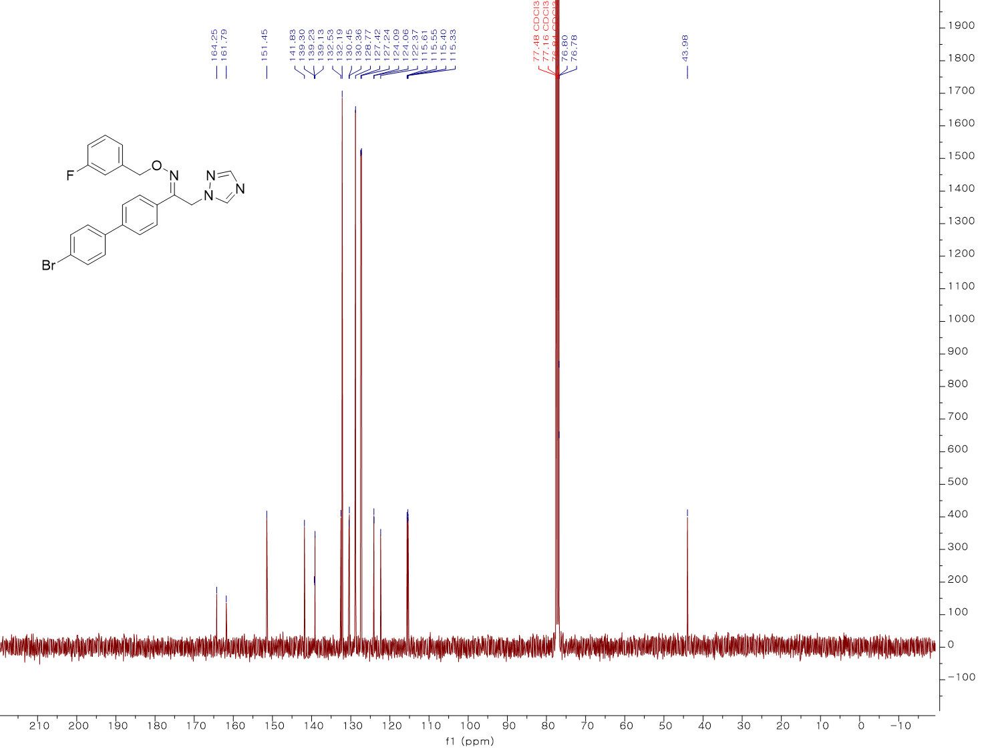
¹³C NMR spectrum (100 MHz, CDCl₃) of KH10
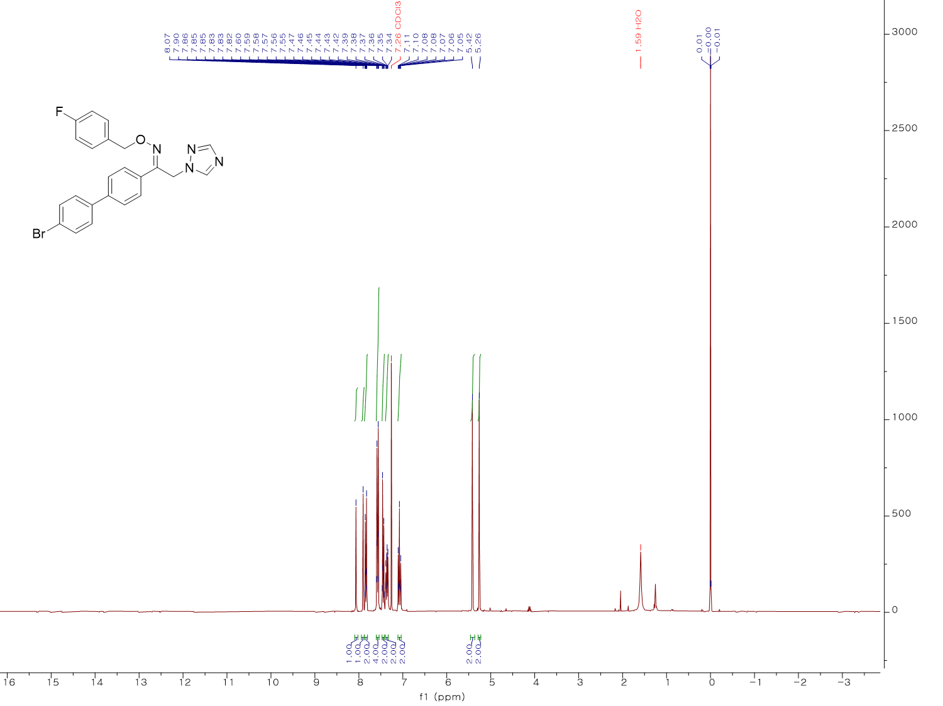
¹H NMR spectrum (300 MHz, CDCl₃) of KH11
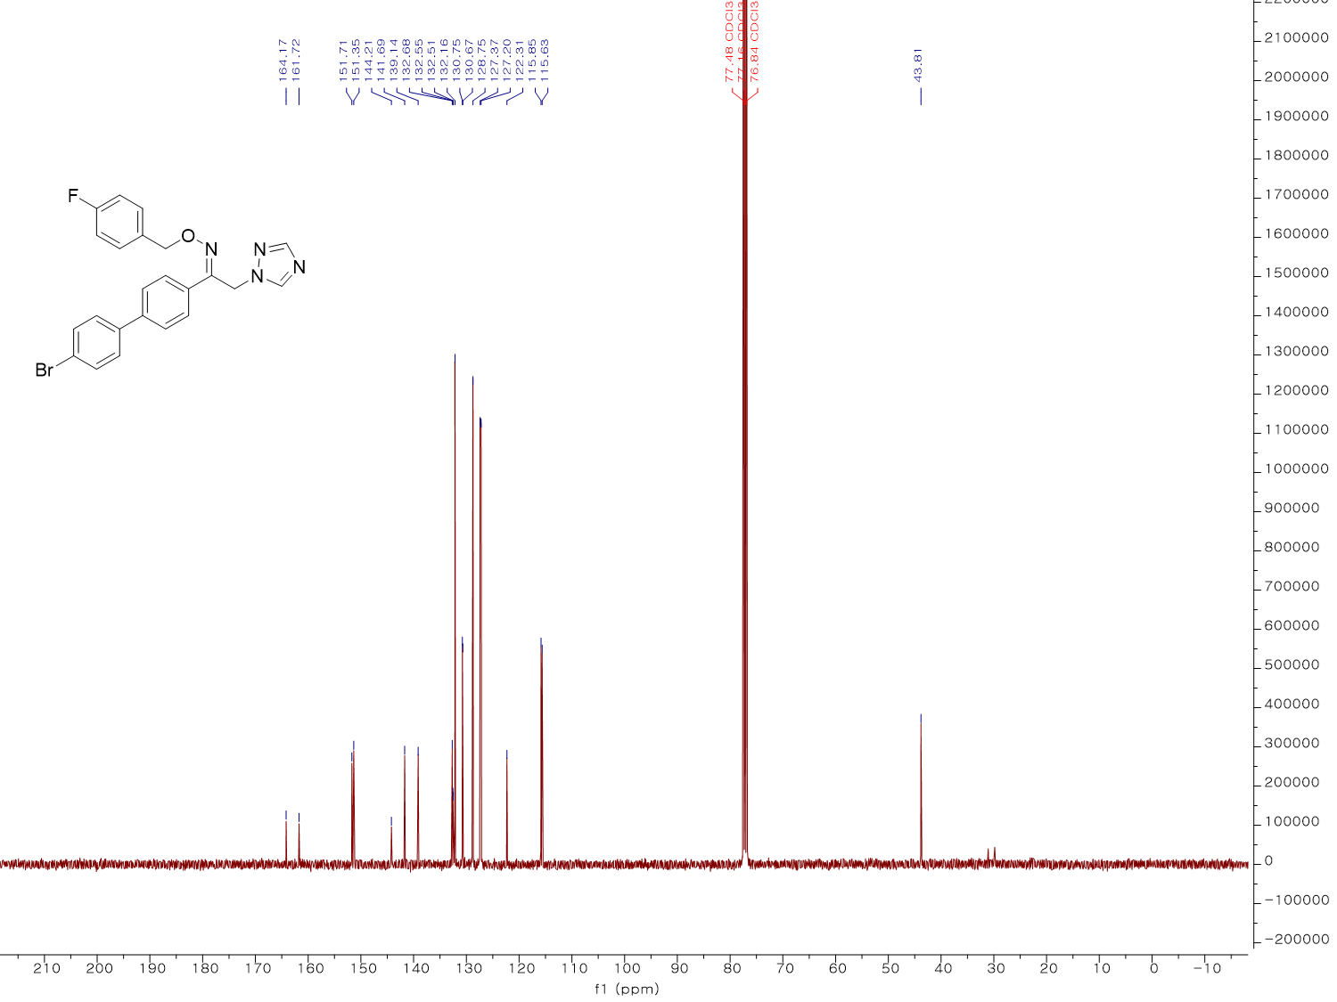
¹³C NMR spectrum (100 MHz, CDCl₃) of KH11
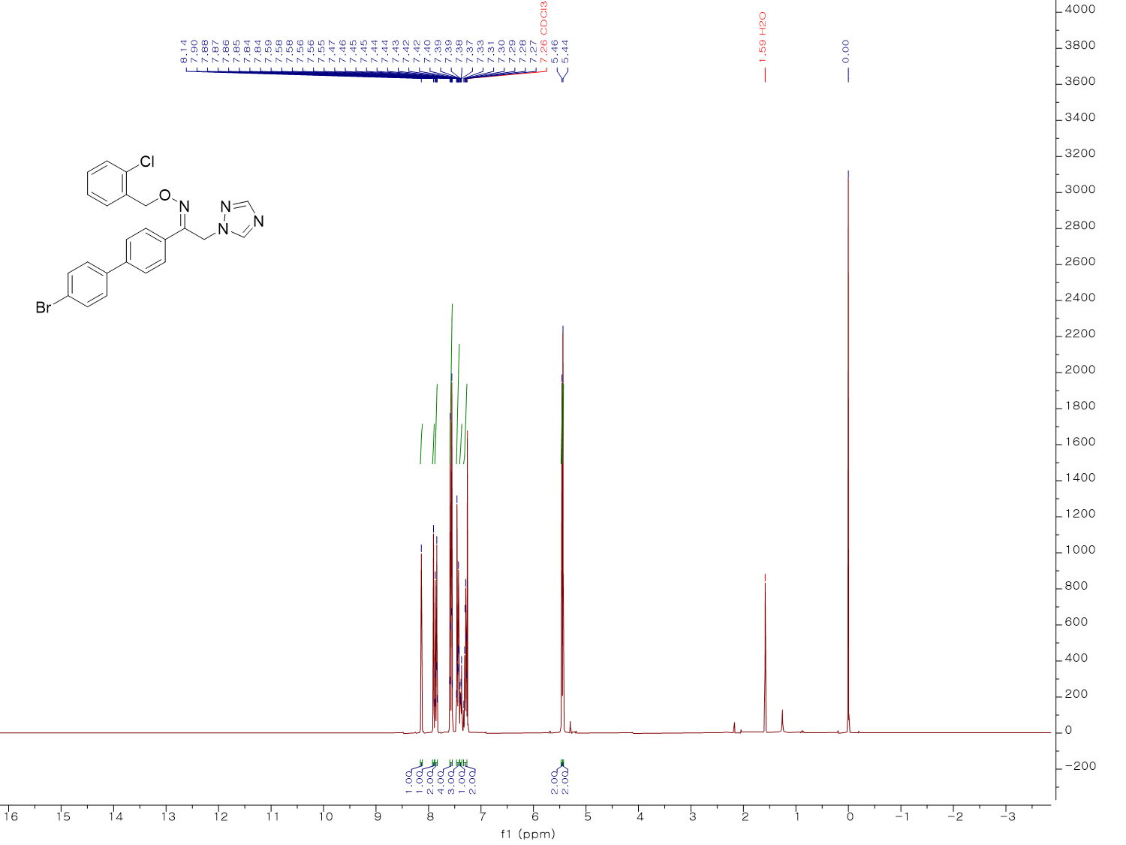
¹H NMR spectrum (300 MHz, CDCl₃) of KH12
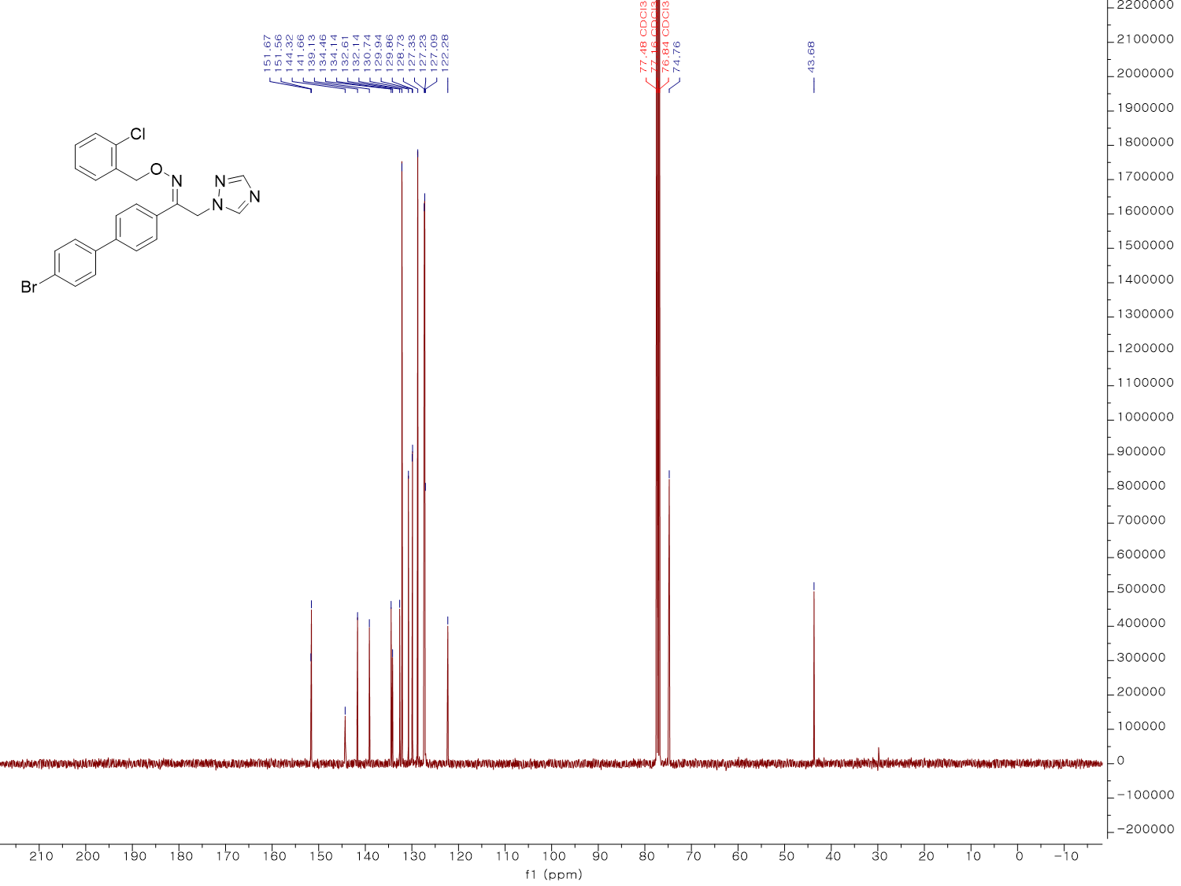
¹³C NMR spectrum (100 MHz, CDCl₃) of KH12
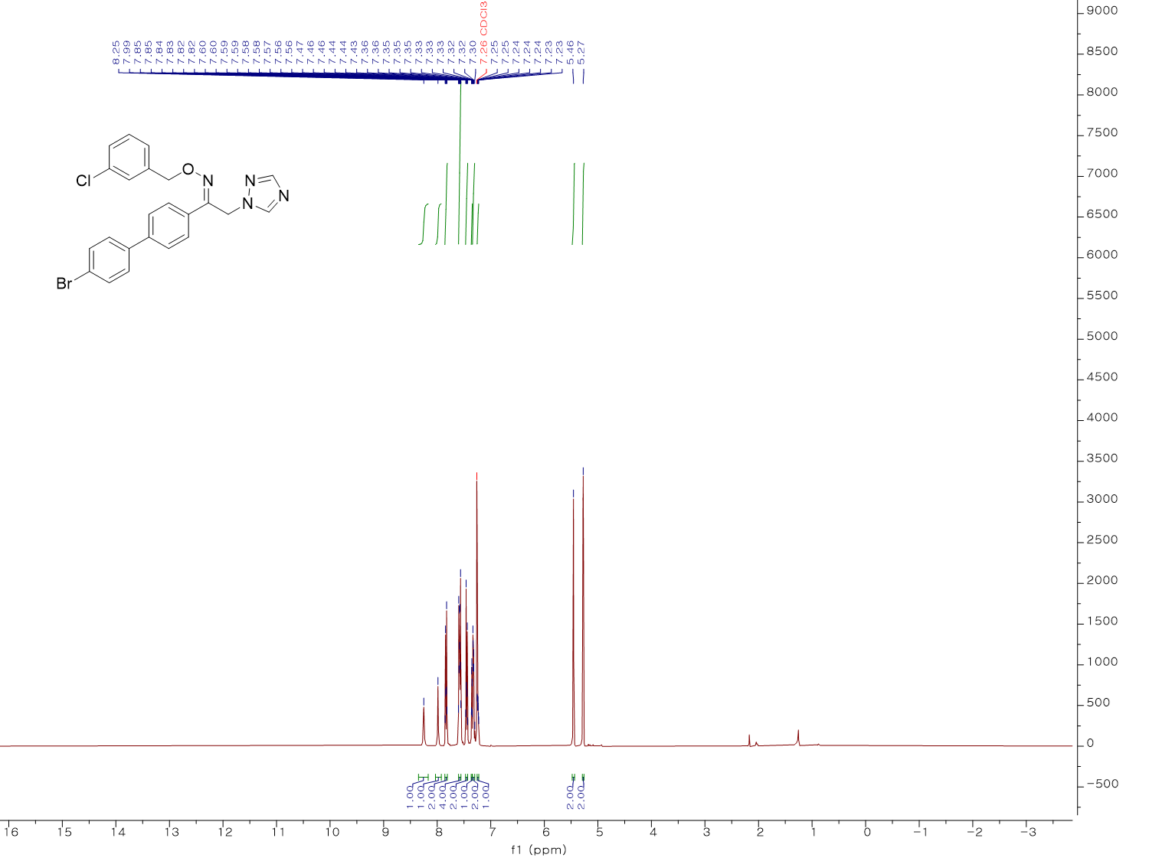¹H NMR spectrum (400 MHz, CDCl₃) of KH13
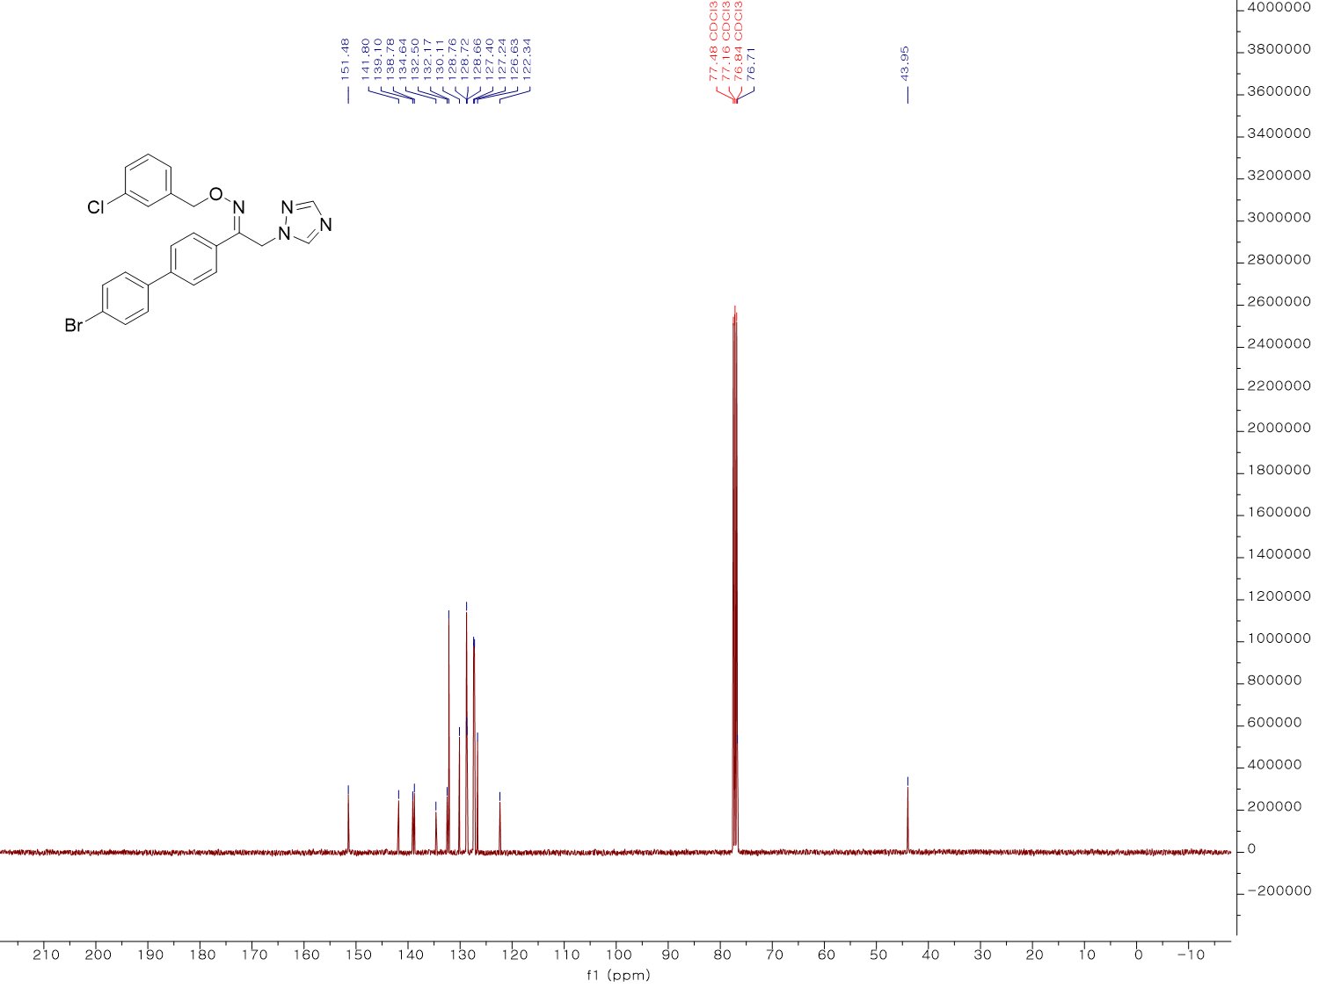
¹³C NMR spectrum (100 MHz, CDCl₃) of KH13
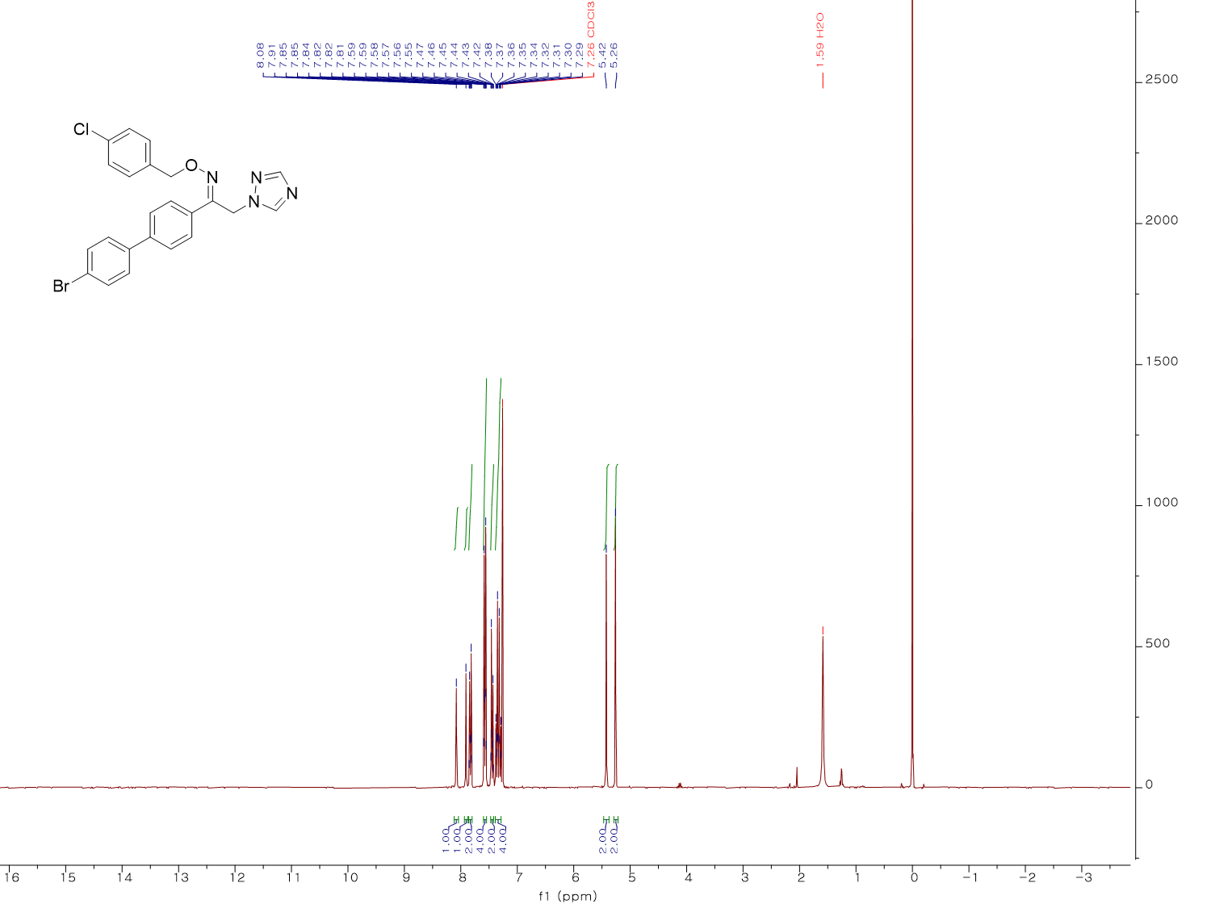
¹H NMR spectrum (300 MHz, CDCl₃) of KH14
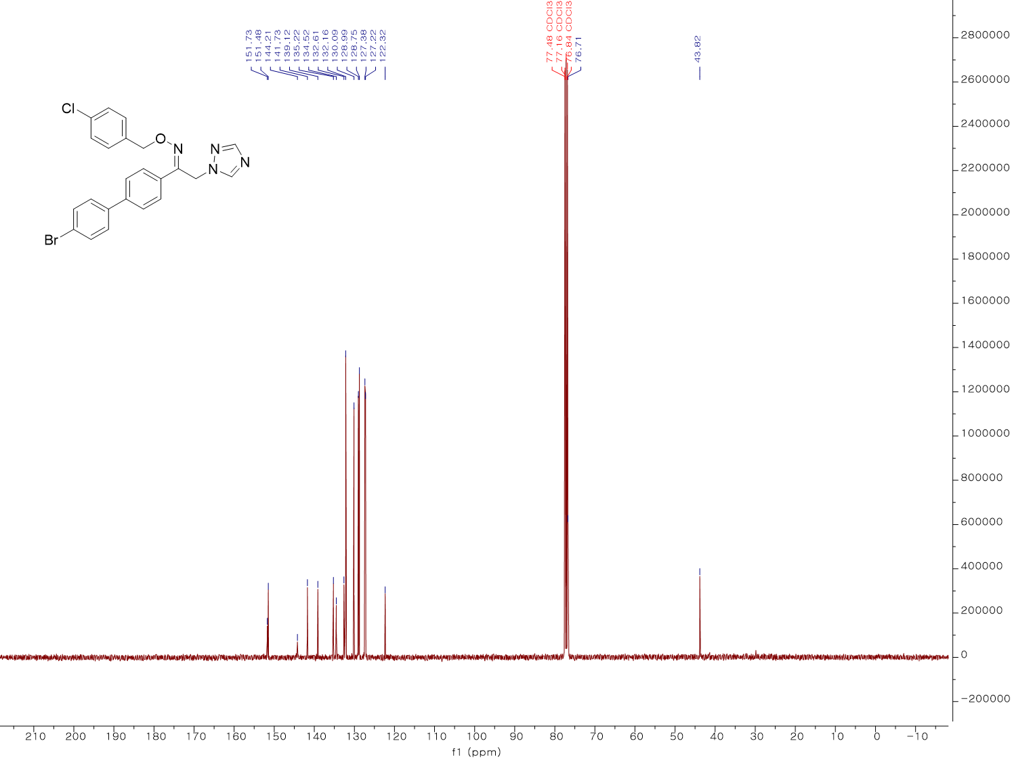¹³C NMR spectrum (100 MHz, CDCl₃) of KH14
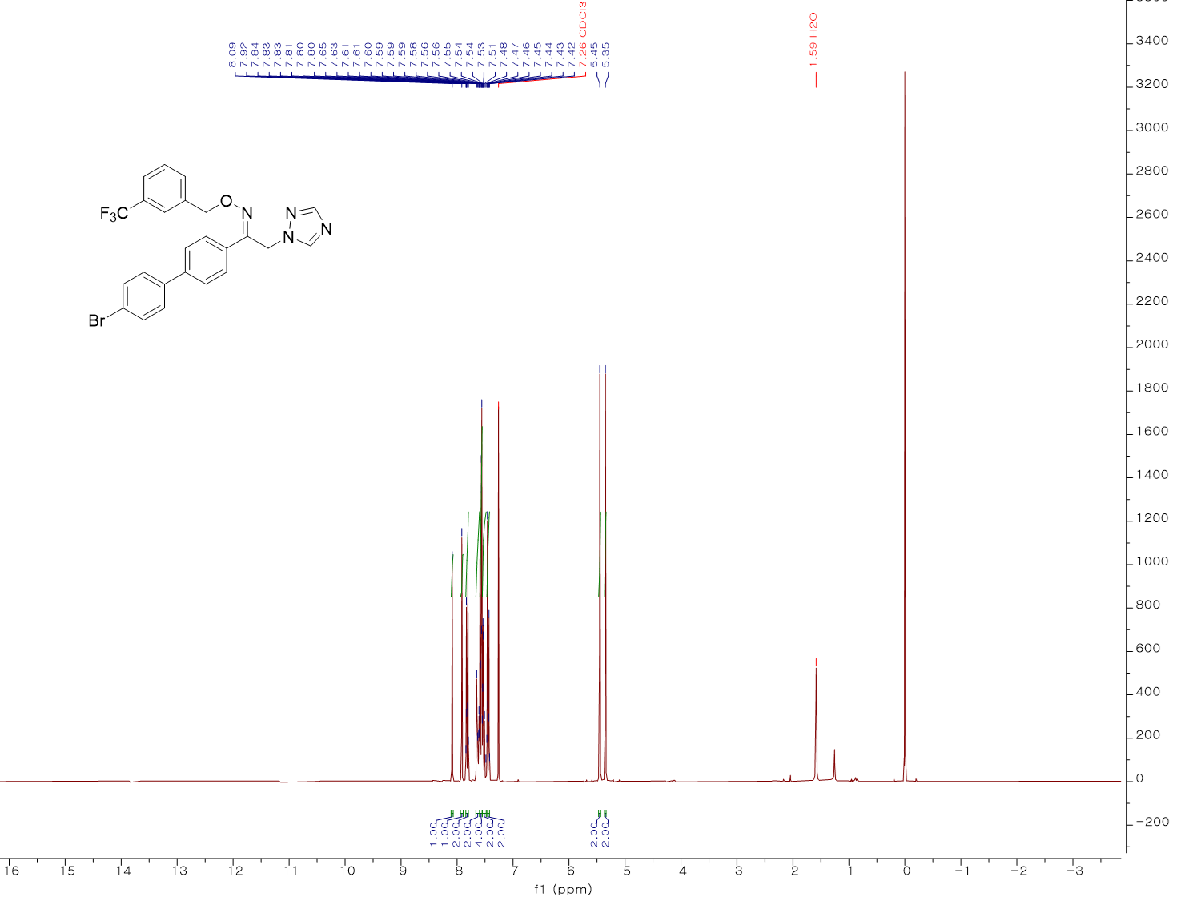
¹H NMR spectrum (300 MHz, CDCl₃) of KH15
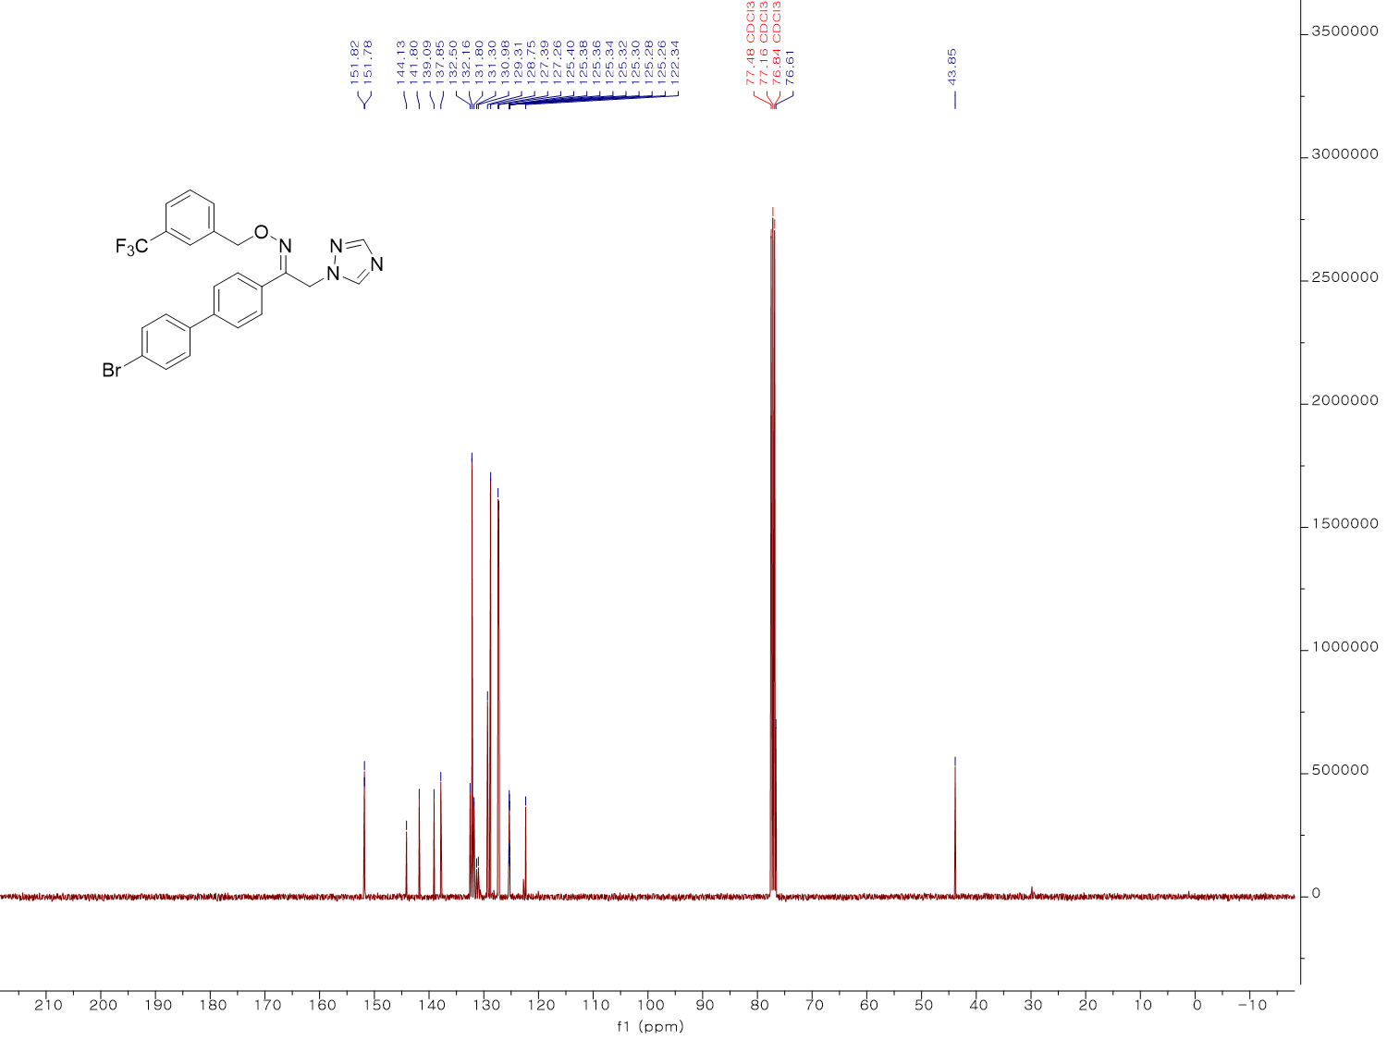
¹³C NMR spectrum (100 MHz, CDCl₃) of KH15
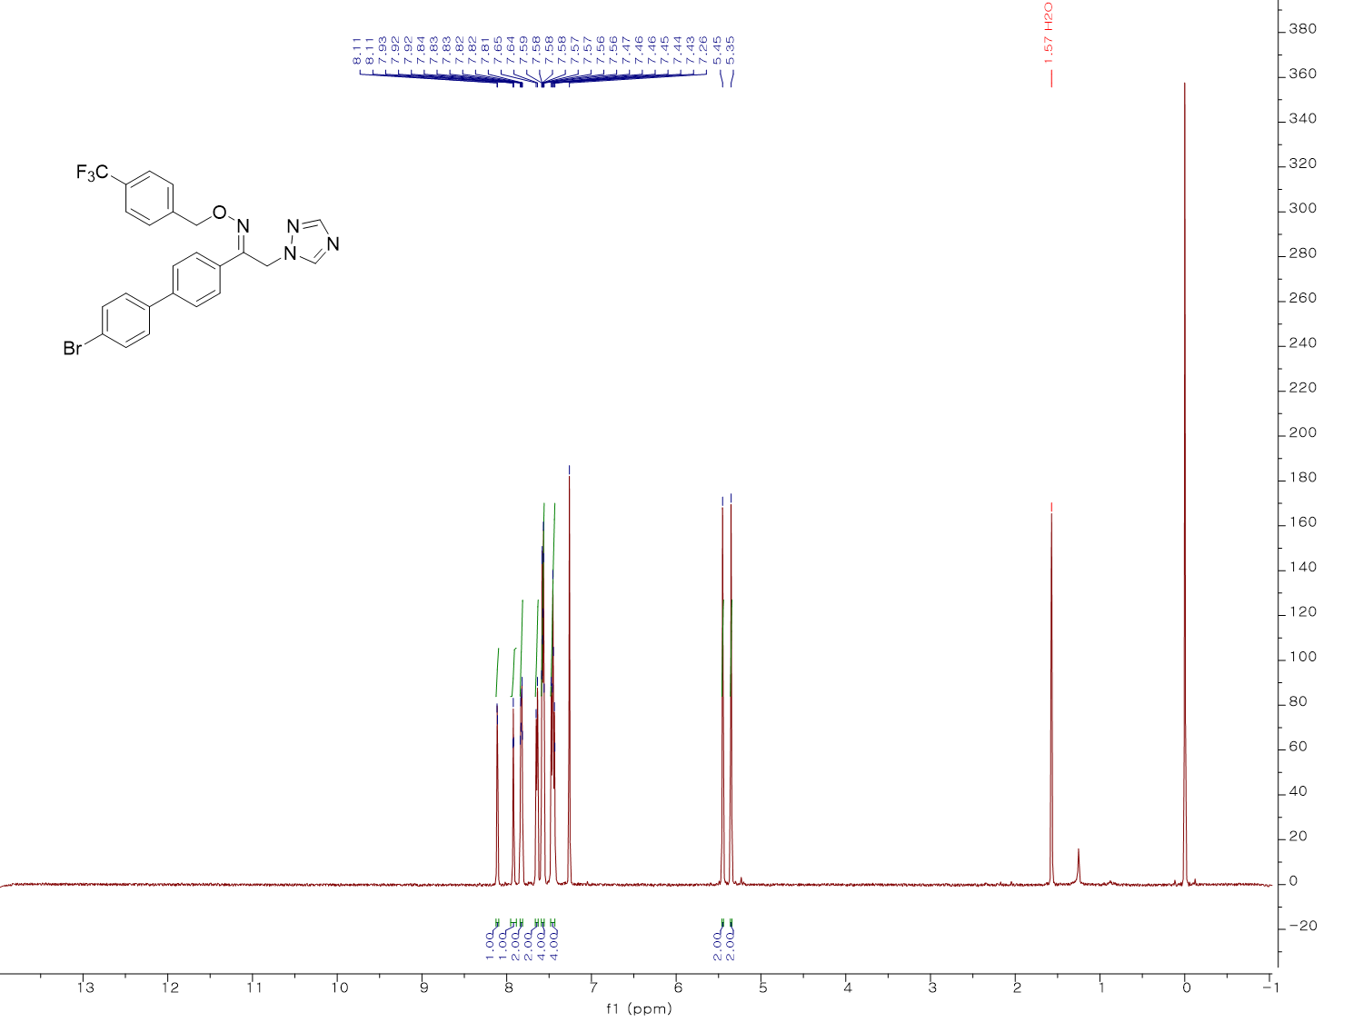
¹H NMR spectrum (500 MHz, CDCl₃) of KH16
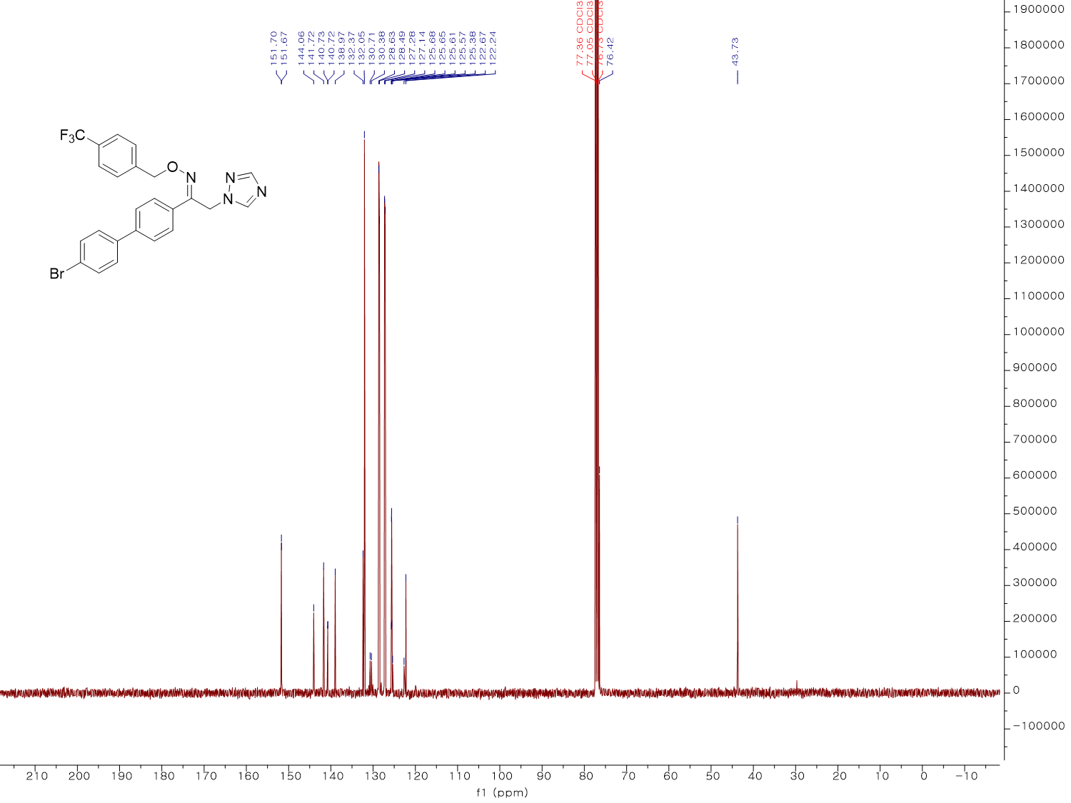
¹³C NMR spectrum (100 MHz, CDCl₃) of KH16
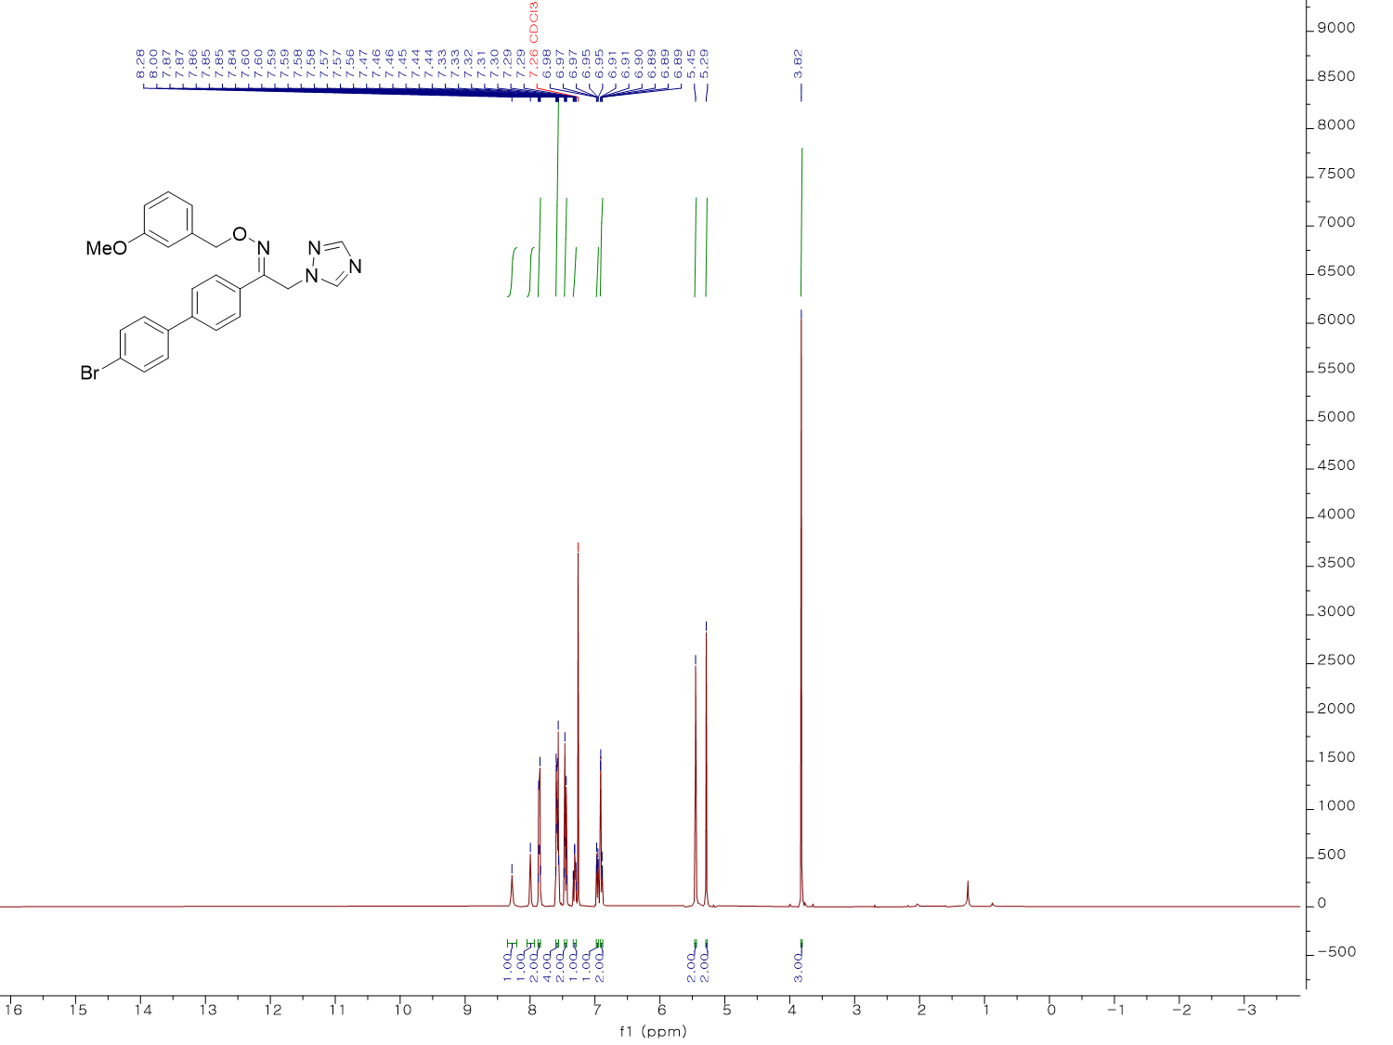¹H NMR spectrum (400 MHz, CDCl₃) of KH17
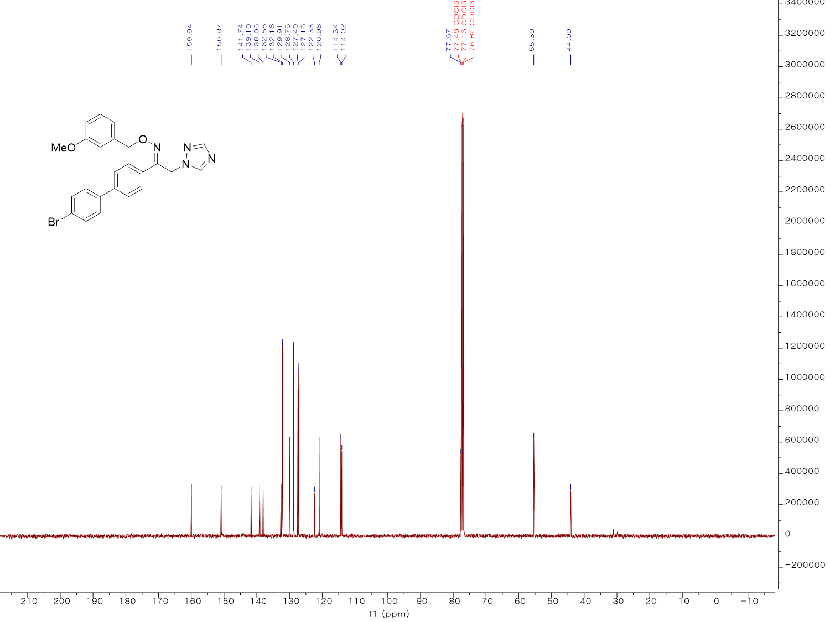¹³C NMR spectrum (100 MHz, CDCl₃) of KH17
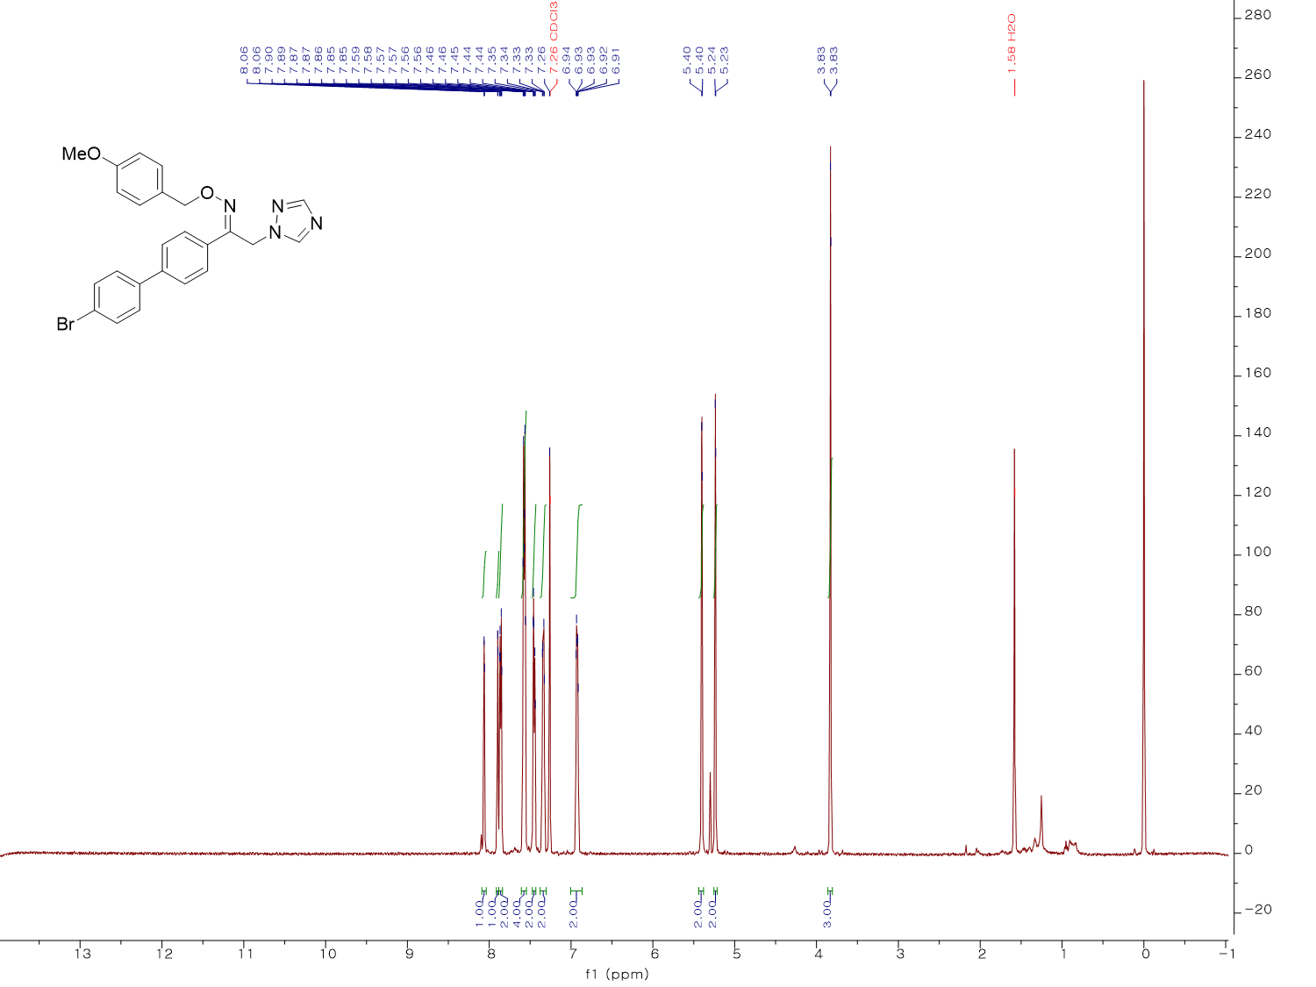
¹H NMR spectrum (500 MHz, CDCl₃) of KH18
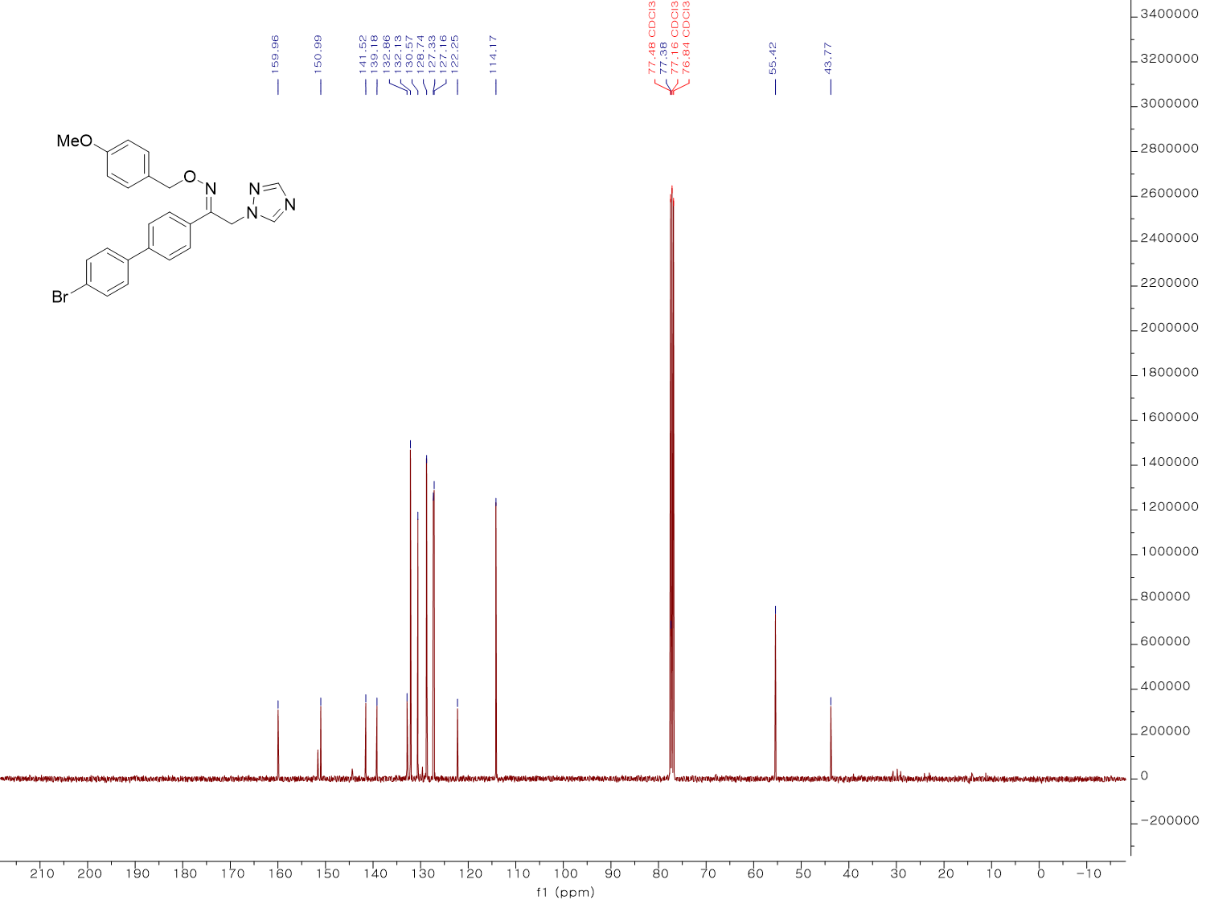
¹³C NMR spectrum (100 MHz, CDCl₃) of KH18
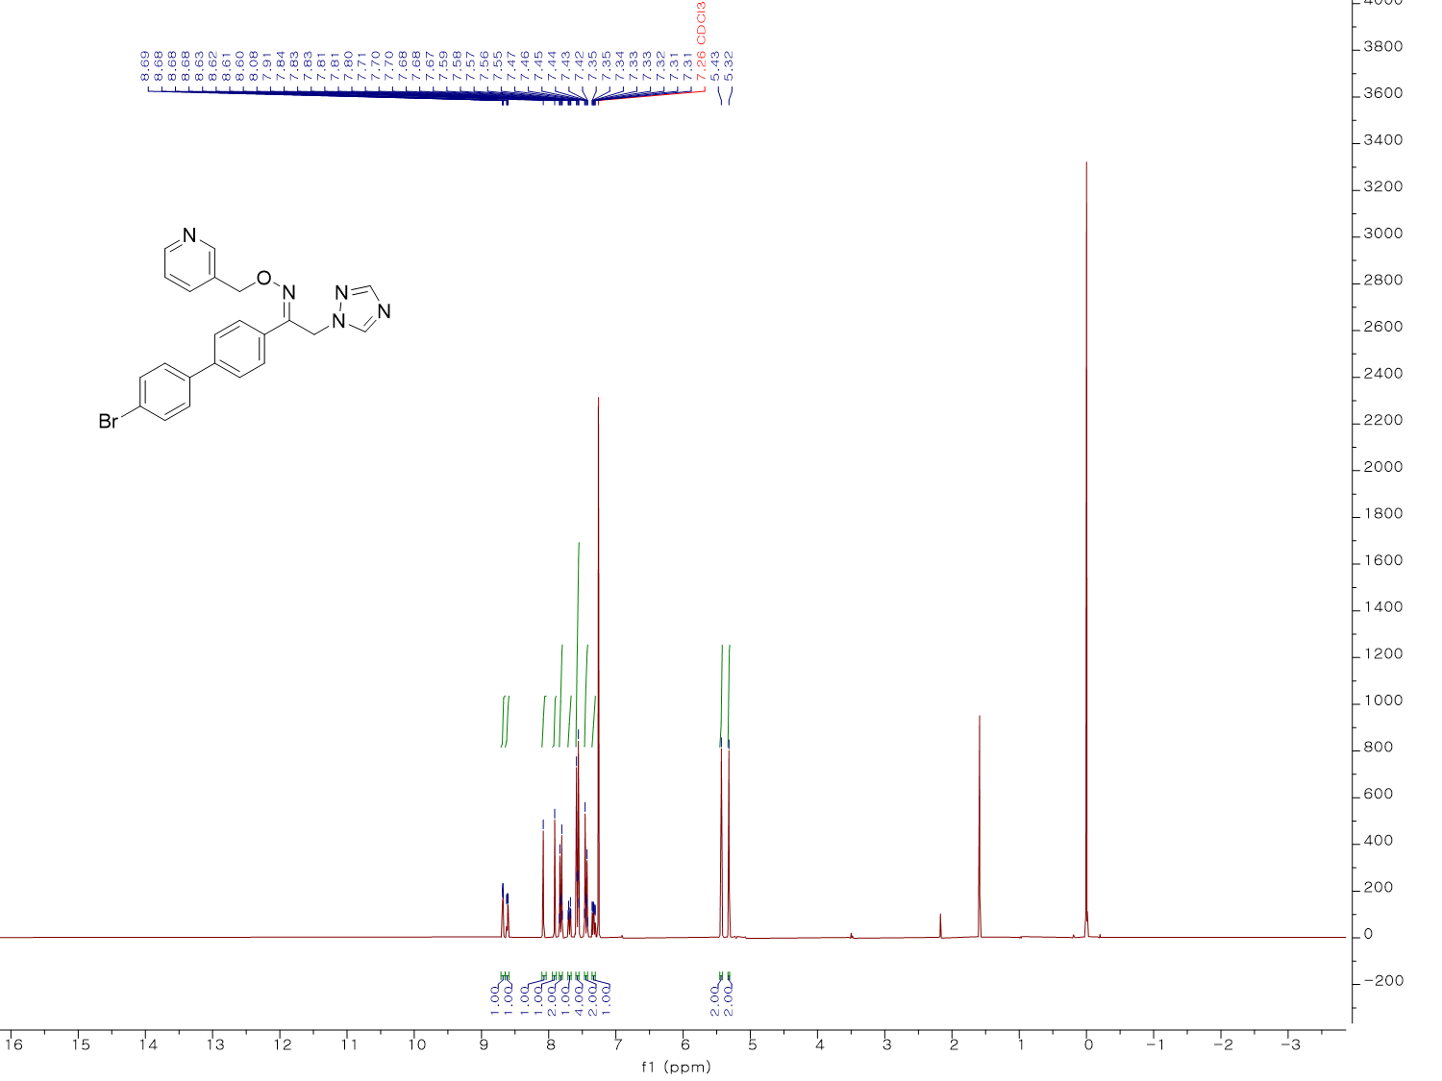
¹H NMR spectrum (300 MHz, CDCl₃) of KH19
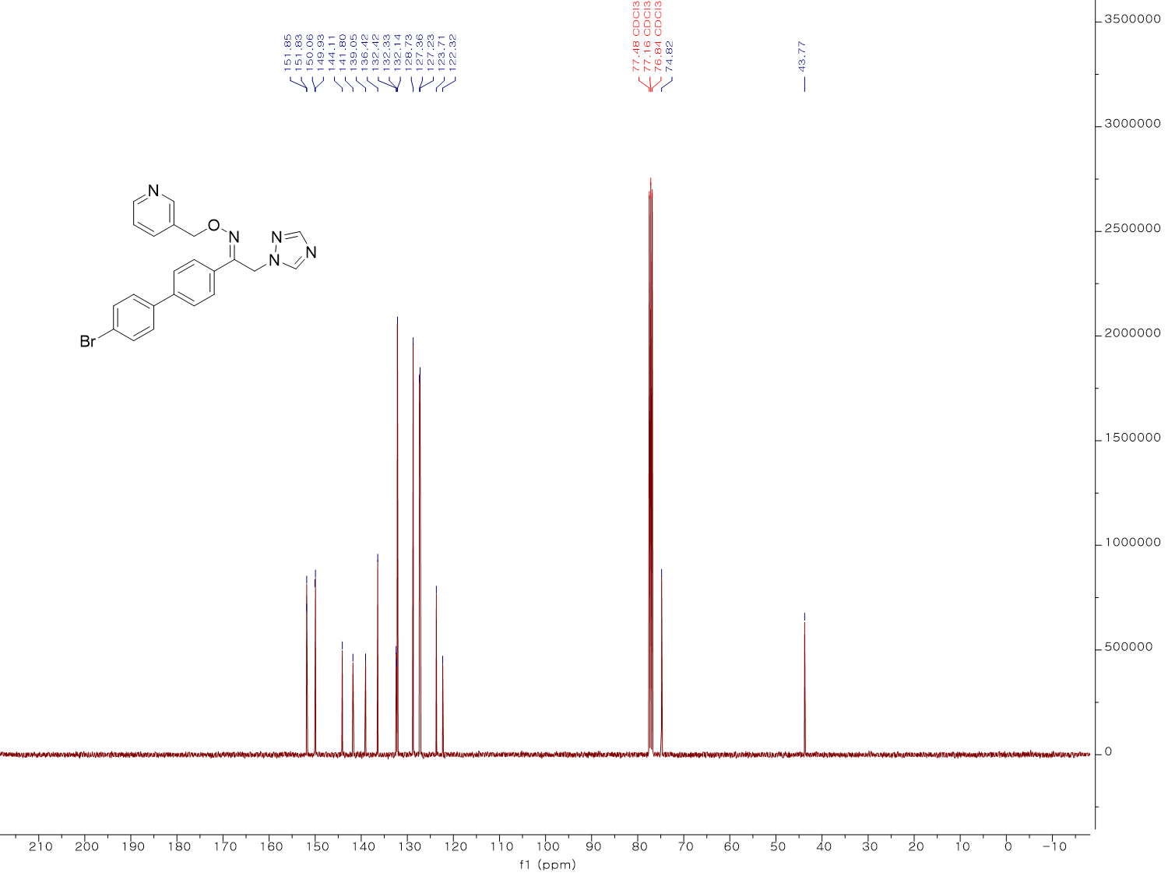
¹³C NMR spectrum (100 MHz, CDCl₃) of KH19
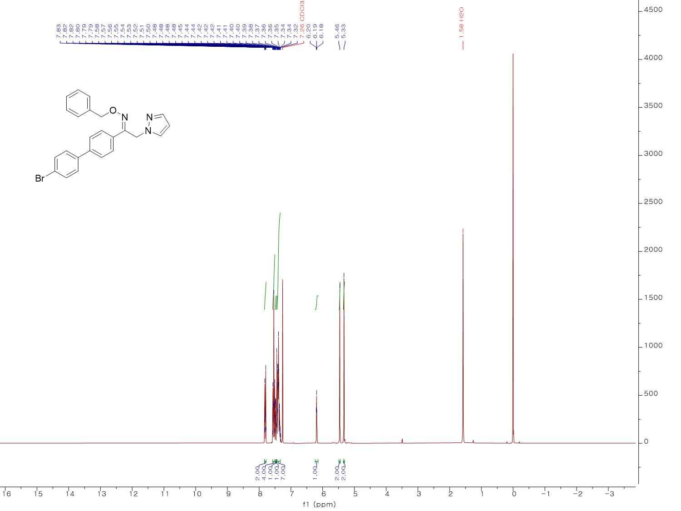
¹H NMR spectrum (300 MHz, CDCl₃) of KH20
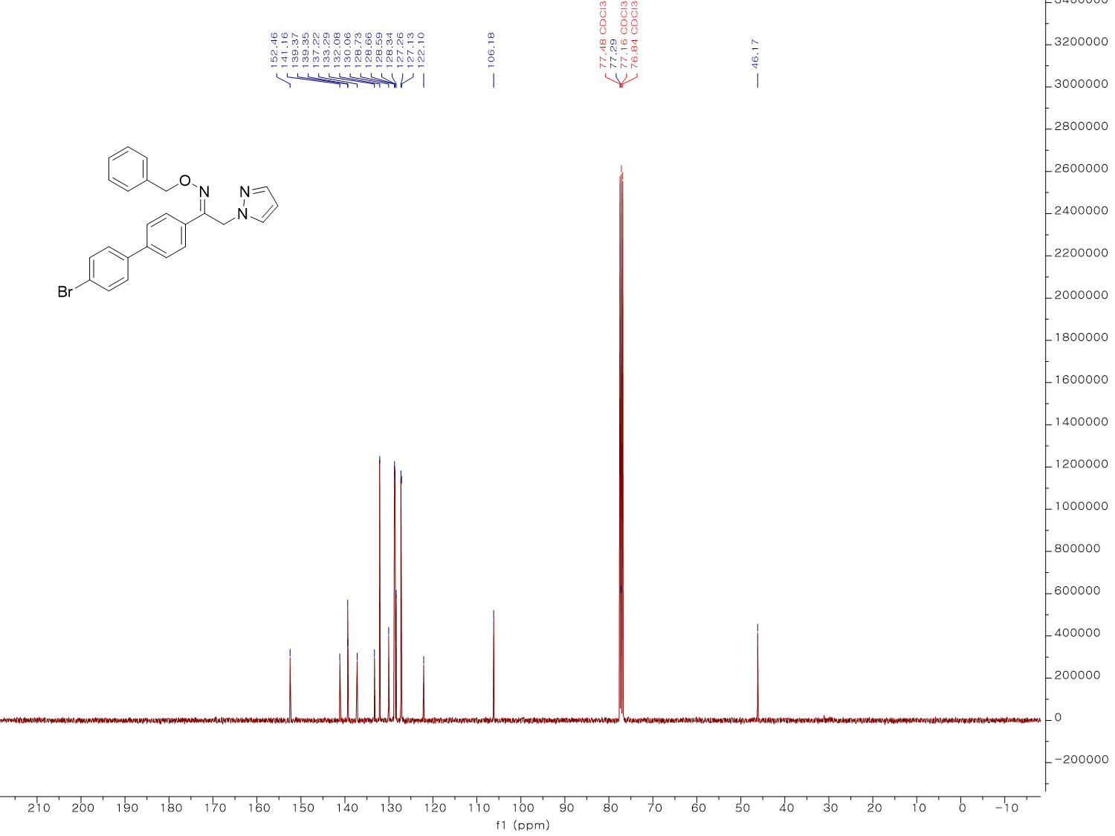
¹³C NMR spectrum (100 MHz, CDCl₃) of KH20
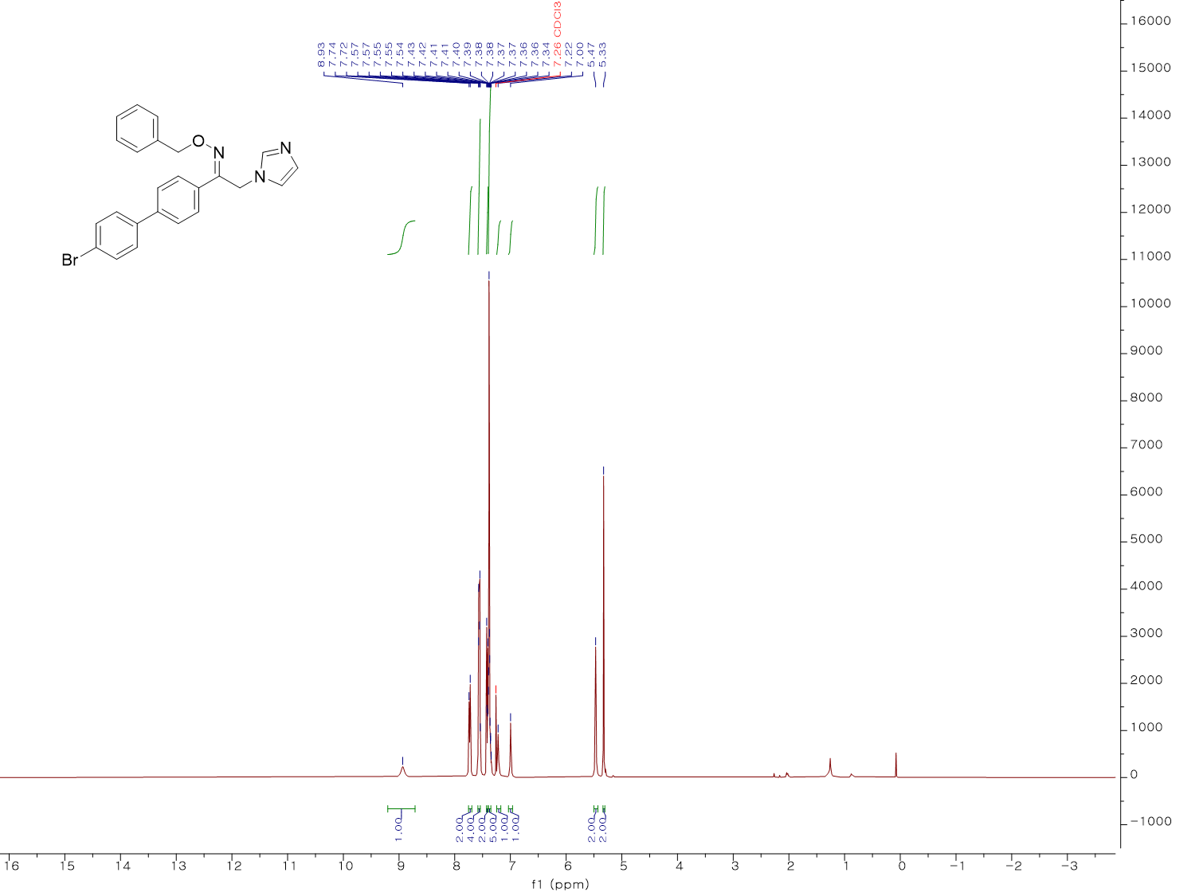
¹H NMR spectrum (400 MHz, CDCl₃) of KH21
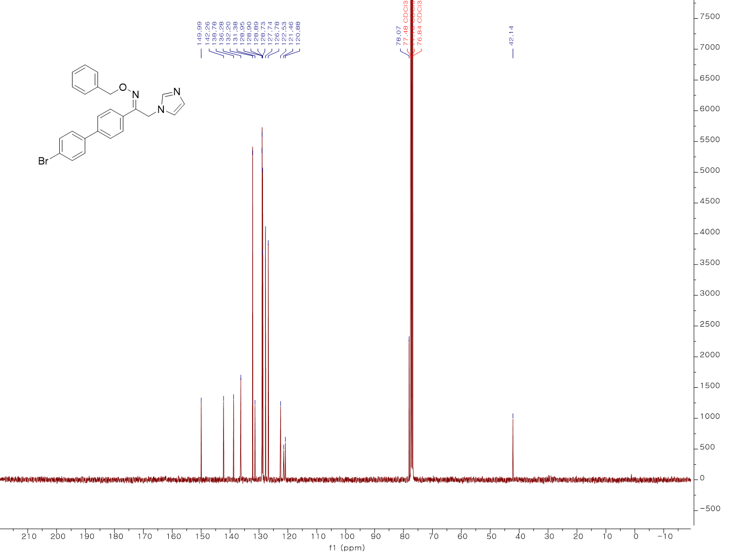
¹³C NMR spectrum (100 MHz, CDCl₃) of KH21
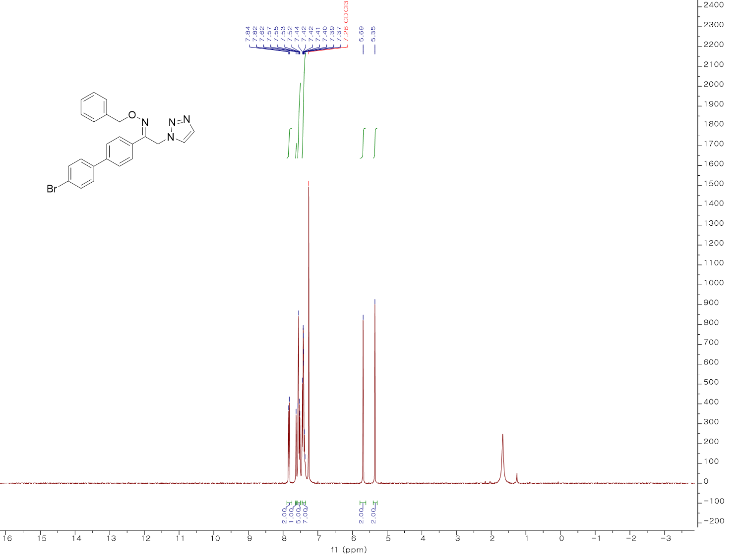
¹H NMR spectrum (400 MHz, CDCl₃) of KH22
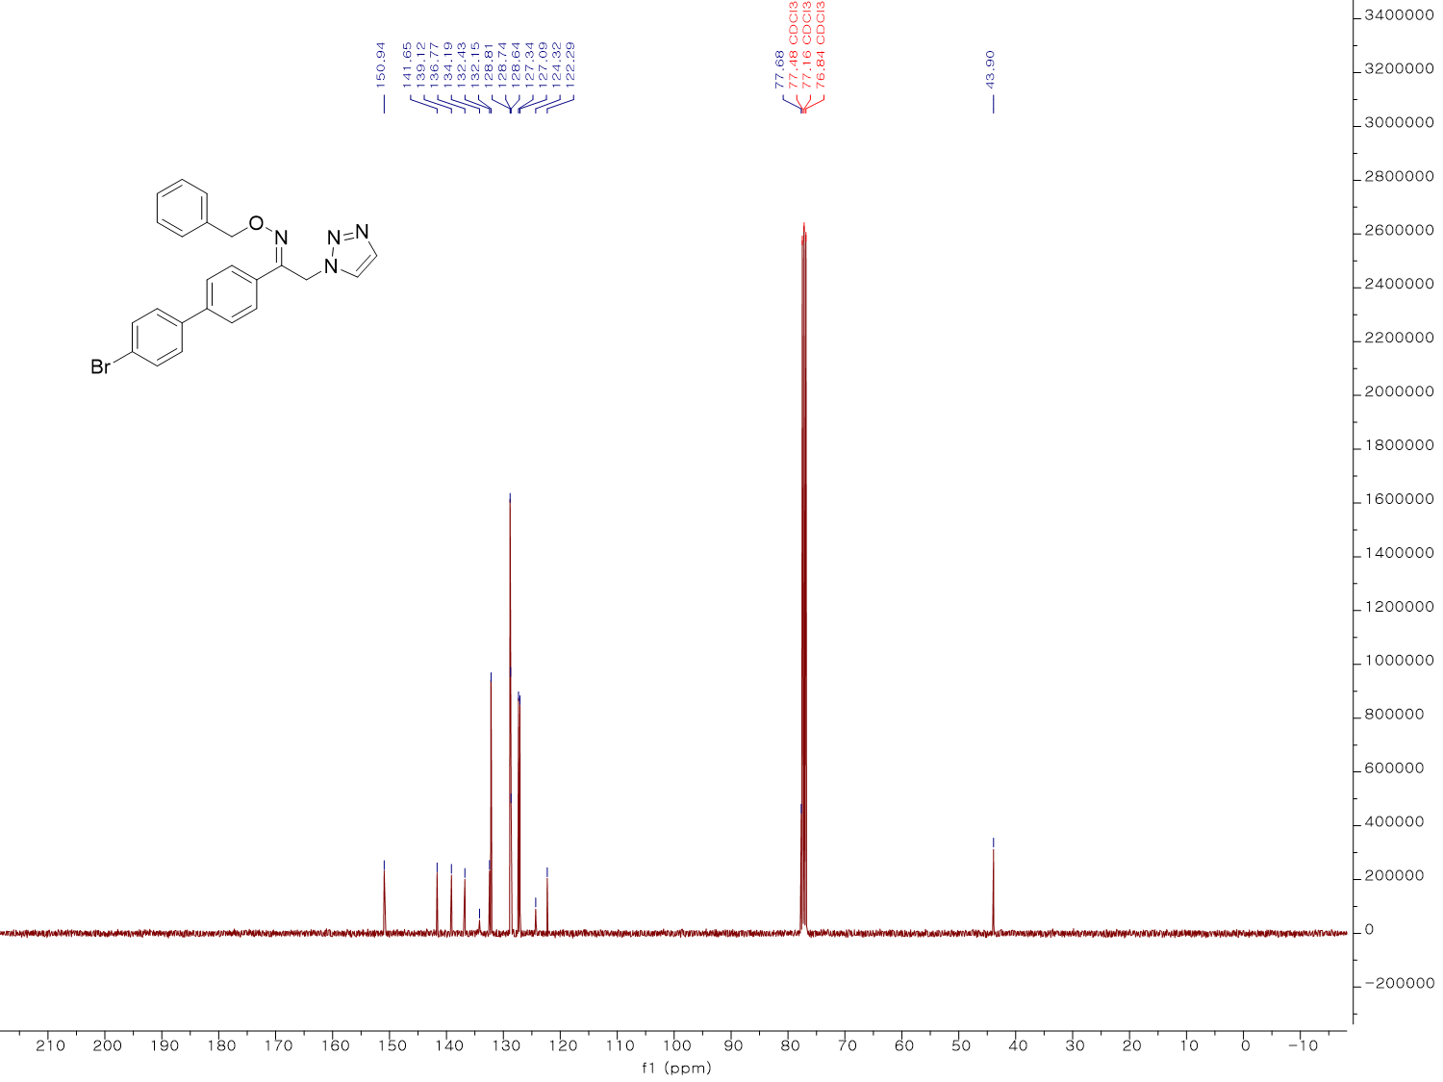
¹³C NMR spectrum (100 MHz, CDCl₃) of KH22
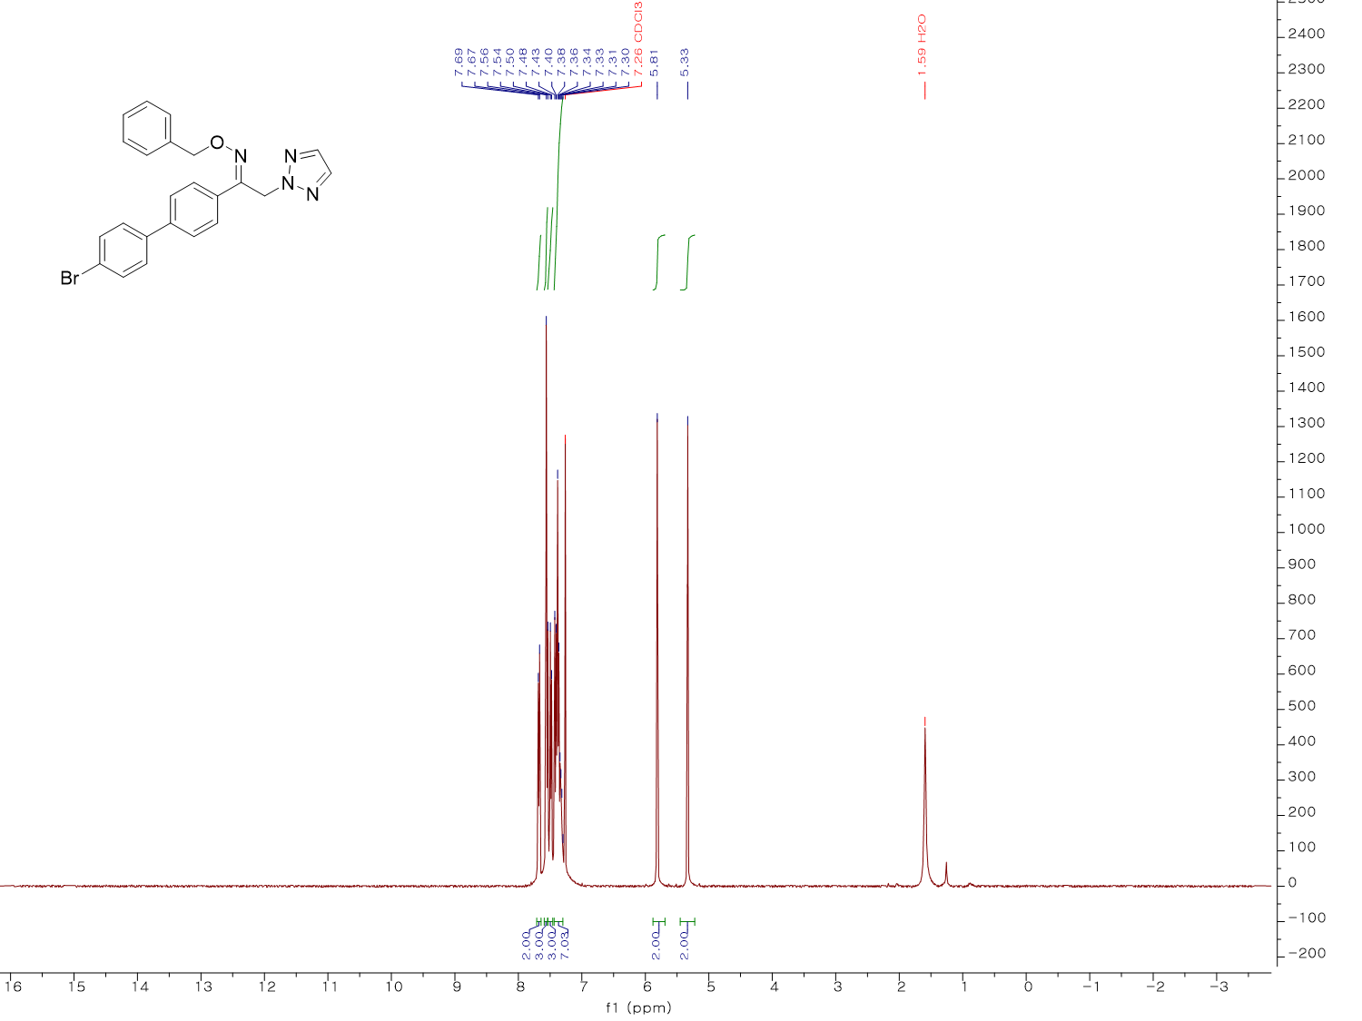
¹H NMR spectrum (400 MHz, CDCl₃) of KH23
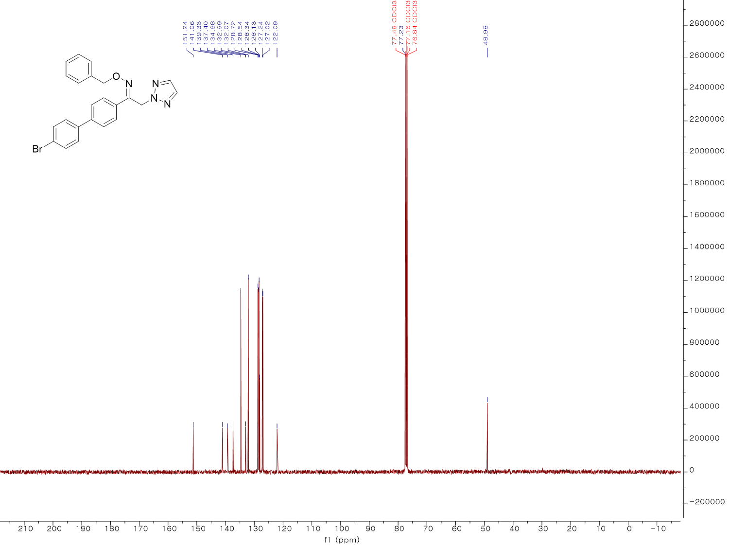
¹³C NMR spectrum (100 MHz, CDCl₃) of KH23
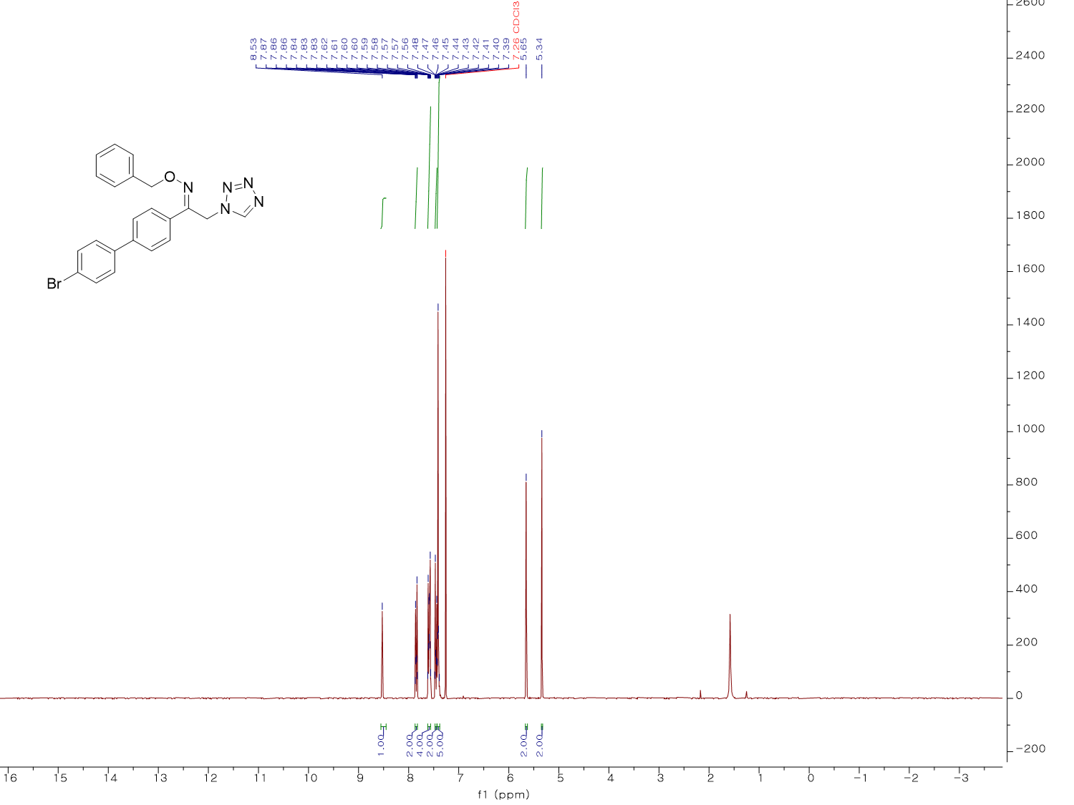
¹H NMR spectrum (300 MHz, CDCl₃) of KH24
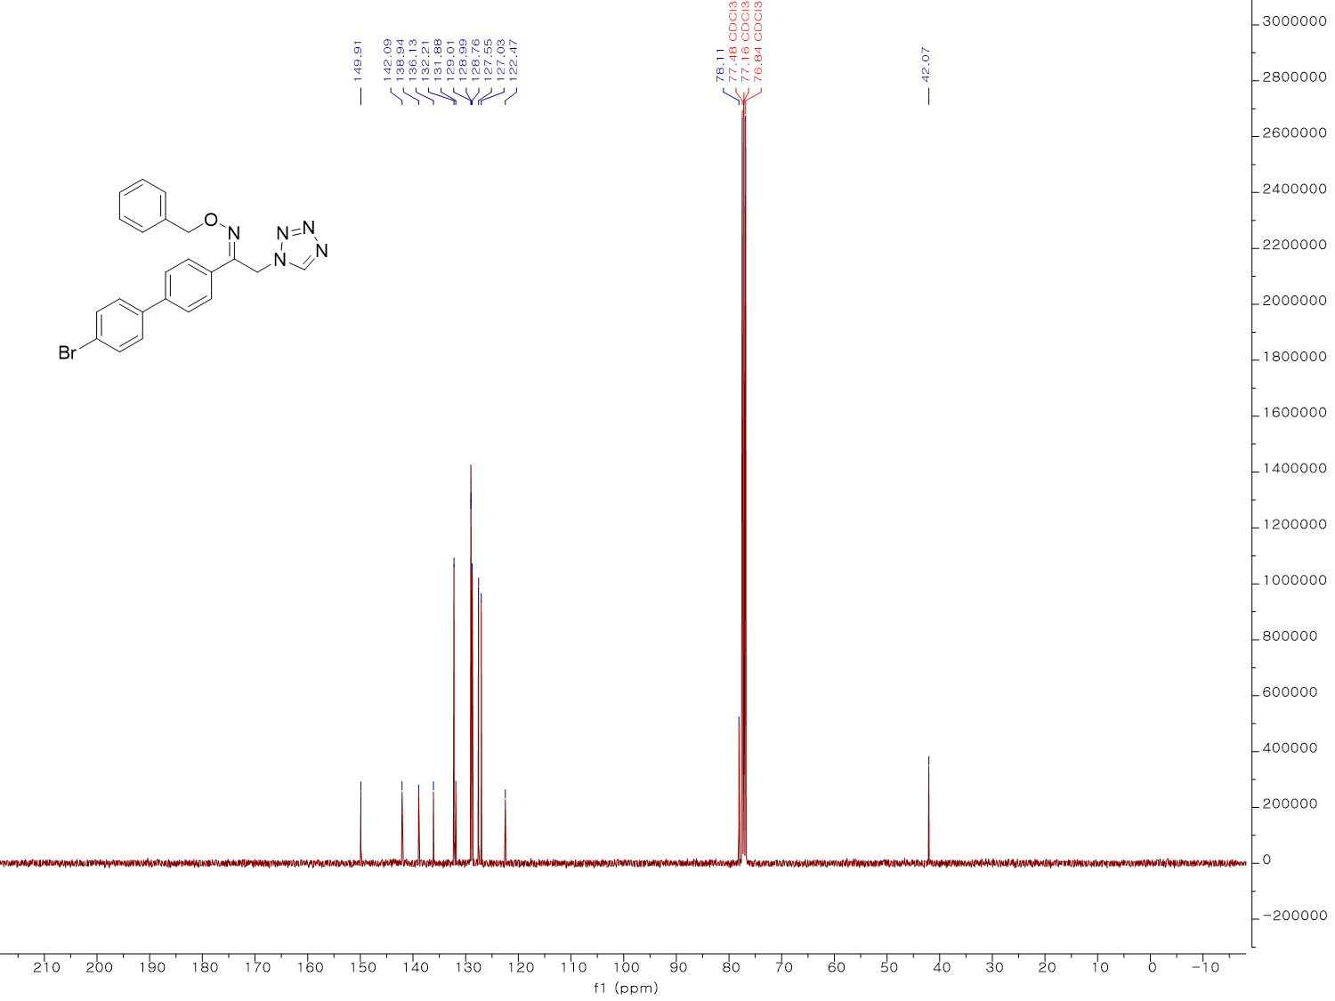
¹³C NMR spectrum (100 MHz, CDCl₃) of KH24
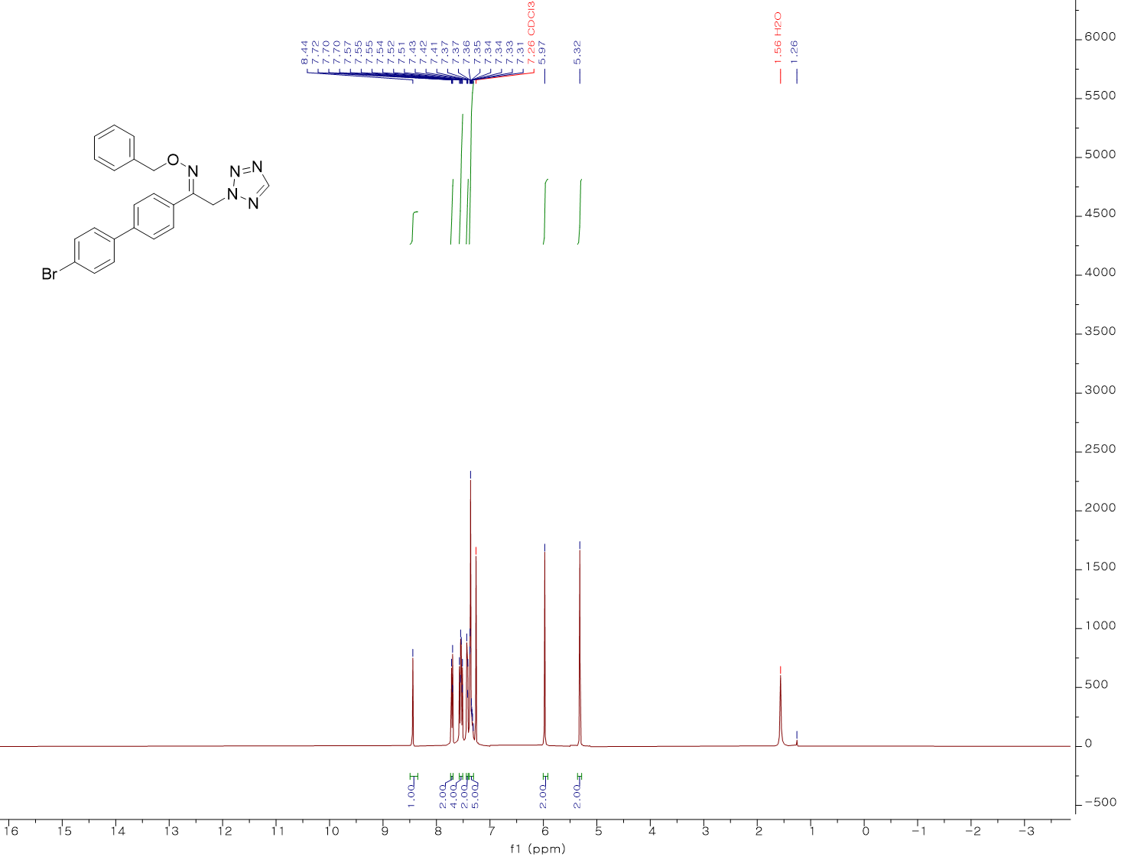
¹H NMR spectrum (400 MHz, CDCl₃) of KH25
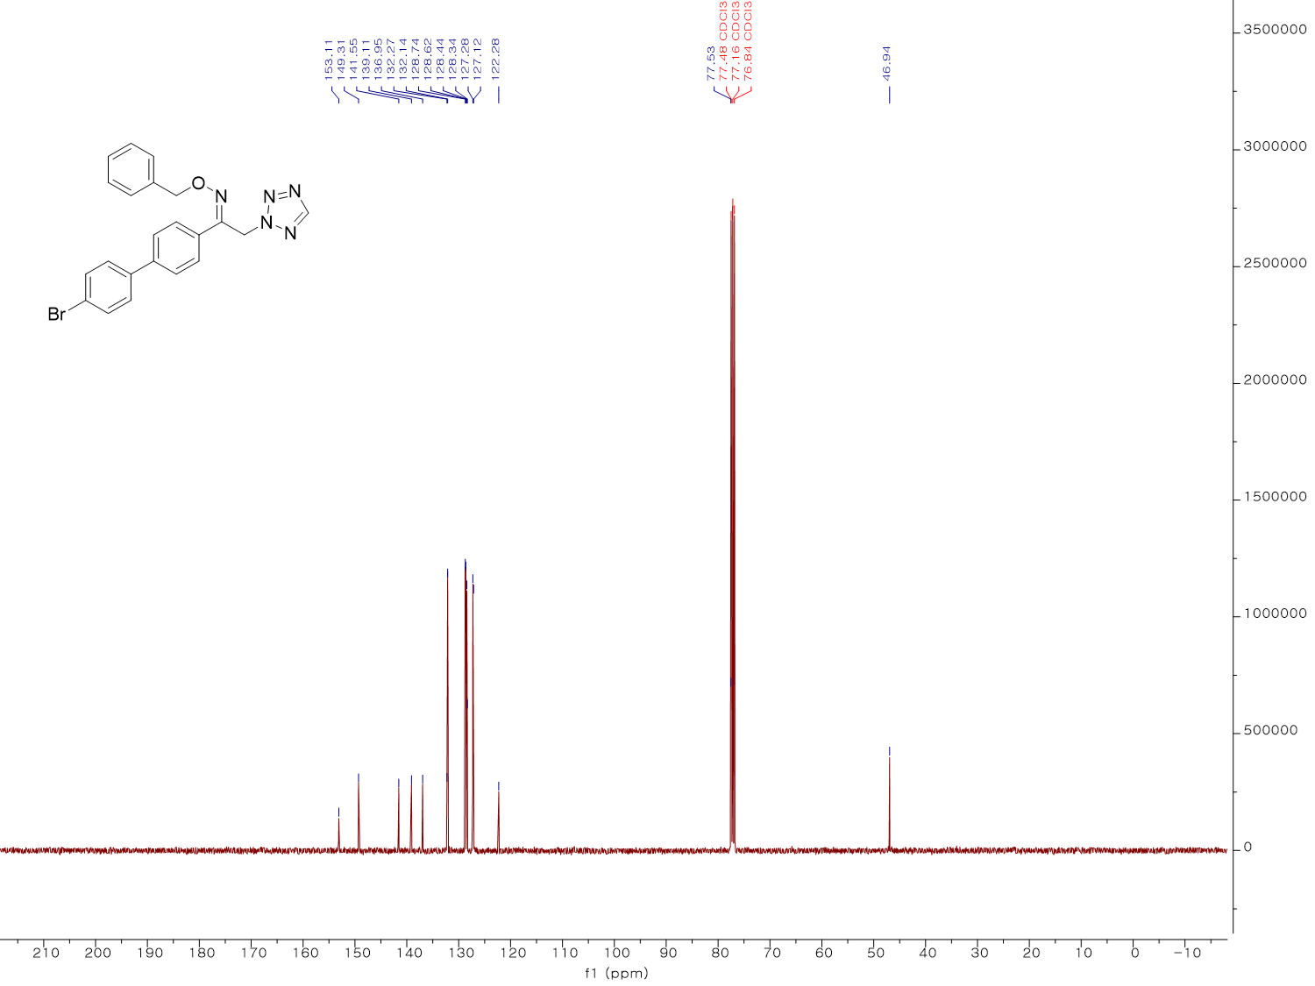
¹³C NMR spectrum (100 MHz, CDCl₃) of KH25
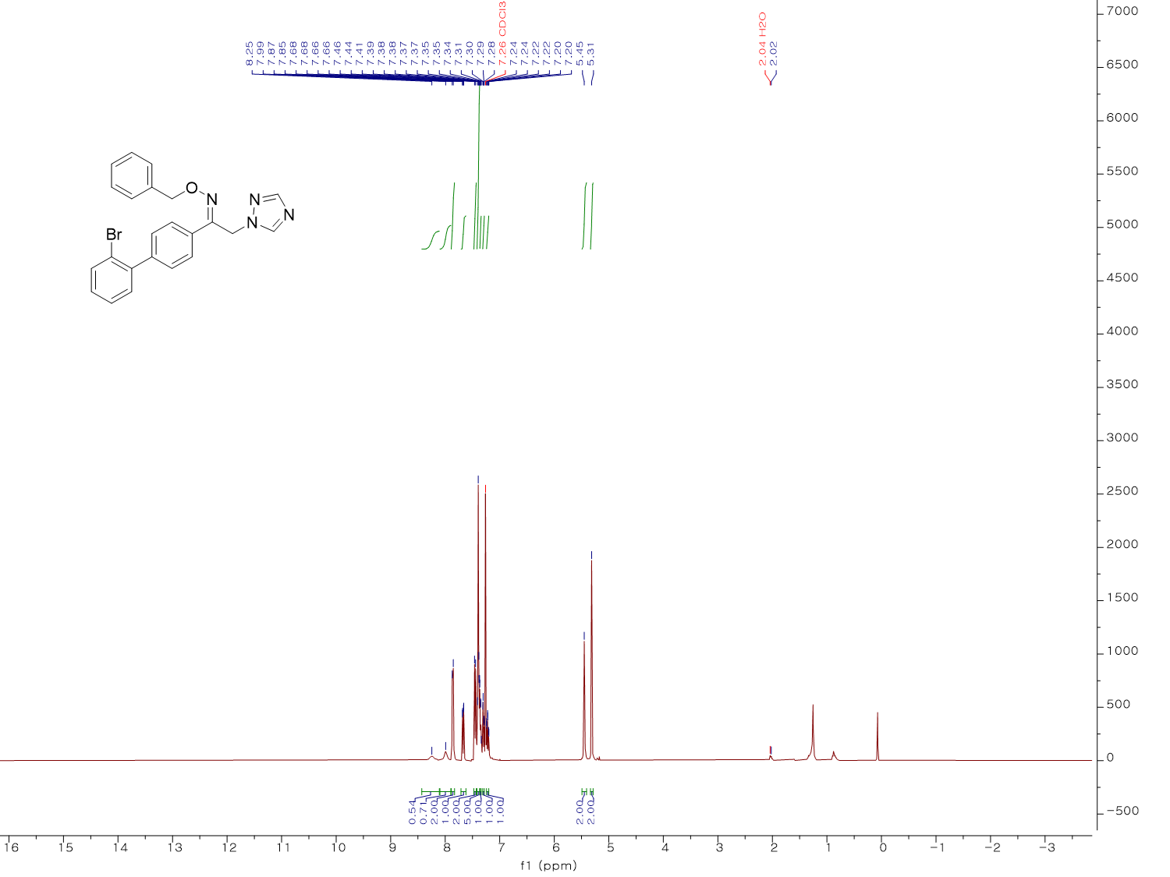
¹H NMR spectrum (400 MHz, CDCl₃) of KH26
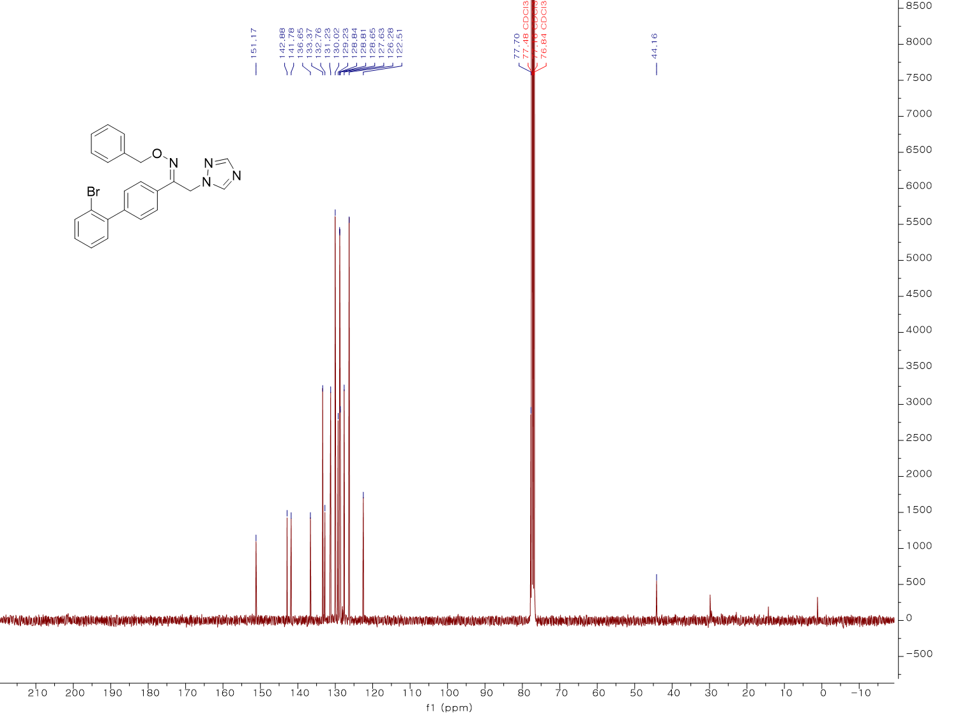
¹³C NMR spectrum (100 MHz, CDCl₃) of KH26
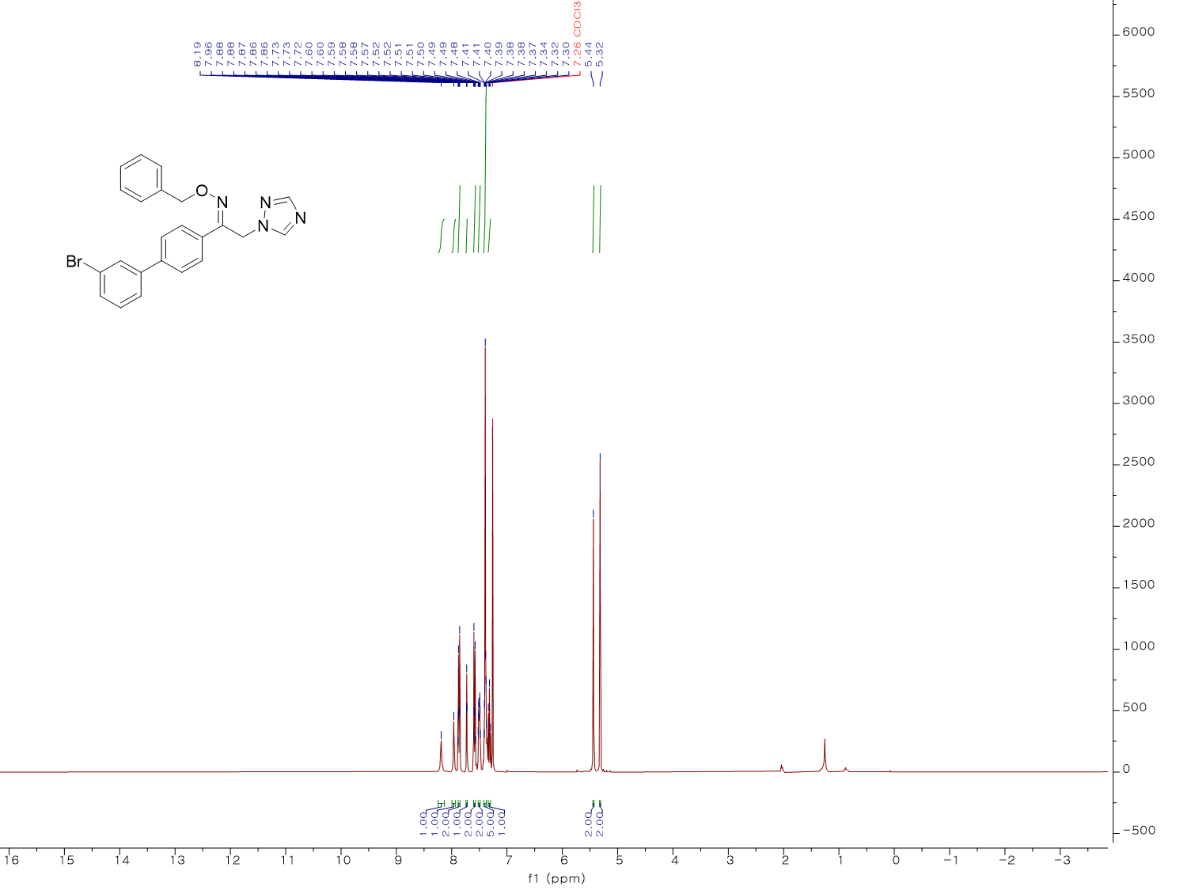
¹H NMR spectrum (400 MHz, CDCl₃) of KH27
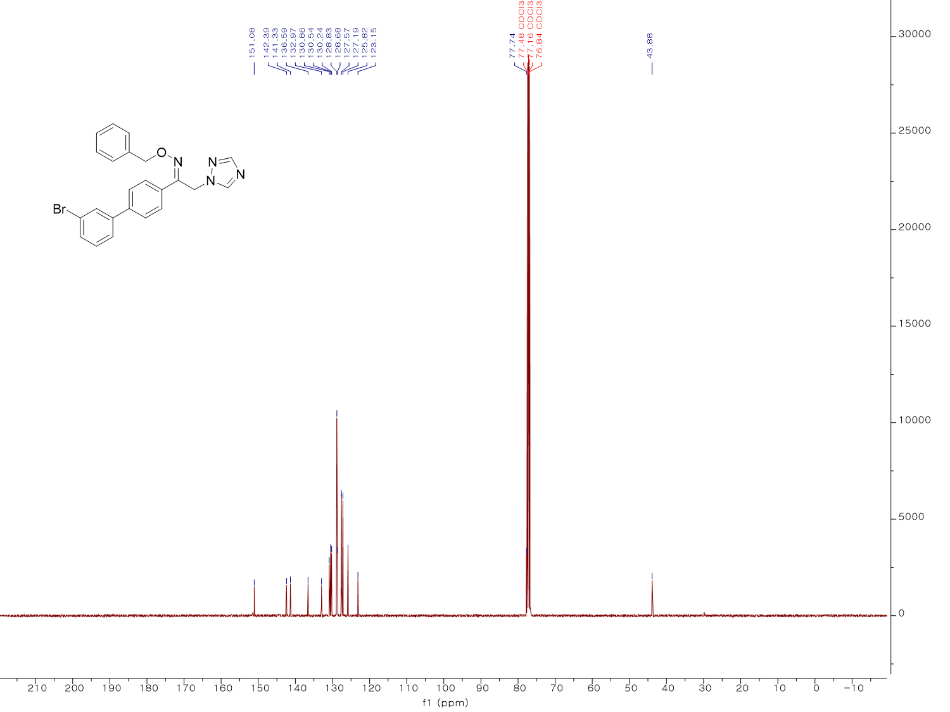
¹³C NMR spectrum (100 MHz, CDCl₃) of KH27
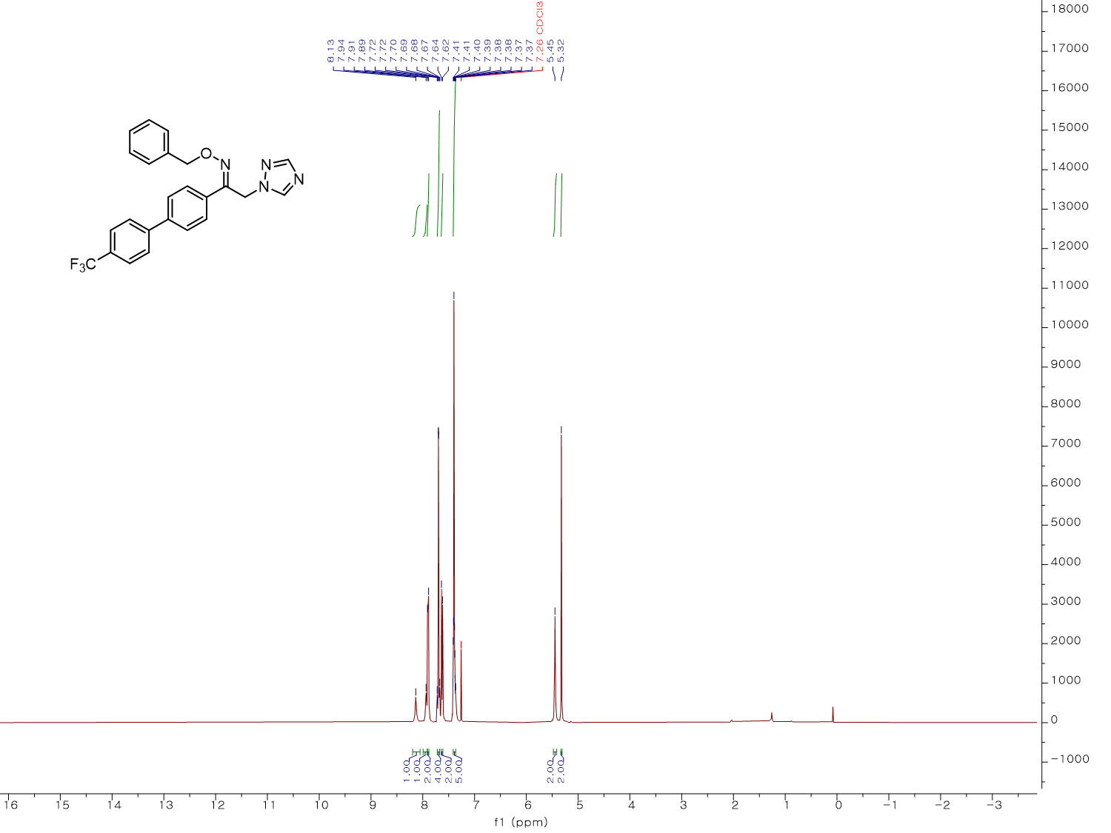
¹H NMR spectrum (400 MHz, CDCl₃) of KH28
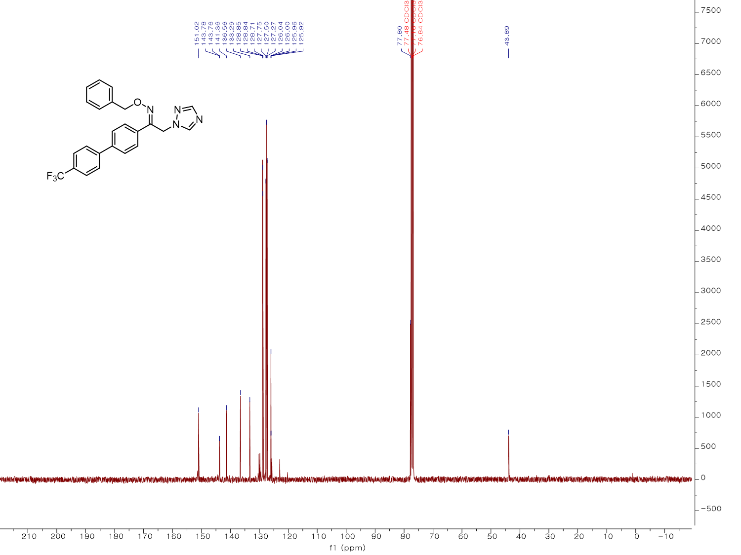
¹³C NMR spectrum (100 MHz, CDCl₃) of KH28
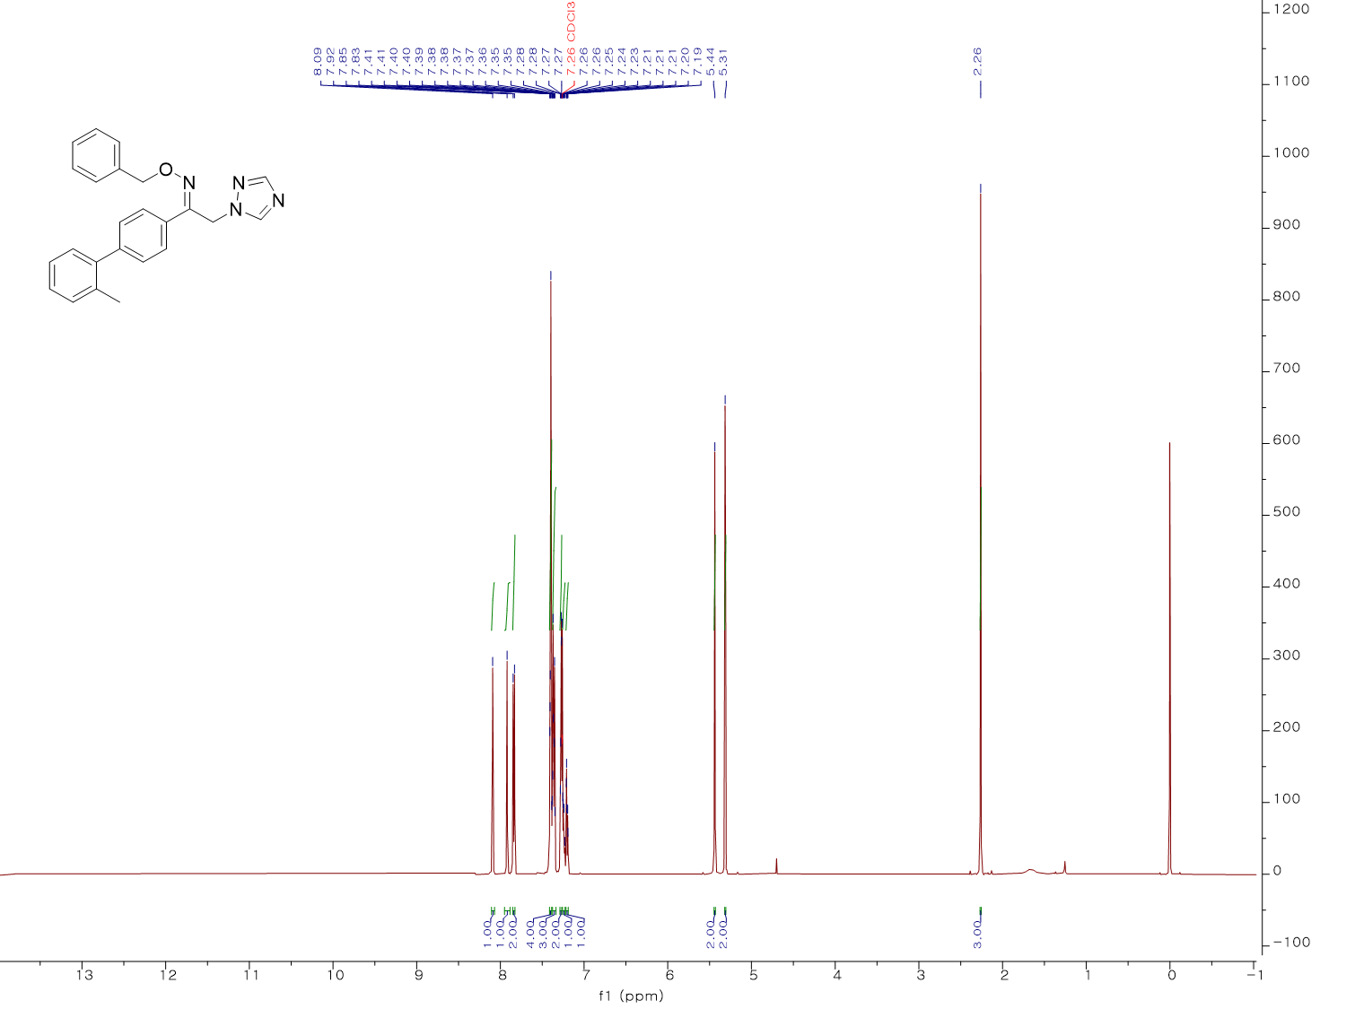
¹H NMR spectrum (500 MHz, CDCl₃) of KH29
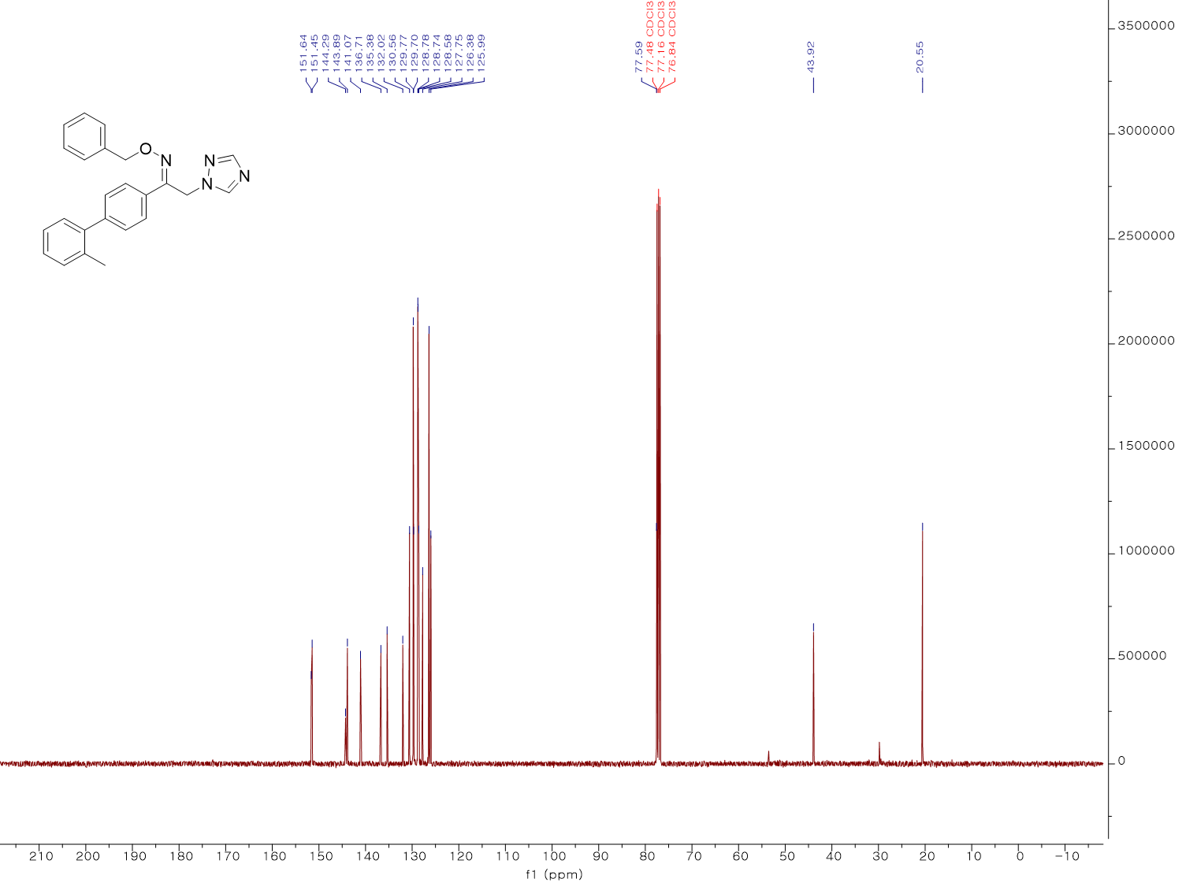
¹³C NMR spectrum (100 MHz, CDCl₃) of KH29
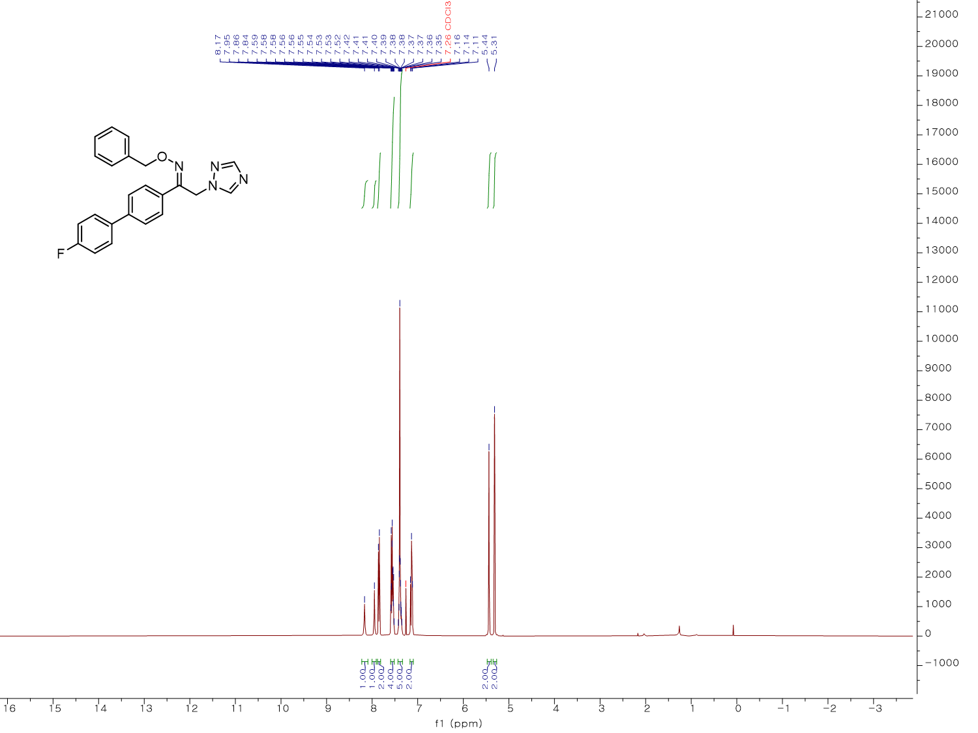
¹H NMR spectrum (400 MHz, CDCl₃) of KH30
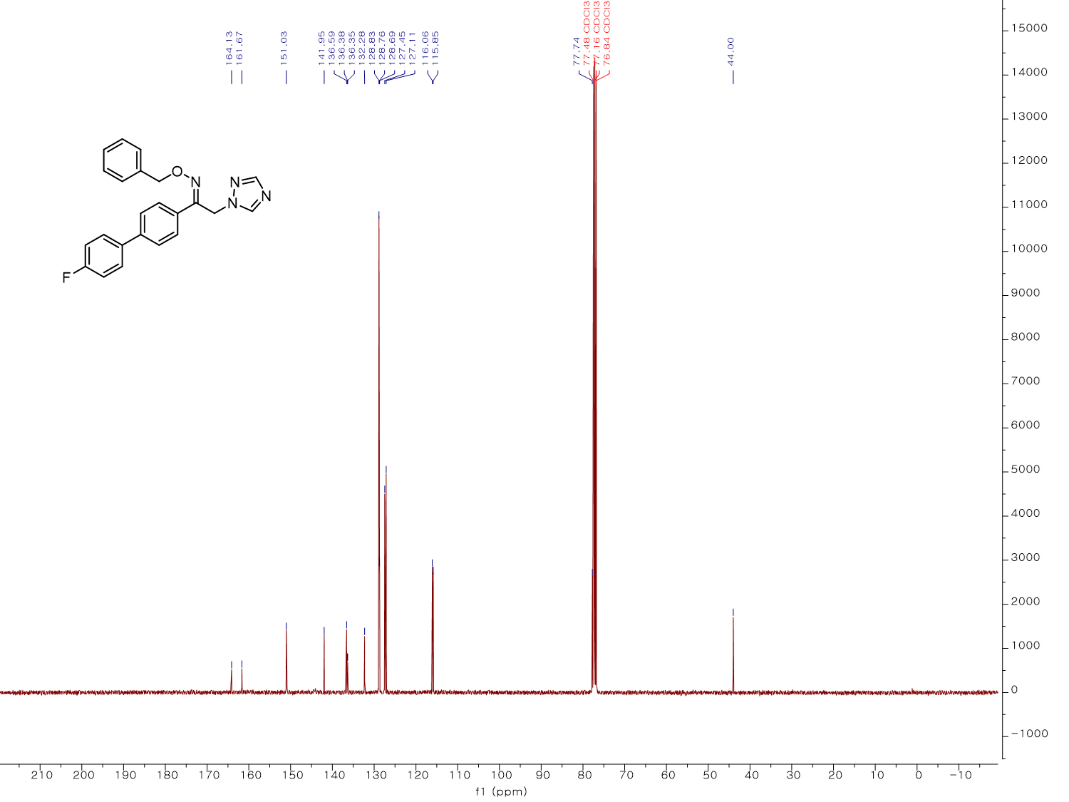
¹³C NMR spectrum (100 MHz, CDCl₃) of KH30
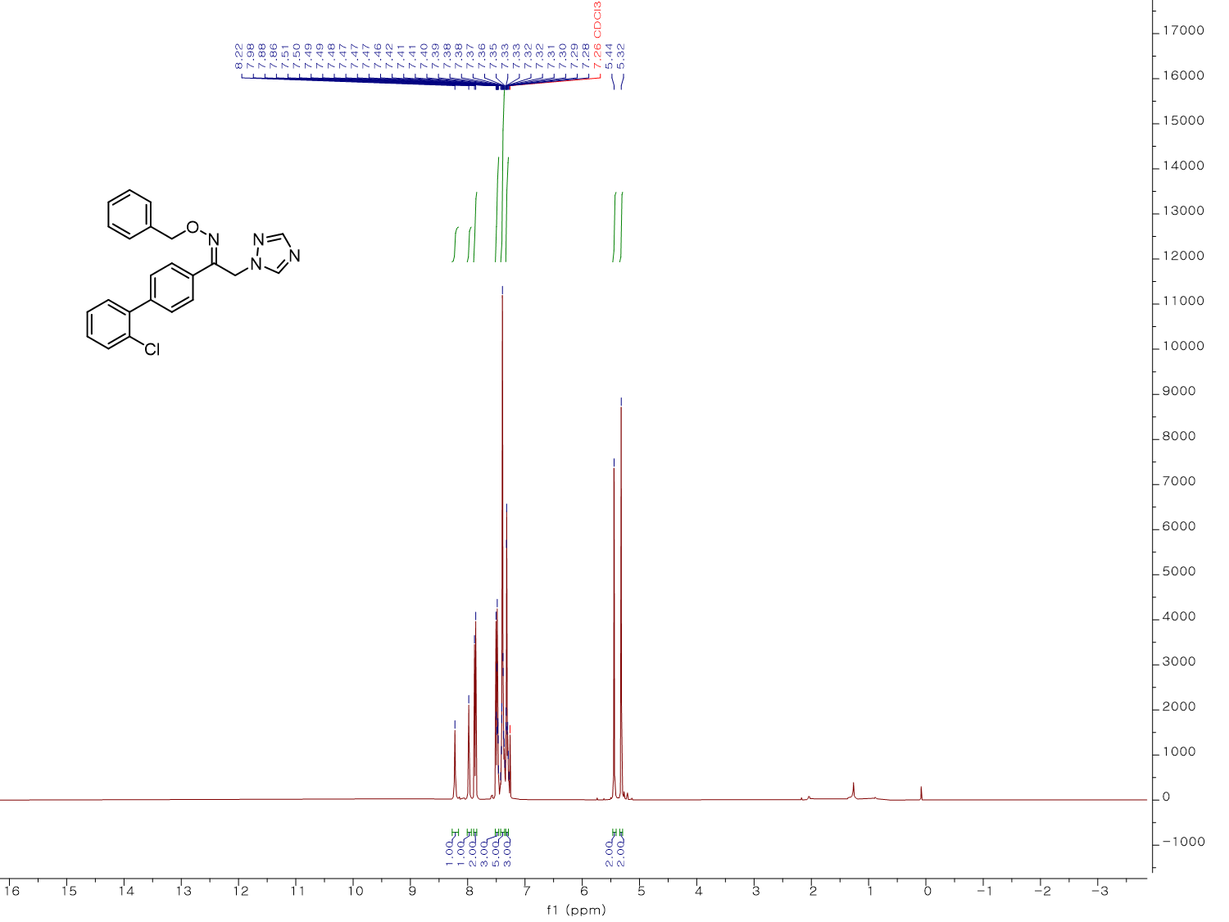
¹H NMR spectrum (400 MHz, CDCl₃) of KH31
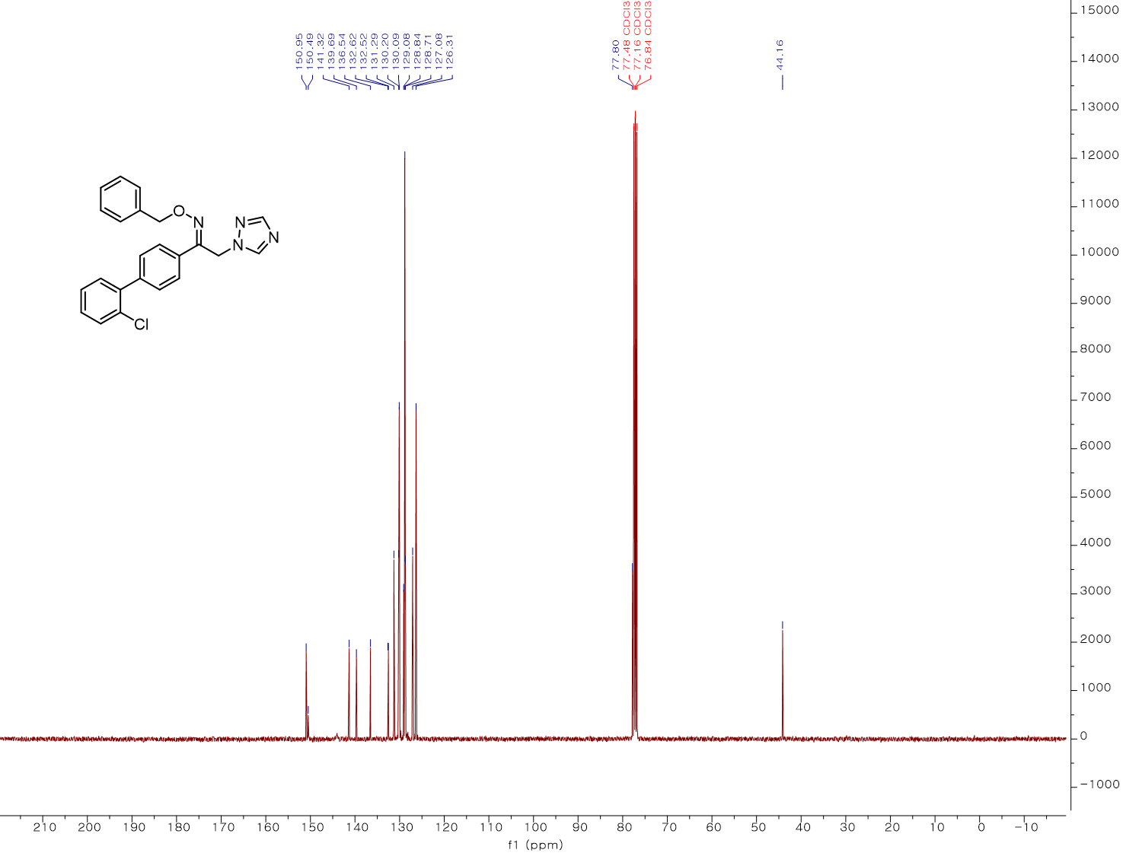
¹³C NMR spectrum (100 MHz, CDCl₃) of KH31
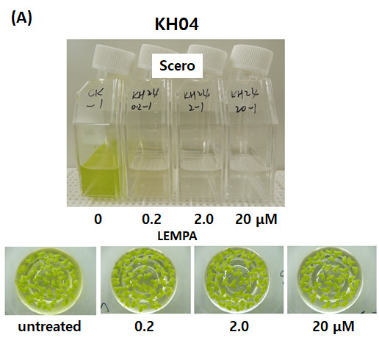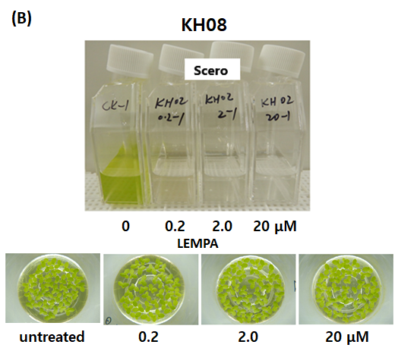
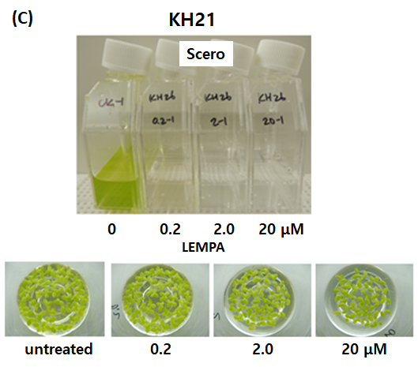
Figure S1. Pictures of growth inhibition responses of Scenedesmus rotundus (Scero) and Lemna paucicostata (LEMPA) treated with 3 concentrations of (A) KH04, (B) KH08, and (C) KH21.

