Supplementary data for: “Spectral measurements of mitochondrial thermal tolerance in failing hearts of temperate and tropical perciformes.”

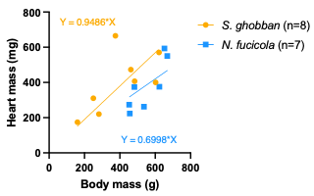
Figure S. 1 Correlation between body mass (g) and heart mass (mg) in the temperate wrasse species N. fucicola (blue) and tropical wrasse species S. ghobban (orange). Linear regression was calculated using the least-squared method in GraphPad Prism, forcing the line to x=0. Each scatter represents one individual.

Table S. 1. Results of the two-way fixed model ANOVA analysis.

Parameter | Figure | Fixed effect | P value | F (DFn, DFd)
Oxygen out | S.2 | Temperature | 0.0024 | F (2.091, 15.52) = 8.917
 |  | Species | 0.0094 | F (1, 12) = 9.527
O₂ consumption | 2.B | Temperature | 0.3174 | F (1.918, 18.65) = 1.215
 |  | Species | <0.0001 | F (1, 175) = 23.18
ECG Rate | 2.C | Temperature | 0.0108 | F (3.707, 33.17) = 3.997
 |  | Species | 0.178 | F (1, 13) = 2.027
Heart Rate | 2.D | Temperature | 0.0011 | F (3.507, 33.96) = 6.265
 |  | Species | 0.6634 | F (1, 13) = 0.1984
Max. Pressure | 2.E | Temperature | 0.2097 | F (2.892, 27.70) = 1.614
 |  | Species | 0.1944 | F (1, 14) = 1.858
Mean outflow P. | 2.F | Temperature | <0.0001 | F (2.287, 20.70) = 15.37
 |  | Species | 0.0925 | F (1, 14) = 3.261
FMN | 3.B | Temperature | 0.0048 | F (22, 159) = 2.097
 |  | Species | 0.9706 | F (1, 9) = 0.001435
Cyt b | 3.B | Temperature | 0.1302 | F (1.361, 10.33) = 2.623
 |  | Species | 0.3037 | F (1, 11) = 1.164
Cyt c | 3.B | Temperature | 0.4394 | F (2.423, 21.04) = 0.8993
 |  | Species | 0.3549 | F (1, 13) = 0.9202
Cyt aa3 | 3.B | Temperature | 0.3278 | F (1.635, 12.18) = 1.186
 |  | Species | 0.8097 | F (1, 10) = 0.06115

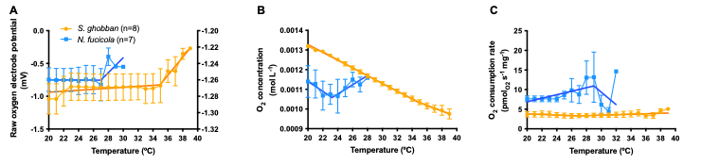
Figure S. 2. Heart oxygen consumption calculation from oxygen saturation recordings in the perfusion media exiting perfused hearts. (A) raw measurements from the MI-730 flow through oxygen electrode (Microelectrodes Inc., Bedford, USA). (B) Conversion of the oxygen saturation recordings to O₂ concentration, with consideration of temperature-dependent diffusion coefficient and water pressure. (C) Oxygen consumption rate of the heart, per milligram of tissue. Data presented as mean ± s.e.m. Detailed description of the analysis can be found at https://github.com/julio0029/spectral_analysis/blob/main/O2_Analysis.py.

