A Computational Study of Ivermectin and Doxycycline Combination Drug against SARS-CoV-2 Infection
Meenakshi Rana¹*, Pooja Yadav², Papia Chowdhury²

¹Department of Physics, School of Sciences, Uttarakhand Open University, Haldwani, 263139, Uttarakhand, India

²Department of Physics and Materials Science and Engineering,
Jaypee Institute of Information Technology, Noida 201309, Uttar Pradesh, India.

*Corresponding author: papia.chowdhury@jiit.ac.in

Keywords: COVID-19; SARS-CoV-2; Ivermectin; Doxycycline; 3CLpro,

SD1: Various parameters like binding affinity, hydrogen bonded interaction, hydrophobic interaction, dipole moment, for three best docked poses for ivermectin+doxycycline: 6LU7 complex.

Pose | Binding affinity (Kcal/mol) | No of Hydrogen bond | No of Hydrophobic interaction | Dipole moment
1 | -7.4 | 11 | 0 | 2.237
2 | -7.1 | 2 | 3 | 2.424
3 | -6.7 | 6 | 3 | 1.633

SD 3: Interactions between SARS-CoV-2 protease and two drugs obtained with individual and sequential docking: hydrogen bonding

Hydrogen Bond Interaction
Drugs | Individual docking |  |  | Drugs | Sequential docking
Ivermectin | Residues | Protein Atom | Ligand Atom | Ivermectin+Doxycycline | Residues | Protein Atom | Ligand Atom
Ivermectin | THR25 | HG1 | O | Ivermectin+Doxycycline | GLY143 | HN | O
Ivermectin | THR26 | HN | O | Ivermectin+Doxycycline | GLY143 | HN | O
Ivermectin | ASN142 | HD22 | O | Ivermectin+Doxycycline | SER144 | HN | O
Ivermectin | THR26 | O | H | Ivermectin+Doxycycline | SER144 | HG | O
Ivermectin | THR26 | O | H | Ivermectin+Doxycycline | CYS145 | HN | O
Ivermectin | THR25 | CA | O | Ivermectin+Doxycycline | GLU166 | HN | O
Ivermectin | PRO168 | CA | O | Ivermectin+Doxycycline | A:LEU141 | O | H
Doxycycline | ASN142 | HD22 | O | Ivermectin+Doxycycline | ASN142: | OD1 | C
Doxycycline | GLU166 | H | H | Ivermectin+Doxycycline | HIS41 | NE2 | C
Doxycycline | GLN189 | OE1 | H | Ivermectin+Doxycycline | GLN189 | OE1 | C
Doxycycline | ASN142 | OD1 | H | Ivermectin+Doxycycline
Doxycycline | HIS163 | NE2 | C | Ivermectin+Doxycycline

SD 3: Pressure progression data for bare 6LU7, Ivermectin: 6LU7, Doxycycline: 6LU7 and Ivermectin+Doxycycline: 6LU7 complex view up to 100000 ps

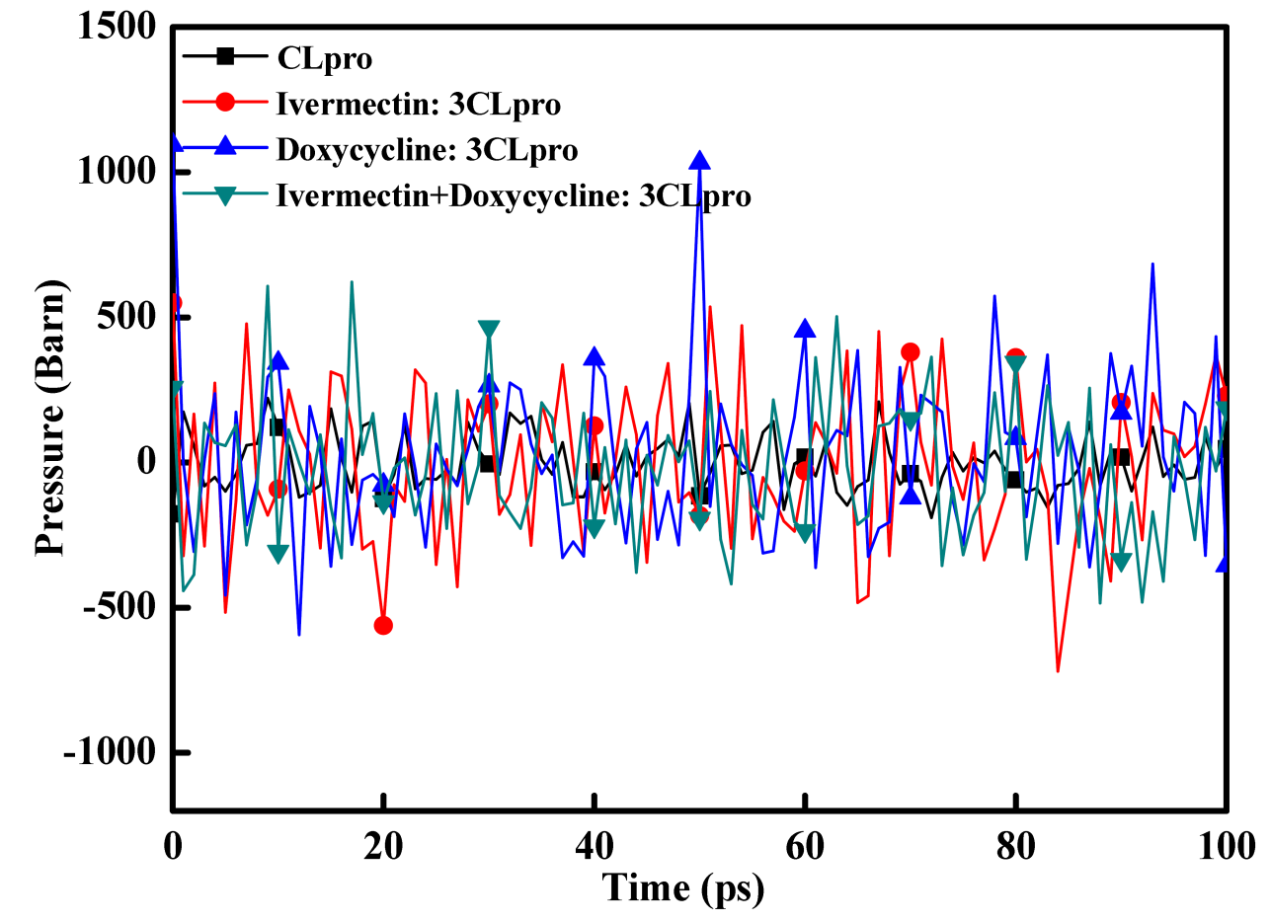

SD 4: Density progression data for bare 6LU7, Ivermectin: 6LU7, Doxycycline: 6LU7 and Ivermectin+Doxycycline: 6LU7 complex view up to 100000 ps.

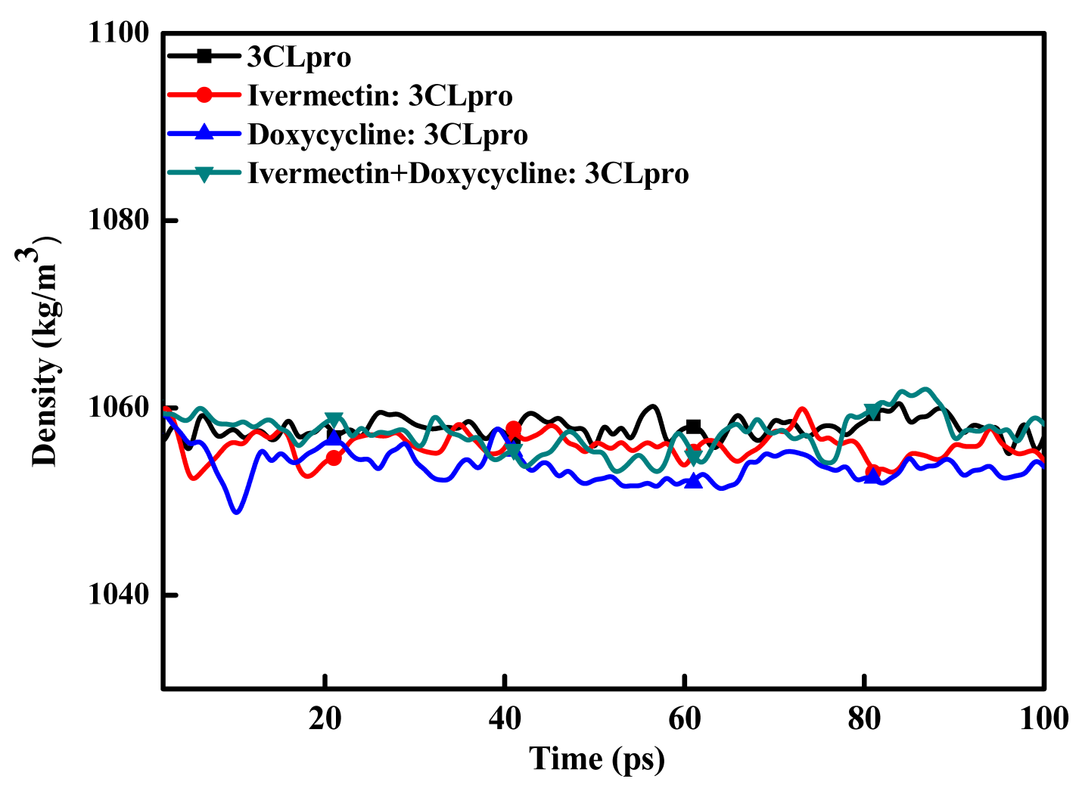

SD 5: Radius of gyration progression data for bare 6LU7view up to 10000ps, Ivermectin: 6LU7 view up to 10000ps, Doxycyline: 6LU7 and Ivermectin+Doxycycline: 6LU7 complex view up to 10000ps.Inset of the figure: Radius of gyration progression data for bare 6LU7 and Ivermectin+Doxycyline: 6LU7 complex view up to 100000ps

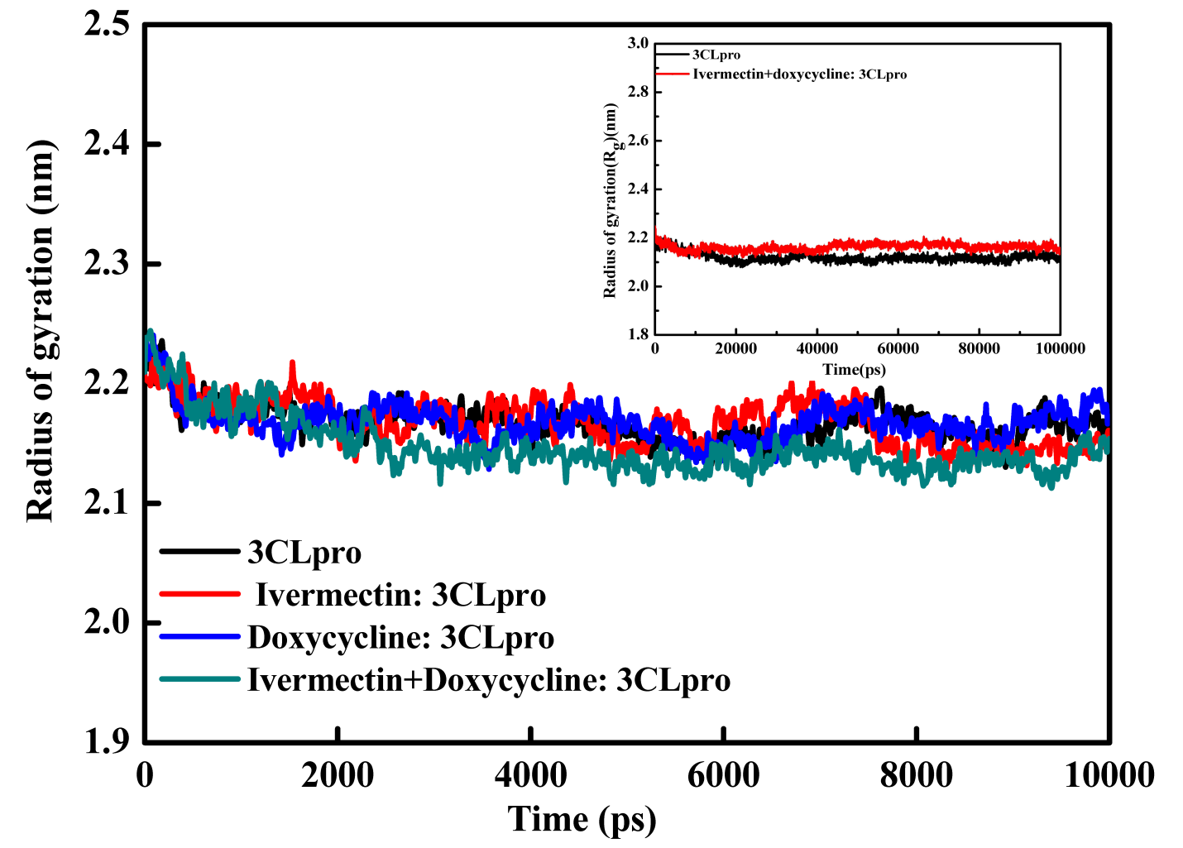

SD 6: SASA area progression data for bare 6LU7, Ivermectin: 6LU7, Doxycyline: 6LU7 and Ivermectin+Doxycyline: 6LU7 complexview up to 10000ps. Inset of the figure: SASA area progression data for bare 6LU7 and Ivermectin+Doxycyline: 6LU7 complex view up to 100000ps

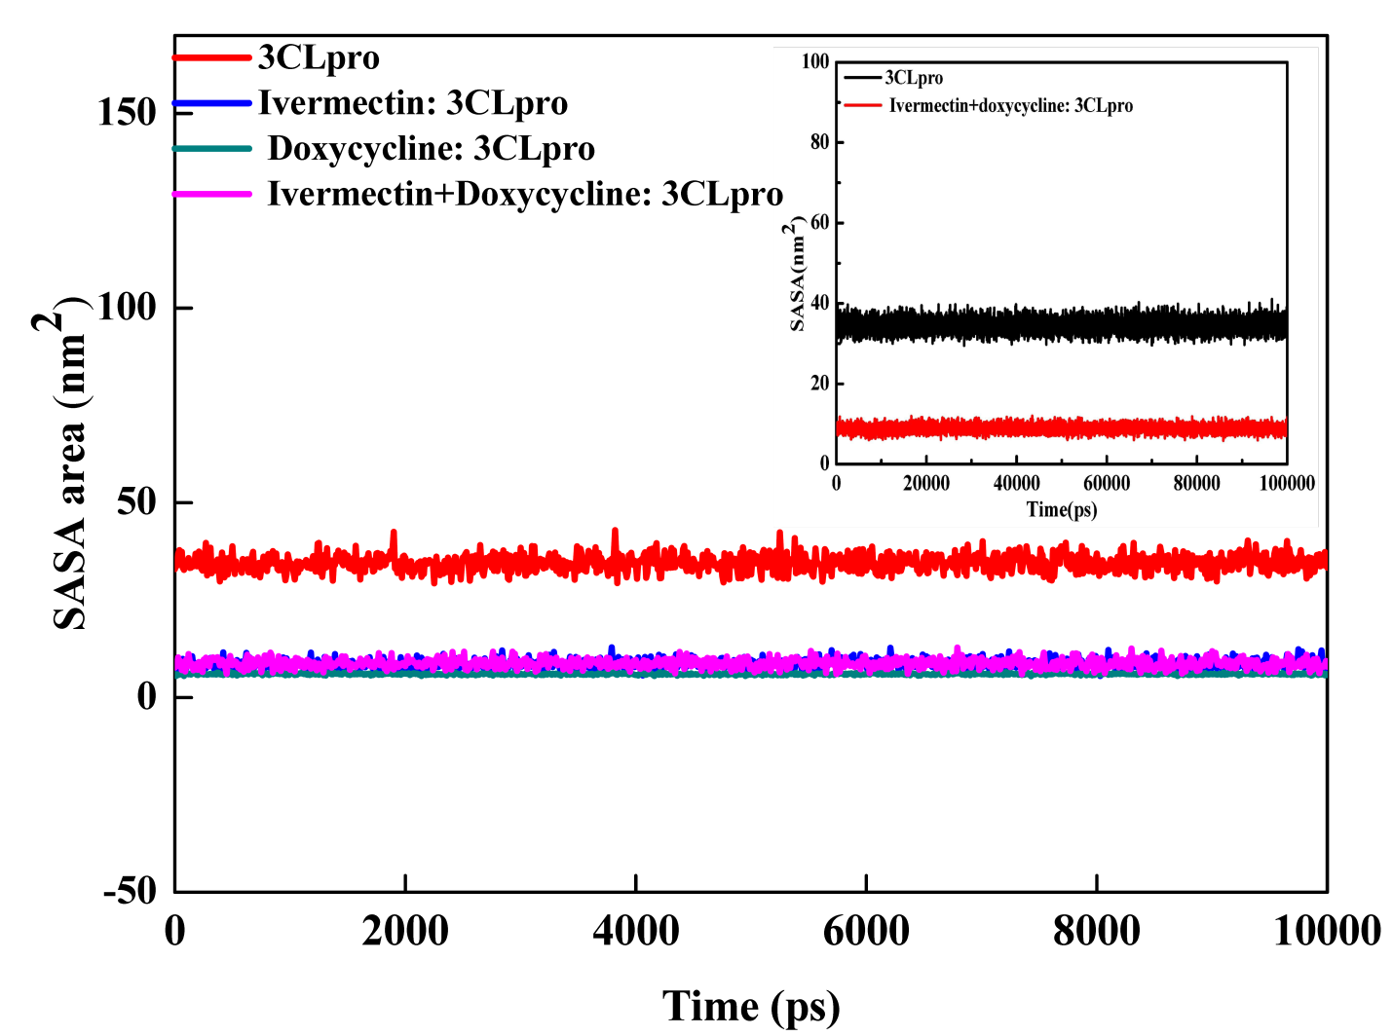

SD 7:Various energy data for Ivermectin: 6LU7 complex for the period of 0 ps to 100000 ps.

#Complex Number: 1
===============
SUMMARY
===============

van der Waal energy = -0.016+/- 0.0007 Kcal/mol

Electrostatic energy = -0.0771 +/- 0.005 Kcal/mol

Polar solvation energy = -2.04 +/- 0.196 Kcal/mol

SASA energy = 0.04 +/- 0.018 Kcal/mol

SAV energy = 0.000 +/- 0.000 kcal/mol

WCA energy = 0.000 +/- 0.000 kcal/mol

Binding energy = -2.085 +/- 0.187 Kcal/mol

===============
END
===============

SD 8: Various energy data for Doxycycline: 6LU7 complex for the period of 0 ps to 100000 ps.

#Complex Number: 1
===============
SUMMARY
===============

van der Waal energy = -5.623 +/- 0.375 Kcal/mol

Electrostatic energy = -2.034 +/- 0.149 Kcal/mol

Polar solvation energy = 6.628 +/- 0.326 Kcal/mol

SASA energy = -0.582 +/- 0.042 Kcal/mol

SAV energy = 0.000 +/- 0.000 Kcal/mol

WCA energy = 0.000 +/- 0.000 Kcal/mol

Binding energy = -1.590+/- 0.301 Kcal/mol

===============
END

SD 9: Various energy data for Ivermectin+Doxycycline: 6LU7 complex for the period of 0 ps to 100000 ps.

#Complex Number: 1
===============
SUMMARY
===============

van der Waal energy = -0.131 +/- 0.060 Kcal/mol

Electrostatic energy = -0.114 +/- 0.028 Kcal/mol

Polar solvation energy = -2.325 +/- 0.321 Kcal/mol

SASA energy = 0.038 +/- 0.023 Kcal/mol

SAV energy = 0.000 +/- 0.000 Kcal/mol

WCA energy = 0.000 +/- 0.000 Kcal/mol

Binding energy = -2.544 +/- 0.309 Kcal/mol

===============
END

