Appendix A: Visual Cue Implementations
This appendix presents supplementary figures from the 20 mapped studies. These examples illustrate further applications of Dillman’s Visual Interaction Cues Framework beyond those highlighted in the main text (Section 4.1). Figures are grouped by framework dimension. Main text figures are listed for continuity, while additional figures are labeled sequentially (A1–A9).
4.1.1 Task/Purpose Dimension
A.1 Discover Cues
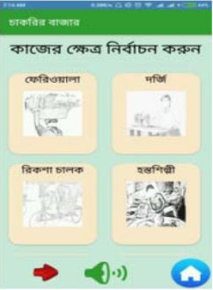 | 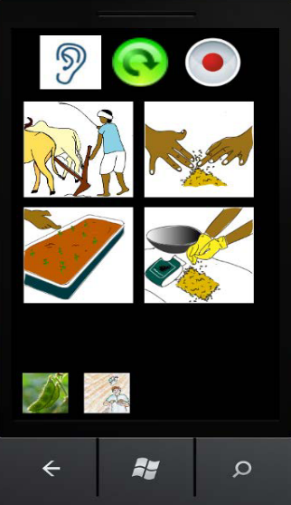 | 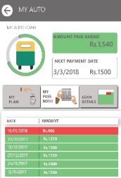
Figure 2. UI section highlighting for category identification [18] | Figure 3. Color-coded sections for menu navigation [23] | Figure 4. Red–green arrows simplifying debit/credit transactions [24]
A.2 Look Cues
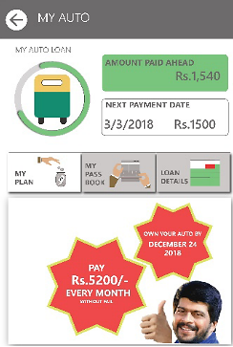 | 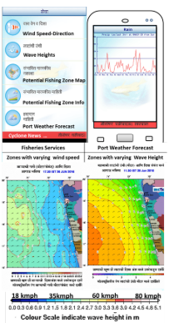
Figure 5 Local celebrity photo used to increase interface trust [16] | Figure 6. Agricultural alerts (Adapted from mKRISHI® interface [25]  )

A.3 Go Cues
Figure 7. Directional arrows and instructional icons for navigation (Adapted from Jan et al., [24]) | 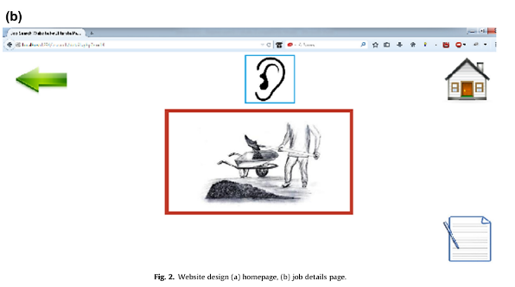 Figure 8: Return Home button for a Job application [26].
   | 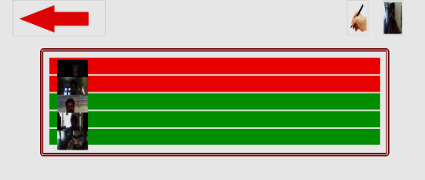

4.1.2 Dimension II: Visual Affordance / Markedness
A.4 Subtle cues

Figure 9. Category-wise color coding and subtle glow cues [17].
A.5 Emphasized cues
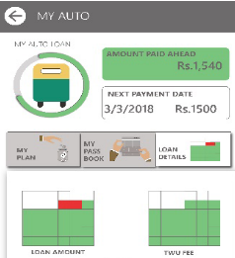Figure 10: Color-coded financial indicators [16] | 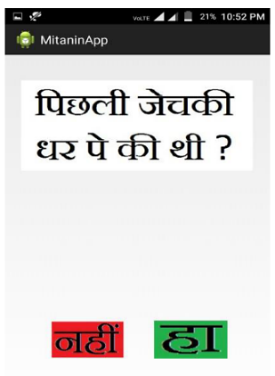  Figure 11: High-contrast coloured button for active state [27]. | 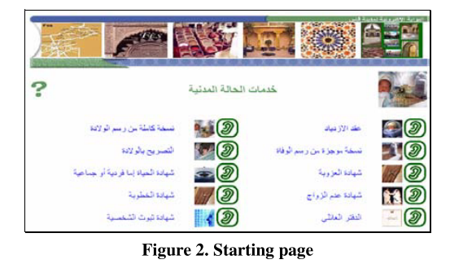Figure 12: Bold sizing and outline for markedness [28].
A.6 Integrated cues
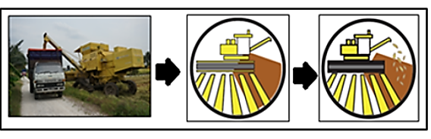 Figure 13: Agricultural metaphor using tractor and funnel UI [15]. | 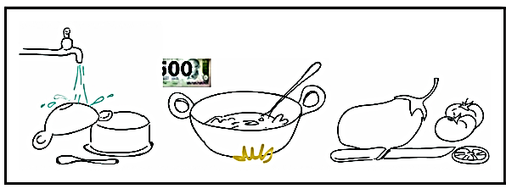  Figure 14: Animation depicting action cue (e.g., water, steam). (Adapted from [29]).
A.7 Overlaid cues
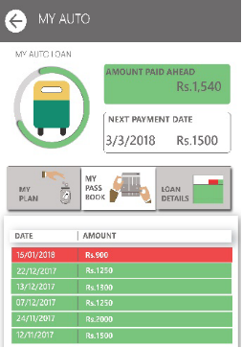  Figure 15: Color-coded payment status sindicators [16]. | 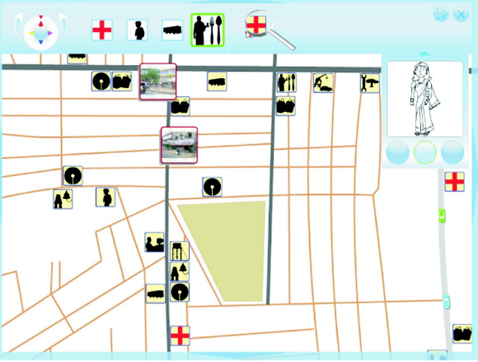  Figure 16. Highlighted maps and directional arrows. Adapted from [23] | Figure 17. Top-navigation bar with breadcrumb progress [30].

4.1.3 Dimension III: Trigger / Action in Visual Cues
A.8 User-triggered cues
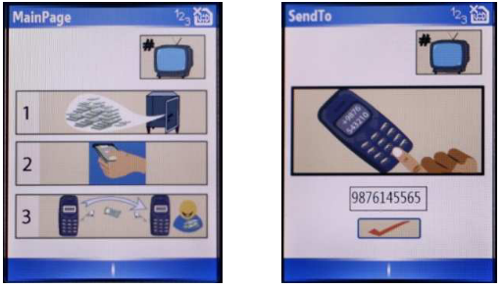  Figure 18: Clipart-based navigation UI [31], | 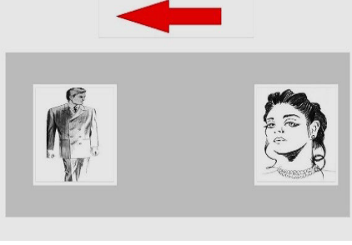  Figure 19: Job selection icons for men/women categories [32].

A.9 Context-triggered cues
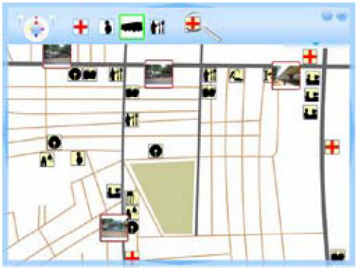 Figure 20: Landmark-based navigation map[29]. | 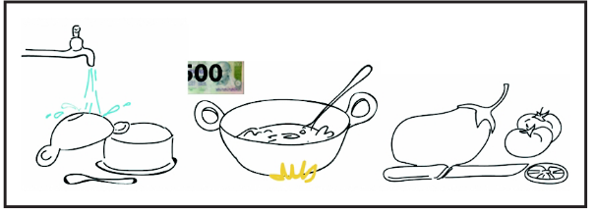  Figure 21: Animated action metaphors for boiling, pouring[29]. | 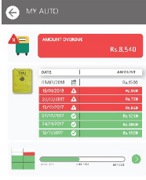Figure 22: Linear progress bar with color-coded tracking[16].

A.10 Agent-Triggered Cues
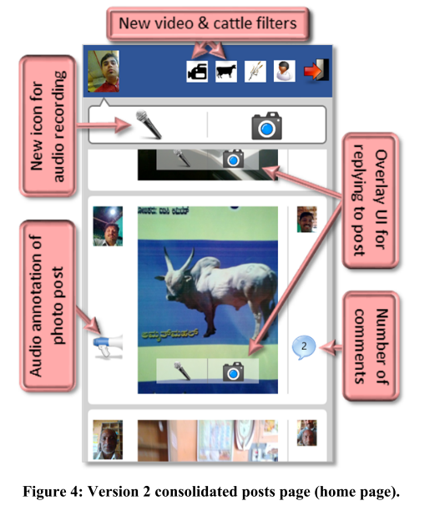  Figure 23: Agent-Triggered Cues in KrishiPusta [15] | 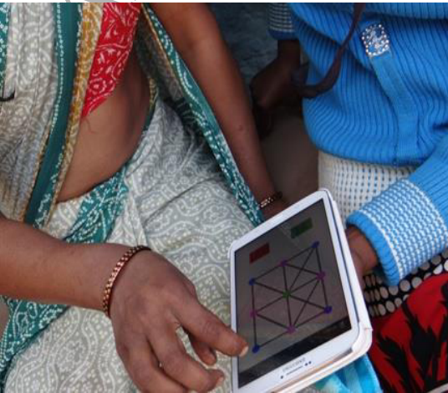  Figure 24: Rangoli-Pattern Login Interface [8]

A.11 Persistent cues
Figure 25. Top-navigation bar with breadcrumb progress [23]

Appendix B: Selected Research Papers for Review
Sno. | Year | Research Articles
1 | 1997 | Sally Grisedale, Mike Graves, A. G. (1997). Designing a graphical user interface for healthcare workers in rural India. CHI 97, Atlanta GA I ISA, 471–478.
2 | 2006 | Medhi, I., Sagar, A., & Toyama, K. (2006, May). Text-free user interfaces for illiterate and semi-literate users. In 2006 international conference on information and communication technologies and development (pp. 72-82). IEEE.
3 | 2007 | Taoufik, I., Kabaili, H., & Kettani, D. (2007, December). Designing an e-government portal accessible to illiterate citizens. In Proceedings of the 1st international conference on Theory and practice of electronic governance (pp. 327-336).
4 | 2008 | Joshi, A., Welankar, N., BL, N., Kanitkar, K., & Sheikh, R. (2008, September). Rangoli: a visual phonebook for low-literate users. In Proceedings of the 10th international conference on Human computer interaction with mobile devices and services (pp. 217-223).
5 | 2009 | Medhi, I., Gautama, S. N., & Toyama, K. (2009, April). A comparison of mobile money-transfer UIs for non-literate and semi-literate users. In Proceedings of the SIGCHI Conference on Human Factors in Computing Systems (pp. 1741-1750).
6 | 2013 | Cuendet, S., Medhi, I., Bali, K., & Cutrell, E. (2013, April). VideoKheti: Making video content accessible to low-literate and novice users. In Proceedings of the SIGCHI conference on human factors in computing systems (pp. 2833-2842).
7 | 2014 | Tiwari, P., & Sorathia, K. (2014, August). Visualising and systematizing a per-poor ICT intervention for Rural and Semi-urban Mothers in India. In Proceedings of the 7th International Symposium on Visual Information Communication and Interaction (pp. 129-138).
8 | 2015 | Medhi-Thies, I., Ferreira, P., Gupta, N., O'Neill, J., & Cutrell, E. (2015, February). KrishiPustak: a social networking system for low-literate farmers. In Proceedings of the 18th ACM Conference on Computer Supported Cooperative Work & Social Computing (pp. 1670-1681).
9 | 2016 | Hill, J., & Simha, R. (2016, May). Designing a literacy-based mobile application for adult learners. In Proceedings of the 2016 CHI Conference Extended Abstracts on Human Factors in Computing Systems (pp. 3076-3083).
10 | 2016 | Singh, D., Piplani, D., Srinivasan, K., & Shinde, S. (2016, December). Visual design for blue ocean services: mKRISHI® fisheries. In Proceedings of the 8th Indian Conference on Human Computer Interaction (pp. 96-101).
11 | 2017 | Khan, I. A., Hussain, S. S., Shah, S. Z. A., Iqbal, T., & Shafi, M. (2017). Job search website for illiterate users of Pakistan. Telematics and Informatics, 34(2), 481-489.
12 | 2017 | Vitos, M., Altenbuchner, J., Stevens, M., Conquest, G., Lewis, J., & Haklay, M. (2017, February). Supporting collaboration with non-literate forest communities in the congo-basin. In Proceedings of the 2017 ACM Conference on Computer Supported Cooperative Work and Social Computing (pp. 1576-1590).
13 | 2017 | Ahmad, T., Batool, A., Khalid, M. S., & Ibtasam, S. (2017, November). Scrolling, Navigation, and Selection: How New Smartphone Users Discover It. In Proceedings of the Ninth International Conference on Information and Communication Technologies and Development (pp. 1-5).
14 | 2018 | Shah, H., & Sengupta, A. (2018). Designing mobile based computational support for low-literate community health workers. International Journal of Human-Computer Studies, 115, 1-8.
15 | 2018 | Padhi, D. R., Joshi, A., Shrivastava, A., & Tulaskar, R. (2018, December). Hierarchy or List? Comparing Menu Navigation by Emergent Users. In Proceedings of the 9th Indian Conference on Human-Computer Interaction (pp. 29-34).
16 | 2019 | Ahmed, M. A., Islam, M. N., Jannat, F., & Sultana, Z. (2019, January). Towards developing a mobile application for illiterate people to reduce digital divide. In 2019 International Conference on Computer Communication and Informatics (ICCCI) (pp. 1-5). IEEE.
17 | 2019 | Tandon, U., Siri, L., Mehra, A., & O'Neill, J. (2019, January). Designing a financial management smartphone app for users with mixed literacies. In Proceedings of the Tenth International Conference on Information and Communication Technologies and Development (pp. 1-5).
18 | 2020 | Jan, S., Maqsood, I., Ahmed, S., Wadud, Z., & Ahmad, I. (2020). Investigating the Use of Email Application in Illiterate and SemiIlliterate Population,”. Computers, Materials\& Continua, 62(3).
19 | 2020 | Jamali, S. N., Admodisastro, N., & Kamarudin, A. (2020, September). Metaphor design in localising user interface for farmers in Malaysia using user-centered approach. In 2020 International Conference on Computer Science and Its Application in Agriculture (ICOSICA) (pp. 1-7). IEEE.
20 | 2021 | Ilyas, Q. M., Ahmad, M., Zaman, N., Alshamari, M. A., & Ahmed, I. (2021). Localized text-free user interfaces. IEEE Access, 10, 2357-2371.

