Supplementary Information for
Superentangled polymer networks by stable acoustic cavitation

Cindy Escalona ^{1,†}, Hyoeun Kim ^{1,†}, Seungo Baek ^{1,2,†}, Haeji Kim ³, Jingyu Deng ⁴, Taewon Kang ³, Junsoo Kim ^{3*}, and Gun Kim ^{1,2*}

Corresponding authors:
gun.kim@ntu.edu.sg
junsoo.kim@northwestern.edu

The PDF file includes:

Supplementary Text
Figs. S1 to S10
Tables S1 to S3
References
Movies S1

Other Supplementary Information for this manuscript include the following:

Movies S1

Supplementary Text

Bubble dynamics
To investigate the dynamic response of microbubbles in acoustic fields, we numerically solved the Rayleigh-Plesset equation (34, 35), which describes the radial motion of a gas bubble in a liquid medium. The governing equation is:

$RR''+\frac{3}{2}R'^{2}=\frac{1}{ρ}(P_{g}+\frac{R}{c}\frac{dP_{g}}{dt}-P_{a}-P-\frac{2σ}{R}-4μ\frac{R'}{R})$ [1]

where R is the instantaneous bubble radius, P_{a} is the ambient pressure, and $c$, $ρ$, $μ$, and $σ$ denote the speed of sound, density, viscosity, and surface energy of water, respectively. The internal gas pressure (P_{g}) was modeled as an adiabatic process:

$P_{g}=P_{a}(\frac{R_{0}}{R})^{3γ}$ [2]

where $γ=1.4$ is the adiabatic index, R₀ is the initial bubble radius of the bubble nucleus. The acoustic pressure (P) was applied as a sinusoidal driving term:

$P=P_{0}sin(kx-ωt)$ [3]

where P₀ is the peak acoustic pressure amplitude, and $ω$ ($=2πf$) and $k$ are the angular frequency and wavenumber, respectively. Numerical simulations were performed using the Radau stiff ODE solver in Python. For each frequency ($f$ = 0.1, 0.5, 1.0, and 5.0 MHz), the peak pressure amplitude (P₀) was varied from 0.1 to 3.0 MPa in 0.1 MPa increments. Each simulation covered 100 acoustic cycles, with 10,000 uniformly spaced time steps. Initial conditions were set as R₀ = 2 and 5 μm and R’₀ = 0 m s⁻¹. The mean bubble radius (R_{mean}) was computed over the last 50% of the simulation duration to exclude initial transients, and was normalized by R₀. This bubble expansion ratio (R_{mean}/R₀) was then used to quantify oscillation amplitude as a function of acoustic pressure and frequency.
In standing waves, oscillating bubbles experience translational motion due to the primary Bjerknes force (F_{B}) (34). This force arises from the phase difference between the time-varying bubble volume and the spatial pressure gradient of the acoustic field, and is expressed as:

$F_{B}=-<V\frac{∂P}{∂x}>$ [4]

where V is the instantaneous bubble volume, $\frac{∂P}{∂x}$ is the spatial gradient of acoustic pressure, and $<⋅>$ denotes a time-average over one acoustic cycle. In standing waves, the direction of F_{B} is determined by the ratio R to the resonance radius (R_{res}), the radius at which the bubble’s natural frequency matches the driving frequency. The resonance radius can be estimated from the Minnaert relation:

$R_{res}=\frac{1}{2πf}\sqrt{\frac{3γP_{a}}{ρ}}$ [5]

When R < R₀, the bubble oscillates in-phase with the acoustic pressure, driving it toward pressure antinodes. In contrast, when R > R₀, the bubble oscillates out-of-phase with the pressure field, driving it toward pressure nodes. This resonance-dependent reversal in migration direction plays a central role in determining the spatial distribution of bubbles in standing wave fields.

Characteristics of FUS beam and standing waves
The theoretical full width at half maximum (FWHM) beamwidth, B_{FWHM}, and depth-of-field, D_{FWHM}, of the FUS beam are determined by (36):

$B_{FWHM}=1.028λf_{\#}$ [6]

$D_{FWHM}=7.08λ{f_{\#}}^{2}$ [7]

where $λ$ is the wavelength and f# is the f-number of the transducer. Since D_{FWHM} for each excitation frequency (24 mm for 438 kHz, 12 mm for 876 kHz, 8 mm for 1,314 kHz, and 7 mm for 1,500 kHz) was larger than the mold thickness L (5.5 mm), the focal region can be approximated using one-dimensional (1-D) wave propagation (fig. S4). Within the mold, standing waves form due to multiple reflections at the acoustic membrane attached to the top and bottom surfaces. In 1-D wave propagation, standing waves can be modeled as the superposition of forward- and backward-reflected waves. The general expression for the pressure distribution at position z is given by (37):

$P(z)=P_{0}\sum_{n=0}^{N}{{r_{T}}^{[\frac{n+1}{2}]}{r_{B}}^{[\frac{n}{2}]}ηsin(kϕ-ωt)}=P_{0}Ξsin(ωt-φ)$ [8]

where:

$ϕ=nL+z+(L-2z)(n mod 2)$ [9]

$η=e^{-αfϕ}$ [10]

$Ξ=\sqrt{[\sum_{n=0}^{N}{{r_{T}}^{[\frac{n+1}{2}]}{r_{B}}^{[\frac{n}{2}]}ηsin(kϕ)}]^{2}+[\sum_{n=0}^{N}{{r_{T}}^{[\frac{n+1}{2}]}{r_{B}}^{[\frac{n}{2}]}ηcos(kϕ)}]^{2}}$ [11]

$φ=tan^{-1}(\frac{\sum_{n=0}^{N}{{r_{T}}^{[\frac{n+1}{2}]}{r_{B}}^{[\frac{n}{2}]}ηsin(kϕ)}}{\sum_{n=0}^{N}{{r_{T}}^{[\frac{n+1}{2}]}{r_{B}}^{[\frac{n}{2}]}ηcos(kϕ)}})$ [12]

Here, $ϕ$ represents the travel distance of the n-th reflected wave. The reflection coefficient for a wave incident from medium 1 to medium 2 is given by:

$r=(ρ_{2}c_{2}-ρ_{1}c_{1})/(ρ_{2}c_{2}+ρ_{1}c_{1})$ [13]

The subscripts T and B denote the top and bottom boundaries, respectively. The attenuation correction term ($η$) accounts for the exponential decay of energy as it propagates through the sample, governed by the attenuation coefficient ($α$). The amplification factor of standing waves, $Ξ$, derived from phasor algebra, facilitates the estimation of the superposed pressure, with the corresponding phase value given by $φ$. The peak pressure at the antinode of standing waves is then determined as:

$P_{Antinode}=arg max_{z∈[0,L]}P_{0}Ξ$ [14]

Based on this model, for our experimental condition with L = 5.5 mm, the standing waves further amplify the acoustic pressure of the FUS transducer by 1.3, 1.1, 1.1, and 1.5 times at 438, 876, 1,314, and 1,500 kHz, respectively.
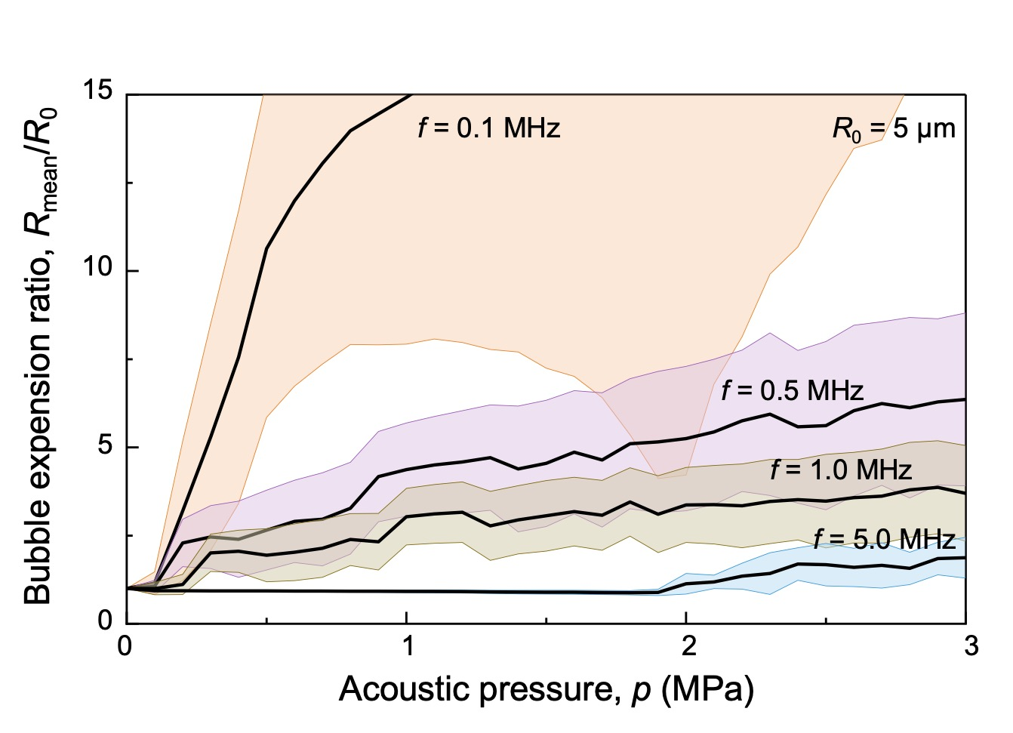
Figure S1. Simulated bubble expansion ratio (R_{mean}/R₀) as a function of acoustic pressure at frequencies of 0.1, 0.5, 1.0, and 5.0 MHz. The initial bubble radius was set to R₀ = 5 μm.

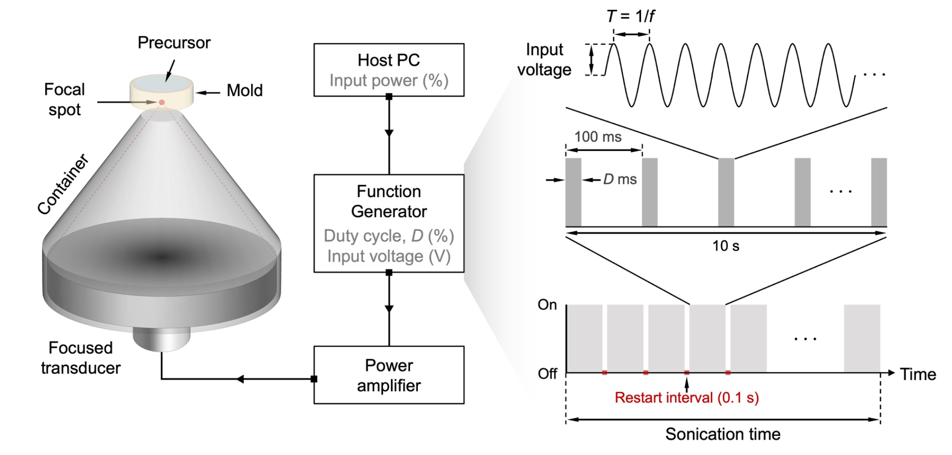
Figure S2. Experimental setup and pulsed ultrasound scheme. The precursor in the mold is positioned at the focal spot of a FUS transducer. FUS is applied with on-off control using a 100 ms pulse repetition time. Both duty cycle and input voltage (will be calibrated to the acoustic pressure) are adjustable via the function generator, enabling precise control of ultrasound application.

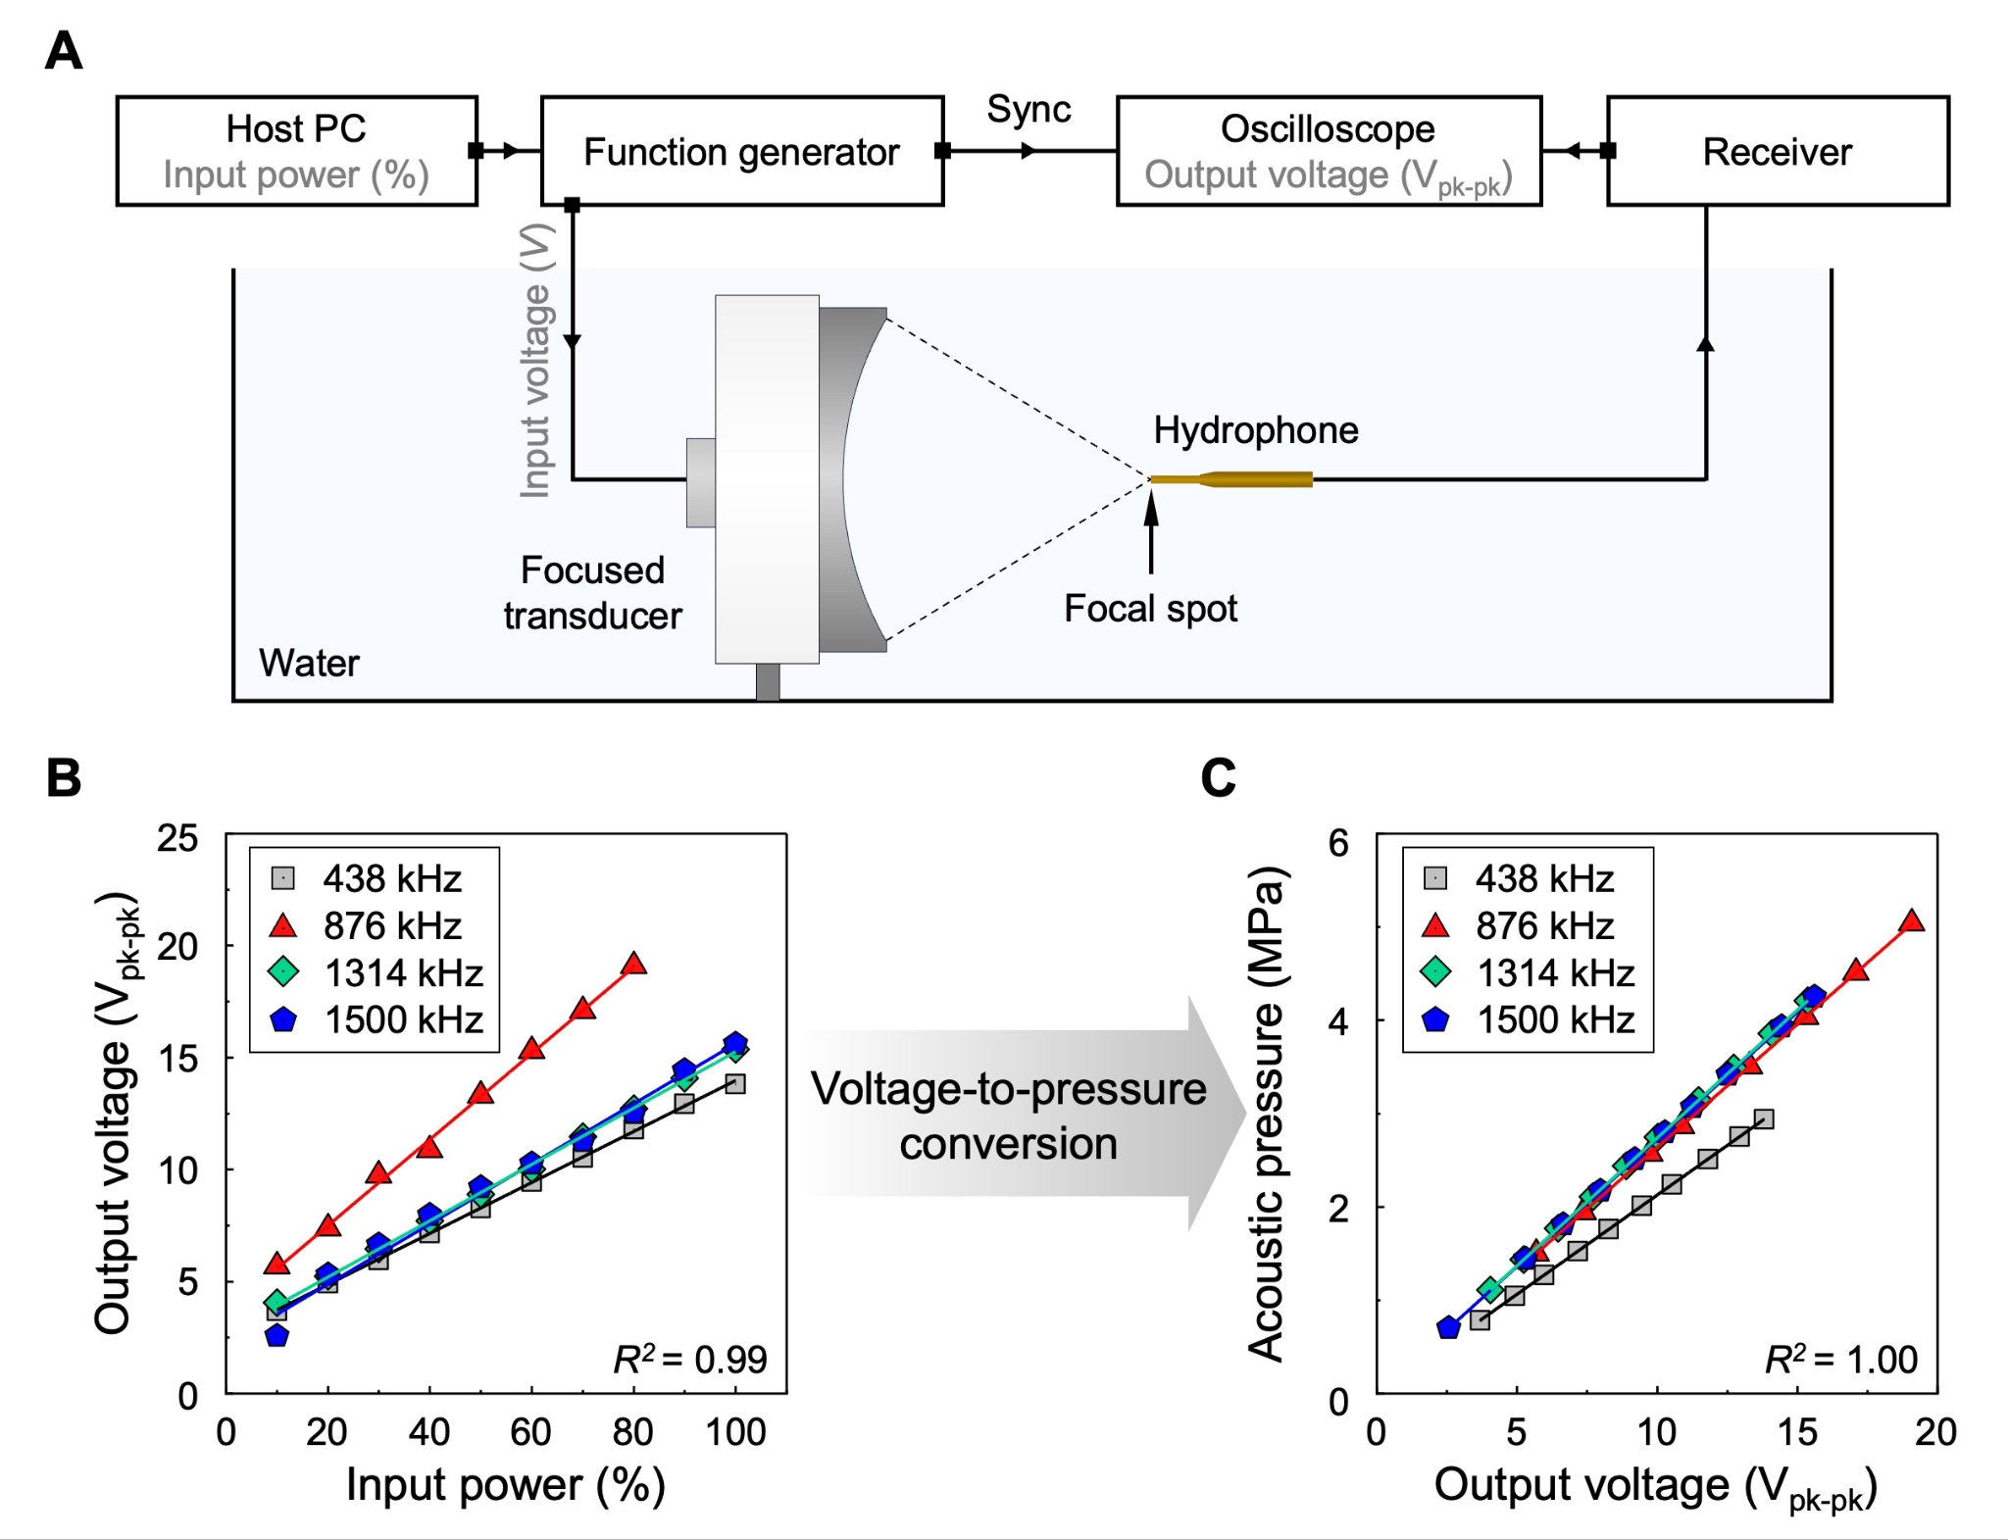
Figure S3. Calibration of transducer acoustic pressure. (A) Experimental setup for calibration. (B) Conversion curve from input power to output voltage for each frequency (438, 876, 1,314, and 1,500 kHz). (C) Conversion curve from output voltage to acoustic pressure for the same set of frequencies.

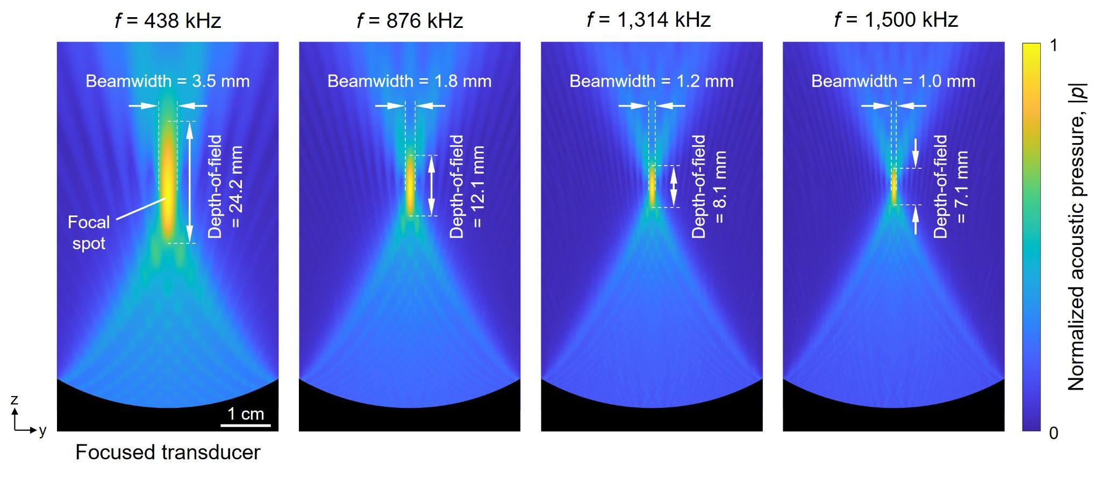
Figure S4. Simulated pressure fields at different frequencies. The pressure values are normalized to the spatial maximum in each case. The simulated beamwidth and depth-of-field of the FUS beam match theoretical values (supplementary text). The mold thickness is set to 5.5 mm to be smaller than the depth of field, where the standing waves are approximately 1D.

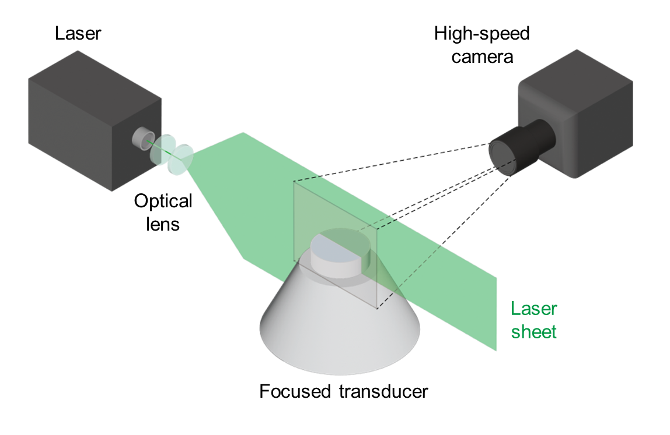
Figure S5. Schematic of the high-speed video setup for visualizing standing wave beam patterns within the mold. The mold, filled with deionized water containing microbeads, was positioned so that the FUS focal spot coincided with its geometrical center. A laser sheet illuminated a vertical cross-section of the mold. During FUS application, the motion of microbeads was recorded in real time using a high-speed camera.

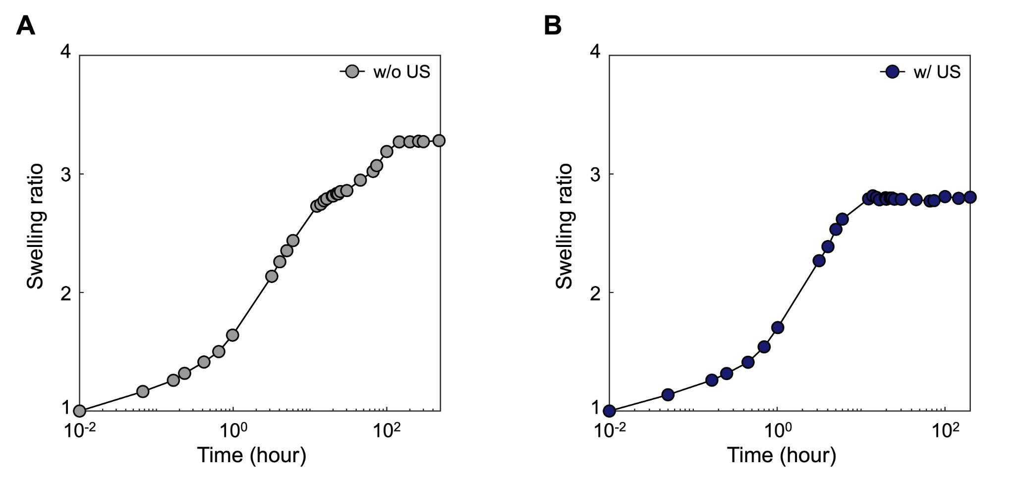
Figure S6. Swelling of the highly entangled hydrogel over time. (A) Without ultrasound. (B) With ultrasound. The ultrasound conditions: Duty cycle = 4%, acoustic pressure = 1.18 MPa, total energy = 9 kJ/cm², and frequency = 438 kHz. After synthesis, the hydrogel is submerged in water and is weighed at various times. After 20 hours, the hydrogel swells to equilibrium. The observed time to equilibrium is understood in terms of the diffusion of water in a polymer of a given thickness. Estimate the time to equilibrium by τ ~ L²/D, where L is the thickness (1.3 mm) and D is the diffusivity of water (10⁻⁹ m² s), giving τ ~ 0.5 hours.

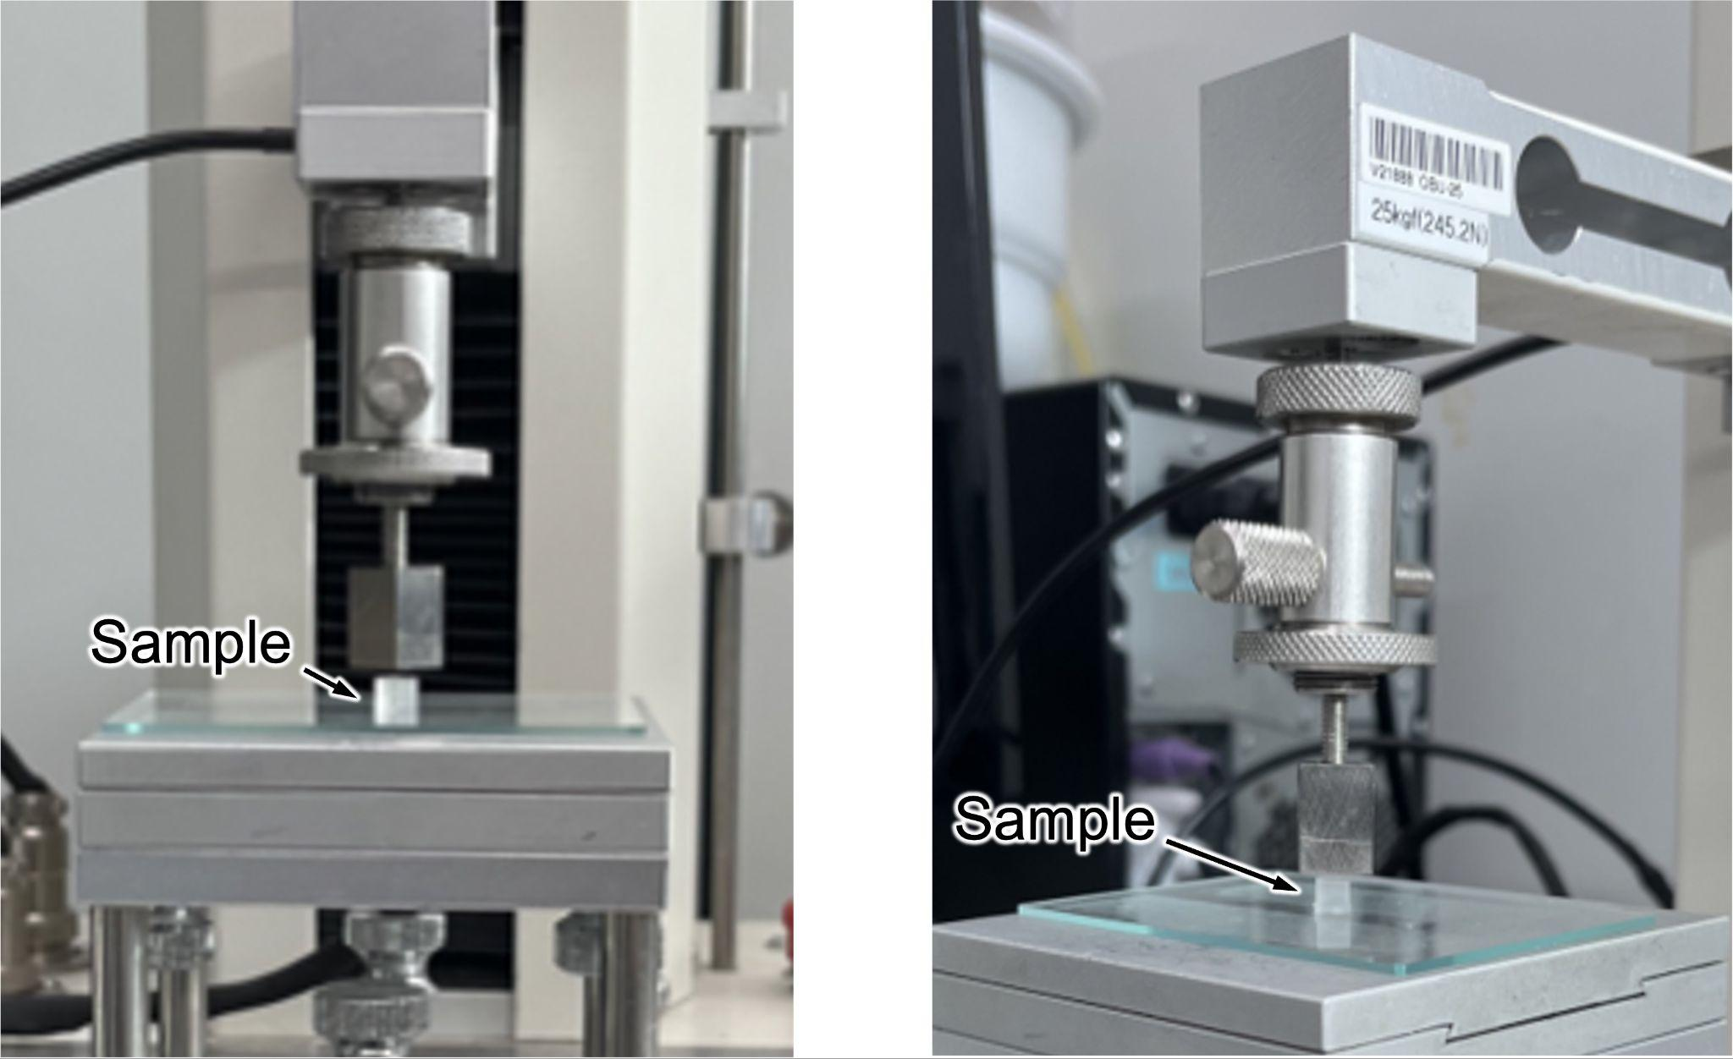
Figure S7. Experimental setup for compression testing of swollen hydrogel samples. Laser-cut hydrogel samples were positioned at the center along the loading axis. A preload of 0.0010 N was applied to ensure complete contact, and the test was conducted at a constant rate of 0.04 mm s⁻¹.

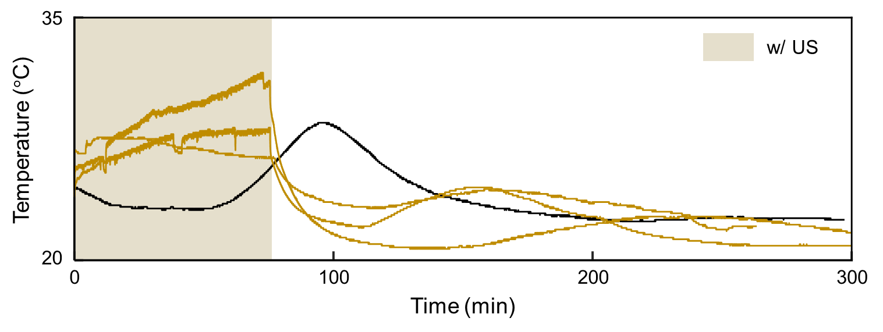
Figure S8. Repeated temperature profiles under 9 kJ/cm² sonication. The navy line indicates the reference sample, and the yellow lines represent samples subjected to ultrasound. The shaded background represents the duration of ultrasound application. Repeated measurements showed no significant thermal accumulation, supporting that the effects of ultrasound are primarily from mechanical rather than thermal.

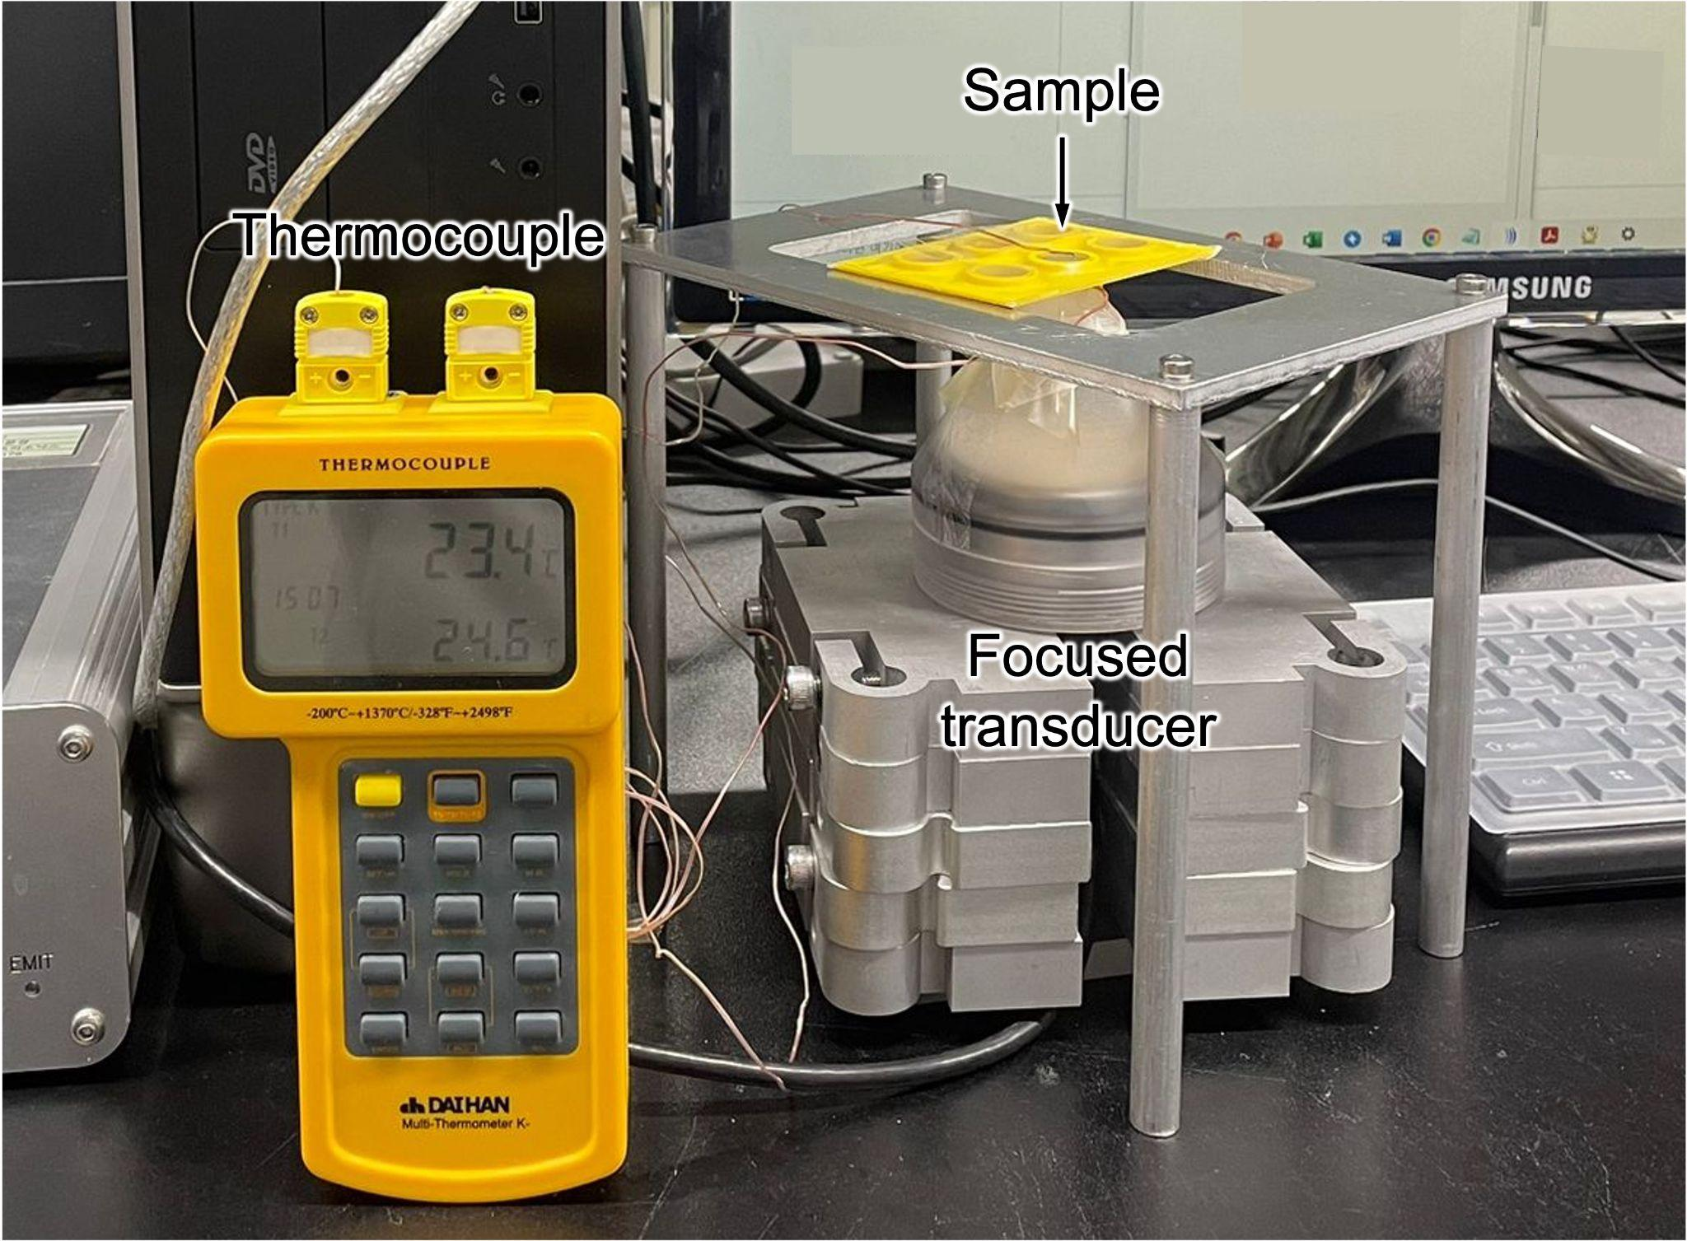
Figure S9. Monitoring temperature during polymerization. A thermocouple was placed at the ultrasound focal region, in the center of the mold, to record the temperature during polymerization. The hydrogel precursor was irradiated from below using the FUS transducer, with a 2 mm-thick ultrasound transmission gel layer ensuring efficient energy transfer.

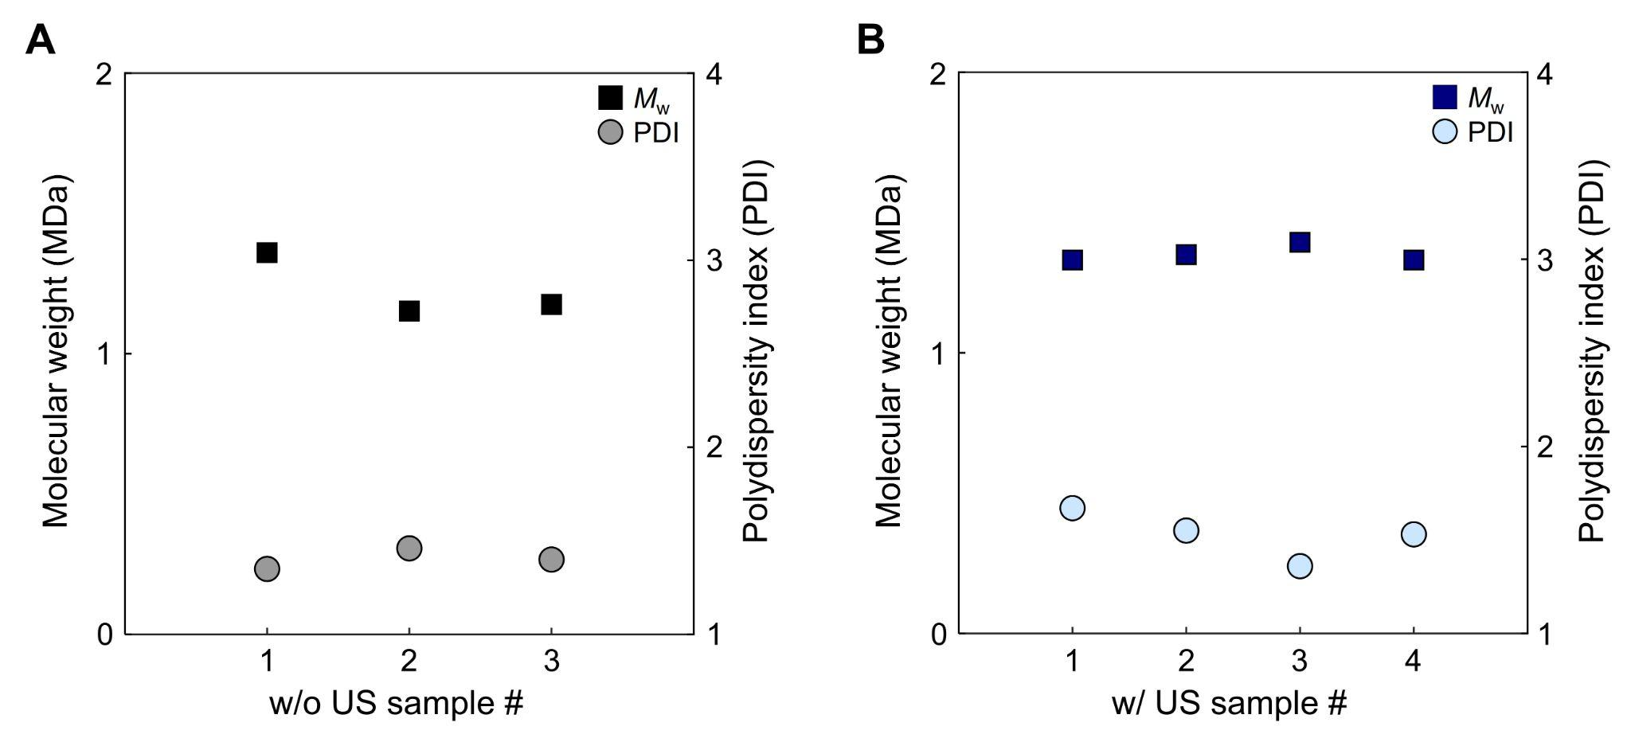
Figure S10. Comparison of molecular weight (M_{w}) and polydispersity index (PDI) between samples with ultrasound and without ultrasound polymer. (A) Without ultrasound. (B) With ultrasound. The ultrasound conditions: Duty cycle = 4%, acoustic pressure = 1.18 MPa, total energy = 9 kJ/cm², and frequency = 438 kHz.

 | 438 kHz |  |  | 876 kHz |  |  | 1,314 kHz |  |  | 1,500 kHz
Input power (%) | Acoustic pressure (MPa) | I_{SPTA}  (W cm⁻²) | F  (kg (m s)⁻²) | Acoustic pressure (MPa) | I_{SPTA}  (W cm⁻²) | F  (kg (m s)⁻²) | Acoustic pressure (MPa) | I_{SPTA}  (W cm⁻²) | F  (kg (m s)⁻²) | Acoustic pressure (MPa) | I_{SPTA}  (W cm⁻²) | F  (kg (m s)⁻²)
10 | 0.73 | 17.54 | 2.36 | 1.32 | 57.55 | 15.46 | 0.98 | 31.50 | 12.69 | 0.62 | 12.58 | 5.79
20 | 0.97 | 31.37 | 4.21 | 1.71 | 96.62 | 25.96 | 1.26 | 52.61 | 21.20 | 1.27 | 53.41 | 24.57
30 | 1.18 | 46.10 | 6.19 | 2.26 | 168.99 | 45.40 | 1.56 | 80.09 | 32.27 | 1.60 | 83.96 | 38.62
40 | 1.42 | 66.50 | 8.93 | 2.52 | 210.11 | 56.44 | 1.86 | 113.80 | 45.86 | 1.91 | 120.69 | 55.52
50 | 1.64 | 88.62 | 11.90 | 3.09 | 314.58 | 84.51 | 2.14 | 151.77 | 61.16 | 2.21 | 160.90 | 74.01
60 | 1.87 | 115.93 | 15.57 | 3.55 | 416.46 | 111.88 | 2.42 | 192.70 | 77.65 | 2.46 | 200.20 | 92.09
70 | 2.08 | 143.50 | 19.27 | 3.97 | 519.55 | 139.57 | 2.77 | 252.50 | 101.75 | 2.70 | 240.89 | 110.81
80 | 2.34 | 180.58 | 24.26 | 4.43 | 648.45 | 174.20 | 3.07 | 310.85 | 125.26 | 3.01 | 298.11 | 137.13
90 | 2.56 | 216.70 | 29.11 | N/A | N/A | N/A | 3.40 | 380.47 | 153.31 | 3.46 | 395.36 | 181.87
100 | 2.74 | 247.15 | 33.20 | N/A | N/A | N/A | 3.71 | 453.31 | 182.67 | 3.74 | 462.44 | 212.72
Table S1. Acoustic pressure, energy (I_{SPTA}), and radiation force (F) applied to the precursor solution. These values were corrected for transmission loss through the acoustic membrane.
Normalized Energy | Duty Cycle (%)
Input power (%) |  | 10 | 20 | 30 | 40 | 50 | 60 | 70 | 80 | 90 | 100
Input power (%) | 10 | 0.007 | 0.014 | 0.021 | 0.028 | 0.036 | 0.043 | 0.050 | 0.057 | 0.064 | 0.071
Input power (%) | 20 | 0.013 | 0.025 | 0.038 | 0.051 | 0.063 | 0.076 | 0.089 | 0.102 | 0.114 | 0.127
Input power (%) | 30 | 0.019 | 0.037 | 0.056 | 0.075 | 0.093 | 0.112 | 0.131 | 0.149 | 0.168 | 0.187
Input power (%) | 40 | 0.027 | 0.054 | 0.081 | 0.108 | 0.135 | 0.161 | 0.188 | 0.215 | 0.242 | 0.269
Input power (%) | 50 | 0.036 | 0.072 | 0.108 | 0.143 | 0.179 | 0.215 | 0.251 | 0.287 | 0.323 | 0.359
Input power (%) | 60 | 0.047 | 0.094 | 0.141 | 0.188 | 0.235 | 0.281 | 0.328 | 0.375 | 0.422 | 0.469
Input power (%) | 70 | 0.058 | 0.116 | 0.174 | 0.232 | 0.290 | 0.348 | 0.406 | 0.464 | 0.523 | 0.581
Input power (%) | 80 | 0.073 | 0.146 | 0.219 | 0.292 | 0.365 | 0.438 | 0.511 | 0.585 | 0.658 | 0.731
Input power (%) | 90 | 0.088 | 0.175 | 0.263 | 0.351 | 0.438 | 0.526 | 0.614 | 0.701 | 0.789 | 0.877
Input power (%) | 100 | 0.100 | 0.200 | 0.300 | 0.400 | 0.500 | 0.600 | 0.700 | 0.800 | 0.900 | 1.000
Table S2. Normalized ultrasound energy at various duty cycles and input power. This matrix allows us to find the ultrasound conditions for Fig. 4D and 4E, where ultrasound energy is constant at different duty cycles.

 | Duty cycle (%) | Acoustic pressure (MPa) | Number Average (M_{n}) | Weight average (M_{w}) | Z average (M_{z}) | Polydispersity index (PDI)
Ultrasound parameter | 10 | 2.74 | 719.57 | 1.299.88 | 1.628.94 | 1.81
Ultrasound parameter | 30 | 1.87 | 886.24 | 1.359.07 | 1.686.45 | 1.53
Ultrasound parameter | 40 | 1.42 | 776.96 | 1.290.40 | 1.661.18 | 1.66
Ultrasound parameter | 50 | 1.18 | 421.26 | 1.123.30 | 1.626.56 | 2.67
Ultrasound parameter | 80 | 0.97 | 256.19 | 1.001.96 | 1.547.02 | 3.91
Table S3. Molecular weight distribution and polydispersity in Figure 4D. Numerical values corresponding to Fig.4D, showing the effect of ultrasound duty cycle on M_{n} and PDI. As the duty cycle increases, inertial cavitation with elevated temperature and radical generation occurs, resulting in reduced M_{n} and increased PDI.
References and notes
34. O. Louisnard, Analytical expressions for primary Bjerknes force on inertial cavitation bubbles. Phys. Rev. E—Statistical Nonlinear Soft Matter Phys. 78, 036322 (2008).
35. W.-S. Chen, X. Lu, Y. Liu, P. Zhong, The effect of surface agitation on ultrasound-mediated gene transfer in vitro. J. Acoust. Soc. Am. 116, 2440–2450 (2004).
36. K. Raum, W. D. O’Brien, Pulse-echo field distribution measurement technique for high-frequency ultrasound sources. IEEE Trans. Ultrason. Ferroelectr. Freq. Control 44, 810–815 (1997).
37. S. Baek, G. Kim, J.-Y. Kim, Nonlinear standing waves for assessing material nonlinearity in thin samples. Ultrasonics 142, 107385 (2024).

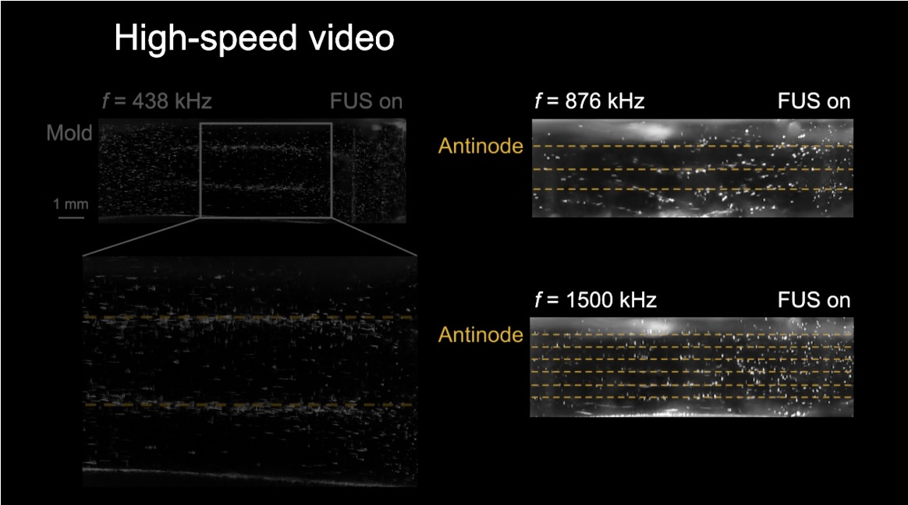
Movie S1. High-speed video showing standing wave formation inside the mold at excitation frequencies of 438, 876, and 1,500 kHz. With increasing frequency, more antinodes are formed. No large bubbles or inertial cavitation are observed, given the spatial resolution (~10 μm).

