Preparing Dispersion Model Surface Meteorological Inputs Using High-Resolution Rapid Refresh (HRRR) Data
Xueying Zhang*^{1,2}, Elaine Symanski^{1,2}, Hannah Renee Paduch², Itai Kloog^{3,4}, Yuxuan Wang⁵, Yang Liu⁶
- Department of Medicine, Section of Epidemiology and Population Sciences, Baylor College of Medicine, Houston, TX, USA
- Center for Precision Environmental Health, Baylor College of Medicine, Houston, TX, USA
- Department of Environmental Medicine, Icahn School of Medicine at Mount Sinai, New York, NY, USA
- Institute for Exposomic Research, Icahn School of Medicine at Mount Sinai, New York, NY, USA
- Department of Earth and Atmospheric Sciences, University of Houston, Houston, TX, USA
- Gangarosa Department of Environmental Health, Rollins School of Public Health, Emory University, Atlanta, Georgia, USA

Corresponding author:
Xueying Zhang, xueying.zhang@bcm.edu
Department of Medicine Section of Epidemiology and Population Sciences and Center for Precision Environmental Health, Baylor College of Medicine, Houston, TX, USA

KEYWORDS: Meteorology, Dispersion Model, Atmospheric Science, Air Quality

Figure S1. Pairwise Pearson correlation coefficients between AERMET-format meteorological variables derived from HRRR scenarios 1 (variables names ended with “_hrrr1”) and corresponding observational meteorological data (variable named ended with “_obs”). Correlations were computed for numerical meteorology only. H: sensible heat flux, u: surface friction velocity, w: convective velocity scale, Z_{ic}: convective mixing height, Z_{im}: mechanical mixing height, L: Monin-Obukhov length, z₀: surface roughness length, Bo: Bowen ratio, r: Albedo, Ws: wind speed, Wd: wind direction in degrees, temp: temperature in Kelvin at 2m reference height, pamt: hourly precipitation amount in kg/m², rh: relative humidity, pres: station pressure, ccvr: cloud cover scale to 0-10 where 5 translates to 50% cloud cover.
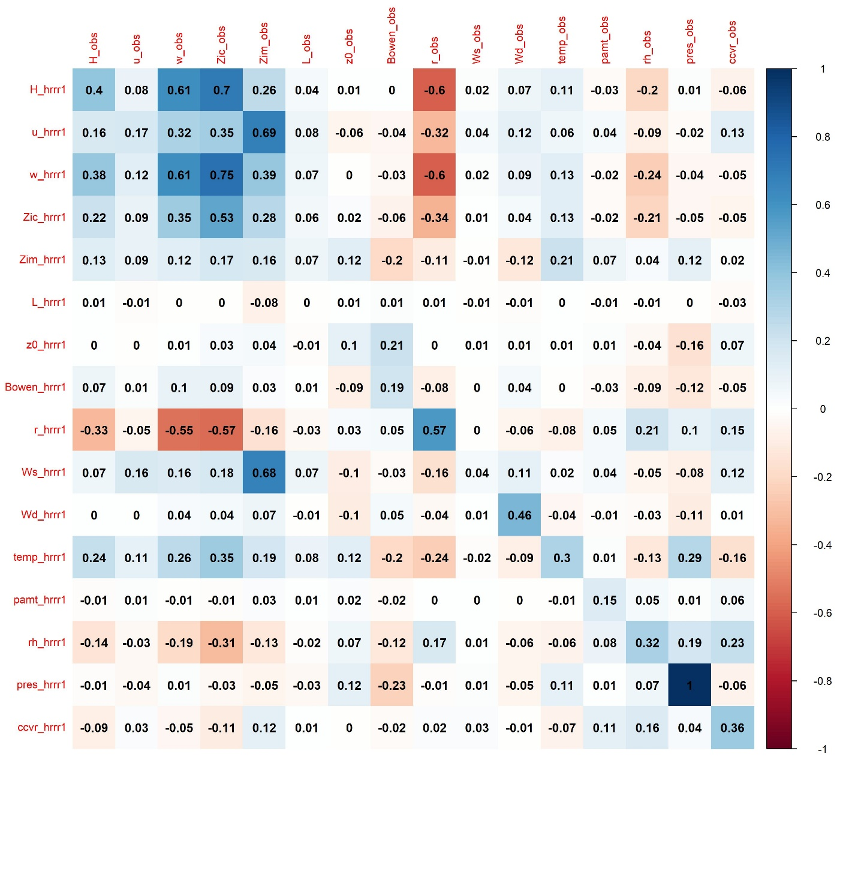

Figure S2. Pairwise Pearson correlation coefficients between AERMET-format meteorological variables derived from HRRR scenarios 2 (variables names ended with “_hrrr2”) and corresponding observational meteorological data (variable named ended with “_obs”). Correlations were computed for numerical meteorology only. H: sensible heat flux, u: surface friction velocity, w: convective velocity scale, Z_{ic}: convective mixing height, Z_{im}: mechanical mixing height, L: Monin-Obukhov length, z₀: surface roughness length, Bo: Bowen ratio, r: Albedo, Ws: wind speed, Wd: wind direction in degrees, temp: temperature in Kelvin at 2m reference height, pamt: hourly precipitation amount in kg/m², rh: relative humidity, pres: station pressure, ccvr: cloud cover scale to 0-10 where 5 translates to 50% cloud cover.
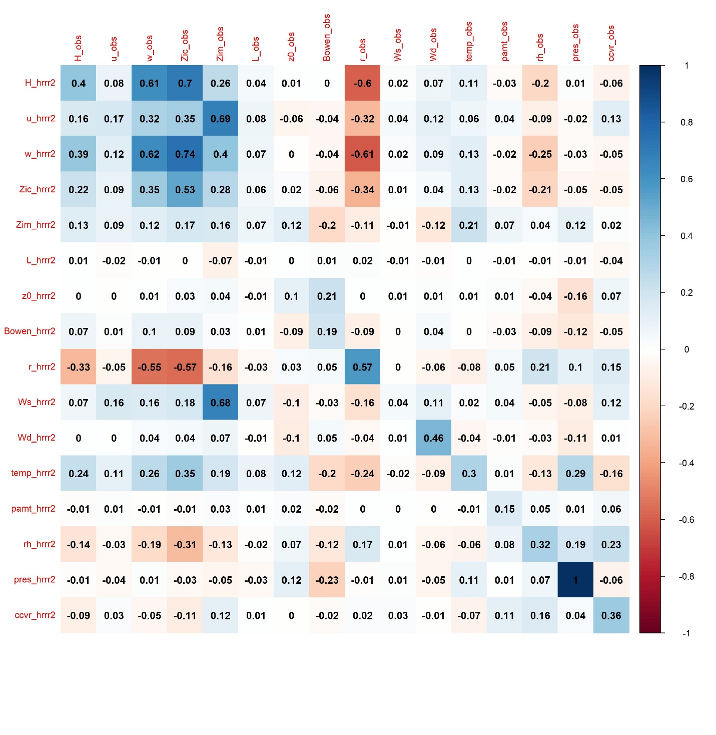

Figure S3. Pairwise Pearson correlation coefficients between AERMET-format meteorological variables derived from HRRR scenarios 3 (variables names ended with “_hrrr3”) and corresponding observational meteorological data (variable named ended with “_obs”). Correlations were computed for numerical meteorology only. H: sensible heat flux, u: surface friction velocity, w: convective velocity scale, Z_{ic}: convective mixing height, Z_{im}: mechanical mixing height, L: Monin-Obukhov length, z₀: surface roughness length, Bo: Bowen ratio, r: Albedo, Ws: wind speed, Wd: wind direction in degrees, temp: temperature in Kelvin at 2m reference height, pamt: hourly precipitation amount in kg/m², rh: relative humidity, pres: station pressure, ccvr: cloud cover scale to 0-10 where 5 translates to 50% cloud cover.
