Fig S1. Kaplan–Meier survival curves for cumulative cardiovascular disease incidence by CTI index

Fig S2.Subgroup analyses of the association between theCTI index and CVD incidence in a population with CKM syndrome stages 0–3
The model was adjusted for Age, Gender, Smoking statues, Drinking statues, Education level, Marital status,eGFR,UA,SBP, Proteinuria,LDL, Physical activity level,Income level,Diabetes,Hypertension,Antihypertensive medications medications,Hypoglycaemic medications,Lipid-lowering drugs. (excluding the variable for subgroup stratification)

Fig S3. Relationship between CTI and Cardiovascular Disease risk in different sensitivity analyses
The model was adjusted for Age, Gender, Smoking statues, Drinking statues, Education level, Marital status,eGFR,UA,SBP, Proteinuria,LDL, Physical activity level,Income level,Diabetes,Hypertension,Antihypertensive medications medications,Hypoglycaemic medications,Lipid-lowering drugs.

Fig S4. Path diagram of the mediation analysis of WC, FBG, and BMI on the relationship between CTI and cardiovascular disease.
The graphs in (A–C) represented the mediating role of WC, FBG, and BMI, respectively.

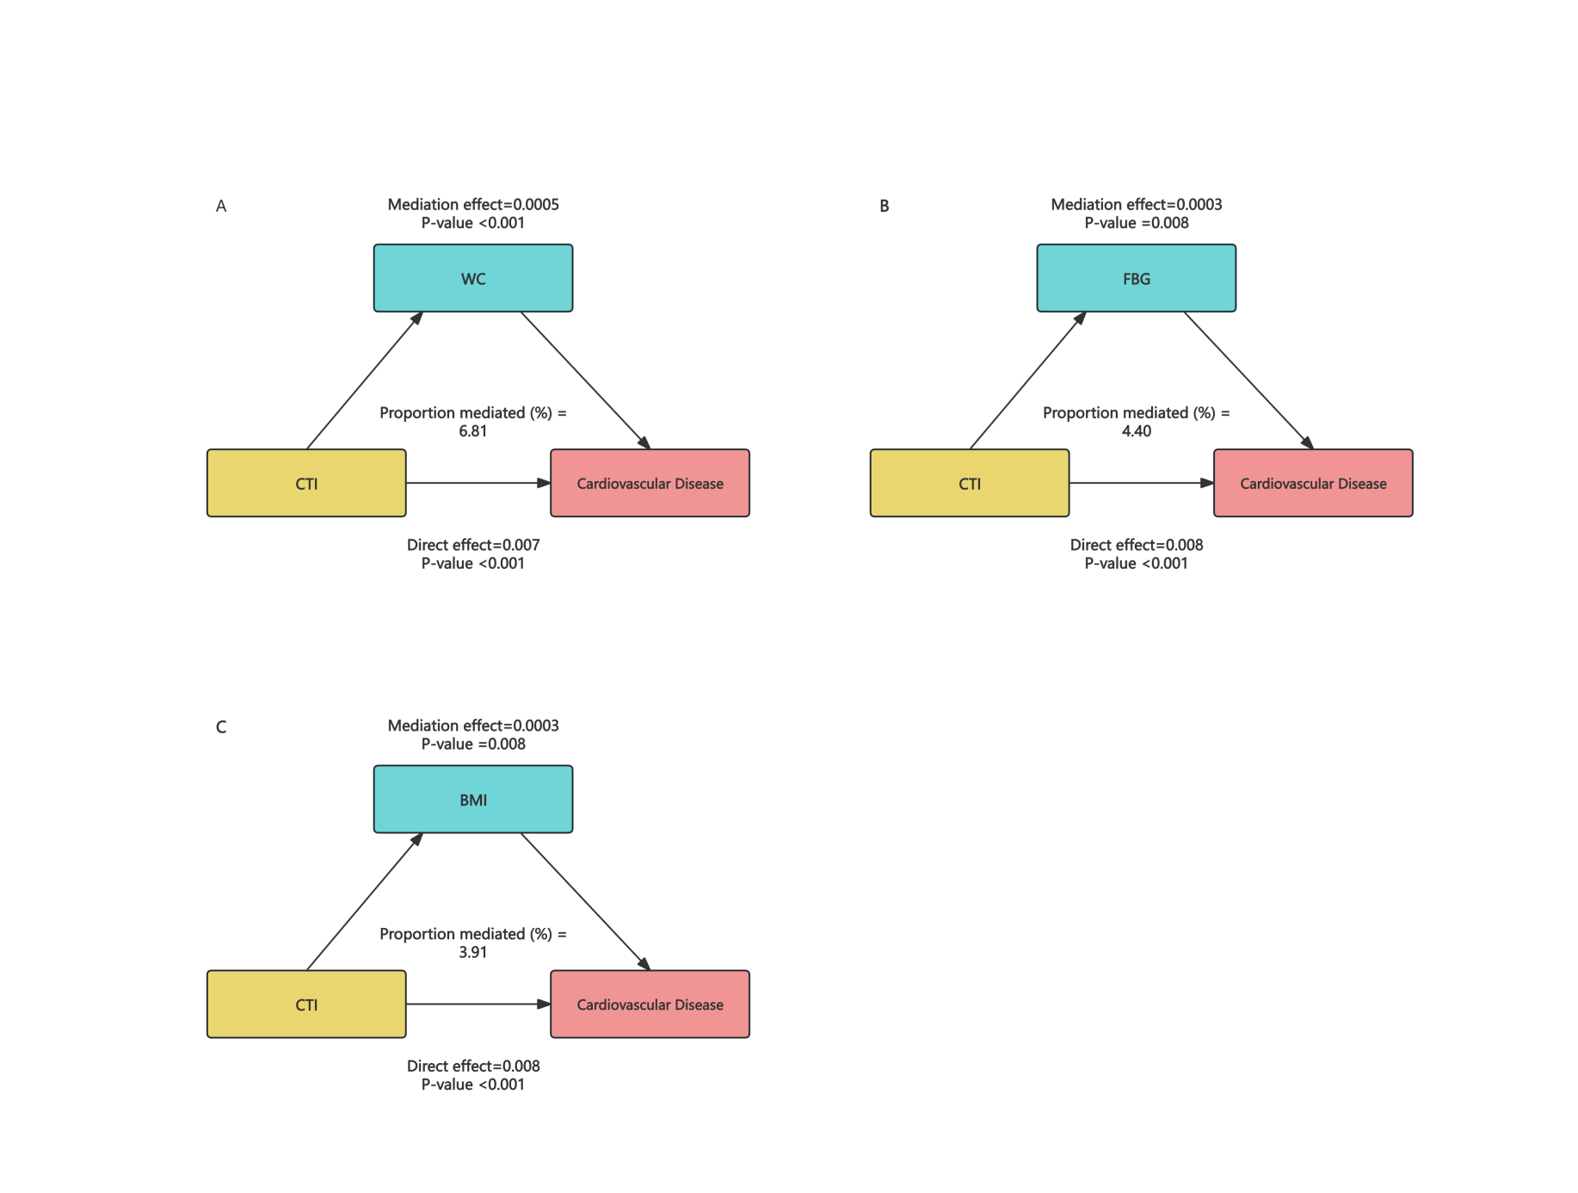
Table S1. exclude upper and lower limits of relevant extreme values
Variable | Lower limit | Upper limit | Exclusion rules  Exclude when below the lower limit or above or equal to the upper limit
WC | 51 | 190
BMI | 14.277315865 | 48.442906574
SBP | 80 | 242
DBP | 43.3 | 150
FBG | 2.35 | 25
eGFR | 4.99716982 | 668.90766419
HDL | 0.05 | 4.98
TG | 0.07 | 18.81
TC | 0.38 | 17.3
LDL | 0.01 | 12.36
hs-CRO | 0.01 | 184.8

Table S3 The results of the
collinearity screening
variable | VIF
Sex | 1.43
Age | 1.527
eGFR | 1.195
UA | 2.277
SBP | 2.319
Proteinuria | 1.164
LDL | 1.23
BMI | 1.063
Income | 1.116
FBG | 1.131
WC | 1.225
Physical activity | 1.646
Education level | 1.603
Smoking status | 1.782
Drinking status | 2.599
Marital status | 1.075
Diabetes | 1.288
Hypertension | 1.33
Antihypertensive medications | 1.033

Table S3. 1. Baseline characteristics participants according to the quartile of CTI.
Characteristic | Total | Q1 | Q2 | Q3 | Q4 | P-value
 | (N=85728) | (N=22061) | (N=21624) | (N=21220) | (N=20823)
Age，years | 50.48±11.89 | 47.85±12.06 | 50.19±11.85 | 51.34±11.79 | 52.68±11.31 | ＜0.001
Gender,n(%) |  |  |  |  |  | ＜0.001
Female，n (%) | 18219 (21.25) | 5687 (25.78) | 4411 (20.40) | 4027 (18.98) | 4094 (19.66)
Male | 67509 (78.75) | 16374 (74.22) | 17213 (79.60) | 17193 (81.02) | 16729 (80.34)
Education level(%) |  |  |  |  |  | ＜0.001
High school or above | 17670 (20.61) | 5052 (22.90) | 4434 (20.50) | 4254 (20.05) | 3930 (18.87)
Less than high school | 68058 (79.39) | 17009 (77.10) | 17190 (79.50) | 16966 (79.95) | 16893 (81.13)
Smoking statues,n (%) |  |  |  |  |  | ＜0.001
No | 52206 (60.90) | 13703 (62.11) | 13120 (60.67) | 12750 (60.08) | 12633 (60.67)
Yes | 33522 (39.10) | 8358 (37.89) | 8504 (39.33) | 8470 (39.92) | 8190 (39.33)
Drinking statues,n (%) |  |  |  |  |  | 0.007
No | 53087 (61.92) | 13705 (62.12) | 13385 (61.90) | 13081 (61.64) | 12916 (62.03)
Yes | 32641 (38.08) | 8356 (37.88) | 8239 (38.10) | 8139 (38.36) | 7907 (37.97)
CTI | 8.55±0.98 | 7.34±0.46 | 8.24±0.19 | 8.86±0.19 | 9.82±0.52
FBG, mg/dl | 5.44±1.60 | 4.96±0.76 | 5.15±0.97 | 5.39±1.29 | 6.32±2.47 | ＜0.001
eGFR | 83.00±23.78 | 85.38±22.22 | 82.74±23.33 | 82.05±22.95 | 81.72±26.34 | ＜0.001
BMI, kg/m2 | 25.05±3.45 | 23.39±3.05 | 24.76±3.18 | 25.62±3.30 | 26.55±3.44 | ＜0.001
WC, cm | 86.83±9.90 | 82.42±9.58 | 85.62±9.15 | 88.16±9.19 | 91.39±9.40 | ＜0.001
TG, mg/dl | 1.27 (0.89–1.93) | 0.80 (0.62–1.06) | 1.13 (0.89–1.44) | 1.46 (1.12–1.95) | 2.41 (1.68–3.67) | ＜0.001
TC, mg/dl | 4.95±1.13 | 4.73±0.94 | 4.91±1.05 | 5.03±1.11 | 5.13±1.35 | ＜0.001
HDL-c, mg/dl | 1.55±0.40 | 1.57±0.39 | 1.55±0.38 | 1.54±0.39 | 1.53±0.43 | ＜0.001
LDL-c, mg/dl | 2.35±0.91 | 2.30±0.76 | 2.41±0.81 | 2.41±0.93 | 2.27±1.11 | ＜0.001
CRP, mg/dl | 2.29±5.33 | 0.32±0.48 | 1.05±1.52 | 2.34±3.16 | 5.61±9.36 | ＜0.001
UA | 286.87±82.50 | 266.01±70.83 | 282.08±75.94 | 294.31±83.78 | 306.37±92.97
SBP, mmHg | 130.06±20.46 | 124.09±18.81 | 128.77±19.89 | 131.90±20.36 | 135.84±20.95 | ＜0.001
DBP, mmHg | 83.34±11.62 | 80.17±10.95 | 82.75±11.30 | 84.38±11.56 | 86.25±11.83 | ＜0.001
Lipid‐lowering medications, n (%) |  |  |  |  |  | ＜0.001
No | 85041 (99.20) | 21986 (99.66) | 21499 (99.42) | 21023 (99.07) | 20533 (98.61)
Yes | 687 (0.80) | 75 (0.34) | 125 (0.58) | 197 (0.93) | 290 (1.39)
Antihypertensive medications, n (%) |  |  |  |  |  | ＜0.001
No | 77398 (90.28) | 21019 (95.28) | 19854 (91.81) | 18824 (88.71) | 17701 (85.01)
Yes | 8330 (9.72) | 1042 (4.72) | 1770 (8.19) | 2396 (11.29) | 3122 (14.99)
Hypoglycaemic medications, n (%) |  |  |  |  |  | ＜0.001
No | 83971 (97.95) | 21922 (99.37) | 21394 (98.94) | 20831 (98.17) | 19824 (95.20)
Yes | 1757 (2.05) | 139 (0.63) | 230 (1.06) | 389 (1.83) | 999 (4.80)
Hypertension, n (%) |  |  |  |  |  | ＜0.001
No | 49385 (57.61) | 15785 (71.55) | 13094 (60.55) | 11279 (53.15) | 9227 (44.31)
Yes | 36343 (42.39) | 6276 (28.45) | 8530 (39.45) | 9941 (46.85) | 11596 (55.69)
Diabetes, n (%) |  |  |  |  |  | ＜0.001
No | 78361 (91.41) | 21658 (98.17) | 20799 (96.18) | 19645 (92.58) | 16259 (78.08)
Yes | 7367 (8.59) | 403 (1.83) | 825 (3.82) | 1575 (7.42) | 4564 (21.92)
CKM stage |  |  |  |  |  | ＜0.001
0 | 3642 (4.25) | 2368 (10.73) | 850 (3.93) | 358 (1.69) | 66 (0.32)
1 | 23301 (27.18) | 10674 (48.38) | 7539 (34.86) | 4062 (19.14) | 1026 (4.93)
2 | 48563 (56.65) | 7460 (33.82) | 11037 (51.04) | 14074 (66.32) | 15992 (76.80)
3 | 10222 (11.92) | 1559 (7.07) | 2198 (10.16) | 2726 (12.85) | 3739 (17.96)
CVD，n (%) |  |  |  |  |  | ＜0.001
No | 71505 (83.41) | 19646 (89.05) | 18521 (85.65) | 17326 (81.65) | 16012 (76.90)
Yes | 14223 (16.59) | 2415 (10.95) | 3103 (14.35) | 3894 (18.35) | 4811 (23.10)

