Table 3 Persuasive robot behavior characteristics
Game State | Gestures and Facial Expressions | Verbal | Strategy
1a)Start of game (first time playing)
 | 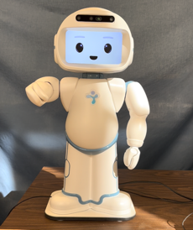 | I have heard you are very good at this game! I’m excited to play with you. | Praise and compliments with emotion
 | 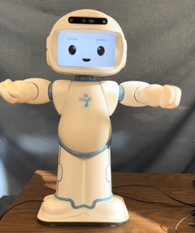 | So many people have enjoyed playing this game! Let’s see if you will enjoy playing it too. | Appeal via others
 | 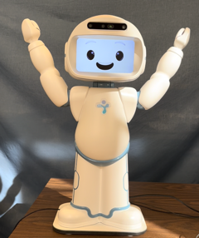 | It would make me happy if you would play this game with me. | Appeal with emotion
 | 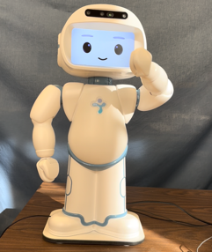 | You should play this game because I know it can help improve your memory. | Expertise
1b)Start of game (subsequent play)
 | 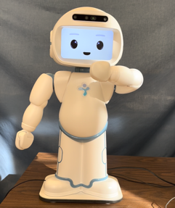 | It would make me happy if you would play this game again with me today. | Appeal with emotion
 | 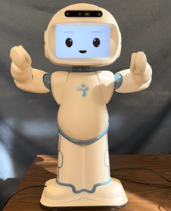 | I know this game can help improve your memory. I’m so happy to see that you are improving at the game. | Expertise with emotion
2a)During game (at a pause between button presses)
 | 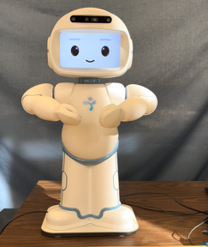 | You are definitely one of the best players! | Praise and compliments
 | 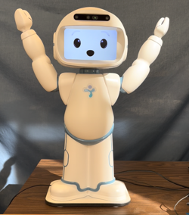 | Wow, you are doing great so far! Keep it up! | Praise and compliments with amazement
 | 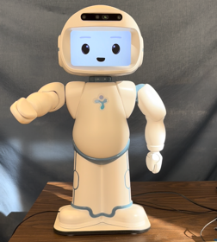 | I am keeping track of your high score. Keep going! | Encouragement with reciprocity
2b)During game, upon successful completion of a round
 | 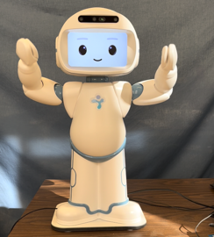 | Fantastic job! Let’s see how you do on the next round! | Praise with amazement
 | 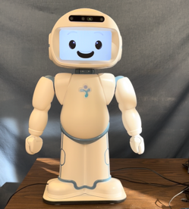 | You are doing great so far, let’s see how many rounds you can play in a row! | Compliment with anticipation
3)Wrong button pressed (try again)
 | 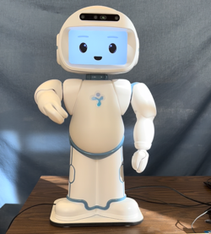 | That’s okay, I will start the game over again for you. Now you can go again. | Encouragement with reciprocity
 | 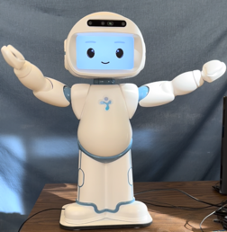 | It looks like you are on a roll! Would you like to try again? | Praise, encouragement with expertise
 | 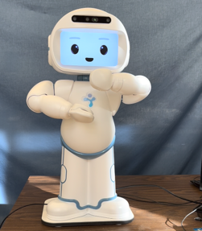 | I see you hit the wrong button. Why don’t you try again? | Encouragement with expertise
4)End of game
 | 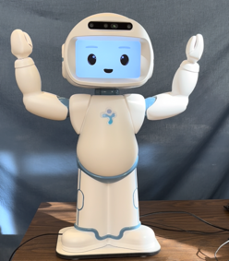 | That was fun! Let’s do this again at the same time tomorrow. | Commitment with engagement
 | 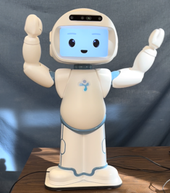 | You did great at this game! I can’t wait to see how you do next time. | Compliment with anticipation
 | 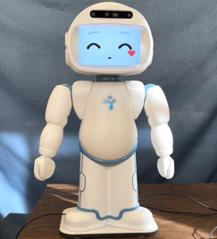 | It would make me happy if you would play this game again with me tomorrow. | Commitment with emotion
 | 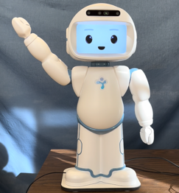 | It was nice spending time with you, see you next time! | Compliment with anticipation

