Supplementary Information

Non-thermal atmospheric-pressure plasma promotes cellulase production in Neurospora crassa

Nan-Nan Yu^{a,b}, Wirinthip Ketyaª, Kirubel Amsalu^{c}, Jun-Sup Limª, Hu-Nan Sun^{b}, Eun-Ha Choi^{a,c}, Gyungsoon Park^{a,c,*}

ª Plasma Bioscience Research Center, Department of Plasma-Bio Display, Kwangwoon University, Seoul 01897, Korea
^{b} College of Life Science and Technology, Heilongjiang Bayi Agricultural University, Daqing, Heilongjiang 163319, P.R. China
^{c} Department of Electrical and Biological Physics, Kwangwoon University, Seoul 01897, Korea

* Corresponding Author
Department of Electrical and Biological Physics, Kwangwoon University
20 Kwangwoon-ro, Nowon-gu, Seoul 01897, Korea
Phone: +82-2-940-8324
Fax: +82-2-940-5664
Email: gyungp@kw.ac.kr
Supplementary Table S1. Filter paper enzyme (FPase) activity, total protein concentration, specific FPase activity in glucose or avicel media after MS-DBD plasma treatment

Glucose
Incubation time | Plasma treatment time (second) | FPase activity (IUª/mL) | Protein concentration (μg/mL) | Specific FPase activity (IU/mg)
24 h | 0 | 0.038 ± 0.005^{b} | 34.755 ± 9.461 | 1.156 ± 0.229
24 h | 10 | 0.039 ± 0.003 | 36.034 ± 11.078 | 1.152 ± 0.302
24 h | 30 | 0.038 ± 0.004 | 33.213 ± 13.886 | 1.271 ± 0.390
24 h | 60 | 0.039 ± 0.003 | 28.970 ± 15.981 | 1.729 ± 0.798
24 h | 120 | 0.038 ± 0.004 | 31.248 ± 11.040 | 1.337 ± 0.427
24 h | 300 | 0.038 ± 0.005 | 34.461 ± 11.281 | 1.234 ± 0.457
24 h | 600 | 0.039 ± 0.002 | 25.493 ± 16.813 | 2.150 ± 1.131
48 h | 0 | 0.038 ± 0.003 | 72.773 ± 41.663 | 0.672 ± 0.331
48 h | 10 | 0.038 ± 0.003 | 69.386 ± 33.459 | 0.669 ± 0.298
48 h | 30 | 0.038 ± 0.003 | 69.365 ± 36.660 | 0.714 ± 0.406
48 h | 60 | 0.040 ± 0.005 | 84.280 ± 55.584 | 0.639 ± 0.311
48 h | 120 | 0.038 ± 0.003 | 69.146 ± 38.050 | 0.743 ± 0.429
48 h | 300 | 0.038 ± 0.006 | 72.827 ± 35.851 | 0.609 ± 0.214
48 h | 600 | 0.040 ± 0.004 | 64.298 ± 34.774 | 0.759 ± 0.306
Avicel
Incubation time | Plasma treatment time (second) | FPase activity (IU/mL) | Protein concentration (μg/mL) | Specific FPase activity (IU/mg)
24 h | 0 | 0.248 ± 0.015 | 158.159 ± 21.301 | 1.587 ± 0.197
24 h | 10 | 0.261 ± 0.014 | 178.577 ± 7.463 | 1.466 ± 0.112
24 h | 30 | 0.253 ± 0.022 | 170.220 ± 6.974 | 1.491 ± 0.170
24 h | 60 | 0.246 ± 0.023 | 159.357 ± 5.717 | 1.544 ± 0.153
24 h | 120 | 0.267 ± 0.021 | 157.607 ± 20.318 | 0.172 ± 0.257
24 h | 300 | 0.273 ± 0.033 | 159.176 ± 17.588 | 0.174 ± 0.303
24 h | 600 | 0.263 ± 0.035 | 163.535 ± 4.973 | 1.607 ± 0.194
48 h | 0 | 0.289 ± 0.051 | 210.062 ± 7.648 | 1.381 ± 0.274
48 h | 10 | 0.292 ± 0.026 | 224.191 ± 11.459 | 1.301 ± 0.072
48 h | 30 | 0.272 ± 0.042 | 212.648 ± 8.314 | 1.272 ± 0.152
48 h | 60 | 0.275 ± 0.024 | 201.287 ± 9.087 | 1.182 ± 0.290
48 h | 120 | 0.298 ± 0.052 | 209.253 ± 12.403 | 1.424 ± 0.233
48 h | 300 | 0.299 ± 0.046 | 215.462 ± 9.785 | 1.384 ± 0.165
48 h | 600 | 0.278 ± 0.035 | 203.824 ± 10.599 | 1.359 ± 0.110
ª IU: one International Unit (IU) of enzyme activity was defined as the amount of enzyme that released 1 µM of reducing sugar per minute.
^{b} Each value is the mean of 6 or 9 replicate measurements (three replicates per experiment and two or three independent experiments)
Supplementary Table S2. Filter paper enzyme (FPase) activity, total protein concentration, and specific FPase activity measured in media at 24 and 48 h after fungal hyphae were placed in MS-DBD plasma-treated or untreated VM media and then avicel was immediately added (final concentration 2%).

Avicel
Incubation time | Plasma treatment time (second) | FPase activity (IUª /mL) | Protein concentration (μg/mL) | Specific FPase activity (IU/mg)
24 h | 0 | 0.191 ± 0.016^{b} | 120.453 ± 7.558 | 1.595 ± 0.242
24 h | 120 | 0.218 ± 0.011 | 130.065 ± 2.268 | 1.674 ± 0.080
24 h | 300 | 0.240 ± 0.001 | 131.267 ± 1.876 | 1.828 ± 0.029
48 h | 0 | 0.254 ± 0.001 | 181.430 ± 1.376 | 1.402 ± 0.013
48 h | 120 | 0.307 ± 0.009 | 194.647 ± 3.122 | 1.575 ± 0.063
48 h | 300 | 0.283 ± 0.011 | 182.031 ± 2.384 | 1.552 ± 0.050
ª IU: one International Unit (IU) of enzyme activity was defined as the amount of enzyme that released 1 µM of reducing sugar per minute.
^{b} Each value is the mean of 3 replicate measurements.

Supplementary Table S3. Effects of inhibition or deletion of Ca²⁺ channel on cellulases production. (a) FPase activity, total protein concentration, and specific FPase activity in media. Wild type fungal hyphae in VM media were treated with MS-DBD plasma, immediately followed by the addition of avicel and LaC1₃ (Ca²⁺ channel inhibitor). (b) FPase activity, total protein concentration, and specific FPase activity in media. Wild type and deletion mutant of Ca²⁺ channel (Δmid-1) were treated with MS-DBD plasma, immediately followed by the addition of avicel.

Incubation time | Plasma treatment time (second) | Addition of LaCl₃ | FPase activity (IUª/mL) | Protein concentration (μg/mL) | Specific FPase activity (IU/mg)
24 h | 0 | ˗ | 0.227 ± 0.032^{b} | 137.102 ± 49.759 | 1.858 ± 0.653
24 h | 300 | ˗ | 0.246 ± 0.029 | 151.427 ± 40.313 | 1.734 ± 0.486
24 h | 0 | + | 0.102 ± 0.044 | 70.507 ± 39.369 | 1.729 ± 0.596
24 h | 300 | + | 0.111 ± 0.058 | 70.757 ± 43.008 | 1.871 ± 0.585
48 h | 0 | ˗ | 0.271 ± 0.029 | 202.368 ± 54.692 | 1.407 ± 0.303
48 h | 300 | ˗ | 0.265 ± 0.019 | 200.513 ± 40.728 | 1.367 ± 0.280
48 h | 0 | + | 0.151 ± 0.013 | 111.853 ± 40.218 | 1.539 ± 0.603
48 h | 300 | + | 0.143 ± 0.027 | 112.907 ± 42.294 | 1.423 ± 0.552

Strain | Incubation time | Plasma treatment time (second) | FPase activity (IU/mL) | Protein concentration (μg/mL) | Specific FPase activity (IU/mg)
Wild type | 24 h | 0 | 0.227 ± 0.032 | 137.102 ± 49.759 | 1.858 ± 0.653
Wild type | 24 h | 300 | 0.246 ± 0.029 | 151.427 ± 40.313 | 1.734 ± 0.486
Wild type | 48 h | 0 | 0.271 ± 0.029 | 202.368 ± 54.692 | 1.407 ± 0.303
Wild type | 48 h | 300 | 0.265 ± 0.019 | 200.513 ± 40.728 | 1.367 ± 0.280
Δmid-1 | 24 h | 0 | 0.070 ± 0.013 | 48.667 ± 18.249 | 1.595 ± 0.469
Δmid-1 | 24 h | 300 | 0.057 ± 0.011 | 46.218 ± 17.304 | 1.353 ± 0.388
Δmid-1 | 48 h | 0 | 0.253 ± 0.077 | 146.469 ± 60.805 | 1.826 ± 0.329
Δmid-1 | 48 h | 300 | 0.243 ± 0.067 | 138.423 ± 61.162 | 1.910 ± 0.511
ª IU: one International Unit (IU) of enzyme activity was defined as the amount of enzyme that released 1 µM of reducing sugar per minute.
^{b} Each value is the average of 9 replicate measurements (three replicates per experiment and three independent experiments)
Supplementary Table S4. Filter paper enzyme (FPase) activity, protein concentration, and specific FPase activity measured in media after MS-DBD plasma treatment, immediately followed by addition of avicel and cPTIO (a) or after SNP treatment (b).

(a)
Incubation time | Plasma treatment (second) | Addition of cPTIO | FPase activity (IUª/mL) | Protein concentration (μg/mL) | Specific FPase activity (IU/mg)
24 h | 0 | ˗ | 0.209 ± 0.007^{b} | 174.194 ± 22.709 | 1.219 ± 0.183
24 h | 300 | ˗ | 0.179 ± 0.023 | 169.623 ± 12.538 | 1.062 ± 0.155
24 h | 0 | + | 0.028 ± 0.002 | 86.203 ± 14.566 | 0.332 ± 0.070
24 h | 300 | + | 0.026 ± 0.003 | 93.361 ± 27.543 | 0.304 ± 0.095
48 h | 0 | ˗ | 0.251 ± 0.041 | 243.040 ± 8.728 | 1.031 ± 0.135
48 h | 300 | ˗ | 0.236 ± 0.033 | 239.031 ± 2.783 | 0.987 ± 0.134
48 h | 0 | + | 0.070 ± 0.035 | 135.736 ± 7.933 | 0.509 ± 0.235
48 h | 300 | + | 0.044 ± 0.006 | 134.661 ± 23.194 | 0.343 ± 0.097

(b)
Incubation time | SNP treatment (mM) | FPase activity (IU/mL) | Protein concentration (μg/mL) | Specific FPase activity (IU/mg)
24 h | 0 | 0.214 ± 0.017 | 133.893 ± 25.384 | 1.637 ± 0.249
24 h | 0.1 | 0.259 ± 0.018 | 158.896 ± 24.958 | 1.660 ± 0.207
24 h | 0.5 | 0.226 ± 0.014 | 138.752 ± 10.912 | 1.636 ± 0.175
24 h | 0.8 | 0.238 ± 0.028 | 136.933 ± 8.140 | 1.741 ± 0.205
48 h | 0 | 0.257 ± 0.031 | 170.055 ± 28.640 | 1.543 ± 0.281
48 h | 0.1 | 0.298 ± 0.052 | 191.084 ± 36.186 | 1.573 ± 0.190
48 h | 0.5 | 0.362 ± 0.030 | 211.829 ± 34.904 | 1.747 ± 0.296
48 h | 0.8 | 0.299 ± 0.011 | 179.223 ± 29.849 | 1.709 ± 0.284
ª IU: one International Unit (IU) of enzyme activity was defined as the amount of enzyme that released 1 µM of reducing sugar per minute.
^{b} Each value is the average of 6 or 9 replicate measurements (three replicates per experiment and two or three independent experiments)

Supplementary Table S5. Filter paper enzyme (FPase) activity, total protein concentration and specific FPase activity in glucose or avicel mediaª after 9.4 W plasma jet (a), 2.1 W plasma jet (b) or 1.5 W MS-DBD plasma (c) treatment.

(a)
Media | Incubation time | 9.4 J/s Plasma jet treatment (second) | FPase activity (IU^{b}/mL) | Protein concentration (μg/mL) | Specific FPase activity (IU/mg)
Glucose | 24 h | 0 | 0.049 ± 0.009^{c} | 8.517 ± 3.832 | 5.988 ± 2.749
Glucose | 24 h | 10 | 0.057 ± 0.011 | 10.860 ± 1.641 | 5.303 ± 1.114
Glucose | 24 h | 30 | 0.054 ± 0.004 | 12.313 ± 3.959 | 4.863 ± 1.962
Glucose | 24 h | 60 | 0.053 ± 0.004 | 10.497 ± 3.690 | 6.409 ± 4.847
Glucose | 24 h | 120 | 0.055 ± 0.009 | 8.193 ± 4.761 | 5.612 ± 2.588
Glucose | 24 h | 300 | 0.041 ± 0.012 | 8.309 ± 5.100 | 3.501 ± 0.851
Glucose | 24 h | 600 | 0.064 ± 0.034 | 9.704 ± 2.937 | 8.646 ± 6.455
Glucose | 48 h | 0 | 0.045 ± 0.006 | 28.076 ± 13.302 | 1.892 ± 0.692
Glucose | 48 h | 10 | 0.047 ± 0.007 | 31.564 ± 19.139 | 2.290 ± 1.609
Glucose | 48 h | 30 | 0.051 ± 0.007 | 35.802 ± 13.633 | 1.653 ± 0.806
Glucose | 48 h | 60 | 0.050 ± 0.016 | 38.466 ± 13.357 | 1.377 ± 0.426
Glucose | 48 h | 120 | 0.043 ±0.005 | 19.716 ± 1.398 | 2.214 ± 0.327
Glucose | 48 h | 300 | 0.042 ± 0.005 | 26.573 ± 8.354 | 1.761 ± 0.635
Glucose | 48 h | 600 | 0.041 ± 0.005 | 24.285 ± 5.875 | 1.752 ± 0.312
Avicel | 24 h | 0 | 0.098 ± 0.047 | 68.927 ± 30.276 | 1.436 ± 0.306
Avicel | 24 h | 10 | 0.138 ± 0.073 | 104.028 ± 3.474 | 1.343 ± 0.742
Avicel | 24 h | 30 | 0.187 ± 0.019 | 101.849 ± 4.216 | 1.833 ± 0.148
Avicel | 24 h | 60 | 0.198 ± 0.026 | 103.483 ± 11.587 | 1.918 ± 0.126
Avicel | 24 h | 120 | 0.092 ± 0.061 | 56.538 ± 36.640 | 1.604 ± 0.092
Avicel | 24 h | 300 | 0.087 ± 0.057 | 54.285 ± 29.678 | 1.508 ± 0.253
Avicel | 24 h | 600 | 0.037 ± 0.004 | 26.880 ± 1.163 | 1.399 ± 0.199
Avicel | 48 h | 0 | 0.219 ± 0.083 | 123.416 ± 47.360 | 1.806 ± 0.214
Avicel | 48 h | 10 | 0.243 ± 0.109 | 151.611 ± 21.722 | 1.541 ± 0.499
Avicel | 48 h | 30 | 0.335 ± 0.024 | 178.308 ± 15.528 | 1.886 ± 0.112
Avicel | 48 h | 60 | 0.350 ± 0.085 | 181.940 ± 32.652 | 1.903 ± 0.129
Avicel | 48 h | 120 | 0.215 ± 0.131 | 113.732 ± 61.533 | 1.815 ± 0.225
Avicel | 48 h | 300 | 0.210 ± 0.111 | 121.775 ± 57.761 | 1.689 ± 0.194
Avicel | 48 h | 600 | 0.098 ± 0.023 | 68.506 ± 5.514 | 1.423 ±0.232

(b)
Media | Incubation time | 2.1 J/s Plasma jet treatment (second) | FPase activity (IU/mL) | Protein concentration (μg/mL) | Specific FPase activity (IU/mg)
Glucose | 24 h | 0 | 0.045 ± 0.006 | 23.297 ± 4.416 | 1.979 ± 0.287
Glucose | 24 h | 10 | 0.055 ± 0.006 | 28.817 ± 1.104 | 1.911 ± 0.149
Glucose | 24 h | 30 | 0.055 ± 0.004 | 28.817 ± 2.921 | 1.898 ± 0.130
Glucose | 24 h | 60 | 0.047 ± 0.005 | 29.186 ± 1.275 | 1.616 ± 0.106
Glucose | 24 h | 120 | 0.044 ± 0.001 | 27.345 ± 2.298 | 1.628 ± 0.127
Glucose | 24 h | 300 | 0.048 ± 0.006 | 31.762 ± 1.275 | 1.511 ± 0.235
Glucose | 24 h | 600 | 0.046 ± 0.009 | 28.449 ± 0.637 | 1.621 ± 0.325
Glucose | 48 h | 0 | 0.045 ± 0.002 | 33.970 ± 0.637 | 1.331 ± 0.038
Glucose | 48 h | 10 | 0.049 ± 0.008 | 37.650 ± 1.104 | 1.308 ± 0.214
Glucose | 48 h | 30 | 0.043 ± 0.005 | 30.658 ± 0.637 | 1.387 ± 0.124
Glucose | 48 h | 60 | 0.039 ± 0.004 | 35.442 ± 1.912 | 1.108 ± 0.071
Glucose | 48 h | 120 | 0.040 ± 0.007 | 34.338 ± 0.000 | 1.163 ± 0.202
Glucose | 48 h | 300 | 0.042 ± 0.005 | 34.706 ± 1.687 | 1.209 ± 0.107
Glucose | 48 h | 600 | 0.040 ± 0.005 | 33.234 ± 1.104 | 1.206 ± 0.186
Avicel | 24 h | 0 | 0.254 ± 0.014 | 160.618 ± 8.538 | 1.584 ± 0.095
Avicel | 24 h | 10 | 0.261 ± 0.032 | 156.673 ± 5.055 | 1.663 ± 0.163
Avicel | 24 h | 30 | 0.278 ± 0.015 | 172.390 ± 7.157 | 1.611 ± 0.079
Avicel | 24 h | 60 | 0.273 ± 0.013 | 158.960 ± 12.331 | 1.725 ± 0.117
Avicel | 24 h | 120 | 0.272 ± 0.010 | 163.880 ± 16.769 | 1.674 ± 0.171
Avicel | 24 h | 300 | 0.290 ± 0.046 | 165.739 ± 8.349 | 1.754 ± 0.310
Avicel | 24 h | 600 | 0.267 ± 0.039 | 155.028 ± 3.537 | 1.718 ± 0.225
Avicel | 48 h | 0 | 0.278 ± 0.044 | 197.106 ± 17.575 | 1.426 ± 0.296
Avicel | 48 h | 10 | 0.294 ± 0.057 | 197.516 ± 19.350 | 1.501 ± 0.314
Avicel | 48 h | 30 | 0.300 ± 0.038 | 216.817 ± 34.303 | 1.410 ± 0.241
Avicel | 48 h | 60 | 0.280 ± 0.043 | 199.561 ± 15.267 | 1.415 ± 0.249
Avicel | 48 h | 120 | 0.281 ± 0.051 | 201.443 ± 26.408 | 1.430 ± 0.386
Avicel | 48 h | 300 | 0.268 ± 0.039 | 199.320 ± 17.317 | 1.354 ± 0.235
Avicel | 48 h | 600 | 0.296 ± 0.054 | 196.725 ± 16.455 | 1.509 ± 0.285

(c)
Media | Incubation time | 1.5 J/s MS-DBD Plasma treatment (second) | FPase activity (IU/mL) | Protein concentration (μg/mL) | Specific FPase activity (IU/mg)
Avicel | 24 h | 0 | 0.253 ± 0.030 | 171.066 ± 23.442 | 1.499 ± 0.233
Avicel | 24 h | 10 | 0.262 ± 0.043 | 168.350 ± 20.803 | 1.562 ± 0.239
Avicel | 24 h | 30 | 0.286 ± 0.012 | 175.038 ± 14.406 | 1.643 ± 0.166
Avicel | 24 h | 60 | 0.291 ± 0.019 | 175.659 ± 19.306 | 1.668 ± 0.141
Avicel | 24 h | 120 | 0.298 ± 0.023 | 170.663 ± 18.155 | 1.755 ± 0.130
Avicel | 24 h | 300 | 0.288 ± 0.032 | 172.480 ± 23.459 | 1.681 ± 0.159
Avicel | 24 h | 600 | 0.288 ± 0.027 | 155.962 ± 20.814 | 1.859 ± 0.168
Avicel | 48 h | 0 | 0.273 ± 0.036 | 222.593 ± 43.959 | 1.245 ± 0.134
Avicel | 48 h | 10 | 0.299 ± 0.046 | 234.463 ± 42.387 | 1.288 ± 0.121
Avicel | 48 h | 30 | 0.298 ± 0.037 | 235.490 ± 44.846 | 1.288 ± 0.150
Avicel | 48 h | 60 | 0.302 ± 0.027 | 233.363 ± 39.395 | 1.315 ± 0.136
Avicel | 48 h | 120 | 0.311 ± 0.041 | 229.350 ± 43.985 | 1.381 ± 0.181
Avicel | 48 h | 300 | 0.303 ± 0.053 | 222.851 ± 37.061 | 1.366 ± 0.138
Avicel | 48 h | 600 | 0.318 ± 0.035 | 223.476 ± 41.219 | 1.448 ± 0.169
ª Glucose or avicel was added before plasma treatment.
^{b} IU: one International Unit (IU) of enzyme activity was defined as the amount of enzyme that released 1 µM of reducing sugar per minute.
^{c} Each value is the mean of 3 or 9 replicate measurements (three replicates per experiment and one or three independent experiments).
Supplementary Table S6. Filter paper enzyme activity (FPase), total protein concentration and specific FPase activity in large-scale (300 mL) glucose or avicel mediaª after 2.1 W plasma jet treatment.

Media | Incubation time | Plasma treatment (second) | FPase activity (IU^{b}/mL) | Protein concentration (μg/mL) | Specific FPase activity (IU/mg)
Glucose | 24 h | 0 | 0.065 ± 0.020^{c} | 24.737 ± 0.941 | 2.631 ± 0.745
Glucose | 24 h | 300 | 0.032 ± 0.024 | 22.856 ± 0.000 | 1.403 ± 1.059
Glucose | 24 h | 600 | 0.017 ± 0.013 | 22.856 ± 0.000 | 0.764 ± 0.574
Glucose | 24 h | 900 | 0.026 ± 0.014 | 19.720 ± 1.437 | 1.343 ± 0.827
Glucose | 48 h | 0 | 0.058 ± 0.007 | 30.694 ± 1.437 | 1.895 ± 0.251
Glucose | 48 h | 300 | 0.061 ± 0.007 | 28.185 ± 1.437 | 2.165 ± 0.234
Glucose | 48 h | 600 | 0.050 ± 0.007 | 24.423 ± 1.086 | 2.052 ± 0.365
Glucose | 48 h | 900 | 0.047 ± 0.010 | 24.423 ± 1.086 | 1.913 ± 0.311
Avicel | 24 h | 0 | 0.106 ± 0.035 | 67.544 ± 8.436 | 1.542 ± 0.369
Avicel | 24 h | 300 | 0.128 ± 0.046 | 73.501 ± 12.891 | 1.708 ± 0.451
Avicel | 24 h | 600 | 0.100 ± 0.023 | 61.595 ± 12.794 | 1.660 ± 0.360
Avicel | 24 h | 900 | 0.118 ± 0.020 | 68.518 ± 10.578 | 1.755 ± 0.379
Avicel | 48 h | 0 | 0.216 ± 0.026 | 111.345 ± 17.169 | 1.985 ± 0.365
Avicel | 48 h | 300 | 0.256 ± 0.043 | 124.321 ± 5.280 | 2.067 ± 0.383
Avicel | 48 h | 600 | 0.232 ± 0.023 | 110.916 ± 20.072 | 2.158 ± 0.468
Avicel | 48 h | 900 | 0.242 ± 0.030 | 111.976 ± 21.602 | 2.222 ± 0.394
ª Glucose or avicel was added before plasma treatment.
^{b} IU: one International Unit (IU) of enzyme activity was defined as the amount of enzyme that released 1 µM of reducing sugar per minute.
^{c} Each value is the mean of 3 or 15 replicate measurements (three replicates per experiment and five independent experiments).
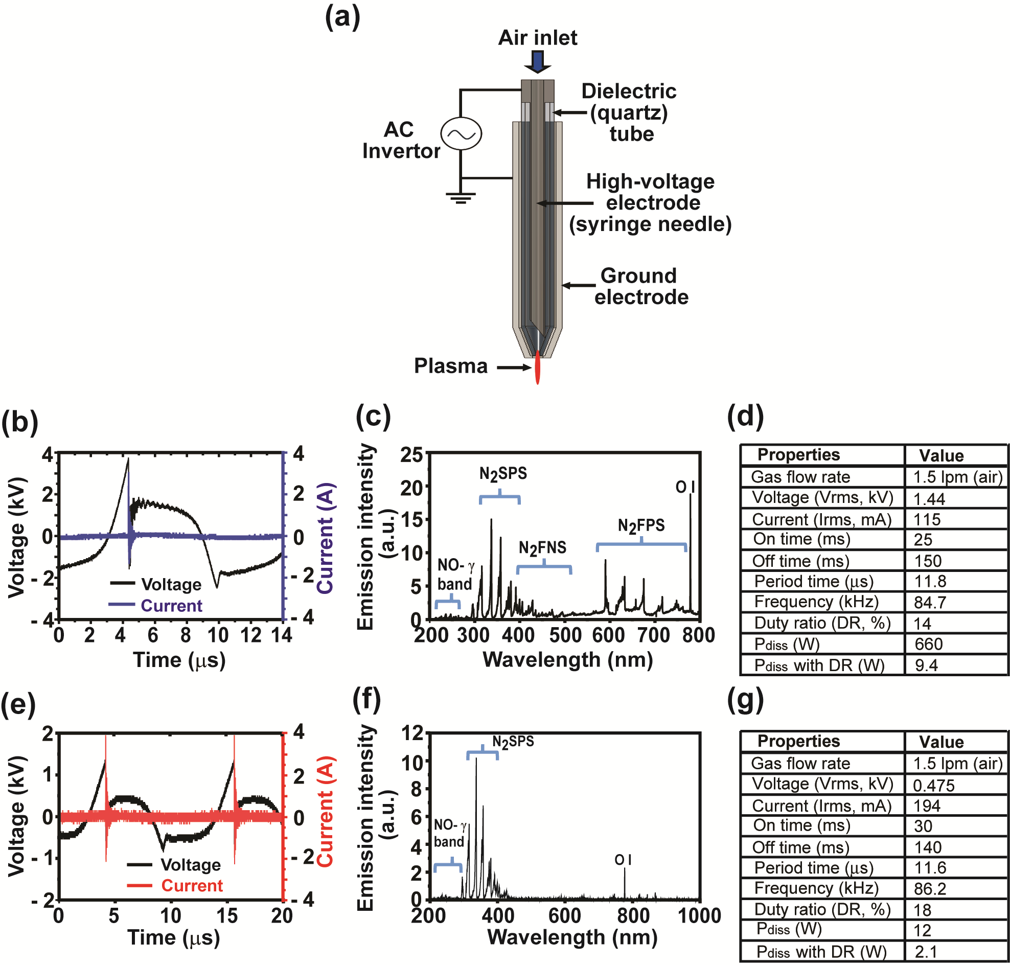
Supplementary Figure S1. Characterization of two plasma jets with different dissipated power, 9.4 W (Jet plasma-1) or 2.1 W (Jet plasma-2). (a) Schematic view of plasma jet, (b-d) voltage and current profile (b), OES spectra (c), and physical properties (d) of Jet plasma-1 with dissipated power 9.4 W. (e-g) voltage and current profile (e), OES spectra (f), and physical properties (g) of Jet plasma-2 with dissipated power 2.1 W.

Supplementary Figure S2. Levels of four cellulolytic enzymes in avicel medium on SDS-PAGE gel. Fungal mycelia were removed by centrifugation, and culture supernatants were harvested at 24h and 48h after MS-DBD plasma treatment. The secreted proteins into media were resolved on SDS-PAGE gel, and gel pictures from three repeated experiments were shown. Bands corresponding to four cellulolytic enzymes are indicated.

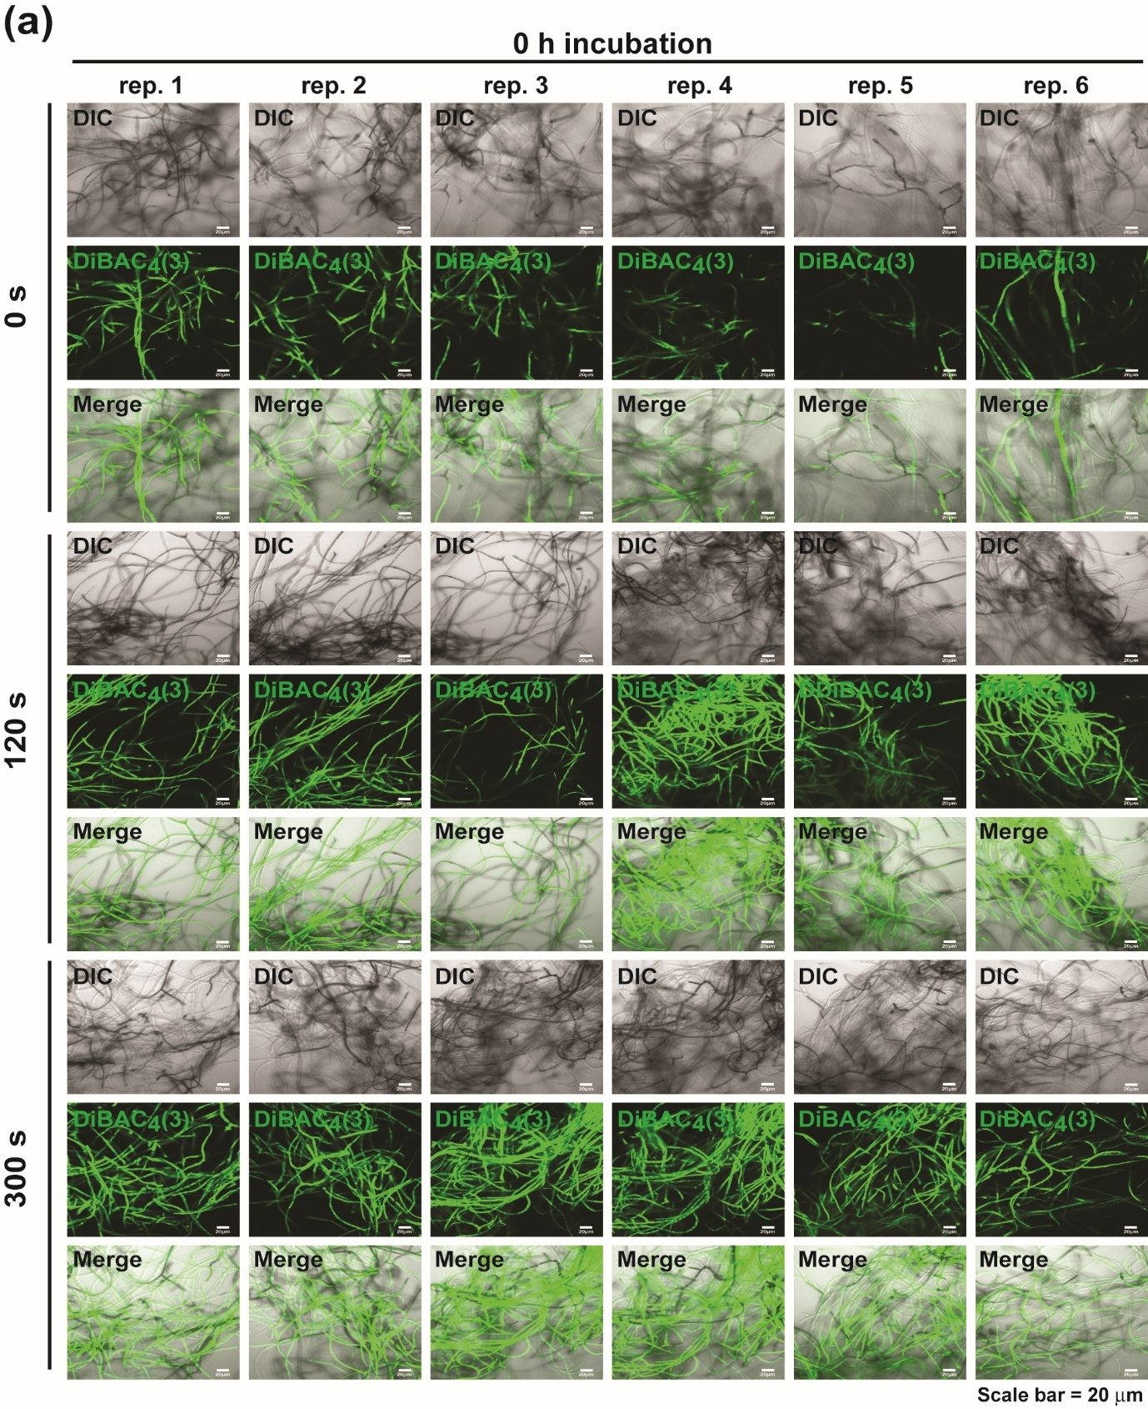
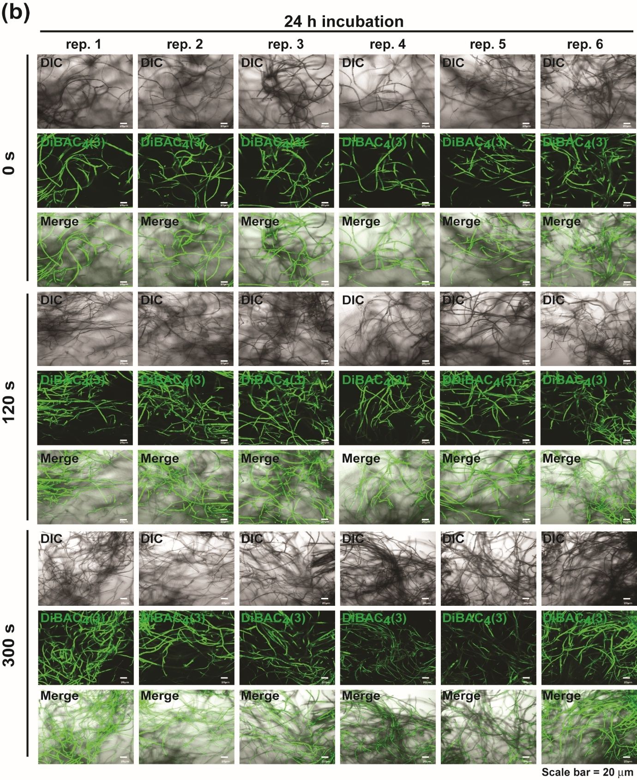
Supplementary Figure S3. Analysis of membrane potential in N. crassa hyphae after plasma treatment. Hyphae were stained with DiBAC₄(3) (green fluorescence) after 0h (a) and 24h (b) of plasma treatment. Pictures of fungal hyphae were taken in 6 different areas. DIC; Differential Interference Contrast, DiBAC₄(3); fluorescence, Merge; combined image of DIC and fluorescence.

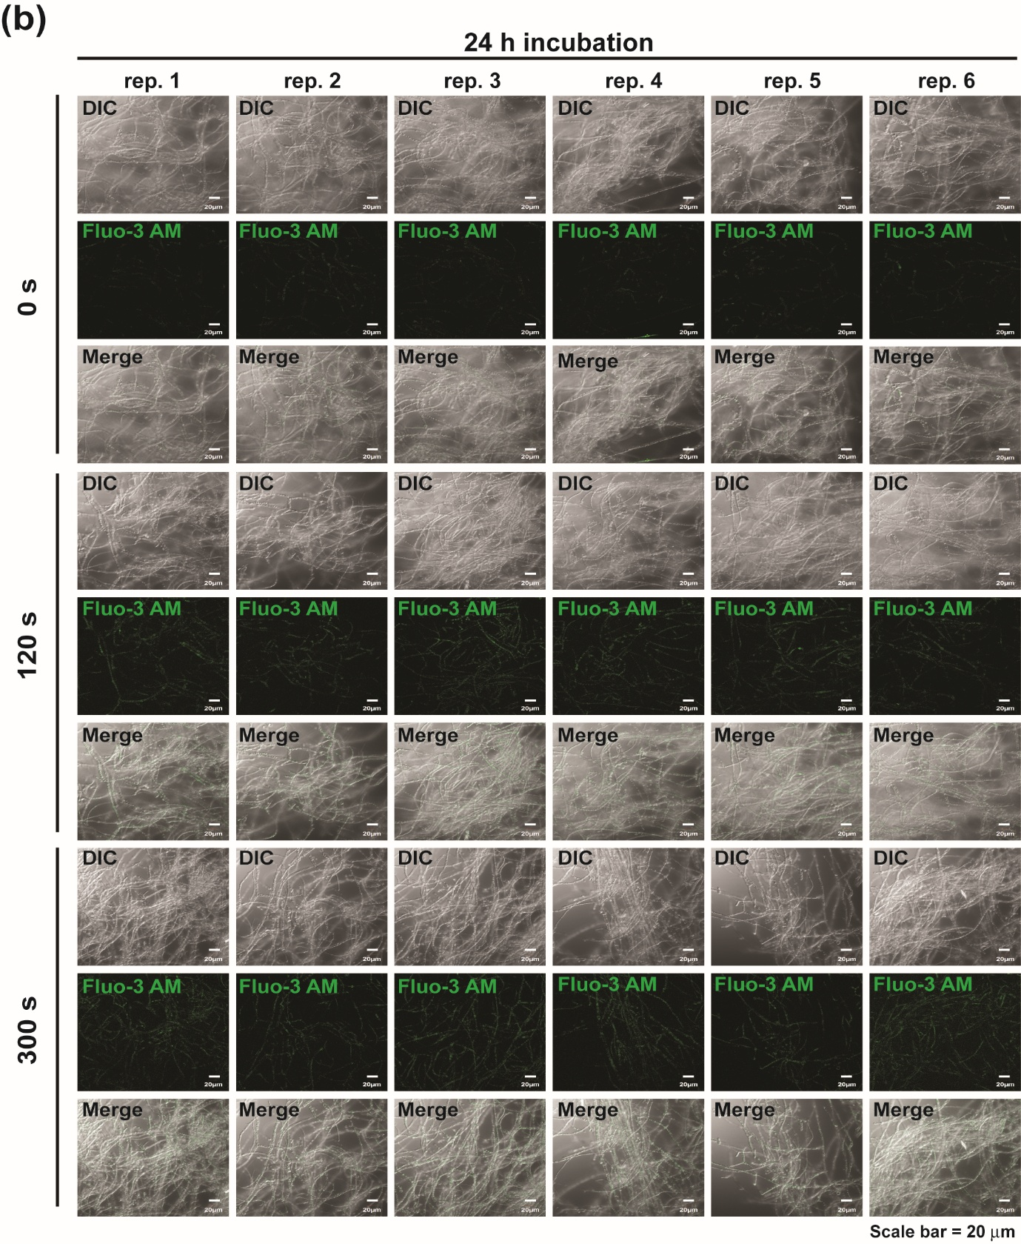
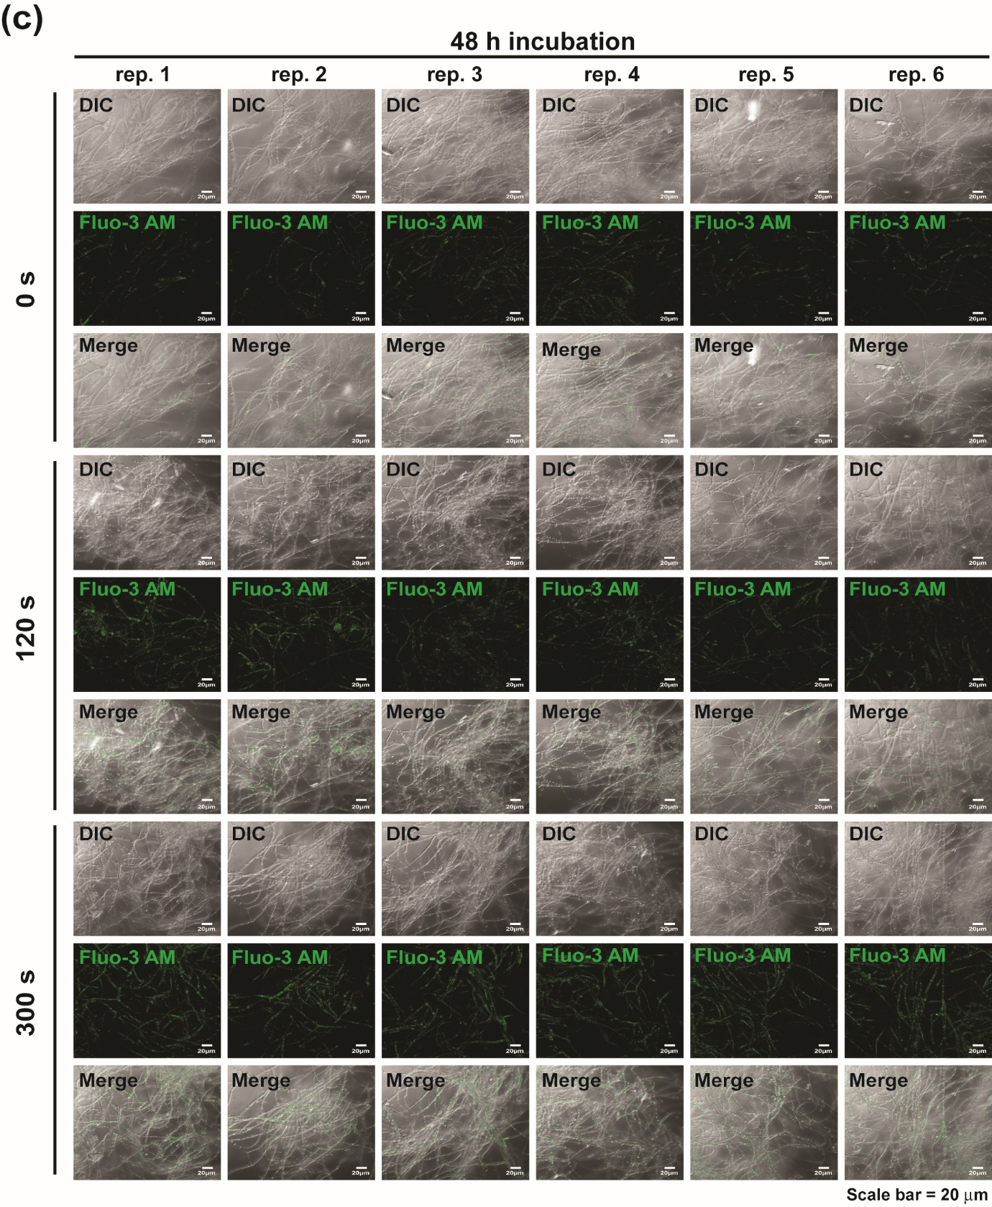
Supplementary Figure S4. Analysis for intracellular Ca²⁺ accumulation after plasma treatment. Hyphae were stained with Fluo-3 AM (green fluorescence) after 4h (a), 24h (b) and 48h (c) of plasma treatment. Pictures of fungal hyphae were taken in 6 different areas. DIC; Differential Interference Contrast, Fluo-3 AM; fluorescence, Merge; combined image of DIC and fluorescence.

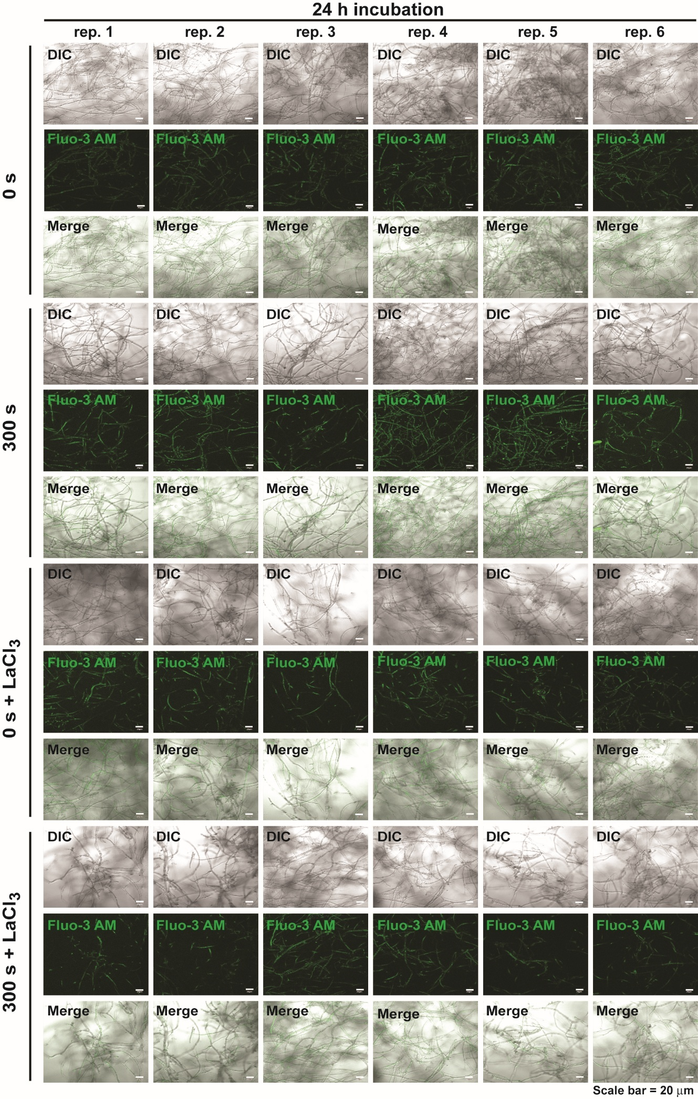
Supplementary Figure S5. Intracellular Ca²⁺ level in plasma-treated fungal hyphae under the condition of inhibition of Ca²⁺ channel. Ca²⁺ stained with Fluo-3 AM in wild type (FGSC4200) fungal hyphae incubated for 24 h after treatment with MS-DBD plasma for 0s or 300s, followed by addition of avicel supplemented with LaC1₃ (Ca²⁺ channel inhibitor, 5 mM) or none. Pictures of fungal hyphae were taken in 6 different areas. DIC; Differential Interference Contrast, DAF-FM DA; fluorescence, Merge; combined image of DIC and fluorescence.

Supplementary Figure S6. Level of mRNA of plc genes (NCU06245 and NCU02175) in fungal hyphae. Fungal hyphae were grown in avicel media for 4 h after plasma treatment. Relative mRNA level compared to that of no plasma treated group was calculated. Each value is the average of 9 replicate measurements (three replicates per experiment and three independent experiments).

Supplementary Figure S7. Effects of deletion of Ca²⁺ channel on cellulases production and intracellular Ca²⁺ level. (a) Growth of knockout mutant of Ca²⁺ channel-encoded gene mid-1 (FGSC11707) in VM-glucose media. (b) FPase activity, total protein concentration, and specific FPase activity in media 24 and 48 h after mid-1 mutant was treated with MS-DBD plasma and none, followed by addition of avicel. Each value represents the relative percentage compared to the value of wild type treated with none (control), averaging 9 replicate measurements (three replicates per experiment and three independent experiments): ** p < 0.01 as determined by Student’s t-test. (c) Ca²⁺ stained with Fluo-3 AM in hyphae of wild type and mid-1 deletion mutant (FGSC11707) incubated for 24 h after treatment with MS-DBD plasma for 0s or 300s, followed by addition of avicel. Pictures of fungal hyphae were taken in 6 different areas. DIC: differential interference contrast, Fluo-3 AM: fluorescence, Merge: combined image of DIC and fluorescence.

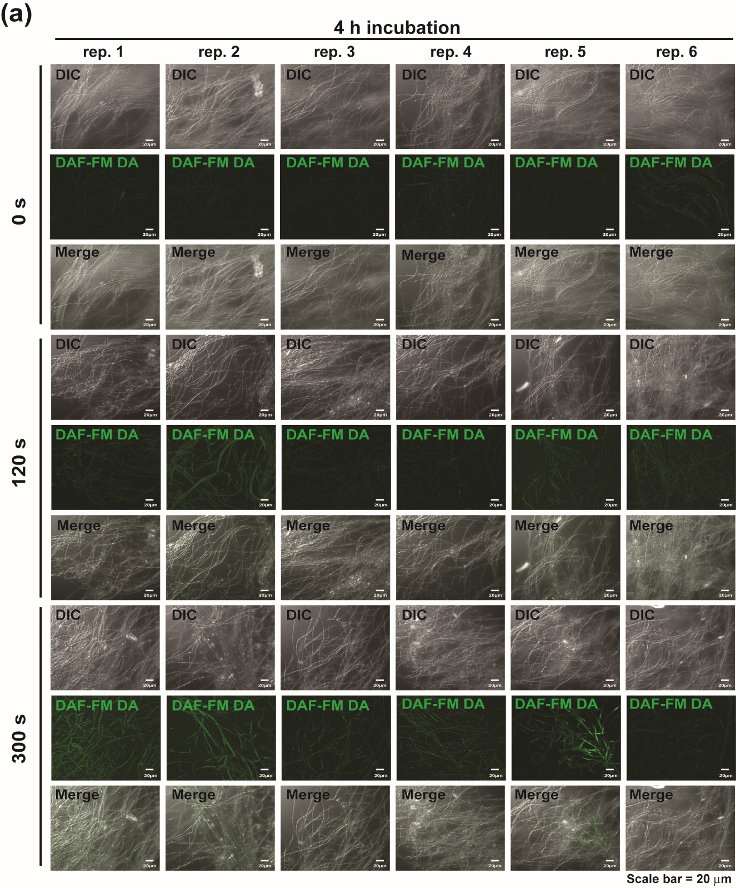
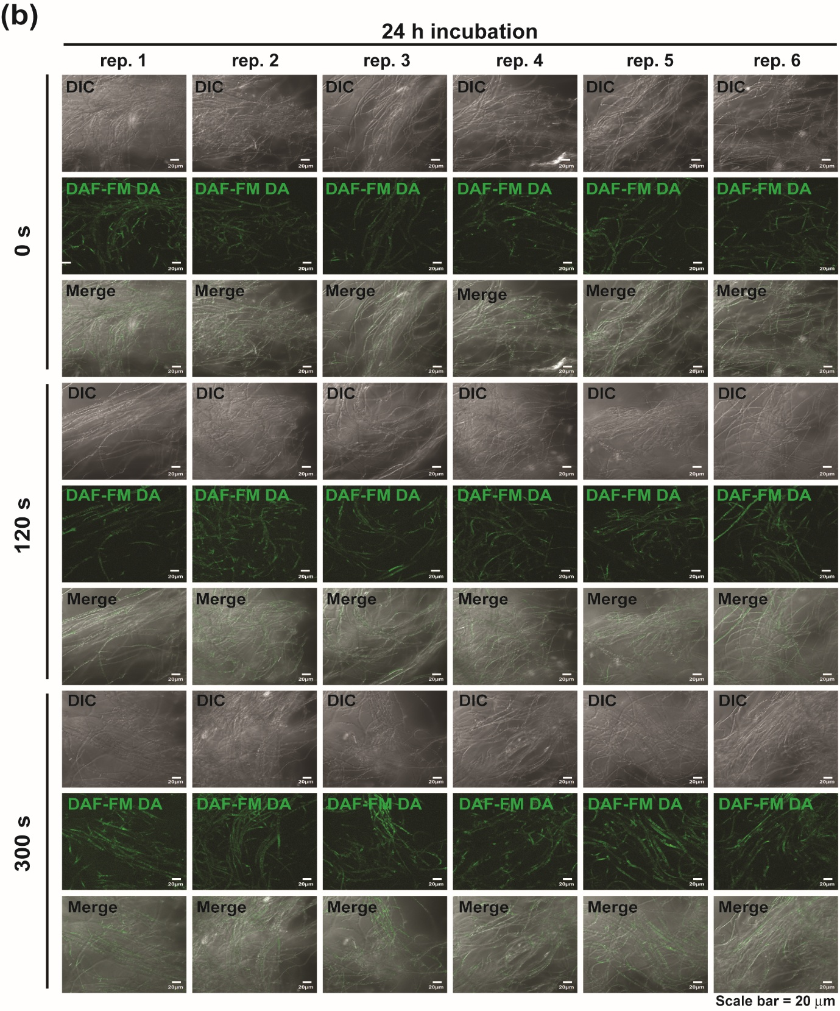
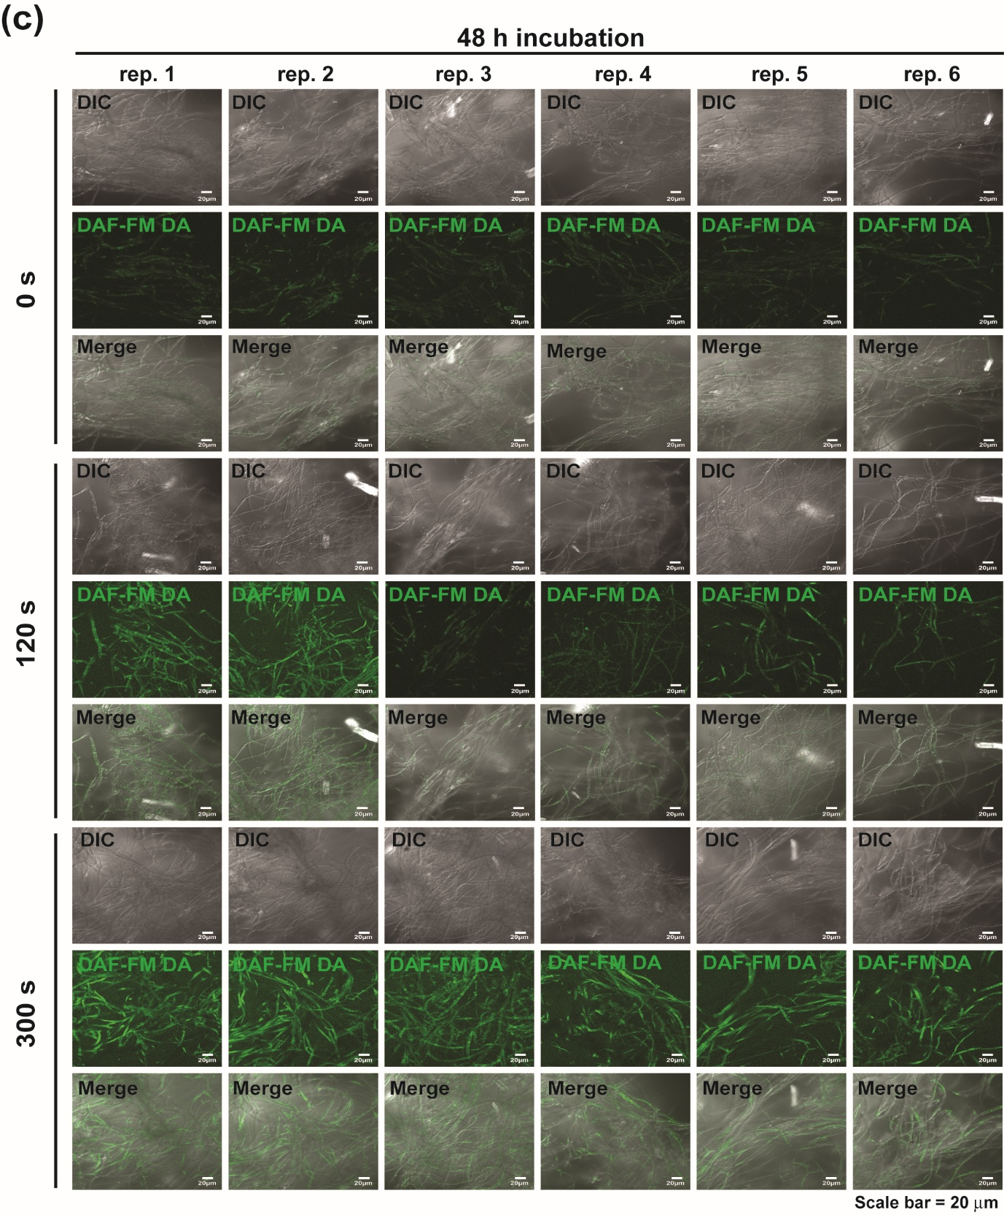
Supplementary Figure S8. Intracellular NO level in N. crassa hyphae after MS-DBD plasma treatment. Fungal hyphae were stained with DAF-FM DA (green fluorescence) after 4 h (a), 24 h (b) and 48 h (c) of plasma treatment. Pictures of fungal hyphae were taken in 6 different areas. DIC; Differential Interference Contrast, DAF-FM DA; fluorescence, Merge; combined image of DIC and fluorescence.

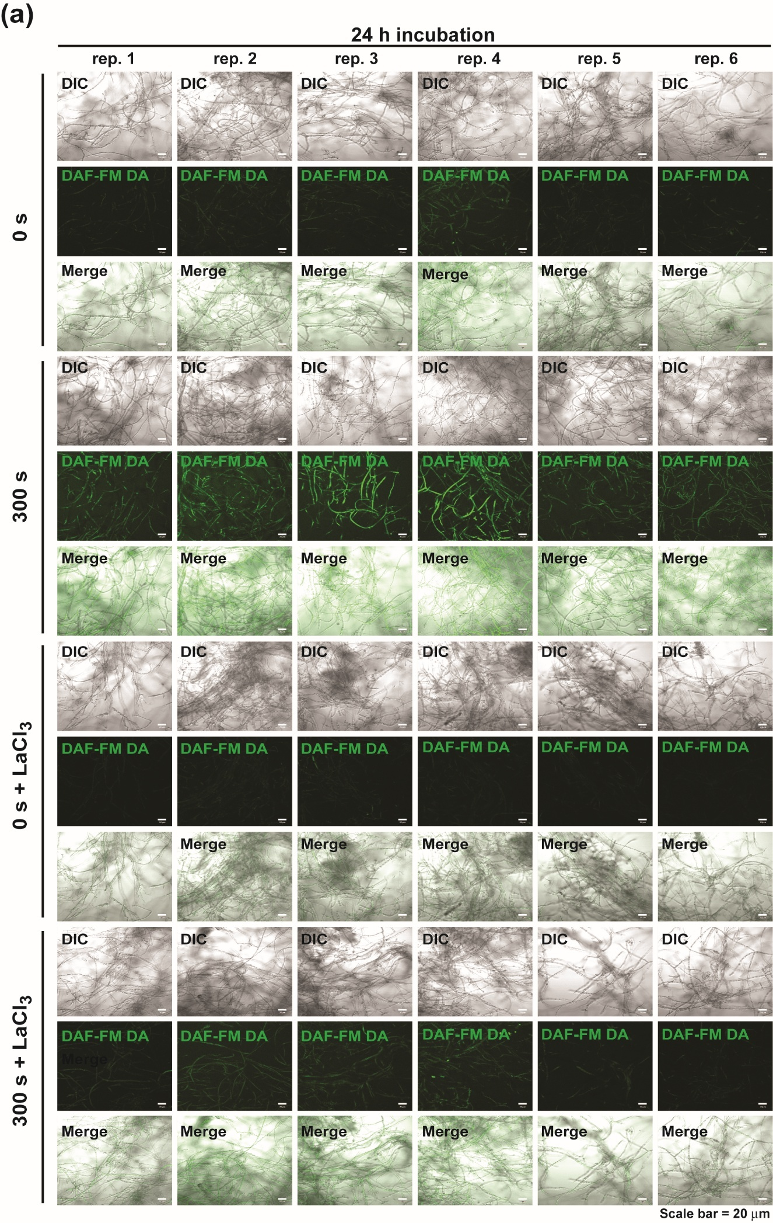
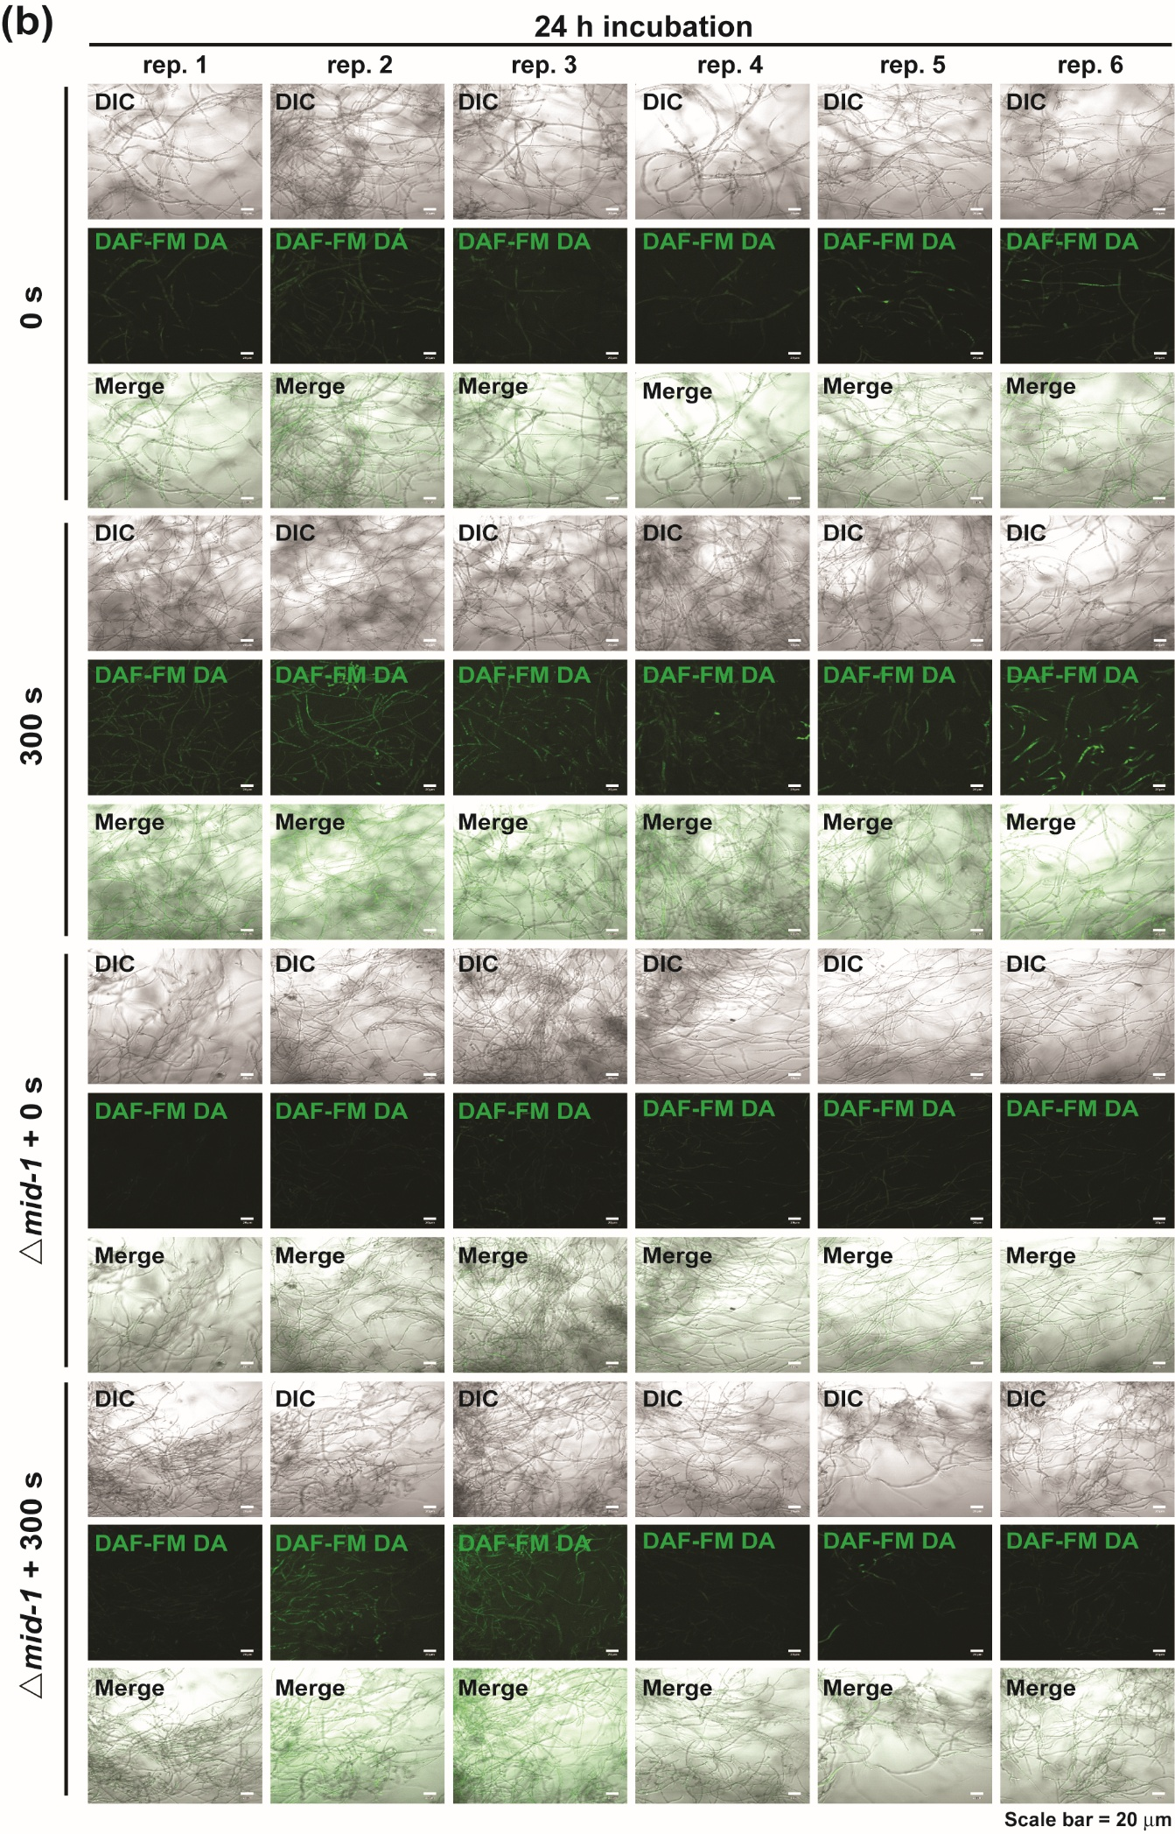
Supplementary Figure S9. Intracellular NO level in LaC1₃-treated wild type (FGSC4200) (a) and mid-1 mutant (FGSC11707) (b) hyphae. The hyphae were cultured in avicel media with or without LaC1₃, respectively, then recovered after 24 h of incubation, and stained with DAF-FM DA (green fluorescence). Pictures of fungal hyphae were taken in 6 different areas. DIC; Differential Interference Contrast, DAF-FM DA; fluorescence, Merge; combined image of DIC and fluorescence.

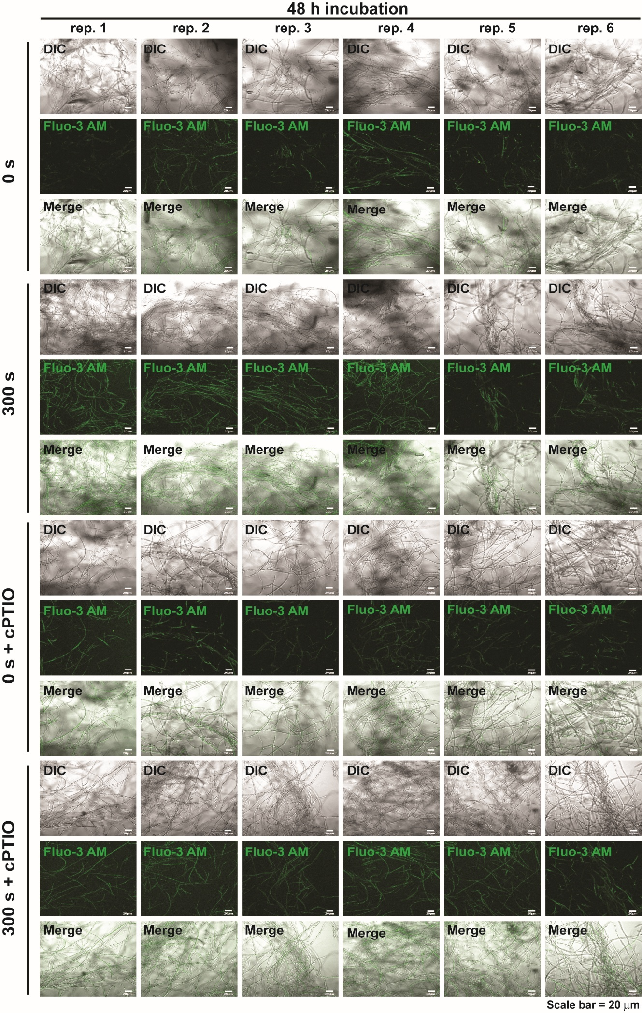
Supplementary Figure S10. Intracellular Ca²⁺ levels in hyphae after 48 h of plasma and cPTIO treatment. Hyphae were stained with Fluo-3 AM (green fluorescence) after 48h of incubation from plasma treatment in avicel media supplemented with cPTIO or none. Pictures of fungal hyphae were taken in 6 different areas. DIC; Differential Interference Contrast, Fluo-3 AM; fluorescence, Merge; combined image of DIC and fluorescence.

Supplementary Figure S11. Effects of MS-DBD plasma treatment on avicel degradation and fungal hyphal growth in media. (a) Level of total reducing sugars produced in avicel medium after MS-DBD plasma treatment. (b) Relative percentage of dry weight (biomass) of fungal mycelia compared to those of non-treated groups grown in glucose media after MS-DBD plasma treatment. Fungal mycelia were harvested after 24 h and 48 h of incubation. Each value is the mean of 6 or 9 replicate measurements (three replicates per experiment and two or three independent experiments): * p < 0.05, ** p < 0.01, *** p < 0.001 as determined by Student’s t-test (control vs. treatment).

