Graphical abstract
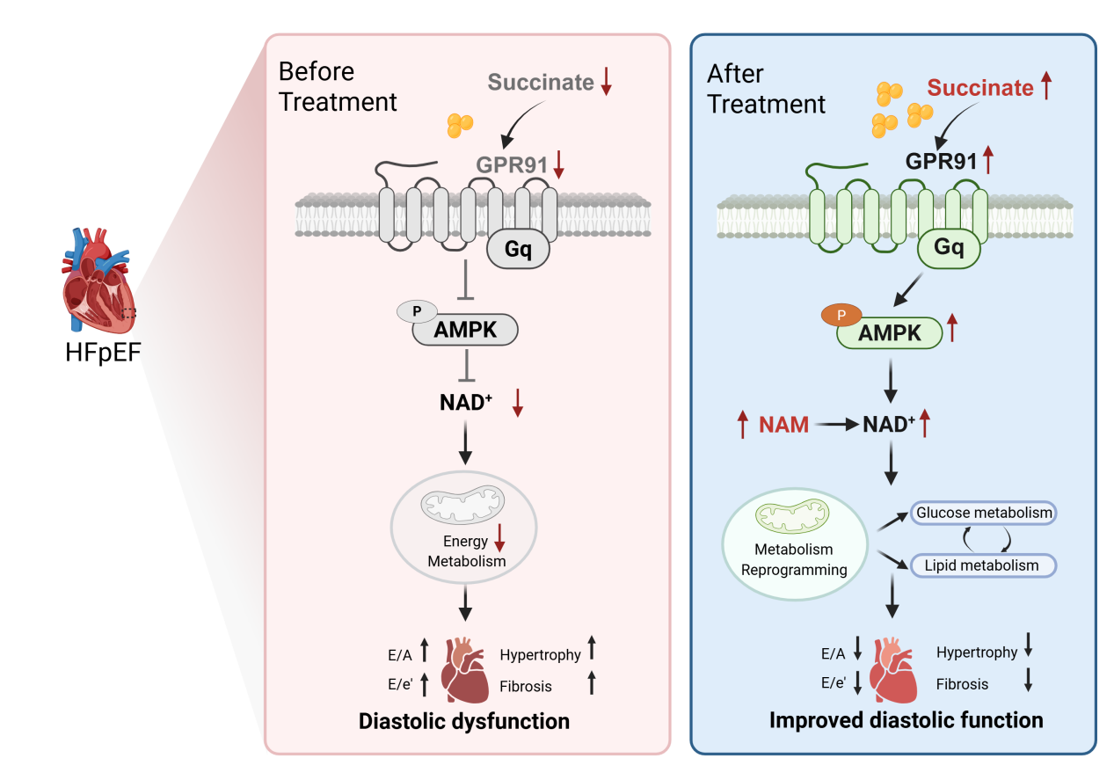
Succinate-GPR91 Signaling Reprograms Cardiac Metabolism and Improves Diastolic Dysfunction. In HFpEF, myocardial succinate levels and its receptor GPR91 are markedly reduced, resulting in insufficient AMPK activation, diminished NAD⁺ biosynthesis, impaired metabolic flexibility, and diastolic dysfunction accompanied by hypertrophy and fibrosis. Exogenous succinate restores GPR91–Gq–AMPK signaling, enhances NAD⁺ production, reprograms myocardial metabolism, and improves diastolic performance. Similarly, direct supplementation with the NAD⁺ precursor nicotinamide bypasses receptor signaling to replenish NAD⁺ pools and attenuate HFpEF-associated cardiac dysfunction. These findings identify the succinate–GPR91–AMPK–NAD⁺ axis as a potential therapeutic target for HFpEF.

