Electronic Supplementary Materials
Dual-modal colorimetric and fluorescent sensing of antineoplastic drug fludarabine via bimetallic-doped nitrogen carbon dots nanozyme
Ali O Alqarni ª, Rayed Ali A. Alqahtani ª, Ashraf M Mahmoudª, Meshal H. Almabadi^{b}, Fatmah M. Alshareef^{c}, Mohamed N. Goda^{d}, Ramadan Ali^{e}, Mohamed M. El-Wekil^{f}
ª Department of Pharmaceutical Chemistry, Faculty of Pharmacy, Najran University, Najran, Kingdom of Saudi Arabia
^{b} Department of Chemistry, Faculty of Science, University of Jeddah, Jeddah, Saudi Arabia
^{c} Department of Chemistry, Faculty of Science, King Abdulaziz University, P. O. Box 80203, Jeddah 21589, Saudi Arabia
^{d} Department of Chemistry, College of Science, Imam Mohammad Ibn Saud Islamic University (IMSIU), Riyadh 11623, Saudi Arabia
^{e} Department of Pharmaceutical Chemistry, Faculty of Pharmacy, University of Tabuk, Tabuk 71491, Saudi Arabia
^{f} Department of Pharmaceutical Analytical Chemistry, Faculty of Pharmacy, Assiut University, Assiut 71526, Egypt
Correspondence
Email: raalqahtani@nu.edu.sa
Instruments
Fluorescence measurements were recorded using a Shimadzu RF-5301 PC spectrofluorometer (3 nm slit width, 1 cm path length quartz cuvette). Transmission electron microscopy (TEM, JEOL JEM-100CX II) was employed to characterize the morphology of CuNi@CDs, while Fourier-transform infrared spectroscopy (FT-IR, Nicolet™ iS™10) was used to identify surface functional groups. Elemental composition was analyzed by energy-dispersive X-ray spectroscopy (EDX, NEX QC+ QuantEZ), and structural characteristics were further examined using X-ray diffraction (XRD, PW 1710). Particle size distribution and hydrodynamic diameter were assessed by dynamic light scattering (DLS, Zetasizer Nano ZS, ZEN 3600, Malvern, UK). X-ray photoelectron spectroscopy (XPS, ESCA Ulvac-PHI 1600, PHI Quantum 2000, USA) was conducted to probe surface chemical states, while UV–Vis absorption spectra were obtained using a Shimadzu UV-1601 PC spectrophotometer (Tokyo, Japan). The metal content of the nanomaterials was quantified by inductively coupled plasma atomic emission spectroscopy (ICP-AES, PerkinElmer, USA).

Samples preparation
For pharmaceutical analysis, fludarabine phosphate (50 mg, lyophilized powder for injection) was reconstituted by accurately weighing 5.0 mg and dissolving it in 25 mL of ultrapure water. Appropriate aliquots were subsequently diluted with ultrapure water to obtain working solutions within the calibration range. For biological samples, 200 μL of urine or serum was diluted with acetate buffer (pH 3.8) to match the desired concentration range. Quantification of FLD in both pharmaceutical and biological matrices was performed using the standard addition method to minimize matrix interference and ensure analytical accuracy.

Fluorescence quantum yield measurements of NCDs and CuNi@NCDs (X)
The quantum yield (QY) values were calculated according to the following equation using quinine sulfate (QS) as a reference in 0.1 mol/L H₂SO₄ (QY = 54 %). By measuring the absorbance (less than 0.05) and emission spectra of a certain concentration of X and QS at the same excitation wavelength at 360 nm, the absorbance and fluorescence integrals area were substituted into the following formula:
$$ϕ_{X}= ϕ_{QS}× \frac{F_{X}}{F_{QS}}×\frac{A_{QS}}{A_{X}}×\frac{η_{X}}{η_{QS}}$$
Φ_{X} represents the quantum yield of X, ϕ_{QS} represents the quantum yield of QS, F_{X} is the fluorescence intensity of X, F_{QS} is the fluorescence intensity of QS, A refers to the absorbance value and η refers to the refractive index of the solvent (distilled water). The synthesized X were dissolved in distilled water (η = 1.33) and QS was dissolved in 0.1 M H₂SO₄ (η = 1.33).

Kinetic studies
Using CuNi@NCDs as the catalyst, OPD was oxidized by H₂O₂ to produce DAP, exhibiting a characteristic absorbance at 425 nm. Reactions were carried out in acetate buffer with sequential reagent addition, and key parameters, including pH, temperature, incubation time, and the Cu/Ni ratio, were optimized to maximize catalytic activity. DAP concentration was determined via the Lambert–Beer law, and kinetic parameters (Kₘ and Vₘₐₓ) were obtained from Lineweaver–Burk plots.

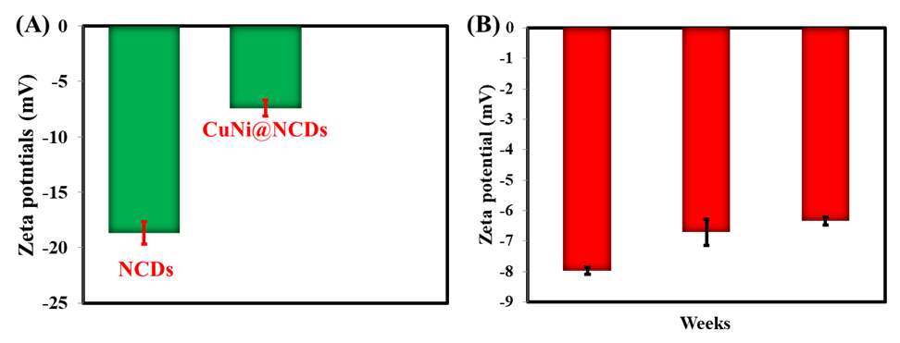
Fig. S1(A) Zeta potentials of NCDs and CuNi@NCDs while (B) Zeta potential measurements of CuNi@NCDs for successive three weeks.

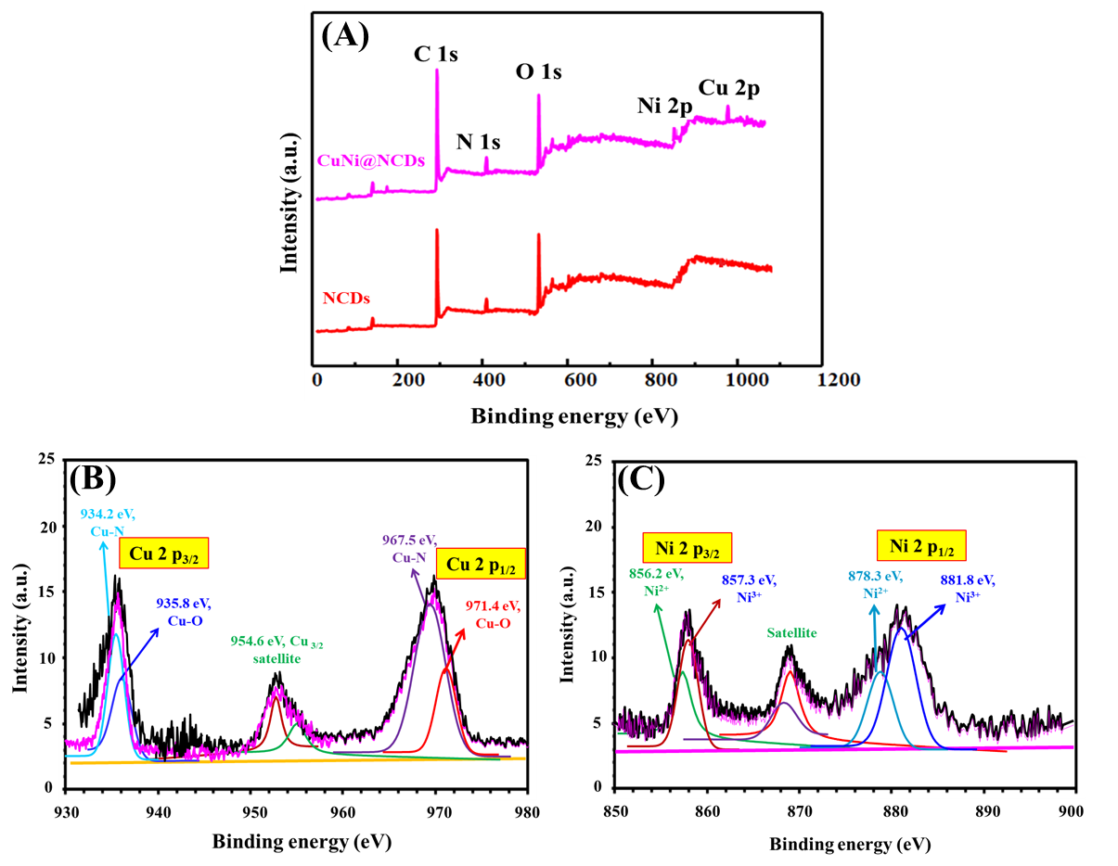

Fig. S2(A) XPS survey of CuNi@NCDs; (B) Deconvoluted spectra of Cu 2p; (C) Deconvoluted spectra of Ni 2p.

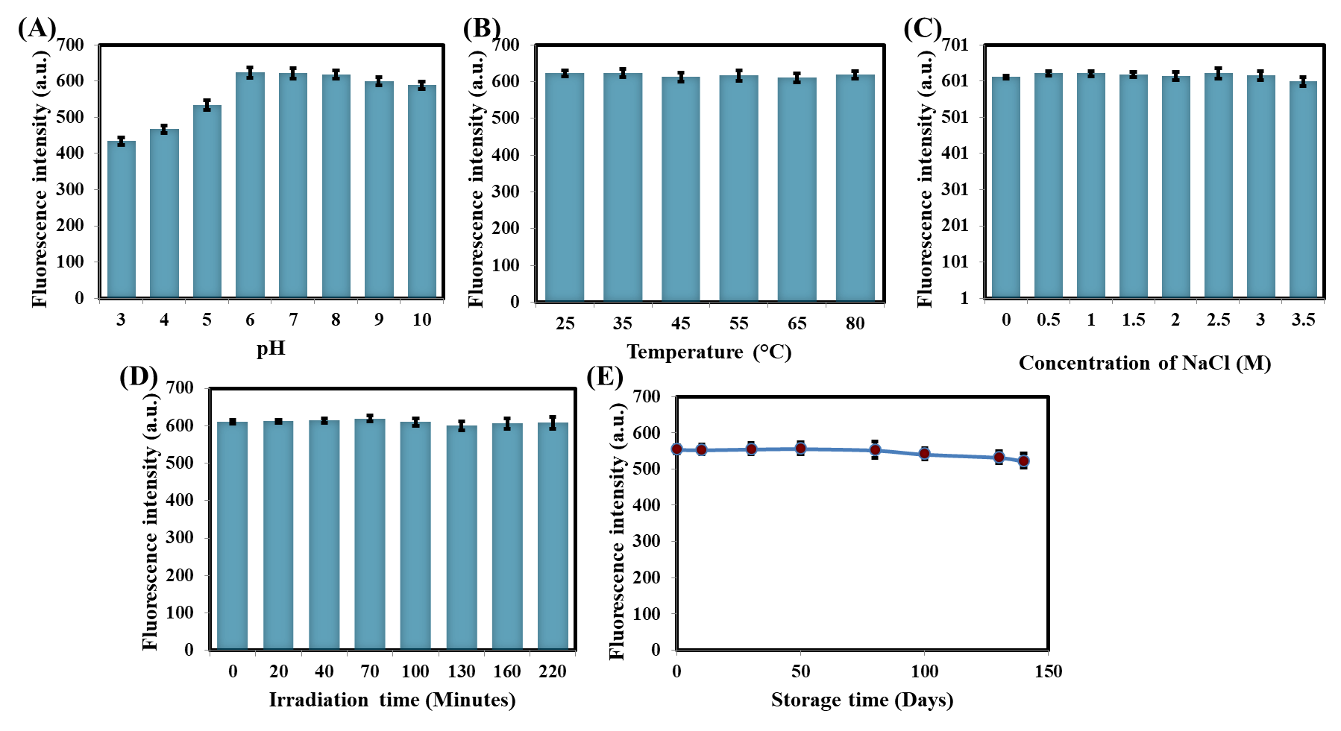

Fig. S3 PL readings of CuNi@NCDs under various conditions: (A) pH, (B) temperature, (C) NaCl, (D) irradiation time, and (E) storage days.

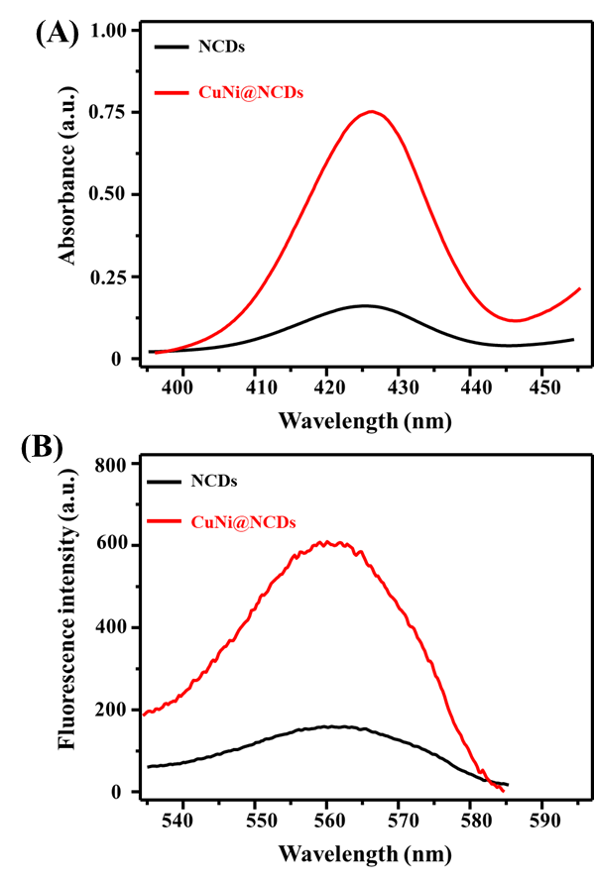

Fig. S4 (A) UV/Vis and (B) PL readings of NCDs and CuNi@NCDs.

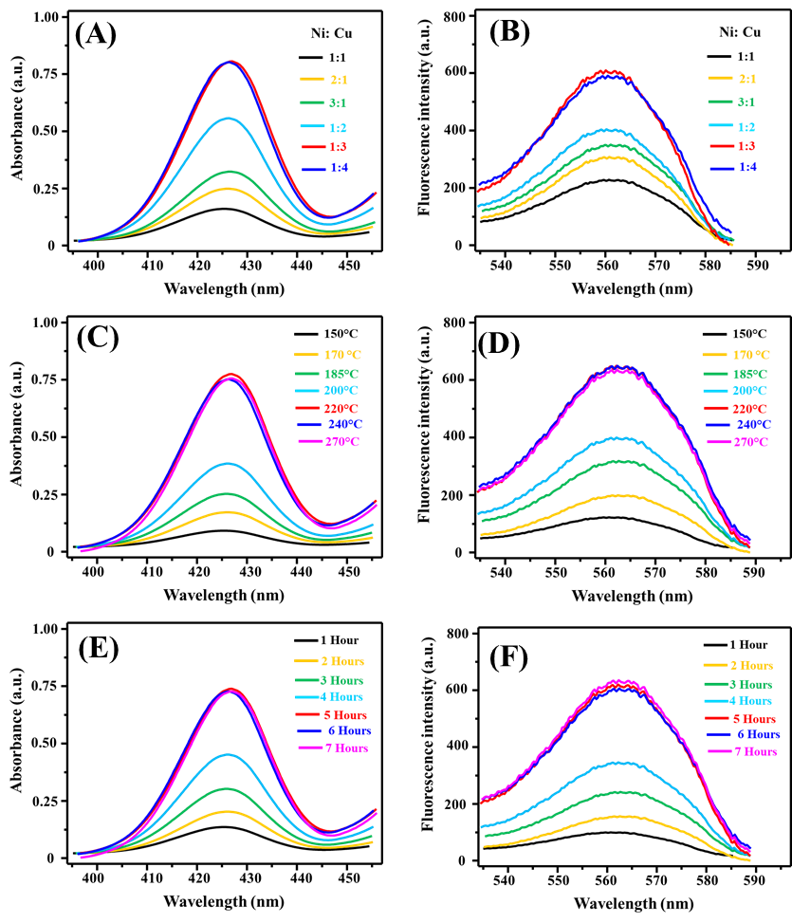

Fig. S5 UV/Vis (A, C, E) and fluorescence (B, D, F) spectra for the effect of Ni: Cu ratio, synthesis temperature, and synthesis time.

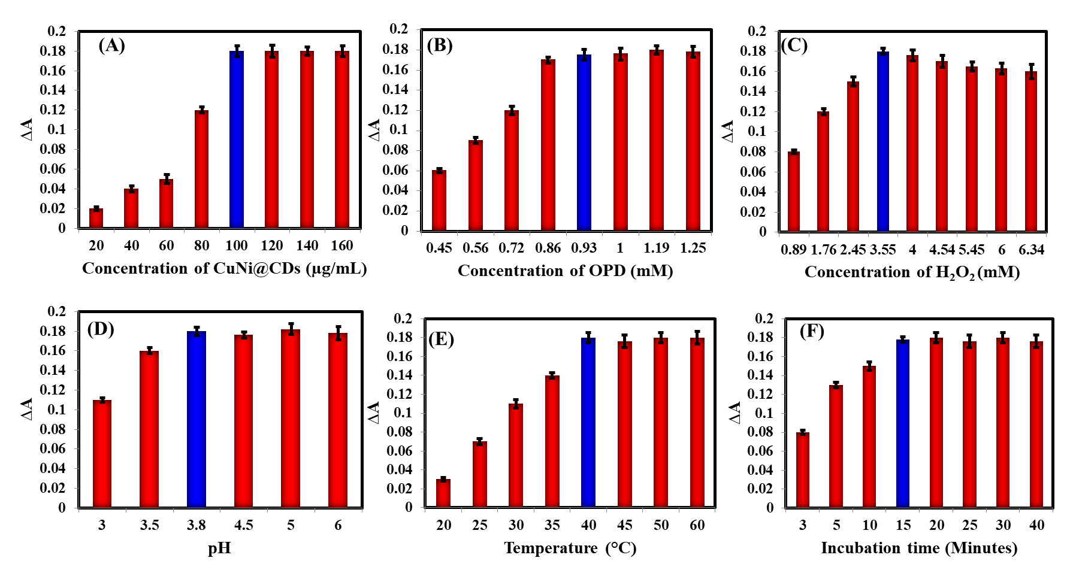

Fig. S6 UV/Vis for peroxidase-mimetic activity of CuNi@NCDs after changing (A) concentration of CuNi@NCDs, (B) concentration of OPD, (C) concentration of H₂O₂, (D) pH, (E) incubation temperature, and (F) incubation time. Concentration of FLD is 50 µM.

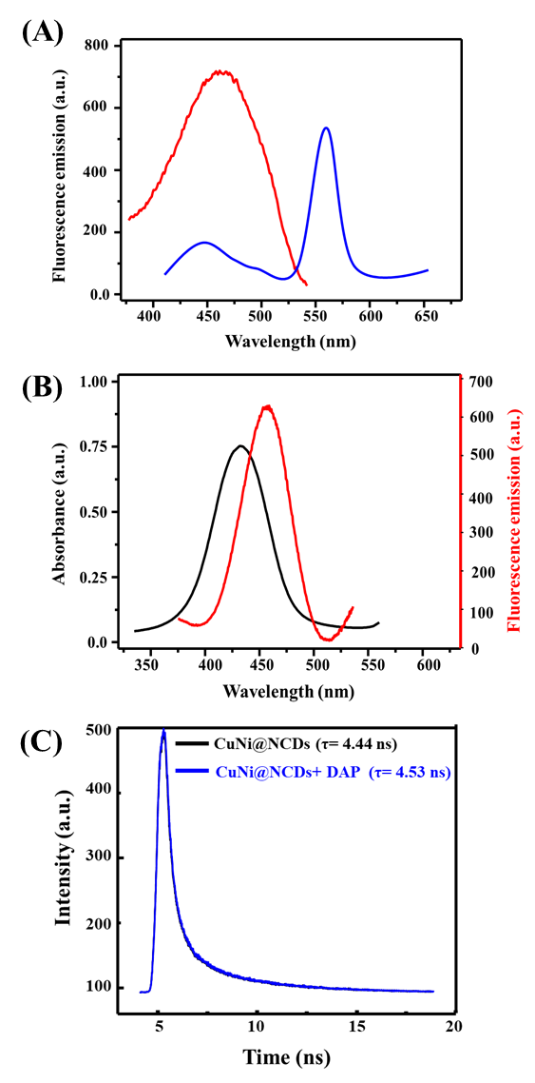

Fig. S7 (A) Emission spectra of CuNi@NCDs and CuNi@NCDs/DAP; (B) Emission spectrum of CuNi@NCDs and UV/Vis absorption of DAP; (C) Fluorescence decay profiles with/without DAP.

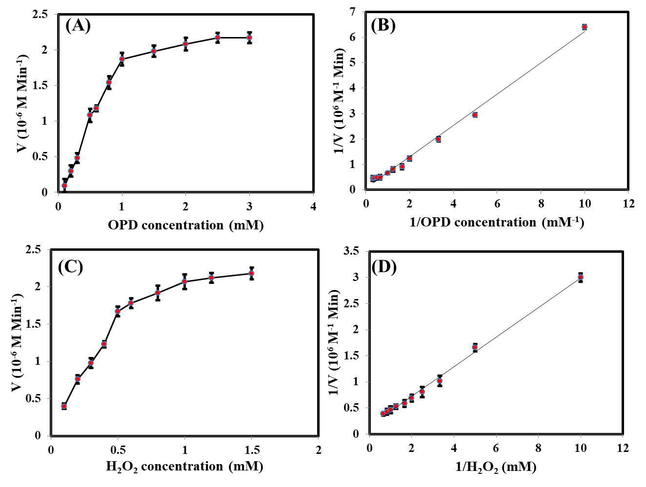

Fig. S8 Michaelis–Menten and Lineweaver–Burk plots illustrating the peroxidase-like kinetics of FeCu@CDs.
(A) Michaelis–Menten curve for OPD at 1 mM H₂O₂.
(B) Corresponding Lineweaver–Burk plot for OPD.
(C) Michaelis–Menten curve for H₂O₂ at 0.25 mM OPD.
(D) Corresponding Lineweaver–Burk plot for H₂O₂.

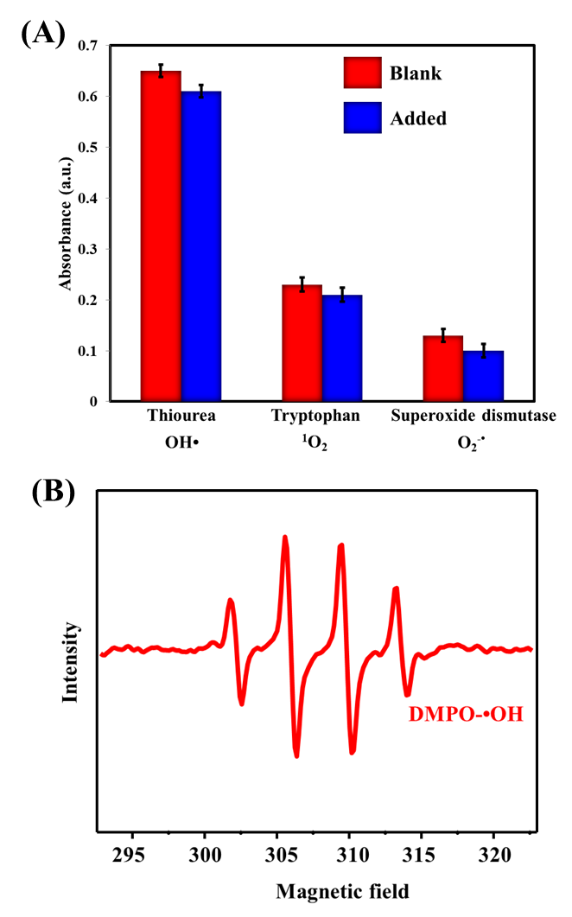

Fig. S9 (A) UV-Vis absorption at 425 nm before (blank) and after adding the ROS capture agents in the CuNi@NCDs/ OPD/H₂O₂ system; (B) EPR spectra of the DMPO-•OH adduct.

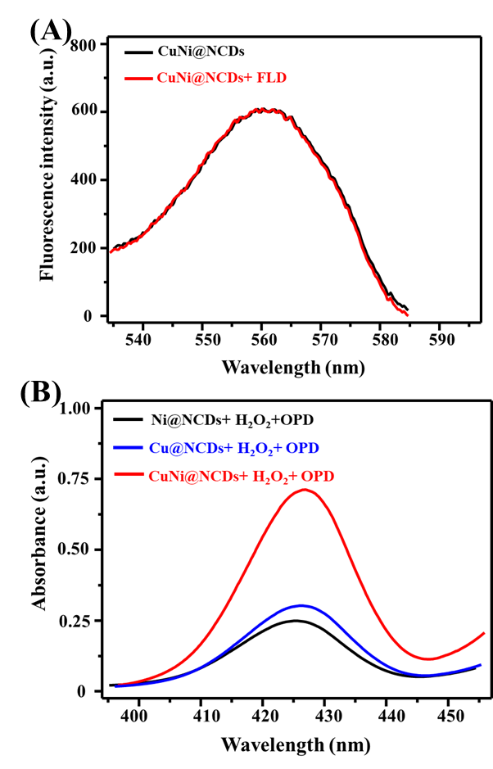

Fig. S10 (A) Emission spectra of CuNi@NCDs and CuNi@NCDs/100 µM FLD; (B) UV/Vis of Ni@NCDs, Cu@NCDs, and CuNi@NCDs in the presence of H₂O₂ and OPD.

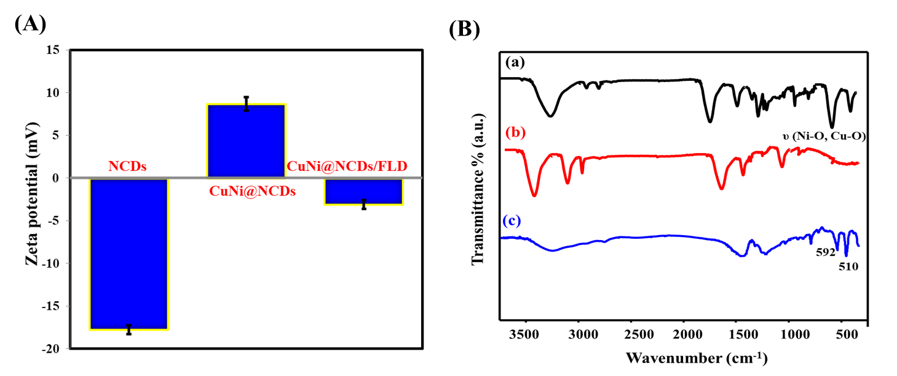

Fig. S11 (A) Zeta potential measurement of NCDs, CuNi@NCDs, and CuNi@NCDs/FLD; (B) FTIR spectra of (a) CuNi@NCDs, (b) FLD, and (c) CuNi@NCDs/FLD mixture.

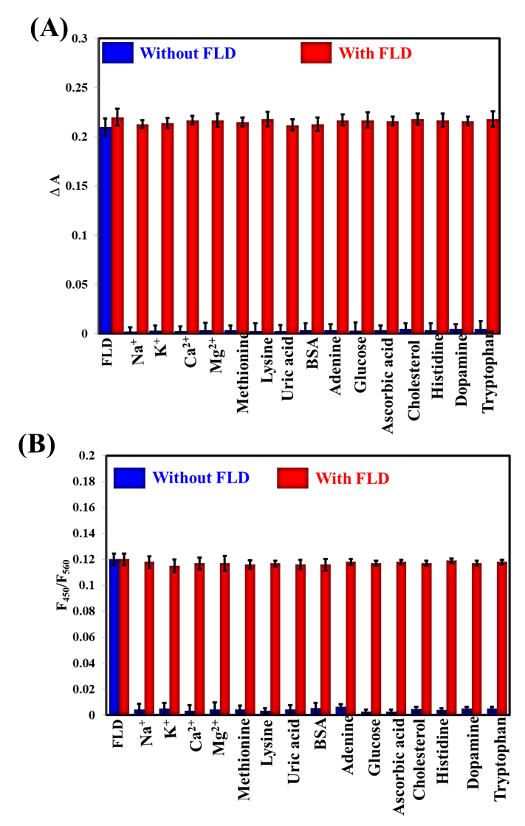

Fig. S12 Selectivity of CuNi@NCDs/H₂O₂/OPD system for detection of 50 µM FLD via (A) colorimetric and (B) fluorometric modes.

Nanocatalyst | Substrate | Km (mM) | V_{max} (10⁻⁷ M s⁻¹) | Reference
HRP | H₂O₂  OPD | 3.70  0.59 | 8.71  4.65 | [1]  [2]
Cu₂O nanowire | H₂O₂  OPD | 242  0.47 | 4.30  5.54 | [3]
MOF-919(Fe-Cu) | H₂O₂  OPD | 0.24  1.36 | 4.15  14.62 | [4]
Fe₃O₄-PEI | H₂O₂  OPD | 200  7.5 | 6.2  13.5 | [5]
CuNi@NCDs | H₂O₂  OPD | 0.165  0.875 | 14.75  11.39 | This work
Table S1. Comparison of Km and Vmax between CuNi@NCDs and other nanocatalysts.

Table S1. Comparison of Km and Vmax between Fe/N@C-dots and other nanocatalysts.

Table S2 Precision of dual-mode method for determination of FLD using CuNi@NCDs/OPD/H₂O₂ system (n=6).
Method | Concentration (µM) | Intraday precision |  |  | Intraday precision
Method | Concentration (µM) | Measured (µM) | Recovery % | RSD % | Measured (µM) | Recovery % | RSD %
Colorimetric | 2.0  50.0  300.0 | 2.08  52.43  298.66 | 104.0  104.9  99.6 | 2.56  2.12  3.07 | 1.95  48.56  296.87 | 97.5  97.1  98.9 | 2.56  3.28  2.09
Fluorometric | 2.0  50.0  300.0 | 1.95  48.54  302.67 | 97.5  97.1  100.9 | 1.45  2.09  3.13 | 2.12  48.56  297.54 | 106.0  97.1  99.1 | 2.45  3.76  2.62

References
- J. Chen, X. Wei, H. Tang, J.C. Munyemana, M. Guan, S. Zhang, H. Qiu, Deep eutectic solvents-assisted synthesis of ZnCo₂O₄ nanosheets as peroxidase-like nanozyme and its application in colorimetric logic gate. Talanta. 222 (2021), Article 121680.
- L. Gao, J. Zhuang, L. Nie, J. Zhang, Y. Zhang, N. Gu, T. Wang, J. Feng, D. Yang, S. Perrett, X. Yan, Intrinsic peroxidase-like activity of ferromagnetic nanoparticles. Nat. Nanotechnol. 2 (2007), pp. 577-583.
- G.L. Li, P. Ma, Y.F. Zhang, X.L. Liu, H. Zhang, W.M. Xue, Y. Mi, Y.E. Luo, H.M. Fan, Synthesis of Cu₂O nanowire mesocrystals using PTCDA as a modifier and their superior peroxidase-like activity. J. Mater. Sci. 51 (2016), pp. 3979-88.
- S. Kulandaivel, C.H. Lin, Y.C. Yeh, The bi-metallic MOF-919 (Fe-Cu) nanozyme capable of bifunctional enzyme-mimicking catalytic activity. Chem. Commun. (Camb). 58 (2022). Pp. 569-572.
- T. Wang, X. Hu, Y. Yang, Q. Wu, C. He, X. He, Z. Wang, X. Mao, New Insight into Assembled Fe₃O₄@PEI@Ag Structure as Acceptable Agent with Enzymatic and Photothermal Properties. Int. J. Mol. Sci. 23 (2022), p. 10743.

