ADDITIONAL FILE 3
Supplemental Figure 1: Feature selection using elastic net constraints model. The 10-fold cross-validation and the minimal criteria process was used to generate the optimal penalization coefficient lambda (λ) in the model. As a result, λ values of 0.04294 and 0.06113 were selected for the BMUS (a) and SWE (c) features, respectively. (b) and (d) Elastic net constraints coefficient profiles of the BMUS and SWE features. The dotted vertical line was drawn at the value selected by 10-fold cross-validation when the optimal λ resulted in six (BMUS) and eight (SWE) nonzero coefficients, respectively.
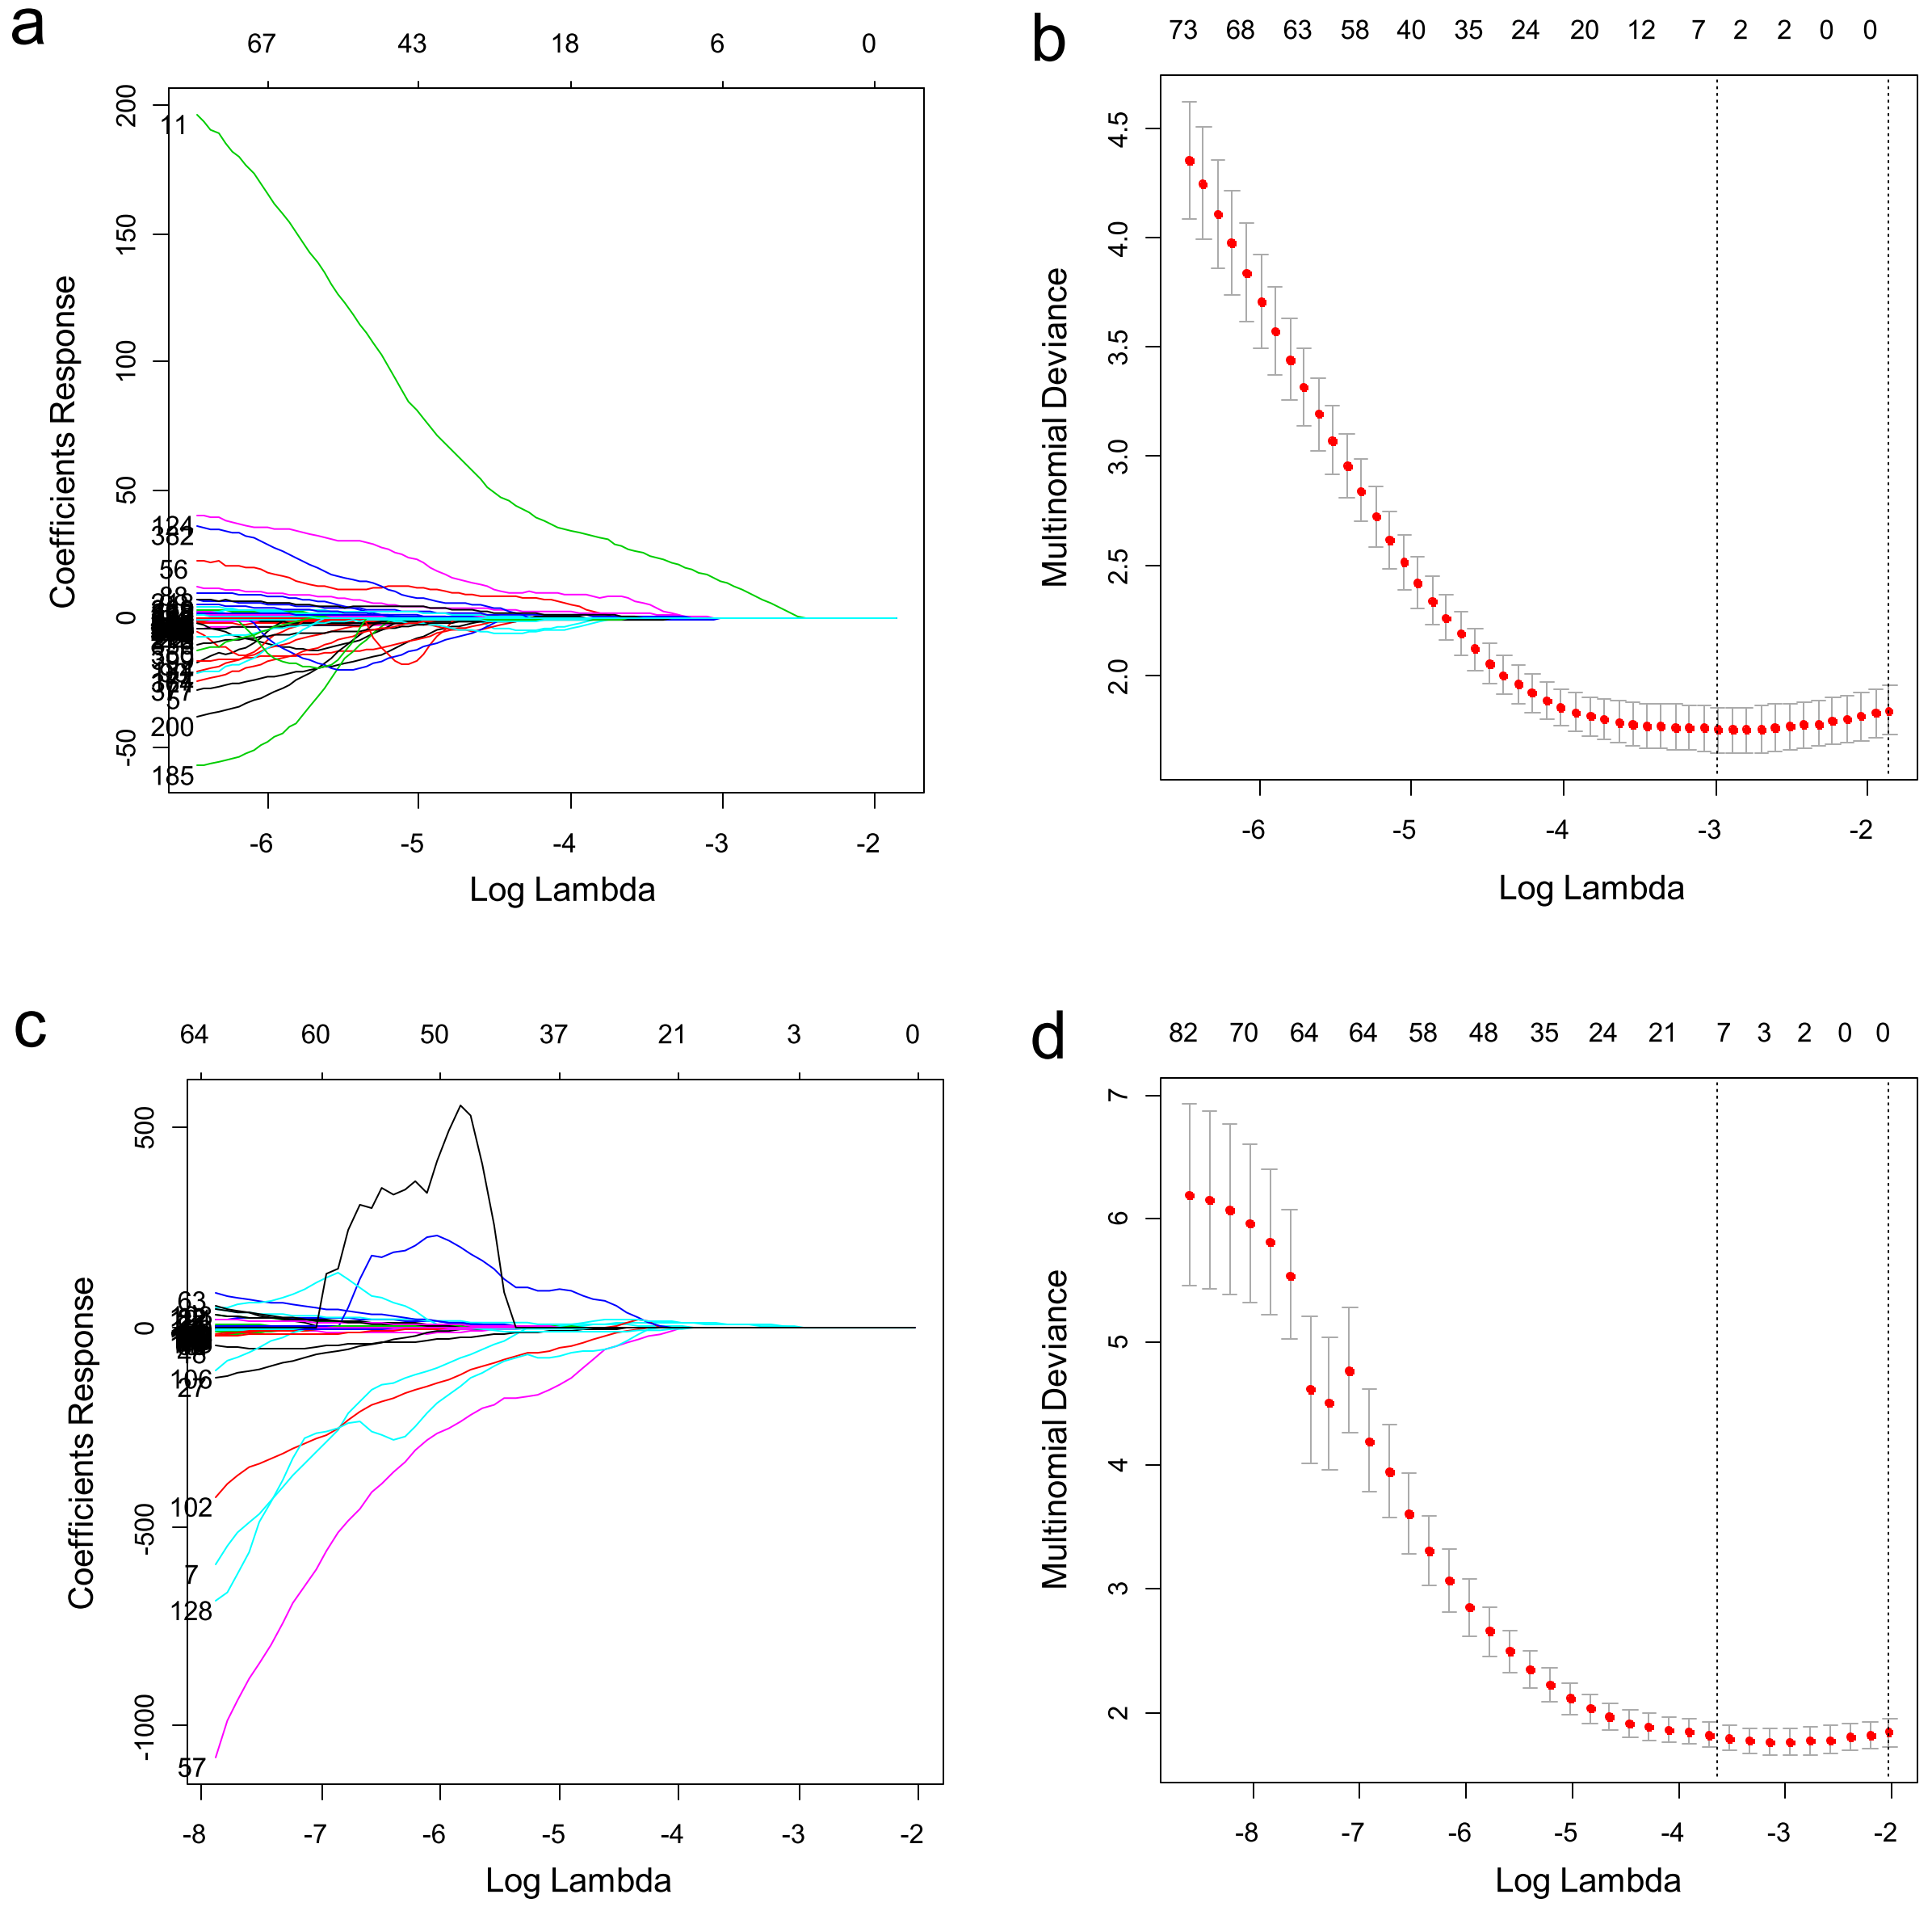
Supplemental Figure 2: Bar graphs represent the percentage of patient to develop different ALN status based on the cutoff values of the Nomo-score for each subgroup stratified by age (a: ≤ 60 years; b: >60 years), and ultrasound-reported ALN status (c: cN0; d: cN+).

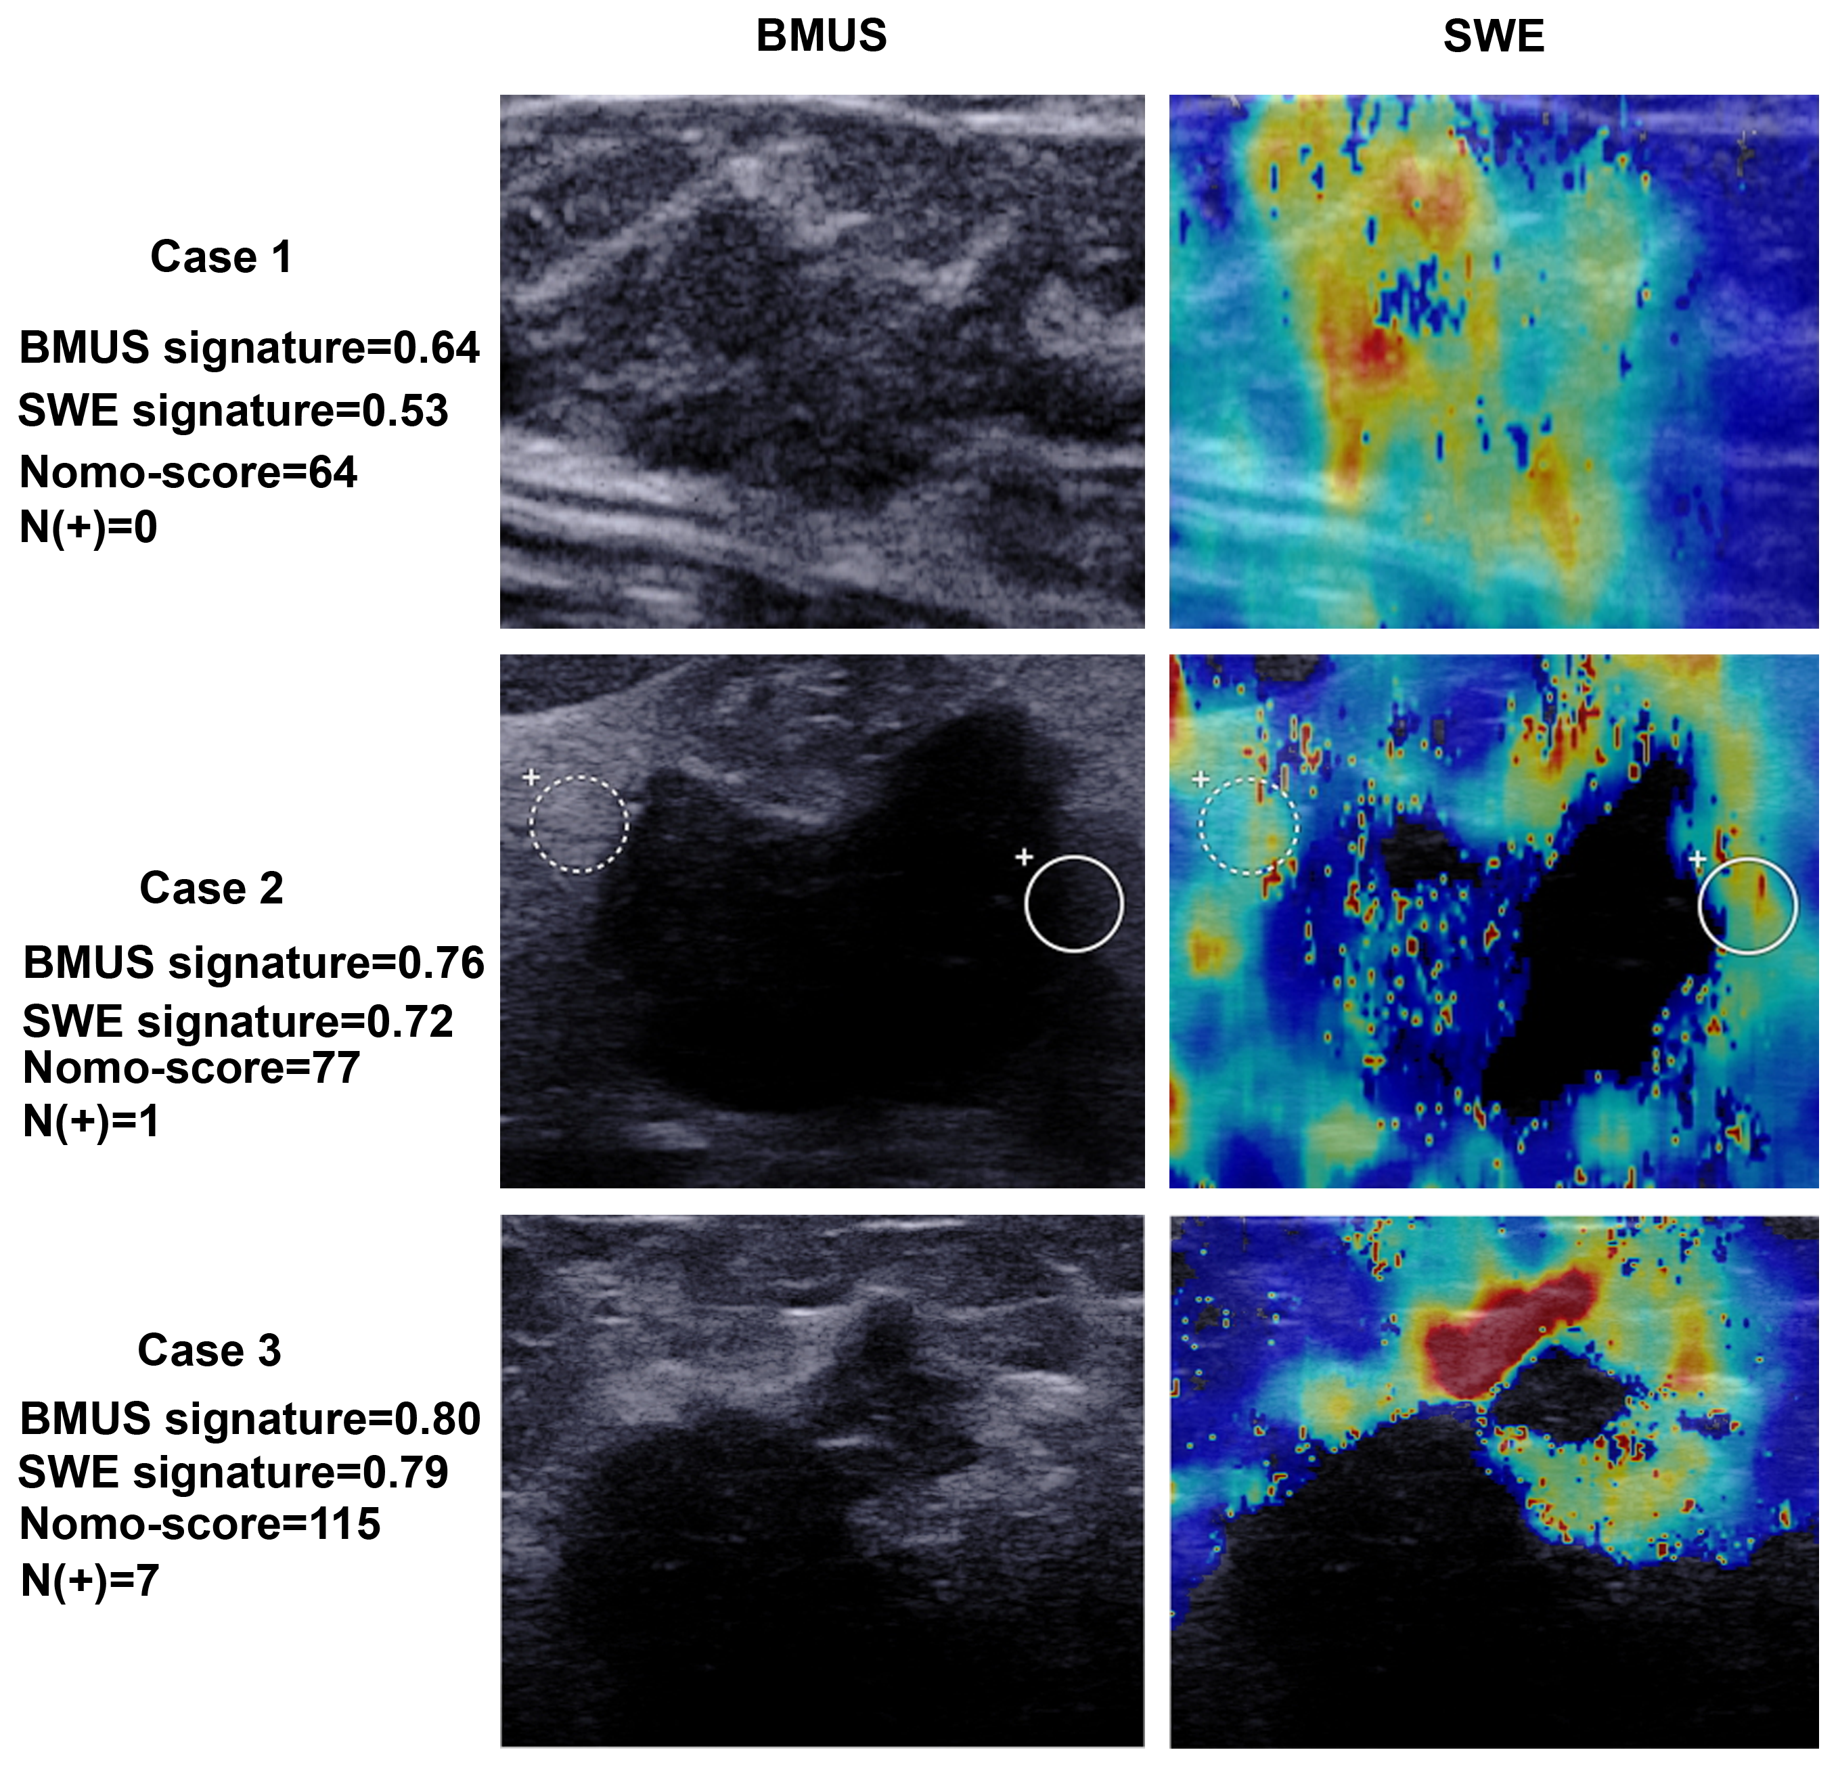
Supplemental Figure 3: Typical cases of patients with different ALN status and radiomic signatures.

