ADDITIONAL FILE 1
Supplemental Narrative

Detailed descriptions on shear-wave elastography (SWE)
The Supersonic Aixplorer system (SuperSonic Imagine, Aix-en-Provence, France) system was equipped with a 15–4 MHz linear array transducer with default software pre-sets for breast imaging (1). Mass size (longest diameter, perimeter and area), BI-RADS features of shape (oval, round, irregular), orientation (parallel or not) and margin (circumscribed or not) were recorded for each mass, together with a BI-RADS assessment (2, benign; 3, probably benign; 4a, low index of suspicion; 4b, intermediate index of suspicion; 4c, moderate index of suspicion; or 5, highly suggestive of malignancy).
After recording the B-mode features, SWE imaging was conducted with the same transducer on the system. The recommended technique for SWE was to image the tumor with no pressure induced by the transducer before switching to SWE mode. After a few seconds of immobilization to allow the SWE image to stabilize, the SWE image was frozen and saved. At each site, investigators were first trained on phantoms and then on at least 10 non-study patients before enrolling their first participant.
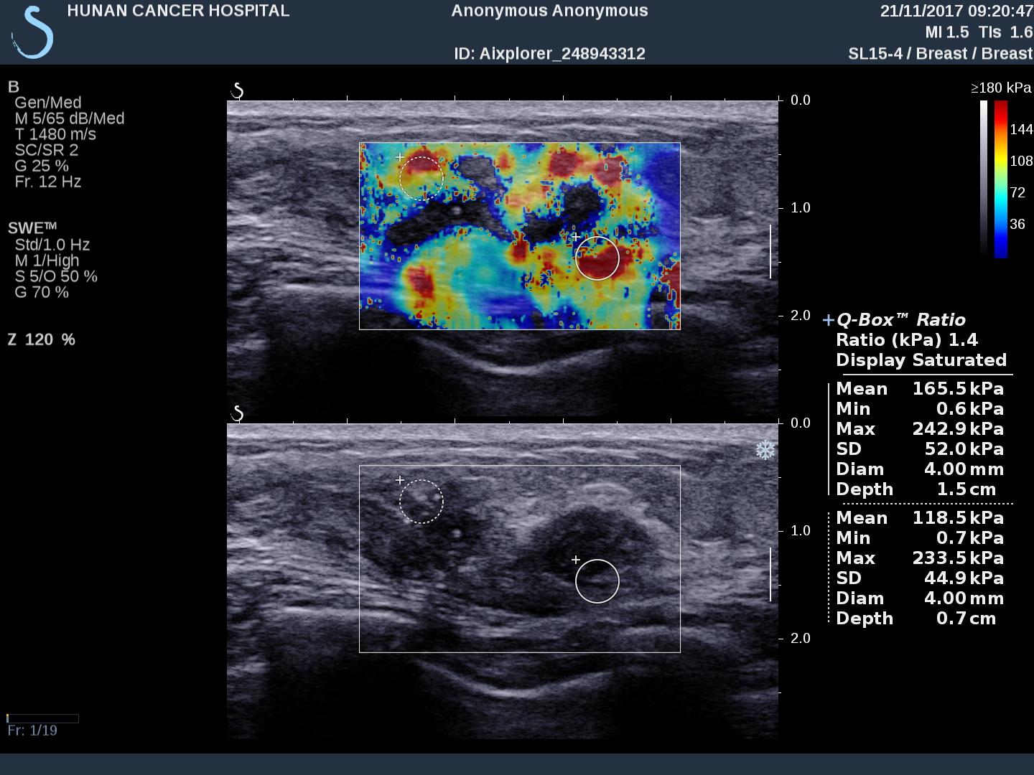
Three consecutive and distinct SWE images of the mass were acquired by the same operator in the same imaging plane, the probe having been removed and re-applied between each acquisition. In each image, the tissue stiffness of each pixel in the SWE image was displayed as a semi-transparent colour overlay with a range from dark blue, indicating the lowest stiffness (at just over 0 kPa), up to red, indicating the highest stiffness (set at 180 kPa for this study) (Example Figure). Areas of black on the SWE images represent tissue in which no shear wave was detected. Using the system’ s review capability, the perimeter of the mass (including surrounding tissue stiffness) was traced and the operator determined the largest diameter on each SWE image. Where no zone of altered stiffness was apparent and the mass was homogeneously soft (blue) on SWE, the dimensions recorded were those of the mass seen on the underlying B-mode image.
Example Figure A 63-year-old woman with invasive ductal carcinoma. Top: SWE image shows increased stiffness (coded in red and orange) in the peritumoral region. Bottom: B-mode image shows an irregular hypoechoic mass with an echogenic halo that was considered to be a Breast Imaging Re-porting and Data System (BI-RADS) category 5 lesion. One ROI is in the stiffest part of the lesion (solid circle) and another is in the adjacent subcutaneous fat (dotted circle). The quantitative values for the two ROIs are shown in kPa in the panel on the right: the lesion value is given first (mean 165.5 kPa), followed by the value in fat (mean 118.5 kPa).
References:
1. Cosgrove DO, Berg WA, Doré CJ, et al. Shear wave elastography for breast masses is highly reproducible. Eur Radiol 2012; 22(5):1023-32.

Detailed descriptions of the statistical methodology

Ⅰ. The least absolute shrinkage and selection operator (LASSO) algorithm
We used the LASSO algorithm to select the most important ALN-status related features and construct radiomics signature for BMUS and SWE in the training set. This algorithm minimizes a log partial likelihood subject to the sum of the absolute values of the parameters bounded by a constant:
$\hat{β}=arg min l\left(β\right)$, subject to $\sum{\left|β_{j}\right|}≤t$
where $\hat{β}$ is the obtained parameters, $l\left(β\right)$ is the log partial likelihood of the logistic regression model, and $t＞0$ is a constant.
The LASSO algorithm shrinks some coefficients and reduces others to exactly 0 via the absolute constraint. In this study, the constant t was set as 0.015, and LASSO selected 2 and 4 nonzero coefficients $\hat{β}$ for BMUS and SWE, respectively.
Reference: Sauerbrei W, Royston P, Binder H. Selection of important variables and determination of functional form for continuous predictors in multivariable model building. Stat Med 2007; 26 (30):5512-28.

Ⅱ. Decision curve analysis (DCA)
The DCA was used to assess the clinical utility of the SWE radiomics nomogram. The DCA algorithm assesses prediction models by calculating the range of threshold probabilities in which a prediction model was clinically useful. DCA is a compositive method for evaluating and comparing different prediction models. The theory of DCA can be illustrated by the equation below:
$$\frac{a-c}{d-b}=\frac{1-P_{t}}{P_{t}}$$
where d – b represents the influence of unnecessary treatment. If treatment is directed by a prediction model, d – b is the harm related to a false-positive result compared with a true-negative result. Inversely, a – c represents the consequence of rejecting beneficial treatment, in other words, the harm from a false-negative result compared with a true-positive result. P_{t} represents where the expected benefit of treatment is equal to the expected benefit of refraining from treatment.
Reference: Vickers AJ, Elkin EB. Decision curve analysis: a novel method for evaluating prediction models. Med Decis Making 2006; 26(6):565-74.

Radiomics signature formula
SWE signature = -0.0542221641
+ wavelet-HL_gldm_DependenceNonUniformityNormalized_R*1.7389406890
+ wavelet-HH_glszm_SmallAreaEmphasis_G*0.0318023468
- wavelet-LH_glcm_ClusterShade_B*0.0039258834
+ wavelet-HL_gldm_DependenceNonUniformityNormalized_B*0.6180210524
- gradient_glszm_SmallAreaLowGrayLevelEmphasis_B*1.2175247828
+ lbp-2D_firstorder_Mean_B * 0.0658947277
+logarithm_firstorder_Range_GREY*0.0009046385
- logarithm_glcm_MaximumProbability_GREY*0.1250994448

BMUS signature = -5.086804e+01
+ wavelet-LH_glszm_largeareahighgra* 4.537134e-11
+ wavelet-LL_glcm_idmn* 5.163007e+01
+ logarithm_gldm_smalldependenceem* 1.302940
+ logarithm_ngtdm_complexity* 4.052072e-03
- gradient_glszm_smallarealowgrayl*1.358122
+ lbp-2D_firstorder_rootmeansquared* 1.802641e-02

