Supplementary Table 1. Summary of the data sets utilized in this research and their features.
Dataset | Platform | Disease | Sample
GSE6477 | GPL96 | MM | 125 cases of MM and 15 controls
GSE16558 | GPL6244 | MM | 60 cases of MM and 5 controls
GSE175384 | GPL18573 | AL | 32 cases of AL and 40 controls
GSE4581 | GPL570 | MM | 414 cases of MM (414 with survival data)
GSE73040 | GPL6244 | AL | 9 cases of AL and 5 controls
MMRF | TCGA | MM | 764 primary MM samples (763 with survival data)
GSE188222 | GPL24676 | AL | 3 cases of AL and 1 control
GSE271107 | GPL24676 | MM | 4 cases of MM and 5 controls

Notes: MM: Multiple myeloma; AL: Immunoglobulin light-chain amyloidosis; GEO: Gene Expression Omnibus; TCGA: The Cancer Genome Atlas.

Supplementary Table 2. GO Pathway Enrichment Analysis Results.
ONTOLOGY | ID | Description | BgRatio | P value
GO/BP | GO:0030098 | lymphocyte differentiation | 422/18614 | 0.001
GO/BP | GO:1903131 | mononuclear cell differentiation | 474/18614 | 0.001
GO/BP | GO:0050804 | modulation of chemical synaptic transmission | 487/18614 | 0.002
GO/BP | GO:0099177 | regulation of trans-synaptic signaling | 488/18614 | 0.002
GO/BP | GO:0034976 | response to endoplasmic reticulum stress | 259/18614 | 0.001
GO/CC | GO:0098978 | glutamatergic synapse | 410/19518 | 0.001
GO/CC | GO:0032279 | asymmetric synapse | 353/19518 | 0.004
GO/CC | GO:0098984 | neuron to neuron synapse | 382/19518 | 0.005
GO/CC | GO:0097060 | synaptic membrane | 390/19518 | 0.005
GO/CC | GO:0009897 | external side of plasma membrane | 426/19518 | 0.007
GO/MF | GO:0008083 | growth factor activity | 116/8859 | 0.028
GO/MF | GO:1901681 | sulfur compound binding | 133/8859 | 0.036
GO/MF | GO:0046982 | protein heterodimerization activity | 138/8859 | 0.038
GO/MF | GO:0001618 | virus receptor activity | 19/8859 | 0.287
GO/MF | GO:0140272 | exogenous protein binding | 21/8859 | 0.287

Notes: GO: Gene Ontology; BP: Biological Process; CC: Cellular Component; MF: Molecular Function.

Supplementary Table 3. KEGG Pathway Enrichment Analysis Results.
Function | ID | Description | BgRatio | P value
KEGG | hsa04514 | Cell adhesion molecules | 158/8859 | 0.005
KEGG | hsa04530 | Tight junction | 170/8859 | 0.006
KEGG | hsa04510 | Focal adhesion | 203/8859 | 0.010
KEGG | hsa05205 | Proteoglycans in cancer | 204/8859 | 0.010
KEGG | hsa05218 | Melanoma | 73/8859 | 0.011
KEGG | hsa05223 | Non-small cell lung cancer | 73/8859 | 0.011
KEGG | hsa05100 | Bacterial invasion of epithelial cells | 78/8859 | 0.013
KEGG | hsa01521 | EGFR tyrosine kinase inhibitor resistance | 80/8859 | 0.013
KEGG | hsa05222 | Small cell lung cancer | 93/8859 | 0.018
KEGG | hsa03265 | Virion -Ebolavirus, Lyssavirus and Morbillivirus | 12/8859 | 0.026
KEGG | hsa04724 | Glutamatergic synapse | 116/8859 | 0.028
KEGG | hsa04068 | FoxO signaling pathway | 133/8859 | 0.036
KEGG | hsa05135 | Yersinia infection | 138/8859 | 0.038
KEGG | hsa00531 | Glycosaminoglycan degradation | 19/8859 | 0.287
KEGG | hsa05226 | Gastric cancer | 150/8859 | 0.287
KEGG | hsa04151 | PI3K-Akt signaling pathway | 362/8859 | 0.287
KEGG | hsa00532 | Glycosaminoglycan biosynthesis - chondroitin sulfate / dermatan sulfate | 21/8859 | 0.287
Notes: KEGG: Kyoto Encyclopedia of Genes and Genomes.

Supplementary Table 4. Univariate Cox regression analysis of 23 genes.
Gene | HR | HR.95L | HR.95H | P value
HOMER3 | 1.20 | 1.08 | 1.34 | 0.00
OPN3 | 1.84 | 1.53 | 2.20 | 0.00
CLEC2D | 1.28 | 1.13 | 1.45 | 0.00
DNAJC3 | 1.29 | 1.09 | 1.53 | 0.00
ERF | 1.38 | 1.18 | 1.62 | 0.00
PLA2G2D | 0.87 | 0.76 | 1.00 | 0.05
PRR7 | 1.35 | 1.16 | 1.56 | 0.00
RCBTB2 | 0.86 | 0.77 | 0.96 | 0.01
ARPC5L | 1.47 | 1.25 | 1.74 | 0.00
USO1 | 1.35 | 1.10 | 1.66 | 0.00
EIF4EBP2 | 1.77 | 1.46 | 2.14 | 0.00
GRIK4 | 0.86 | 0.77 | 0.96 | 0.01
ITGB1 | 1.23 | 1.10 | 1.37 | 0.00
AZIN1 | 1.81 | 1.50 | 2.18 | 0.00
CBS | 1.24 | 1.08 | 1.42 | 0.00
NFIL3 | 1.50 | 1.33 | 1.69 | 0.00
CSGALNACT2 | 1.37 | 1.16 | 1.61 | 0.00
THOP1 | 2.01 | 1.69 | 2.41 | 0.00
TMEM259 | 1.28 | 1.07 | 1.54 | 0.01
PTP4A3 | 1.10 | 1.04 | 1.16 | 0.00
LSAMP | 0.83 | 0.76 | 0.90 | 0.00
SELL | 1.11 | 1.05 | 1.18 | 0.00
P2RY11 | 1.53 | 1.28 | 1.82 | 0.00

Supplementary Table 5. Gene Coefficients from LASSO Regression Analysis.
Gene | Coef
HOMER3 | 0.059
OPN3 | 0.184
CLEC2D | 0.119
PLA2G2D | -0.040
PRR7 | 0.020
RCBTB2 | -0.126
EIF4EBP2 | 0.059
AZIN1 | 0.052
NFIL3 | 0.076
THOP1 | 0.403
PTP4A3 | 0.051
LSAMP | -0.157
Notes: Coef: Coefficient.

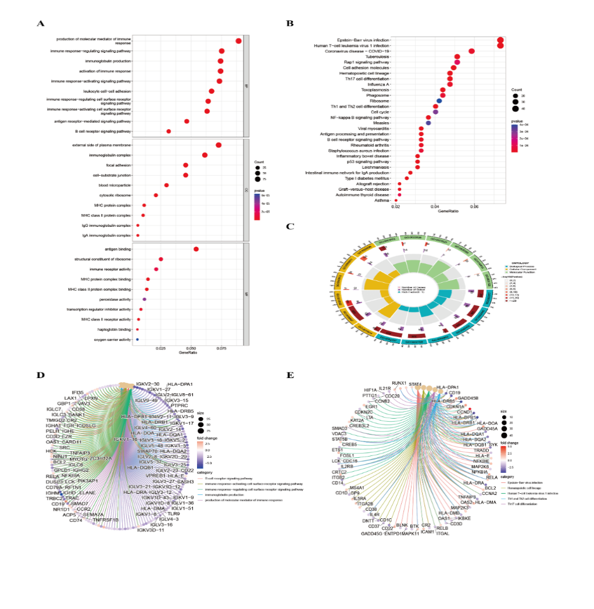

Supplementary Figure S1. Functional analysis for DEGs. (A) Analysis of the DEGs using GO. (B) An analysis of DEGs using KEGG. (C) Gene-Biological Process Association Network. (D) The circle chart shows the genes enriched in different GO terms. (E) The circle chart shows the genes enriched in different KEGG terms.

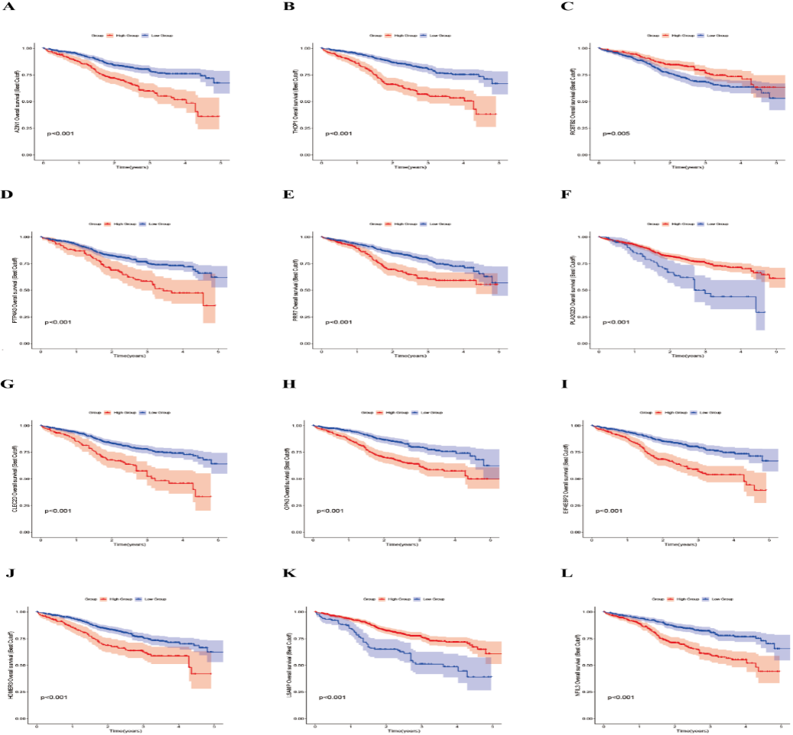

Supplementary Figure S2. Prognostic genes KM curve. (A)AZIN1;(B) THOP1;(C) RCBTB2;(D) PTP4A3;(D) PTP4A3;(E) PRR7;(F) PLA2G2D;(G) CLEC2D;(H) OPN3;(I) EIF4EBP2;(J) HOMER3;(K) LSAMP;(L) NFIL3.

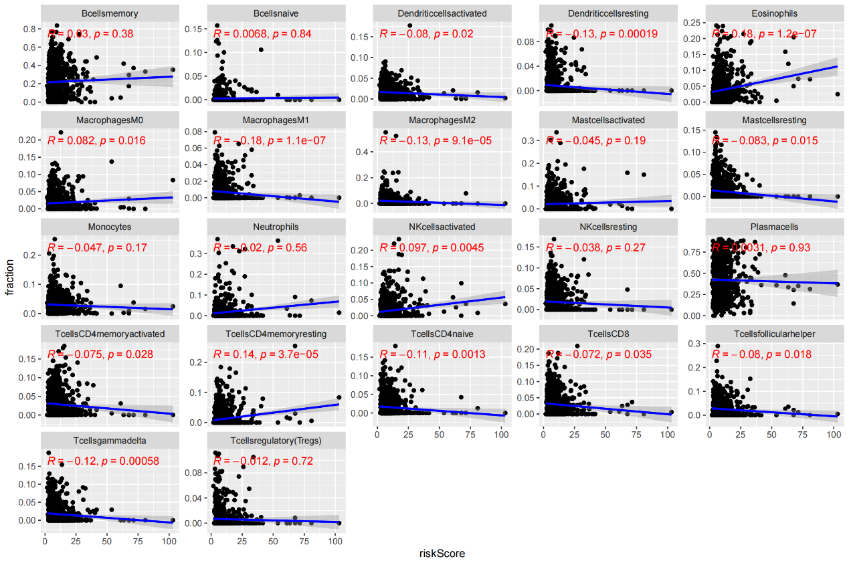

Supplementary Figure S3. Matrix of scatter plots showing the correlation between risk scores and immune cell infiltration levels.

