Supplementary Material 1. The total areas of mangrove ecosystem in each National Parks of Indonesia
 | National Park | Mangrove Area (Ha)
1 | Lorentz (LRZ) | 195100.9697
2 | Sembilang (SBG) | 86430.7881
3 | Wasur (WSR) | 7352.19006
4 | Kepulauan Togean (KTG) | 6315.18139
5 | Rawa Aopa Watumohai (RAW) | 6159.54804
6 | Kutai (KTI) | 3971.09918
7 | Gunung Maras (GMS) | 2915.52194
8 | Tanjung Puting (TJP) | 2872.5074
9 | Teluk Cenderawasih (TLC) | 1957.93814
10 | Ujung Kulon (UJK) | 1913.20666
11 | Bunaken (BNK) | 1491.85313
12 | Komodo (KMD) | 966.38384
13 | Way Kambas (WKB) | 844.24982
14 | Alas Purwo (APW) | 842.38857
15 | Wakatobi (WKT) | 838.29286
16 | Bali Barat (BLB) | 480.46683
17 | Kepulauan Karimunjawa (KRJ) | 457.01451
18 | Gunung Palung (GNP) | 308.63129
19 | Baluran (BLR) | 294.09761
20 | Manusela (MNS) | 288.31422
21 | Siberut (SBR) | 132.67255
22 | Berbak (BRB) | 64.96462
23 | Kepulauan Seribu (KPS) | 31.94438

Supplementary Material 2. The trend calculation of NDVI in each National Parks
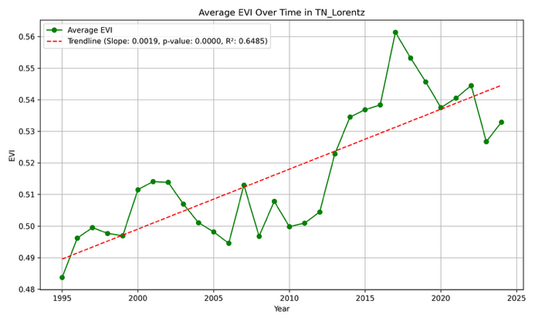 | 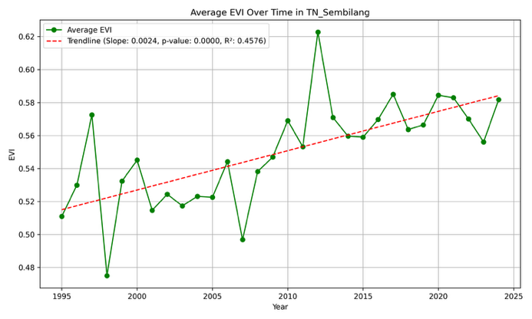
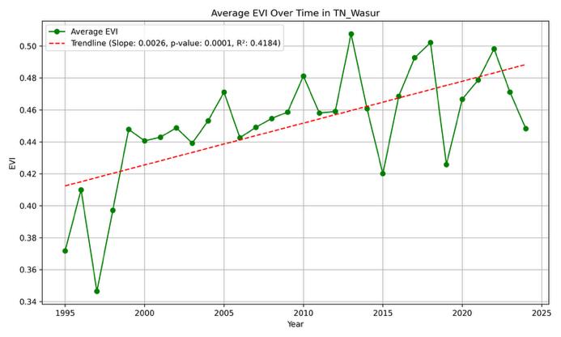 | 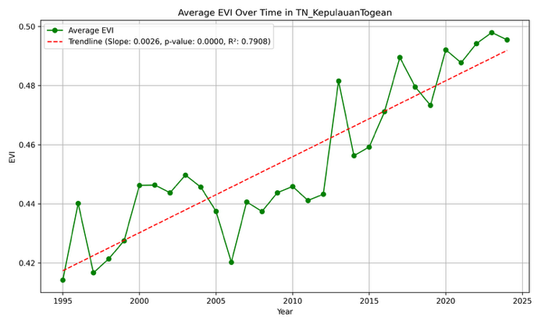
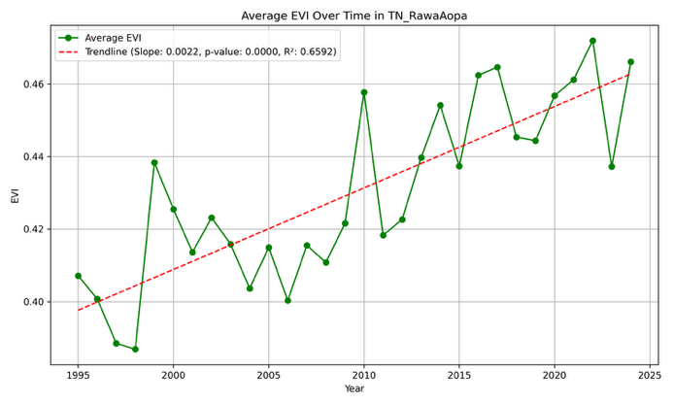 | 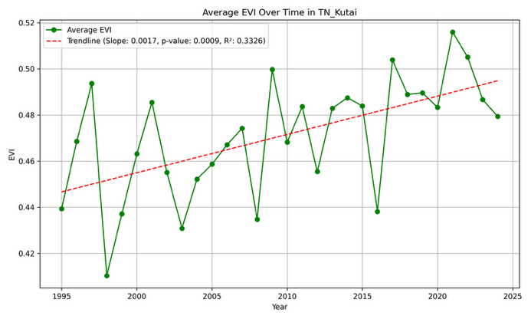
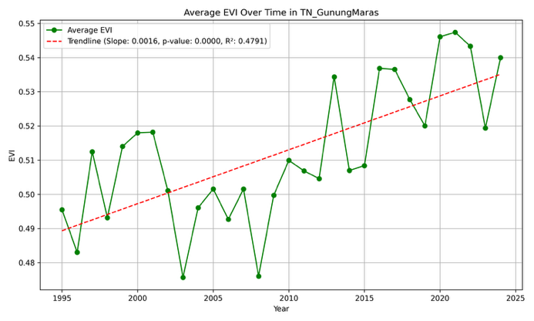 | 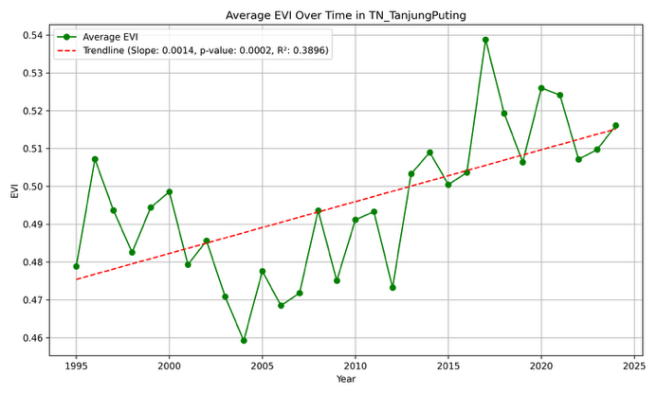
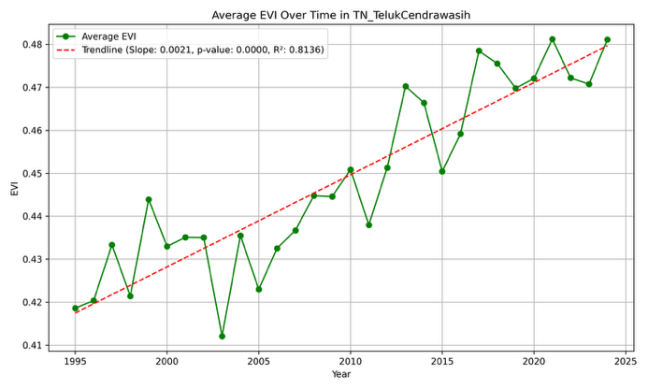 | 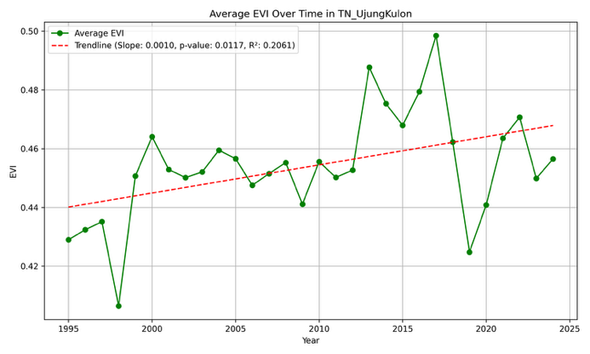
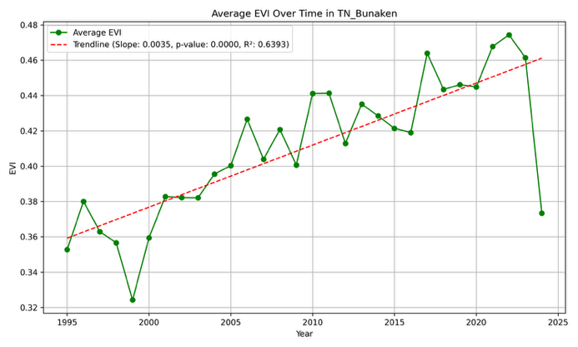 | 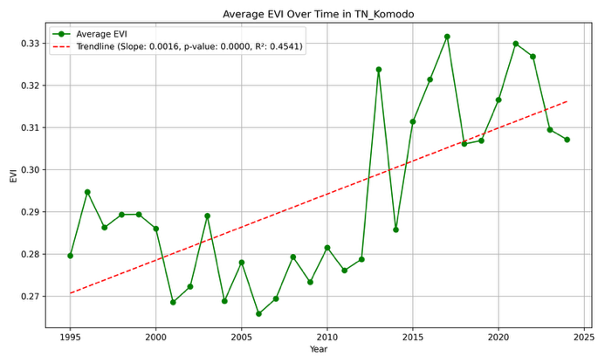
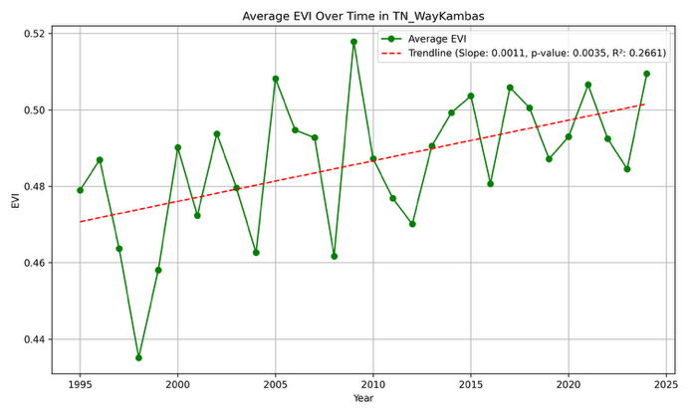 | 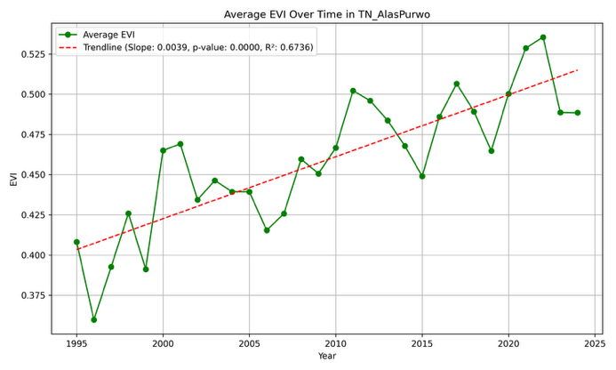
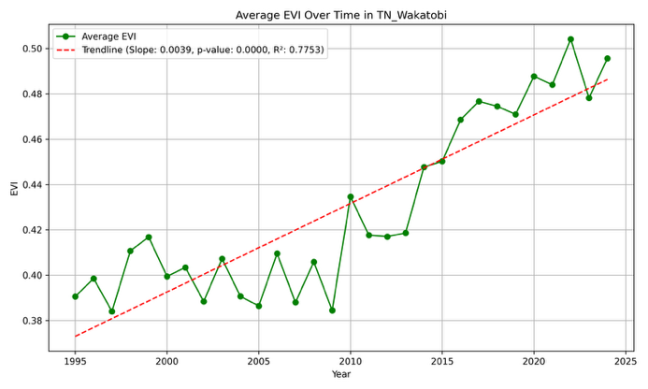 | 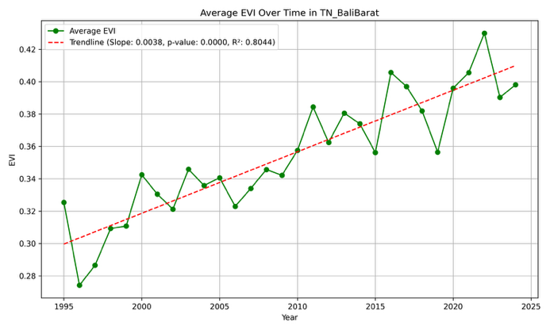
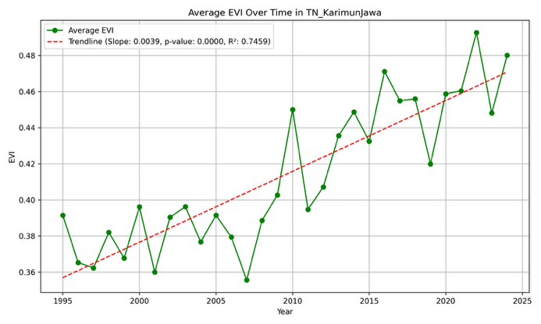 | 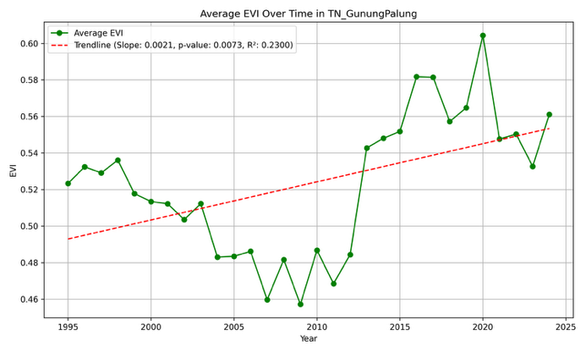
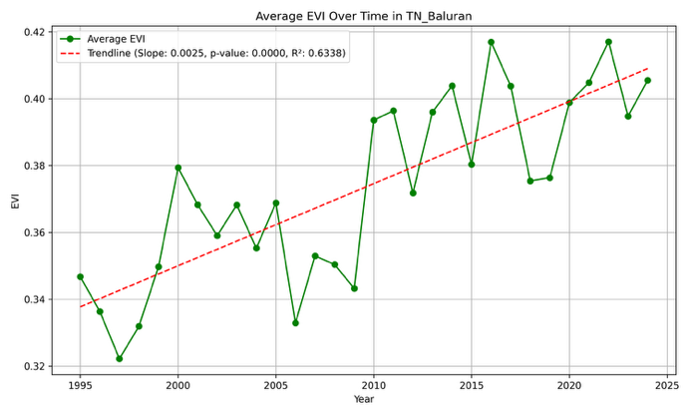 | 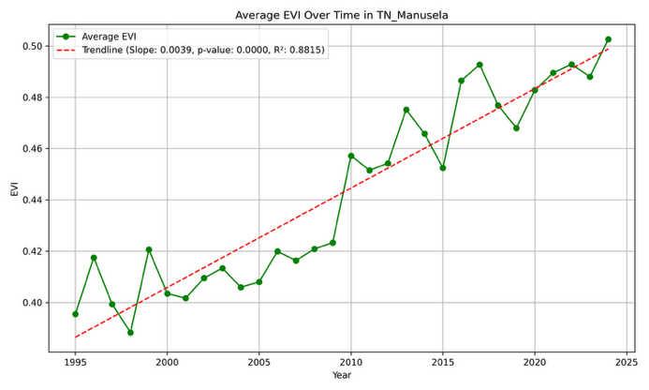
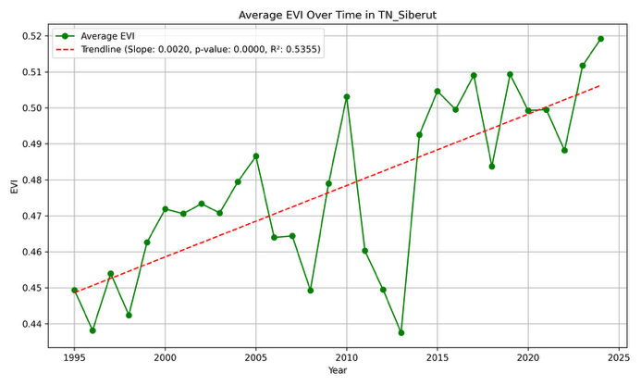 | 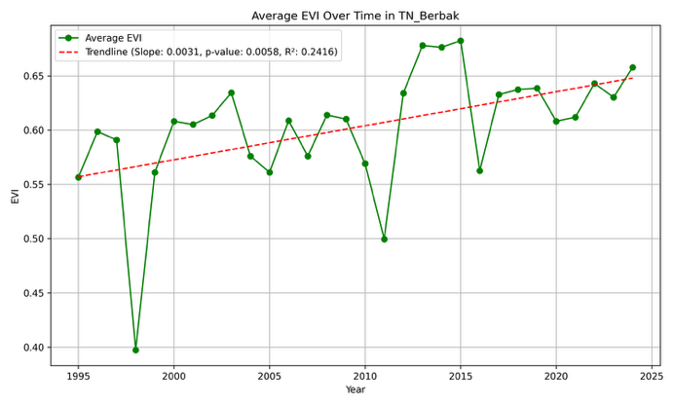
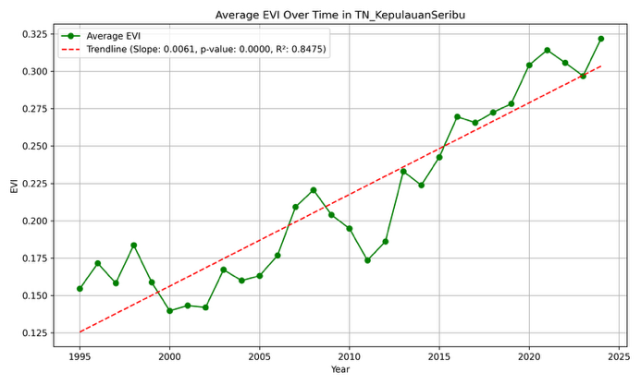

Supplementary Material 3
Table of area changes in each National Park based on Global Mangrove Wacth Data
National Park | Area Changes (1996-2020) (ha)
TN Lorentz | 596.699
TN Sembilang | -989.75
TN Wasur | -11.934
TN Kepulauan Togean | 79.144
TN Rawa Aopa Watumohai | -150.621
TN Kutai | -260.04
TN Gunung Maras | -78.348
TN Tanjung Puting | -85.567
TN Teluk Cenderawasih | 13.736
TN Ujung Kulon | 13.478
TN Bunaken | -20.825
TN Komodo | -113.966
TN Way Kambas | -23.8
TN Alas Purwo | 144.45
TN Wakatobi | -20.767
TN Bali Barat | 48.495
TN Karimunjawa | 24.441
TN Gunung Palung | NaN
TN Baluran | 19.08
TN Manusela | -22.344
TN Siberut | -0.972
TN Berbak | NaN
TN Kepulauan Seribu | NaN

