Electronic Supplementary Material
Compatibilization and toughening of biodegradable poly (lactic acid) / cellulose acetate films by polyamide amine dendrimers

Yansong Huang^{a,b}, Yujuan Jin^{a,b,}*, Bo Wang^{a,b}, Huafeng Tian^{a,b,}**, Yunxuan Weng^{b,} Shuang Men^{a,b}

ª College of chemistry and materials Engineering, Beijing Technology and Business University, Beijing, P. R. China, 100048.
^{b} Beijing Key Laboratory of Quality Evaluation Technology for Hygiene and Safety of Plastics, Beijing Technology and Business University, Beijing, P. R. China, 100048

* Corresponding author:
Email address: tianhuafeng@th.btbu.edu.cn (H, Tian), jinyujuan@th.btbu.edu.cn (Y, Jin)

Tab.S1 The characteristic group peaks in the PLA/CA blends.
 | v(C-H) /cm⁻¹ | v(-C=O) /cm⁻¹ | v(C-O-C) /cm⁻¹ |  | v(N-H) /cm⁻¹
PLA | 2947 | 1747 | 1180,1128 | 1078,1041
CA | 2949 | 1754 | 1237,1161 | 1047
PAMAM | 2949 | 1737 | 1177 | 1043 | 1650,1545
PAMAM content (phr)
0 | 2919 | 1747 | 1180,1128 | 1080,1041
1 | 2925 | 1735 | 1213 | 1028
2 | 2925 | 1735 | 1212 | 1028
3 | 2919 | 1735 | 1213 | 1029
4 | 2949 | 1752 | 1180,1128 | 1080,1042
5 | 2947 | 1747 | 1180,1128 | 1081,1042

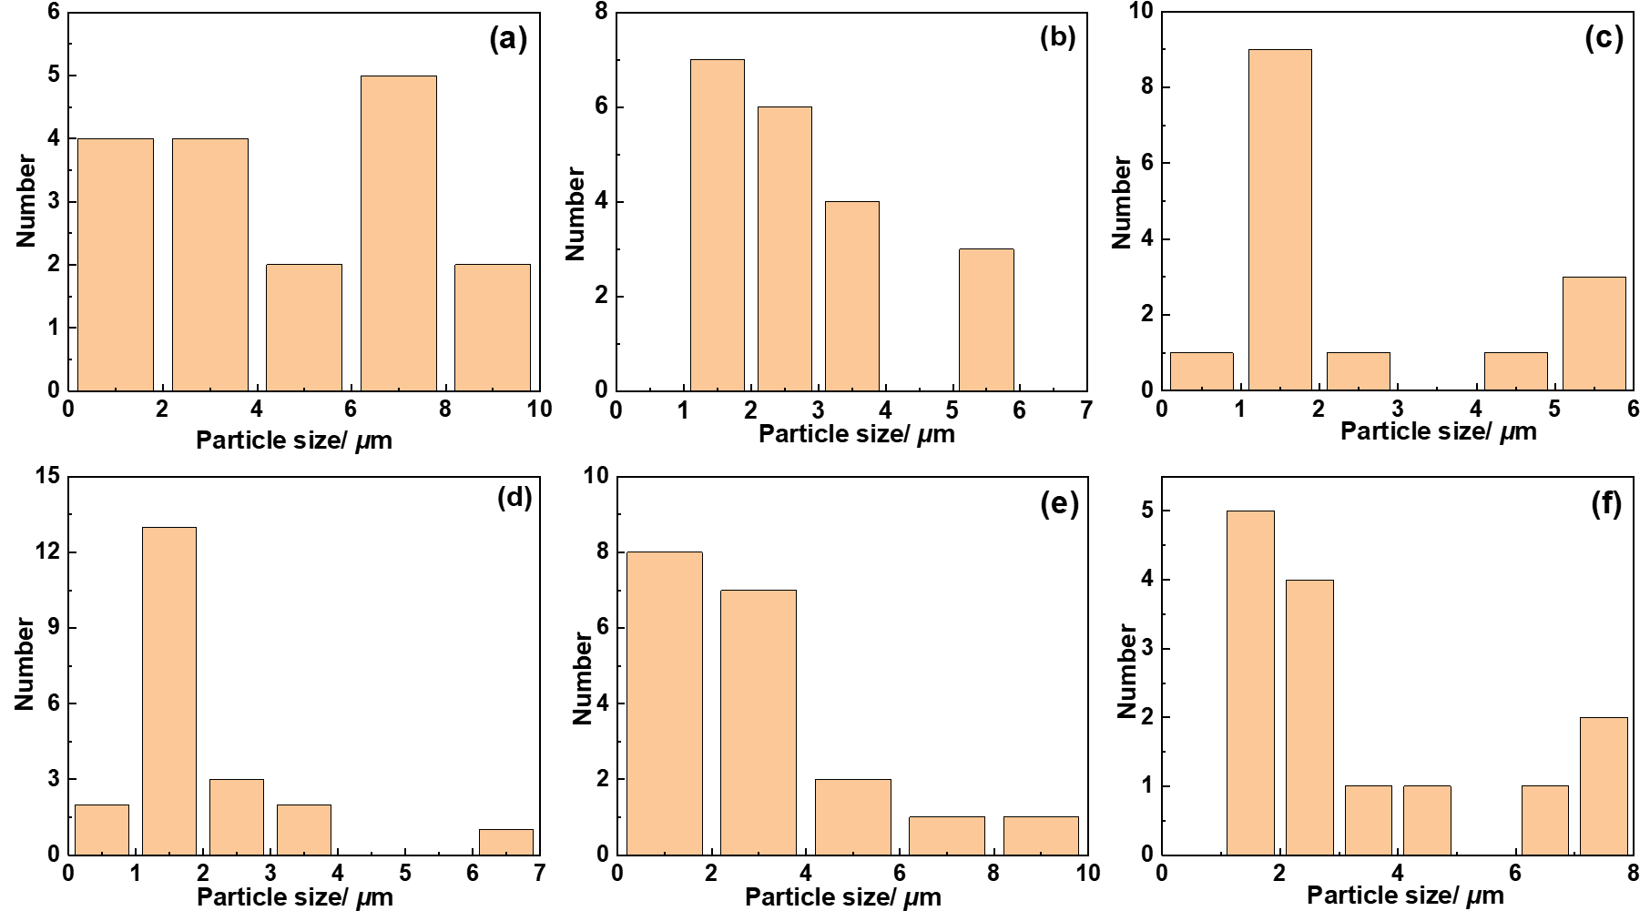
Fig. S1 Statistics of CA particle size in SEM image of PLA/CA blend film with different PAMAM content, (a) 0phr, (b) 1phr, (c) 2phr, (d) 3phr, (e) 4phr, (f) 5phr.

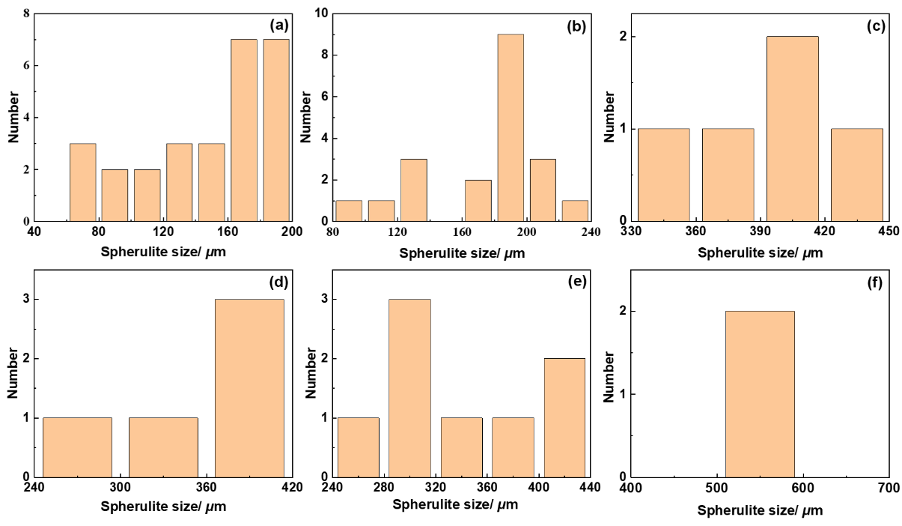
Fig.S2 Statistics of spherulite size of PLA/CA blend systems after isothermal crystallization at 120°C for 30 minutes, (a) 0phr, (b) 1phr, (c) 2phr, (d) 3phr, (e) 4phr, (f) 5phr.

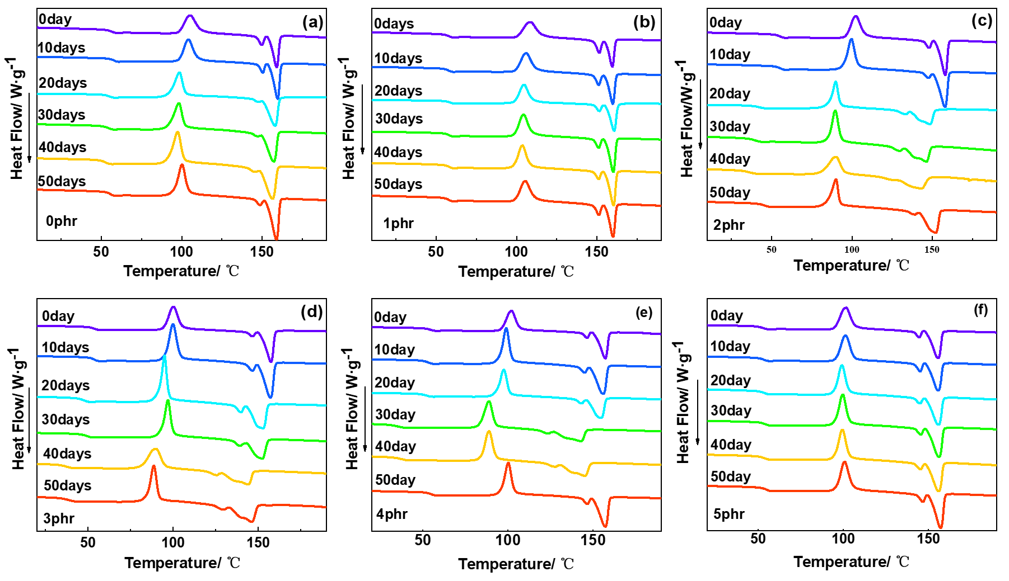
Fig.S3 DSC curves of the rest of the PLA/CA blend system before and after degradation, (a) 0phr, (b) 1phr, (c) 2phr, (d) 3phr, (e) 4phr, (f) 5phr.

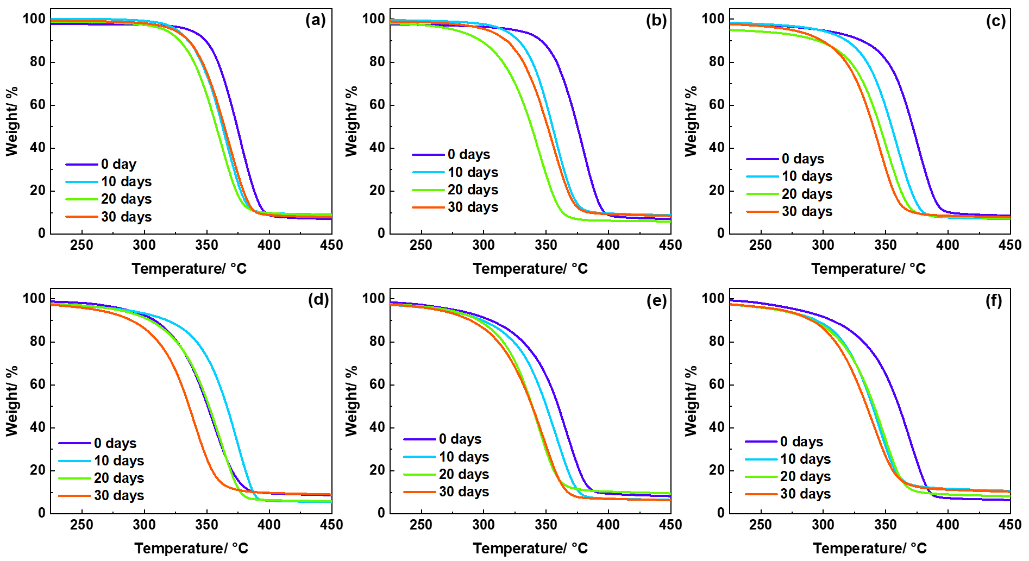
Fig.S4 TGA curves of the rest of the PLA/CA blend system before and after degradation, (a) 2phr, (b) 4phr, (c) 5phr.

