Supplementary mateiral

- Supplementary Tables

1.1 Table S1. Mass spectrometry detection parameters
Core Compounds | m/z | DP(V) | CE(V)
Echinacoside | 785.2/623.3 | -97 | -46
Verbascoside | 623.2/461.3 | -115 | -39
Cistanoside F | 487.1/178.7 | -119 | -28
Isoverbascoside | 623.2/461.0 | -157 | -41
Tubuloside A | 827.3/160.8 | -148 | -51
Tubuloside B | 665.4/160.9 | -117 | -45
Caffeic Acid | 179.3/134.9 | -82 | -20
Hydroxytyrosol | 153.0/122.9 | -80 | -19
8-Epi-Loganic Acid | 375.3/169.1 | -80 | -26
Dexamethasone | 437.2/361.2 | -71 | -27
DP:Declustering Potential; CE: Collision Energy.

1.2 Table S2. Concentrations of various blood components in WT and 5×FAD mice (ng/mL)
Group | Time  (h) | Animal  ID | Caffeic  acid | Echinacoside | Verbascoside | Cistanoside F | Isoverbascoside | Hydroxytyrosol |  | Tubuloside A | 8-Epi-Loganic acid | TubulosideB
WT | 0 | C97 | ND | 2 | < LOD | ND | 0.357 |  | ND | 0.277 | ND | 0.147
WT | 0 | C22 | ND | 2.94 | < LOD | ND | 0.167 |  | ND | 0.241 | ND | 0.0339
WT | 0 | C24 | ND | 0.128 | < LOD | ND | 0.0485 |  | ND | 0.0319 | ND | 0.0492
WT | 0.5 | B66 | 53.2 | 909 | 28.7 | 1.19 | 6.65 |  | ND | 24.7 | 5.13 | 0.315
WT | 0.5 | B68 | 35.3 | 661 | 19.2 | 0.961 | 5.16 |  | ND | 15.6 | 2.84 | 0.257
WT | 0.5 | B69 | 68.5 | 804 | 26.7 | 1.11 | 6.18 |  | ND | 21.3 | 2.39 | 0.264
WT | 0.5 | C30 | 91.4 | 1190 | 29.1 | 1.32 | 6.92 |  | ND | 26.3 | 3.78 | 0.471
WT | 1 | B70 | 0.902 | 235 | 3.51 | 0.531 | 1.16 |  | ND | 5.8 | 0.812 | 0.0151
WT | 1 | C22 | ND | 125 | 1.35 | 0.506 | 0.623 |  | 22.6 | 2.91 | ND | 0.108
WT | 1 | C4 | ND | 170 | 2.73 | 0.526 | 0.876 |  | 6.23 | 3.14 | 1.98 | 0.00699
WT | 1 | C98 | 21.2 | 331 | 7.05 | 0.591 | 1.58 |  | 1.82 | 7.34 | 0.856 | 0.159
WT | 2 | B71 | ND | 61.7 | 0.261 | 0.524 | 0.223 |  | 51.3 | 0.829 | 0.826 | 0.0051
WT | 2 | C8 | 4.3 | 109 | 2.11 | 0.59 | 0.586 |  | 6.51 | 1.85 | 0.739 | 0.0372
WT | 2 | C16 | 13 | 342 | 6.74 | 0.917 | 2.08 |  | 34.9 | 4.91 | 2.08 | 0.177
WT | 2 | C99 | 5.42 | 109 | 4.53 | 0.803 | 1.05 |  | 26.8 | 1.6 | ND | 0.101
WT | 4 | C17 | ND | 50.1 | 8.93 | 1.15 | 1.9 |  | 59.6 | 0.565 | ND | 0.0163
WT | 4 | C19 | ND | 89.4 | 0.815 | 0.377 | 3.24 |  | 79.1 | 1.46 | ND | < LOD
WT | 4 | C20 | ND | 9.93 | < LOD | ND | 0.187 |  | 596 | 0.28 | ND | < LOD
WT | 4 | B32 | ND | 138 | 19.6 | 1.54 | 3.71 |  | 436 | 1.26 | ND | 0.551
WT | 0 | B38 | ND | 1.16 | ND | ND | < LOD |  | 6.58 | 0.113 | ND | < LOD
WT | 0 | B39 | ND | 1.72 | < LOD | ND | 0.0582 |  | 1.82 | 0.0549 | ND | < LOD
WT | 0 | B41 | ND | 1.28 | ND | ND | < LOD |  | 1.28 | 0.0704 | ND | < LOD
WT | 0.5 | B35 | 65.3 | 1350 | 38.1 | 1.61 | 7.26 |  | ND | 27.6 | 5.41 | 0.413
WT | 0.5 | B36 | ND | 863 | 23.8 | 1.03 | 10.7 |  | ND | 15.1 | 5.27 | 0.261
WT | 0.5 | B37 | ND | 850 | 22.6 | 1.05 | 3.96 |  | 1.6 | 18.3 | 4.26 | 0.299
WT | 0.5 | B42 | ND | 960 | 32 | 1.79 | 5.04 |  | ND | 21.3 | 4.93 | 0.178
WT | 1 | C35 | ND | 394 | 12 | 0.679 | 2.51 |  | 1.28 | 9.76 | 4.07 | 0.228
WT | 1 | C36 | ND | 483 | 15 | 0.962 | 2.29 |  | 5.7 | 9.07 | 3.81 | 0.144
WT | 1 | C37 | ND | 744 | 25.5 | 1.38 | 3.58 |  | 27.2 | 14.2 | 5.84 | 0.243
WT | 1 | C54 | ND | 595 | 20.2 | 1.49 | 3.11 |  | 129 | 9.69 | 5.3 | 0.263
WT | 2 | B73 | ND | 681 | 44.4 | 2.49 | 6.13 |  | 51.1 | 13.3 | 0.937 | 0.383
WT | 2 | C38 | ND | 286 | 24.3 | 1.97 | 4.68 |  | 73.8 | 8.72 | 0.732 | 0.501
WT | 2 | C40 | ND | 353 | 15.7 | 1.62 | 4.13 |  | 3.72 | 6.71 | 0.733 | 0.14
WT | 2 | C51 | ND | 429 | 6.53 | 0.981 | 1.72 |  | 113 | 7.13 | 0.954 | 0.0906
WT | 4 | C41 | 171 | 182 | 20.2 | 2.14 | 1.46 |  | 7.35 | 4.72 | 0.843 | 0.0349
WT | 4 | C42 | ND | 6.17 | 0.6 | 0.416 | 0.0528 |  | 66.5 | 0.184 | ND | < LOD
WT | 4 | C43 | 11.4 | 108 | 10.9 | 1.02 | 3.1 |  | 68.3 | 1.79 | ND | 0.0712
WT | 4 | C53 | 188 | 48.5 | 2.29 | 1.08 | 0.357 |  | 436 | 1.18 | ND | < LOD
 |  | quantitative lower limit | 10 | 2 | 5 | 2 | 5 |  | 2 | 5 | 2 | 2

The table presents the concentrations of blood components in WT and 5×FAD mice at different time points."ND" indicates that the component was not detected at the time point. "< LOD" indicates that the concentration was below the limit of detection.

1.3 Table S3. Screening results of disease-drug-target interactions for network pharmacology analysis.
CCH |  |  |  |  |  |  |  |  |  |  |  |  |  |  | Tubuloside B
GeneCards database |  |  |  |  |  |  |  |  |  | OMIM database |  |  |  |  | SwissTarget  Prediction
DDC | EPO | MB | GRK2 | VWF | PGF | ABCD1 | EDNRB | CLLS3 | SLC17A5 | CTRC | CYBB | CANDF7 | IGS1 | MCMTC | SPHK2
MMP7 | GFAP | RPS27A | GRP | CERNA3 | GDF15 | MT-TL1 | CDKN3 | CERCAM | MIR424 | GFI1 | SLC6A8 | SGO | MBP1 | PENTT | ENPP2
FOXP2 | EDN1 | AFP | C5 | SOD2-OT1 | MMP13 | CBS | CLU | FNBP1 | SST | ALG14 | BCAP31 | AGS1 | CPSQ3 | CD32 | DNM1
PDP1 | AGT | MAOB | ADORA3 | GLA | TREM1 | MMP9 | RBP4 | CUBN | GNAS | FCGR2A | CCCSX | QARS | ARMD7 | MEPCA | CHRM4
GCG | TTN | ADORA1 | SAA4 | CAT | MAP1B | BCL2 | PWAR1 | MBL2 | PARP1 | NCF2 | CLCR | TFAR15 | DBM | TNFA | CHRM5
SFTPA2 | CSF3 | RPL36A  HNRNPH2 | PWAR4 | SNCA | OXT | BDNF | MIR320A | ADD3 | ERCC2 | COPD | ZNF163 | CLOVE | CGD3 | SCN2 | CHRM2
BECN1 | TTR | HTR3A | MYOCD | S100B | FABP2 | INS | SIRT1 | HTRA1 | GLUL | IL1R1 | CMS15 | PDGFR | AMCBX2 | IDDEBF | CHRM1
SULT1A3 | CCL2 | MYOC | FBLN5 | MIR195 | SERPINB2 | SOD1 | ACE2 | CLLS1 | PGR-AS1 | IL1RN | IGFR2 | CRMO3 | CCDS1 | CRMO2 | CHRM3
HRH2 | AGTR1 | MIR34C | ABCB7 | PON1 | SLC6A3 | SHANK2 | GJB2 | FOLR1 | GAS5 | STAT1 | CADASIL1 | DIRA | DXS1357E | IMD31B | BCHE
TMCO1 | ADRB2 | SLC2A3 | SRF | NFKB1 | GSTM1 | IGFBP7 | APOL1 | CLLS5 | ANGPT2 | SGOL1 | PRIP | IMD31A | MBL2D | CAID | MET
AMBP | VEGFA | RMRP | ADRA2A | F3 | GRN | TAC3 | MIR181C | CMTS | C11orf65 | TREX1 | ARMD11 | SGO1 | CARASIL | HERNS | GRIN1
INPP5D | NPPA | SFTPA1 | CNBP | B2M | HIF1A | OGA | COL1A1 | CLLU1OS | CD34 | QARS1 | AAA | CRV | MBPD | MSCCA | GRIN2A
EPX | SERPINE1 | CHI3L1 | MMP10 | TGFB2 | PLA2G6 | ECM1 | CHRNA3 | CLLU1 | SERPINI1 | PDCD10 | CEDNIK | GLNRS | CADASIL2 | CLAPO | SMO
BSG | GPT | XRCC1 | SLC5A1 | CALCA | CHAT | NCOA3 | SFTPD | CLLS2 | TSPO | PIK3CA | CML | CCM3 | IMD34 | MCM | CYP19A1
SLC6A2 | REN | DYNC2H1 | PTAFR | TSC1 | BACE1 | LOC109  504728 | GSTT1 | CLLD6 | KDR | PDGFRB | HMOX1D | MCAP | AD1 | IMF1 | CCNE2
COL18A1 | APOB | LRP2 | BPI | GSTP1 | ADAMTS13 | AGO2 | OTC | TTC5 | TARDBP | CLLS4 | P40PHOX | IBGC4 | LMNS | SPDA1 | CDK2
RNU4ATAC | MIR132 | FABP1 | CYP11B1 | COL1A2 | ABCC8 | VASP | DBH | PRKCH | ATP1A2 | CTEPH1 | CGDX | TBN | NEDMVIC | NEDMLHB | ADRA1D
SLC2A4 | GBA1 | CS | ACP3 | EDNRA | ENO2 | STH | NAGLU | GATM | GSN | HLA-B | CRTR | C7orf22 | IMF2 | MGC4067 | ADRA1A
DMPK | PLAT | TRA-TGC7-1 | AOC1 | EGF | PSEN2 | C1D | HCRT | CYBA | DNMT1 | TNF | BAP31 | CGD1 | CASIL | KIAA0172 | ADRA1B
ITIH4 | ELN | LTBP2 | MIR124-1HG | PDGFB | NOS1 | GLRA1 | GNB3 | CYBC1 | ACHE | HLA-DPB1 | D13S25 | CHDS7 | KURU | BDPLT10 | KDR
..... | ... | ... | ... | ... | ... | ... | ... | ... | ... | ... | ... | ... | ... | ... | ...
The table shows the potential targets of Tubuloside B(Tub-B) for treating chronic cerebral hypoperfusion (CCH). Abbreviations: Gene Symbol, official gene symbol.

- Supplementary Figures

Figure S1. Flow cytometric analysis of Aβ₂₅–₃₅-induced apoptosis in PC12 cells. Representative scatter plots of Annexin V-FITC/PI double staining and statistical analysis of the percentage of apoptotic cells.Data are presented as mean ± SD (n ≥ 3). *p < 0.05, **p < 0.01, ***p < 0.001 compared to the Aβ₂₅–₃₅ model group (one-way ANOVA with Tukey's post hoc test).

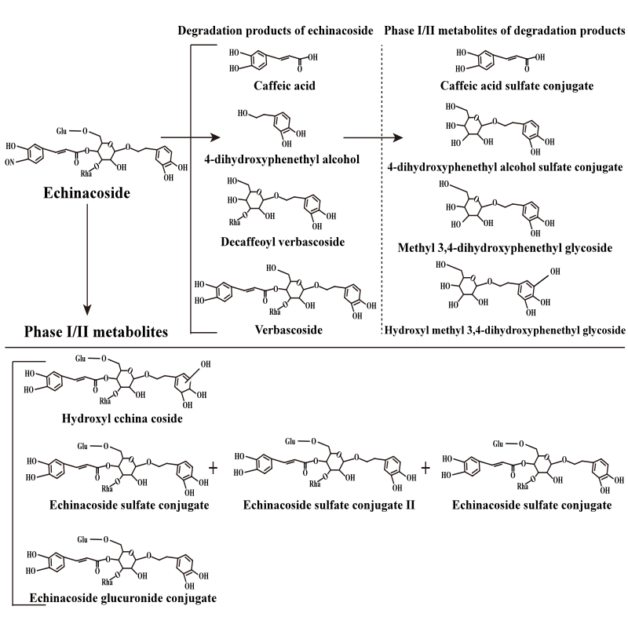

Figure S2. UPLC-QQQ-MS analysis of plasma components in rats after oral administration of TGC extract.
Representative chromatograms showing the main phenylethanoid glycoside components of TGC and their metabolites,including Echinacoside, Tubuloside A, Tubuloside B, Acteoside (Verbascoside), etc., along with metabolites M1 and M2.

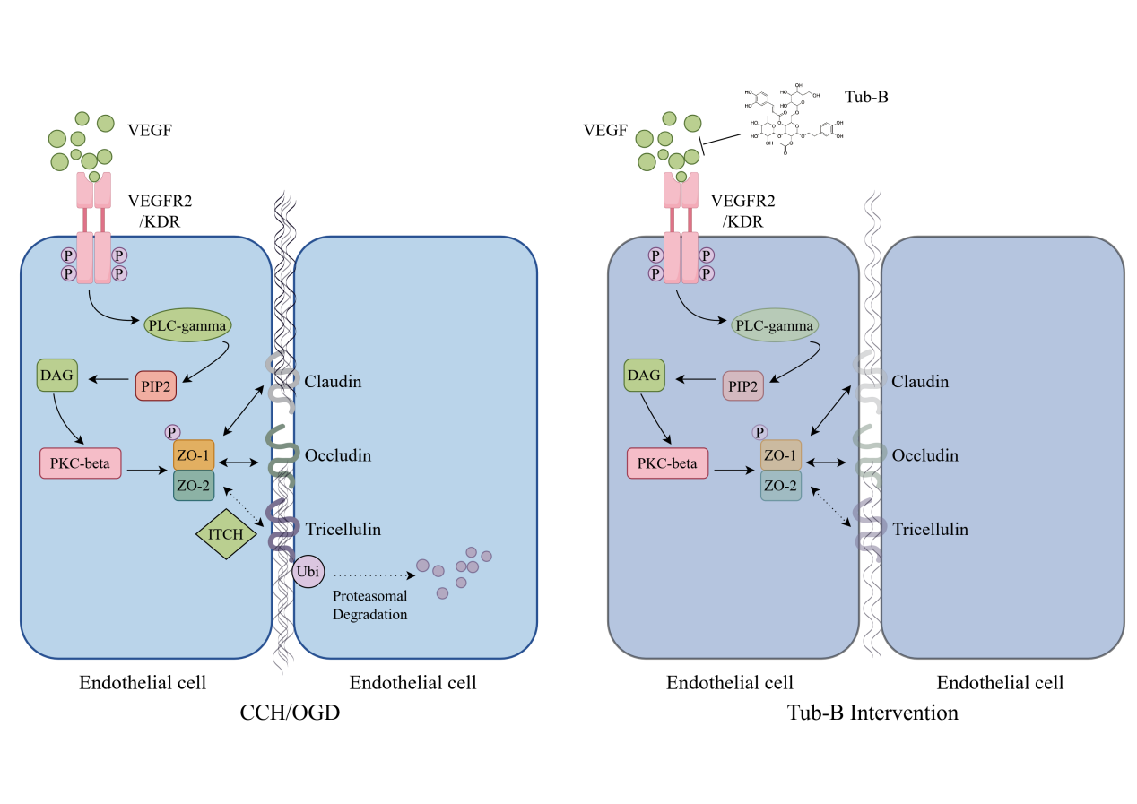
Figure S3. Schematic diagram illustrating the neuroprotective mechanism of Tubuloside B against CCH.
Tub-B protects against Aβ toxicity,inhibits apoptosis and Caspase-3/7 activation, stabilizes TRIC protein, reduces its ubiquitination-mediated degradation, preserves BBB integrity, and improves learning and memory function.

