Airborne particulate matter (PM_{2.5}) triggers ocular hypertension through pyroptosis

Supplementary Imformation

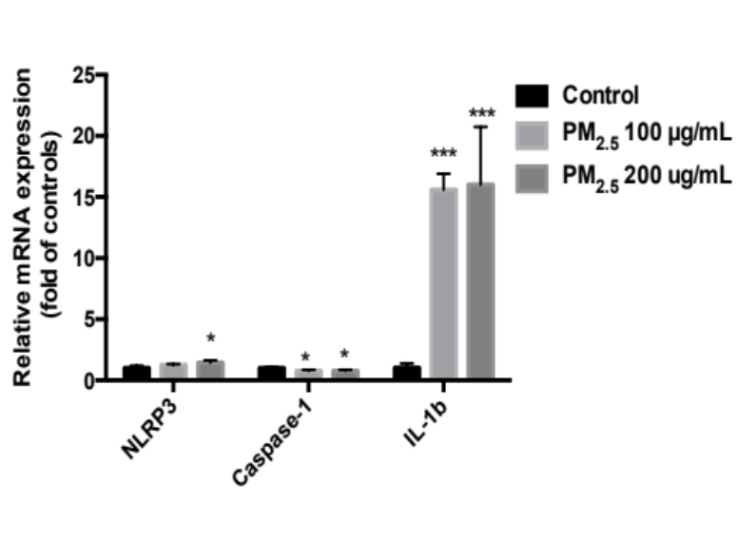
Figure S1, Expressions of NLRP3 inflammasome-related mRNA in PM_{2.5}-treated TM cells. qPCR showed mRNA expression of NLRP3 increased significantly after HTMs treated by PM_{2.5} 100 μg/mL or 200 μg/mL (n = 3 cell lines, *p<0.05, one-way ANOVA, compared with the control). The mRNA expression of Caspase-1 decreased after HTMs treated by PM_{2.5} 100 μg/mL or 200 μg/mL (n = 3 cell lines, *p<0.05, one-way ANOVA, compared with the control). The mRNA expression of IL-1β increased significantly after HTMs treated by PM_{2.5} 100 μg/mL or 200 μg/mL (n = 6 cell lines, *p<0.05, one-way ANOVA, compared with the control).

Figure S2. NAC inhibited ROS elevation in PM_{2.5}-treated HTM cells. Representative ROS fluorescence staining images of Rosup negative control (NC, 50 μg/mL), Rosup positive control (PC, 500 μg/mL), PBS control group (control), PM_{2.5} 100 μg/mL group (PM_{2.5}) and NAC+PM_{2.5} group. ROS levels were detected by Reactive Oxygen Species Assay Kit. ﻿In each panel, from left to right are bright filed, ﬂuorescence, and merged images of ﬂuorescence and bright field. ﻿HTMs were treated with PM_{2.5} 100 μg/mL for 48 h, pretreated with or without NAC 3 mM for 2 h. ROS levels were significantly increased in HTMs treated with Rosup positive control and 100 ug/ml PM_{2.5.} Magnification, 10X.

