Mutation of platelet-derived growth factor receptor β causes and exacerbates the severity of brain arteriovenous malformation through enhancing angiogenesis.

Running Title: Mutation of Pdgfrb enhances bAVM severity

Alka Yadav¹, Leandro Barbosa Do Prado¹, Mustafa Mohamed¹, Calvin Wang¹, Joshua Shi¹, Zahra Shabani¹, Rich Liang¹, Kelly Press¹, Courtney Tom¹, Ethan A. Winkler², Hua Su¹

¹Center for Cerebrovascular Research, Department of Anesthesia and Perioperative Care, University of California, San Francisco, California, USA.
²Department of Neurosurgery, University of California, San Francisco, California, USA

Supplementary Figures:

Suppl Fig 1: Timeline for model induction and sample analysis.

Suppl Fig 2. Pdgfrβ and Eng mutations cause hemorrhage in the brain. a. Prussian-stained sections. The arrows indicate the iron-deposited area (hemorrhage). Scale bar: 50 µm. b. Quantification of microhemorrhage. n=6-7. F7: Pdgfrβ F7 mutant mice; Eng^{flf}: PdgfbicreER;Eng^{f/f} mice; Eng^{flf};F7^{+/-}: PdgfbicreER;Eng^{f/f};F7^{+/-} mice.
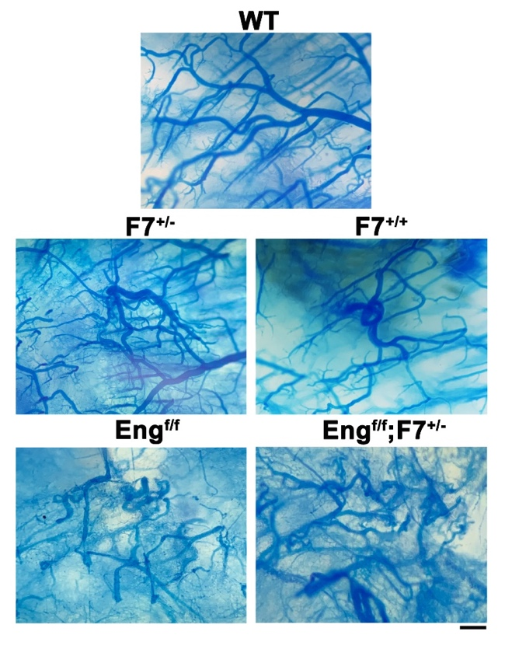

Suppl Fig 3: Arteriovenous shunts in the brain of Pdgfrβ (F7) and Eng mutant mice. Brain vessels were cast with latex dye. The particles in the latex dye are too large to pass through a capillary. Latex dye is present in the veins after being injected into the left cardiac ventricle only when in the presence of an arteriovenous (AV) shunt. Scale bar: 500 µm. WT: wild-type mice; F7: Pdgfrβ F7 mutant mice; Eng^{flf}: PdgfbicreER;Eng^{f/f} mice; Eng^{flf};F7^{+/-}: PdgfbicreER;Eng^{f/f};F7^{+/-} mice.

Suppl Fig 4. Pdgfrβ F7 mutation upregulated pro-angiogenic gene expression and downregulated Alk1 expression; overexpression of ALK1 in brain endothelial cells reversed the gene expression profiles. Quantification of Vegfa (a), Kdr (b), Akt3 (c), and Alk1 (d) expression. WT: wild type mice; F7^{+/-} RFP; Pdgfrβ F7 heterozygous mutation mice treated with AAV.cc84-RFP; F7^{+/-} ALK1: Pdgfrβ F7 heterozygous mutation mice treated with AAV.cc84-ALK1. N=5-6.

Supplementary tables:
Suppl Table 1. Key differentially expressed genes related to angiogenesis induced by Pdgfrβ F7 mutation in brain angiogenic region.
Gene | Log2 fold-change | p-value
Pdgfb | -0.23 | 0.04
Acvrl1/Alk1 | -0.53 | 0.0003
Eng | -0.27 | 0.015
Id1 | -0.41 | 0.028
Vegfa | 0.61 | 6.66E-06
Akt3 | 0.38 | 0.0006
Tgfβ1 | -0.66 | 0.002
Kdr | 0.73 | 0.002

Suppl Table 2. Key differentially expressed genes related to angiogenesis and inflammation upregulated by Pdgfrβ F7 mutation in the bAVMs Eng-deficient mice.
Gene | Log2 fold-change | p-value
Klf2*** | 1.6 | 1.10E-18
Eno1*** | 0.6 | 9.44E-09
Ccl28** | 3.0 | 2.40E-09
S100a9** | 3.5 | 3.25E-05
S100a8** | 3.8 | 0.0002
C1qa** | 0.7 | 0.0003
Klf4*** | 1.2 | 3.31E-06
Tmem181** | 1.4 | 0.0070
C3** | 1.7 | 0.0007
Map3k6*** | 1.07 | 0.0070
Tgfβ1*** | 0.7 | 0.0002
Ccl25** | 1.0 | 0.0007
Vegfa*** | 0.3 | 0.04
Angpt2*** | 1.1 | 0.04
*** Angiogenesis related genes
** Inflammation related genes

Suppl Table 3. Pro-angiogenic and pro-inflammatory pathways upregulated by Pdgfrβ F7 mutation in bAVMs of Eng mutant mice.
Pathways | Adjusted p value
Angiogenesis | 0.00027
Adaptive Immune Response | 0.000504
Positive regulation of Cell Motility | 1.02E-06
Positive regulation of inflammatory response | 0.048877

