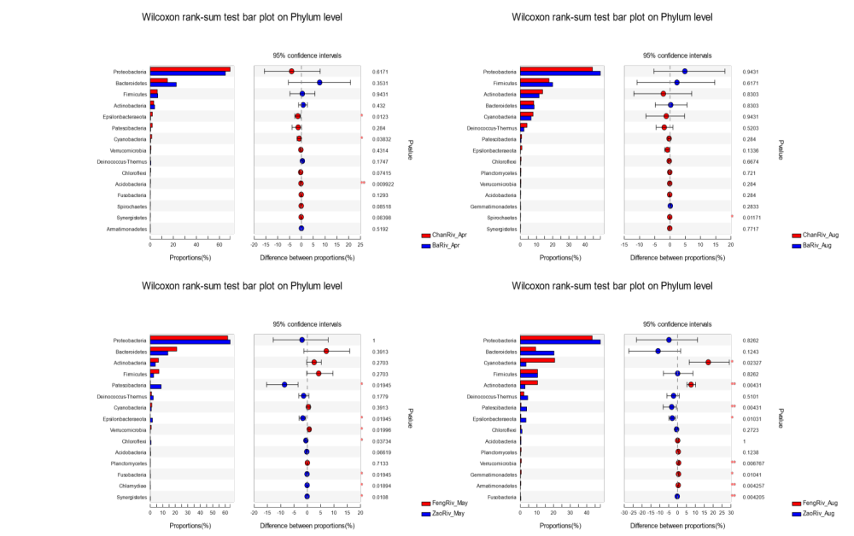

Figure S1 Comparison of the fist 15 major phyla between river segment sample groups: a) and b) are for sample groups from April and August of 2019 for the Chan and Ba Rivers, c) and d) are for sample groups from May and August of 2019 for the Feng and Zao Rivers

Figure S2 LEfSe analysis to identify differences of microbial communities between closely related river segments for the same sampling period. (a,b) are cladograms for the comparative analysis between the Chan and Ba Rivers for the April and August of 2019 samples, (c,d) are cladograms between the Feng and Zao Rivers for the May and August of 2019 samples; (e,f) are histograms of the LDA scores computed for phylum and class differentially abundant between the Chan and Ba Rivers in April and August of 2019, (g,h) are histograms of the LDA scores computed for phylum and class differentially abundant between the Feng and Zao Rivers in May and August of 2019.

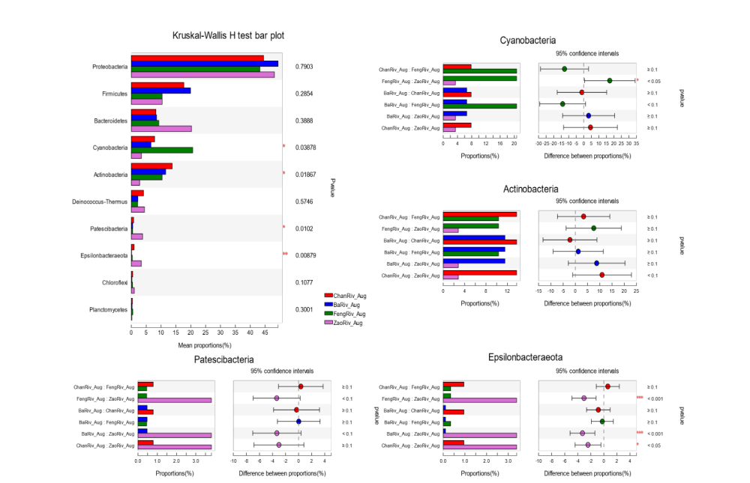
Figure S3 Kruskal-Wallis H test results for the statistical significances of major phyla between the Chan, Ba, Feng, and Zao Rivers in August: (a) Histogram of the mean proportions for the top ten major phyla, b) – e) are histograms of the mean proportions of phylum and difference between proportions for Cyanobacteria, Actinobacteria, Patescibacteria, and Epsilonbacterarota, respectively, which had statistically significant differences between the compared rivers.

Figure S4 Distribution of absolute taxon abundance:

Table S1. Average Indices of Microbial Communities for Sample Groups

Sample group | Estimators
Sample group | sobs | shannon | simpson | chao | coverage | sh_even | si_even
QM_Chan_Apr | 23.60 | 0.48 | 0.82 | 24.30 | 1.00 | 0.15 | 0.05
QM_Feng_Aug | 36.50 | 1.33 | 0.46 | 38.67 | 1.00 | 0.37 | 0.07
ChanRiv_Apr | 31.43 | 1.05 | 0.53 | 33.81 | 1.00 | 0.30 | 0.06
ChanRiv_Aug | 28.67 | 1.51 | 0.31 | 31.67 | 1.00 | 0.45 | 0.12
BaRiv_Apr | 21.00 | 0.96 | 0.51 | 23.72 | 1.00 | 0.32 | 0.10
BaRiv_Aug | 26.00 | 1.41 | 0.34 | 32.64 | 1.00 | 0.43 | 0.12
ChanBaJoined_Apr | 14.00 | 0.91 | 0.53 | 15.00 | 1.00 | 0.35 | 0.15
ChanBaJoined_Aug | 33.25 | 1.54 | 0.29 | 40.67 | 1.00 | 0.44 | 0.11
FengRiv_May | 19.80 | 1.11 | 0.45 | 21.30 | 1.00 | 0.38 | 0.12
FengRiv_Aug | 32.50 | 1.54 | 0.31 | 41.24 | 1.00 | 0.44 | 0.11
ZaoRiv_May | 32.00 | 1.25 | 0.45 | 36.50 | 1.00 | 0.36 | 0.07
ZaoRiv_Aug | 36.60 | 1.50 | 0.36 | 40.65 | 1.00 | 0.42 | 0.08

Table S2. RDA and Linear Regression Analyses of Environmental Variables with Microbial Communities

Environmental variables | RDA |  | Linear Regression
Environmental variables | r² | p-value | r² | p-value
pH | 0.164 | 0.007 | 0.000 | 0.987
DO | 0.208 | 0.002 | 0.195 | 0.000
EC | 0.183 | 0.007 | 0.031 | 0.177
Resistance | 0.214 | 0.001 | 0.112 | 0.008
Turbidity | 0.024 | 0.448 | 0.017 | 0.319
Ammonia | 0.001 | 0.972 | 0.000 | 1.000
Nitrite | 0.009 | 0.764 | 0.010 | 0.442
Nitrate | 0.407 | 0.001 | 0.400 | 0.000
Total nitrogen | 0.406 | 0.001 | 0.399 | 0.000
Total phosphorus | 0.006 | 0.843 | 0.000 | 0.989
Soluble phosphorus | 0.012 | 0.698 | 0.010 | 0.450
Hardness | 0.149 | 0.008 | 0.133 | 0.004
CODMn | 0.001 | 0.981 | 0.001 | 0.815
TOC | 0.131 | 0.020 | 0.108 | 0.010

Table S3 Differentially Abundant Phyla at Different Sampling Periods at the Same River Segment

Clade | ChanRiv (Apr-Aug) |  | BaRiv (Apr-Aug) |  | FengRiv (May-Aug) |  | ZaoRiv (Apr-Aug)
Clade | April | August | April | August | May | August | May | August
Phylum | 1 | 3 | 2 | 7 | 2 | 18 | 0 | 0
 | Proteobacteria | Firmicutes  Actinobacteria  Deinococcus_Thermus | Proteobacteria  Bacteroidetes | Firmicutes  Actinobacteria  Cyanobacteria  Chlamydiae  Planctomycetes  Chloroflexi  Gemmatimonadetes | Proteobacteria  Bacteroidetes | Cyanobacteria  Deinococcus_Thermus  Fusobacteria  Gemmatimonadetes  Kiritimatiellaeota  Omnitrophicaeota  Planctomycetes  Chloroflexi  Acidobacteria  Patescibacteria  Armatimonadetes  Latescibacteria  Dependentiae  Fibrobacteres  Nitrospirae  Spirochaetes  Chlamydiae  Margulisbacteria
Class | 3 | 5 | 2 | 21 | 2 | 30 | 0 | 0

Table S4 Differentially Abundant Phyla in the Two Compared Rivers for the Same Sampling Period

Clade | April (Chan-Ba) |  | August (Chan-Ba) |  | May (Feng-Zao) |  | August (Feng-Zao)
Clade | ChanRiv | BaRiv | ChanRiv | BaRiv | FengRiv | ZaoRiv | FengRiv | ZaoRiv
Phylum | 7 | 0 | 1 | 0 | 1 | 14 | 5 | 12
 | Epsilonbacteraeota  Cyanobacteria  Acidobacteria  Planctomycetes  Gemmatimonadetes  Chlamydiae  Kiritimatiellaeota  BRC1 |  | Spirochaetes |  | Verrucomicrobia (soil) | Patescibacteria  Epsilonbacteraeota  Chloroflexi  Kiritimatiellaeota  Chlamydiae  Lentisphaerae  Fusobacteria  Dependentiae  Omnitrophicaeota  WPS_2  Synergistetes  Nitrospirae  Elusimicrobia  Fibrobacteres | Cyanobacteria  Actinobacteria  Verrucomicrobia  Gemmatimonadetes  Armatimonadetes | Patescibacteria  Epsilonbacteraeota  Diapherotrites  Kiritimatiellaeota  Omnitrophicaeota  Elusimicrobia  Fusobacteria  Chlamydiae  WPS_2  WS2  Synergistetes  Dependentiae
Class | 26 | 0 | 1 | 0 | 1 | 43 | 9 | 27

Table S5 Differentially Abundant Phyla at all Four Rivers for the Same Sampling Season

Clade | Apr/May (Chan-Ba-Feng-Zao) |  |  |  | August (Chan-Ba-Feng-Zao)
Clade | ChanRiv | BaRiv | FengRiv | ZaoRiv | ChanRiv | BaRiv | FengRiv | ZaoRiv
Phylum | 4 | 0 | 2 | 10 | 1 | 0 | 6 | 12
 | Epsilonbacteraeota  Kiritimatiellaeota  Synergistetes  Gemmatimonadetes |  | Verrucomicrobia  Planctomycetes | Patescibacteria  Deinococcus_Thermus  Chloroflexi  Omnitrophicaeota  Dependentiae  Acidobacteria  Chlamydiae  WPS_2  Elusimicrobia  Fibrobacteres | Actinobacteria |  | Cyanobacteria  Verrucomicrobia  Gemmatimonadetes  Acidobacteria  Armatimonadetes  Margulisbacteria | Patescibacteria  Epsilonbacteraeota  Omnitrophicaeota  Lentisphaerae  Fusobacteria  Synergistetes  Kiritimatiellaeota  WPS_2  Spirochaetes  Dependentiae  Latescibacteria  Elusimicrobia
Class | 8 | 0 | 3 | 41 | 1 | 2 | 8 | 39

