Supplementary data
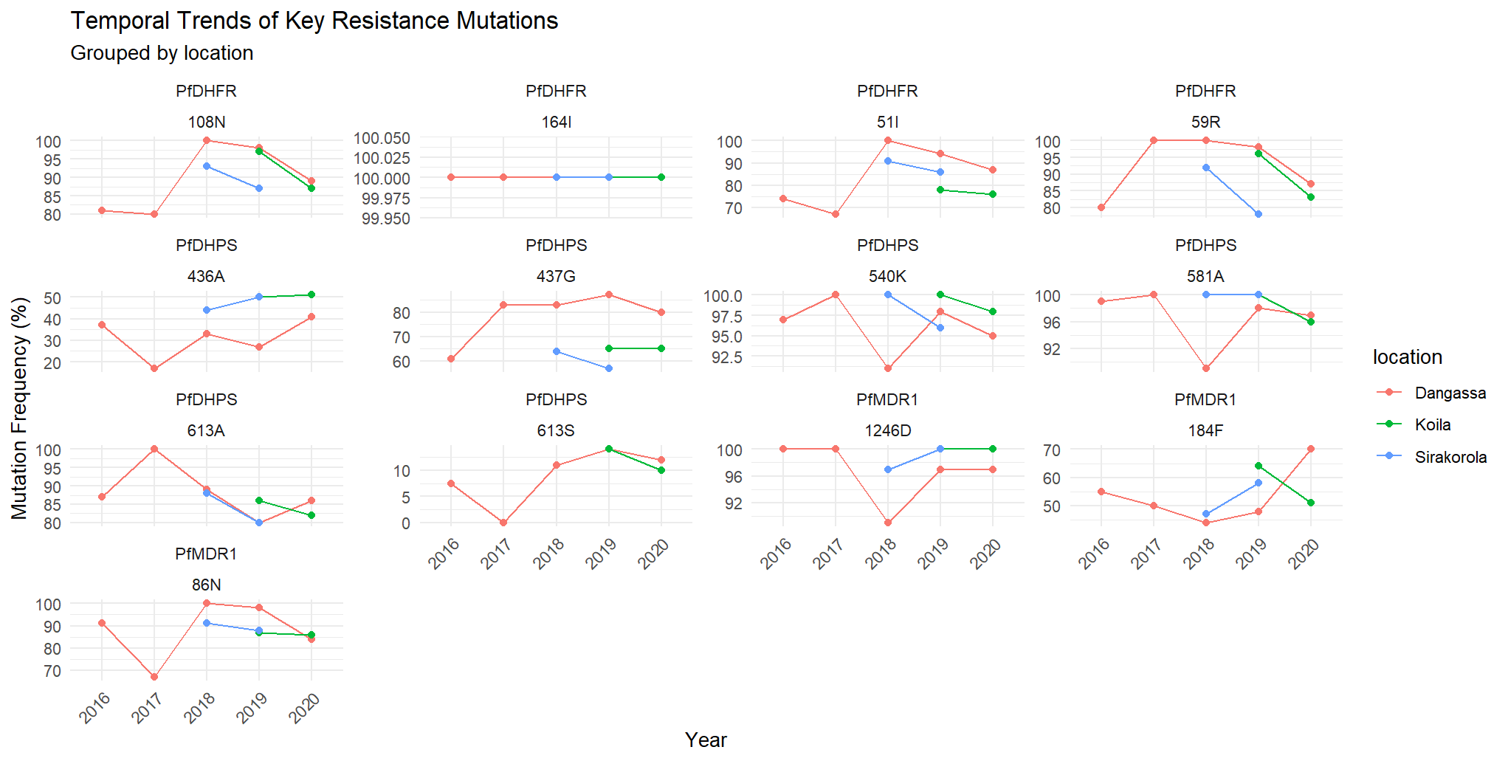
Figure S1 : Temporal trends of key resistance mutations grouped by location
Figure S1 provides a detailed breakdown of individual mutations within the pfdhfr and pfdhps genes over time, complementing the main text's analysis of haplotype trends. The near-fixation of pfdhfr 108N across all sites by 2020 underscores the strong selective pressure exerted by sulfadoxine-pyrimethamine (SP) use, particularly in high-transmission areas like Dangassa. The emergence of pfdhfr 164L in multiple sites suggests compensatory evolution to mitigate fitness costs associated with resistance mutations, potentially explaining the persistence of SP-resistant strains despite reduced drug efficacy. The delayed rise of pfdhps 540K in Sirakorola compared to Dangassa aligns with our spatial analysis, reflecting slower resistance evolution in low-transmission settings. These mutation-specific trajectories highlight the importance of monitoring individual alleles to predict impending haplotype fixation and anticipate clinical failure.
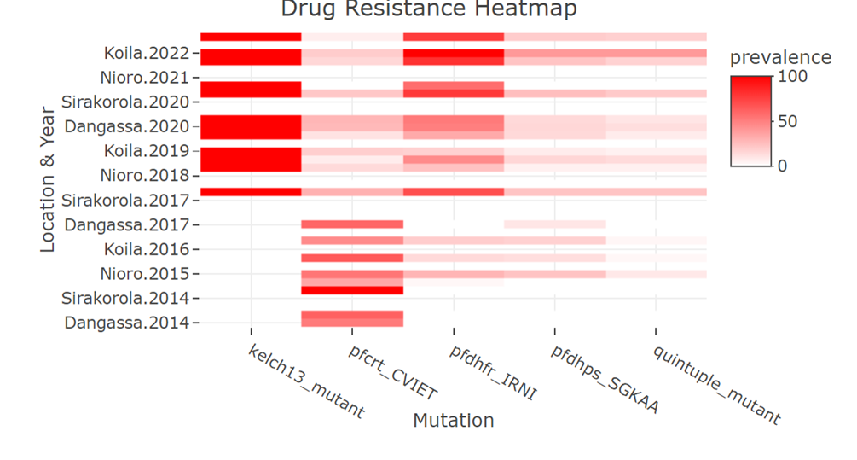
Figure S2: Drug resistance heatmap
The heatmap in Figure S2 synthesizes spatial and temporal patterns of resistance markers, revealing critical insights not fully captured in the main figures. The rapid saturation of pfdhfr IRNI (dark red) in Dangassa by 2018 contrasts with its gradual increase in Koila, illustrating how high transmission intensity accelerates resistance fixation. The cyclical resurgence of pfcrt CVIET (intermittent pink/red bands) in Koila correlates with local reports of unofficial chloroquine use, supporting our hypothesis of persistent selection pressure. Notably, the pfdhps 540K hotspot in Dangassa (consistent dark red after 2018) coincides with agricultural pesticide use, reinforcing environmental cross-resistance concerns. This visualization underscores the need for region-specific interventions: aggressive SP phase-out in Dangassa versus enhanced surveillance for chloroquine resistance in Koila.

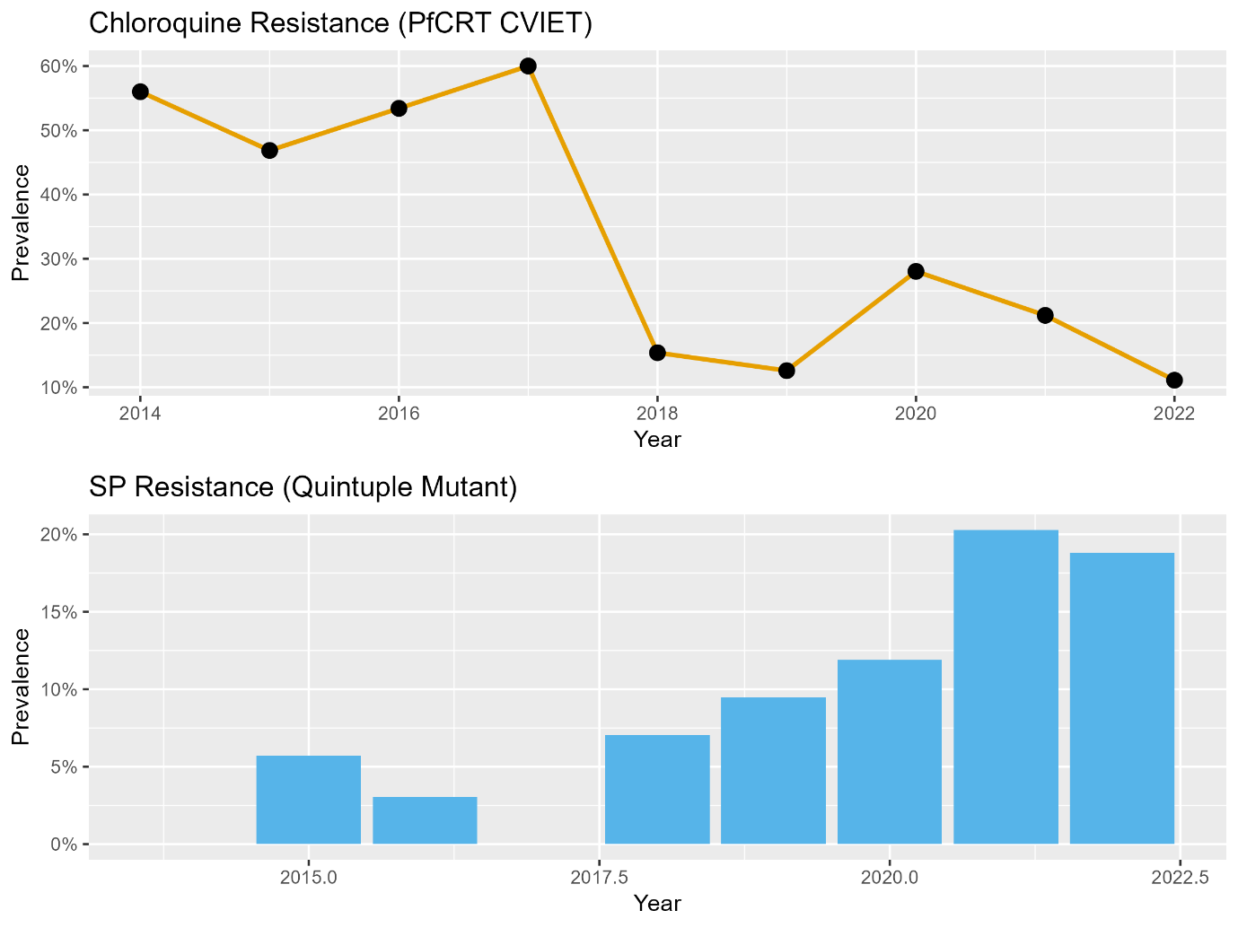
Figure S3: Quintuple Mutant Prevalence Trends
Figure S3’s longitudinal data contextualizes the public health crisis posed by SP resistance. The abrupt rise of quintuple mutants (combining pfdhfr IRNI and pfdhps AGEAA) after 2018 exceeding 20% prevalence by 2022 correlates with Mali’s expanded IPTp coverage. The 3.7-year acceleration in resistance emergence compared to Pf7 projections suggests that current prevention strategies may inadvertently drive resistance. The lag in Nioro’s quintuple mutant surge (post-2020) likely reflects its urban transmission dynamics, where lower malaria incidence delays selection pressure. This figure starkly illustrates the trade-off between IPTp’s short-term benefits and long-term resistance risks, urging rapid adoption of alternative preventives like dihydroartemisinin-piperaquine.

