Spatiotemporal Trends of Land Surface Temperature and Surface Urban Heat Island Intensification Across India
Shahid Mirza¹, Rohini Lakshman Bhawar², Sunil R. Patil^{1*}
¹Department of Physics, Institute of Science Nagpur, RT Road, Civil Lines, Nagpur, MS, India, Pin-440001
²Department of Atmospheric and Space Sciences, Savitribai Phule Pune University, Ganeshkhind, Pune, MS, India, Pin-411007

¹shahidmirzahere@gmail.com
²rohinibhawar@gmail.com
^{1*}phy.patil@iscnagpur.ac.in

Supporting Information
S1. Detailed Information of Biogeographic Zones
Himalaya and Trans-Himalaya (HTH): The northern mountainous regions of India are defined by their high altitudes and cold climates, with the Himalayas serving as a climatic barrier shaping weather patterns across the Indian subcontinent. These ranges feature deep valleys and a fragmented topography, predominantly spanning India, Nepal, and Bhutan (Khullar D.R., 2023). Their northern slopes extend into Tibet (Trans-Himalayas), while the western-most stretches reach Pakistan, Afghanistan, and Central Asia. This region includes the Indian states of Jammu and Kashmir, Ladakh, Himachal Pradesh, Uttarakhand, Sikkim and Arunachal Pradesh (Rao K. S. et al., 2016). For the UHI calculations, we select Srinagar, Jammu, Dehradun, and Haridwar cities from this zone.
Indo-Gangetic Plain (IGP): The Indo-Gangetic Plain is an expansive and fertile region covering approximately $7×{10}^{5}$ square kilometres in northern India (Fazal, 2013). It is situated between the Peninsular region and the Himalayan foothills (Fazal, 2013). This vast plain is characterized by flat, alluvial soils that makes it one of the most agriculturally productive areas in the world. The region experiences climatic extremes, with scorching summers and mild to moderate winters, making seasonal adaptation crucial for inhabitants (Khullar D.R., 2023; Mani, 2012). The Gangetic Plains extend across several Indian states, including Punjab, Haryana, Uttar Pradesh, Bihar, and portions of West Bengal, serving as a cultural and economic heartland of the country. Delhi, Agra, Lucknow, Kanpur, Prayagraj, Varanasi and Patna cities are selected for the respective zone.
Semi-Arid Region (SAR): The northern arid regions of India predominantly encompass the states of Punjab, Rajasthan, and Gujarat. These areas are characterized by their dry climate and semi-arid conditions, which make them vulnerable to fluctuations in conventional food production (Dubash, 2019). Accounting for 16.6% of India’s land area, these regions face significant challenges in maintaining agricultural productivity and ensuring food security amidst changing climatic patterns (Khullar D.R., 2023; Walker & Ryan, 1990). Amritsar, Ludhiana, Jaipur, Ahmadabad, Vadodara, Bhopal, Indore, Kota, Chandigarh and Gwalior are the focused cities for the UHI calculation from the zone.
Great Indian Desert (DES): The Great Indian Desert, commonly referred to as the Thar Desert, is located in northwestern India, covering 5.6% of the country's land area (Khullar D.R., 2023). This arid region experiences extreme temperatures and has minimal vegetation, exacerbating heat stress during the summer months (Bhatnagar et al., 2013). The desert's dry and easily erodible soil is frequently carried away by strong winds. These winds deposit sediment near fertile areas, impacting agricultural regions and contributing to environmental challenges in the surrounding zones (Sivaperuman, 2009). Jodhpur and Bikaner are the only million plus cities in the zone, hence a Cluster City which is a combination of Gandhidham, Anjar and Kandla are selected.
Deccan Plateau (DP): The Deccan Plateau, spanning most of southern India, is characterized by a semi-arid to tropical climate and notable temperature fluctuations, particularly during summer (Loudyi et al., 2022). Covering 42% of India's land area, it includes the states of Madhya Pradesh, Chhattisgarh, Maharashtra, Telangana, Karnataka, Jharkhand, Odisha, and Andhra Pradesh (Khullar D.R., 2023). Bounded by the Vindhya and Satpura ranges separating it from the Gangetic plain in the north and the Indian Ocean in the south, the plateau forms a triangular shape. Its elevation ranges from approximately 300 meters above mean sea level (MSL) in the north to nearly 1000 meters above MSL in the south (Fisher, 2018). Jabalpur, Nagpur, Raipur, Hyderabad, Dhanbad, Bengaluru, Madurai, Mysore, Tiruchirappalli and Salem are selected from DP zone.
Western Ghats (WG): The climate of the WG varies with altitude and proximity to the equator (Kadur & Bawa, 2005). Lower regions experience a humid tropical climate, influenced by their closeness to the sea. Higher elevations, 1,500 m in the north and 2,000 m in the south, experience more temperate climate (B., 2019; Kulkarni et al., 2020). This zone starts with the part of Gujrat state from north, goes towards south by covering Maharashtra, Goa, Karnataka, Kerala up to Tamil Nadu (Khullar D.R., 2023). Nasik, Pune and Coimbatore cities are considered for the UHI investigation.
Western Coastal Region (WCR): Bordering the Arabian Sea, this region is characterized by a tropical monsoon climate, encompassing a blend of urban hubs and forested landscapes that shape its local temperature dynamics (Forrest R. Miller, 1968). This region spans across the states of Gujarat, Goa, Kerala, and the western parts of Maharashtra and Karnataka. The area faces significant challenges, including coastal erosion, notably in Kerala and Karnataka. Climate change aggravates these issues through rising temperatures, shifting rainfall patterns, and intensified weather extremes, posing substantial threats to agriculture, water resources, and coastal infrastructure (United States. Hydrographic Office, 1920). Surat, Mumbai, Thiruvananthapuram and Ernakulam are selected.
Eastern Coastal Region (ECR): It is situated along the Bay of Bengal, is characterized by its low-lying terrain and tropical climate with consistently high humidity levels (Rai & Rai, 2024). This region encompasses the states of Tamil Nadu, Odisha, Andhra Pradesh, and the eastern parts of West Bengal. Known for its fertile deltas and dense population, ECR is vital for agriculture, fisheries, and economic activities, despite vulnerability to cyclones and rising sea levels (Sahu & Das, 2021). Kolkata, Visakhapatnam, Vijayawada, Chennai and Pondicherry cities are taken from the zone.
Northeast (NE): This zone, comprising the states of Assam, Meghalaya, Manipur, Mizoram, Tripura, and Nagaland, is distinguished by its diverse topography, lush forests, and abundant biodiversity (Karlsson, 2011). The Northeastern region is predominantly hilly and heavily forested, featuring a humid subtropical climate. Summer temperatures in the plains range from 30 to 33 °C, while the hills maintain the cooler conditions, with an average summer temperature of around 20 °C and a minimum of approximately 15 °C (Resilience et al., 2020). As Guwahati is the only city in the NE which has million plus population, so as to extend the UHI investigation in one of the diverse ecosystem zones of India, we considered three more cities (Shillong, Agartala and Imphal) having population more ranging between 1 to 6 lakhs.

Table S1: Population status of selected cities (Census 2001, 2001; Eurostat, 2024; MOSP, 2024; UNSD, 2024; WPP, 2024)
Sr. No. | City | 2001 (Census) | 2024 (Est) | Growth (%)
1 | Srinagar | 952324 | 1698000 | 78.30
2 | Jammu | 614000 | 738000 | 20.19
3 | Dehradun | 177509 | 464000 | 161.40
4 | Haridwar | 426674 | 992000 | 132.50
5 | Delhi | 9879172 | 32941000 | 233.44
6 | Agra | 1275134 | 2368000 | 85.71
7 | Lucknow | 2185927 | 3945000 | 80.47
8 | Kanpur | 2555811 | 3234000 | 26.54
9 | Prayagraj | 1018092 | 1465000 | 43.90
10 | Varanasi | 1103952 | 1652000 | 49.64
11 | Patna | 1432209 | 2580000 | 80.14
12 | Amritsar | 1003917 | 1452000 | 44.63
13 | Ludhiana | 1398467 | 1951000 | 39.51
14 | Jaipur | 2322575 | 4207000 | 81.14
15 | Ahmadabad | 3694974 | 8651000 | 134.13
16 | Vadodara | 1411228 | 2324000 | 64.68
17 | Gwalior | 827026 | 1475000 | 78.35
18 | Indore | 1506062 | 3302000 | 119.25
19 | Bhopal | 1458416 | 2565000 | 75.88
20 | Kota | 694316 | 1517000 | 118.49
21 | Chandigarh | 808515 | 1215000 | 50.28
22 | Jodhpur | 860818 | 1587000 | 84.36
23 | Bikaner | 529690 | 819000 | 54.62
24 | Cluster City | 234731 | 578700 | 146.54
25 | Nagpur | 2052066 | 3047000 | 48.48
26 | Raipur | 670042 | 1817000 | 171.18
27 | Hyderabad | 3658510 | 10801000 | 195.23
28 | Dhanbad | 199258 | 1390000 | 597.59
29 | Bengaluru | 4313248 | 13608000 | 215.49
30 | Jabalpur | 933747 | 1551000 | 66.10
31 | Madurai | 1195000 | 1872000 | 56.65
32 | Mysore | 799228 | 1316000 | 64.66
33 | Tiruchirappalli | 752066 | 1245000 | 65.54
34 | Salem | 697061 | 1195000 | 71.43
35 | Nasik | 1077236 | 2237000 | 107.66
36 | Pune | 2538473 | 7166374 | 182.31
37 | Coimbatore | 930882 | 3009000 | 223.24
38 | Surat | 2702304 | 8065000 | 198.45
39 | Mumbai | 11978450 | 21297000 | 77.79
40 | Thiruvananthapuram | 889635 | 2891000 | 224.96
41 | Ernakulam | 1355972 | 3507000 | 158.63
42 | Kolkata | 4580546 | 15332793 | 234.74
43 | Visakhapatnam | 1042388 | 2331000 | 123.62
44 | Vijayawada | 945530 | 2230000 | 135.85
45 | Chennai | 4343645 | 11776147 | 171.11
46 | Pondicherry | 735332 | 919000 | 24.98
47 | Guwahati | 814000 | 1358000 | 66.83
48 | Shillong | 267662 | 508000 | 89.79
49 | Agartala | 273000 | 652000 | 138.83
50 | Imphal | 456113 | 646000 | 41.63

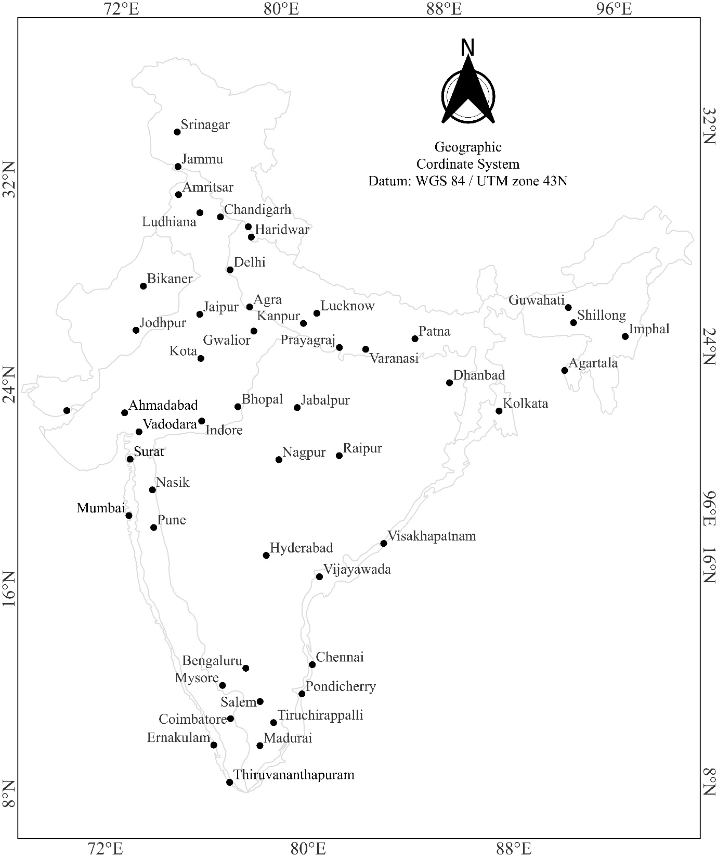
Figure S1: Location of 50 selected cities on country (India) map

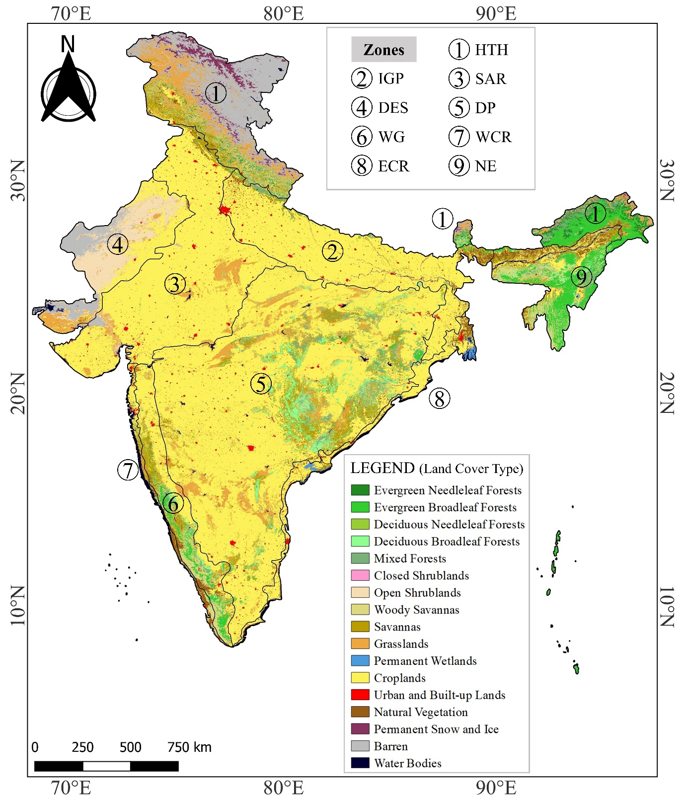
Figure S2a: Land use and land cover map of India using MODIS MCD12Q1 (500 m) product
Figure S2b: Study area (city) delineation process for UHI computation, extracted from the built-up class of MODIS Land Cover images. Figure showing the urban area of Lucknow city (example) in red patches

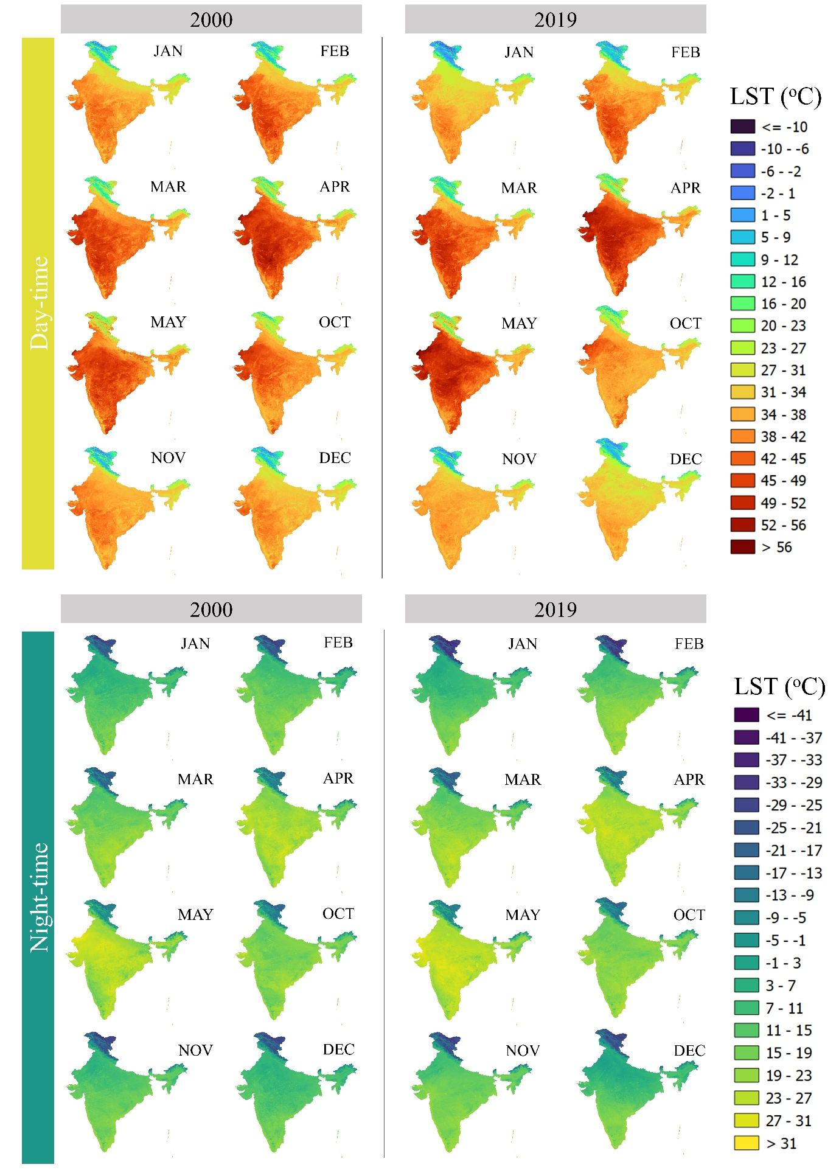
Figure S3: Reference maps for the 2000-2019 Difference map (main paper Figure 3)

S2. Detailed Workflow of Statistical Analysis
S2.1. Mann-Kendall Test
The non-parametric Mann–Kendall test is applied in this study to identify the presence of a monotonic (increasing or decreasing) trend in long-term LST time series for India and its biogeographic zones. The Mann–Kendall test evaluates two hypotheses:
Null Hypothesis – H₀: No monotonic trend
Alternate Hypothesis – H_{a}: A monotonic (upward or downward) trend exists
The test begins by arranging the LST observations in chronological order. For every pair of observations ${(x}_{j},x_{i})$ where $j>i$. The sign of the difference $(x_{j}-x_{i})$ is computed using expression (1).
$$sgn=\left\{\begin{aligned}+1 if x_{j}-x_{i}>0 \\ 0 if x_{j}-x_{i}=0 \\ -1 if x_{j}-x_{i}<0\end{aligned}\right. -----(1)$$
An indicator function assigns values of +1, 0 or –1 depending on whether the later observation is higher, equal or lower than the earlier one.
Summing all indicator values gives the $S$ statistic, where a positive $S$ suggests increasing LST with time and a negative $S$ indicates a decreasing trend.
The variance of S i.e. $var\left(S\right)$ is calculated by accounting for tied values and the standardized test statistic Z_{s} is derived which can be seen as equation (2) and (3).
$$var\left(S\right)=\frac{1}{18}\left[n\left(n-1\right)\left(2n+5\right)-\sum_{i=1}^{m}{t_{i}\left(t_{i}-1\right)\left(2t_{i}+5\right)}\right] -----(2)$$
$$Z_{s}=\frac{1}{18}\left\{\begin{aligned}\frac{S-1}{\sqrt{var\left(S\right)}} if S>0 \\ 0 if S=0 \\ \frac{S+1}{\sqrt{var\left(S\right)}} if S<0\end{aligned}\right. -----(3)$$
A positive $Z_{s}$ denotes an upward trend and a negative $Z_{s}$ denotes a downward trend. The significance of the trend is evaluated by comparing $Z_{s}$ with the corresponding critical values of the standard normal distribution at different significance level (commonly α = 0.01 to α = 0.4 i.e. 99% to 60% of confidence level)
If $Z_{s}$ exceeds the critical threshold, the null hypothesis of no trend is rejected, confirming a statistically significant monotonic increase or decrease in LST.

S2.2. Estimation of Sen’s Slope (annual LST growth rate)
The slope estimates in the of Mann–Kendall trend analysis is a generalized form of Sen’s slope estimator. This approach is more robust and non-parametric for the estimation of slope for the set of pairs ${(x}_{j},x_{i})$. Slope can be estimated using equation (4).
$$Sen^{'}s Slope= Median \left(\frac{x_{j}-x_{i}}{j-i}\right);i<j -----(4)$$

S2.3. Analysis of Variance (ANOVA)
Null and alternate hypothesis described by equation (5) and equation (6).
Null Hypothesis (H_{o}):
$$m1=m2=m3=m4=m5=m6=m7=m8=m9 -----(5)$$
The null hypothesis assumes that the means of the LST for all nine biogeographic zones are equal, indicating no significant difference in LST trends among them. If the test supports Null Hypothesis (H_{o}), it suggests that the LST profiles across these zones are statistically similar.
Alternate Hypothesis (H_{a}):
$$m1≠m2≠m3≠m4≠m5≠m6≠m7≠m8≠m9 -----(6)$$
If the ANOVA test results reject the null hypothesis, the alternate hypothesis is accepted, indicating that at least one zone's mean temperature significantly differs from the others, confirming variability in LST trends between the zones.
The formula for ANOVA test is defined as equation (7):
$$F=\frac{MSC}{MSE} -----(7)$$
The parameters involved in the formula can be seen in the calculations of ANOVA as discussed in Table S2.
The calculated F value in the ANOVA test must be compared with the critical value from the F-distribution table. If the computed F value exceeds the critical value at a given significance level, the null hypothesis is rejected, indicating a significant difference between the means of the groups.

Table S2: Parameters used in ANOVA Analysis ($α=0.05$)
Source | Degree of Freedom | Sum of Squares | Mean Square
Between Samples | $$k-1$$ | $$SSG=\sum_{i=1}^{k}{n_{i}{({\overline{x}}_{i}-\overline{x})}^{2}}$$ | $$MSC=\frac{SSG}{(k-1)}$$
Within Samples | $$n-k$$ | $$SSE=\sum_{i=1}^{k}{\left(n_{i}-1\right){S_{i}}^{2}}$$ | $$MSE=\frac{SSE}{(n-k)}$$
Total | $$n-1$$ | $$SS=SSG+SSE$$ | $$F=\frac{SS}{(n-1)}$$
where $α$ = level of significance, $n$ = Overall sample side, includes all the groups, $n_{i}$ = Sample side of group I, $\overline{x}$ = Overall average, ${\overline{x}}_{i}$ = Average of group I and $S_{i}$ = Standard deviation of group i.

References
B., Viju. (2019). Flood and fury : ecological devastation in the Western Ghats.
Bhatnagar, C., Sharma, S. K., Mathur, M., & Sharma, B. K. (2013). Ophidians of Rajasthan. Faunal Heritage of Rajasthan, India: General Background and Ecology of Vertebrates, 311–330. https://doi.org/10.1007/978-1-4614-0800-0_10
Census 2001, I. (2001). Census 2001 Data Online| National Portal of India. https://www.india.gov.in/census-2001-data-online
Dubash, N. K. . (2019). India in a warming world : integrating climate change and development.
Eurostat. (2024). Overview - Population and demography - Eurostat. https://ec.europa.eu/eurostat/web/population-demography
Fazal, Shahab. (2013). Land use dynamics in a developing economy : regional perspectives from India. 96.
Fisher, M. Herbert. (2018). An environmental history of India : from earliest times to the twenty-first century. 301.
Forrest R. Miller, R. N. K. (1968). Structure of an Arabian Sea Summer Monsoon System. East-West Center Press. https://www.google.co.in/books/edition/Structure_of_an_Arabian_Sea_Summer_Monso/5cAjAAAAMAAJ?hl=en&gbpv=0&bsq=western%20coast%20of%20india%20climate
Kadur, Sandesh., & Bawa, K. S. . (2005). Sahyadris, India’s Western Ghats, a vanishing heritage. 239.
Karlsson, B. G. . (2011). Unruly Hills.
Khullar D.R. (2023). India: A Comprehensive Geography (6th ed.). https://www.tpscollegepatna.org/book/INDIA%20-%20A%20Comprehensive%20Geography_D%20R%20Khullar.pdf
Kulkarni, A., Sabin, T. P., Chowdary, J. S., KoteswaraRao, K., Priya, P., Gandhi, N., Bhaskar, P., Buri, V. K., & Sabade, S. S. (2020). Precipitation changes in India. Assessment of Climate Change over the Indian Region: A Report of the Ministry of Earth Sciences (MoES), Government of India, 47–72. https://doi.org/10.1007/978-981-15-4327-2_3
Loudyi, D., Hasnaoui, M. D., & Fekri, A. (2022). Flood Risk Management Practices in Morocco : Facts and Challenges Fund of Solidarity against Catastrophic Events Master Plan for Integrated Water Resources Management National Flood protection Plan Prevention Plan against Flood Risk. http://dx.doi.org/10.1007/978-981-16-2904-4_2
Mani, M. S. . (2012). Ecology and Biogeography in India.
MOSP. (2024). Ministry of Statistics and Program Implementation | Government Of India. https://www.mospi.gov.in/
Rai, P. Kuma., & Rai, Shalini. (2024). Climate, Environment and Agricultural Development.
Rao K. S., Saxena K. G., & Tiwari B. K. (2016). Biodiversity, climate change and socio-economic development in the Indian Himalaya : an overview. Bishen Singh Mahendra Pal Singh. https://search.worldcat.org/title/944220091
Resilience, B. C., Chain, T. V., Gardens, S. T., Objective, P., Sector, P., Name, A., Entity, E., & Board, T. (2020). Draft Project Proposal for funding under National Adaptation Fund for Climate Change Building Climate Resilience in Tea Value Chain for Small Tea Gardens ( STGs ) Title of Project / Programme : Building Climate Resilience in Tea Value Chain for Small Tea . 1–47.
Sahu, B. K., & Das, S. (2021). Microzooplankton in Estuaries, Mangroves, and Lagoons of East Coast of India. Estuarine Biogeochemical Dynamics of the East Coast of India, 183–209. https://doi.org/10.1007/978-3-030-68980-3_12
Sivaperuman, C. . (2009). Faunal ecology and conservation of the Great Indian Desert. 222.
United States. Hydrographic Office. (1920). West Coast of India Pilot. https://www.google.co.in/books/edition/West_Coast_of_India_Pilot/wWsDAAAAYAAJ?hl=en&gbpv=0
UNSD. (2024). UNSD - Welcome to UNSD. https://unstats.un.org/UNSDWebsite/
Walker, T. S. ., & Ryan, J. G. . (1990). Village and household economies in India’s semi-arid tropics. 394.
WPP. (2024). World Population Prospects. https://population.un.org/wpp/

