Supplementary Material
The effect and attributable risk of daily temperature on category C infectious diarrhea in Guangdong Province, China
Qiang Hao ^{a,b}, Qi Gao ^{c}, Ran Zhao ^{a,b}, Haitao Wang ª, Hao Li ^{a,b}, Baofa Jiang ^{a,b,*}
ª Department of Epidemiology, School of Public Health, Cheeloo College of Medicine, Shandong University, Jinan 250012, Shandong Province, People’s Republic of China
^{b} Shandong University Climate Change and Health Center, Jinan 250012, Shandong Province, People’s Republic of China
^{c} Department of Biostatistics, School of Public Health, Cheeloo College of Medicine, Shandong University, Jinan 250012, Shandong Province, People’s Republic of China
Journal name: Environmental Science and Pollution Research
*Corresponding author: Baofa Jiang, Department of Epidemiology, School of Public Health, Cheeloo College of Medicine, Shandong University, No.44 Wenhuaxi Road, Lixia District, Jinan 250012, Shandong Province, People’s Republic of China. E-mail address: bjiang@sdu.edu.cn Tel: +86-0531-88382141

Table A1 City-specific modifiers in Guangdong province
City | Latitude | Longitude | Population density | Urbanization rate | Primary school student | Disposable income | GDP per capita | Medical technician | Medical bed
Chaozhou | 23.40 | 116.38 | 725.46 | 63.74 | 72.27 | 20,366.37 | 3.41 | 3.41 | 2.33
Dongguan | 22.90 | 113.89 | 3,368.37 | 88.92 | 86.31 | 38,754.80 | 7.64 | 5.40 | 3.31
Foshan | 23.11 | 112.88 | 1,952.25 | 94.93 | 66.39 | 38,527.27 | 10.82 | 5.95 | 4.39
Guangzhou | 23.34 | 113.51 | 1,821.59 | 85.67 | 69.08 | 46,877.00 | 13.56 | 9.46 | 6.08
Heyuan | 23.98 | 114.91 | 196.28 | 42.15 | 89.99 | 14,636.20 | 2.69 | 4.53 | 3.95
Huizhou | 23.25 | 114.61 | 418.86 | 68.07 | 105.67 | 30,189.87 | 6.72 | 5.88 | 4.52
Jiangmen | 22.61 | 113.06 | 476.06 | 64.70 | 67.73 | 27,216.70 | 4.97 | 5.57 | 4.39
Jieyang | 23.33 | 116.11 | 1,157.02 | 50.81 | 81.27 | 16,305.23 | 3.12 | 3.19 | 2.49
Maoming | 22.06 | 111.00 | 532.36 | 39.94 | 95.26 | 16,838.73 | 4.07 | 4.54 | 4.51
Meizhou | 24.16 | 116.13 | 274.46 | 47.76 | 72.29 | 16,428.27 | 2.22 | 4.91 | 3.59
Qingyuan | 24.33 | 112.92 | 201.37 | 49.12 | 78.45 | 17,188.77 | 3.36 | 5.00 | 3.93
Shantou | 23.28 | 116.52 | 2,524.63 | 70.12 | 90.29 | 18,991.77 | 3.40 | 3.75 | 2.89
Shanwei | 23.07 | 115.50 | 621.09 | 54.94 | 81.13 | 20,680.33 | 2.55 | 3.26 | 2.64
Shaoguan | 24.70 | 113.80 | 159.25 | 54.29 | 74.55 | 18,247.77 | 3.96 | 6.23 | 5.48
Shenzhen | 22.65 | 114.20 | 5,686.20 | 100.00 | 75.36 | 44,758.67 | 15.83 | 6.61 | 3.00
Yangjiang | 22.09 | 111.82 | 315.87 | 49.92 | 82.28 | 23,203.00 | 4.91 | 5.26 | 4.24
Yunfu | 22.92 | 112.03 | 316.20 | 40.22 | 84.24 | 20,240.10 | 2.93 | 4.63 | 3.26
Zhanjiang | 21.08 | 110.32 | 546.13 | 40.66 | 79.26 | 16,622.63 | 3.32 | 4.56 | 4.21
Zhaoqing | 23.59 | 112.11 | 272.65 | 45.08 | 84.69 | 23,793.00 | 4.86 | 5.20 | 3.70
Zhongshan | 22.62 | 113.38 | 1,800.77 | 88.13 | 86.22 | 37,723.57 | 9.41 | 6.25 | 4.18
Zhuhai | 22.15 | 113.26 | 947.58 | 88.25 | 90.28 | 36,515.63 | 12.42 | 8.96 | 5.15

Table A2 Description of the meteorological and OID data in Guangdong province
City | Total OID | Daily OID | MT (℃) | RH (%) | PR (mm) | WV (m/s)
Chaozhou | 1,335 | 1(2) | 23.2(10.5) | 77.5(14) | 4.6(1.2) | 1.7(0.7)
Dongguan | 22,197 | 20(10) | 23.1(9.5) | 77.8(16) | 6.1(3.2) | 2.4(1)
Foshan | 20,078 | 18(15) | 22(10.3) | 79.5(13) | 7(4.8) | 2.3(1.2)
Guangzhou | 34,901 | 32(18) | 22(10.3) | 79.5(13) | 7(4.8) | 2.3(1.2)
Heyuan | 2,600 | 2(2) | 22.1(10.5) | 76.6(15) | 6.1(3.6) | 1.9(0.9)
Huizhou | 6,935 | 6(6) | 22.5(9.7) | 77.8(14) | 5.5(2.5) | 2.2(1.1)
Jiangmen | 22,423 | 22(12) | 23.3(9.7) | 78.9(14) | 5.1(1.5) | 2.1(1.2)
Jieyang | 9,355 | 9(6) | 22(10) | 80.6(13) | 5.5(3.1) | 2(0.9)
Maoming | 7,712 | 7(5) | 23.8(8.3) | 83.8(10) | 3.8(0.8) | 2.9(1.3)
Meizhou | 26,203 | 24(13) | 21.8(10.6) | 77.5(14) | 4.8(2.8) | 1.5(0.5)
Qingyuan | 17,630 | 16(9) | 22.2(10.5) | 76.9(19) | 6.2(3.3) | 2.9(1.7)
Shantou | 15,204 | 14(8) | 23.2(10.5) | 77.5(14) | 4.6(1.2) | 1.7(0.7)
Shanwei | 7,209 | 7(5) | 23.2(9.7) | 78.6(14) | 5.1(1.4) | 2.4(1)
Shaoguan | 4,823 | 4(5) | 20.7(12.5) | 79.2(16) | 5.5(3.3) | 2.4(1.2)
Shenzhen | 78,033 | 71(39) | 23.5(9.2) | 74.7(14) | 5.2(1.4) | 2(1)
Yangjiang | 17,179 | 16(8) | 23.1(9) | 81.3(13) | 5.8(1.9) | 3.6(1.5)
Yunfu | 2,571 | 2(2) | 22.8(9.8) | 83(10) | 3.9(1.4) | 1.7(0.8)
Zhanjiang | 4,150 | 4(3) | 23.7(9.1) | 82.7(11) | 4.2(1) | 3.3(1.7)
Zhaoqing | 18,601 | 17(10) | 21.9(10.8) | 80.4(13) | 5.7(3.7) | 1.4(0.6)
Zhongshan | 16,732 | 15(11) | 23.2(9.8) | 77.9(15) | 5.6(1.9) | 1.8(0.8)
Zhuhai | 17,190 | 16(8) | 23.5(9.7) | 80.2(14) | 5.6(1.6) | 2.5(1)
Note: The data outside the brackets is median, and the data inside the brackets is quantile range. OID: other infectious diarrhea; MT: mean temperature; RH: relative humidity; PR: precipitation; WV: wind velocity.
Table A3 The maximum lag and cumulative effects in low and high temperatures
Group | Low temperature |  |  |  | High temperature
 | Lag(d) | Maximum lag RR | Cumulative RR |  | Lag(d) | Maximum lag RR |  | Cumulative RR
Total | 20 | 1.046(1.035,1.058) | 1.026(1.015,1.038) |  | 15 | 1.006(0.998,1.014) |  | 1.006(0.999,1.013)
Gender
Male | 20 | 1.043(1.032,1.055) | 1.026(1.015,1.038) |  | 18 | 1.007(0.998,1.016) |  | 1.006(0.999,1.014)
Female | 21 | 1.047(1.032,1.061) | 1.025(1.011,1.040) |  | 29 | 1.009(1.000,1.018) |  | 1.008(0.999,1.017)
Age (years)
≤5 | 20 | 1.044(1.032,1.056) | 1.026(1.014,1.038) |  | 19 | 1.013(1.004,1.022) |  | 1.009(1.001,1.018)
6-19 | 20 | 1.101(1.065,1.138) | 1.073(1.044,1.103) |  | 0 | 1.007(0.979,1.036) |  | 0.983(0.958,1.009)
≥20 | 24 | 1.028(1.011,1.045) | 0.999(0.977,1.022) |  | 0 | 1.019(1.004,1.034) |  | 1.003(0.990,1.016)
Occupation
Scattered and nursery children | 20 | 1.044(1.032,1.057) | 1.026(1.015,1.038) |  | 19 | 1.012(1.003,1.022) |  | 1.009(1.001,1.017)
Housekeeping and Unemployed | 21 | 1.041(1.018,1.065) | 1.018(0.997,1.039) |  | 0 | 1.025(1.000,1.052) |  | 1.008(0.994,1.022)
Students | 19 | 1.121(1.067,1.178) | 1.093(1.045,1.143) |  | 0 | 0.994(0.956,1.033) |  | 0.973(0.946,1.002)
Farmers | 21 | 1.011(0.992,1.030) | 0.993(0.972,1.014) |  | 16 | 1.005(0.986,1.024) |  | 1.004(0.988,1.020)
Workers | 27 | 1.001(0.960,1.044) | 0.972(0.926,1.020) |  | 0 | 1.030(0.996,1.065) |  | 0.994(0.967,1.021)
Others | 23 | 1.034(1.009,1.059) | 1.005(0.977,1.032) |  | 0 | 1.032(1.006,1.059) |  | 1.013(0.997,1.030)

Table A4 Attributable fraction of temperature to different subgroups
Group |  | Temperature |  |  | Low temperature |  |  | High temperature
 |  | % | 95%eCI |  | % | 95%eCI |  | % | 95%eCI
Total |  | 17.14 | 2.83~26.32 |  | 4.23 | 1.79~5.71 |  | 1.34 | 0.86~1.64
Gender | Male | 29.40 | 4.86~45.15 |  | 7.26 | 3.08~9.8 |  | 2.29 | 1.47~2.81
 | Female | 16.98 | 2.85~26.05 |  | 4.17 | 1.78~5.63 |  | 1.32 | 0.83~1.63
Age (years) | ≤5 | 19.25 | 4.54~28.81 |  | 4.67 | 2.12~6.21 |  | 1.4 | 0.98~1.66
 | 6-19 | 14.02 | -0.36~23.16 |  | 3.92 | 1.61~5.35 |  | 0.94 | 0.39~1.27
 | ≥20 | 10.75 | -2.3~18.99 |  | 2.83 | 0.72~4.12 |  | 1.22 | 0.55~1.64
Occupation | Scattered and nursery children | 19.16 | 4.45~28.7 |  | 4.65 | 2.1~6.19 |  | 1.4 | 0.97~1.66
 | Housekeeping and Unemployed | 12.42 | -0.25~20.65 |  | 2.89 | 0.79~4.19 |  | 1.46 | 0.63~1.97
 | Students | 14.44 | -0.05~23.63 |  | 4.3 | 2.12~5.65 |  | 0.69 | 0.25~0.97
 | Farmers | 1.9 | -13.95~11.74 |  | 2.02 | -0.46~3.52 |  | 0.67 | 0.01~1.09
 | Workers | 21.49 | 11.17~28.26 |  | 3.57 | 1.96~4.55 |  | 2.22 | 1.5~2.65
 | Others | 14.57 | 2.68~22.12 |  | 3.19 | 1.17~4.43 |  | 1.32 | 0.62~1.77

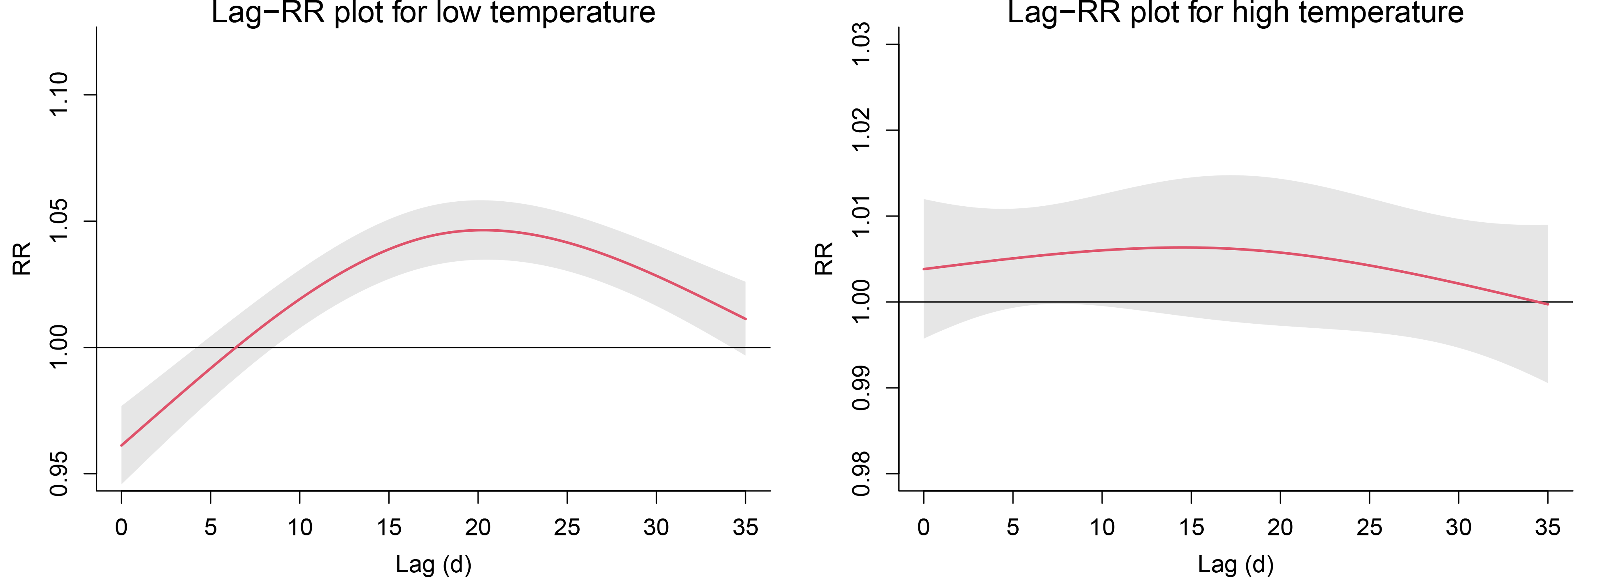
Fig. A1 Lag curve of the total population in low and high temperatures

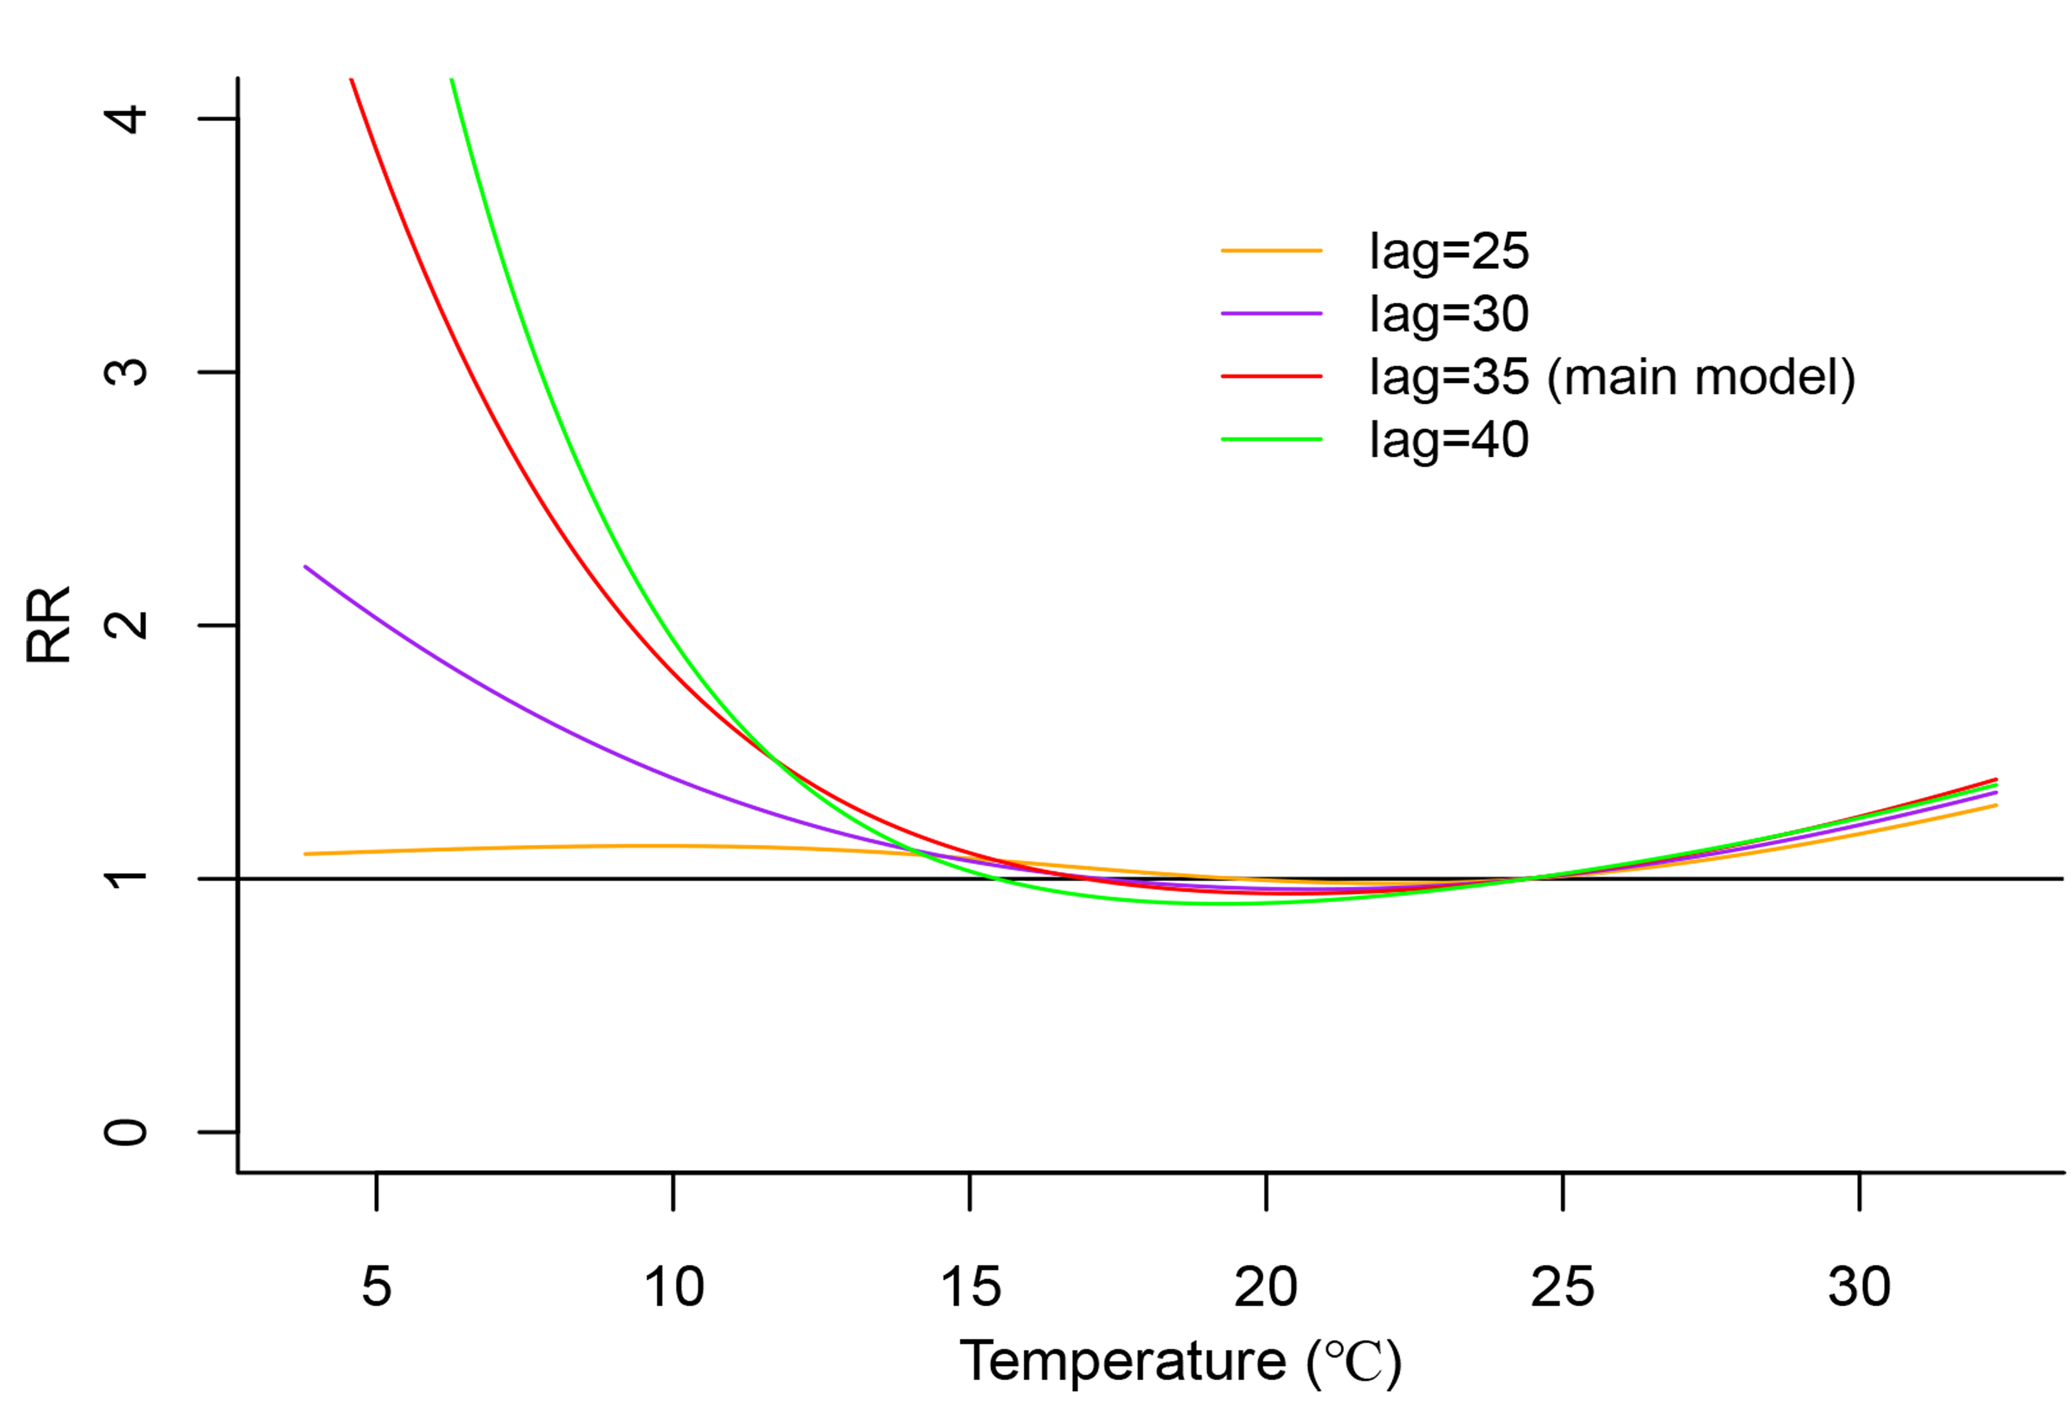
Fig. A2 Pooled estimates of daily mean temperature on OID when changing the max lag period

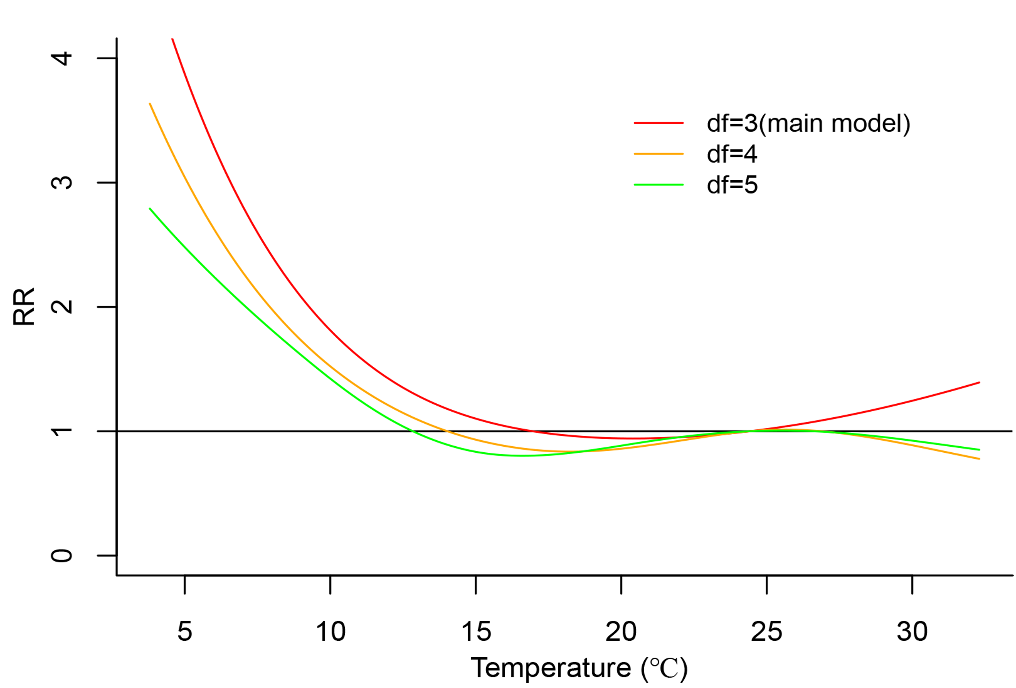
Fig. A3 Pooled estimates of daily mean temperature on OID when changing the degrees of freedom of temperature
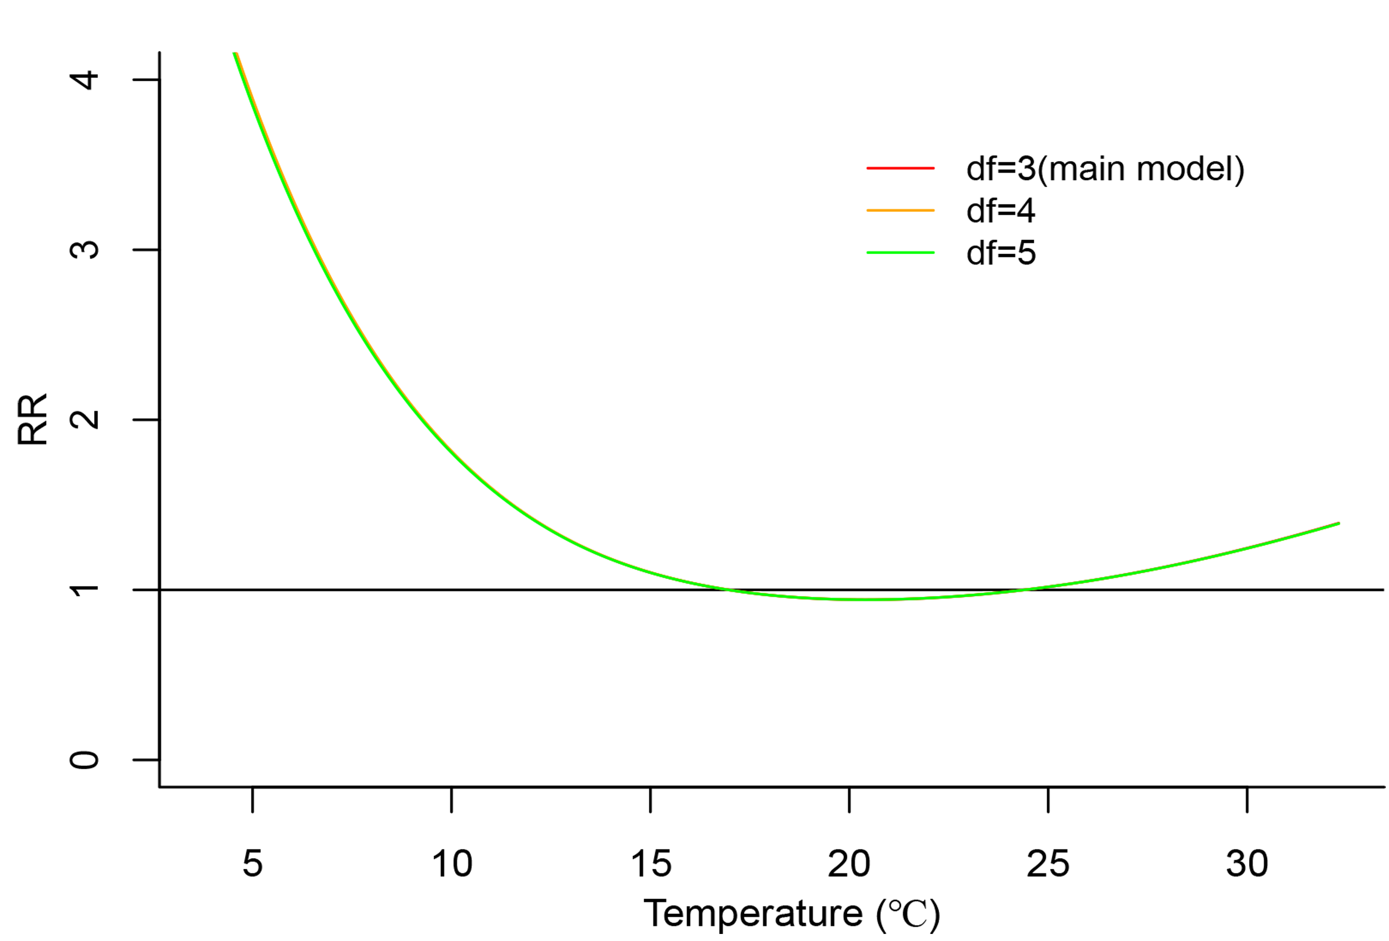
Fig. A4 Pooled estimates of daily mean temperature on OID when changing the degrees of freedom of relative humidity (The three lines are nearly overlapped)
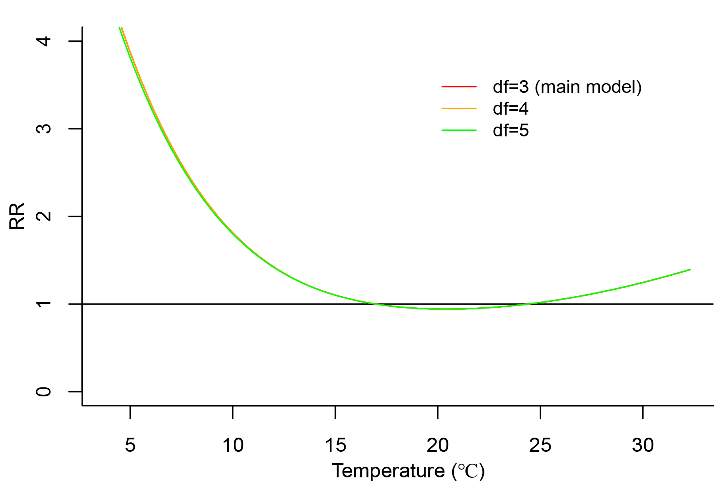
Fig. A5 Pooled estimates of daily mean temperature on OID when changing the degrees of freedom of rainfall (The three lines are nearly overlapped)
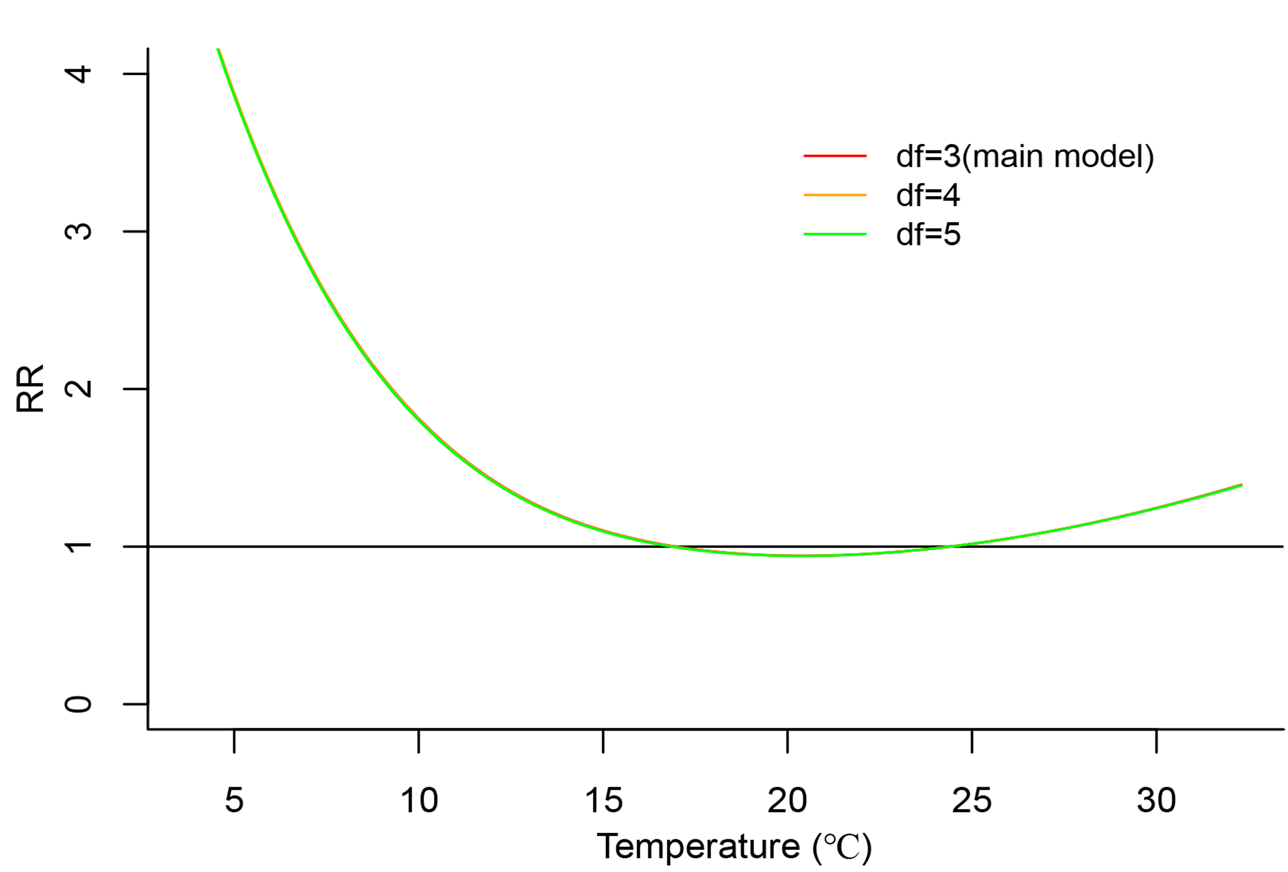
Fig. A6 Pooled estimates of daily mean temperature on OID when changing the degrees of freedom of wind speed (The three lines are nearly overlapped.)
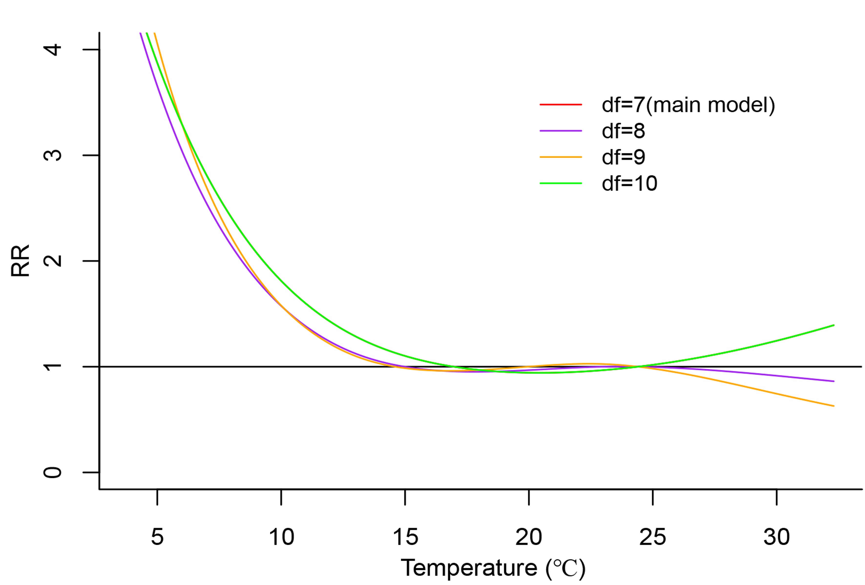
Fig. A7 Pooled estimates of daily mean temperature on OID when changing the degrees of freedom for time per year
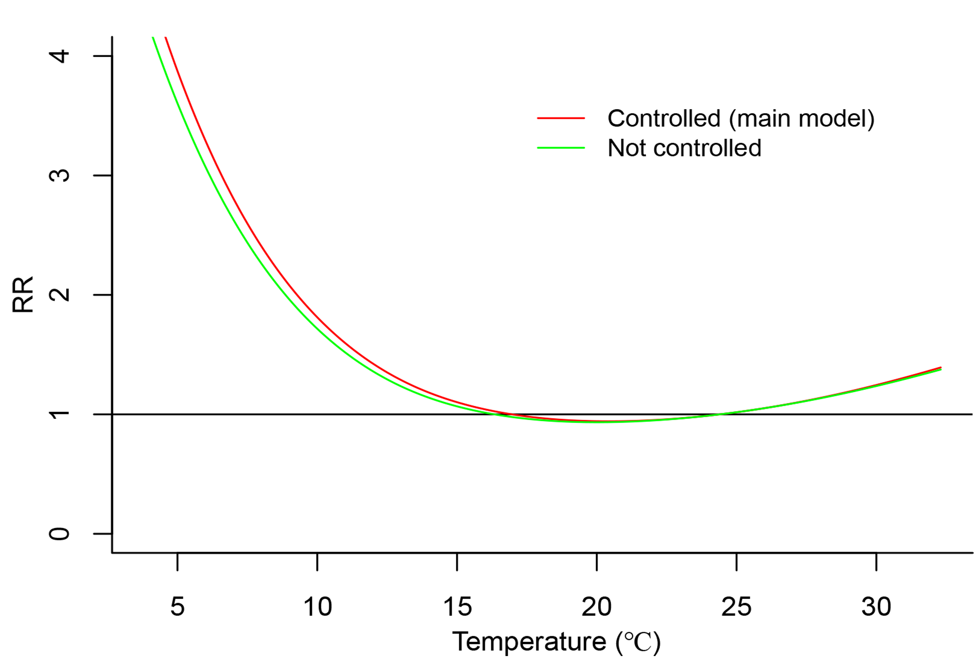
Fig. A8 Pooled estimates of daily mean temperature on OID when controlling the autocorrelation or not

