A mitochondrion-targeted natural polyphenolic copper carrier overcomes tumor resistance to cisplatin by potentiating cuproptosis

Haoyu Yang^{a#}, Xiang Xiong^{b#}, Xin Chenª, Siqi Huangª, Hongfang Daiª, Liqin Yuan^{b*}, Jialong Fan ^{c}, Zhenhong Xiang ª, Wei Wang ^{a*}, Yan Qin ^{a*}
ª School of Pharmacy, Hunan University of Chinese Medicine, Changsha, Hunan, 410208, P.R. China
^{b} The Second Xiangya Hospital, Central South University, Changsha, Hunan, 410011, P.R. China
^{c} Hunan Provincial Key Laboratory of the Research and Development of Novel Pharmaceutical Preparations, Changsha Medical University, Changsha, China
# These authors contributed equally to this work and should be regarded as the first authors
* To whom correspondence should be addressed. Tel: +86–731–88458223;
E–mail: Yan Qin (email, qin86yan@hotmail.com); Wei Wang (email, wangwei402@hotmail. com); Liqin Yuan (email, yuanliqin@csu.edu.cn)

Contents
Figure S1. The characterization of bm–Cur 3
Figure S2. HRLC-MS spectrometry of bm–Cur reaction with GSH 4
Figure S3. The Uv-vis spectra of bm–Cur reaction with GSH 4
Figure S4. The GSH consumption capacity test of bm–Cur 5
Figure S5. Cytotoxicity of bm–Cur on cisplatin-sensitive hepatocellular carcinoma cells 5
Figure S6. Cytotoxicity of bm–Cur on cisplatin-resistant hepatocellular carcinoma cells 6
Figure S7. Stability test of bCCM 6
Figure S8. bm–Cur content detection in bCCM 6
Figure S9. The GSH consumption capacity test of bCCM 7
Figure S10. Detection of GSH levels with different treatments on HepG2 cells 7
Figure S11. Quantification of xCT proteins in BEL7402/DDP cells 8
Table S1. IC₅₀ for different cells with different administrations 8
Figure S12. The CCK-8 assay of AML-12 cells treat with bCCM 8
Figure S13. Bright field image of BEL7402/DDP cells for Live/dead staining 9
Figure S14. Bright field image of BEL7402/DDP cells for apoptosis 9
Figure S15. Bright field image of BEL7402/DDP cells for intracellular copper ions levels detection 9
Figure S16. Cytotoxicity of copper ions on BEL7402/DDP cells 9
Figure S17. Cytotoxicity of UK5099 on BEL7402/DDP cells 10
Figure S18. Quantification of drug-resistant proteins in BEL7402/DDP cells 10
Figure S19. Transcriptomics analysis of BEL7402/DDP cells with bCCM treatment 11
Figure S20. Mitochondrial GSH detection on HepG2 cells 11
Figure S21. Quantitative analysis of Western blot at mitochondrial level 12
Figure S22. Zebrafish toxicity assay 13
Figure S23. Hemolysis test of bCCM 14
Figure S24. Biosafety and biocompability assay of bCCM 14
Figure S25. Quantitative analysis of mean fluorescence by Tunel assay 15

Fig. S1. The characterization of bm–Cur. Low resolution liquid chromatography-mass spectrometry of bm–Cur. ESI- scanning for C₁₉H₁₆O₆ (Mw = 340.33) detected [M - H] ⁻ at m/z = 339.25.
Fig. S2. High-resolution liquid chromatography-mass spectrometry of bm–Cur (40 μM) reaction with GSH (10 mM) for 24 h. ESI- scanning for C₂₉H₃₃N₃O₁₂S (Mw = 647.18) detected [M - H] ⁻ at m/z = 646.1423.

Fig. S3. The Uv-vis spectra of bm–Cur reaction with GSH. (A) UV–vis spectra of different bm–Cur concentrations. (B) UV–vis spectra of bm–Cur (40 μM) reaction with different GSH concentrations for 1 h. (C) UV–vis spectra of bm–Cur (40 μM) reaction with 10 mM GSH over time.

Fig. S4. GSH consumption capacity test of bm–Cur. The consumed GSH of BEL7402/DDP cells with different concentrations of bm–Cur treatments for 24 h. (n ≥ 3; error bars represent SD, *P ≤ 0.05; **P ≤ 0.01; ***P ≤ 0.001; ****P ≤ 0.0001).

Fig. S5. Cytotoxicity of bm–Cur on cisplatin-sensitive hepatocellular carcinoma cells. (A-B) The cell viability of Hepatocellular carcinoma sensitive cells (HepG2 and Hepa1-6 cells) treated with different concentrations of bm–Cur for 48 h. (n ≥ 3; error bars represent SD, *P ≤ 0.05; **P ≤ 0.01; ***P ≤ 0.001; ****P ≤ 0.0001).
Fig. S6. Cytotoxicity of bm–Cur on cisplatin-resistant hepatocellular carcinoma cells. (A-B) The cell viability of Hepatocellular carcinoma cisplatin-resistant cells (BEL7402/DDP and HepG2/DDP cells) treated with different concentrations of bm–Cur for 48 h. (n ≥ 3; error bars represent SD, *P ≤ 0.05; **P ≤ 0.01; ***P ≤ 0.001; ****P ≤ 0.0001).

Fig. S7. Concentration standard curve of bm–Cur and the amount of bm–Cur in bCCM. Releasing bm–Cur (μM) = [A430 (30 μg/mL bCCM + 10mM GSH, 2 h)-0.2123]/0.0146 = 39.22.

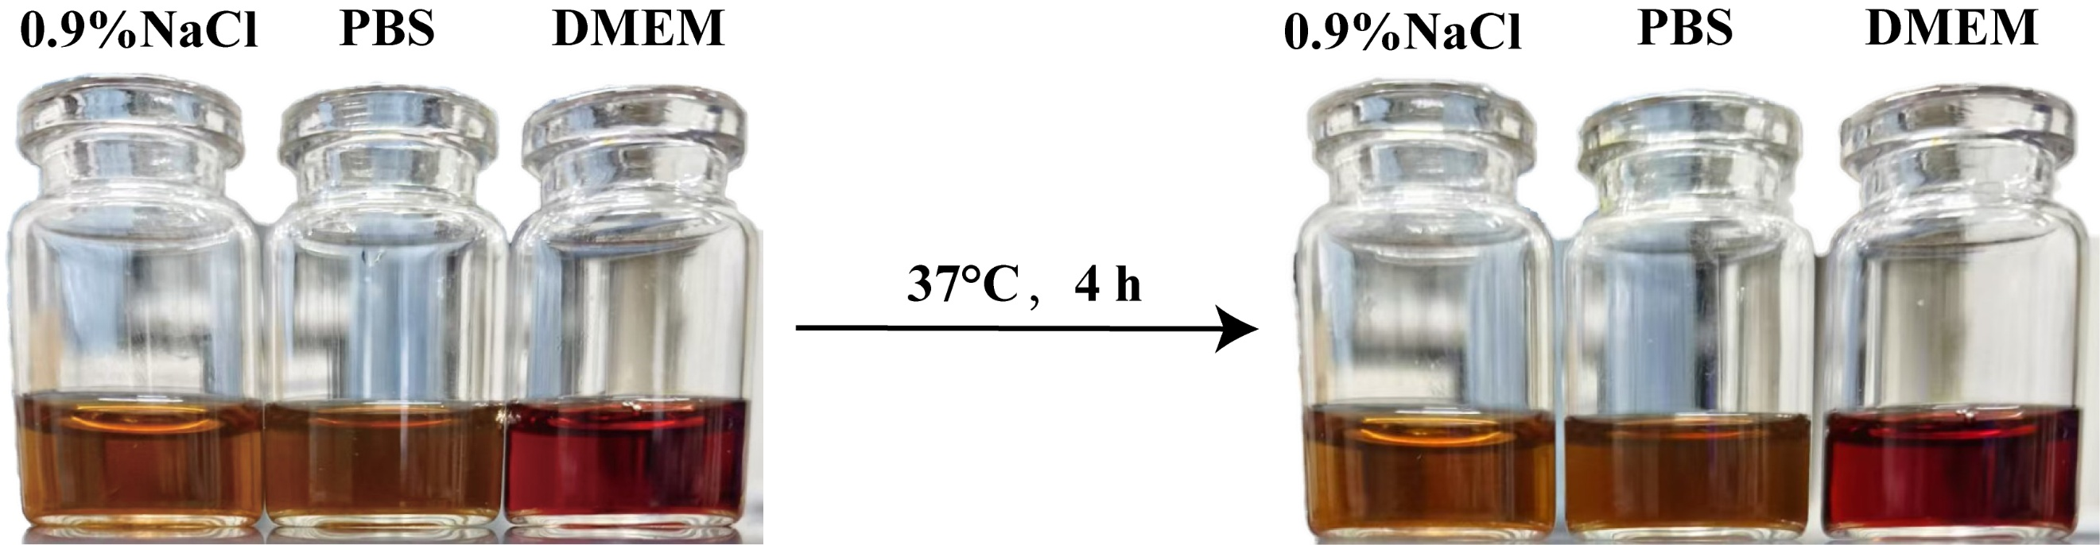
Fig. S8. Stability test of bCCM in various solutions.

Fig. S9. GSH consumption capacity test of bCCM. (A-B) The consumed GSH of HepG2 and BEL7402/DDP cells treated with different concentrations of bCCM for 24 h. (n ≥ 3; error bars represent SD, *P ≤ 0.05; **P ≤ 0.01; ***P ≤ 0.001; ****P ≤ 0.0001)

Fig. S10. Detection of GSH levels with different treatments on HepG2 cells. (A) The consumed GSH and (B) relative GSH level treated with different groups for 24 h. (n ≥ 3; error bars represent SD, *P ≤ 0.05; **P ≤ 0.01; ***P ≤ 0.001; ****P ≤ 0.0001).

Fig. S11. Quantification of xCT protein in BEL7402/DDP cells treated with different groups for 24 h. (n ≥ 3; error bars represent SD, *P ≤ 0.05; **P ≤ 0.01; ***P ≤ 0.001; ****P ≤ 0.0001).

Table. S1. IC₅₀ for different cells with different administrations (mean±SD, n=3)
IC₅₀ | bCCM (μg/mL) | DDP (μM)
HepG2 | 29.1±0.6 | 11.3±0.2
BEL7402/DDP | 65.4±1.2 | 47.2±0.9
A2780/DDP | 40.2±0.6 | 66.4±1.7

Fig. S12. The cell viability of AML-12 with treatment of different bCCM concentrations for 24 h. (n ≥ 3; error bars represent SD, *P ≤ 0.05; **P ≤ 0.01; ***P ≤ 0.001; ****P ≤ 0.0001).

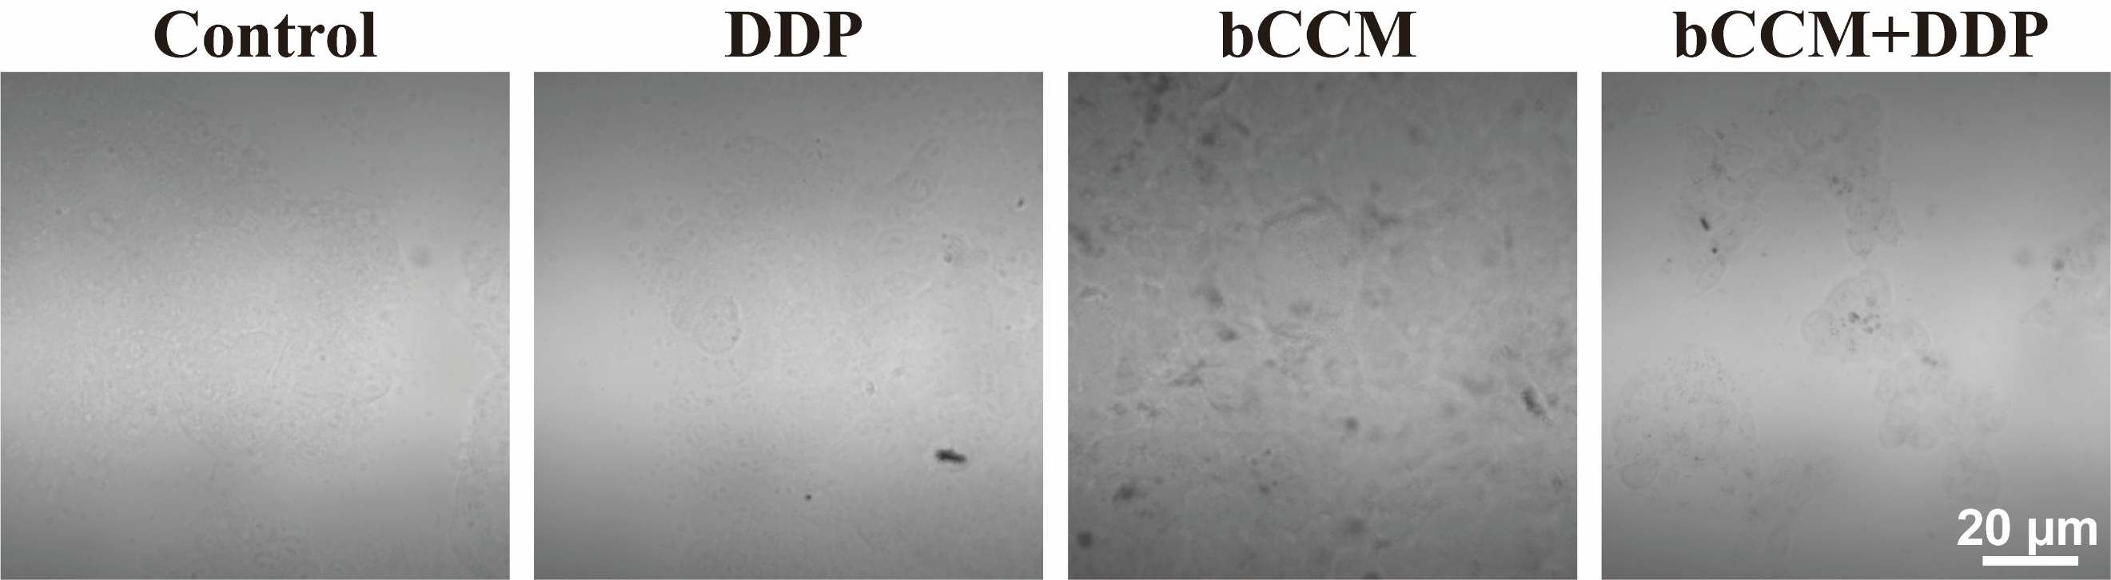
Fig. S13. Bright field image of BEL7402/DDP cells for Live/dead staining.

Fig. S14. Bright field image of BEL7402/DDP cells for apoptosis.

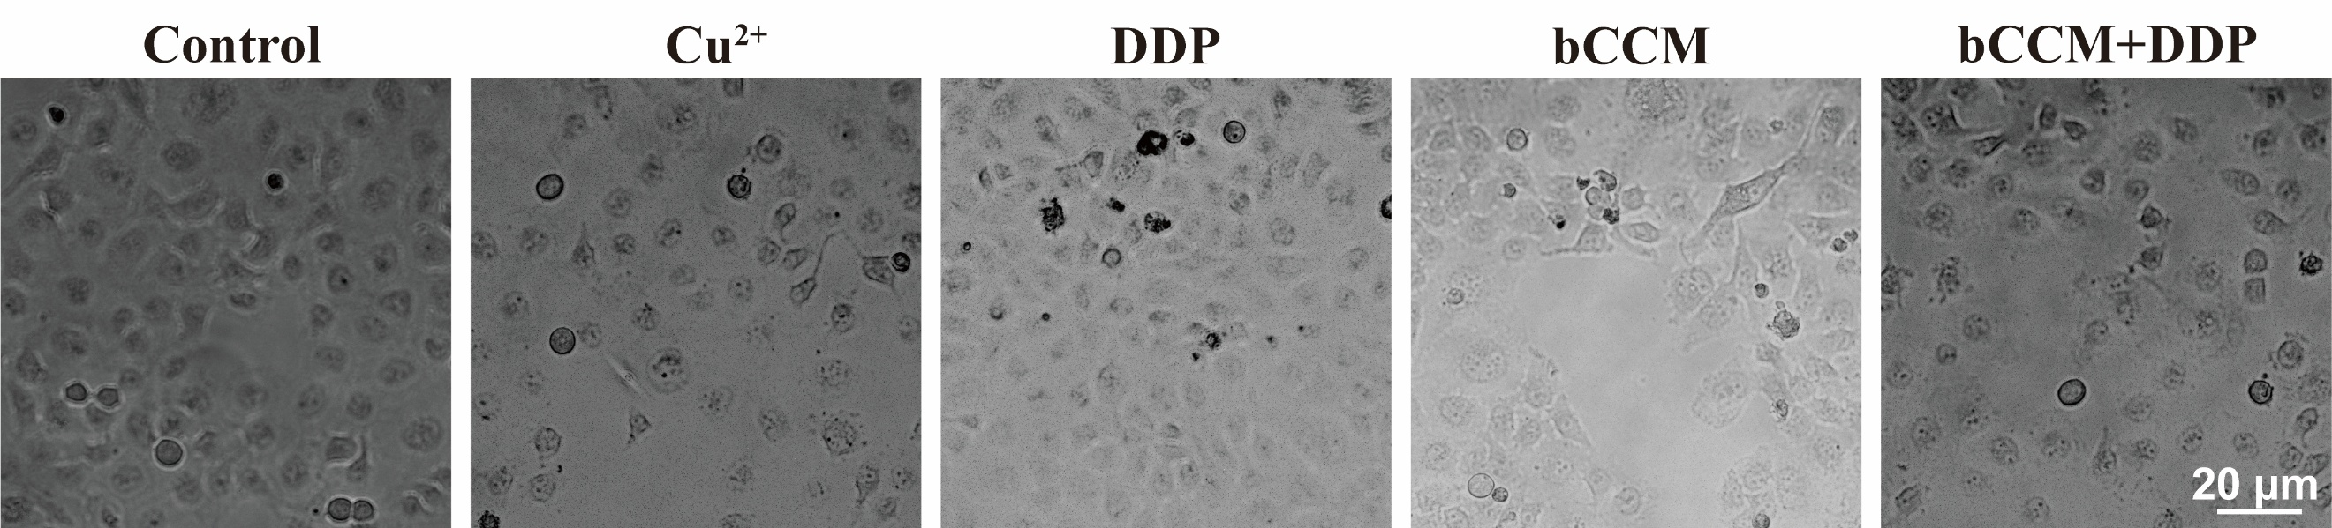
Fig. S15. Bright field image of BEL7402/DDP cells for intracellular copper ions.

Fig. S16. Cytotoxicity of copper ions on BEL7402/DDP cells. The cell viability of BEL7402/DDP cells treated with different concentrations of copper ions for 24 h.
Fig. S17. Cytotoxicity of UK5099 on BEL7402/DDP cells. The cell viability of BEL7402/DDP cells treated with different concentrations of UK5099 for 24 h.

Fig. S18. Quantification of drug-resistant proteins (A-B) in BEL7402/DDP cells treated with different groups for 24 h. (n ≥ 3; error bars represent SD, *P ≤ 0.05; **P ≤ 0.01; ***P ≤ 0.001; ****P ≤ 0.0001).

Fig. S19. Transcriptomics analysis of BEL7402/DDP cells post 24 h treatment with bCCM. (A) Gene Set Enrichment Analysis (GSEA) for Glutathione Metabolism, Citrate (TCA) cycle, Platinum drug resistance and ABC transporters pathways. (B) Protein–protein interaction (PPI) network of Cuprotosis and drug resistance.

Fig. S20. The Relative mito-GSH level with different treatments on HepG2 cells for 24 h. (n ≥ 3; error bars represent SD, *P ≤ 0.05; **P ≤ 0.01; ***P ≤ 0.001; ****P ≤ 0.0001).

Fig. S21. Quantitative analysis of different proteins at the mitochondrial level. (A) Quantification of xCT in BEL7402/DDP cells treated with different groups for 24 h. (B-D) Quantification of cuproptosis-associated proteins in BEL7402/DDP cells treated with different groups for 24 h. (n ≥ 3; error bars represent SD, *P ≤ 0.05; **P ≤ 0.01; ***P ≤ 0.001; ****P ≤ 0.0001).
Fig. S22. Zebrafish toxicity assay of different groups. (A) Representative images of zebrafish from the Control group. (B) Representative images of zebrafish from the DDP group. (C) Representative images of zebrafish from the bCCM group. (D) Representative images of zebrafish from the bCCM+DDP group. (n=3)

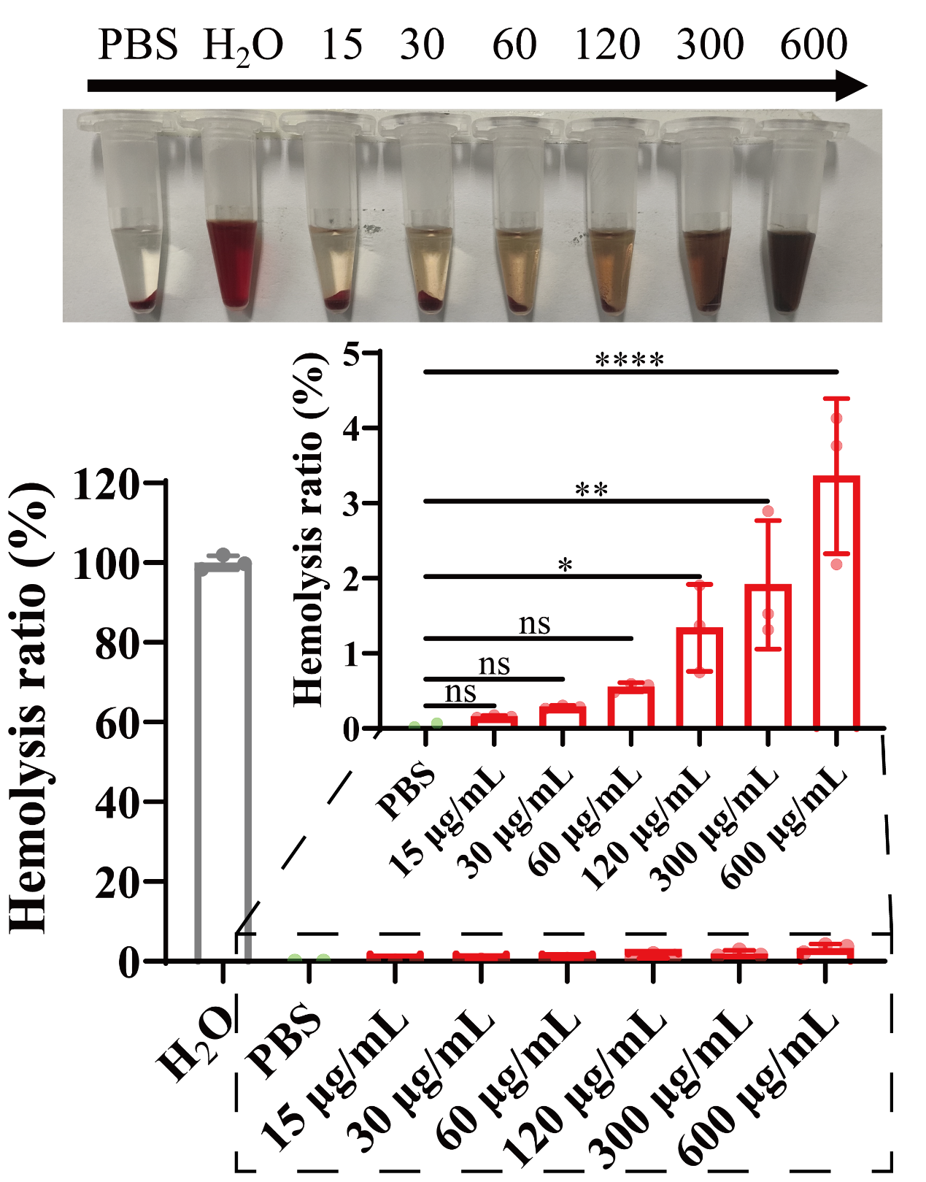
Fig. S23. Hemolysis images of erythrocytes incubated in H₂O, PBS and bCCM and quantification of hemolysis rate. (n ≥ 3; error bars represent SD, *P ≤ 0.05; **P ≤ 0.01; ***P ≤ 0.001; ****P ≤ 0.0001).

Fig. S24. Biosafety and biocompatitably of bCCM. (A) WBC: white blood cell, (B) RBC: red blood cell, (C) HGB: hemoglobin, (D) PLT: blood platelet. Liver function markers: (E) ALT: alanine aminotransferase and (F) AST: aspartate aminotransferase. Kidney function markers: (G) CREA: creatinine and (H) BUN: blood urea-nitrogen. Error bars denote the standard deviation. (n ≥ 3; error bars represent SD, *P ≤ 0.05; **P ≤ 0.01; ***P ≤ 0.001; ****P ≤ 0.0001).

Fig. S25. Quantitative analysis of mean fluorescence by Tunel assay. (n ≥ 3; error bars represent SD, *P ≤ 0.05; **P ≤ 0.01; ***P ≤ 0.001; ****P ≤ 0.0001).

