‌Supplementary Materials‌
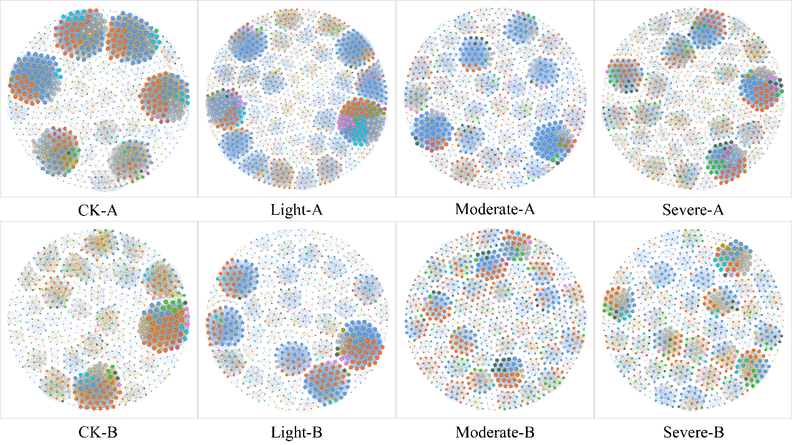
Note: Networks were constructed based on Spearman correlations. P-values from the upper triangle were FDR-corrected using the Benjamini–Hochberg procedure, with a unified threshold of |r| ≥ 0.60 and q < 0.05. Self-loops and nodes with degree zero were removed. Nodes represent taxa (species), and edges represent significant correlations; positive and negative edges were assigned according to the sign of the correlation coefficient. Network metrics included the number of nodes, number of edges, proportion of positive edges, average degree, network density, global clustering coefficient, average path length, diameter, and modularity (Louvain). The same hereafter.
Figure S1. Bacterial co-occurrence network at the species level

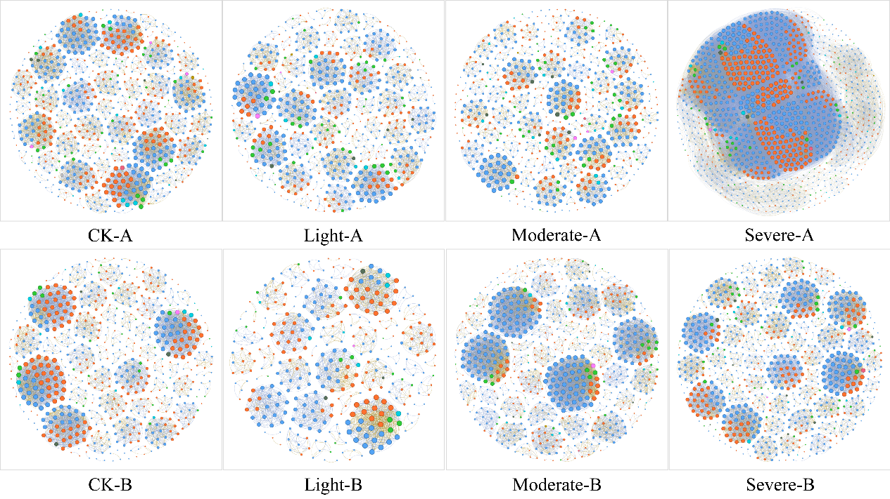
Figure S2. Fungi co-occurrence network at the species level

Table S1. Summary of LMM results for bacterial alpha diversity (Depth)
Indicator | F | df | P | Partial η² | R²  (Marginal) | R²  (Conditional) | q  (FDR) | B vs A
ACE | 6.875 | 1, 27 | 0.014 | 0.203 | 0.051 | 0.772 | 0.014 | B>A
Simpson | 21.891 | 1, 27 | <0.001 | 0.448 | 0.346 | 0.511 | <0.001 | B<A
Pielou_e | 22.245 | 1, 27 | <0.001 | 0.452 | 0.358 | 0.501 | <0.001 | B<A

Table S2. Summary of LMM results for fungal alpha diversity (Depth)
Indicator | F | df | P | Partial η² | R²  (Marginal) | R²  (Conditional) | q  (FDR) | B vs A
ACE | 0.088 | 1, 27 | 0.769 | 0.003 | 0.002 | 0.198 | 0.769 | B<A
Simpson | 5.299 | 1, 27 | 0.029 | 0.164 | 0.104 | 0.393 | 0.029 | B<A
Pielou_e | 3.337 | 1, 27 | 0.079 | 0.110 | 0.055 | 0.490 | 0.079 | B<A

Table S3. Within-group dispersion (distance to centroid), mean ± SE (Wildfire severity )
Group | Mean | SE
CK | 0.0514 | 0.0021
Light | 0.1647 | 0.0086
Moderate | 0.0267 | 0.0021
Severe | 0.1235 | 0.0064

Table S4. Pairwise comparisons of within-group dispersion (Tukey HSD; Wildfire severity)
Compariosn | Difference（diff） | 95% CI lower | 95% CI upper | Adjusted P-value
Light-CK | 0.1133 | 0.0922 | 0.1344 | <0.0001
Moderate-CK | -0.0247 | -0.0458 | -0.0036 | 0.0162
Severe-CK | 0.0721 | 0.0510 | 0.0932 | <0.0001
Moderate-Light | -0.1382 | -0.1591 | -0.1169 | <0.0001
Severe-Light | -0.0412 | -0.0623 | -0.0201 | 0.0004
Moderate-Severe | 0.0967 | 0.0757 | 0.1179 | <0.0001

Table S5. Within-group dispersion (distance to centroid), mean ± SE (Depth)
Soil layer | Mean | SE
A | 0.0965 | 0.0063
B | 0.1899 | 0.0079

Table S6. Pairwise comparisons of within-group dispersion (Tukey HSD, Depth)
Comparison | Difference (diff) | 95% CI lower | 95% CI upper | Adjusted P-value
B-A | 0.0934 | 0.0730 | 0.1137 | <0.0001

Table S7. PERMANOVA (overall model; Bray–Curtis; 9,999 permutations)
Term | Df | Sum of squares | R2 | F | P-value
Model | 7 | 1.19882 | 0.98124 | 239.14 | <0.0001
Residual | 32 | 0.02292 | 0.01876 | - | -
Total | 39 | 1.22173 | 1.00000 | - | -

