SUPPORTING DOCUMENT
Leveraging Molecular Descriptors and Explainable Machine Learning for Monomer Conversion Prediction in Photoinduced Electron Transfer-Reversible Addition-Fragmentation Chain Transfer Polymerization

Berna Alemdagª, Azra Kocaarslan^{a,b,*}, Gözde Kabay^{a,*}

ª Karlsruhe Institute of Technology (KIT), Institute of Functional Interfaces (IFG), Department for Bioengineering and Biosystems, 76344 Eggenstein-Leopoldshafen, Germany.
^{b} Karlsruhe Institute of Technology (KIT), Institute of Nanotechnology (INT), Department for Bioengineering and Biosystems, 76344 Eggenstein-Leopoldshafen, Germany.
E-mail: gozde.kabay@kit.edu; azra.kocaarslan@kit.edu

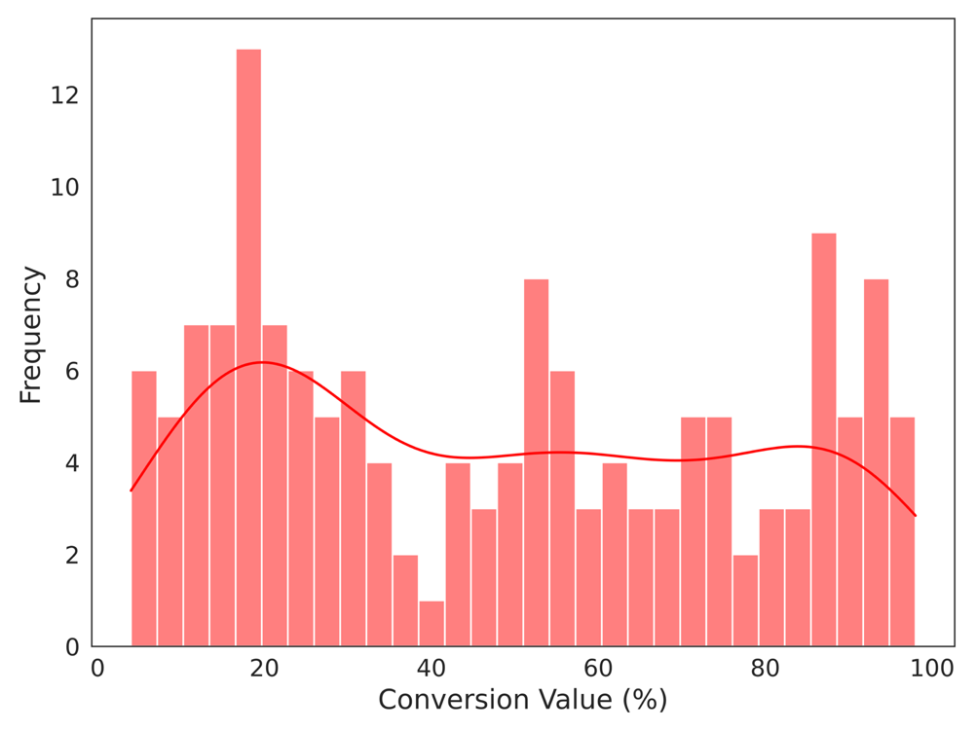

Figure S1. Histogram of conversion (%) values. The graph shows the frequency distribution of the “conversion” (target variable) values in the dataset. The x-axis represents the percentage values of conversion, and the y-axis shows the frequency of data points within each bin.
Table S1. Summary of the conversion data distribution obtained from 152 entries used as target features for model development and testing.
Parameter | Value
Standard deviation | 29.27
Minimum value (%) | 4
25th percentile (%) | 19.75
50th percentile (%) | 47.5
75th percentile (%) | 74.25
Maximum value (%) | 98
Number of features | 83

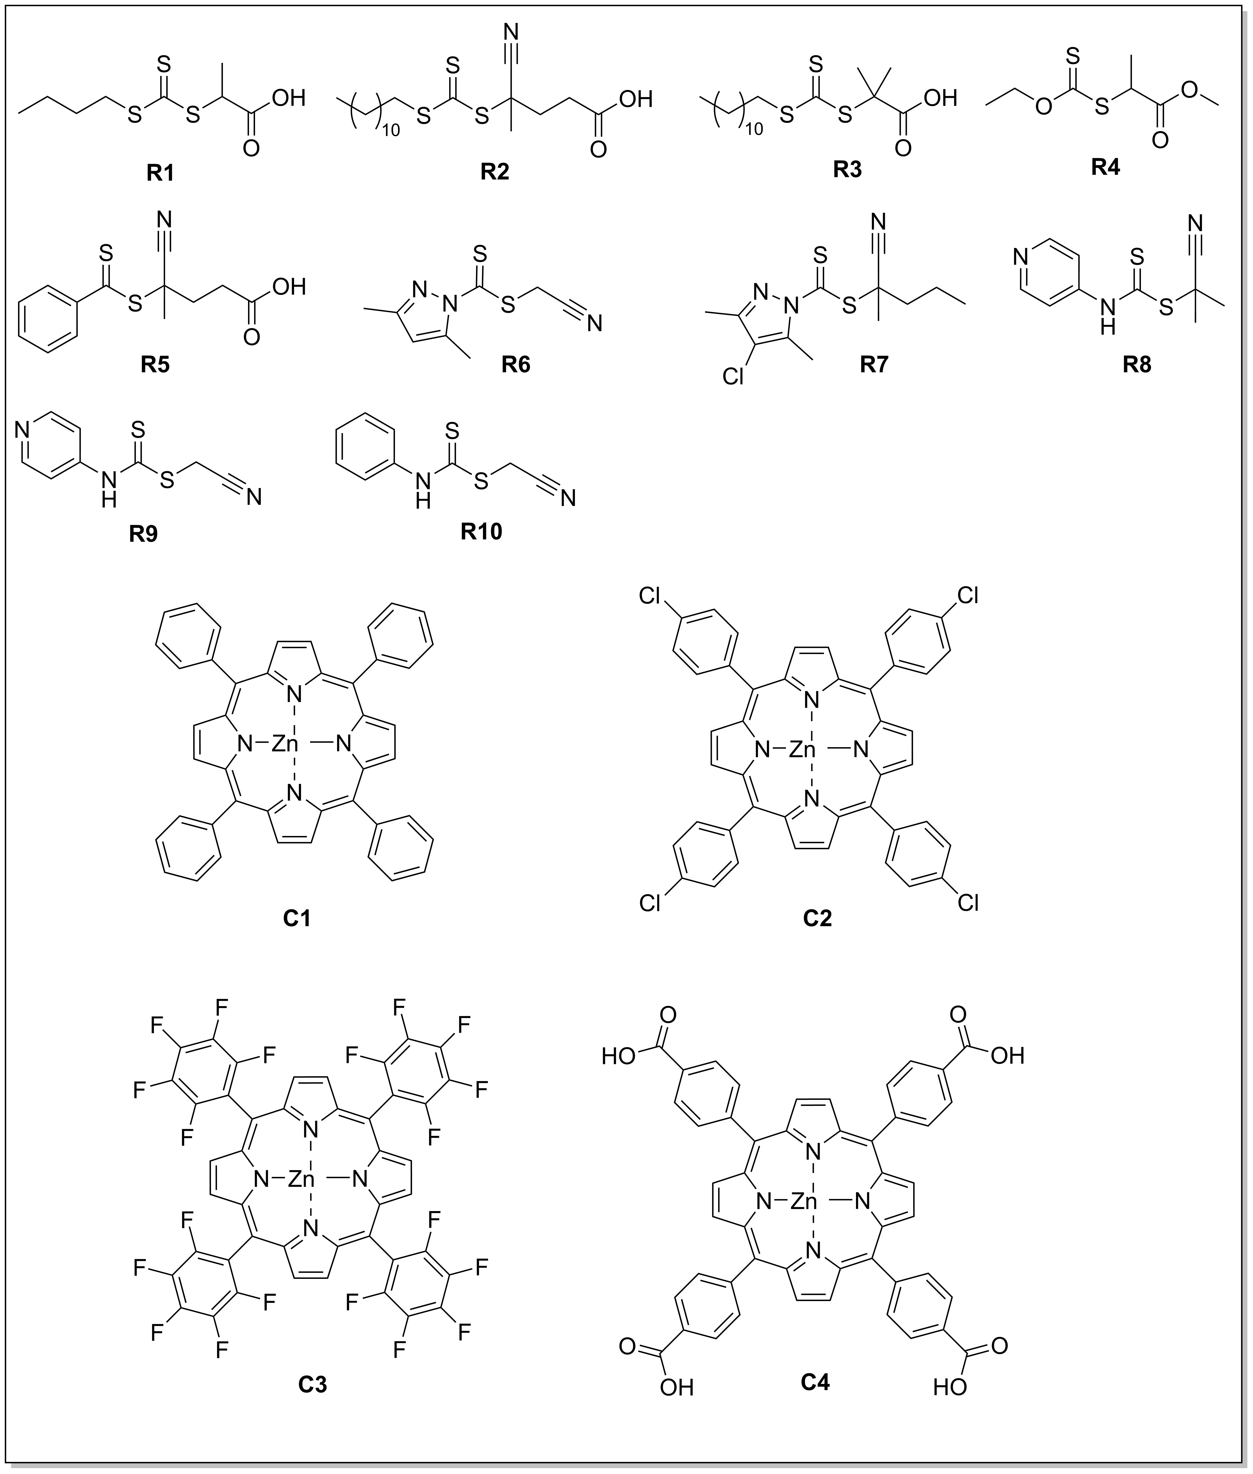
Figure S2. Chemical structures of representative compounds used in this study. R1–R10 demonstrate small-molecule chain transfer agents (CTAs). C1–C4 demonstrate zinc porphyrin-based photocatalysts with different meso-substituents: C1 (phenyl), C2 (dichlorophenyl), C3 (pentafluorophenyl), and C4 (carboxyphenyl).
Table S2. A list of RDKit descriptors and thermodynamic properties employed in this study.^{[1]}
Category |  | Input Features
Molecular Descriptors from RDKit
Hydrophobicity / surface area descriptors |  | SlogP_VSA1, SlogP_VSA2, SlogP_VSA3, SlogP_VSA4, SlogP_VSA5, SlogP_VSA6, SlogP_VSA7, SlogP_VSA8,  SlogP_VSA9, SlogP_VSA10, SlogP_VSA11, SlogP_VSA12
Polarizability / dispersion interaction descriptors |  | SMR_VSA1, SMR_VSA2, SMR_VSA3, SMR_VSA4, SMR_VSA5,  SMR_VSA6, SMR_VSA7, SMR_VSA8, SMR_VSA9, SMR_VSA10
Topology and electronic distribution descriptors |  | VSA_EState1, VSA_EState2, VSA_EState3, VSA_EState4, VSA_EState5, VSA_EState6, VSA_EState7, VSA_EState8, VSA_EState9, VSA_EState10
Electrostatic / charge descriptors |  | PEOE_VSA1, PEOE_VSA2, PEOE_VSA3, PEOE_VSA4, PEOE_VSA5,  PEOE_VSA6, PEOE_VSA7, PEOE_VSA8, PEOE_VSA9, PEOE_VSA10, PEOE_VSA11, PEOE_VSA12, PEOE_VSA13, PEOE_VSA14
Electronic state / topological descriptors |  | EState_VSA1, EState_VSA2, EState_VSA3, EState_VSA4, EState_VSA5, EState_VSA6, EState_VSA7, EState_VSA8, EState_VSA9, EState_VSA10, EState_VSA11
Global polarity / H-bonding capacity descriptor |  | TPSA
Global size/shape descriptor |  | LabuteASA
Molecular weight descriptor |  | MolWt, HeavyAtomMolWt, ExactMolWt
Electronic descriptors |  | NumValenceElectrons, NumRadicalElectrons
Charge descriptors |  | MaxPartialCharge, MinPartialCharge, MaxAbsPartialCharge, MinAbsPartialCharge
Morgan fingerprint density descriptors |  | FpDensityMorgan1, FpDensityMorgan2, FpDensityMorgan3
Shape indices |  | Kappa1, Kappa2, Kappa3
Topological descriptors |  | RingCount, BalabanJ, BertzCT
EState indices |  | MaxAbsEStateIndex, MinAbsEStateIndex, MaxEStateIndex, MinEStateIndex
Chi descriptors |  | Chi0, Chi0n, Chi0v, Chi1, Chi1n, Chi1v, Chi2n, Chi2v, Chi3n, Chi3v, Chi4n, Chi4v
Molar logarithm of the partition coefficient (logP) |  | MolLogP
The fraction of sp3-hybridized carbon atom in molecule. |  | FractionCSP3
Alpha value of Hall-Kier |  | HallKierAlpha
Coefficient of characteristic polynomial of adjacency matrix of hydrogen suppressed molecular graph |  | Ipc
Specific functional group present |  | fr_Al_COO, fr_Al_OH, fr_Al_OH_noTert, fr_ArN, fr_Ar_COO, fr_Ar_N, fr_Ar_NH, fr_Ar_OH, fr_COO, fr_COO2, fr_C_O, fr_C_O_noCOO, fr_C_S, fr_HOCCN, fr_Imine, fr_NH0, fr_NH1, fr_NH2, fr_N_O,fr_Ndealkylation1, fr_Ndealkylation2, fr_Nhpyrrole, fr_SH, fr_aldehyde, fr_alkyl_carbamate, fr_alkyl_halide, fr_allylic_oxid, fr_amide, fr_amidine, fr_aniline, fr_aryl_methyl, fr_azide, fr_azo, fr_barbitur, fr_benzene, fr_benzodiazepine, fr_bicyclic, fr_diazo, fr_dihydropyridine, fr_epoxide, fr_ester, fr_ether, fr_furan, fr_guanido, fr_halogen, fr_hdrzine, fr_hdrzone, fr_imidazole, fr_imide, fr_isocyan, fr_isothiocyan, fr_ketone, fr_ketone_Topliss, fr_lactam,fr_lactone, fr_methoxy, fr_morpholine, fr_nitrile, fr_nitro, fr_nitro_arom, fr_nitro_arom_nonortho, fr_nitroso, fr_oxazole, fr_oxime, fr_para_hydroxylation, fr_phenol, fr_phenol_noOrthoHbond, fr_phos_acid, fr_phos_ester, fr_piperdine, fr_piperzine, fr_priamide, fr_prisulfonamd, fr_pyridine, fr_quatN, fr_sulfide, fr_sulfonamd, fr_sulfone, fr_term_acetylene, fr_tetrazole, fr_thiazole, fr_thiocyan, fr_thiophene, fr_unbrch_alkane, fr_urea.
Thermodynamic properties of RAFT agents^{[2–4]}
RAFT agent type | ∆H_{stab} (kJ mol⁻¹) |  | ∆H_{frag} (kJ mol⁻¹) | RSE (kJ mol⁻¹)
BTPA | 59.4 |  | -4.4 | 41.3
CDTPA | 59.4 |  | -4.4 | 59.0
DDMAT | 59.4 |  | -4.4 | 54.9
Xanthate | 86.8 |  | -44.3 | 41.3
CPADB | 41.3 |  | +21.0 | 59.0
DTC1 | 47.9 |  | -5.5 | 31.9
DTC2 | 45.0 |  | -3.2 | 59.0
CBPCD | 90.6 |  | -32.7 | 59.0
CMPCD | 90.6 |  | -32.7 | 31.9
CMPhCD | 90.6 |  | -32.7 | 31.9
*Enthalpy values of RAFT stability (∆H_{stab}), the fragmentation efficiency (∆H_{frag}), and the radical stabilization energy (RSE) of the leaving R● group radicals (kJ/mol) for the various RAFT agents. List of RAFT agents employed in this work composed of trithiocarbonates (including, 2-(butylthiocarbonothioylthio) propanoic acid (BTPA, R1), 4-cyano-4-[(dodecylsulfanylthiocarbonyl)sulfanyl]pentanoic acid (CDTPA, R2), 2-(dodecylthiocarbonothioylthio)-2-methylpropionic acid (DDMAT, R3), methyl 2-((ethoxycarbonothioyl)thio)propanoate (Xanthate, R4), 4-cyano-4-(phenylcarbonothioylthio)pentanoic acid (CPADB, R5), cyanomethyl (3,5-dimethyl-1H-pyrazole)-carbodithioate (DTC1, R6), and 2-cyanobutan-2-yl 4-chloro-3,5-dimethyl-1H-pyrazole-1-carbodithioate (DTC2, R7), 2-cyanobutan-2-yl methyl(pyridin-4-yl)carbamodithioate (CBPCD, R8), cyanomethyl methyl(4-pyridyl)carbamodithioate (CMPCD, R9), and cyanomethyl methyl(phenyl)carbamodithioate (CMPhCD, R10).

Model | Type | Key parameters | Nonlinearity
LR | Linear | None (baseline) | No
Ridge | Linear (L2) | alpha=1.0 | No
Lasso | Linear (L1) | alpha=0.1 | No
SVR | Kernel | C=1.0  kernel= “rbf” | Yes  (via kernel)
k-NN | Instance-based | k=5 | Implicit (local)
RF | Ensemble (Bagging) | n_estimators=100  random_state=42  max_depth=None | Yes
GBR | Ensemble (Boosting) | random_state=42  n_estimators=100 | Yes
XGBoost | Ensemble (Boosting) | n_estimators=100  random_state=42  verbosity=0 | Yes
CatBoost | Ensemble (Boosting) | early_stopping=True  verbose=0  random_state=42 | Yes
MLP | Artificial Neural Network | hidden_layer_sizes = (128, 64)  max_iter =300 | Yes
Table S3. Summary of the regression models evaluated in this study. The table outlines the model types, key hyperparameters, their ability to model nonlinearity, and essential features relevant to our dataset. Linear models (LR, RR, Lasso) provide interpretable baselines and help control multicollinearity. Kernel-based (SVR) and instance-based (k-NN) models introduce nonlinear modeling capabilities, but they differ in their sensitivity to feature scaling. Ensemble methods (RF, GBR, XGBoost, CatBoost) feature robustness and high predictive accuracy, with CatBoost providing the best stability for diverse molecular descriptors. The neural network model (MLP) offers flexible nonlinear modeling but requires careful tuning and larger datasets for optimal results.^{[5]}

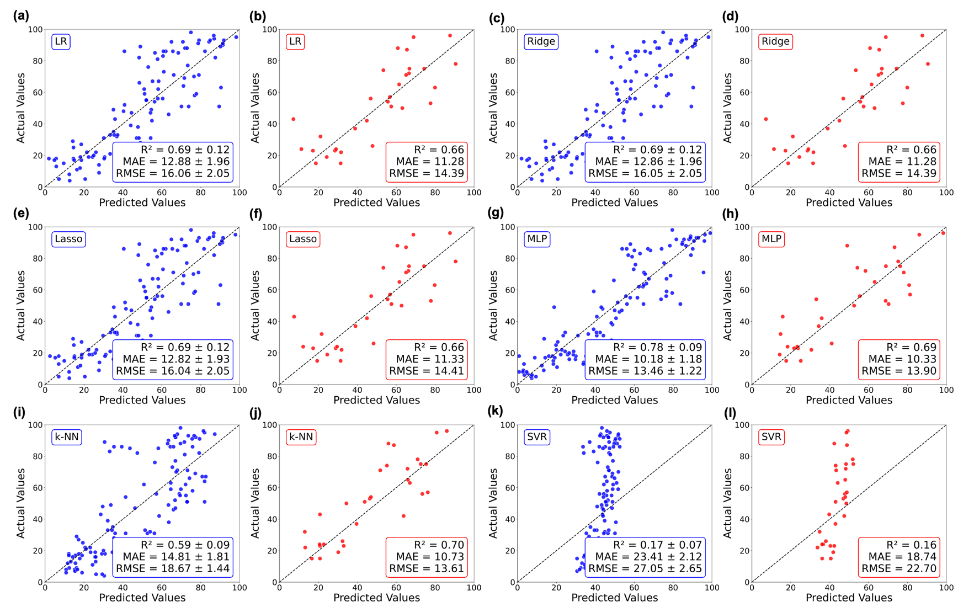
Figure S3. Parity plots demonstrating predicted versus actual PET-RAFT monomer conversion (%) values for (a, b) Linear Regression (LR), (c, d) Ridge, (e, f) Lasso, (g, h) Multi-Layer Perceptron (MLP), (i, j) k-Nearest Neighbors (k-NN), and (k, l) Support Vector Regression (SVR). The blue-dotted graphs correspond to predictions obtained during five-fold CV on the training set, while the red-dotted plots show predictions on the unseen test set for model evaluation. RMSE and MAE values represent data in pps. The dashed diagonal line (x = y) indicates ideal prediction, where predicted and actual values are equal (x = y).
Table S4. A summary of model training performance metrics with k-fold cross-validation (k = 5).

Model | R² | R²_SD | RMSE  (pps) | RMSE_SD | MAE  (pps) | MAE_SD
XGBoost | 0.83 | 0.11 | 11.51 | 3.33 | 8.14 | 2.18
CatBoost | 0.82 | 0.07 | 12.18 | 1.81 | 9.62 | 1.71
RF | 0.82 | 0.10 | 11.88 | 2.60 | 9.25 | 2.39
GBR | 0.81 | 0.09 | 12.54 | 2.27 | 9.06 | 1.83
k-NN | 0.59 | 0.09 | 18.67 | 1.44 | 14.80 | 1.81
MLP | 0.78 | 0.09 | 13.46 | 1.22 | 10.18 | 1.18
LR | 0.69 | 0.12 | 16.06 | 2.04 | 12.88 | 1.96
Ridge | 0.69 | 0.12 | 16.05 | 2.05 | 12.86 | 1.96
Lasso | 0.69 | 0.12 | 16.04 | 2.05 | 12.82 | 1.93
SVR | 0.17 | 0.07 | 27.05 | 2.65 | 23.41 | 2.12

Table S5. Model test performance metrics comparison for PET-RAFT polymerization yield prediction using the held-out test set.

ML model | R ² | RMSE | MAE
CatBoost | 0.84 | 10.04 | 8.16
RF | 0.84 | 9.93 | 8.17
GBR | 0.78 | 11.59 | 8.98
XGBoost | 0.77 | 11.80 | 9.25
k-NN | 0.70 | 13.61 | 10.73
MLP | 0.69 | 13.90 | 10.33
LR | 0.66 | 14.39 | 11.28
Ridge | 0.66 | 14.39 | 11.28
Lasso | 0.66 | 14.41 | 11.31
SVR | 0.16 | 22.70 | 18.74

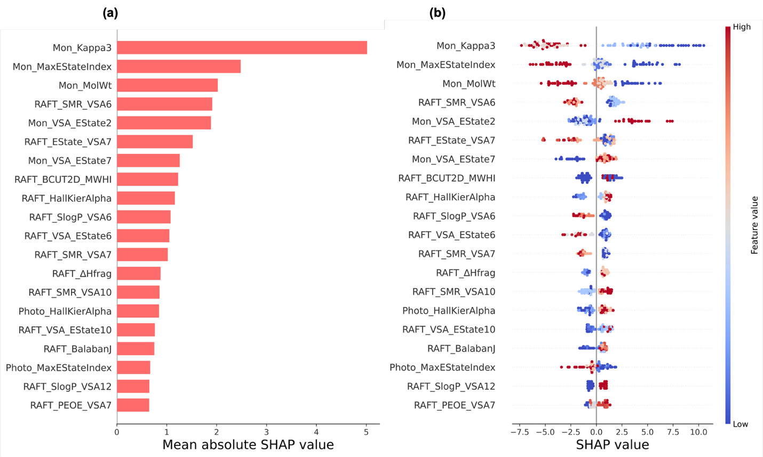
Figure S4. Global feature importance ranking for the CatBoost model. (a) The bar chart displays the mean absolute SHAP values for each input feature, indicating their overall contribution to the model output. Higher mean absolute SHAP values (red bars) indicate greater predictive impact of the individual feature across the dataset. (b) The beeswarm plot illustrates the spread of the impact of molecular descriptors on conversion prediction across 100 randomly selected samples from the dataset. Each point represents a single sample, along with its low (blue) and high (red) values for the prediction. Features are ranked by their overall importance based on the mean absolute SHAP value. The vertical line at x = 0 represents no impact on the prediction.
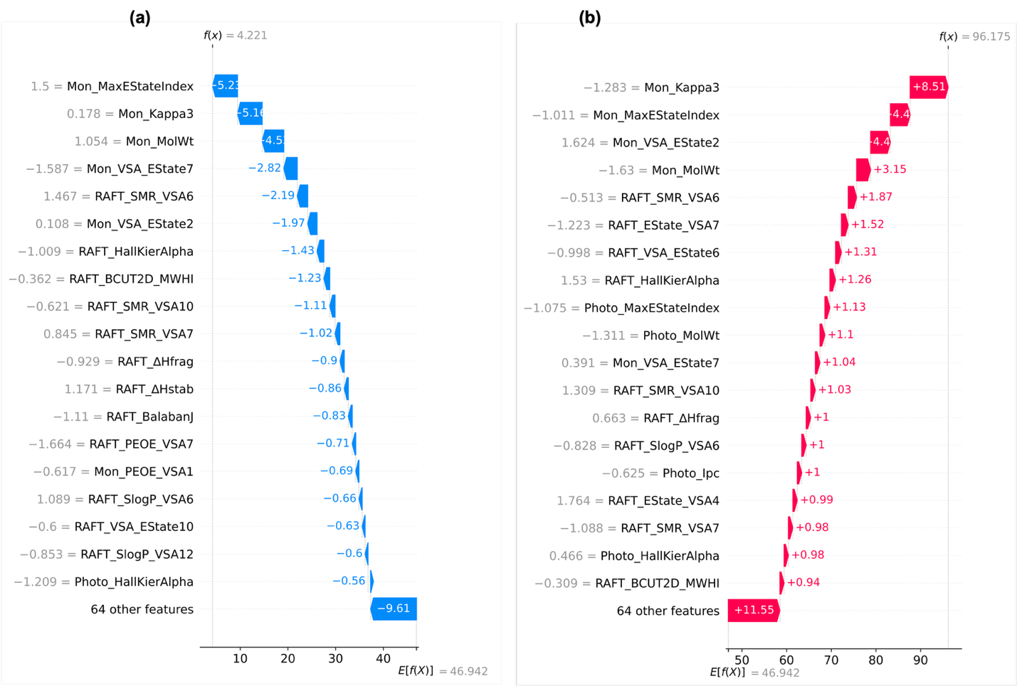Figure S5. Local SHAP waterfall plots show how different features contribute to PET-RAFT conversion predictions for two typical reactions. (a) A low-conversion example (4% conversion, BzMA with ZnTCPP and DTC2), where bulky monomer descriptors (high Mon_Kappa3, Mon_MolWt) and unfavorable RAFT parameters hindered monomer conversion. (b) A high-conversion example (96% conversion, DMA with ZnTPP and BTPA), where favorable monomer topology (low Mon_Kappa3), low molecular weight, and efficient RAFT fragmentation enthalpy (ΔH_frag) increased the prediction. Positive (blue) and negative (red) bars show additive feature contributions relative to the model baseline of E[f(x)] = 46.942.

References
[1] S. Barman, U. Sarkar, Adv Theory Simul 2025, 2401517.
[2] E. H. Krenske, E. I. Izgorodina, M. L. Coote, ACS Symposium Series 2006, 944, 406.
[3] P. M. Lathrop, Z. Duan, C. Ling, Y. A. Elabd, C. Kravaris, Processes 2019, Vol. 7, Page 768 2019, 7, 768.
[4] G. Ng, K. Jung, J. Li, C. Wu, L. Zhang, C. Boyer, Polym Chem 2021, 12, 6548.
[5] Supervised learning — scikit-learn 1.7.1 documentation, .

