Supplementary Materials

Bradycardia Risk Associated with Intravenous Dexmedetomidine: A Retrospective Study of Risk Factors and Clinical Outcomes in Critically Ill Patients (BRAID)

Table of Contents:
Page 2 Inclusion and exclusion criteria
Page 3 Supplemental Table 1: Multivariable logistic regression for bradycardia
Page 4 Supplemental Figure 1: Multivariable regression adjusting for baseline heart rate.
Page 5 Supplemental Figure S2: Risk factors for bradycardia with bradycardia defined as heart rate less than 50.

Inclusion and Exclusion Criteria
Inclusion Criteria:
- Patients ≥18 years old
- Patients receiving dexmedetomidine infusion
- Documented heart rate data throughout dexmedetomidine administration
- Mechanically ventilated patients
Exclusion Criteria:
- Pre-existing bradycardia (heart rate <60 bpm) in the 24 hours before dexmedetomidine initiation
- Patients on heart rate lowering medications
- Patients receiving neuromuscular blocking agents (paralytics)

Additional Analyses

Table S1. Multivariable logistic regression analysis of factors associated with bradycardia

Variable | OR | OR (95% CI) | p-value
Age (per year) | 1.01 | 1.01 (1.01-1.02) | <0.001
Male Sex | 0.89 | 0.89 (0.77-1.03) | 0.109
BMI (per unit) | 1.01 | 1.01 (1.00-1.02) | 0.009
SOFA Score (per point) | 1.03 | 1.03 (1.00-1.05) | 0.043
Congestive Heart Failure | 0.84 | 0.84 (0.72-0.97) | 0.022
Peripheral Vascular Disease | 0.71 | 0.71 (0.60-0.84) | <0.001
Cerebrovascular Disease | 1.21 | 1.21 (1.02-1.43) | 0.031
Dementia | 1.68 | 1.68 (1.21-2.32) | 0.002
Chronic Pulmonary Disease | 1.21 | 1.21 (1.04-1.41) | 0.016
Diabetes | 0.72 | 0.72 (0.59-0.87) | <0.001
Hypertension | 0.99 | 0.99 (0.74-1.33) | 0.966
Renal Disease | 0.93 | 0.93 (0.79-1.11) | 0.430
Moderate/Severe Liver Disease | 1.64 | 1.64 (1.25-2.14) | <0.001

OR = Odds Ratio; CI = Confidence Interval

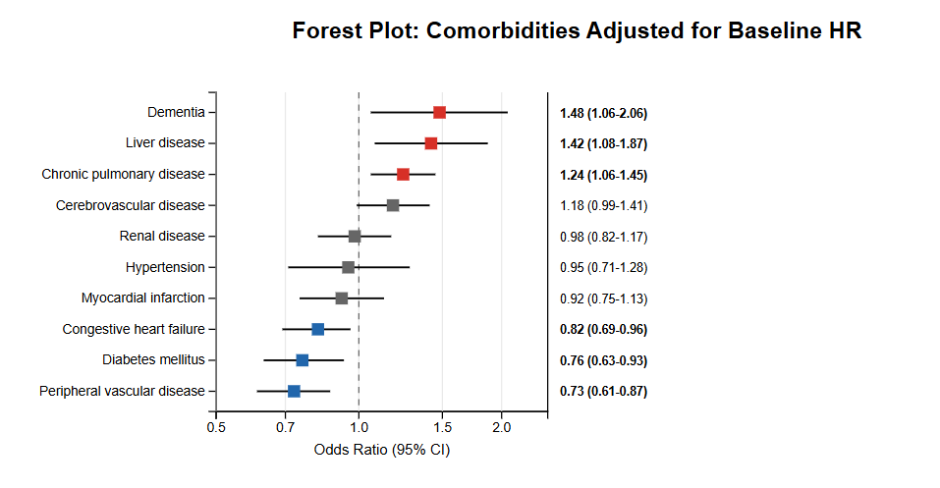

Figure S1. Multivariable regression adjusting for baseline heart rate.

Severe Bradycardia (HR < 50 bpm)

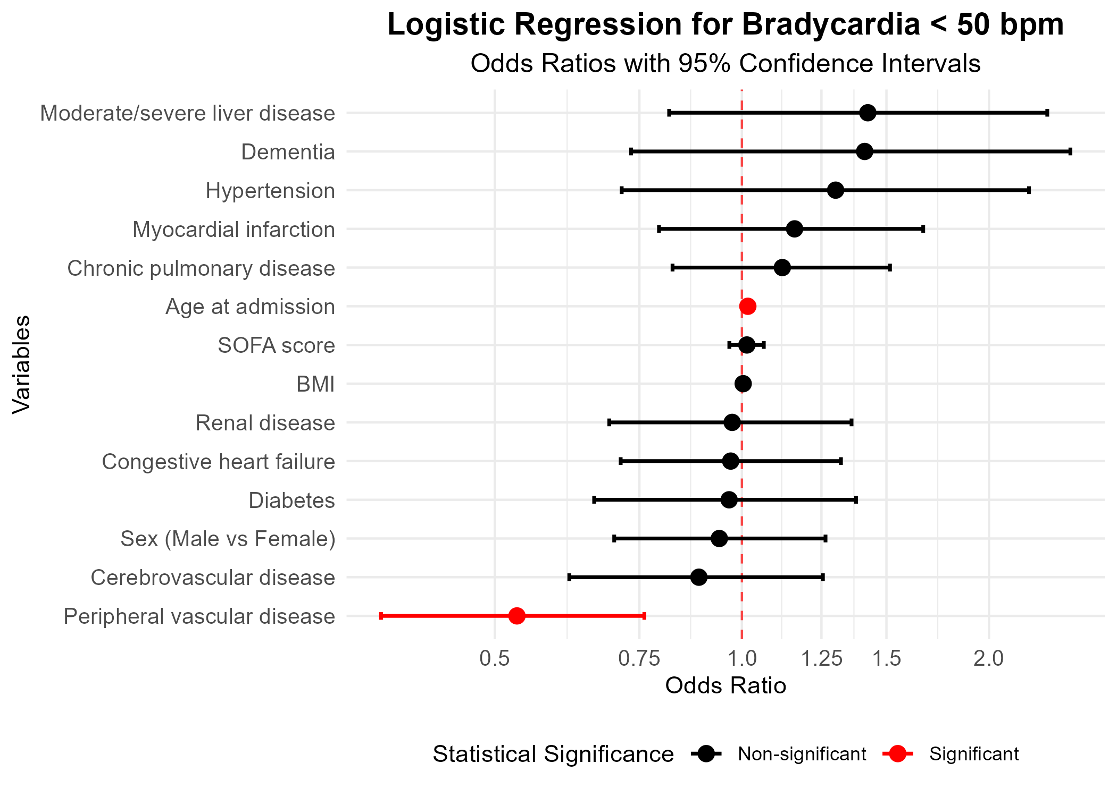

Figure S2. Risk factors for bradycardia with bradycardia defined as heart rate less than 50.

Table S2. Multivariable Logistic Regression Results for Bradycardia <50 bpm
Variable | Odds Ratio | 95% CI | P-value
Age at admission | 1.017 | (1.006 - 1.028) | 0.0021
Sex (Male vs Female) | 0.939 | (0.699 - 1.264) | 0.6745
BMI | 1.004 | (0.987 - 1.016) | 0.6353
SOFA score | 1.014 | (0.965 - 1.063) | 0.5733
Myocardial infarction | 1.159 | (0.792 - 1.663) | 0.4334
Congestive heart failure | 0.969 | (0.712 - 1.32) | 0.8417
Peripheral vascular disease | 0.532 | (0.363 - 0.761) | 0.0008
Cerebrovascular disease | 0.886 | (0.616 - 1.255) | 0.5054
Dementia | 1.411 | (0.733 - 2.513) | 0.2698
Chronic pulmonary disease | 1.120 | (0.823 - 1.515) | 0.4655
Hypertention | 1.301 | (0.714 - 2.238) | 0.3642
Diabetes | 0.965 | (0.661 - 1.378) | 0.8478
Moderate/severe liver disease | 1.424 | (0.815 - 2.355) | 0.1894
Renal disease | 0.973 | (0.689 - 1.36) | 0.8749

