Influence of habitat and climate on the spatial distribution of outbreaks of the Hylesia metabus moth, responsible for Lepidopterism, in coastal French Guiana
Raphaël Fougeray¹, Isaline Orhon¹, Manon Denux¹, Romane Ibanez¹, Romane Leseur¹, Liliana Ballesteros-Meija^{2,3}, Rodolphe Rougerie⁴, Giacomo Sellan⁵, Yi Moua^{6,7}, Mónica Arias ⁸† and Melanie McClure ¹†*
¹ Laboratoire Écologie, Évolution, Interactions des Systèmes Amazoniens (LEEISA), Université de Guyane, CNRS, IFREMER, 97300 Cayenne, France.
² DGD-REVE Direction Générale Déléguée à la Recherche, à l'Expertise, à la Valorisation et à l'Enseignement-Formation.
³ CESAB, Centre de Synthèse et d’Analyse sur la Biodiversité, Montpellier, France.
⁴ Institut de Systématique, Évolution, Biodiversité (ISYEB), CNRS, MNHN, EPHE, Sorbonne Université, Université des Antilles, Paris, France.
⁵ CIRAD, UMR EcoFoG (AgroParisTech, CNRS, INRAE, Université des Antilles, Université de Guyane), Campus Agronomique, Kourou, France.
⁶ Espace-Dev, IRD, Univ Montpellier, Univ Guyane, Univ La Réunion, Univ Antilles, Univ Nouvelle Calédonie, Montpellier, France.
⁷ Espace-Dev, Univ Guyane, Cayenne / Kourou, Guyane française, France.
⁸ PHIM, Univ Montpellier, CIRAD, INRAE, Institut Agro, IRD, CEDEX 5, 34398 Montpellier, France.
†Co-last authors: Mónica Arias & Melanie McClure
*Corresponding author. E-mail: melanie.mcclure@cnrs.fr

Supplementary information

French abstract
Comprendre comment les facteurs écologiques influencent l’occurrence spatiale des pullulations d’insectes est essentiel, en particulier pour les espèces nuisibles ayant un impact significatif sur la santé humaine. Le papillon cendre Hylesia metabus est un Lépidoptère généraliste doté d’écailles (setae) urticantes. Cette espèce provoque de sévères réactions dermatologiques et ses pullulations posent de sérieux problèmes de santé publique le long des côtes du Venezuela et de la Guyane française. Malgré sa large distribution dans le nord de l’Amérique du Sud, les pullulations restent imprévisibles et localisées. Dans cette étude, nous avons exploré les facteurs associés à la distribution spatiale des pullulations en examinant 13 sites en Guyane française. Nous avons évalué la structure forestière, la composition spécifique des arbres, la couverture forestière, ainsi que la pression de prédation aviaire. Nous avons également utilisé des modèles de distribution d’espèces afin d'examiner l’effet des conditions climatiques. Les sites plus à risques se caractérisent par une faible densité d’arbres, un taux de prédation élevée, des variations de température quotidienne minimales et des changements saisonniers marqués. Ces conditions sont plus fréquentes le long du littoral guyanais, contrairement aux écosystèmes forestiers intérieurs, plus stables et diversifiés, où les pullulations sont rares, voire absentes. Ces résultats mettent en évidence les caractéristiques des habitats associées aux pullulations, constituant une première étape vers la mise en place de stratégies de surveillance et de mitigations futures dans un contexte de changement environnemental.

Materials and Methods

Risk of Hylesia metabus outbreaks
To assess the risk of H. metabus outbreaks along the coast, we categorized sites based on local outbreak records. This assessment was conducted by reviewing local news articles, identifying municipal needs related to the medical and social consequences of outbreaks, and through informal discussions with members of the general public in the affected areas. The review focused on articles from France-Guyane, Guyane la 1ère, and available reports from the Cellule Régionale Permanente d’Observation et de Prévention de la Papillonite en Guyane (CROPP; a regional service to help predict and prevent outbreaks). To avoid overestimating outbreak frequency by counting multiple mentions of the same event, only one outbreak report per locality was recorded when they occurred within a one-month interval. An inventory of the collected data and available documents is provided in Table S1. Additional details, including links to relevant press articles (in French), are available in the Zenodo archive https://doi.org/10.5281/zenodo.15414490.
Table S1 Number of Hylesia metabus outbreak reports in the local press and public information bulletins in French Guiana from 2006 to 2021. Reports occurring within a one-month interval in the same locality were considered as a single event to avoid duplication.
City | Number of times H. metabus were reported
Sinnamary | 10
Iracoubo | 9
Rémire-Montjoly | 7
Matoury | 5
Roura | 5
Cayenne | 4
Kourou | 3
Macouria | 2
Cacao | 1
Saint-Laurent-du-Maroni | 1
Mana | 1

Line intercept transect
At each study site, three 16-meter line-intercept transects were used to sample tree communities. This method quantifies vegetation by recording the length of plant material (trunks, branches, leaves) intersecting the transect line (Fig. S1). For each tree intersecting the line, species identity, circumference at 1.3 m from the ground, and intercept length were recorded. This technique, commonly used in forest inventories, provides reliable estimates of vegetation structure, especially in dense environments (Caratti 2006; Fraver et al. 2018).
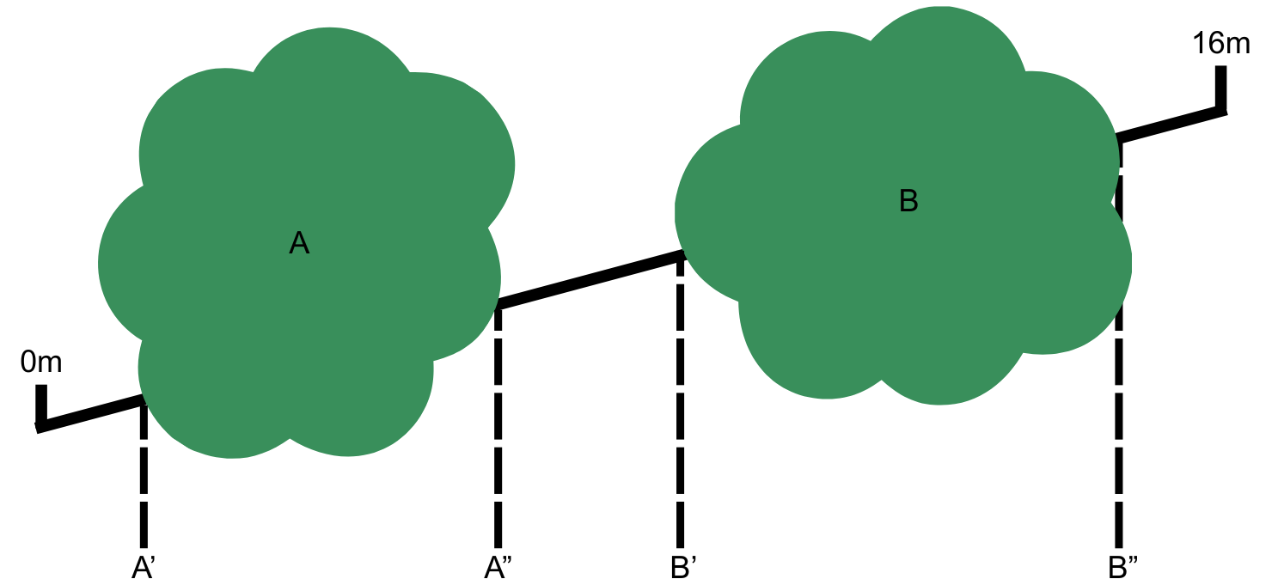
Fig. S1 Schematic representation of a line-intercept transect: A’-A” and B’-B” show the measures for the intercept lengths of tree A and tree B (in green) intersecting the transect

Biodiversity indices
For each line-intercept transect, three diversity indices were calculated: species richness, Shannon and Piélou. Species richness ($S$) was calculated as the total number of species observed within each sampling unit. This metric provides a simple count of the unique taxa present, without accounting for their relative abundances. Shannon diversity index ($H'$) was calculated using the formula:
$$H' = -\sum_{i = 1}^{S}{p_{i}ln(p_{i})}$$
where $S$ is the total number of species, and $p_{i}$ is the proportional abundance of the $i$-th species in the community (i.e., the number of individuals of species $i$ divided by the total number of individuals across all species). The Shannon index accounts for both species richness and the evenness of species abundances, assigning higher values to communities with a more equitable distribution of individuals among species. Pielou’s evenness index ($J'$) was calculated as:
$$J' = \frac{H'}{ln(S)}$$
where $H'$ is the Shannon diversity index and $S$ is the species richness. Pielou's index provides a standardized measure of evenness, ranging from 0 (high dominance by a few species) to 1 (perfectly even distribution of individuals among species). All calculations were performed in R v.4.4.0. using the vegan package (Oksanen et al. 2024).

List of H. metabus host plants
Hylesia metabus is a polyphagous moth whose larvae feed on a wide variety of plant species (Table S2). Approximately 32 host plants have been documented (see Ciminera 2017 and references therein), spanning 20 different families, which reflects the ecological flexibility of this species. The list includes both native and introduced plants, ranging from common tropical trees such as Cecropia obtusa (Urticaceae) and Virola sebifera (Myristicaceae) to cultivated or economically important species like Theobroma cacao (Malvaceae), Mangifera indica (Anacardiaceae), and Psidium guajava (Myrtaceae).

Measure of canopy cover using ImageJ
The forest cover at each transect was assessed using photographs of the canopy taken with a fisheye lens (Samyang 7.5mm lens / Olympus OM-D E-M5). These photographs were imported into the software ImageJ, where a mask was created using the color threshold tool by reducing the maximum brightness value, such that the forest appeared darker than the sky. The images were then converted into binary format using the "make binary" tool, with the masked areas (forest) represented as white pixels and the remaining areas (sky) as black pixels. The percentage of white pixels in the image was calculated using the "measurement" tool, providing the percentage of forest cover.
Table S2 Host plants of Hylesia metabus, as listed in Ciminera 2017, with the number of individuals found in the transects (identified to the species when possible, but also included when identified to the genus; empty cells correspond to 0).
Family | Species | Number of individuals in the transects
Acanthaceae | Avicennia germinans | 8
Anacardiaceae | Anacardium occidentale
 | Mangifera indica
 | Tapirira guianensis | 10
Annonaceae | Annona squamosa | 34
 | Guatteria sp.
Bignoniaceae | Jacaranda copaia
Bixaceae | Bixa orellana
Combretaceae | Laguncularia racemosa
 | Terminalia catappa
Euphorbiaceae | Croton matourensis
 | Hura crepitans
 | Maprounea guianensis | 3
 | Sapium glandulosum | 2
Fabaceae | Erythrina poeppigiana
 | Inga edulis | 23
Hypericaceae | Vismia guianensis | 13
 | Vismia sp. | 13
Malpighiaceae | Byrsonima crassifolia
Malvaceae | Theobroma cacao | 4
Myristicaceae | Virola sebifera | 4
Myrtaceae | Eucalyptus sp.
 | Psidium guajava
 | Syzygium cumini
 | Syzygium malaccense
Piperaceae | Piper aduncum
Polygonaceae | Coccoloba latifolia
Rhizophoraceae | Rhizophora mangle | 7
Rubiaceae | Isertia coccinea
Rutaceae | Citrus sp.
Simaroubaceae | Homalolepis cedron
Urticaceae | Cecropia obtusa | 11

Caterpillar models and predation marks
Artificial caterpillars (3 cm × 0.5 cm) were made from light green plasticine to mimic cryptic, palatable larvae. They were placed on branches 1.5–2 m above the ground and spaced at least 2 m apart along transects (100 per site, Fig. S2). After ~72h of exposure, caterpillars were collected and inspected for predation marks. Attacks were categorized visually based on impression shape, following published criteria (Eötvös and Lövei 2013; Lövei and Ferrante 2017; Fig. S3).
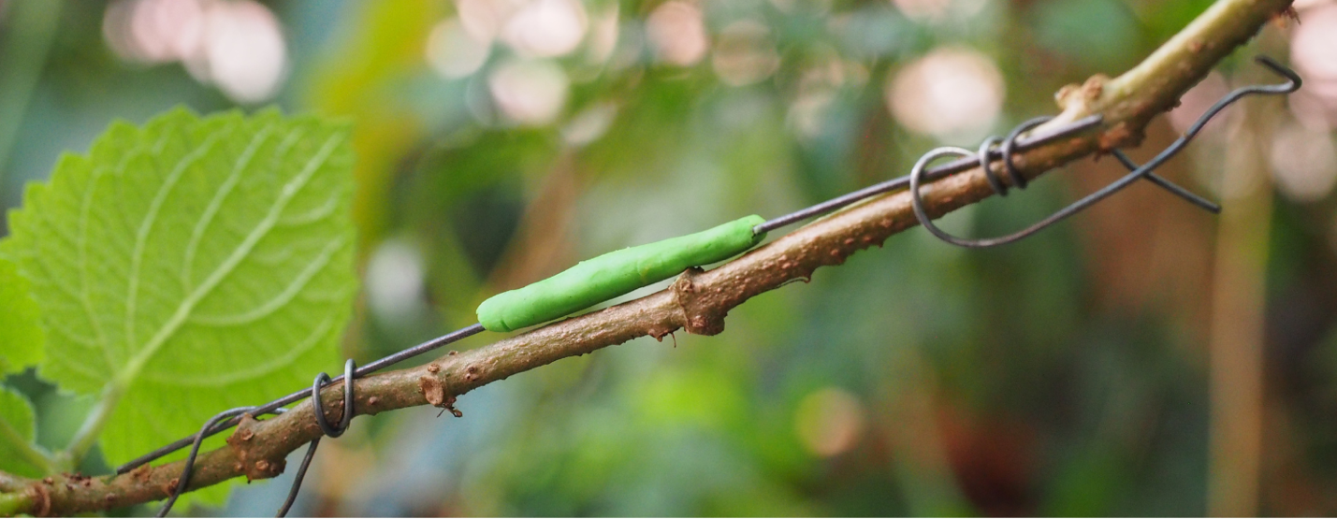
Fig. S2 Photograph of artificial caterpillar placed on a branch
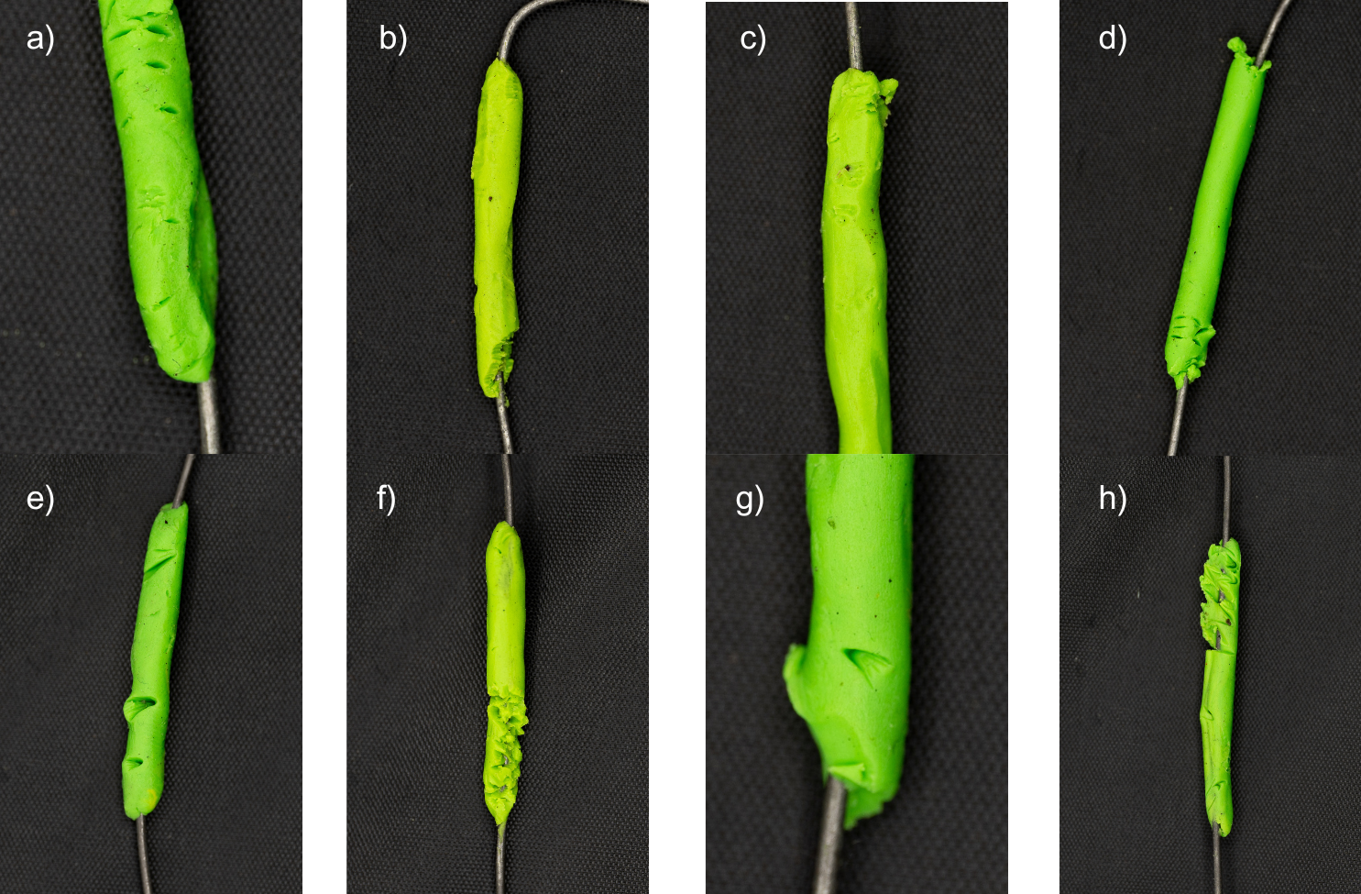
Fig. S3 Examples of predation marks left by: arthropods (a-d) and birds (e-h)

Variables used for the spatial generalized additive models
To assess habitat differences, spatial generalized additive models (sGAM) with ordinal response structure were used. Variables showing inconsistencies (e.g., total intercept measures and total intercepts for host plants), as well as those with a variance inflation factor (VIF) greater than 5, were excluded from the models (Table S3).
Table S3 Variables used for the proportional odds logistic regression models (POLR) analysis, with excluded variables (VIF > 5 or inconsistencies) indicated in bold.
Variable | Description
Total basal area (m²) | The total basal area (sum of all Ge).
Basal area of host plants (m²) | The total basal area occupied by host plants (sum of all host plant Ge).
Canopy cover (%) | The tree canopy estimated based on photographs.
Number of host plants | The total number of host plant species that intercepted the transect.
Number of trees | The total number of trees that intercepted the transect.
Pielou’s evenness index (J') | A measure of species evenness within the transect, showing how evenly individuals are distributed across species.
Predation rate | Predation rate by birds on artificial clay caterpillars.
Species richness (S) | The total number of different tree species that intercept the transect.
Basal area host plant ratio | The ratio of the total basal area occupied by potential host plants.
Intercept host plant ratio | The ratio of intercepts measured occupied by potential host plants.
Proportion of host plants | The proportion of trees that intercepted the transect that were potential host plants.
Shannon diversity index (H’) | Index that accounts for both species richness and the evenness of species abundance.
Total intercept measures | Sum of all intercept lengths.
Total intercepts for host plants | Sum of host plant intercept lengths.

Target-group background
To minimize biases in the model related to uneven spatial sampling, the target-group background method was applied. This approach refines the selection of pseudo-absences by focusing on areas where surveys similar to those conducted for our focal species have taken place. In this study, various moth families—Saturniidae, Sphingidae, and Noctuidae—were used as the target group for H. metabus (Fig. S4a), while the class Magnoliopsida was used as the target group for host plants (Fig. S4b).
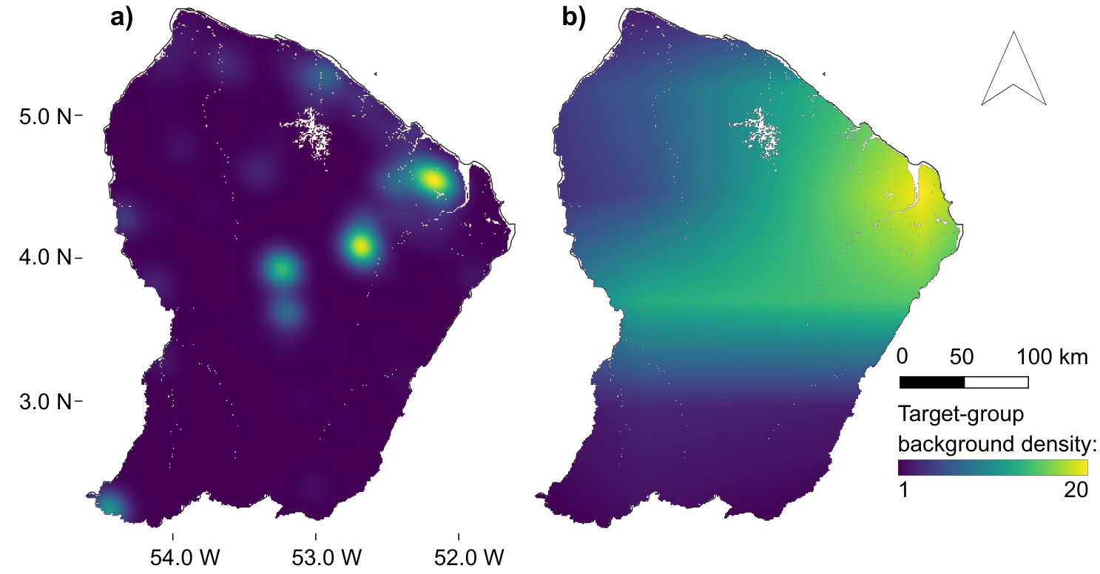
Fig. S4 Kernel density maps of occurrence records used for the target-group background with (a) density of occurrences for moth families Saturniidae, Sphingidae, and Noctuidae, used as a target group for Hylesia metabus, and (b) density of occurrences for the plant class Magnoliopsida, used as a target group for host plants. Density values are scaled between 1 and 20

Results

Mean values for all variables collected for each site
For each line-intercept transect, several forest structure and diversity indicators were recorded, including predation rate, tree abundance, total intercept length, basal area and canopy cover. Additionally, three diversity indices were calculated: species richness, Shannon diversity index, and Pielou’s evenness index. For each site, values were averaged across the three transects to obtain site-level means (Table S4). These site-level indicators were also averaged by habitat type—savanna, coastal forest, hill and valley forest and mid-altitude forest—to explore structural and compositional differences among habitat categories (Table S5).

PCA
The principal component analysis (PCA) revealed that the first two axes explained 61.5% and 23.9% of the total variance, respectively, capturing a cumulative 85.4% of the variability in the data. Predation rate and the number of trees were primarily associated with the two first axis (Predation rate: Dim1, loading = 0.75, contribution = 30%, cos² = 0.6; Dim2, loading = -0.60, contribution = 50%, cos² = 0.4; Number of trees: Dim1, loading = 0.74, contribution = 30%, cos² = 0.6; Dim2, loading = 0.60, contribution = 50%, cos² = 0.4). While the canopy cover was associated with the first and the third dimensions (Dim1, loading = 0.86, contribution = 40%, cos² = 0.7; Dim3, loading = -0.51, contribution = 60%, cos² = 0.3). Sites from Outbreak group 1 (least prone to outbreaks; n = 4) tended to show high canopy cover and tree richness (three sites with high positive Dim1 scores), with moderate to low predation rates (most sites close to 0 or slightly negative on Dim2). In contrast, Outbreak Group 2 (intermediate; n = 6) was more heterogeneous, including sites with both low and high tree richness and variable canopy cover, with sites relatively evenly distributed along both dimensions. Finally, Outbreak Group 3 (most outbreak-prone; n = 3) was characterized by lower canopy cover and tree richness (two sites with strongly negative Dim1 scores), and relatively high predation rates (two sites with positive Dim2 scores). These PCA findings are consistent with the results of the sGAM, which highlighted a decline in canopy cover and number of trees and an increase in predation rate along the outbreak gradient.
Table S4 Mean values for all variables collected for each site; values equal to or superior to the overall median are in bold.
Sites (with outbreak propensity in parentheses) | Predation rate | Number of trees | Number of host plants | Proportion of host plant | Total tree basal area (m²) | Basal area of host plants (m²) | Basal area host plant ratio
Cacao (1) | 0.07 | 11.33 | 2 | 0.16 | 3607 | 23 | 0.00
Mountain des singes (1) | 0.01 | 12.00 | 0.33 | 0.05 | 1301 | 287 | 0.08
Mana (1) | 0.12 | 6.00 | 2.67 | 0.48 | 1906 | 1217 | 0.36
Saint-Laurent-du-Maroni (1) | 0.03 | 8.67 | 3.00 | 0.35 | 2807 | 258 | 0.22
Lake Petit-Saut (2) | 0.17 | 13.00 | 0.33 | 0.04 | 1193 | 4 | 0.00
Bridge Larivot (Macouria) (2) | 0.00 | 5.00 | 5.00 | 1.00 | 3369 | 3369 | 1.00
Macouria botanical garden (2) | 0.01 | 5.33 | 3.33 | 0.56 | 1523 | 732 | 0.60
Savannah of Matiti (Macouria) (2) | 0.01 | 6.00 | 2.33 | 0.39 | 897 | 590 | 0.71
Roura (2) | 0.01 | 7.00 | 4.67 | 0.61 | 1129 | 376 | 0.61
Kaw mountain (2) | 0.15 | 8.67 | 3.00 | 0.33 | 673 | 370 | 0.56
Dégrad des Cannes (boat harbour, Rémire-Montjoly) (3) | 0.04 | 8.00 | 2.33 | 0.31 | 2378 | 166 | 0.09
Iracoubo (3) | 0.11 | 5.67 | 2.33 | 0.38 | 571 | 294 | 0.53
Sinnamary (3) | 0.12 | 6.33 | 1.00 | 0.15 | 1127 | 55 | 0.08
Median | 0.04 | 7.00 | 2.33 | 0.35 | 1301 | 294 | 0.36
Sites (with outbreak propensity in parentheses) | Total intercept measures | Total intercept for host plants | Intercept host plant ratio | Canopy cover (%) | Tree species richness (S) | Shannon diversity index (H') | Pielou's evenness index (J')
Cacao (1) | 2113 | 180 | 0.08 | 95 | 9.33 | 2.18 | 0.98
Mountain des singes (Kourou) (1) | 53 | 10 | 0.11 | 89 | 8.33 | 1.73 | 0.92
Mana (1) | 1623 | 887 | 0.55 | 94 | 4.67 | 1.35 | 0.90
Saint-Laurent-du-Maroni (1) | 1747 | 870 | 0.49 | 96 | 5.33 | 1.56 | 0.95
Lake Petit-Saut (2) | 1623 | 1 | 0.00 | 95 | 5.33 | 1.27 | 0.77
Bridge Larivot (Macouria) (2) | 19 | 19 | 1.00 | 88 | 2.00 | 0.62 | 0.90
Macouria botanical garden (2) | 24 | 15 | 0.64 | 68 | 2.67 | 0.87 | 0.90
Savannah of Matiti (Macouria) (2) | 42 | 16 | 0.44 | 61 | 4.67 | 1.48 | 0.98
Roura (2) | 42 | 20 | 0.55 | 79 | 3.67 | 1.31 | 1.02
Kaw Mountain (2) | 1803 | 660 | 0.37 | 94 | 6.00 | 1.70 | 0.97
Dégrad des Cannes (boat harbour, Rémire-Montjoly) (3) | 1463 | 497 | 0.36 | 97 | 4.33 | 1.30 | 0.89
Iracoubo (3) | 1397 | 467 | 0.37 | 80 | 3.00 | 1.00 | 0.94
Sinnamary (3) | 1460 | 193 | 0.13 | 95 | 5.33 | 1.56 | 0.93
Median | 1460 | 180 | 0.37 | 94 | 4.67 | 1.35 | 0.93

Table S5 Mean values for some of the ecological variables and diversity indices measured per forest habitat for 13 sites in French Guiana.
Habitat | Number of sites | Number of trees | Number of host plants | Proportion of host plants | Canopy cover (%) | Tree species richness (S)
Savanna | 4 | 5.83 | 2.25 | 0.37 | 76.07 | 3.92
Coastal forest | 5 | 6.93 | 3.53 | 0.55 | 90.83 | 4
Hill and valley forest | 2 | 12.50 | 0.33 | 0.04 | 92.10 | 6.83
Mid-altitude mountain forest | 2 | 10 | 2.50 | 0.25 | 94.44 | 7.67

References
Caratti JF (2006) Line Intercept (LI). Lutes Duncan C Keane Robert E Caratti John F Key Carl H Benson Nathan C Sutherl. Steve Gangi Larry J 2006 FIREMON Fire Eff. Monit. Inventory Syst. Gen Tech Rep RMRS-GTR-164-CD Fort Collins CO US Dep. Agric. For. Serv. Rocky Mt. Res. Stn. P LI-1-13 164
Eötvös C, Lövei GL (2013) Documenting predator marks on dummy caterpillars. In: Saska P, Knapp M, Honek A, Martinkova Z (eds) XVIth European Carabidologists Meeting - Book of Abstracts with Conference Programme: Carabids and man - can we live with(out) each other? European Carabidologists Meeting, p 31
Fraver S, Ducey MJ, Woodall CW, D’Amato AW, Milo AM, Palik BJ (2018) Influence of transect length and downed woody debris abundance on precision of the line-intersect sampling method. For. Ecosyst. 5:1–10
Lövei GL, Ferrante M (2017) A review of the sentinel prey method as a way of quantifying invertebrate predation under field conditions. Insect Sci. 24:528–542
Muscarella R, Galante PJ, Soley-Guardia M, Boria RA, Kass JM, Uriarte M, Anderson RP (2014) ENMeval: An R package for conducting spatially independent evaluations and estimating optimal model complexity for Maxent ecological niche models. Methods Ecol Evol 5(11):1198–1205. https://doi.org/10.1111/2041-210X.12261
Oksanen J, Simpson GL, Blanchet FG, Kindt R, Legendre P, Minchin PR, O’Hara RB, Solymos P, Stevens MHH, Szoecs E, Wagner H, Barbour M, Bedward M, Bolker B, Borcard D, Carvalho G, Chirico M, Caceres MD, Durand S, Evangelista HBA, FitzJohn R, Friendly M, Furneaux B, Hannigan G, Hill MO, Lahti L, McGlinn D, Ouellette M-H, Cunha ER, Smith T, Stier A, Braak CJFT, Weedon J (2024) vegan: Community Ecology Package

